ACCA5011
Advance Software Development

Jamie Richards (0852036)
ACCA5011 – Advance software development
Table of Contents
1 – Introduction Page - 2
2 – Task 1 - Algorithms Page - 2
2.1 – Dijkstra’s Algorithm Page - 3
2.1.1 – Dijkstra’s Algorithm Breakdown Page - 3
2.2 – A* Algorithm Page - 4
2.2.1 – A* Algorithm Breakdown Page - 4
2.3 – Comparison Page - 5
3 – Task 2 - Maze Page - 5
3.1 – Implementation Page - 5
3.2 – Results Page - 10
4 – Conclusion Page - 14
5 – References Page - 15

1 - Introduction

This report will consist of two separate tasks, firstly task one will be an in-depth review on Dijkstra’s Algorithm and the A* Algorithm, each comprising of a description, examples of use and a comparison. The second task in this report will be in relation to the implementation of pseudocode, to be more specific, while using a prebuild pathfinding program a solution will be made to solve the generated maze, this report will end with a conclusion.

2 – Task 1 - Algorithm

This task as mentioned in the introduction will comply of a review on Dijkstra’s and the A* algorithms, firstly what is an algorithm?
“When algorithms are defined rigorously in Computer Science literature (which only happens rarely), they are generally identified with abstract machines, mathematical models of computers, sometimes idealized by allowing access to “unbounded memory”. My aims here are to argue that this does not square with our intuitions about algorithms and the way we interpret and apply results about them; to promote the problem of defining algorithms correctly; and to describe briefly a plausible solution, by which algorithms are recursive definitions while machines model implementations, a special kind of algorithms.” [1]
The above statement cited from the book Mathematics Unlimited written by Yiannis N Moschovakis exhibits the writers view on what algorithms are, going into to compare them to machines and how people interpret them.
An algorithm can be simply viewed as a formula or technique which solves problems, each step of an algorithm is shaped to identify a solution. However, this can be questioned depending on the field algorithms are used on, for instance in game development algorithms would mainly be used to create realistic physics such as player movement.
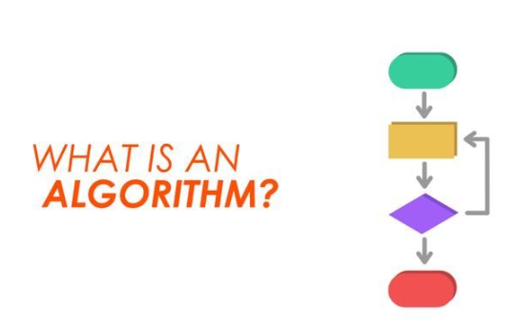
[2] Figure 1 above taken from the young wonks website is a perfect illustration of what is an algorithm? With a simple image showing a step-by-step structure to represent the algorithm itself.
2.1 – Dijkstra’s Algorithm
One of the most well-known algorithms, known as the Dijkstra’s Algorithm, is used to find the quickest path from the beginning to end of a weighted graph. A weighted graph is a conventional graph with numerical valued edges often called weights. The edges or nodes within a graph would hold a value with a purpose depending on the context of the graph. [3]
Dijkstra’s Algorithm is commonly used in navigation technologies such as satnavs and was created by Dr Edsger Dijkstra in1959, the algorithm itself can only be used with positive values in its weights or edges because of the way the algorithm uses calculations to find the quickest way to the end of the graph.

2.1.1 – Dijkstra’s Algorithm Breakdown
To breakdown Dijkstra’s Algorithm starting at the beginning the initial node needs to be set to 0, known as the initial node, edges are then connected between the nodes. The other nodes and edges will need to be marked as unvisited otherwise they won’t be visited again once checked by the algorithm.
From the initial node, the algorithm will then follow the edge to the adjacent node, marking it as visited and moving to the next, once done the distance between the nodes visited will be calculated.
This procedure is repeated until the smallest known distance is found. [4]
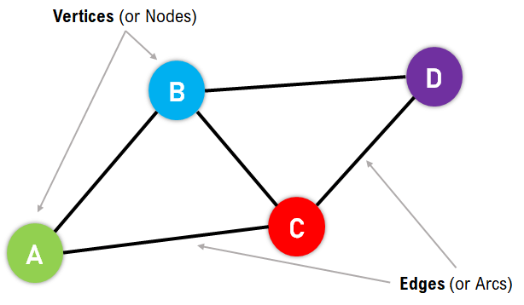
[5] Figure 2 on the left taken from the javat point website illustrates the components of a weighted graph, with nodes and edges clearly marked.
It can be seen where the algorithm would travel between notes and gives a better understanding of the movements.

2.2 – A* Algorithm
A* or the A-star algorithm like Dijkstra’s algorithm is also used to find the quickest route from the beginning to end.
“The A* algorithm combines the best aspects of two other algorithms:
- Dijkstra's Algorithm: This algorithm finds the shortest path to all nodes from a single source node.
- Greedy Best-First Search: This algorithm explores the node that appears to be closest to the goal, based on a heuristic function.
Imagine you're trying to find the shortest route between two cities on a map. While Dijkstra's algorithm would explore in all directions and Best-First Search might head straight toward the destination (potentially missing shortcuts), A* does something cleverer. It considers both:
- The distance already travelled from the start
- A smart estimate of the remaining distance to the goal
This combination helps A* make informed decisions about which path to explore next, making it both efficient and accurate.” [6]
The statement above citied from the website data camp written by data science content writer Rajesh Kumar, exemplifies the A* algorithm using attributes from two other algorithms to produce results. Dijkstra’s algorithm which as mentioned above looks for the quickest path and best first search which applies a heuristic function also know as a target or aim to get to.

2.2.1 – A* Algorithm Breakdown
The A* algorithm uses a few formulas when visiting nodes in a graph, shown below:
f(n) = g(n)+h(n)
n = node
- F(n) – obtains the cost of the solution through n.
- G(n) – is the cost from the initial node to n.
- H(n) – estimates the cost of n to the target node
To begin the A* algorithm adds all available nodes to an open list and using the formula above uses zero as a value for the start node, h(n) then is used to estimate the distance to reach the target node. The process consists of the selection of the smallest value node and if the target node is hit the process is complete if not the next node is selected with the node just visited added to a closed list. The same is done for each of the neighbouring nodes and continues until the list is empty.

2.3 – Comparison
Both Dijkstra’s and A* are pathfinding algorithms however the A* algorithm can be viewed as a better version of the Dijkstra’s algorithm due to the fact it explores which node to visit first, making it more effective even more so if the user has an aim to achieve.
Furthermore, the A* algorithm incorporates Dijkstra’s and first search attributes within itself where Dijkstra’s does not allow the user to reach an end goal however if there is no target node needed, and the user just needs the quickest path then Dijkstra is the obvious choice.

3 – Task 2 - Maze
For this task a pathfinding program will be used, the program is designed to generate a random maze which the player needs to navigate through. This task will be split into two sections, firstly the implementation, where the solution will be made to solve the maze and secondly the results that came from the implementation.
Once the program is run the user is presented with three options:
- Option 1 – This is a manual run through where a random maze is generated, and the user can move themselves with the assigned keys as well as view the maze.
- Option 2 – Is the automatic mode which utilises the GridNavigatorAutomatic::Navigate() method within the program to solve the maze, this is what will be created in the implementation part of this task.
- Option 3 – Is where the program will run option 2 ten thousand times, results from this should be interesting.

3.1 – Implementation
Before starting on the solution for this task and reviewing the code further for the program it can be seen the grid class will become important with its array of griditem. Known as an enum it represents different types of attributes such as the player, wall, target and if its empty or not. In the solution getgrid() will be used to return a two dimensional array with a pointer to griditem**, this will also be used for the player movement which is identified with griditem::player, the same works for the wall and target by simply replacing player with wall or target.
To start the solution, it would be safe to check if the grid is complete or not shown in the below snippet:
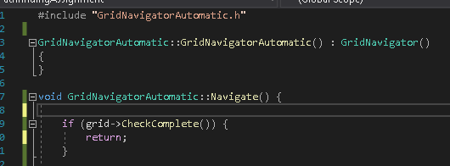
Next the player would need to be located, this will be done by scanning the grid for the players position, again as mentioned above the player would be represented by griditem::player. The next snippet below shows the a for loop which is locating the player if found the loop will be exited.
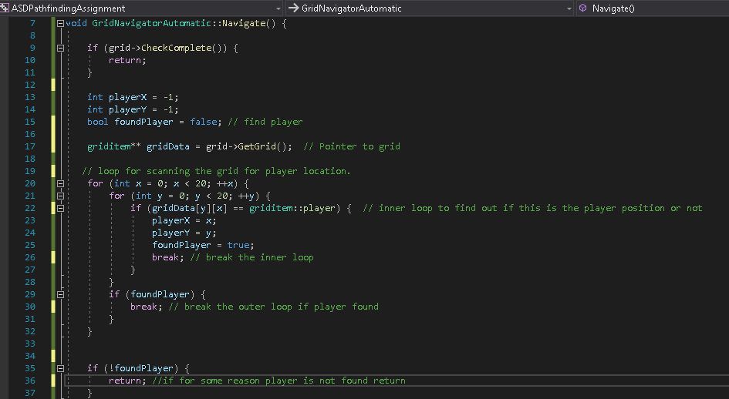
Next in the solution the direction of the possible moves will be made (left, right, up or down). This will be represented in pairs such as 0, -1 representing up, 0,1 down and so forth.
Keeping in mind a check will also be made for any spaces that has a wall or griditem::wall as mentioned previously, this can be seen in the below snippet.
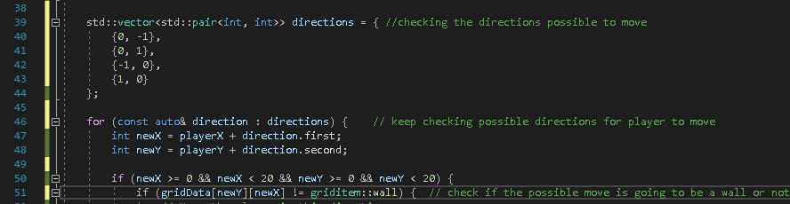
As shown above another loop is used for determining if a wall is present or not and an if statement which will determine whether to move there or not.
The enum or classes for movement used can be seen as movdirection::up down etc.
Finally move the player in a position that is empty.
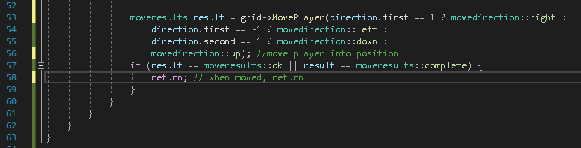

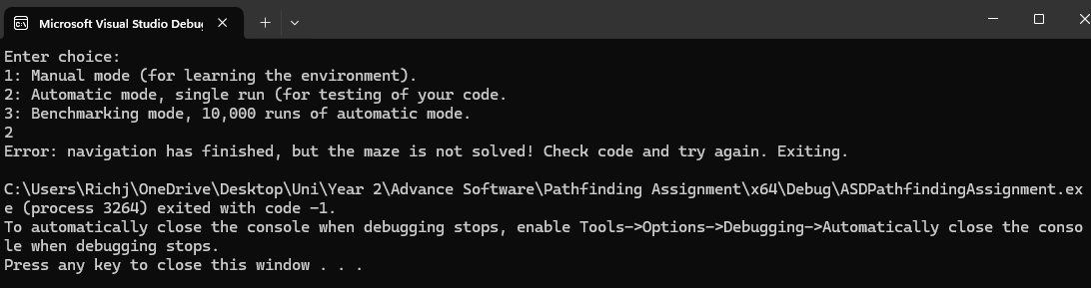
The above snippet shows what happens when the program is started and option 2 selected, an error message indicating the navigation was completed but the maze was not solved, this would be due to player not successfully reaching the target meaning there are a few checks needed and possible improvements to the solution.
To start these checks firstly looking at the check complete function in the program ensuring that the function is correctly detecting if the player reaches the target, this will be done by going into the grid class and ensuring the position is accurate.
Next the player movement should always be moving towards the target by going into open paths however thinking on this further what if there is more than one open path, a better approach would be to improve the strategy of the movement by always attempting to move toward the target, for instance move horizontally rather than vertically or vice versa.
Before trying to obtain a better strategy, the maze needs to be successfully completed, after further reviewing the solution current made, some debugging strategies can be used to ensure the player is moving and to where to, first isostream is added to allow this.
In order do this grid->PrintGrid() will be used to show the maze and player position in the console. Furthermore adding std::cout to print out messages during the running of the console will help, for example once a player has moved it can display player moved successfully etc.
The snippet below illustrates these debugging methods:
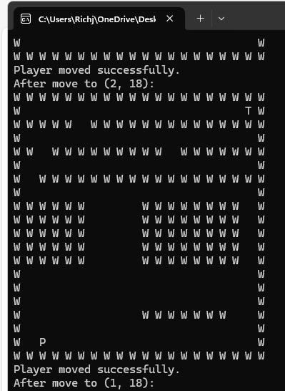
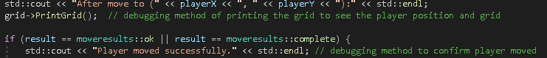
As she snippet to the left shows, the console displays the maze with the walls shown as W, the target as T and the player position as P.
Using the debugging methods discussed the console also shows that the player moved successfully and where the player moved.
In this instance the player moved from grids 2,18 to 1,18. This can be viewed as a back track and will need to be investigated because looking at the maze there was no need to move back to the starting spot.

Progressing further into the solution above and noticing there was no need to check if the maze was solved at first instance therefore moving this further into the solution.
The solution needed a target therefore adding in the target’s locations may help, upon further research it seemed what’s known as a greedy algorithm could be applied here like Dijkstra’s algorithm previously discussed. However, the issues with this is the algorithm only makes decisions on the data it currently has at any one time meaning its not looking at the big picture of finding the target only moving into an empty space. [7]

The below snippets show what was produce so far.
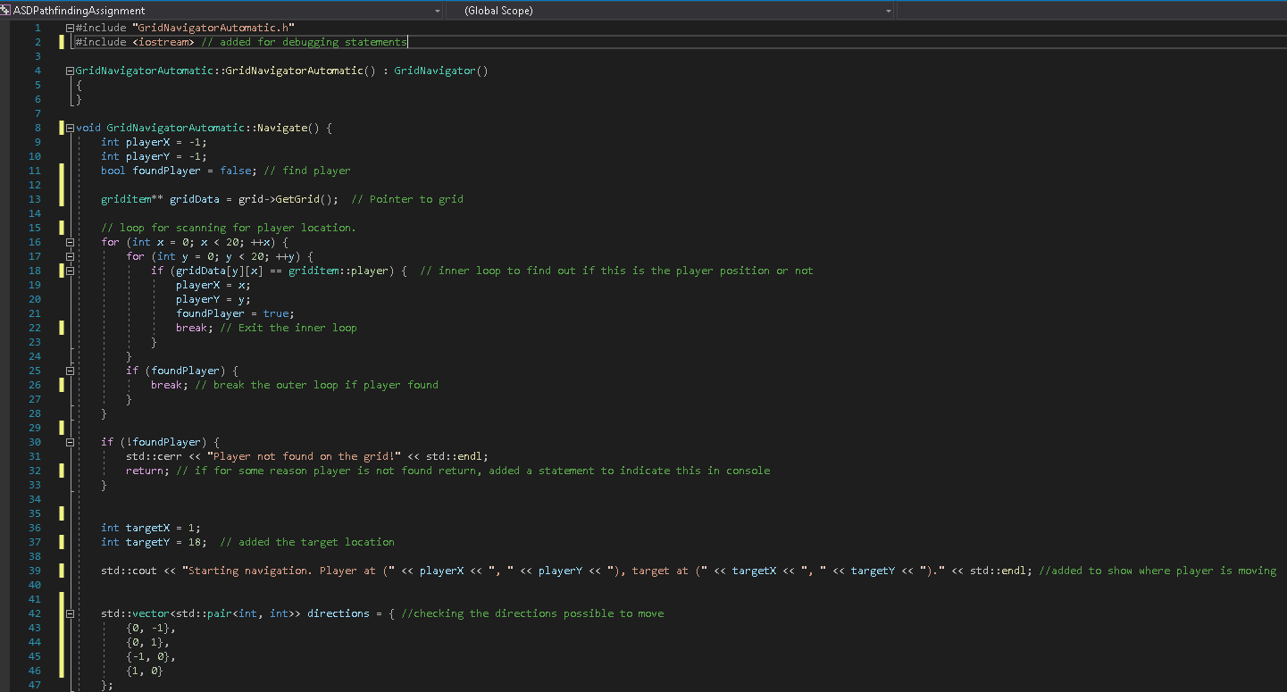
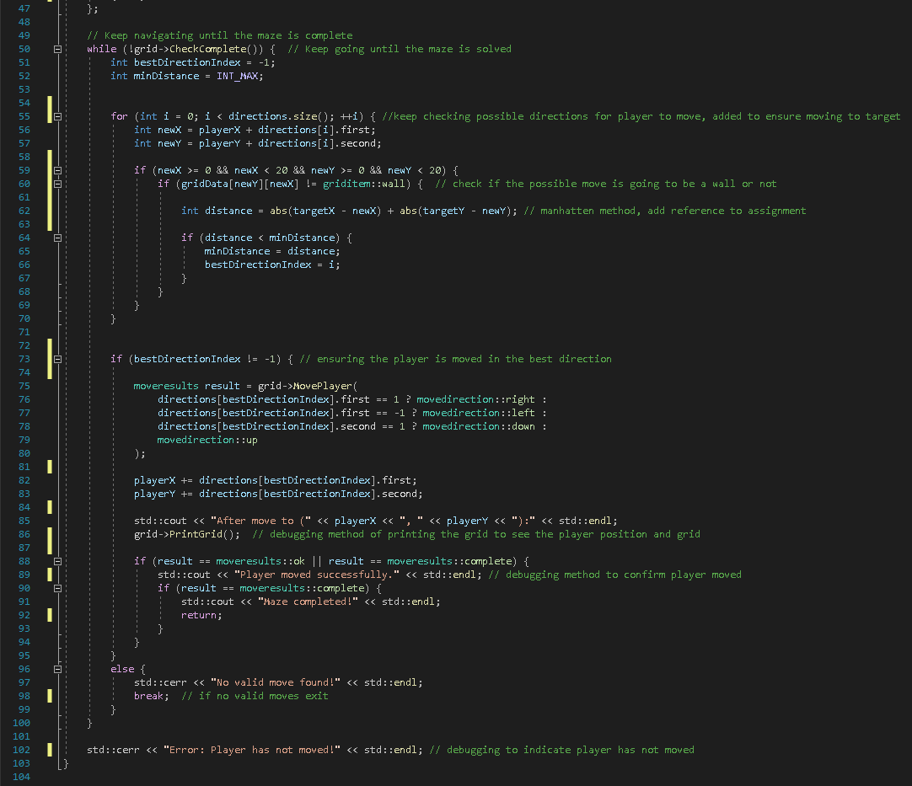

This solution unfortunately did not successfully complete the maze and kept the players movement minimal with no progression towards to target, even with the greedy approach and the incorporation of a method called Manhattan distance which in theory aims to choose the best direction closest to a target, [8]
Amending pseudocode to correct mistakes aspects overlook, one being the target location incorrectly set provided better results but still had the player getting stuck or repeating itself in movements for example one result had the player move forward a good few spaces then hit a wall but instead of moving left or right the player moved backwards then forwards.

3.2 – Results
This section of this task is based on the results from the implementation of a solution to this maze, however the maze has not been solved with the current solution. To fix this Dijkstra’s algorithm will be added as well as a rework of the pseudocode, firstly a keeping the loop for locating the player position and tidying up the directions we have the start of the solution looking the same as before.
Next adding in the start of Dijkstra’s algorithm with a priority queue, moving to Dijkstra loop with expands and explores the grids. Furthermore, including an if statement to establish if a grid is the target or not. More debugging was added to ensure the grid shows the player moving and in case of instances where they would get stuck or not move, this happened a few times during testing therefore it was necessary to add more debugging tools such as statements.
The purpose of using Dijkstra’s algorithm as discussed in task one was to explore the shortest path for the player to take to reach the target, this was done by exploring the grids, expanding outwards and keeping a record of the costs to reach each grid. The priority queue was used to always expand a node with the lowest cost allowing the exploration to the most promising path first. An array was also used to keep track of the distance to reach each grid or cell, ensuring to mark the high-cost grids. When the target was found a path reconstruction was used to trace back to the player and allow the player than to follow the path to solve the maze.
On the following page are two snippet images showing what the solution looks like:
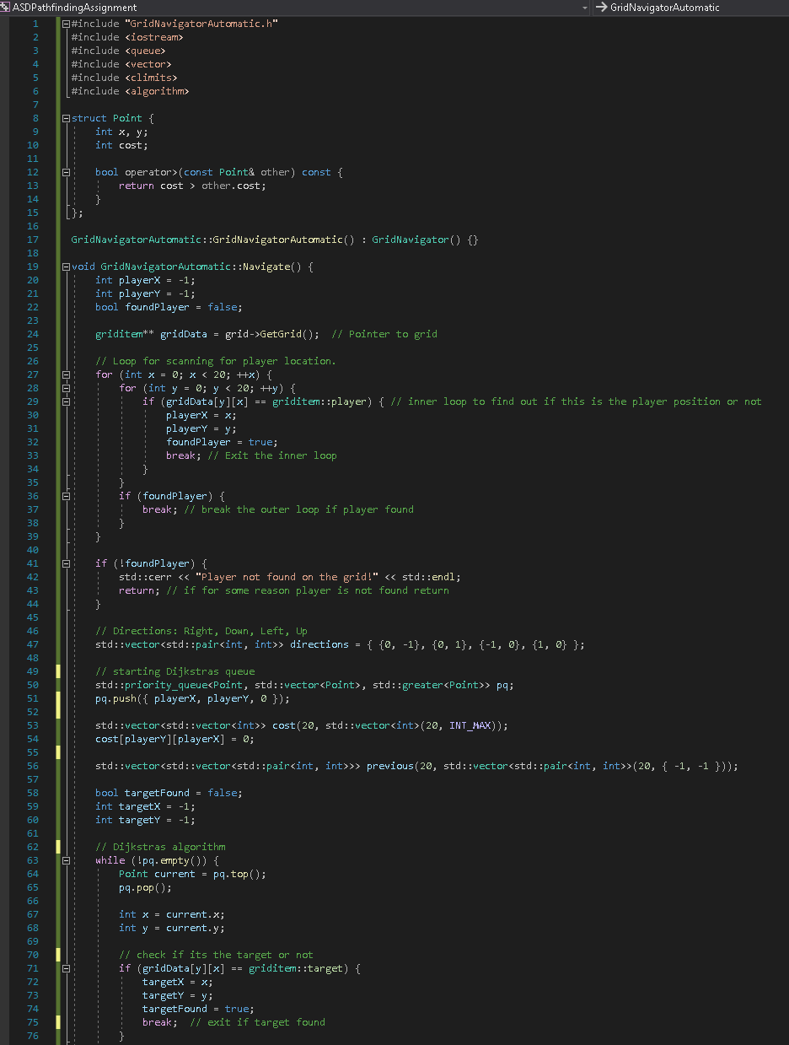
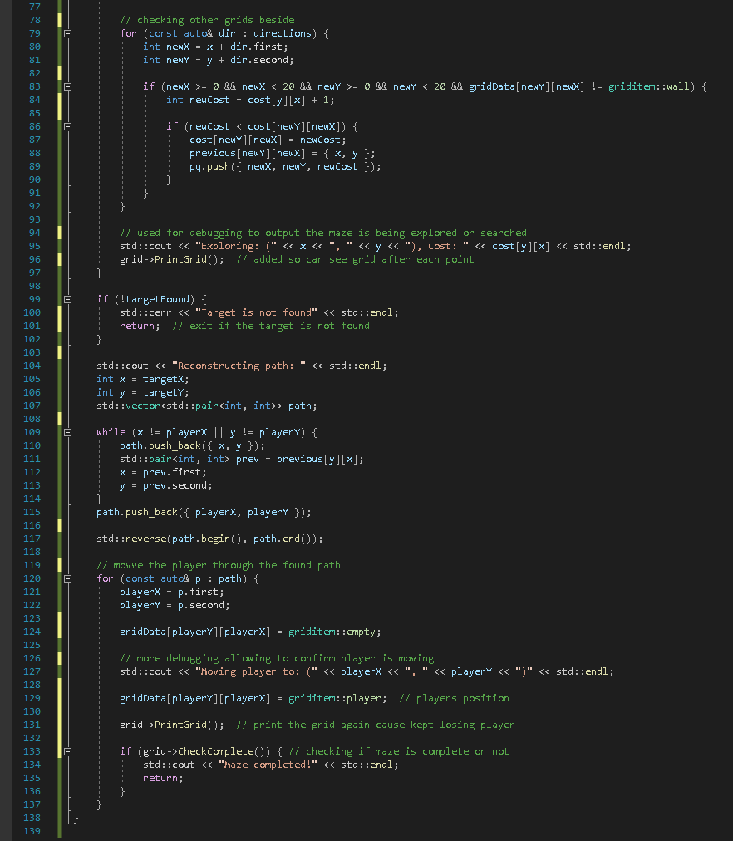
Running the program and selecting option 2 showed the running of the algorithm as intended where the maze was searched by Dijkstra’s algorithm and eventually the movement of the player can be seen in the printed grid.

The outcome leading to the below snippet
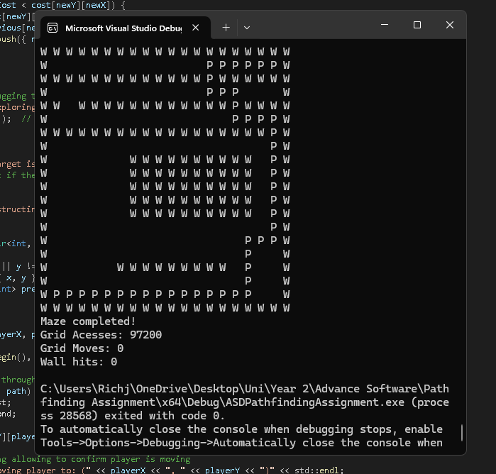
It can be seen the maze was completed and the grid print shows the player reaching the target however an unknown issue is clear where the players position is not marked correctly on the grid nearer the top of the maze, it looks as if the player jumps from one position to another. Furthermore, the grid moves and wall hits both indicate zero again questioning is this solution working.
Selecting option 3 where the program runs the solution ten thousand times seems to take a long time to complete indicating the solution needs far more improvements in the manner it solves the maze.

4 - Conclusion
Even though the solution came across that it worked in the program questions were being asked on whether it was correctly working, efficient and could it be improved. The main answer being yes, the solution could be improved, one way would be to switch to the A* algorithm with a heuristic allowing a faster convergence to the target.
Furthermore, upon reviewing the solution nodes weren’t getting marked as visited therefore this would improve the solution further as well as removing the debugging prints.
Ultimately when in a pathfinding situation the clear answer is an A* algorithm over Dijkstra’s especially if efficiency is needed and even though the solution produced can be used as a foundation, by optimising the search strategy it could become significantly enhanced.

5 – References
[1] Y. N. Moschovakis. Y. N. Moschovakis. "What is an algorithm?" in Mathematics Unlimited — 2001 and BeyondAnonymous 2001, . DOI: https://doi.org/10.1007/978-3-642-56478-9_46.
[2] Anonymous . An introduction to algorithms both in real life and in math and computer science. Available: https://www.youngwonks.com/blog/What-is-an-Algorithm-and-What-are-the-Different-Types-of-Algorithms.
[3] Anonymous . Understanding Weighted Graph: Definition, Types, and Applications. Available: https://testbook.com/maths/weighted-graph.
[4] E. C. Navone. (-09-28). Dijkstra's Shortest Path Algorithm - A Detailed and Visual Introduction. Available: https://www.freecodecamp.org/news/dijkstras-shortest-path-algorithm-visual-introduction/.
[5] Anonymous . Dijkstra's Algorithm - Javatpoint. Available: https://www.javatpoint.com/dijkstras-algorithm.
[6] Rajesh Kumar. . The A* Algorithm: A Complete Guide. Available: https://www.datacamp.com/tutorial/a-star-algorithm.
[7] Moore Karleigh. . Greedy Algorithms | Brilliant Math & Science Wiki. Available: https://brilliant.org/wiki/greedy-algorithm/.

