
Referencing with Word

Creating citations and a bibliography

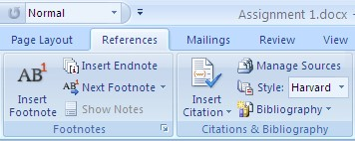
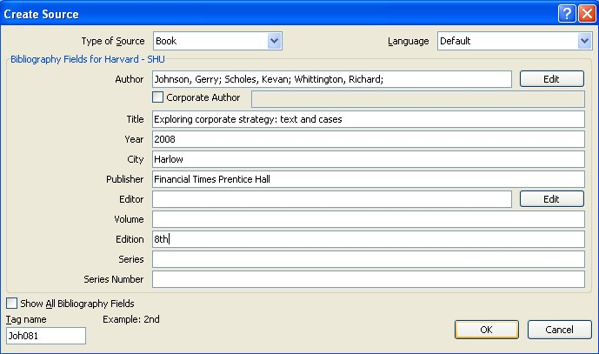
- In your Word document, click on the References tab.
- In the Citations & Bibliography group,
choose the referencing Style you would like from the drop down list. This will usually be
Harvard-SHU 2013

- Place the cursor in your text where you want a citation to appear. Click on Insert Citation and then from the menu choose Add New Source.

- In the Create Source box, select which
Type of Source your reference is: Book,
Journal Article or Web Site, etc.

Complete the details of the source in the boxes provided. Follow the examples of
how to enter the information.
Click on the OK button. A citation will then appear in your work.

TIPS: Use the Edit button next to the author field to help you to enter authors in the correct format. Use the Corporate author field when a company or organisation is the author.
5. Repeat steps 3 and 4 for any other citations you would like to create.

6.

Place the cursor in your text where you
want your bibliography to appear.

Click on
Bibliography

and then select
the Bibliography or Works Cited option.
A bibliography will then appear in your
work.

Editing a citation

In Word, you can edit an in-text citation to include a page number. This is useful if you have quoted or used a diagram from a printed source in your work.
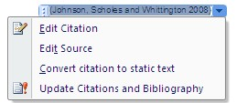
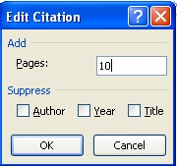
In your work, click on the citation you want to edit - a blue box will appear around it.

Click on the arrow to the right of the citation to display a menu.
In the Edit Citation window, type the page number on which

the quote or diagram can be found in the original source into
the Pages box. Then click OK.
The citation in your work will then change to show the page number.

Editing a source

You many need to edit a source to change the details about a reference.

In the References tab, Citations & Bibliography group, click on Manage Sources.
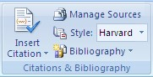
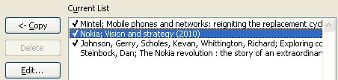
In the Source Manager window highlight the source

you would like to edit in the Current List
.

Click on the
Edit
button.

In the Edit Source window change the details as required and click on OK.

Updating your citations and bibliography

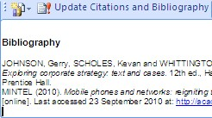
You will need to update your citations and bibliography if you have edited a source or if you have added additional
citations to your work after creating the bibliography.
Click anywhere in your bibliography and then click on
Update Citations and Bibliography in the blue box which appears above it.

