How accessible are Welsh Theatres?
By Jaimee Fraser-Ivett

How accessible are Welsh Theatres?

Section One; Introduction. What this project is about, why it is important in today’s theatrical landscape

Section Two; Methodology; explaining the methodology used and why/Challenges and Limitations

Section Three; Background. A brief history on the origins of the project’s beginnings

Section Four; Literature Review. Comparing and Contrasting literature linked to this project

Section Five; Questionnaire. Discussion and evaluation of the questionaries results

Section Six; Theatre’s visited. An exploration of the theatre’s visited as part of this project’s research

Section Seven; Collaborations. Collaborations explored during the project

Section Eight; Conclusion and recommendations

Section Nine; Appendix

Section Ten; Bibliography

Section One; Introduction
The rights for disabled patrons and actors accessing theatres in the UK is an increasingly pressing matter. Laws and equality acts have been drafted and approved by governments that have included transport, housing and living conditions. Some changes are still in the making, like the European Accessibility Act which will ensure that everything online, e.g. apps, websites and online banking, will be fully accessible. (DEPT/2025) Despite major changes in other sectors, there are some parts of the entertainment industry still in need of renovation to be accessible to all.
In a recent survey by RiDC (Research for Disabled Consumers), three in every ten wheelchair users attending a live performance said their accessible seats had an obstructed view and a quarter said the accessible seats were too far from the stage. (RiDC/2024). For disabled performers, being on the other side of the stage is a similar story. ‘While nearly 20% of the U.S. population has a disability, the proportion of disabled characters in movies is estimated to be only around 1%’. For the theatre that number is even lower. (Sunrise Medical/2018)
This project will investigate whether theatres in South Wales are accessible to physically disabled actors and if accessibility for disabled patrons is the same for abled bodied members of the audience.
Groups have been demanding better accessibility for wheelchair and physically disabled actors for many years.
Examples include:
• Disability Rights UK: As the leading charity run by and for people with lived experience of disability or health conditions, they influence national policy on independent living, benefits, education, employment, transport, human rights, and other issues.
• Shape Arts: A disability-led arts organization working to improve access to culture for disabled people by providing opportunities for disabled artists, training cultural institutions, and running participatory arts and development programs.
- Disability Arts Cymru; Disability Arts Cymru is a charity that promotes equal opportunities in the arts for disabled people in Wales, focusing on disability-led arts, developing creative talent, and providing training and resources for arts organizations to become more accessible and inclusive.

- Arts Council of Wales; Arts Council of Wales is an independent charity, established in 1994. Their funding comes from both the Welsh Government and The National Lottery. Most of their funding goes to artists and arts organizations carrying out programmes of work across Wales. They sometimes run their own projects.

These are only a handful of the many wonderful groups and organizations that work tirelessly to create better accessibility for everybody to feel supported and safe in the creative sector.

This project aims to identify theatres that have good accessibility, and those struggling in accommodating their disabled patrons, performers and stage crew. Wider conversations regarding funding are necessary as some theatres may have less commercial backing than other, more independent theatres. This research is becoming increasingly important as more theatrical shows are using disabled actors in their productions, and if many regional theatres cannot accommodate disabled actors, then a show may struggle to tour and only be profitable in bigger locations, so many people will miss out on representational theatre.

Section Two; Methodology
Research methods:
- This project used ‘SurveyMonkey’ to ask questions to individuals, some with no physical disability and some with mobility and other issues. SurveyMonkey is an efficient way of asking questions to a wide audience, and the result analysis is easy to use.
- Visits to theatres to interview the staff and gather information.
- Interviewing and asking questions and documented findings of actors’ experiences.
- Collaboration, building a bigger picture on this project topic, sharing ideas and findings.
- Research using literature, articles and information.

This project ensured that all participants gave consent for the information they provided to be used.
The participants had the right to confidentiality and anonymity.
The participants can remove their consent from this project at any point.

Permission from the theatres and venues visited was given and photographs allowed to be included in this project.

The research methods chosen were the most efficient way of collecting data. ‘SurveyMonkey’ does have an answer limit and so could limit the number of responses. This problem was resolved by creating further identical questionnaires and later using a separate data collecting application, Jotform, to get more results.
The survey was distributed through ‘Snapchat’, given to a disability-friendly group and to fellow abled bodied students.
The questions were based on accessibility issues for wheelchair users, and those with mobility issues.

Section Three; Background
The author of this project works as a teacher in a drama group for individuals with special needs. Many of the students use wheelchairs or have a physical disability.
The author has been arguing for better wheelchair and disability accessibility for actors for a while. The theatre they work at is largely inaccessible to people who struggle to walk, and so performances have to ensure that the scenes for wheelchair-using actors are performed on ground level. Inaccessibility prevents these actors from bonding with fellow cast members on stage and experiencing the joy of doing theatre with friends.
In many theatres, seating for physically disabled audience members is at the back of the venue, or in spaces first come, first served. Accessibility for wheelchair users in many theatres visited are only in the Stalls and Grand Circle where there are a limited number of dedicated spaces.
There are some theatres that cater specifically to the needs of physically disabled actors. The West End venue, @SohoPlace, is accessible for wheelchair using actors as it housed the premier of the musical ‘The Little Big Things’, a show in which wheelchair users were lead characters. (London Theatre/Nov 2023)
Some theatres have addressed issues around mobility and accessibility, for example the Grand Theatre, Swansea. A historic and listed building, the Grand Theatre executives have spent money over the years on renovations and accessibility, providing a lift and a downstairs café. The upstairs Depot Studio is accessible by lift but with only a few accessible seats with restricted viewing as front row seating is not accessible; the Grand Circle seats are only accessible via stairs.
A theatre with good accessibility for wheelchair users is the Wales Millenium Centre in Cardiff. It has accessible lifts to tiered seats, and the backstage is accessible for actors. The Weston Studio, a rehearsal space, is mostly entered via one flight of steep stairs. However, the Weston Studio has a lift for actors ensuring every actor enjoys the same experience. Hijinx Theatre Company has their home in the Millennium Centre and performs regularly on the main stage and surrounding theatrical houses. Hijinx is a group of actors with learning disabilities and some neurotypical and able-bodied actors. They perform mostly in Cardiff-based theatres in shows based around their personal experiences, such as ‘Housemates’ , a production based around the real story of a neurotypical university student living with a friend with Downs Syndrome in the 1970’s. (Hijinx/2025) The show, like all of Hijinx’s other productions , tackles real life accessibility issues with wit, heart and the driving need for change.

Six theatres were visited for this project.
The theatres were chosen for several reasons; some were known to the author, so there were connections to the staff who were contacted for interviews and information.
They were chosen because of their age, structure and size. Three of the theatres were built pre-1900 and are listed buildings. By being built in different eras they have different regulations so changes to their structure would be difficult. Three theatres were post 1990, modern buildings and would have been designed with accessibility in mind. The theatres provided information on the changing standards in theatres’ perception of accessibility.
The author visited the six local theatres to investigate how accessible or inaccessible their stages and backstages are to wheelchair or mobility affected actors.
Where and when does it take place?
This project discusses and dissects an ever-changing theatrical landscape, and so it takes place at any given moment. Some collaborations within this project have taken place on certain dates, and these will be specified at a later point in this project.
Analysis of key moments or case studies from your project.

A key moment during the research of this project was the discovery of the lack of funding for theatres that have a smaller revenue than bigger, more commercial theatres, and are therefore missing out on key funding that could afford some theatres the chance to upgrade their accessibility. Documents on the findings of a lack of funding in Welsh theatres can be found in the Appendix.

The six buildings focused on are;
Swansea Grand Theatre (Swansea)
Nidum Theatre (Neath)
Gwyn Hall (Neath)
Halliwell Theatre (Carmarthen)
Cardiff Millenium Centre (Cardiff)
Pontardawe Arts Centre (Swansea Valley).

Section Four; Literature review
When conducting the literature review, the author of this project found little in the way of research or investigations being done on this topic, as there was not much research on wheelchair access in Welsh Theatres. This was surprising to discover, as it was assumed that this increasingly prevalent topic would be something of great importance within the world of analytical literature. However, wheelchair accessibility is not something people are necessarily aware of. In 2021, 24% of the population in Wales was classified as disabled, but only 4% of these people held high positions of power in the arts. (Census, 2021). These are the people with the most powerful voices who can make a change, but it seems that nobody is discussing the grassroots issue of disability. The literature reviews that were found discussed accessibility regarding hearing impairment and/or neurodivergence; every positive article written about disability in the theatre is a spotlight on other forms of disability, which in itself is something little discussed. It was disheartening to see so little focus on wheelchair users in the theatre.
An article that has direct links to accessibility in Wales is a piece based on interviews with disabled actors and creatives from Wales, and how they feel stereotyped and pigeonholed. (BBC/2023). The creatives speak of being asked to audition for diversity and then not being offered a recall. The article shares a similarity to the research on wheelchair accessibility for this project; roles are not available for people with disabilities. Actor Ruth Fabby said in the article, ‘We should have disabled Romeos’. For the most part, pre-existing acting roles do not accommodate actors with disabilities as the roles were written with abled bodied actors in mind.

Section Five; Questionnaire
To gather information on how accessibility affects disabled individuals in and around Welsh theatres a survey was sent out to two groups. The first, a group of able-bodied friends of the author and the other group were disabled and wheelchair using actors. This was to investigate how people with different needs viewed these issues.

This survey was sent out and answers were returned within a fortnight.
The participants who completed the questionnaire on social media were abled bodied actors, but another round of the survey was sent out to wheelchair using actors.

Question One: Are you aware of any theatres in Wales that accommodate actors with physical disabilities, for example a ramp for stage access?
Six respondents said yes and nine said no, indicating that some theatres are not promoting their accessibility as a significant number of able-bodied actors have never noticed disability friendly areas, or theatres not being accessible.
Question Two: Are you a performer with a physical disability?
Six responses were received.
Question Three: If you are comfortable answering, please indicate your disability.
The six people who responded had additional learning needs (ALN); three had sight issues, two were wheelchair users.
Question Four: What restrictions have prevented you from accessing areas of the theatre?
One person said, ‘Sometimes the wheelchair can’t get on the stage’.
Another answer was, ‘Not enough space for wheelchairs, limited access to theatre and poor training with theatre staff.’
Question Five: Are you part of an ALN (additional learning needs) group? If your answer is yes, what benefits has this had in your day-to-day life?
The answers were predominantly,’ interaction’ and ‘meeting friends’ something that is important in life.
The following questions were answered by both physically abled and disabled participants.
Question Six: As an audience member have you ever seen this sign (or one similar) for a hearing loop?
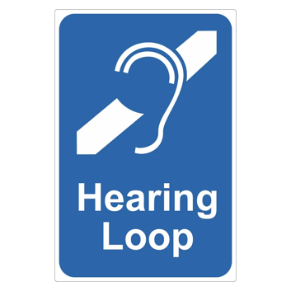
Eleven respondents said yes, and one said no.
This shows that there at least seems to be one type of accessibility that everyone is aware of and therefore its implementation is a success. This is a clear sign that some forms of accessibility are becoming a cultural norm, so accessibility for wheelchair access should follow suit.

Question Seven: In your opinion, has accessibility for performance in the theatre improved in the last decade?
One respondent said, ‘it is slowly becoming more accessible, however experience wise there is no equality.’ The inclusion of more ramps was mentioned five times, the consensus was that theatre is becoming more accessible for people with mental and auditory disabilities but not physical.

Question Eight; What suggestions would you have for making theatres more accessible to actors with a physical disability?
In response to this question there were many suggestions such as, ‘creating ramps,’ ‘lighting on ramps’ and ‘In making shows, theatres have more options for casting actors with disabilities.’

‘Make it compulsory that entertainment venues must have things in place for disabled people and police it with better training for staff, especially about disabilities that are not visible.’
A suggestion was to guarantee training for all staff members, and it should be the norm in all theatres.
The author of this project has found theatre staff are willing to help but unsure of how, so an improvement in accessibility could be made with some basic training.

Section Six; Theatre Visits
Theatre 1; The Pontardawe Arts Centre
The Pontardawe Arts Centre is a theatre space in Pontardawe, Swansea Valley. It was opened as a theatre in the 1990s but had been operating as a community hub prior to its conversion. Pontardawe Arts Centre operates as a theatrical venue and has three studio spaces and one large theatre that has stood on the site since 1909. It has been given multiple updates since then, and is currently undergoing a major renovation, which will include a cinema, bar and an improved box office. This new area will be made accessible for wheelchair users, but the original theatre layout will remain, meaning there will not be accessibility to the stage. Some long-term staff members of Pontardawe Arts Centre feel angry that the stage and backstage area are not accessible to people with mobility issues, and the local council seems unwilling to rectify this. The stage is not accessible, and when discussed with staff members they said that ‘The money for accessibility just isn’t there’. This is an issue found in many theatres around Wales, a substantial lack of money.

Photograph 1:
The main stage at Pontardawe Arts Centre has all the beauty and grandeur of an early 19th century building. This photograph clearly shows that the Edwardians didn’t consider accessibility. There is no lift or ramp up to the stage, which restricts people with mobility issues from performing.

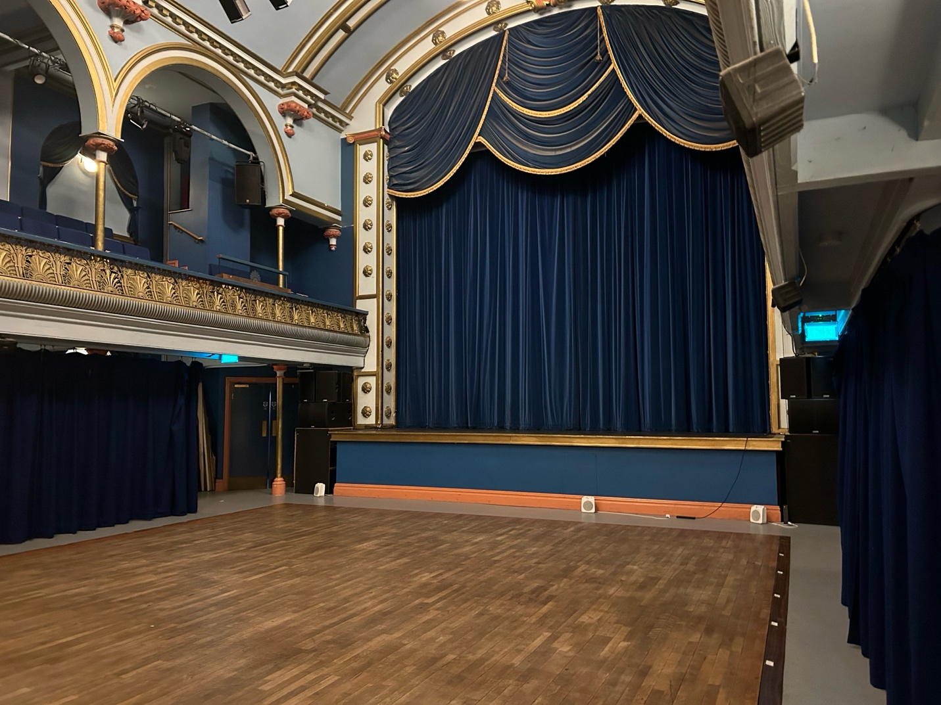

Photograph 2:
This image is of the main backstage area at the Pontardawe Arts Centre, the only area which has access to the stage and dressing rooms. The backstage corridor is on the ground level so does have a degree of accessibility, however as the photo shows the corridor is rather small and so bigger wheelchairs may struggle to get through.

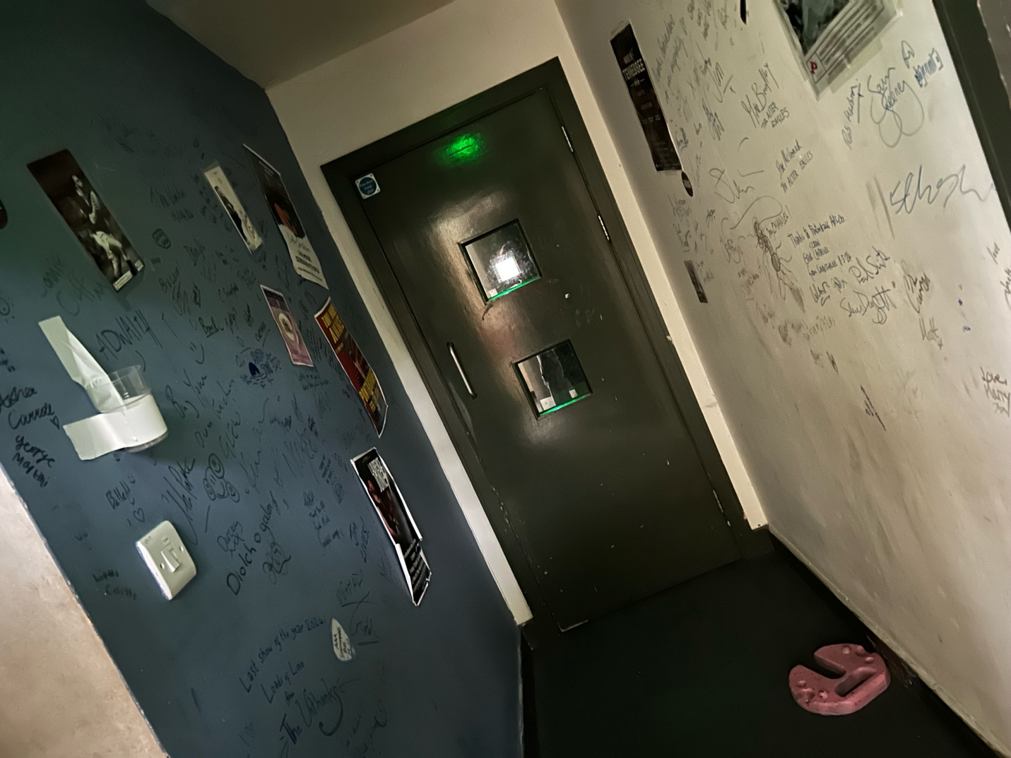
An interesting discussion with the co-manager of the Gwyn Hall in Neath mentioned that wheelchair designs are getting bigger, and so theatres that used to be able to accommodate all wheelchair models are now not able to and losing clientele. To widen these hallways and backstage areas for all wheelchairs would mean renovation at both Pontardawe Arts Centre and the Gwyn Hall, and this is impossible as they do not have the necessary funds.

Photograph 3
This shows access to the main stage at Pontardawe Arts Centre. An actor would need to climb the stairs and enter through the door, so wheelchair users and actors with mobility issues would struggle here. The small stairs are nearly impossible for a girl with Downs Syndrome who has trouble walking, especially in the blackout of the show. Pontardawe is one of the only theatres visited that did not have a lift or ramp to the stage.

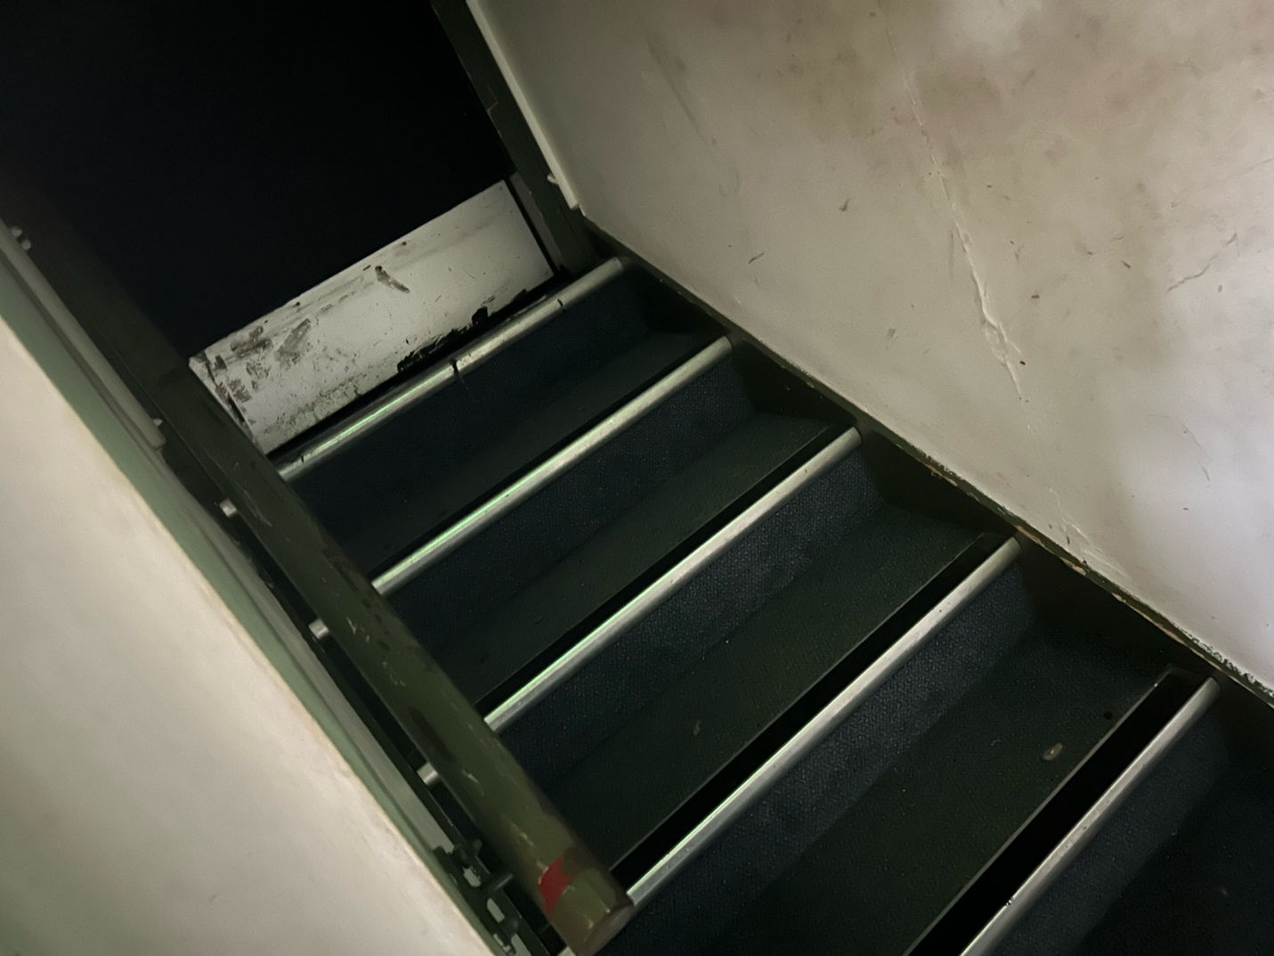
Pontardawe Arts Centre is in the midst of development but not developing for accessibility. Actors are still restricted from performing on stage, and tight spaces backstage mean that even away from the stairs, accessibility is a key issue.
The Gwyn Hall
The Gwyn Hall was built in 1887, and has housed touring artists, feature films, local amateur dramatic societies and a millennium of pantomimes. ‘Oh yes, they have! Oh no they haven’t!’.
The Gwyn Hall has one large theatre space, a cafe/bar, two cinema screens and rehearsal spaces.
Until 2007 the theatre retained its original Victorian structure, which included a balcony in the main theatre hall. Tragically, a fire ripped through the building in 2007 whilst renovation work was ongoing, and much of the original interior was lost. Memories of the past are still found in every crevice of this old building, such as the spiral staircase leading up to the roof and the original brick work that is a reminder of the past.
Before the fire destroyed the building and closed it for over four years, there were plans to perform a major renovation, making the stage and backstage more wheelchair accessible.
Assessment of its accessibility was made during a visit to the theatre, and the manager of the Gwyn Hall reported that it had passed all accessibility checks and so before even talking a step into the theatre it was clear that this theatre was officially a safe and welcoming place for actors and customers in wheelchairs and with mobility aids.
Access to the main stage and backstage is extremely accessible for actors with mobility issues. The backstage area is all on one level and has wide spaces that allow actors and backstage technicians to move freely around the wings. When a member of staff was asked, they said that they’ve had wheelchairs on stage in the past, and there was no issue regarding their needs. Backstage, there are wheelchair accessible showers and bathrooms, and the dressing rooms and green room are small but accessible. From a performer's point of view, the new Gwyn Hall is a very accessible place.
From an audience point of view, however, accessibility does have areas for potential improvement. There are only two wheelchair accessible entry points for audience members, so if a school with wheelchair using pupils came for a visit there would not be sufficient seating. There are regular sign language interpreters at certain performances and autistic friendly performances of shows and cinema screenings.
The manager of the Gwyn Hall has kindly sent an access review checklist he completed of the building to be included in this project. The checklist was sent to Arts Council Wales in the hopes of being awarded more funding for the theatre. The checklist informs us of what is already in place at the theatre, such as the accessibility aspects, but also what could be improved if funding was given. Please refer to the full checklist in the Appendix.

Photograph 1:
This is of one of three backstage areas in the Gwyn Hall, usually used as a dressing room during shows. The backstage area is accessible as it has a large floorspace that is wide enough to accommodate wheelchairs, lighted mirrors and charging points. The only possible negative is that it tends to get busy, i.e. pantomime season.
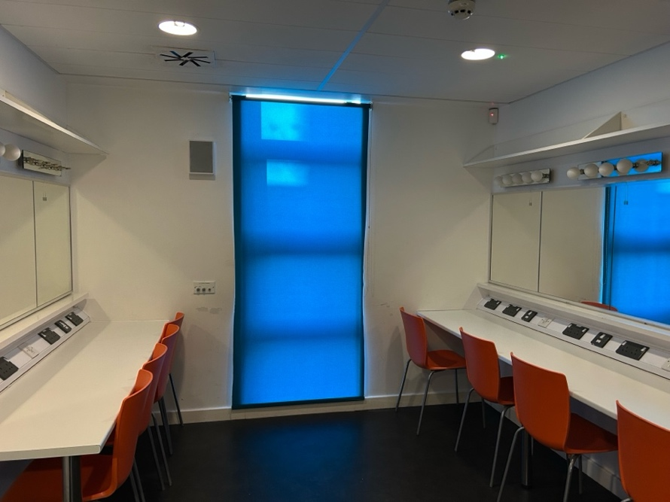
Photograph 2;
This is the green room at the Gwyn Hall. It is built in the same style as the dressing rooms and has the same layout, but without dressing tables and mirrors. Like the dressing room, the green room has a wide floor plan and a large area sufficient for wheelchair users.
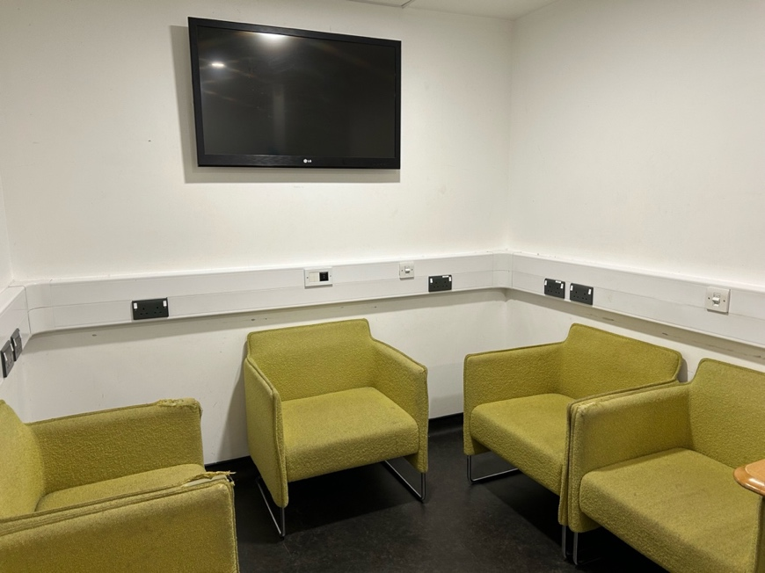
The Gwyn Hall is a place that has both the wide spaces and accessible equipment to successfully house actors with physical disabilities. If the funding grant is approved, The Gwyn Hall would become an even more accessible space in the future so that many more up-and-coming actors would have their chance to perform on this stage.

Staff at both the Gwyn Hall and Pontardawe Arts Centre have told me that their institutions do not have the money needed to implement accessibility lifts, ramps and other pieces of equipment that could benefit wheelchair-using performers. Both theatres have applied for grants from various councils and organizations in the past, but at this moment there simply is not enough money to improve accessibility when the cost of keeping the theatres afloat is rising every day.
One staff member at Pontardawe Arts Centre, who wished to remain anonymous, said, ‘People just aren’t coming to the theatre anymore. What with rising costs for everyday items, people can’t afford to shell out on luxury things like the theatre.’ As theatres are losing more money every day, they struggle to find the money to focus on the upkeep of a theatre unless it is for essential maintenance.

Wales Millenium Centre (Cardiff).
The Millenium Centre is a much more modern theatre, as it was built in 2000 to welcome the new millennium. It is located at the heart of Cardiff Bay and is the biggest theatre in Wales and the exterior is built from 2,000 tones of recycled Welsh slate.
The Millenium Centre is home to two major theatre spaces and multiple rehearsal studios, and in the past has housed major productions such the UK tours of ‘Wicked’ and ‘Hamilton’.
The theatrical space, the Weston Studio, is a small but versatile space within the Millenium Centre.
The entrance to the Weston Studio is at the Stage Door to the main house theatre, near the disabled parking spaces. Once inside, the backstage area is one long maze of corridors, all of which are on one level and accessible to everyone. All corridors and rooms, such as the dressing rooms and green rooms, have good accessibility. The stage itself is on the second floor, and accessible by two flights of stairs, but a wheelchair friendly lift is available.
The area the author has chosen to focus on is the main space in the Weston Studio. This is where the performances happen, and main stage rehearsals take place.
This area is accessible for all the theatre’s artists as it is all on one level and has a lift as well as stairs. Some shows might choose to build steps into their set, however that is the choice of the touring company and not the theatre itself.
Photographs for the Weston Studio were unavailable.
Unusually, the Millenium Centre dressing rooms house productions from both the Weston Studio and the Millenium Centre and so can get very busy if two shows are on at once. The dressing rooms and the corridors surrounding them are wide and accessible, and the showers in the dressing rooms are wheelchair friendly. The only negative is that the way to both stages is via stairs or a lift, and the lift is only wide enough to fit one wheelchair user at a time.
If this area were to be improved in terms of accessibility, a recommendation would be to build another accessible lift to the stages so that the waiting time for physically disabled actors would be reduced.
However, it is clear from the evidence provided that this part of the venue is very much leading the way in terms of accessibility.

Nidum Arts Centre:
Nidum Arts Centre is part of Neath Port Talbot College in Neath and well known to the author. The college’s theatre space is accessible as the author had seen wheelchair-using performers using the stage. The photographs show how accessible this building is.
The entrances to the Nidum theatre are through two separate areas; the first is straight through the doors when entering the building, and the second entrance is closer to the dressing rooms. Both are accessible to all.
As the building is also a studio, the Nidum has two studio rehearsal spaces. Both rehearsal spaces have wheelchair accessibility and are wide open plans that can accommodate every type of actor. The whole space of the Nidum is on one level, there are no raised stages or stairs, except to the lighting booth.
A downside to the backstage area of the Nidum is that there is only one narrow corridor that leads to the dressing rooms and stage, and it can get blocked with sets, props and actors very quickly on show days. If an actor with mobility issues were to use the corridor, then it would have to be cleared beforehand.
The theatre is all on one level and therefore accessible from every entrance. The two backstage entrances are accessible from the backstage corridor, and the front entrances are accessible via the ground level in front of the stage; the main fire exit is also in front of the main stage. On reviewing the whole building, the only part of the Nidum that is not accessible to actors with mobility issues is the sound desk, and from an actor's perspective the sound desk is not visited regularly.

Photograph 1:
This photograph shows one of two large studio spaces in the Nidum Theatre. The open space is large enough for a wheelchair or mobility aided performer to move freely around the room without the worry of hurting themselves or equipment. The doors beyond the curtain can also open to create one big rehearsal space and can fit several classes at any one time.
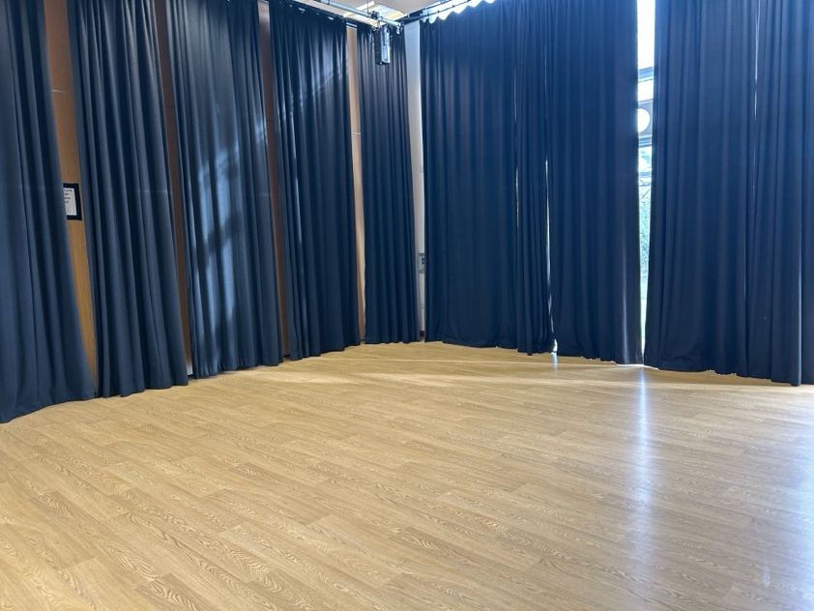

Photograph 2:
This is one of two dressings room at the Nidum Theatre. Compared to other theatres these dressing rooms are the smallest and therefore most inaccessible. The space is not very wide and can only accommodate up to ten actors at once. Taking into consideration personal belongings and the costumes this space would struggle to accommodate all actors.
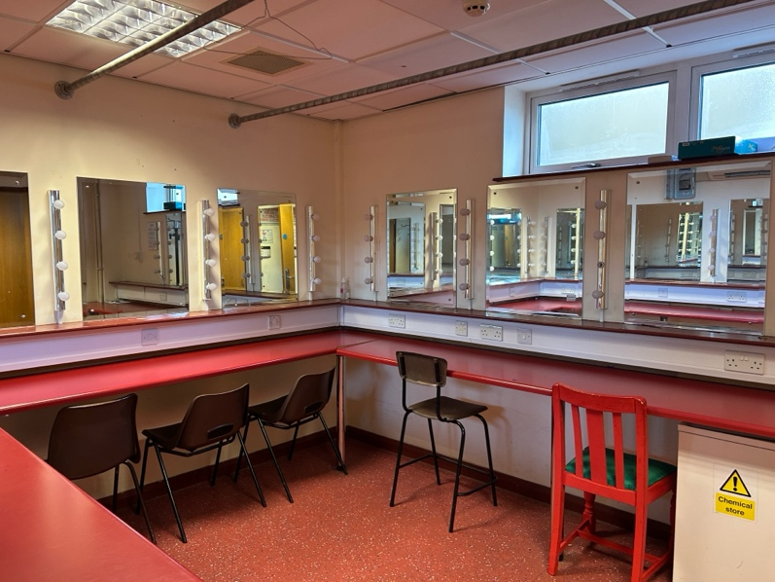
Photograph 3:
The main stage of the Nidum Theatre has a black floor for dance performances and two sets of wings. The space does have a slight slope but is accessible to most wheelchair types. A stage that is on the same level as the audience can benefit both actors and audience as it can give a sense of immersion, and it is also very accessible to performers with mobility issues.
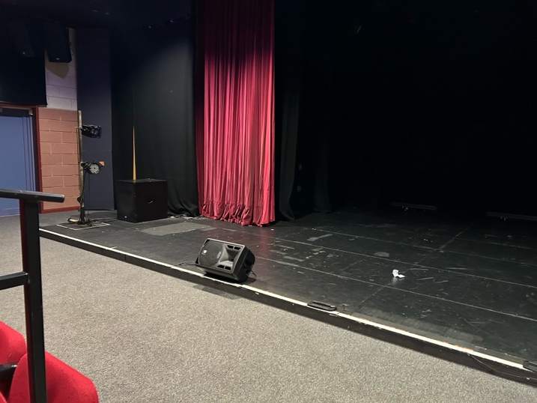
Photograph 4;
This photograph is a sign for a disabled unisex toilet, giving clear indication that the Nidum Theatre is a space that is designed to be used by all.

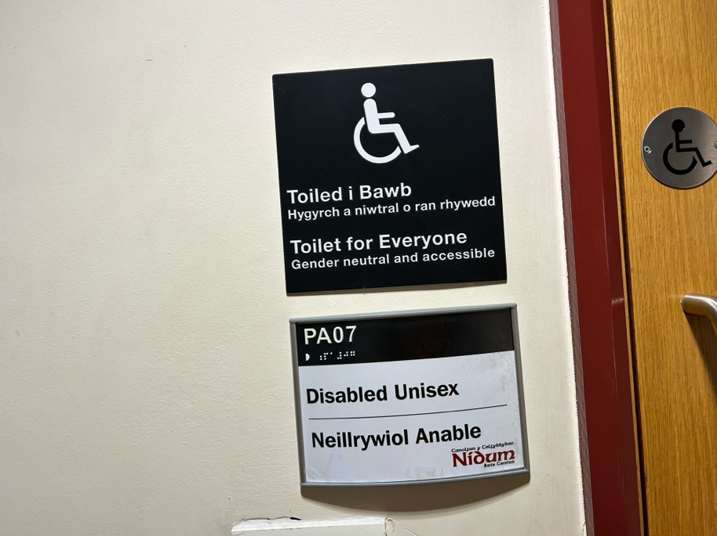

Overall, the Nidum Theatre is a very accessible place, and whilst there are areas for improvement it is clear that this recently built space was constructed with all actors and patrons in mind.

Halliwell Theatre
The Halliwell Theatre is situated in UWTSD, Carmarthen Campus. It is inside the Merlin restaurant and is used for many activities by students, staff and the public.
The theatre was built to be an accessible venue, and it has been used by many actors with all types of disabilities. The Halliwell Theatre is accessible through different entrances; one door via the restaurant entrance, one via the outdoor entrance and another accessible from backstage. The outdoor entrance is not accessible for people with mobility issues as the only access to the stage is down two flights of stairs.
The backstage of the theatre is accessed by a single small corridor that takes actors from one side of the theatre to the other. This area is too small for a wheelchair, if an actor with mobility issues were to perform at the Halliwell theatre, adaptations would have to be made.
Photograph 1:
This shows an audience view of the Halliwell Theatre and shows its unusual architecture and the raked stage; having two sets of stairs to the stage would prevent some actors with physical disabilities from accessing it.
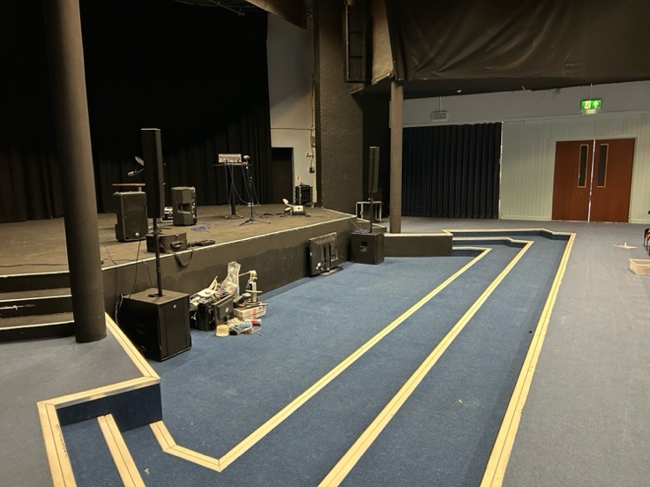

Photograph 2:
This photograph shows the steps up from the backstage corridor. This would create tricky access for an able-bodied person, so an actor with a physical disability would struggle accessing the stage.
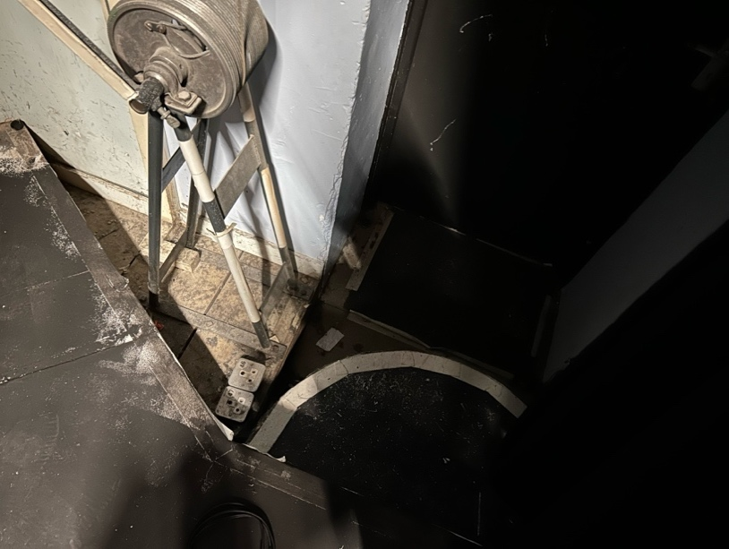
The Halliwell theatre has issues regarding accessibility and adaption, a ramp would need to be fitted if an actor with mobility issues were to perform there, but the dressing room and backstage area do not have any rises and can accommodate all actors or crew members.

Swansea Grand Theatre
Swansea Grand Theatre was built in 1897 for the artistic talent of Swansea and the surrounding areas. Since then, the theatre has undergone vast changes to both its structure and management but has always retained the same ideals, to be the theatrical heart of Swansea. As a listed building, the Grand Theatre cannot be changed or altered much, but developments have been made over the years to modernize the building.
The Grand Theatre is the theatrical hub of Swansea and hosts many amateur theatre societies and dance groups in its studios. There is also a multicultural hub, where people from different backgrounds meet and form groups that celebrate their culture and heritage. Major touring productions take place at the Grand, as does the yearly pantomime. The author of this project has a close connection to this theatre, having been a member of a theatrical youth group that rehearsed and performed on the Grand Theatre’s main stage.
Photograph 1:
This is stage left, and the area between the stage and floor is visible. There is no access to the stage from the audience, unless a specific set design allows for it; but the stage is only accessible to actors via the backstage area. There are no ramps or stairs leading up to the stage, the only accessible entrance is behind the curtain.
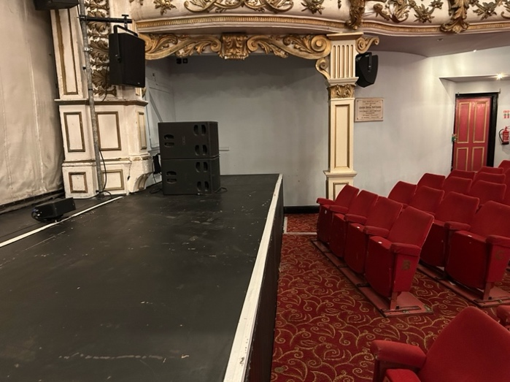
The Grand Theatre is a historical space that has and will continue to make the necessary developments to ensure it is an accessible space for every actor, but as it is an old and listed building, unfortunately much needed adjustments, such as a lift to upstairs changing rooms, will not be possible.

Findings & Analysis
A key theme that emerged is a severe lack of funding for Welsh theatres, specifically smaller theatres. Two of the theatres were struggling to get funding and this directly impacts hopes of improving and upgrading the accessibility features. Another key element discovered was that as wheelchairs are being built bigger, older theatres that have smaller entrances and aisles are struggling to accommodate these newer needs.

This project discovered that of the six theatres visited, most of them have either already implemented accessibility changes or have concrete plans to make structural changes over the next few years. A big issue in this research is the lack of funding for many of them. Out of the six visited, managers and staff from three told of a lack of money to cover structural changes to accommodate new and upgraded wheelchair models. This is an issue that needs to be addressed, but in the current financial climate and the direct hit that the arts in Wales in taking, such as the proposed closing of Cardiff University's music course (Global/2025), it is not surprising these buildings are not getting any funding.

Section Seven; Collaborations
Two acquaintances of the author agreed to collaborate on this project, as their projects shared a connection.
Collaboration one was with Alex Haycock, his independent project researched the visibility of vision loss and blindness within the theatre community. We discussed his findings concerning accessibility and he related a theatre he had visited last year and the less then empathetic behavior people exhibited towards a wheelchair user; a man in a wheelchair needed more time to exit a stall and other people were frustrated with this. We shared how the audience and theatre staff could be at fault for being ablest, and the structure of theatres is inherently wrong for not giving people with disabilities the space they need.
‘It seems to be this perception of disabilities, especially in the arts, that seems quite hard to break.’.
Alex has a visual impairment, and I asked how this affects his theatrical experience. His answer was, ‘I mean, I'm really lucky yes, in the sense that my condition does affect me but it's not all bad while I'm young, because my other eye is still good. It's not massively inhibiting. I can still do all the things to some extent that I used to do before, just not as well. The University has been accommodating and supportive.’
As this project has discovered, having the space to be accommodating isn’t always a guarantee, so it is encouraging to learn that the locations teaching the future generations are becoming more accessible.
Alex went on to explain that experience working on film sets hasn’t been as inclusive. ‘There have been times when they'll put me in a position where they're asking me to respond to something or someone that I just can't see, because they've put me in the position where all the action will be happening on my left and I cannot see it. So, I act into nothing, especially in the short films that I've done, because eyeline is so important with the camera.’
He told me of his difficulties whilst filming, such as a beach scene where he was too distracted with the pain from the bright sun. Interestingly, he went on to say, ‘I mainly don't want to feel like I'm making a nuisance of myself if I ask for things on a set to be changed so I just pretend that I can see whatever it is that they think I can see, and then that would be fine.’

The second collaboration was with Timothy Benning, an autistic actor, whose experience in being neurodivergent in theatre led to his project investigating realistic autistic representation in the media. Both projects focused on accessibility in theatre, and both have found that accessibility, such as dimmer lights and ramps, are not always implemented in theatres. ‘No one autistic is the same, but there’s a generalization within the media. I’ve noticed as well that a lot of the time it's laughing at autistic people rather than with them. Also, in terms of accessibility, another project was about quiet rooms and rooms to get away from everything, but of course, with a lot of autistic actors, people seem to manage it differently. So, it's quite interesting’
Timothy was asked the same questions that the other autistic actors had answered, which can be found in the Appendix and the other responses, found in the Autism and Representation questionnaire, were quite revealing;
How have you found the industry as somebody with autism? ‘It's been okay, but there have been challenges, obviously having ADHD as well. Sometimes they don't mark things down or they'll mark you down for things without you having understanding. I’ve been told off for not communicating my ideas and things like that. I’m very much aware that you've got to be confident to pursue acting, but it's hard, sometimes, because you have these conditions that disable you and there's just no kind of oh, yeah, we understand, you need to have some time off to recover’
What would you change if you had all the power to help people with neurodiversity in theatre?
‘I would absolutely be making things more accessible and giving the wider community more understanding for them.’

Section Eight; Conclusion & Recommendations

After six very interesting visits to theatres and an investigation that has led to many different thought-provoking discoveries, this project is now concluded.
What began as an investigation into the state of accessibility of Welsh Theatres, has become a passion project into an area of accessibility that is rapidly changing and upgrading, but sometimes too fast for theatres to keep up with. Discovering that theatres are struggling to accommodate the newer models of wheelchair is an issue that accessibility in this nation is not going in the way it should. However, there does seem to be more theatrical shows that are written specifically with wheelchair users in mind, meaning that the theatres themselves must be able to accommodate these actors. Whilst writing and researching for this project, there is news that the Broadway production of the musical ‘Wicked’ has cast its first wheelchair using an actress as the character Nessarose, a wheelchair- using character, for the first time in its twenty-two-year history. (Vulture/2025). Actors like Ali Stroker and Amy Trigg, stars of Broadway’s ‘Oklahoma’ and the West End’s ‘The Little Big Things’ are wheelchair users and are proof that the industry is improving in terms of representation, but from research it seems that accessibility is still a second thought for able bodied people.

This project specifically focused on Welsh theatres, but the broader implications of this are endless. Research shows that England has the same issues, and the author has discovered that disabled representation in arts organizations (in England) amounted to just 6% of employees. (GetintoTheatre/July 2024). In 2025, knowing that only 6% of the people working in the whole arts sector in England are disabled is hugely disheartening, and it seems little is being done to fix this gaping issue within our industry.
At this moment, it seems like the theatre industry in Wales is at a crossroads. Theatres are being constructed and redeveloped with accessibility in mind and the rising visibility of wheelchair using actors is giving a platform to people who had previously been left behind by the industry. However, it still is not good enough. Out of the six theatres the author visited, two are not accessible for wheelchair access on the stage. If two theatres in the local South Wales area are not accessible, how many other theatres around the whole of the UK are losing out on talent simply because their stages and theatres are not accessible? Funding cuts are a major issue that has faced almost every theatre the author visited, but this should not be the sole reason that wheelchair users are not feeling represented on stage.
If the author could make a final note on what was learned over the research and writing up of this project, it would be that funding for Welsh theatres, but specifically smaller and more at-risk Welsh theatres, should be increased substantially, because unless funds are made available some of the smaller theatres and venues cannot upgrade their theatrical spaces. With the funding of many arts projects in Wales being cut, funding in Wales is unfortunately facing an all-time low. But if the theatres that need it the most could get the funding they rightfully deserve, then people with mobility issues could get the same theatrical experience as everybody else.

Future research or practical applications

The author of this project is determined to keep fighting for accessibility rights for wheelchair and mobility aided actors and will take this research to the people who can make a change, detailing the findings in a letter intended for those in power who can make the accommodations that are so greatly needed.
The biggest obstacle the author of this project has come across in terms of upgrading accessibility is funding. Going beyond this project, the author is keen to research further into the state of future funding within Welsh Arts as this is an incredibly prevalent topic at this moment.
On a final note, when people talk about disabled actors performing, the language used is always ‘a specific group for people with disabilities’, and never ‘people with disabilities in a diverse drama group’. Why do people have to be put into a specific group to perform? If every theatre around the country was accessible to all disabilities, then why should groups be segregated? Whilst funding is currently a contentious issue, there are hopes for a future where no actor will be stopped from performing anywhere that will help with their creativity and joy for performing.

Analysis
All this vital information gives us one very important piece of news; theatre is struggling to be accessible for people with disabilities, either off stage or on.
Every type of disability is thrust under the harsh light of inaccessibility and the author of this project could have much to say on how theatres all around the United Kingdom are struggling to make their theatres accessible to actors who are deaf, visually impaired or neurodivergent, but of course a topic that large would take this project to places the word count is too limited to go to.

Challenges and limitations
The author of this project faced a limitation when sending out the questionnaires, as the original app used to create the online survey, ‘SurveyMonkey’, could only have a limited number of responses. This is why the resource used was later changed to jotform, as it could allow for more responses. This led to the finished survey having enough responses to draw a conclusive answer.
Visiting six theatres and getting to explore every part of the location led to extensive findings and led to the author of this project drawing some interesting conclusions. Every staff member and manager were accommodating and helpful when the author visited their location and answered any question they were presented with.
Critical reflection on outcomes
This project's objectives were to review the current state of wheelchair accessibility in Welsh Theatres, and to discover how theatres were adapting to change.
The discoveries have made the author realize that theatres are both moving forward but are also falling behind with the changing times. The inclusion of wheelchair friendly backstage and main stage areas for actors has been a welcome discovery as it shows that more actors from diverse backgrounds can perform on stage. However, the fact that some, more historical, theatres still do not have any equipment for wheelchair access is rather concerning. As a result of wheelchairs being built bigger, it means some theatres are struggling to accommodate them, an issue which may continue for many years to come. (2025/THIIS)
If the author could make a final point on what was learned through the research and writing up of this project, it would be that funding for Welsh theatres, but specifically smaller and more at-risk Welsh theatres, should be increased substantially. With the funding of many arts projects in Wales being cut, funding in Wales is unfortunately facing an all-time low. However, this author believes that once people in high positions of power realize and understand what needs to be done to accommodate the talented wheelchair performers then they will strive to improve and make a change within accessibility in Welsh Theatres, and as this research has shown, if people want to make a change to improve access, then this can be done.

Section Nine; Appendix;

Gwyn Hall funding email
https://mail-attachment.googleusercontent.com/attachment/u/0/?ui=2&ik=941ad172b8&attid=0.1&permmsgid=msg-f:1822143883982977228&th=19498e355674b8cc&view=att&zw&disp=safe&saddbat=ANGjdJ9riPcdV9P4ls7w1SeMoOQMjKnCStzolTAeKZC8BLzNGTIOx3iddUOPQPVyWfHSdr5AnWQupqGXK2d4cSURY2kNpqSzh57EEI799TXLuqsXbxjZW2imhInGvXmFzQE_mb7RTu9shp5TPhtUwXiXCW4LH9cTX-mltIE8q5NlK2akIMZJMD2m3PEVtPGto2tLlL73m-vQ54TEp_Kx8CdwDRSGicCi6q8d8avpB9jpS01mUbKkdThx-SKP1pHgvEWmkNj683MAPUcBYdxQtzhOkAZS7PWIhw-MIYHFbq3x_o9QWxuyUEvSFyMYDCfHeBq2rZo_QZhDhSJJVl8qF8y9xBB9CNBngtx3oacQpucrL4jNNs3n2VDbJFJIZzTvAxa9-R_lzdhmp9zCiT29qBrBSXnDrHxw77VUSCAFiuXl6PDF65AMXGONzF9Kf9I3bJ4j51U2fvKhrX1LaiqAoh151dw6SgUKuf96RthtmVNBmqKKoPoIaSiwuDWxCZajjHBXVtt_uZgquOUVEPNYCuztpdK5NumeDL8vEQ5g49EeRzWtfpLLDY-wd2tbarM9zT2rMp6qs29Vo3T-MbxXf-sCHLxuO9kMk0PJJjPtpfP8AH_sYcouYZVfLbWrdc9YlifnCJeaeF6AlqOrGW2pAa2idI9ll7VwkJy1prcct4f3C9t33aKgLtq27egJ46OV8pQQHfyibhLESp5h4j-ymCGLJRoohroPNEtW9Xz6F2JcYCZBY30pPlXuAsA_hLJm-9WUB5CIYZhtOuoy81rFqfLLHtv255-00kCtd2cMEgWKYDI_SF-11JNVJNpj-EdOsChtE4JVc_OnE9gmxGO4mtnhfZVL8ZbnYc5n815UVdSEqFVaAX9Jfoxs9UC32fiqndM1A1UY1uxXUNUleamLy5tTvBbiqZ3SiXNev8e6Msn7Io1TcDnXEMKFNNxn44rsyFpgQvrflOkZ4PxbB-_QfyqKKpBf_OO8mUpFCY1BiDiXns_NKk6F21amjweWda7o-YSF2vyFPKuNw6lhLM53

Questions asked to autistic actors;
Autism and Representation questionnaire;
The author of this project has asked a group of neurodivergent creatives they know professionally to answer a survey based on their experiences being autistic in the performing arts industry. Below are the questions and answers. All participants of the survey have given their permission for their answers to be featured in this survey.
Question One: How does your diagnoses affect your day-to-day life? Both negative and positive
Question Two: I’ve personally found theatre to be an experience built for neurotypical actors. Do you agree? If so, what has prevented you from having the most positive experience when performing/ rehearsing for a show?
Question Three; If given the chance, what would you input to make theatre more accessible to neurodivergent actors?
Answers received;
Amalie’s answers;

Question One - ‘I find my autism helps me think creatively. I find myself being more accepting and understanding. I think there are lots of negatives but it’s how you deal with them. I struggle with sensory overload which in theatre can be a big hurdle to jump over. My day-to-day life is affected differently every day. Some days I can manage more social interaction than others. Other days I just need to sleep which can be irritating because I have stuff to do.’

Question Two- ‘I disagree and agree. I agree that it allows us to excel and be accepted but I also feel like there is a lack of knowledge about how to make spaces inclusive for neurodivergent individuals, especially children’

Question Three- ‘I would focus on the training of the staff. Making sure they are all neurodivergent aware. They have had training on how to make their delivery and attitude accessible, get training so they know how to adapt their spaces to be the most inclusive they can be.’

Anonymous;

Question One- ‘Getting my diagnoses is like a missing piece of puzzle in my head. It explains why I do things. I never look at my autism as an excuse for the things I do, but an explanation. It helped me acknowledge who I am, and why I do what I do on a daily basis. It’s helped me 'learn’ a neurotypical way, so I find myself in less awkward situations. I’ve been learning how to unmask, which is positive but also negative because since my diagnoses people have been saying I'm acting ‘more autistic’. I’m just not working as hard to hide it from people now.’

Question Two- ‘I agree and disagree. Theatre was built on a privilege since its inception, and so theatre is inherently built to accommodate neurotypical people. Audition rooms aren’t accessible, as judging panels hide their true thoughts and feelings from you, and this can be quite challenging as a neurodivergent actor. The thing I struggle with most is tech week. I find it difficult to recognize patterns, and tech week throws the completed patten of a finished show off balance. The lighting and music make me overstimulated, especially when the lightening designers are plotting and don’t tell you where the lights are going to be.’

Question Three- ‘For people to be honest in audition rooms. No secret tasks or secret questions. I get nervous asking questions as the fear of being seen as ‘difficult’ or ‘unprofessional’ impacts me greatly. To have an environment where I can feel free to ask questions for clarity would be something I would love to implement into audition rooms. I’ve had issues with asking questions to neurotypical directors before, as the directors take the questioning as taking offense with their methods. I’ve been told I ‘Shouldn’t challenge the director’, which can be quite harmful to neurodivergent people. Language around neurodivergent people is very important. They should cast autistic shows more authentically. A Broadway show had stim toys and quiet rooms, and this should be the norm for every theatre and every show.’

Section Ten; Bibliography;

Anderson, Kelsey, June 28th, 2025 is the deadline for digital accessibility [Updated Jan 2025] - DEPT®, 24th Jan/2025

Brenner, Alex,Closing the disability employment gap in the theatre industry - Get into Theatre, Published: 3rd Dec/ 2021. Updated: July 2024

Bryan,Nicola, Disabled actors patronised by TV industry, says artist - BBC News, Wales, 25th Feb/2023

Hislop, Bev, Ed Larkin makes it big in 'The Little Big Things' | London Theatre, London, 24th Nov/2023

Home | Disability Arts Cymru, Disability Arts Cymru, 2024

Housemates - Hijinx , Hijinx , 2024

Mazzeo, Esme, Wicked’s Jenna Bainbridge on Reframing Nessa’s Disability, Vulture

Mcivor , Liane, Chunc launches XL size wheelchair with increased dimensions in response to customer demand - THIIS Magazine, 8th Feb/2023

Our organisation | Arts Council of Wales, Arts Council of Wales, 2025

Padilla, Kelly, Portrayal of Wheelchair Users in Cinema | Live Quickie | Sunrise Medical, Colarado, 1st Jan/2024

Roberts Shaw, Maddy, Hundreds of musicians protest ‘shock’ Cardiff University music school closure - Classic FM, 25th Feb/2025

RiDC ,RiDC research for Which? finds half of disabled consumers face access issues at live events | RiDC , New York, 2nd June/2024

Waddington , Beth, Disability, England and Wales - Office for National Statistics, 19th Jan/2023

