Independent Project
LCLM 6005
Student Name: Monica Iordan
Student ID: 2130804

Abstract
In modern corporate settings, leadership continues to be one of the most important factors influencing an organization's efficacy.Leadership strategies that promote flexibility, creativity, and employee dedication are becoming more and more crucial as organizations deal with the demands of globalization, technological advances, workforce diversity, and economic uncertainty. Transformational leadership has become one of the most important and extensively studied leadership philosophies of the past century.By developing a compelling vision, building trust, promoting creativity, and assisting with personal growth, transformational leaders motivate their people to go above and beyond expectations. Through a thorough analysis of scholarly literature and secondary research, this dissertation investigates the effects of transformational leadership on worker performance and organizational success.
Key organizational outcomes, such as employee motivation, job happiness, organizational commitment, creativity, productivity, and overall business performance, are examined in relation to transformational leadership behaviors. The dissertation also examines the difficulties of applying transformational leadership in various organizational situations and assesses the ways in which transformational leaders affect workers. Results show that by fostering a pleasant work environment that promotes engagement, creativity, and discretionary effort, transformational leadership has a favorable impact on both individual and organizational performance. According to the study's findings, companies looking to maintain a competitive edge should fund leadership development initiatives that foster transformational leadership skills. Future researchers, organizations, and managers are advised.
Keywords: Employee engagement, motivation, organizational success, transformational leadership, and leadership theory.
Chapter 1: Introduction

1.1 Background of the Study

It has long been acknowledged that leadership plays a crucial role in determining employee performance, organizational success, and long-term economic sustainability. Organizations have always looked for leaders who can steer teams toward accomplishing strategic goals while also preserving organizational stability and employee devotion. Effective leadership is more crucial than ever in today's complicated and competitive workplaces.
Today's businesses operate in extremely dynamic contexts that are marked by swift technical advancements, intense rivalry on a worldwide scale, shifting employee expectations, and ongoing organizational change. To effectively handle these issues, traditional command-and-control leadership techniques are frequently inadequate. More workers are looking for leadership that inspires rather than just gives orders, meaningful work, and chances for personal growth.
As a result, scholars and professionals have paid close attention to leadership philosophies that emphasize empowerment, involvement, and motivation. Transformational leadership is one of the most significant leadership philosophies that have emerged during the last few decades. Transformational leadership, which was first developed by James MacGregor Burns and later developed by Bernard Bass, emphasizes the leader's capacity to motivate followers to put the organization's needs ahead of their own. Instead, then depending only on incentives and penalties, transformative leaders look for motivate employees through vision, inspiration, intellectual stimulation and individualised support.
Transformational leadership is one of the most significant leadership philosophies that have emerged during the last few decades. Transformational leadership, which was first developed by James MacGregor Burns and later developed by Bernard Bass, emphasizes the leader's capacity to motivate followers to put the organization's needs ahead of their own. Transformational leaders use vision, inspiration, intellectual stimulation, and tailored support to encourage staff members instead of only using rewards and penalties. According to research, transformational leadership enhances organizational commitment, employee motivation, creativity, and overall business performance.
Through a critical analysis of current academic literature and secondary research evidence, this dissertation investigates the effects of transformational leadership on employee performance and organizational success. The goal of the study is to give a thorough understanding of how transformational leadership behaviors affect organizational outcomes and why this leadership style is still very important in modern organizations.
1.2 Research Problem
Organizations still face issues with employee disengagement, decreased productivity, low morale, and significant staff turnover despite extensive studies on leadership effectiveness. Many businesses find it difficult to establish work cultures that motivate staff to go above and beyond the call of duty and actively support organizational goals.
Employee engagement is still a major challenge in many different businesses, according to research done by several organizations. Workers are less likely to show dedication, creativity, or discretionary effort if they lack motivation or feel cut off from the organization's objectives. These results have a detrimental impact on the competitiveness and performance of organizations.
Employee engagement and organizational effectiveness are often shown to be significantly influenced by leadership. Different leadership philosophies, however, provide different results. Transformational leadership is thought to produce deeper levels of commitment and motivation, whereas transactional leadership may accomplish short-term conformity.
Determining the degree to which transformational leadership affects worker performance and advances organizational success is the main issue this research attempts to solve. Organizations looking to increase employee engagement, productivity, and overall effectiveness must comprehend this link.
1.3 Aim of the Study
The purpose of this thesis is:
To thoroughly assess the influence of transformational leadership on employee performance and organizational success by analysing current academic literature and secondary research data.
1.4 Research Objectives
To achieve the stated aim, the following objectives have been developed:
1. To investigate transformational leadership's theoretical underpinnings. 2. To assess the connection between employee motivation and transformative leadership. 3. To investigate how transformational leadership affects work satisfaction and staff engagement. 4. To evaluate how transformative leadership affects innovation and organizational performance. 5. To determine the obstacles and constraints related to transformative leadership. 6. To offer suggestions to organizations looking to enhance their capacity for transformational leadership.

1.5 Research Questions
Main Research Question
• What effects can transformative leadership have on worker productivity and organizational success?
Questions for Secondary Research

• What are transformational leadership's essential traits? • What is the impact of transformative leadership on employee engagement and motivation? • What advantages does transformational leadership provide to an organization? • What obstacles might reduce transformational leadership's efficacy? • How can organizations cultivate the capacity for transformative leadership?

1.6 Significance of the Study
This study's theoretical and practical contributions to organizational management and leadership research make it significant. Practically speaking, companies are always looking for ways to boost efficiency, enhance employee performance, and preserve a competitive edge. Organizations may create more successful leadership development programs by having a better understanding of how transformational leadership affects these results.
The results may also be used by senior managers, human resource specialists, and organizational decision-makers to guide programs related to leadership development, succession planning, and hiring. Organizations can cultivate leaders who can establish highperformance cultures by recognizing leadership behaviors linked to favorable organizational results.
From an academic standpoint, the study adds to the body of literature on leadership by synthesizing recent research findings and critically assessing data regarding the efficacy of transformational leadership. The study also identifies areas that need more investigation, especially regarding contextual elements that affect leadership results.

1.7 Overview of Transformational Leadership
Transformational leadership is typically defined by four fundamental dimensions, commonly known as the "Four I’s":
Idealised Influence Transformational leaders serve as role
models, exemplifying integrity, ethical conduct, and a strong commitment to the values of the organization. Such leaders earn the respect and trust of employees, which enhances their willingness to pursue organizational objectives.
Inspirational Motivation These leaders articulate a compelling vision that motivates employees to strive for ambitious goals. By fostering enthusiasm and optimism, transformational leaders instil a sense of purpose and a shared identity among team members.
Intellectual Stimulation Transformational leaders promote creativity, innovation, and critical thinking. They encourage employees to challenge prevailing assumptions and to devise new solutions for organizational challenges.
Individualised Consideration These leaders acknowledge the unique needs of each employee, offering support, coaching, and mentoring opportunities. This tailored approach fosters employee development and enhances job satisfaction.

1.8 Structure of the Dissertation
There are six chapters in this dissertation.
The research topic is introduced, the study's goals and objectives are outlined, research questions are presented, and the study's importance is explained in Chapter One.
A thorough analysis of scholarly research on transformational leadership, worker performance, and organizational success is given in Chapter 2
. The research rationale, design, data collection techniques, and analytical strategy are all described in Chapter 3.
The results of the literature review are presented in Chapter 4, which also covers important topics about the efficacy of transformational leadership.
Chapter Five offers’ suggestions for managers and organizations looking to adopt transformational leadership techniques.
The dissertation is concluded in Chapter Six with a summary of the main conclusions, a discussion of the limits, and suggestions for additional research.
1.9 Chapter Summary
The notion of transformative leadership has been presented in this chapter, along with its applicability in modern organizational contexts. The research problem, study goals, objectives, and research questions were described in this chapter. The study's importance was also examined, emphasizing both academic and practical contributions. Lastly, the chapter outlined the general framework of the dissertation and gave a summary of transformational leadership. The literature on transformative leadership, worker performance, and organizational success is reviewed critically in the next chapter.

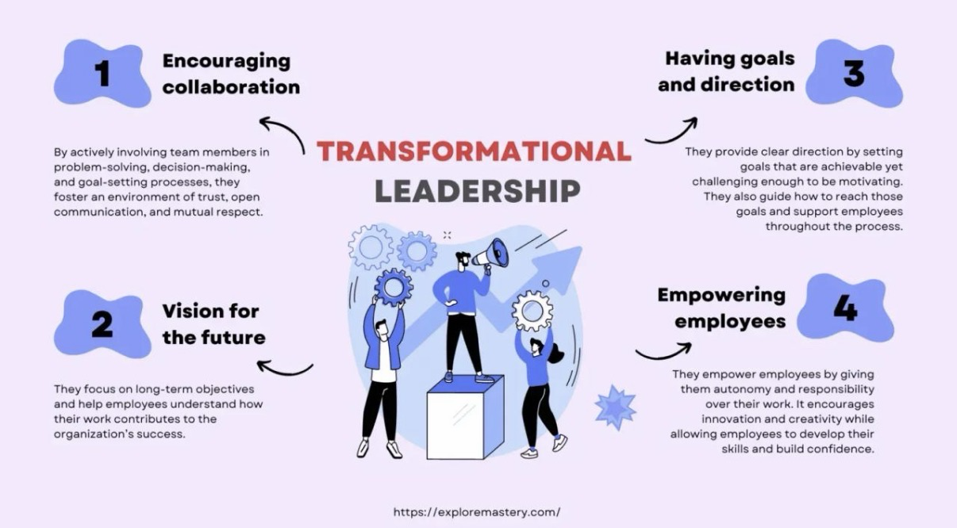

Chapter 2: Literature Review
2.1 Introduction
This chapter's goal is to conduct a critical analysis of the body of research on transformational leadership and how it affects worker productivity and organizational success. Because of its impact on employee behavior, organizational effectiveness, and strategic objectives, leadership continues to be one of the most studied issues in management studies. Many leadership theories have been put out by academics over the years to explain how leaders impact followers and accomplish organizational objectives. Because of its focus on inspiration, vision, employee development, and organizational change, transformational leadership has become one of the most prominent ideas. Before delving deeply into transformational leadership, this chapter first explores the development of leadership theory. The chapter then assesses the connection between organizational commitment, employee engagement, and motivation and transformational leadership.
2.13 Trait Theory of Leadership
Trait Theory, which aimed to pinpoint the personal traits of successful leaders, was one of the first methods of studying leadership. According to early academics, effective leaders have some intrinsic traits that set them apart from non-leaders. Intelligence, self-assurance, tenacity, integrity, and friendliness were frequently noted characteristics.

Trait Theory gained popularity because it gave a straightforward explanation for leadership performance. Organizations frequently tried to find people with desired leadership qualities and assign them to management roles. The idea, however, was criticized for failing to explain why people with similar attributes frequently had different results in various contexts. perspective.

Traditional trait theory and transformational leadership share several traits. For instance, charm, confidence, and effective communication are common traits of transformational leaders. However, by highlighting behaviors and interactions that motivate followers, transformational leadership goes beyond individual characteristics.
According to research, leadership success ultimately depends on how leaders engage with staff members and handle organizational issues, even though some personality traits may promote effective leadership. Therefore, compared to trait theory alone, transformational leadership offers a more thorough account of leadership performance.

2.14 Behavioural Leadership Theory
As researchers turned their focus from leader traits to leader behaviors in the middle of the 20th century, behavioral theories began to take shape. Behavioral researchers looked at what leaders do rather than what they are.

Leadership theory was greatly impacted by two important behavioural research initiatives:

Studies at Ohio State Two main leadership dimensions were found by researchers:
Consideration
• Care for the welfare of employees.
• The growth of constructive connections.
• Leadership that is encouraging.

Starting the Structure
• A focus on tasks.
• Setting objectives.
• Monitoring performance.

Leadership Studies in Michigan Researchers made a distinction between: Employee-Centered Leadership
• Pay attention to what employees need. • Developing relationships. • Support and involvement. Leadership Focused on Production • Pay attention to finishing the assignment. • Effectiveness and performance.

Many employee-oriented behaviors that behavioral theorists have identified are incorporated into transformational leadership. Supportive leadership behaviors linked to employee happiness and organizational effectiveness are quite similar to individualized consideration and inspiring motivation. Because they showed that leadership abilities may be acquired via experience and training rather of being exclusively reliant on innate qualities, behavioral theories made a substantial contribution to leadership study.

2.15 Contingency Theory
According to contingency theories, there isn't a one leadership approach that works for everyone. The organizational environment, employee traits, and task needs are examples of situational aspects that affect leadership success.
The Contingency Theory of Fiedler
According to Fiedler, situational favorability and leadership style interact to determine how effective a leader is.
The effectiveness of leadership is influenced by three major factors:
• Relations between leaders and members
• Task organization
• Power position Fiedler asserts that many leadership philosophies work well in various contexts.
Theory of Situational Leadership
Situational leadership, which was developed by Hersey and Blanchard, advises leaders to modify their approach based on the maturity and skill levels of their followers
. According to the theory, there are four types of leadership:
• Leading
• Mentoring
• Supporting
• Contingency theories are pertinent because they draw attention to transformational leadership's possible drawbacks.
Although transformative leadership typically yields favorable results, it might not always be the best strategy in highly regulated settings where rigorous adherence to procedures is necessary. However, research indicates that transformational leadership is still quite flexible and may be used effectively in a variety of organizational settings.
2.16 Transactional versus Transformational Leadership
Transactional and transformational leadership are two of the most significant similarities found in leadership literature.
Leadership through Transactions
The focus of transactional leadership is on interactions between leaders and followers.
Leaders offer:
• Incentives
• Appreciation
• Rewards for performance
In exchange, workers offer:
• Adherence
• Completing the task
• Reaching objectives
Maintaining organizational stability and making sure regular duties are carried out effectively are two benefits of transactional leadership. However, some contend that transactional leadership might not be able to motivate staff members to go above and beyond the bare minimum of performance standards.
Leadership that Transforms

Beyond merely exchanging rewards, transformational leadership aims to increase employee motivation.

Leaders that are transformational:
Motivate staff
• Promote creativity
• Encourage personal development

Establish common goals Studies repeatedly show that transformative leadership yields better results in relation to:

• Engagement of employees
• Inventiveness
• Organizational dedication
• Contentment at work

According to several studies, the most successful leaders exhibit both transactional and transformative behaviors. While transformational leadership motivates extraordinary achievement, transactional leadership creates structure and responsibility.

2.17 Servant Leadership
Another significant modern leadership philosophy is servant leadership.
Servant leadership, which was first introduced by Greenleaf in 1977, suggests that leaders should put stakeholders' and employees' needs ahead of organizational goals.

Among the traits of servant leaders are:
• Compassion
• Paying attention
• Stewardship
• Community development
• Development of employees

Transformational leadership and servant leadership are similar in many ways, especially when it comes to staff growth and assistance. But there are significant distinctions.

Transformational leadership focuses primarily on inspiring individuals towards organisational goals, whilst servant leadership places greater emphasis on serving employees themselves. According to research, both leadership philosophies have a good impact on organizational performance and employee happiness. According to some academics, there may be especially significant organizational advantages when transformational and servant leadership behaviors are combined.

2.18 Authentic Leadership
Another significant modern leadership philosophy is servant leadership.

Servant leadership, which was first introduced by Greenleaf in 1977, suggests that leaders should put stakeholders' and employees' needs ahead of organizational goals.

Among the traits of servant leaders are: • Compassion • Paying attention Concerns about ethics and organizational integrity have grown in recent years, drawing more focus to authentic leadership. Genuine leaders exhibit:
• Self-knowledge
• Openness
• Moral conduct
• Regularity
• Sincere connections Workers are more likely to trust leaders who are seen as sincere and truthful. Since trust is a key element of transformational impact, authentic leadership enhances transformational leadership.

Workers are more likely to embrace organizational visions and stick with a company amid challenging times if they believe their leaders are genuine. According to research, genuine leadership has a favorable impact on: • The welfare of employees • Organizational

2.19 Emotional Intelligence and Transformational Leadership
The importance of emotional intelligence as a leadership skill is becoming more widely acknowledged.
According to Goleman (1998), emotional intelligence is the capacity to identify, comprehend, and regulate one's own and other people's emotions. Important dimensions consist of:
Self-Awareness recognizing one's own feelings, shortcomings, and talents.
Self-Regulation controlling one's emotions.
Motivation sustaining dedication to objectives.
Empathy: Recognizing the viewpoints and issues of employees.
Social Competencies establishing connections and successfully influencing others.
The efficacy of transformative leadership is strongly correlated with emotional intelligence, according to research.
2.2 Evolution of Leadership Theory
Over the past century, leadership research has undergone significant change. The main goal of early leadership theories was to pinpoint the human traits of successful leaders. These views, referred to as trait theories, proposed that hereditary traits like intelligence, self-assurance, and charm played a major role in determining one's capacity for leadership.
But studies quickly realized that personal traits alone did not account for leadership performance. Following this, behavioral theories were developed that concentrated on the behaviors and activities exhibited by effective leaders. Leadership behaviors linked to employee happiness and organizational effectiveness were found in studies at Ohio State University and the University of Michigan.
Another important breakthrough was the creation of contingency theories. Researchers contended that contextual elements including the organizational environment were crucial to leadership performance and that no single leadership style was always effective.
As organisations became increasingly dynamic, transformational leadership emerged as a more contemporary approach capable of addressing modern organisational challenges. Unlike traditional leadership models that emphasised control and supervision, transformational leadership focused on inspiring employees to achieve exceptional performance and embrace organisational change.

2.3 Transformational Leadership Theory
Burns (1978) introduced transformational leadership and made a distinction between it and transactional leadership.
According to Burns, transformational leaders help followers reach goals above what is often expected by elevating their motives, values, and aspirations.
Later, Bass (1985) developed the thesis by suggesting that transformational leaders inspire followers to surpass performance standards in four crucial ways:
Idealized Impact The ability of the leader to serve as an example is known as idealized influence. Leaders that exhibit honesty, moral behavior, and dedication to company values are respected, trusted, and admired by their staff. These leaders build trust and forge deep emotional bonds with their people. According to research, workers are more likely to imitate the actions of leaders who they believe to be reliable and genuine. As a result, idealized influence greatly enhances organizational

Motivating Inspiration Communicating a compelling vision that offers meaning and purpose is a key component of inspirational motivation.
Transformational leaders set lofty objectives while encouraging hope and self-assurance in their workforce.
According to studies, workers who comprehend the goals of the company and find purpose in their work have greater levels of dedication and engagement. Therefore, inspirational CEOs foster cultures that inspire workers to contribute to the success of the company.
Stimulation of the Mind Employees that receive intellectual stimulation are more likely to question presumptions, investigate novel concepts, and provide creative solutions. By promoting critical thinking and ongoing development, transformational leaders foster creativity. Rapid technology advancements and competitive challenges have made innovation more crucial in today's organizations. Therefore, intellectual stimulation is a crucial leadership trait that supports organizational flexibility and long-term success.
Individualised Consideration
Individualised consideration involves recognising the unique needs, abilities and aspirations of employees. Transformational leaders provide mentoring, coaching and developmental opportunities tailored to individual requirements.
Research demonstrates that employees who feel valued and supported by their leaders experience greater job satisfaction, organisational commitment and motivation

2.4 Transformational Leadership and Employee Motivation
The psychological mechanisms that affect the course, intensity, and persistence of workplace behavior are referred to as employee motivation. Motivated workers are more likely to show dedication, output, and extra effort.

Several motivational theories are closely related to transformational leadership, such as:

The Hierarchy of Needs by Maslow

According to Maslow's 1943 theory, people are driven by a hierarchy of wants that includes everything from self-actualization to physiological demands. By praising staff accomplishments and encouraging personal growth, transformational leaders help to meet higher-level demands like respect, belonging, and self-actualization.

The Two-Factor Theory of Herzberg Herzberg (1959) made a distinction between motivators and hygienic considerations. Motivational elements including acknowledgment, success, accountability, and chances for personal development are all addressed by transformational leadership. As a result, workers have higher levels of intrinsic drive and job satisfaction.

Theory of Self-Determination
According to selfdetermination theory, people become motivated when their demands for relatedness, competence, and autonomy are met. Through relationship-building exercises, coaching, and empowerment, transformational leaders advance these requirements. Transformational leadership and employee motivation are positively correlated, according to numerous empirical research. Workers under transformative leaders often report greater zeal, dedication, and readiness to go above and beyond performance standards.

2.5 Transformational Leadership and Employee Engagement
The emotional, mental, and behavioral dedication workers show to their company and job duties is referred to as employee engagement.
Typically, engaged workers display:
• Increased output
• Increased dedication
• Better customer support
• A decrease in absences
• Reduced intentions to leave
Through a variety of methods, transformational leadership greatly increases employee engagement. First and foremost, motivating leaders foster meaningful workplaces where staff members recognize how their efforts advance organizational goals. Second, transformational leaders encourage people to actively participate in decision-making processes by fostering psychological safety and trust. Employee engagement levels are favorably predicted by transformative leadership, according to research from a variety of industries. Workers are more likely to stay emotionally committed in the success of the company if they believe that their leaders are trustworthy, encouraging, and supportive
.
2.6 Transformational Leadership and Organisational Commitment
An employee's psychological attachment to a company is referred to as organizational commitment. Meyer and Allen (1991) distinguished three aspects of commitment: Emotional Devotion a strong emotional bond with the company. Commitment to Continuity commitment based on the anticipated costs of departing. Normative Dedication commitment brought on by a sense of duty. When it comes to encouraging affective commitment, transformational leadership is especially successful. Transformational leaders improve the emotional bonds between workers and organizations by cultivating trust, acknowledgment, and a common goal. According to studies, workers who encounter transformational leadership are more likely to show loyalty during times of organizational transition and are less likely to look for other employment alternatives.

2.7 Transformational Leadership and Innovation
In modern organizations, innovation is a vital source of competitive advantage.

Businesses that don't innovate often find it difficult to stay relevant in the market and be sustainable over the long run
.
Innovation is facilitated by transformational leadership through:
• Promoting experimentation
• Encouraging originality Encouraging the exchange of knowledge
• Diminishing the fear of failing
• Questioning conventional wisdom

One of the fundamental components of transformative leadership is intellectual stimulation, which is especially crucial for encouraging creative behavior. Workers are more likely to contribute to organizational learning and development if they feel empowered to suggest new ideas. Transformational leadership and innovation outcomes are significantly positively correlated, according to research from the technology, healthcare, and manufacturing sectors.

2.8 Transformational Leadership and Organisational Performance
Organisational performance encompasses both financial and non-financial indicators of success.
Financial indicators include:
• An increase in revenue
• Profitability
• Investment return
• Market share
Among the non-financial metrics are:
• Contentment among employees
• Inventiveness
• Client contentment
• Effectiveness of operations

Employee behavior is one way that transformational leadership affects organizational success. Employees that are engaged and motivated tend to be more productive, which improves organizational results. Strong favorable correlations between transformational leadership and organizational effectiveness have been shown in a number of meta-analyses. When it comes to innovation, customer service, and employee retention, organizations with transformative leadership often outperform their rivals. Additionally, transformational leadership has shown itself to be especially successful when organizations are undergoing change. Organizations are better prepared to manage uncertainty when their leaders are able to convey compelling visions and sustain employee commitment.

2.9 Transformational Leadership During Organisational Change
Technological improvements, mergers, acquisitions, restructuring initiatives, and changing customer expectations often bring about major change for modern organizations. One of the fundamental issues that organizations continue to face is resistance to change.
Workers may be afraid of greater workload, job insecurity, or uncertainty.
Resistance is lessened by transformational leaders through:
• Expressing distinct visions
• Establishing trust
• Promoting involvement Helping
• Resolving issues raised by employees
According to research, transformational leadership raises the possibility of successful implementation and enhances employee acceptance of organizational change.

2.10 Criticisms of Transformational Leadership
Transformational leadership is not without its detractors, despite its broad acceptance.
Ambiguity in Concepts Some scholars contend that theoretical distinctions are challenging since transformational leadership overlaps with other leadership paradigms.
Over-Reliance on Leaders
Opponents contend that transformational leadership could promote an over-reliance on charismatic people rather than strong organizational structures.
Measurement Difficulties
Because of cultural differences and subjective views, it is still difficult to measure transformational leadership behaviors accurately. Possibility of Manipulation Some academics contend that charismatic executives may abuse
Some academics contend that charismatic executives may abuse transformative strategies for their own benefit rather than the good of the organization.
Cultural Restrictions Positive leadership behaviors in one cultural setting can not provide the same results in another. As a result, the efficacy of transformative leadership may differ between nations and sectors.

2.11 Conceptual Framework
Based on the literature reviewed, the following conceptual framework is proposed:
Transformational Leadership
↓
Idealised Influence
↓
Inspirational Motivation
↓
Intellectual Stimulation
↓
Individualised Consideration
↓
Employee Motivation
↓
Employee Engagement
↓
Organisational Commitment
↓
Innovation and Productivity
↓
Organisational Success

2.12 Chapter Summary
The literature on transformative leadership and organizational performance has been critically examined in this chapter. The conversation showed how transformational leadership has a good impact on workers' commitment, motivation, engagement, creativity, and output. Additionally, research indicates that by encouraging high-performance work environments and facilitating organizational change, transformational leadership makes a substantial contribution to organizational success. The literature does, however, also point out several drawbacks, such as conceptual ambiguity, difficulties with measurement, and cultural issues. These results serve as the theoretical basis for the methodology chapter, which describes the research strategy used in this dissertation.

Chapter 3: Research Methodology

3.1 Introduction
The previous chapter evaluated the literature on transformational leadership's impact on employee performance and organizational success as well as its theoretical underpinnings. The literature emphasized how crucial transformational leadership is for fostering employee engagement, motivation, dedication, creativity, and organizational efficacy. This chapter describes the research approach used for the dissertation, building on this theoretical framework.
The methodical process of gathering, analyzing, and interpreting data to address research questions and accomplish research goals is referred to as research methodology. The validity, dependability, and trustworthiness of study findings are greatly impacted by the methodological selection.
As a result, it is crucial to defend the chosen research strategy and provide an explanation of the data collection and analysis. The research philosophy, research approach, research design, data gathering techniques.

3.2 Research Aim and Objectives
The primary aim of this study is:
To critically evaluate the impact of transformational leadership on employee performance and organisational success.
The objectives guiding this research are:
• To investigate transformational leadership's theoretical underpinnings. • To assess the connection between employee motivation and transformative leadership. • To investigate how organizational commitment and employee engagement are affected by transformational leadership. • To evaluate how transformational leadership affects organizational performance and creativity. • To recognize obstacles and constraints related to transformational leadership. • To offer suggestions to organizations looking to increase the efficacy of their leadership. Therefore, the chosen approach must facilitate the accomplishment of these goals by thoroughly analyzing the body of knowledge and supporting data.

3.3 Research Philosophy
The ideas and presumptions about the nature of reality and knowledge that guide a study are referred to as research philosophy. According to Saunders et al. (2019), positivism, interpretivism, realism, and pragmatism are some of the research philosophies that are frequently employed in business and management studies.
The research philosophy used in this dissertation is interpretivist.
According to interpretivism, social processes are complicated and impacted by human interactions, experiences, and perceptions. Contextual considerations, organizational culture, and employee perceptions all play a major role in leadership success.
Therefore, rather than just assessing objective characteristics, understanding transformational leadership necessitates interpretation of current study findings. Because the dissertation aims to investigate how transformational leadership affects employee attitudes, behaviors, and organizational outcomes, the interpretivist philosophy is especially suited. These aspects are frequently subjective and cannot be fully comprehended by using numbers.

3.4 Research Approach
Research approaches generally fall into two categories:
Deductive Method
A deductive approach uses empirical research to test preexisting theories and hypotheses. Researchers start with well-established hypotheses and look for evidence to support them.

The Inductive Method
Using an inductive technique, new ideas are created based on patterns seen in the evidence that has been gathered. From observations, researchers draw more general theoretical inferences.
The research methodology used in this dissertation is deductive. There is already a large body of theoretical and empirical literature that supports transformational leadership. The goal of this research is to assess the current data regarding the efficacy of transformational leadership rather than to create a new theory of leadership.
Therefore, the deductive technique allows the researcher to investigate if findings published in scholarly literature corroborate the idea that transformational leadership enhances organizational success and employee performance.

3.5 Research Design
The general framework that directs data gathering and analysis is provided by research design.
Three designs are frequently used in business research: Investigative Studies used when there is a lack of information about a subject.
Research that is descriptive used to characterize traits, actions, or occurrences.
Explanatory Studies used to look at links between causes and effects. Because it aims to clarify the connection between transformational leadership and organizational outcomes, this dissertation uses an explanatory research design. The goal of the study is to comprehend how employee motivation, engagement, creativity, and performance are impacted by leadership behaviors.
Consequently, the best framework for analyzing these correlations is provided by explanatory research.

3.6 Research Strategy
For this dissertation, a systematic literature review employing secondary research techniques was chosen as the research approach. Analyzing data that has already been gathered by other researchers, organizations, and institutions is known as secondary research.
Among the sources used are:
• Articles from scholarly journals
• Books Industry reports
• Publications from the government Reports from professional bodies Organizational research
• Leadership research databases
Since transformational leadership has been thoroughly researched over several decades, secondary research is suitable. There is already a large amount of data about its impact on organizations and effectiveness. The study offers a thorough understanding of transformative leadership without the need for original data collecting by combining findings from many sources.

3.7 Data Collection Methods
Secondary Data Collection
Information that has previously been gathered and published by other researchers is referred to as secondary data. The study only uses secondary data because of a number of benefits: Availability of Extensive Research One of the most studied philosophies of leadership is transformational leadership. Its consequences in a variety of businesses and nations have been the subject of thousands of scholarly researches.
Cost Effectiveness
It can be costly and time-consuming to gather primary data through surveys or interviews. Efficient access to vast amounts of existing material is made possible by secondary research.
Reliability
Many academic studies undergo rigorous peer review processes before publication, increasing confidence in their findings
Longitudinal Evidence
· Examining studies carried out across several decades is made possible by secondary data, which offers insights into long-term trends and patterns. The following are the main databases used to identify literature: Google Scholar
· JSTOR
· Emerald Perspective
· ScienceDirect
· Taylor and Francis
· Sage Journals

Only reliable and scholarly sources were deemed appropriate for inclusion.

3.8 Inclusion and Exclusion Criteria
Certain standards were set for the selection of literature to guarantee quality and relevance.
Inclusion Criteria
The following criteria were satisfied by the studies that were part of the review:
• Published in reputable scholarly publications
. • Transformational leadership was the main focus.
• Analysed organizational results or worker performance.
• Written in English.
• Applicable to management and commercial settings. •
Research articles that undergo peer revie

Exclusion Criteria
Research was disregarded if it • Concentrated only on subjects unrelated to leadership.
• Were statements of opinion devoid of proof. • The methodology was opaque.
• The complete text was not accessible. •
Had little bearing on the goals of the study. Throughout the literature review process, these standards served to guarantee dependability and consistency.

3.9 Data Analysis
Finding patterns, themes, and connections in gathered data is known as data analysis. Thematic analysis was used because the study was qualitative in nature. Thematic analysis entails:
Step 1: Acquaintance reviewing gathered literature to improve comprehension of important ideas.
Phase Two: Coding identifying recurrent ideas and themes in study results.
Stage 3: Development of the Theme putting related ideas into more general thematic groups.
Phase Four: Interpretation assessing the connections between topics and connecting the results to the goals of the study. The researcher was able to find recurrent patterns related to: • Motivation of employees • Engagement of employees • Organizational dedication • Inventiveness • Efficiency • The performance of the organization Additionally, the method made it easier to compare various studies and sectors.

3.10 Ethical Considerations
Even if there are no human subjects in the study, ethical issues are still crucial.
The following guidelines were adhered to: Academic Honesty Harvard referencing guidelines are used to properly cite all sources.
Steer clear of plagiarism Academic literature-
derived information is paraphrased and properly cited. Precise Representation The results of the research are given impartially and without purposeful prejudice or deception. Honouring Intellectual Property, the paper recognizes the work of earlier authors and scholars. Concerns about participant permission and confidentiality did not apply because no personal data was gathered.

3.11 Research Limitations
Several limitations should be acknowledged.
Reliance on Current Literature
The entire study is based on research that has already been published. As a result, the caliber and extent of previous research have an impact on the results.
Bias in Publication
Research with favorable outcomes is frequently more likely to be published than research with negative or equivocal findings.
Absence of Primary Information
The study is unable to record employee experiences in real time due to the lack of surveys and interviews.
Contextual Variations
Industry, organizational culture, and country environment can all affect how effective a leader is. As a result, conclusions might not be applicable everywhere. Notwithstanding these drawbacks, the substantial corpus of research analyzed offers a solid basis for assessing the efficacy of transformative leadership.

3.12 Chapter Summary
The approach used for the dissertation has been described in this chapter. A logical method and interpretivist philosophy were chosen to provide a methodical assessment of transformational leadership literature. Information was gathered from books, industry reports, and scholarly publications using secondary research techniques. To find recurrent trends about employee performance and organizational success, thematic analysis was used. While some limitations were acknowledged, steps were taken to improve validity, reliability, and ethical compliance. The approach offers a strong framework for analyzing the efficacy of transformative leadership and meeting the goals of the study.

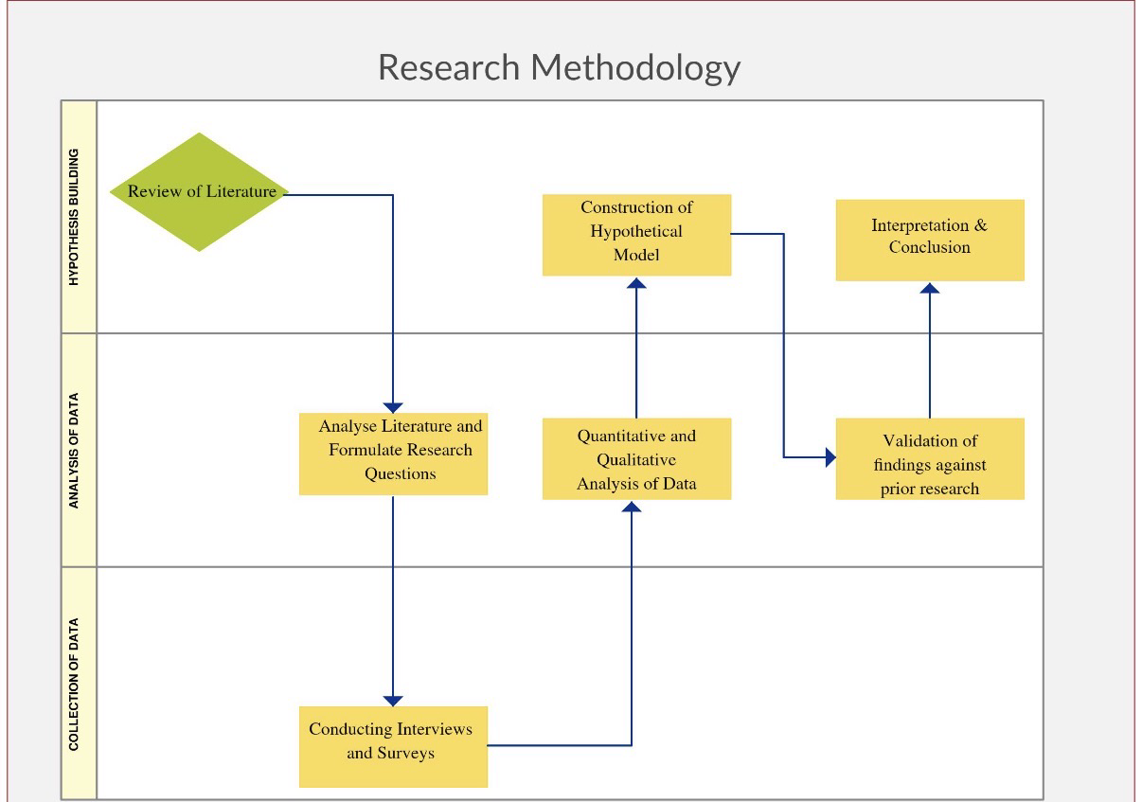

Chapter 4: Findings and Discussion

4.1 Introduction
The results from the literature studied in Chapter Two are presented and critically discussed in this chapter. This chapter's goal is to assess how much transformational leadership affects worker performance and advances organizational success. The results are arranged according to major topics found in the literature through thematic analysis. Employee engagement, motivation, organizational commitment, productivity, creativity, performance, and organizational change are some of these issues. The conversation critically assesses whether transformative leadership regularly yields favorable results in various organizational environments and connects theoretical ideas with practical data. Additionally, the results are evaluated considering the study questions and objectives described in Chapter One.

4.2 Impact of Transformational Leadership on Employee Motivation
The favorable correlation between transformative leadership and employee motivation is one of the most prominent themes found in the research. According to several studies, transformational leaders foster work cultures where staff members feel motivated, appreciated, and dedicated to the organization's objectives. Leaders inspire workers to go above and beyond the call of duty with personalized attention and motivating inspiration. Employees are more motivated when they can see how their work fits into the larger goals of the company, according to research. Transformational leaders successfully convey organizational aspirations and assist staff members in seeing significant links between individual objectives and the success of the company.
According to the research, many of the higher-level requirements listed in Maslow's hierarchy are met by transformational leaders. When working under transformative leaders, employees frequently report feeling more accomplished, more purposeful, and more confident. Additionally, it seems that transformational leadership is especially good at encouraging intrinsic motivation. Transformational leadership encourages workers to discover personal fulfillment in accomplishing organizational goals, in contrast to transactional leadership, which often depends on outside rewards. According to several evaluated studies, workers under the direction of transformational leaders shown greater levels of zeal, perseverance, and discretionary effort
. Because they were emotionally invested in the success of the company, employees often showed a readiness to go above and beyond performance standards.
Nonetheless, other scholars contend that not every employee will be similarly motivated by transformational leadership. Employee reactions to leadership behaviors may be influenced by individual personality traits, cultural backgrounds, and organizational settings. However, the vast bulk of research indicates that transformative leadership significantly improves employee motivation.

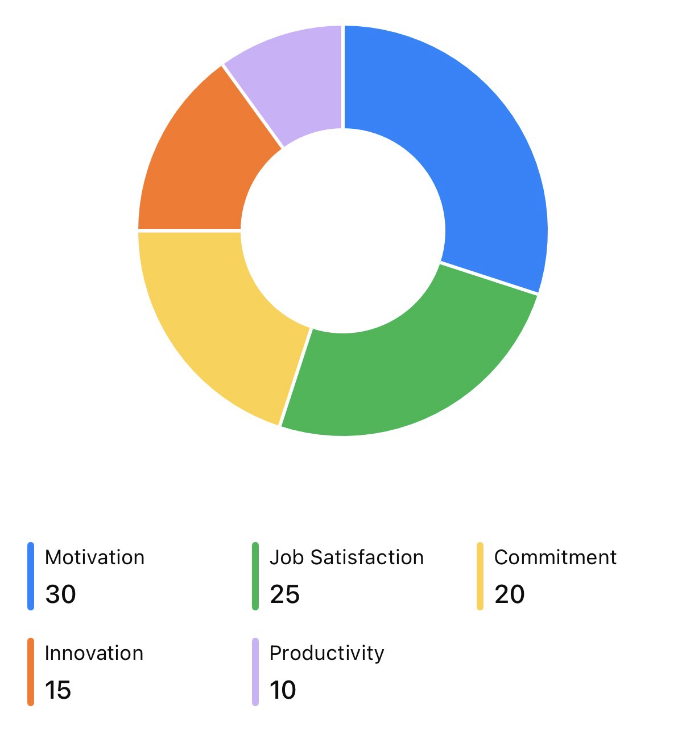

4.3 Impact on Employee Engagement
Another important subject that surfaced in the literature was employee involvement. The emotional and psychological bond that workers have with their jobs and organizations is referred to as employee engagement. Higher levels of dedication, productivity, and job satisfaction are usually exhibited by engaged workers. The results show that transformative leadership has a number of beneficial effects on employee engagement. First, transformational leaders build relationships with staff members based on trust. One of the most significant indicators of employee engagement is consistently found to be trust. Workers who have faith in their leaders are more inclined to offer suggestions, take part in organizational projects, and stick with the company through uncertain times. Second, transformational leaders encourage staff members to participate in decision-making. Strong psychological ties with their company are more likely to form among workers who believe their opinions are respected.
Thirdly, transformative leaders offer opportunities for growth and feedback on a regular basis. Workers see these behaviors as proof that the company appreciates their contributions and potential for advancement. Research from a variety of industries, including healthcare, education, manufacturing, and services, often shows that transformative leadership and employee engagement levels are positively correlated. Businesses with highly engaged employees often encounter: • Increased output • A decrease in absences • Reduced employee attrition • A higher level of client satisfaction • A rise in profitability Therefore, the results provide credence to the claim that transformational leadership's beneficial effects on employee engagement greatly contribute to organizational success.

4.4 Impact on Organisational Commitment
Strong evidence between transformative leadership and organizational commitment was found in the literature review. Workers who encounter transformative leadership frequently grow more emotionally invested in their companies. This result is in good agreement with the affective commitment framework proposed by Meyer and Allen. Transformational leaders increase dedication by:

• A common organizational vision
• Building trust
• Recognition of employees
• Individual assistance
• Opportunities for professional growth Workers often say that transformational leaders make them feel appreciated and respected. As a result, they are more likely to show sustained dedication and loyalty to the company.
Transformational leadership dramatically lowers employee turnover intentions, according to a number of evaluated research. Businesses with high employee turnover can incur significant expenses for hiring, training, and productivity. As a result, leadership strategies that increase staff retention can have a major positive impact on an organization. The results also show that transformational leadership is especially beneficial when organizations are undergoing change. Workers are more likely to support strategic goals and stay dedicated in the face of uncertainty if they have faith in organizational leaders. The idea that transformative leadership increases organizational commitment and favorably affects worker stability is generally well supported by the literature.

4.5 Impact on Innovation and Creativity
One of the key factors influencing an organization's competitiveness in contemporary commercial settings is innovation. Transformational leadership was found to be an important element impacting creativity and innovation in a sizable fraction of the studied literature. In this scenario, the aspect of intellectual stimulation seems especially crucial. Employees are encouraged by transformational leaders to question preconceived notions, scrutinize current procedures, and consider different approaches. According to several studies, workers under transformational leaders were more likely to
• Produce creative concepts Engage in activities that involve solving problems. • Make suggestions for process enhancements • Create original solutions
• Exchange information with coworkers In industries where there are fierce competition and rapid technical improvement, innovation is particularly crucial. Businesses that don't innovate often find it difficult to stay competitive over the long run.
According to research, transformational leaders encourage creativity by establishing psychologically secure workplaces where staff members are at ease taking measured chances. Because transformational leaders see mistakes as chances for growth and learning, employees are less fearful of failing. The results, however, also imply that innovation might not be ensured by transformational leadership alone. Additionally, there must be organizational resources, culture, and strategic support. Therefore, a variety of interrelated elements, rather than just leadership, have an impact on innovation. However, it regularly seems that transformational leadership increases an organization's ability to be creative and innovative
.
4.6 Impact on Employee Productivity
One important measure of an organization's efficacy is employee productivity. Through a number of indirect mechanisms, the literature shows that transformative leadership has a favorable impact on productivity. Transformational leadership enhances elements that subsequently boost performance rather than directly raising productivity
such as:
• Inspiration
• Involvement
• Contentment at work
• Dedication
• Cooperation
• Inventiveness In general, motivated and engaged workers are more inclined to put forth effort to meet company goals. Productivity levels rise as a result. Teams under the direction of transformational leaders consistently performed better than teams under the direction of transactional or laissez-faire leaders, according to several evaluated studies.
By encouraging cooperation and knowledge exchange, transformational leaders also increase productivity. Instead of engaging in needless competition, employees are encouraged to help one another. Additionally, transformative leaders frequently set high standards for performance while also offering the tools and assistance required for success. This combination seems to be especially successful in motivating staff members to reach challenging objectives. Therefore, the results imply that transformative leadership has a major role in increasing productivity in a variety of organizational contexts.

4.7 Impact on Organisational Performance
This dissertation's main goal was to assess how transformational leadership affects organizational success. The literature contains strong evidence suggesting a positive association between transformative leadership and organisational success. Financial and non-financial results are included in organizational performance.
Financial Results
Studies reveal that companies with transformational leadership typically accomplish: • Increased profitability
• A rise in revenue
• A higher return on investment Increased competitiveness in the market

Non-Financial Results

Additionally, transformational leadership helps with: • Contentment among employees
• Client contentment
• The reputation of the organization • The performance of innovation Stability of the workforce
The results imply that increases in organizational performance arise from transformational leadership's simultaneous influence on several employee behaviors. Motivated, engaged, and dedicated workers are more likely to provide excellent customer service, come up with creative solutions, and support strategic goals. Transformational leadership was more successful at times of organizational change and uncertainty, according to several studies. Organizations can sustain stability while pursuing change projects with the support of leaders who can articulate compelling visions. The idea that transformative leadership enhances organizational success is generally well-supported by the data.

4.8Critical Evaluation of Findings
First of all, rather of using objective performance metrics, many studies rely on employee views. Workers may give transformative leaders high ratings because they like them personally rather than because their actions actually boost output.
Second, the effectiveness of leadership may be impacted by cultural variations. Leadership behaviors deemed inspirational in one nation could not have the same results in another.
Thirdly, not every industry will benefit equally from transformational leadership. Procedural compliance may need to be prioritized over inspirational leadership in highly regulated workplaces.
Fourth, an over-reliance on charismatic leaders could lead to organizational dependency. Performance may drastically suffer if transformational leaders depart the company.
Lastly, some academics contend that there is conceptual ambiguity due to the significant overlap between transformational leadership and other leadership theories. The entire body of evidence is still highly positive in spite of these drawbacks.

4.9 Discussion in Relation to Research Objectives
The study goals outlined in Chapter One are directly addressed by the findings.

Goal 1 By analyzing Bass's four dimensions, the theoretical underpinnings of transformative leadership were investigated.
Objective 2: Research shows that via vision, acknowledgment, and support, transformational leadership has a good impact on staff engagement

Goal 3: The results show a substantial correlation between organizational commitment, employee engagement, and transformational leadership.

Objective 4: There is strong evidence that transformational leadership enhances organizational performance, productivity, and creativity.

Objective 5 Contextual variations, measurement difficulties, and reliance on leader attributes were among the constraints noted.

Goal 6: According to the results, organizations ought to fund leadership development initiatives that emphasize transformational leadership skills.

4.10 Chapter Summary
This chapter examined the results of the literature review and assessed how transformational leadership affects worker productivity and organizational success. The results show that employee motivation, engagement, organizational commitment, innovation, productivity, and organizational performance are all positively impacted by transformational leadership. The data clearly shows that transformational leadership is one of the most successful modern leadership philosophies, despite several drawbacks. Developing transformational leadership skills can be very beneficial for organizations looking for long-term competitive advantage.
Chapter 5: Recommendations

5.1 Introduction
The results provided in Chapter Four showed that employee motivation, engagement, organizational commitment, creativity, and overall organizational performance are all significantly improved by transformational leadership. However, intentional organizational effort is needed to get these advantages. Organizations must make investments in systems, procedures, and cultures that foster transformational leadership behaviors since leadership skills do not naturally emerge. Based on the study's findings, this chapter offers suggestions for organizations, managers, and upcoming researchers.

5.2 Leadership Development Programmes
Implementing structured leadership development programs is one of the most crucial suggestions. Technical proficiency, not leadership skills, is a major factor in the promotion of many managers. As a result, someone may have excellent technical knowledge but lack the interpersonal abilities needed to inspire and motivate staff.
Thus, organizations ought to provide training courses that emphasize:
• The ability to communicate
• The capacity for emotional intelligence
• Mentoring and coaching
• Thinking strategically
• Management of change
• Strategies for engaging employees Initiatives for leadership development ought to be ongoing rather than sporadic. Over time, leaders can enhance their transformational leadership skills with the support of ongoing coaching, mentoring, and professional development opportunities.

5.3 Promote Employee Empowerment
When workers feel empowered to contribute to organizational goals, transformational leadership works best.
Organizations ought to:

• When necessary, assign decision-making authority.
• Promote staff involvement in problem-solving. Engage staff members in strategic conversations. • Provide chances for creativity and idea generation.
• Encourage ongoing education and growth.
Employees that feel empowered are more likely to show initiative, inventiveness, and dedication, which eventually improves organizational performance.

5.4 Strengthen Organisational Communication
Throughout the literature research, effective communication emerged as a crucial aspect of transformative leadership. Leaders’ ought to speak:
• Organizational objectives
• Priorities for strategy
• Anticipated results
• Performance standards
• Initiatives for change When workers are aware of how their efforts contribute to the success of the company, they are more likely to stay involved. Therefore, companies should make investments in communication solutions that foster openness and two-way communication between managers and staff.

5.5 Encourage Innovation and Continuous Improvement
For an organization to succeed over the long run, innovation is still crucial. Transformational leaders should establish welcoming settings for their staff: • Exchanging concepts
· Questioning current procedures
• Trying out novel strategies
• Acquiring knowledge from errors Businesses can encourage innovation by: • Creating forums for innovation
• Encouraging original thought
• Encouraging teamwork
• Offering resources for testing These programs can increase an organization's competitiveness and adaptability.

5.6 Prioritise Employee Wellbeing
Through individualized attention and supportive leadership behaviors, transformational leaders continuously boost employee health, according to the literature. Organizations ought to:
• Keep a close eye on workers' well-being. • Help with mental health. Promote a healthy work-life balance. Acknowledge the accomplishments of your staff. • Encourage inclusive work environments. Workers are more likely to stay motivated, involved, and dedicated if they feel appreciated and supported.

5.7 Succession Planning
Over-reliance on individual leaders could be a drawback of transformative leadership. As a result, organizations should set up succession planning procedures to guarantee that leadership skills are dispersed throughout the company. Early identification and development of future leaders should be achieved through: • Programs for developing leaders
• Mentoring agreements
• Assignments that rotate
• Opportunities for professional growth
This strategy promotes long-term sustainability and lessens organizational vulnerability.

5.8 Recommendations for Future Research
Future scholars might want to look into: • Transformational leadership in particular sectors. • The impact of culture on effective leadership. • The connection between remote work and transformational leadership. • Effectiveness of leadership in times of organizational crisis. • A comparison between servant and transformational leadership styles. These fields offer significant chances to increase our existing understanding.

5.9 Chapter Summary
The suggestions made in this chapter are intended to improve organizational performance and leadership efficacy. To maximize the advantages of transformational leadership, organizations should invest in leadership development, employee empowerment, innovation, communication, and wellbeing initiatives.
Chapter 6: Conclusion

6.1 Introduction
This dissertation's goal was to assess how transformational leadership affects worker productivity and organizational success. The study looked at scholarly works on transformational leadership and analyzed data on how it affects employee engagement, motivation, organizational commitment, innovation, and performance. The main conclusions are outlined in this chapter along with their ramifications for organizations and management professionals.

6.2 Summary of Key Findings
According to the literature assessment, transformational leadership is still one of the most powerful and successful leadership philosophies used in modern organizations. The results revealed four fundamental characteristics that set transformational leadership apart: • Idealized Impact • Motivating Inspiration • Stimulation of the Mind • Tailored Attention When combined, these factors give leaders the ability to motivate staff, encourage creativity, and enhance organizational performance. Transformational leadership and employee motivation are positively correlated, according to the evidence examined throughout the dissertation. Workers under transformative leaders often report higher levels of zeal, dedication, and desire to go above and beyond performance standards. In a similar vein, it was discovered that transformative leadership greatly
The literature also shown that organizational commitment is strengthened by transformative leadership. During times of uncertainty and change, workers who have faith in organizational leaders are more likely to stay devoted and helpful. Another significant result of transformative leadership was the emergence of innovation. Employees that are intellectually stimulated are more likely to come up with fresh concepts, question presumptions, and help the company grow. Lastly, the data clearly indicated that transformational leadership improves employee attitudes, behaviors, and productivity, which in turn improves organizational performance.

6.3 Achievement of Research Objectives
All of the mentioned research objectives were satisfactorily met by the dissertation.
Goal 1 We looked at and assessed the theoretical underpinnings of transformational leadership.
Goal Two There is strong evidence to support the investigation of the connection between employee motivation and transformational leadership.
Goal Three The study showed that organizational commitment, employee engagement, and transformative leadership are positively correlated.
Goal Four A critical assessment of transformational leadership's impact on innovation and organizational performance was conducted.
Goal Five Transformational leadership's drawbacks and difficulties were noted and examined. The recommendations in Objective Six were created to help organizations that want to increase the effectiveness of their leadership.
6.4 Answering the Research Question
The main query for the study was: What effects can transformative leadership have on worker productivity and organizational success? The results show that by fostering work cultures that are marked by trust, motivation, engagement, creativity, and commitment, transformational leadership affects employee performance. Long-term organizational success and enhanced organizational performance are strongly impacted by these favorable personnel outcomes. The notion that transformational leadership is a very successful leadership strategy that can improve both human and organizational outcomes is thus supported by the research.

6.5 Limitations of the Study
There are a few restrictions to be aware of. First off, primary research was not included in the study; instead, it relied solely on secondary data. Second, organizational culture, industry, and national context can all affect how effective transformational leadership is. Thirdly, the availability of favorable findings in the literature may be impacted by publication bias. Notwithstanding these drawbacks, the results drawn are well supported by the scope and caliber of the data examined.

6.6 Final Conclusion
To sum up, one of the best leadership strategies available to contemporary organizations is transformational leadership. Transformational leaders have a favorable impact on staff motivation, engagement, commitment, innovation, and productivity, according to the research examined throughout this dissertation. Long-term success and organizational effectiveness are greatly enhanced by these advancements. Leadership strategies that motivate workers, foster creativity, and support organizational adaptation will continue to be crucial as businesses operate in increasingly complex and competitive environments. Organizations can accomplish these goals while also improving employee well-being and organizational success by using the framework that transformational leadership offers. As a result, the results encourage the development and use of transformational leadership techniques in a variety of organizational contexts

Harvard Reference List
Bass, B.M. (1985) Leadership and Performance Beyond Expectations. New York: Free Press.
Bass, B.M. and Avolio, B.J. (1994) Improving Organisational Effectiveness Through Transformational Leadership. Thousand Oaks, CA: Sage Publications.
Bass, B.M. and Riggio, R.E. (2006) Transformational Leadership. 2nd edn. Mahwah, NJ: Lawrence Erlbaum Associates.
Burns, J.M. (1978) Leadership. New York: Harper & Row.
Carter, M.Z., Armenakis, A.A., Feild, H.S. and Mossholder, K.W. (2013) ‘Transformational leadership, relationship quality and employee performance’, Journal of Organisational Behaviour, 34(7), pp. 942–954.
Conger, J.A. and Kanungo, R.N. (1998) Charismatic Leadership in Organisations. Thousand Oaks, CA: Sage Publications.
Daft, R.L. (2021) The Leadership Experience. 8th edn. Boston: Cengage Learning.
Dinh, J.E., Lord, R.G., Gardner, W.L., Meuser, J.D., Liden, R.C. and Hu, J. (2014) ‘Leadership theory and research in the new millennium’, The Leadership Quarterly, 25(1), pp. 36–62.
Dvir, T., Eden, D., Avolio, B.J. and Shamir, B. (2002) ‘Impact of transformational leadership on follower development and performance’, Academy of Management Journal, 45(4), pp. 735–744.
Eisenbeiss, S.A., van Knippenberg, D. and Boerner, S. (2008) ‘Transformational leadership and team innovation’, Journal of Applied Psychology, 93(6), pp. 1438–1446.
Gibbs, G. (1988) Learning by Doing: A Guide to Teaching and Learning Methods. Oxford: Oxford Polytechnic.
Goleman, D. (1998) Working with Emotional Intelligence. London: Bloomsbury.
Hair, J.F., Black, W.C., Babin, B.J. and Anderson, R.E. (2019) Multivariate Data Analysis. 8th edn. Andover: Cengage Learning.
Herzberg, F. (1959) The Motivation to Work. New York: John Wiley & Sons.
Judge, T.A. and Piccolo, R.F. (2004) ‘Transformational and transactional leadership: A meta-analytic test’, Journal of Applied Psychology, 89(5), pp. 755–768.
Kotter, J.P. (1996) Leading Change. Boston: Harvard Business School Press.
Kouzes, J.M. and Posner, B.Z. (2017) The Leadership Challenge. 6th edn. Hoboken, NJ: Wiley.
Luthans, F. (2011) Organisational Behaviour. 12th edn. New York: McGraw-Hill.
Maslow, A.H. (1943) ‘A theory of human motivation’, Psychological Review, 50(4), pp. 370–396.
Meyer, J.P. and Allen, N.J. (1991) ‘A three-component conceptualisation of organisational commitment’, Human Resource Management Review, 1(1), pp. 61–89.
Mullins, L.J. and Christy, G. (2016) Management and Organisational Behaviour. 11th edn. Harlow: Pearson.
Northouse, P.G. (2022) Leadership: Theory and Practice. 9th edn. Thousand Oaks, CA: Sage Publications.
Podsakoff, P.M., MacKenzie, S.B., Moorman, R.H. and Fetter, R. (1990) ‘Transformational leader behaviours and their effects on followers’, The Leadership Quarterly, 1(2), pp. 107–142.
Robbins, S.P. and Judge, T.A. (2022) Organisational Behaviour. 19th edn. Harlow: Pearson.
Saunders, M., Lewis, P. and Thornhill, A. (2019) Research Methods for Business Students. 8th edn. Harlow: Pearson Education.
Schein, E.H. (2017) Organisational Culture and Leadership. 5th edn. Hoboken, NJ: Wiley.
Shamir, B., House, R.J. and Arthur, M.B. (1993) ‘The motivational effects of charismatic leadership’, Organisation Science, 4(4), pp. 577–594.
Yukl, G. (2013) Leadership in Organisations. 8th edn. Harlow: Pearson Education.
Avolio, B.J. and Yammarino, F.J. (2013) Transformational and Charismatic Leadership: The Road Ahead. Bingley: Emerald Publishing.
Bennis, W. (2009) On Becoming a Leader. New York: Basic Books.
Cameron, K.S. and Quinn, R.E. (2011) Diagnosing and Changing Organisational Culture. 3rd edn. San Francisco: Jossey-Bass.
Creswell, J.W. and Creswell, J.D. (2018) Research Design: Qualitative, Quantitative and Mixed Methods Approaches. 5th edn. Thousand Oaks, CA: Sage Publications.
George, B. (2003) Authentic Leadership. San Francisco: Jossey-Bass.
Greenleaf, R.K. (2002) Servant Leadership: A Journey into the Nature of Legitimate Power and Greatness. New York: Paulist Press.
Hackman, J.R. and Oldham, G.R. (1980) Work Redesign. Reading, MA: Addison-Wesley.
House, R.J. (1977) ‘A 1976 theory of charismatic leadership’, in Hunt, J.G. and Larson, L.L. (eds.) Leadership: The Cutting Edge. Carbondale: Southern Illinois University Press.
Kahn, W.A. (1990) ‘Psychological conditions of personal engagement and disengagement at work’, Academy of Management Journal, 33(4), pp. 692–724.
Locke, E.A. and Latham, G.P. (2002) ‘Building a practically useful theory of goal setting and task motivation’, American Psychologist, 57(9), pp. 705–717.
McGregor, D. (1960) The Human Side of Enterprise. New York: McGraw-Hill.
Mintzberg, H. (1973) The Nature of Managerial Work. New York: Harper & Row.
Porter, M.E. (1985) Competitive Advantage. New York: Free Press.
Spector, P.E. (2022) Industrial and Organisational Psychology. 9th edn. Hoboken, NJ: Wiley.
Tichy, N.M. and Devanna, M.A. (1986) The Transformational Leader. New York: Wiley.
Vroom, V.H. (1964) Work and Motivation. New York: Wiley.
Warrick, D.D. (2017) ‘What leaders need to know about organisational culture’, Business Horizons, 60(3), pp. 395–404.
Wood, J., Zeffane, R., Fromholtz, M., Wiesner, R., Morrison, R., Factor, A., Schermerhorn, J.R. and Hunt, J.G. (2021) Organisational Behaviour. 5th edn. Milton: Wiley.

