KNOWLEDGE AND INFORMATION MANAGEMENT OF AMAZON
BMSW5106
STUDENT NAME : ANDRADA BALABAN
STUDENT ID: 1920286
LECTURER NAME : YAJESH KUMAR

Table of Contents
Task 1: Report 3
1.0 Introduction 3
2.0 Organizational Background 3
3.0 Management theories for underpinning the study 4
4.0 Different steps and prerequisites for good management practices 5
Acquisition of Customer Shipment address: 6
Payment system offered to the customer: 7
5.0 Effectiveness of information management and culture in terms of effective customer relationship management 8
6.0 Amazon potential knowledge management challenges 10
7.0 Recommendation for strengthening knowledge management practices 12
8.0 Conclusion 13
Reference List: 18

Task 1: Report

1.0 Introduction
Knowledge and information management are considered two primary progress of Amazon and the organization is required to focus upon those following market challenges. It is also necessary to understand the knowledge challenge which is a biannual program for business organizations to incorporate different research activities for improving their working progress. The study provides elaboration about the challenges that are faced by Amazon and how knowledge management theories help the organization to understand the market and the challenges. The next phase of the study provides elaboration about the effectiveness of knowledge management for creating a knowledge base and maintaining a proper customer relationship. The next phase of the study provides understanding about the challenges that are faced by Amazon and recommendations provided to understand the effective step that can be taken for practices in context to knowledge acquisition-retention-transfer perspective.

2.0 Organizational Background
Amazon is one of the famous American multinational business organizations which focuses upon cloud computing, e-commerce, artificial intelligence, and digital streaming. Due to the covid-19 pandemic, the organization also faced several difficulties coping up with customer requirements. The E-Commerce giant also started to deliver products at low and convenient prices at the time of the coronavirus crisis. The organization hired employees and brought 175000 new warehouses by mid-2020. The demand for customers is increasing gradually and Amazon added 36400 employees in 3 months which increased its headcount by 876800. Amazon also launched an Amazon Web service which provides data on the website and It helps the employees to understand the internet traffic patterns and other statistics for developing the business. The organization also incorporated the AWS portfolio (Jarmooka et al., 2020).
Amazon is one of the largest retailing giants and there provide better quality logistic service across the globe. According to the annual report of 2020, the revenue of the organization is US$425.064 billion. The operating income and net income of the organization are US$22.9 billion and Us$21.331 billion respectively. The core competency of the organization is to identify their customer convenience and accessibility and also understand the pattern of shopping. Amazon is also building the core competencies to online market development and also trying to get detailed knowledge based on the customer requirement.

3.0 Management theories for underpinning the study
Organizational Learning Theory: Every business organization is required to follow the organizational learning theory and is based upon two different aspects. It provides elaboration about the expected outcome that differs from the actual outcome and business organizations can easily gauge in inquiry to understand the challenges.
Espoused Theory: It refers to the formal part of the business organization. Every business organization requests to track their employees for contacting themselves in a positive working atmosphere and carrying out their job. It will also provide comprehensive benefit in context to an understanding about the rising problem and how the organization is taking necessary action for getting a positive outcome. On the other hand, the theory also provides brief elaboration about the problems that are faced by the organization and how knowledge management can provide potential benefits in lowering the issues (Hock et al., 2021).
Theory in use: It is considered one of the actual ways by which the business organization can easily follow the espoused theory and rely upon brainstorming and interaction for solving problems. The theory in use also referred to the flowing and social way by which employees can solve problems and learn. For example, a business organization can take a major step to understand the actual problem which is impacting the working activities. After gathering detailed knowledge, the organization can easily improve the working standard and also motivate the employee to find an actual way in lowering the issues or solving problems with computers. In case of any mismatch between the approaches, the organization can enforce espoused theory which is considered one of the clear and straightforward ways (Lam et al., 2021). It will also provide a conducive environment under which the employee can easily accept the theory and also implement them for improving the working environment.
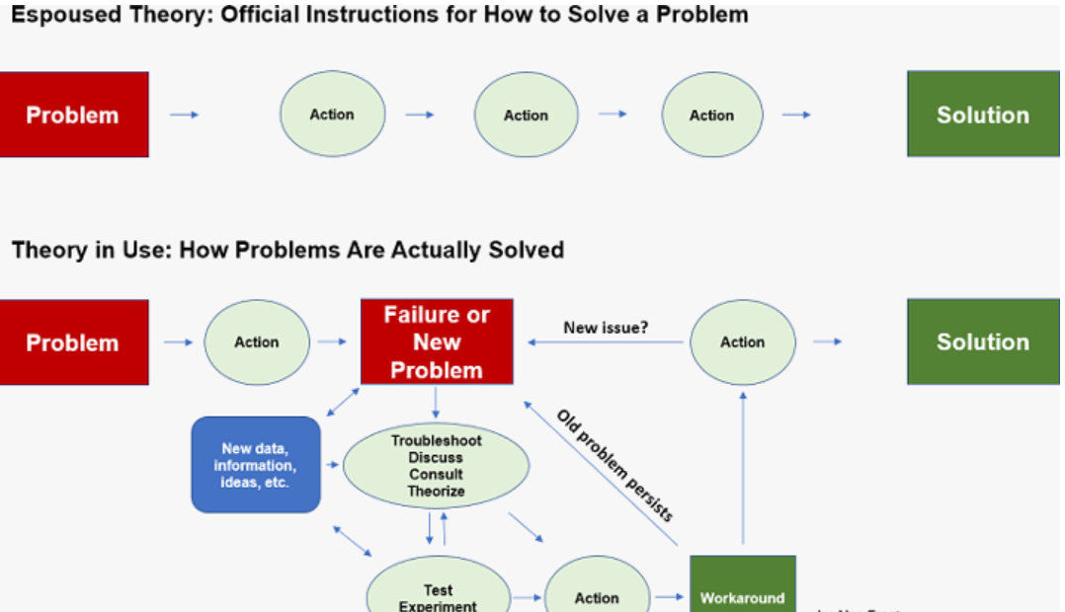
Fig: Theories and their uses
(Source: Lam et al., 2021)
The organizational learning theory also helps employees to develop their knowledge continuously based on the history of data and target-oriented data. Employees can easily get detailed knowledge about the current challenges and work upon it to lower the issues and also make a systematic procedure for maintaining a stable working environment. It also provides a comprehensive benefit to Amazon in improving their working standard and making employees capable of understanding the primary objective of the management information system. The management information system also helps Amazon to enhance the Synergy and also turns the outcome of information to customers through advertisement (Lee et al., 2020).

4.0 Different steps and prerequisites for good management practices
Amazon is an American Multinational E-Commerce company and also one of the leading online retailers in the global market. The organization is offering cloud computing services and Technology is considered one of the primary objectives for the growth of the business and also integrating appropriate customer relationship management. Linux is one of the core strengths behind the technology of Amazon and the organization is incorporating different strategies like ERP for understanding the consumer requirement. Amazon also exposed several threats of sorting and securing the credit card and debit card information of thousands of customers in a day. The organization also tries to maintain proper customer relationship management by incorporating different strategies including understanding customer Trends (Islam and Widen, 2021).
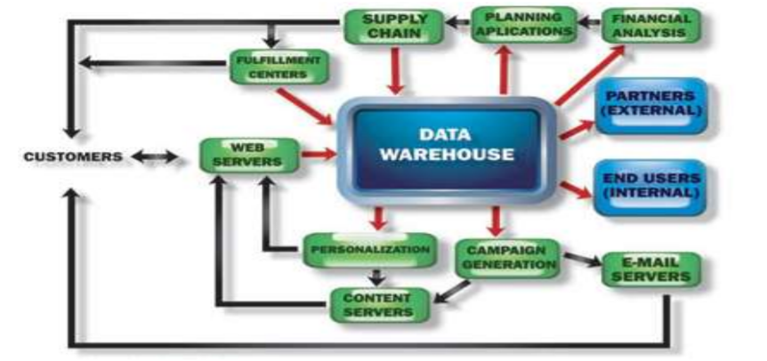
Fig: Data Warehouse of Amazon
(Source: Islam and Widen, 2021)
The sales strategies of Amazon are very unique which reflects its MIS. The operation activity of the organization is based upon a single-level sales strategy. The initial growth of the organization is favoured by the consumer model. The recent development of e-commerce activities also helped the organization to interact with consumers freely and resulted in understanding the ongoing Trend and changes of customer preference. The business model of Amazon also reflects upon the management information system where MIS plays a pivotal role. Elastic cloud computing is one of the vibrant web servers that is offered by the organization and the objective is to develop the working activities. E2C is the primary attractive feature of Amazon which can save more time unemployed can easily ignore additional challenges and their working activity.

Acquisition of Customer Shipment address:
Customers are requested to offer the shipping address to whom the product has been sent. In some cases, it is identified that customers order the product from Amazon and in case they can retrieve their shipping address that has been saved in the registration time. The retiring option also addresses the user to reduce the time involved in re-entering the address. It is also considered one of the time-saving methods and devices Amazon focuses on and also delivers the product without hampering the customer. Amazon also offers several options to their users in context to the shipping methods (Bahramimianrood and Bathaei, 2021). The organization also pays the customer for selecting the shipping method which is identified by the employee with the help of a management information system. The employees of the delivery and logistics department are responsible for understanding the shipment pattern and providing adequate service for retaining the customer. Moreover, the primary technology that is used by Amazon is web service which is one of the important parts of networking. Web service is also considered as the pillar of management information systems in the organization. Use this for understanding the requirements of customers and tracking the logistics. Furthermore, the technology also provides additional benefits to the organization because it is interconnected with vibrant relational data (Demir et al., 2021).
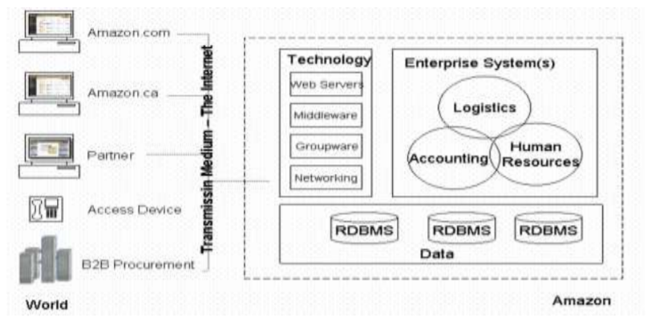
Fig: E-commerce privacy and security of Amazon
(Source: Demir et al., 2021)

Payment system offered to the customer:
The payment gateway system of Amazon it's to the debit card and credit card information on their past purchasing. It means that customers are not required to input card information regularly. On the other hand, Amazon also provides a secure socket locker to store banking information. The employees are trained with high professional technologies under which the information of customers is kept confidential and protected under the consumer data act. The organization also maintains legal policies for ensuring the trust component of consumers. The primary part of Amazon CRM is the integration of a logistic system where the customer can easily contact the logistic members for tracking their product. The market strategy of Amazon reflects the preference behaviour and the product offered as per the requirement of the consumer. The organization is also used in marketing as a tool for collecting information of customers which can be used for marketing activities. The employees of Amazon use ERP packages for handling manufacturing, sales, administration, and logistics (Ahmad et al., 2020).
The business model of Amazon reflects the management information system and it is used by the employees to understand the ongoing changes and preferences of customers. The cloud computing system is considered one of the effective systems by which Amazon stores the data of consumers. The E2C application Amazon Store devices that are used on the internet and the interface help the employers to understand the volume of demand. On the other hand, the organization also uses data mining techniques for storing information about the products and services that are provided to customers. Feedback is considered one of the primary objectives underweight Amazon is focusing on. According to the CEO of Amazon, customer feedback helps in improving the business activity and also making the working standard productive as per customer demand. Providing better quality products to customers is the primary responsibility and the sharing of products by customers on social media is considered one of the second steps of promotion (Melati et al., 2020). Amazon also charges free to their prime customer which is also one of the attractive packages provided for retaining them.

5.0 Effectiveness of information management and culture in terms of effective customer relationship management
Ensuring anti-phishing intervention and organizing products
Amazon is required to have a good customer relationship for enhancing its logistic operation accordingly. The human resources are responsible for understanding the market and also expanding the business in unexplored markets. Moreover, the gathered data can be beneficial for the organization in understanding the purchasing trend of customers, and employees of Amazon can easily analyse the next potential market according to the demographic. The growing population and the pattern of customer shopping are changing rapidly where technology plays one of the pivotal roles. Currently, it is identified that consumers are more focused on social media and social media marketing is one of the effective ways of attracting customers. The segregation of customer preference is based upon the ethnic background where internet providers diversify and the environment for shopping (Al Mansoori et al., 2021). On the other hand, providing an exclusive web experience as per customer background also helps the organization to grow. Customers from different backgrounds get happy when the logistic employees communicate in their language.
Information of social networking and improve the website operation
Amazon is required to understand the synergy and implement different strategies for improving its business. Amazon has also incorporated a management information system for advertising and improving its sales. The social media platform is considered one of the growing platforms where every business organization focuses on promotion. The social media platform is diversified and Amazon is incorporating different Strategies for attracting customers. The E-Commerce business joint promotes their business based on the service provided to maximum customers. The positive feedback of customers is also highlighted in social media which helps in attracting customers toward their logistics and service. For the growth of the business, Amazon has Incorporated a better social networking profile which is also considered one of the effective ways in promoting their product (Epaminonda et al., 2020).
Ensure better consumer introduction and build customer relationship management
Amazon has successfully built a device customer relationship with the help of a positive logistic operational activity. Format any appropriate standard of business the organization also focuses upon marketing campaigns to understand the needs of consumers. The organization uses customer data for promoting their business and also offers new products as per the customer Trend. Acquisition of the market is not only the solution for Amazon. The organization also uses CRM techniques with the help of enterprise resource management solutions for improving human resource management. Despite this, Amazon has also Incorporated the CRM technique to track its business activities and logistic activities (Bahar et al., 2020). A key performance indicator is a primary objective that helps the organization to understand the success rate of the business every quarter. Key performance indicators also benefit Amazon for gaining from success on the market and also improvising the working standard of employees. The management information system is related to the success of the organization where key performance indicators motivate the employees for gaining success.
The organization also faces several difficulties in maintaining appropriate standards of sales and marketing activities. for improving the marketing activities, the organization focused upon management information system and together data about their sales are with the organization use ERP. ERP is considered one of the primary progress for the success of Amazon which also helps them in lowering the errors and pitfalls in managing their business. ERP is also considered one of the effective processes where the organization can easily understand the ongoing pattern and changing trend of consumers (Sohu et al., 2020).
Include virtual assistant and AI
Amazon started to use artificial intelligence in the system as a primary tool for upgrading the bonding between customers and employees. It is also one of the effective tools that help the organization for conducting a long-run business. Necessary changes are made based on the information gathered through the internet. Management information systems also help the employees of Amazon to understand the requirements of the market and communicate with the stakeholders accordingly. Amazon has started using intelligent virtual agents to understand the issues that are associated with the operation and logistics. The 24-hour chat service has been incorporated by Amazon to gather feedback from customers and respond based on product and service (Serenko and Bontis, 2021). Moreover, the supply chain management, operation management, customer relationship management, and human resource management of Amazon have collaborated as an intelligent virtual agent. The management information system started responding to the queries of consumers which is considered effective in growing the business. Despite this, the intelligent virtual agent also helps the business organization to cut the number of service costs.

6.0 Amazon potential knowledge management challenges
Knowledge management can be considered one of the most appropriate and efficient aspects for Amazon which can provide comprehensive benefit to the organization. Amazon performs business activities across different continents and interacts with a large number of consumers. Knowledge gathered from different past incidents and potential challenges which forced the organization to take necessary measures can also provide efficient support to the organizational infrastructure (Qandah et al., 2020). The organization has to manage available information and knowledge about different issues more precisely to access comprehensive benefits by exercising the knowledge. There are also several inconveniences on the way of utilizing knowledge management in Amazon.
Employees lack knowledge about knowledge management tools
The organization includes a large number of employees and individual workers who do not have similar workability or knowledge performance. Hence, the organization has to identify and choose between the employees for recruiting within the knowledge management. Employees and workers are also very inconvenienced to using developed and improved methods of knowledge management tools without appropriate knowledge. Amazon has to provide appropriate training and understanding about the knowledge management tool which includes time and capital investment.
Inappropriate uses of knowledge management
Knowledge management is very effective and appropriate for the development of Amazon and can also ensure better organizational sustainability. Using knowledge management without appropriate direction or insufficient information can create significant inconvenience for the organization. Rather than, inappropriate knowledge management can also detect organizational cash flow or workforce potential toward different directions and waste of resources (Fletcher et al., 2020).
Organizing and storing knowledge
Amazon performs business activities across different potential markets and a huge number of consumers across 13 countries. The knowledge gathered from organizational activities along with different strategic approaches required huge storage and accessibility. The knowledge management of any organization has to take issues more instantly and analyse them effectively to identify the most suitable approach for resolving them. Without appropriate storage and organization of knowledge can create major inconvenience for the organizational employees or workers to associate effective knowledge management approaches. It will also enhance the performance of the employees' workforce and emphasize long sustainable business growth.
Uses and methods of utilizing knowledge management
Knowledge management is very effective and supportive to develop new standards of organizational activities as well as providing a useful platform for the growth of the brand. Though Amazon cannot depend on knowledge management for the resolution of every issue or expect every potential opportunity performed by the knowledge management during any critical issue. The use and approaches of knowledge management mostly depend upon individual workers and their creative and innovative skills. Amazon can face major issues regarding the abilities of workers managing the segment.
The above-mentioned challenges are the most common and effective issues which can cause difficulties for Amazon. Knowledge management can be considered one of the most effective strategies to incorporate different approaches and resolve various critical issues. Amazon has to concentrate on effectively maintaining the performance of individual employees associated with knowledge management and the appropriate organization of data (Ghalavand et al., 2020).

7.0 Recommendation for strengthening knowledge management practices
The organizational learning theory is very effective and appropriate for developing appropriate standards of knowledge management practices. The theory is also efficient for supporting organization requirements and achieving better success by fulfilling the objectives. The organizational knowledge management theory is also one of the most popular and effective knowledge management theories which can be used by Amazon for developing better opportunities. The organizational knowledge management theory includes ecological and technological knowledge management approaches. Ecological knowledge management mostly concentrates on the performance and interaction of human resources as well as analysing the information around the consumers. Where the technological knowledge concentrates on organizational performance and different instruments used within the organization. Amazon must incorporate information and knowledge across different levels and areas of action (Al-Emran et al., 2020). The availability of different strategic approaches and various perspectives allow Amazon to gain more flexible opportunities of understanding and evaluate the problem. Knowledge management can also provide comprehensive benefits to the organization by incorporating better creative and innovative approaches. Analysing the performance and growth of individual workers can also allow Amazon to incorporate the most suitable individual worker for the use of knowledge management in context to the organizational development. Knowledge management also provides a brief opportunity to the employees and workers to ensure better performance and inflict their abilities on the organizational infrastructure. The knowledge management including analysis and understanding of organizational stakeholders can provide a significant overview for including new changes or experimenting with different project works.
For enhancing the performance of knowledge management practices the Amazon can include several factors within the organization. Better training and appropriate understanding about the uses of knowledge management can significantly help the individual employees to gain appropriate measures of utilization. Apart from training and developing individual employees' abilities, the organization can also enhance the storage and organization of information based on different aspects. Cloud storage and technological devices are very convenient for storing and organizing different kinds of data with high efficiency. Including technological devices and smart instruments will help Amazon to sort and provide effective information instantly (Harb and Abu, 2020).
The employee's engagement and the standard of the employee's workforce also play a crucial role in the management and development of knowledge utilization. The appropriate engagement of individual employees and the workforce can effectively develop better standards of knowledge management. Facilitating collaboration and sharing knowledge across different levels of organizational positions can also ensure better accessibility of knowledge management. Sharing knowledge across different organizational positions also improves the relationship and bonding between different teams and team members. Creating a supportive organizational culture with innovative hydrology can significantly improve the approaches of knowledge management and the abilities of the segment to support organizational performance (Pham et al., 2020). Amazon can increase the endurance of knowledge management by emphasizing individual abilities and appropriate management of information according to different aspects beneficial for the organization.

8.0 Conclusion
Knowledge and information management can be considered one of the most effective and crucial components of any business or organization which can provide comprehensive benefits to the organization. The study described different aspects of the potential influence of knowledge management in context to Amazon and its activities. The study also elaborates on organizational learning theory and organizational knowledge management theory. The comparative analysis of both theories ensures a better understanding and improves the performance of organizational approaches regarding knowledge management. Identifying different issues faced by Amazon and evaluating appropriate measures for approaching the issues has also collaborated in this study. Effective knowledge management and appropriate uses can significantly help Amazon to gain better opportunities across different segments of organizational performance.
Task 2: Poster
Introduction
The study is based upon the management information system and how it provides potential benefits to Amazon regarding their growth of business and also maintaining appropriate standards of customer relationship management. E-Commerce is considered one of the growing progress where Technology plays a pivotal role. Amazon has started using ERP tools for gathering detailed information about customer requirements and providing products as per them. The study also provides additional challenges that are faced by the organization and how they are incorporating different strategies following the issues of challenges.
Amazon Information management and its uses
It is necessary to understand the importance of the management information system that is used by Amazon for interacting with customers and also returning them. Amazon reflects its success based on the achievement of their goal and how they are retaining their customers. Amazon started using a management information system which is considered one of the integrated ways for bringing the Synergy in between the information system and customer. Amazon is continuously growing its business and started incorporating organizational learning theory to understand the operational activity. The theory in use is considered one of the typical advances that are used by Amazon to understand the problem and incorporate new steps in different processes for getting appropriate solutions. It is considered one of the progressive ways by which the organization can easily improvise the feedback loop and take a strategy for modifying their working activities (Sahibzada et al., 2021). Amazon also follows the double loop planning system which is incorporated in the change in theory in use. It provides a comprehensive understanding of the necessary steps that should be taken by managers before entering a new market. The HRM is responsible for understanding the market and targeting the market according to the trend of the business.
Customer acquisition on shipment address
The primary issue that is faced by logistic service is the continuous changes of address by the customer. It is considered one of the ongoing problems that are faced by Amazon. According to the management information strategy, customers are required to offer a specific address where the logistics service will be given and the shipment will be done in time. The continuous changes of address may result in facing difficulty for the logistic service and can be also considered one of the major drawbacks for Amazon (Nyame et al., 2020). For improvising shipment standards, the organization has integrated enterprise Resource Management. The technology used by Amazon comprises web service which is also considered as the primary pillar of management information system.
Offered payment system
The primary part of Amazon CRM is integrating the logistic system and also communicating with customers regarding their payment procedure. It is identified that Amazon started using Netscape secure server as a tool that is helping the organization in securing the banking information of consumers. Moreover, the data cannot be used by any employee and it is safeguarded with cloud-based software. The marketing strategy of Amazon reflects upon the behaviour and preference of consumers and based on the changes the organization provides the necessary service. In shipment logistics, consumers can easily track their product by logging in on the Amazon website and entering their order number or Identity number (Manesh et al., 2020). In the case of payment criteria, the organization follows both debit Card and credit card facilities for customers when the data are stored confidentially. Employees of Amazon also use the ERP tool for gathering detailed information about the logistic service and the current demand of customer.
Building customer relationships and understanding of preference
Customer relationship is considered one of the primary progress for increasing the business and also gaining profit from the market. Social media tools are considered one of the primary platforms for promoting the product and gathering feedback about the product. Amazon has also incorporated new strategies for improving the shopping nature of customers and also making them reliable to shop in the period of covid pandemic (Buntak et al., 2020). The covid-19 pandemic has disrupted the shopping nature of customers and customers seen focusing upon online delivery of the product. For a better understanding of the product, Amazon has started incorporating different strategies which include safe delivery of product indoor steps. It is one of the effective ways by which the organization is improving its customer base and demand for the product.
Uses of AI and virtual agents
Artificial intelligence system is considered as a tool that is used by Amazon for building good bonding with customers. It is also considered as a tool that is used for making a long run of the business and taking necessary steps for changing the business pattern as per future requirements. Despite this, supply chain management, operation management, and customer relationship management are incorporated as virtual agents for communicating with customers and also understanding the changing preference and tastes (Akinnuwesi et al., 2020). Social media is considered one of the important platforms from which Amazon can get detailed information about the requirements of customers and how the business standards are changing continuously.
Market Gaps and Sales activities of Amazon
It is also necessary to understand the market gaps where the management information system plays a pivotal role in standardizing the business activities. ERP tool is considered one of the primary tools for driving the success of Amazon. Implementation of intelligent virtual agents for Amazon is considered beneficial in context to the growth of the business. Social networking is based upon both virtual and non-virtual modes and also can spread business. It also provides a long-lasting emotional impression upon the customer's mind which attracts them to shop from Amazon regularly.
Conclusion
The study provides elaboration about the management information system of Amazon and how they are maintaining their supply chain management in context to the growth of the business. Management information systems also provided a major benefit to Amazon in creating a long-lasting emotional impression upon the mind of the customer. The study also focuses upon the necessary changes that should be done by Amazon for improving the business and also making their working activities stable after the impact of the covid-19 pandemic.

Reference List:
Ahmad, S. F., Shahid, M. K., and Syed, A. S. (2020). ROLE OF KNOWLEDGE MANAGEMENT IN STRATEGICALLY SUITABLE DECISION MAKING IN TELECOMMUNICATION SECTOR. EDITORIAL BOARD, 60.
Akinnuwesi, B. A., Odumabo, A., and Aribisala, B. S. (2020). Knowledge grid: An intelligent system for collaboration and knowledge management in Nigerian Universities. Data Science Journal, 19(1).
Al Mansoori, S., Salloum, S. A., and Shaalan, K. (2021). The impact of artificial intelligence and information technologies on the efficiency of knowledge management at modern organizations: a systematic review. Recent Advances in Intelligent Systems and Smart Applications, 163-182.
Al-Emran, M., Mezhuyev, V., and Kamaludin, A. (2020). Towards a conceptual model for examining the impact of knowledge management factors on mobile learning acceptance. Technology in Society, 61, 101247.
Bahar, N., Wahab, S. N., and Rahman, M. (2020). Impact of knowledge management capability on supply chain management and organizational practices in the logistics industry. VINE Journal of Information and Knowledge Management Systems.
Bahramimianrood, B., and Bathaei, M. (2021). The Impact of Information Technology on Knowledge Management in the Supply Chain. Journal of Social, Management and Tourism Letter, 2021, 1-11.
Buntak, K., Kovačić, M., and Martinčević, I. (2020). Impact of digital transformation on knowledge management in organization during covid 19. Advances in Business-Related Scientific Research Journal, 11(1), 36-47.
Demir, A., Budur, T., Omer, H. M., and Heshmati, A. (2021). Links between knowledge management and organizational sustainability: does the ISO 9001 certification have an effect?. Knowledge Management Research and Practice, 1-14.
Epaminonda, E., Chaanine, J., Vrontis, D., Thrassou, A., and Christofi, M. (2020). Information communication technology, knowledge management, job and customer satisfaction: a study of healthcare workers in Lebanon. Journal of Knowledge Management.
Fletcher-Brown, J., Carter, D., Pereira, V., and Chandwani, R. (2020). Mobile technology to give a resource-based knowledge management advantage to community health nurses in an emerging economies context. Journal of Knowledge Management.
Ghalavand, H., Panahi, S., and Sedghi, S. (2020). Opportunities and challenges of social media for health knowledge management: A narrative review. Journal of Education and Health Promotion, 9.
Harb, Y., and Abu-Shanab, E. (2020). A descriptive framework for the field of knowledge management. Knowledge and Information Systems, 62(12), 4481-4508.
Hock-Doepgen, M., Clauss, T., Kraus, S., and Cheng, C. F. (2021). Knowledge management capabilities and organizational risk-taking for business model innovation in SMEs. Journal of Business Research, 130, 683-697.
Islam, M. A., and Widen, G. (2021). Bibliometric analysis of the VINE Journal of Information and Knowledge Management Systems: 2000–2020. VINE Journal of Information and Knowledge Management Systems.
Jarmooka, Q., Fulford, R. G., Morris, R., and Barratt-Pugh, L. (2020). The mapping of information and communication technologies, and knowledge management processes, with company innovation. Journal of Knowledge Management.
Lam, L., Nguyen, P., Le, N., and Tran, K. (2021). The relation among organizational culture, knowledge management, and innovation capability: Its implication for open innovation. Journal of Open Innovation: Technology, Market, and Complexity, 7(1), 66.
Lee, C. S., Yew, L. Y., Chew, P. L., Chee, Y. K., Hiew, Y. T., and Wong, J. P. (2020, July). Information Science-Knowledge Management-HCI-Project Management-CRM Models-Software Processes. In International Conference on Computational Science and Its Applications (pp. 797-811). Springer, Cham.
Manesh, M. F., Pellegrini, M. M., Marzi, G., and Dabic, M. (2020). Knowledge management in the fourth industrial revolution: Mapping the literature and scoping future avenues. IEEE Transactions on Engineering Management, 68(1), 289-300.
Melati, C., Janissek-Muniz, R., and Curado, C. M. M. (2020). Decision-Making Quality of Public Managers: Contributions from Intelligence and Knowledge Management. Revista de Administração Contemporânea, 25.
Nyame, G., Qin, Z., Obour Agyekum, K. O. B., and Sifah, E. B. (2020). An ECDSA approach to access control in knowledge management systems using blockchain. Information, 11(2), 111.
Pham, Q. T., Pham-Nguyen, A. V., Misra, S., and Damaševičius, R. (2020). Increasing innovative working behaviour of information technology employees in Vietnam by knowledge management approach. Computers, 9(3), 61.
Qandah, R., Suifan, T. S., and Obeidat, B. Y. (2020). The impact of knowledge management capabilities on innovation in entrepreneurial companies in Jordan. International Journal of Organizational Analysis.
Sahibzada, U. F., Latif, K. F., and Xu, Y. (2021). Symmetric and asymmetric modeling of knowledge management enablers to knowledge management processes and knowledge worker productivity in higher education institutes. Journal of Enterprise Information Management.
Serenko, A., and Bontis, N. (2021). Global ranking of knowledge management and intellectual capital academic journals: a 2021 update. Journal of Knowledge Management.
Sohu, J. M., Tian, H., Rahoo, L. A., Dakhan, S. A., Soomro, H. A., and Naveed, H. M. (2020). Feasibility Study of Knowledge Management Establishment in Private Degree Awarding Institute of Pakistan. IJCSNS Int. J. Comput. Sci. Netw. Secure, 20(12), 177-183.


