Samantha McGrath
2247313
Surface Patterns & Textiles
Module: ADAD4018 Ways of Thinking
*Written in American English

Task One: Manifesto = 548
Task Two: Semiotic Analysis = 519
Task Three: Practice-Based Writing = 547

Task One: Manifesto

- Embrace change. You are not living if you are not changing.
- Do not be afraid to try something new. We do not know if we are doing something the best possible way if we never try other options.
- Be comfortable with the process. The end goal is not always the be-all and end-all.
- Look beyond the surface. A large portion of our opinions are developed at-a-glance. We must look deeply before forming a true opinion.
- Quality over quantity. In today’s consumeristic culture we must find value in what we already have.
- Do not be wasteful. If we want the work to be lasting, our planet must also be lasting.
- Art is not just a job, but a lifestyle. Our lives should reflect our art process and outcome.
- Authenticity is invaluable. Do not forget it.

2. Do not be afraid to try something new. We do not know if we are doing something the best way possible if we never try other options.

To try something new is to explore new options. Not just in the art world, but in the world as a whole. Expanding perspective and exploring other options allows an individual to find what works best for them. This statement can be applicable to any facet of life. John Stuart Mill in his book On Liberty (1859), states “A general State education is a mere contrivance for moulding people to be exactly like another” (1859, p. 190). He continues to explain that this allows the government to mold citizens into whatever the government wants them to be. With this, the general population becomes identical to one another, therefore becoming expendable. While this argument is intended for general education over a population, this can be applicable to any topic. In art, if we are not exposed or allowed to explore other options and methods of creating, then no new art would be created. Artists themselves would become expendable. What joy can be found in something if you never learn something new.

5. Quality over quantity. In today’s consumeristic culture we must find value in what we already have.

The belief that one can never have enough “things” is constantly pushed upon society. Every advertisement, commercial, and magazine’s main objective today is to tempt people to purchase new products. However, the consequences of our spending habits have quickly caught up to us. In addition to an excessive number of products, the frequency these products are bought at are increasing each year. It appears that as production speed increases, the product quality decreases. In the book Entrepreneurship Development and Opportunities in Circular Economy (2020), author Neeta Baporikar describe this phenomenon as planned obsolescence, explaining how companies now make it so “products are planned and designed with an artificially limited useful life so that the consumers change their products frequently” (2020, p.64). Focusing on the quality of products not only prevents excessive waste, but also saves more money. In today’s economy, when the sole goal for consumers is to spend as much as possible, many have found themselves struggling financially with how often and how much they must buy. Majority of the time, what we already have will suffice.

7. Art is not just a job, but a lifestyle. Our lives should reflect our art process and outcome.

Throughout history, art has been apart of everyday life, a necessity for survival. If one was to view art in a more obscure and less definitive way, they would realize that art is everywhere. It’s not just in our museums, galleries, and in frames, but in our morning routines, our clothes, our lives. Art as a whole, is much more nebulous than we might think. In a looser definition, art can be seen as something to be appreciated for its beauty. While beauty is not the inherent purpose of our existence, it is something that we often strive for in every aspect of our lives. For example, our clothing is not just for covering ourselves anymore, nor is it only seen as something nice to look at. It is something that sends a message to those perceiving us, a statement of who we are. Stella Bruzzi and Pamela Church Gibson explain this in their book Fashion Culture; Theories, Explorations, and Analysis (2000), discussing the belief that “Fashion is an intrinsic part of the performance of urban life” (2000, p. 11). Boldly stated, fashion is a performance, an art that influences one’s life. We are living art, in art, for art.

Bibliography
Baporikar, N. (2020). Entrepreneurship Development and Opportunities in Circular Economy.
Hershey, PA, IGI Global.
Bruzzi, S. and Gibson, P. C. (2000). Fashion Cultures; Theories, explorations, and analysis.
London and New York, Rutledge.
Mill, J.S. (1859). On Liberty. London, J.W. Parker and Son.

Task Two: Semiotic Analysis

Semiotics have been incredibly influential in society for thousands of years. Before written language, we used symbols and pictures to convey our messages. With semiotics, we are able to communicate with one another, passing on messages and stories to new generations. Context of what was occurring at the time of the creation of the image does, however, denote more specifics without any blatant explanation.

Based on background knowledge, the observer can make associations with the image/performance. Roland Barthes uses wrestling as an example in his book Mythologies (1957). He explains how through wrestling a sort of story being told, “that in America wrestling represents a sort of mythological fight between Good and Evil” (1957, p. 23). Through performance a story is told to the audience. It is not only the action itself, but the response that it evokes, how people perceive it.
Elements of Sociology explore.

While interpretation may be vague in some instances, the overall message can typically be depicted. As previously mentioned, within certain pictures more context is necessary. Barthes also discusses this in his book Elements of Sociology, explaining how “the language is elaborated not by the ‘speaking mass’ but by a deciding group” (1964, p.31). Only those with the relevant prior knowledge really understand the core message. The social and historical context of an image can change an image’s meaning depending on the viewer. In her book Visual Methodologies Gillian Rose discusses by using historical photos in books as an example. Rose discusses the setup of these images, and how in certain images that explore “the importance of visual images to postmodern culture” (2007, p.17), one must have relevant previous knowledge to understand the images’ significance. The current state of the world shapes the audience’s response, and “To analyse images through this lens you will need to understand contemporary economic processes in a synthetic manner” (2007, p. 17). The message of the photo is lost without background knowledge, and therefore so is the purpose of the image.

The automobile manufacturer Fiat released a campaign in June of 2010 in France consisting of two adverts. One image included a black bear in a fluffy polar bear costume, while another followed the same format with a black panther in a fluffy brown bear costume (see Fig. 1). The advert exudes a playful sense of danger, with the panther seemingly in the process of taking the bear costume off. Teddy bears are associated with softness, childhood, and innocence. The representation of the panther stripping the consume off, is the implication that underneath, there lies something more dangerous, and therefore more enthralling and thrilling. The advert’s only text besides the company name is “Black Jack: Reveal Your Dark Side”. The purpose of the text is to confirm to the viewer the response the company wants to evoke a feeling of risk, something often associated with adrenaline. They are telling someone that the car itself is fast and sleek, both associated with adrenaline, but is hidden under a not so dangerous appearance. The car is a force to be reckoned with hidden under a soft exterior, just like the panther.

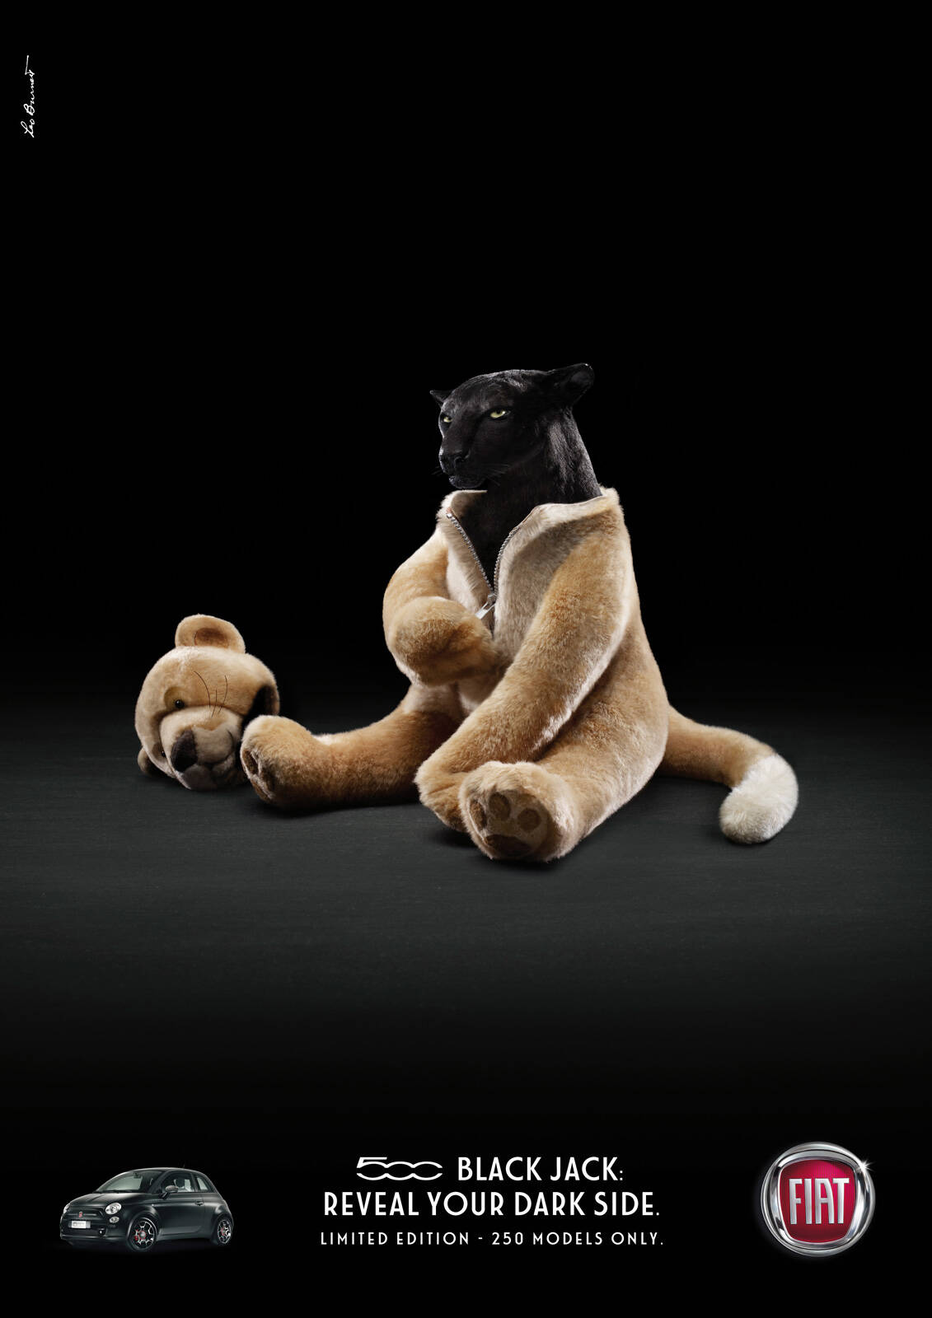

Fig. 1 Black panther, Black bear, FIAT Advertising Campaign, 2010

Bibliography

Barthes, R. (1964). Elements of Sociology. New York, Hill and Wang.
Barthes, R. (1957). Mythologies. New York, Hill and Wang.
Rose, G. (2007) Visual Methodologies. London, Sage Publications.

List of Figures
Figure 1: Black Panther, Black Bear, FIAT Advertising Campaign, (2010) Accessed:
https://www.adsoftheworld.com/campaigns/black-panther (Accessed 2nd December 2023)

Task Three: Practice-Based Writing
Word: Clothing
Adjective: Durability

Our clothing goes through everything we do. Due to this, the durability of our clothing is essential. The Merriam Webster Dictionary (2024) defines the word durable as “able to exist for a long time without significant deterioration in quality or value”. How long our clothing can last determines how often we need to buy more. The lower quality our clothing is, the more often it is likely break, tear, and become discarded, usually ending its lifespan in the landfill.

I observe certain brands that were originally intended to be worn as workwear, now being worn as “fashion pieces” and statements. Brands such as Carhartt, Dickies, and Levi’s increasing in popularity among the fashion community for not just their style, but also for their durability. This can be beneficial to the environment as people are less likely to buy products from these companies as frequently as they might have from others because these products are much stronger than before. In February 2020 Sara B. Marcketti and Elena K. Karpova explained it best in The Dangers of Fashion: Towards Ethical and Sustainable Solutions, declaring “The easiest strategy to reduce the waste is not to generate it. With respect to fashion, it means reducing the demand for new clothes” (p.225). Since these brands’ original audience were blue collar workers, those whose jobs required clothing that could handle the wear and tear of their profession, they were made to last.

Another main issue with the current clothing crisis and its effects on over production is that clothing is viewed differently today. Anastasia Denisova discusses this point in her book Fashion Media and Sustainability, stating “Consumers look at the symbolic meaning of a product much more than its practical value” (2021, p.9). Durable workwear brands have only now become fashionable to the public because the current silhouette and material of these clothes is in trend. The brands themselves have not changed much, but now people who have no true need for these specific clothes wear them just as much as the original audience they were intended for. W

In the arguments surrounding the clothing industry and its over production, the topic of synthetics fibers, particularly polyester, has become a big discussion. The rate at which we are making garments is a large issue. While natural fibers are best for the environment, too much of any fabric is a problem. However, tackling the issue of synthetic fibers is a start. Renewable fabrics that come from natural resources like cotton, hemp, and linen are all durable materials, when properly cared for, and can be remade with less environmental effects than non-renewable fabrics. These non-renewable fabrics contribute heavily to the landfills full of cloth, as they are not biodegradable. Sara B. Marcketti and Elena E. Karpova explore this point in The Dangers of Fashion: Towards Ethical and Sustainable Solutions, observing that “The ‘Take-make-use-dispose’ model of linear economy, in which products are usually disposed at the end of life” (2020, p. 82). Since these garments have been discarded in landfills without the opportunity to biodegrade, our chances of being able to reuse these materials is low. But by investing in stronger, more durable clothing made of renewable fibers we lower the impact we have in the long run, at least compared to what it could be.

Bibliography
Denisova, A. (2021) Fashion Media and Sustainability. London, University of Westminster
Press.
Marcketti, S.B., Karpova, E. E., (2020) The Dangers of Fashion: Towards Ethical and
Sustainable Solutions. London, Bloomsbury Visual Arts.
Merriam Webster (2023) Durable definition and meaning – Merriam-Webster [Website Merriam-
Webster] Available at: https://www.merriam-webster.com/dictionary/durable (Accessed 27th December 2023)
Shirvastava, A., Jain, G., Paul, J. (2020) Circular Economy and Re-Commerce in the Fashion
Industry. Hershey, PA, IGI Global.

