THE WAY WE LIVE NOW Evaluation Form

Name: Adonia Williams

Please evaluate your work in relation to the two criteria below.

FINAL WORK:
From the final edit of 6-10 images, select & insert what you consider to be the 3 images that most successfully demonstrate your response to the project title. Please evaluate how resolved the final work seems and explain the conceptual relationship between the work and the original title. (100-150 words)

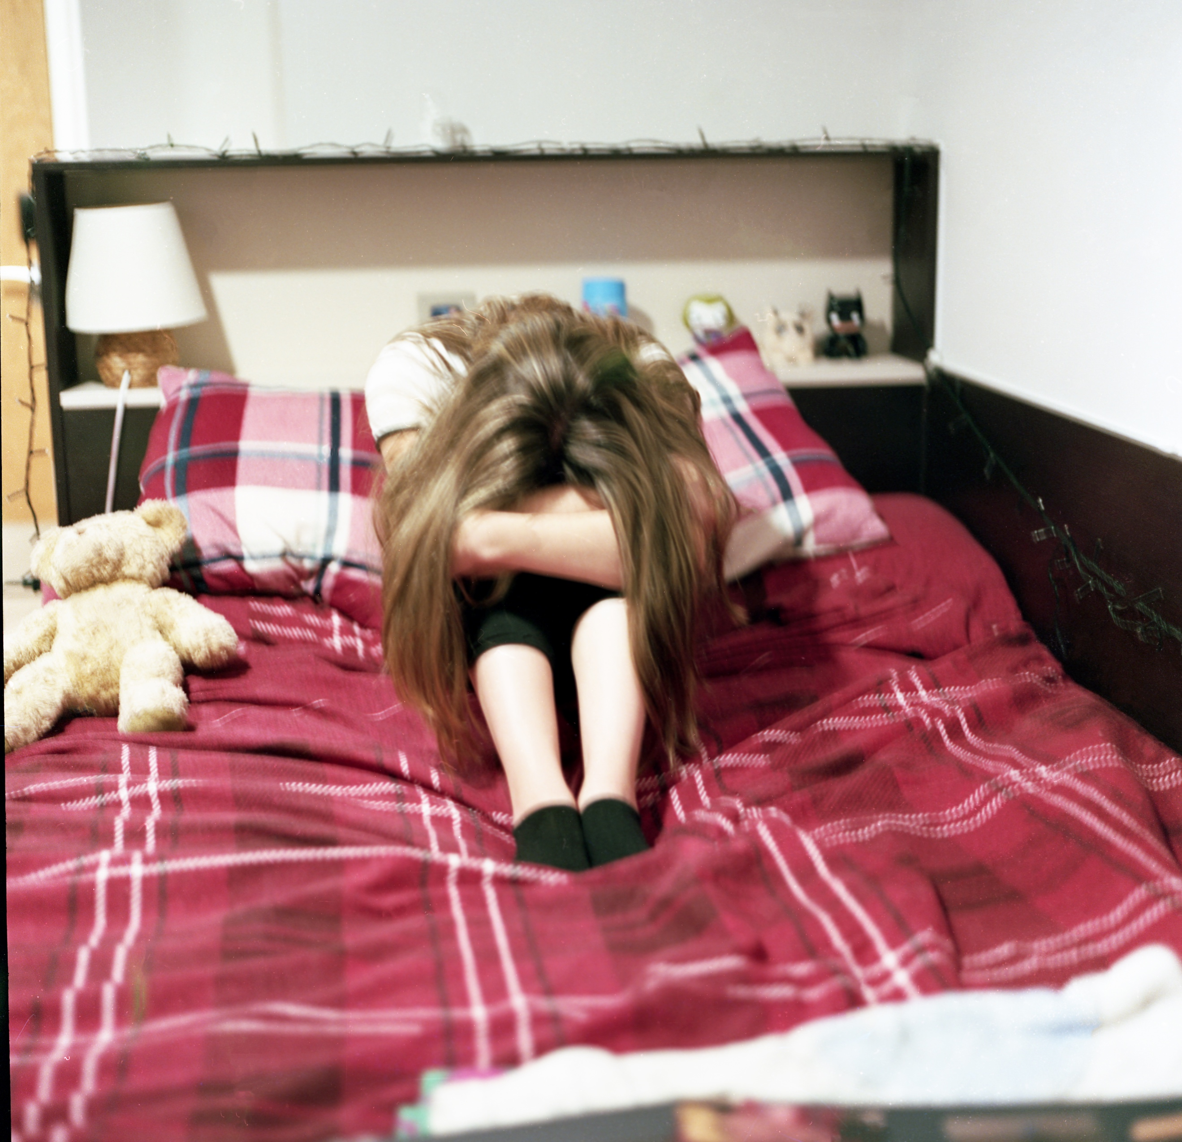
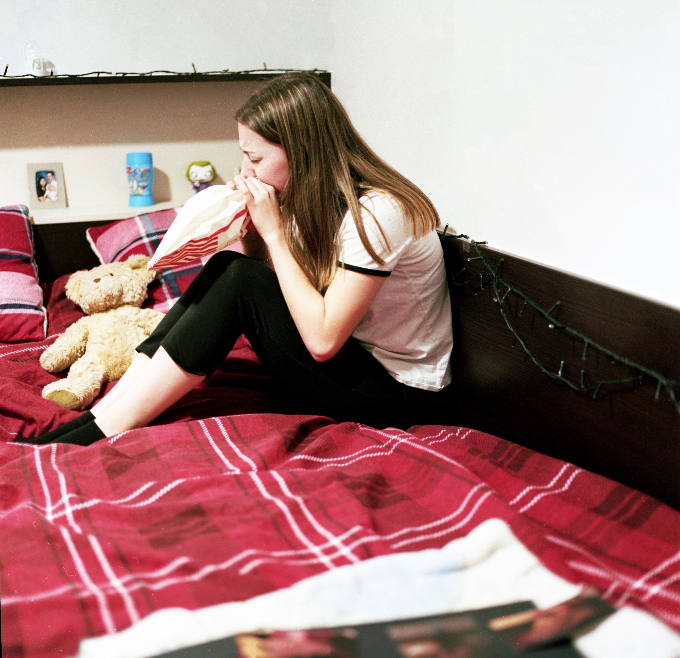
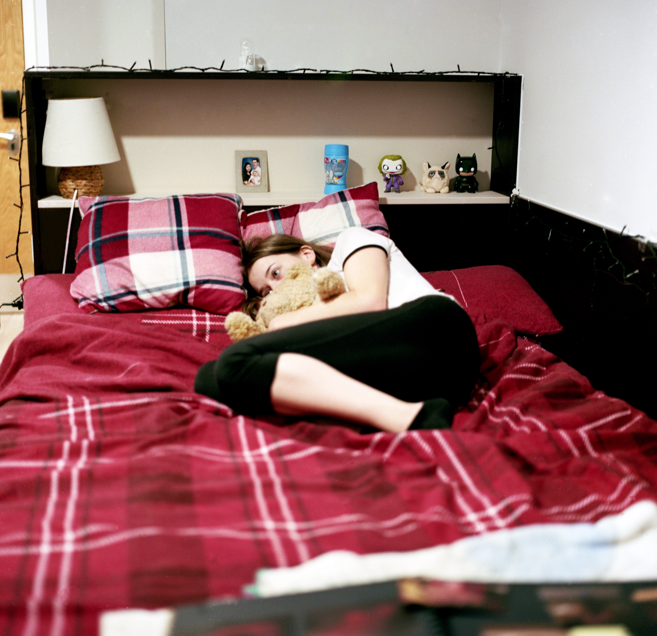

I believe that these photographs respond to the project title successfully as they express how such simple daily task of getting ready can be so difficult when suffering from mental health. These photographs document my morning routine that is part of the way I live now especially since I have been moved into different surroundings that has worsened my mental state. Personally the first image was the most successful as it looks more vibrant than the others which illustrates how even though everything around me is okay I struggle to see the positives. I came to the decision that these 3 images would be the photographs that I stitch into and make myself into a silhouette to allow people to be able to interact and put themselves in that position by not being able to see me.

RESEARCH:
Please identify the 3 pieces of research that have most influenced your project and discuss how they affected the development of your work. (100-150 words)

Edward Honaker
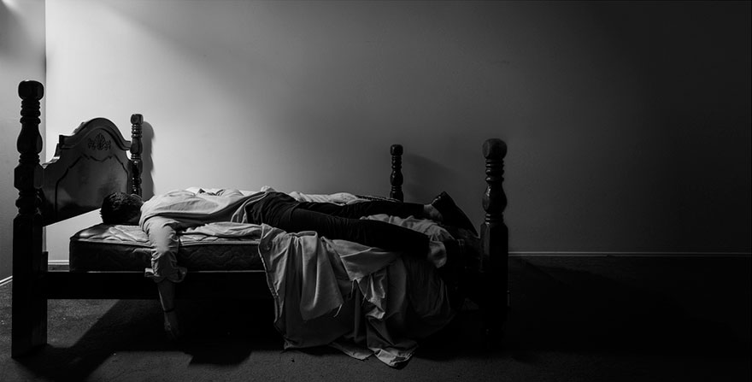
Initially I looked at Edward Honaker’s work as I found his photographs very relatable as he documents his depression. Honaker gave me the idea of showing my morning routine as that is when my anxiety is most prevalent and leaving the comfort of my bed is a struggle.

Gabriel Isak
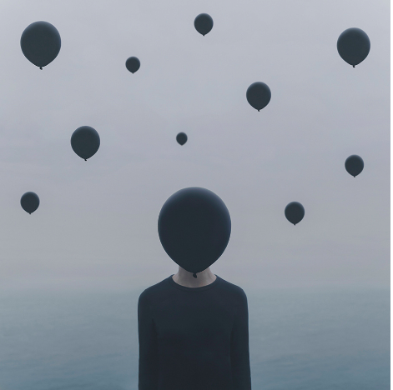
Gabriel Isak was the first photographer that influenced the beginning of my project as he took photographs based on his mood and locations and this gave me the idea that I could document myself in my room as that is the place I get most anxious.

Julie Cockburn
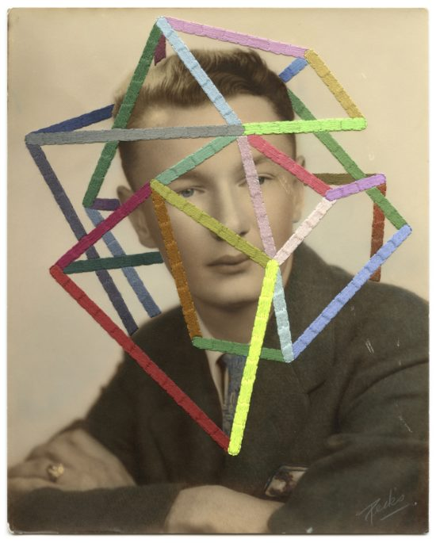

Julie Cockburn’s work was essential to help me establish that embroidery would be used in some of my final images. Cockburn’s pattern in the image above was used an inspiration for a stitch that was used in my final images.

PLEASE SUBMIT TO MOODLE BY 12 NOON ON MONDAY 3rd DECEMBER

