

EFFECTIVE TEAM WORKING AND
COMMUNICATION (H&Sc)
BMSW4002
Model of communication and the Communication skill
by
Olaniyi Toafeek Oladimeji
(2009509)

Course Lecturer: Diya Ganguly
2191 Words

April, 2021

Table of Contents
1.0 INTRODUCTION 3
2.0 MODELS OF COMMUNICATION 3
3.0 Shannon and Weaver (1948) 3
4.0 Shramm (1954) 4
5.0 Berlo (1960) 5
6.0 COMMUNICATION SKILLS 6
6.1 Verbal Communication.............................................................................................................6
6.2 Non-Verbal Communication......................................................................................................6
6.3 Listeng Communication.............................................................................................................7
6.3.1 Active listening …………………………………………………………………………………………………………………..7
6.3.1 Empathetic listening…………………………………………………………………………………………………………...7
7.0 Case Study Context of Poor communication at Work place…………………………………………………….7
8.0 Poor communication……………………………………………………………………………………………………………….7
8.1 Case of study of Mark and engineer (David)……………………………………………………………………………8
9.0 CLOSING REMARKS..............................................................................................................….8
10.0 REFERENCES..........................................................................................................................9
11.0 APENDIX 1………………………………………………………………………………………………………………………….10
12.0 APENDIX 2………………………………………………………………………………………………………………………….11

INTRODUCTION
This paper is a report on a study based on information from secondary sources on effective team working on communication. The key issues are communication models and skills. Foss (2008) speaks of communication as the process by which information and common understanding are transmitted from one person or source to another. As the term implies, communication serves as a tool through which understanding, feelings, ideas and thoughts are created and exchanged between a sender and a receiver. Constructing and sustaining relationships, whether at home or at the workplace, are greatly facilitated by communication. From the above definition of communication, the most important elements therein are the sender and the receiver. The communication process therefore involves the sum of all the actions things involved between transmitting and understanding the information between the sender and the receiver (Miller, 2005). In clearer terms, below is a diagram by McShare et al (2003) depicting the communication process.
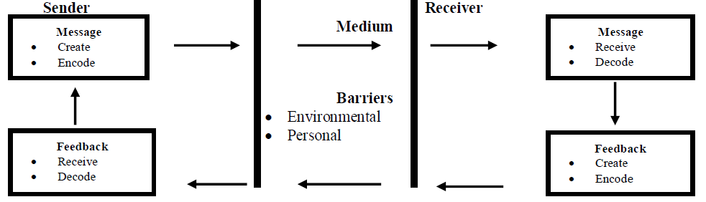
Nevertheless, a given communication process often suffers certain degree of barriers resulting from environmental and personal factors, says Canary (2011). Here, a barrier can be defined as anything that can have the message disrupted or distorted, any may include, disparate perceptions of the message, obstacles associated with language, interruptions, emotions, and attitudes, among others. In short lack of effective communication can really hamper the success of an organization (Craig, 1999; Lunenburg, 2010).

MODELS OF COMMUNICATION
Communication model is the pictorial depiction of the entire communication process. For a better understanding of the concept three communication models by Shannon and Weaver (1948), Schramm (1954) and Berlo (1960) are presented below.

Shannon and Weaver (1948)
The Shannon and-Weaver Model comprised five elements, namely information source, transmitter, channel, receiver, and destination. The information is safeguarded in the information source and sending forth the information requires encoding the message into signals for it to be transmitted through the channel to its destination. In the process it is recognized that the channel may carry some noise leading to the possibility of the signal getting an entirely disparate information from the source. The message is eventually said to arrive its destination after reaching the receiver and being decoded by the said receiver based on available signal.
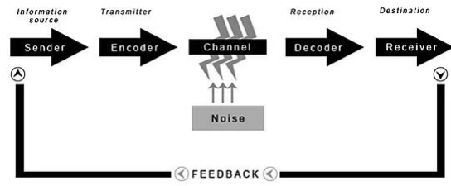

However, given the stage-by-stage process which the message goes through, from the information source, the transmitter, the channel, the receiver to the information destination, Shannon and Weaver contended that there may arise three levels of communication-related problems:
- "The technical problem: how accurately can the message be transmitted?
- The semantic problem: how precisely is the meaning 'conveyed'?
- The effectiveness problem: how effectively does the received meaning affect behavior?" (Schulz et al, 2013)
There is indeed a sense in the above concerns in the case, for example, of a telephone conversation between a couple, Pedro and Maria, Maria asked Pedro to get her a chicken on his way back from work. On entering the house from work, Pedro announced his arrive by asking his wife where she was, to which she replied that she was in the sitting room. When, thereafter, she demanded for the chicken, Pedro's reply was: "Oh, no! I thought you said when I come home, I will see you in the kitchen!"
Pedro's misunderstanding of what was demanded by Maria stems can be explained on the basis of the aspect of the Shannon–Weaver model which states that the flow of information being interfered with by noise or poor signal, or both (Schulz et al, 2013), thereby making "chicken" to sound like "kitchen." Since the most important thing in the communication process is for the intention of the sender be accurately decoded and understood by the receiver and given that there is the possibility of disruptive elements in the process of the Shannon–Weaver model, the situation could be avoided by Pedro making sure that he fully understood what Maria was saying either by asking her to repeat herself for emphasis or calling her back when the signal was clement.
Shramm (1954)
Propounded by Wilbur Schramm in 1954, the so-called Schramm Model is a two-pronged communication that is circular in nature that links a sender and a receiver. The model stipulates that a given message must be encoded before being transmitted through a medium to a receiver who will, in turn, decode it, in order to understand the content of the message. The model also stipulates that sender of the message must receive feedback from the receiver for the process of communication to be deemed complete.
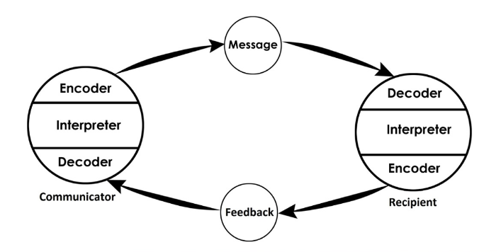

There is also the issue of field of experience in the Schramm Model, one that has to do with the extent to which such factors as experiences, environment and culture can impact on how a sender and receiver encode or decode a message. One striking thing about this aspect of the communication link between a sender and a receiver is that communication is very smooth if the two belong to the same field of experience.

Berlo (1960)
The Berlo’s model of communication involves the various segments of message, including content, elements, treatment, structure, and code. The model equally places importance on both the sender and receiver in a communication process. In addition, the model uses the SMCR approach in which S - Source; M – Message; C – Channel; R – Receiver; the source also called the sender is the one from whom the thought originates.
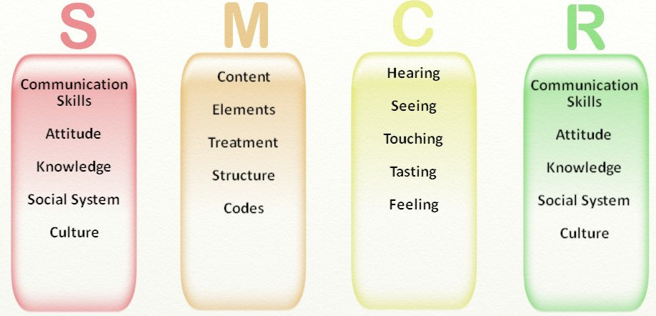

communication process, Berlo posits that source also known as the sender gives birth to the original information which he pushes to the receiver by having his ideas carefully converted into words. For Berlo the sender and receivers should share competence in communication skills, have common knowledge, comportment, cultural and social orientations for an ideal communication to take place between them. These factors are equally said to facilitate encoding and decoding (Bette, 1972). It is also to be noted that the model does not place emphasis on feedback, nor on barriers that could disrupt the flow of communication.
The above could be understood from the story told of a professor of English who lived near a village but did not interact with the villagers because they did not share much in common socio-culturally and professionally. But when one day his house was on fire and he ran into the village shouting severally "The edifice is being consumed by a great conflagration!", the villagers ignored him until the house turn to ashes. It is obvious the villagers ignored him, thereby refusing to help him because, as explained by the Berlo's model, they were not at the same level of academic and linguistic expertise with the professor and therefore were not able to understand his strange English diction. The professor should come down to their level by using ordinary words like fire and house.

COMMUNICATION SKILLS
Communication skills can be understood through two forms of competence. The first describes communication skills as the abilities used by someone to receive or send information (Cheney, 2011). The process of receiving or sending information necessitates the second definition of the skills, one that speaks of the term as the tools used by an individual to surmount the barriers hindering effective communication. Different types of communication skills exist, namely verbal, non-verbal, and listening skills.
Verbal Communication
According to Keyton (2011), verbal communication may be in written or oral form. We can therefore refer to verbal communication as an agreed-upon and rule-governed system of symbols or words used to share meaning (Hill, 1996).
Specifically, in the workplace, oral form of verbal communication is carried out among the members of staff particularly in such forms as face-to-face, interpersonal conversation, telephone discussion, public address lectures and conferences, among others. At the same time, the written aspect of verbal communication always comes in written forms and they serve many purposes especially as a means of conveying information people and audience in far away places. They also help in having information and records preserved or kept permanently and can equally come as instructions, rules and regulations, policies, posters, memos, reports, and bulletins, among others. Be that as it may, verbal communication skills (written or oral) have to do with the capacity of an individual to express his thoughts in an understandable and concise manner, and to be able to create or arouse focus, energy, and passion such express.
Non-Verbal Communication
Regarding non-verbal communication, a message or information is conveyed and, in most cases, understood without the use of words. That is why the term is also called "silent language" (Goman, 2002).it therefore involves the use of such non-verbal tools as gestures, cues, and facial expressions to convey a message between a sender and receiver. For instance, different context-specific messages can be conveyed by using either of a glance, frown, stare, or smile. In any of such cases the contextual meaning or significance of the message is grasped.
.
Listening Communication
Communicating effectively does not involve expressing oneself by spoken or non-verbal means, it equally involves listening to receive and understand what the message conveyed by another. Therefore, listening skills have to do with the ability of an individual to completely attend with honest intent the expression from another person (Burstein, 2010). Listening communication skills can either be active or empathetic.
Active listening
Active listening concerns an aspect of listening and makes someone to be engaged in a conversation with another positively. In this context, the listener pays complete attention to what is being said without interruption or challenging the flow of the speech being made (====). Also, someone with active listening makes the person speaking to him to feel heard and esteemed. In this way, active listening is the foundation for any successful conversation.
Empathetic listening
Emphatic listening is also known as reflective listening, and it concerns listening and responding to another person in such a way that mutual understanding and confidence are enhanced. It is an essential skill that enables a listener to receive and accurately understand the central theme of the speaker, thereby becoming able to respond appropriately.
Case Study Contexts of Poor Communication at the Workplace
Having discussed communication skills above it would be fitting to now show in real terms two cases of poor workplace-related communication. The cases correlate with certain theoretical frameworks related to communication in the literature.
Poor communication, in our environment, there are many poor communications around everywhere home, school or working place which often occurs when discrepancy between what someone said and what is heard in another words, the person being communicated to understands what you are communicate to them,
1) case of mark and engineer.
Mark worked for engineer and he did marketing for the engineer (David) David was very smart, but he had a very tough time communicating his ideas. David described the first step in building software as a wireframe, mark asked David what he meant. David said, so you do not know what a wireframe is? Mark replied no, I do not.
Seriously everyone knows a what a wireframe is’.
Both debated if wireframe is well known. he finally asked him what it was, and he said, ’it’s how you want your app to look on the screen. what do you want to see on the screen? cannot believe you don’t know that.’’
About a week later they went to a client’s office. He started telling the client that we needed to get his wireframe together.
The client stopped him and said, ’wait, stop. First I need to know……what ‘s a wireframe?’’.
David looked at mark as if saying ‘’I hate that you are right’’.
The root cause of this poor communication skill is because the engineer used jargon.
Jargon is when someone uses specialised words or vocabulary in speech or writing that is only known to a specific group, department, or industry.

The second case study concerns the manager of a water bottling company who did not pay attention in terms of active listening to the complaints and concerns of both his staff and customers. Usually, the customers' complaints were conveyed through the employees of the company. The manager's reasoning was that the members of staff were fond of complaining and that since the customers never complained to him directly, it was possible that the employees were either making bogus claims of the customers' complaints or they were simply exaggerating the minor concerns raised by the customers. After a while, when the customers observed that nothing was being done to take care of their grievances, they deserted the company for other companies. The workers also eventually walked away one after the other. Here, the so-called managerial grid theory by Crampton (1998) should have been adopted by the manager as it preaches the need for managers to be active listeners to motivate the workers to always contribute morally and practically towards the effective running of the company.

CLOSING REMARKS
During this report, we have explained the communication process using the various models to show how the process can be carried out effectively in the workplace. I have equally demonstrated the various communication skills and it is our hope that the practical application of the models and skills in the workplace based on context-specific requirements will lead to effective communication will lead to organizational growth and progress.

REFERENCES
Bette, A. (1972). Berlo's Communication Process Model as Applied to the Behavioral Theories of Maslow, Herzberg, and McGrego. Stead Source: The Academy of Management Journal, Vol. 15, No. 3 (Sep.,1972), pp. 389-394
Berlo, D. K. (1960), The process of communication; an introduction to theory and practice. New York:Holt, Rinehart and Winston.
Burstein, J. (2010). Have you heard?: Active listening. New York, NY: Crabtree Publishing.
Canary, H. (2011). Communication and organizational knowledge: Contemporary issues for theory and practice. Florence, KY: Taylor & Francis.
Cheney, G. (2011). Organizational communication in an age of globalization: Issues, reflections, practices. Long Grove, IL: Waveland Press.
Craig, R. T. (1999) Communication Theory as a Field: Communication Theory 9(2): 119–161.
Foss, K.A. (2008). Theories of human communication 9th edition, Belmont, CA:Thomson Wadsworth.
Goman, C. K. (2002) Cross-cultural Business Practices Communication World, 19:22-5 in Hargie, O., Dickson, D., Tourish, D. (2004) Communication Skills for Effective Management. Palgrave Macmillan. Hampshire.
Hill, L. (1996) Building Effective One-on-One Work Relationships Harvard Business School Technical Notes, 9-497-028, 1996 cited in Wertheim, E. G. (2005) http://web.cba.neu.edu/~ewertheim/interper/feedback.htm
Keyton, J. (2002). Communicating in groups: Building relationships for effective decision making (2nd ed.). Boston: McGraw-Hill.
Lunenburg, F. C. (2010) Communication: The Process, Barriers, and Improving Effectiveness Schooling Volume 1, No. 1
McShane, S. L., & Von Glinow, M. A. (2003). Organizational behavior: Emerging realities for the workplace revolution (2nd ed.). Boston: McGraw-Hill.
Miller, Katherine (2005). Communication Theories: Perspectives, Processes, and Contexts (2nd ed.).McGraw-Hill Higher Education. Schramm, W. (1954). How communication works. In W. Schramm (Ed.), The process and effects of communication (pp. 3-26). Urbana, Illinois: University of Illinois Press.
Schulz, Peter. Cobley, Paul. (2013). Theories and Models of Communication, Berlin: De GruyterMouton. 2013.
Shannon, C. E., & Weaver, W. (1949), The mathematical theory of communication. Urbana, Illinois: University of Illinois Press
http://www.steemit.communication.skill

Appendix 1

MARIA and PEDRO

Pedro works on a building site and Maria is his wife.
One day Maria phoned Pedro.
‘Hello, Pedro, when you’re coming home, see if you can get me a chicken.’
‘Okay,’ replied Pedro.
When he got home, Pedro took off his boots and coat and went into the kitchen.
‘Maria, where are you?’ He said.
‘Here – in the sitting room,’ she said.
When Pedro went into the sitting room, Maria said, ‘Where is the chicken?’
‘What Chicken?’ Asked Pedro.
The one I asked you to get on your way home.’
Oh, no! I thought you said when I come home I will see you in the kitchen!

Q: Why do you think Pedro misunderstood Maria?
Q: Whose Model of Communication explains this confusion and why?
Q: How could this have been prevented?
Q: Whose Model of Communication explains how it could have been avoided

Appendix 2

THE PROFESSOR and THE VILLAGE PEOPLE
A Professor of English at a well-known Welsh University lived in a large house not far from a little village. He never went into the village, bur shopped in the town near the University because he had nothing in common with the village people, who were largely uneducated and did manual jobs.
One night, the professor fell asleep while smoking his pipe and the pipe fell onto the carpet and started a fire.
When the professor awoke and saw the house on fire, he rushed into the village, screaming:
‘The edifice is being consumed by a great conflagration!’
‘The edifice is being consumed by a great conflagration!’
The village people looked at him and continued doing what they were doing
‘Don’t you understand?’ He said. ‘‘The edifice is being consumed by a great conflagration!’
They ignored him.
When the Professor returned home, he saw that his house had been completely destroyed. He sat down on the ground and wept.
The next day, he went into the village crying. ‘Why, oh why didn’t you help me? My home has been destroyed by the fire. I came and begged you last night.’ He wept.
‘But Professor, why didn’t you say that your house was on fire? We would have helped.’

Q: Why didn’t the village people help the Professor?
Q: What should he have done to get them to help him?
Q: Whose model of communication do you think can explain this situation?

