Module Title: Contemporary Themes in the Hotel and Hospitality Sector

Module code: BMIH6001

Conference Research Paper

TOPIC: ARTIFICIAL INTELLIGENCE IN HOSPITALITY AND TOURISM

Student name: Monica-Cristina Grigoruta
Student number: 2132111
Teacher name: Ernest Balutie Wavei

Table of Contents
Introduction 4
Literature review 4
AI Applications in the Hospitality Industry 4
Impact and importance of AI in the hospitality industry operations 5
Implication issues of AI in the hospitality and tourism sector 6
Possible solutions for better AI implication in the tourism and hospitality sector 7
Method 7
Data Collection Method 7
Data Analysis Procedure 7
Tools Or Frameworks 8
Theme impact analysis 8
Political 8
Economic 9
Social 10
Technological 11
Conclusion 12
Recommendations 12
Involving personalisation concerns through AI 12
Creating a Dynamic Pricing Concern 12
Conducting sentiment analysis and analysing the results 13
References 14

Introduction
In a modern digitised environment, AI is actively used in the tourism and hospitality industry operations to improve the quality of customer services, optimise the operations and cater to the personalised demands of the customers to ensure better attraction. Thus, with the help of AI, tourism-based task automation, real-time management and data updating, system optimisation and immersive travel experience development for customers are actively considered in the industry (García-Madurga and Grilló-Méndez, 2023).
The UK tourism industry is a constantly developing sector with an increasing number of tourism services in the operations. So far, the industry has achieved about 92% of the tourist visit rate before the pandemic. There is also a 3% increase in the number of tourists willing to stay longer and obtain the services of the UK tourism operations (Visit Britain, 2024). The current Consumer Price Index is also 21% higher than that of 2019 (Visit Britain, 2024). This indicates a steady growth in the UK hospitality and tourism industry after the pandemic. On the other hand, demand for AI-based tourism services is also increasing in the UK, as about 40% of consumers are using AI to plan for their holidays (PWC, 2024). Thus, in this assignment, the impact of AI has been critically evaluated on the tourism industry operations of the UK.

Literature review

AI Applications in the Hospitality Industry
Various applications of artificial intelligence can be observed in the industry of tourism and hospitality. The use of AI in personalised recommendations after analysing customer preference and previous encounters with the organisation can be considered one of the most popular usage methods at this time (Doborjeh et al., 2022). Here, Customers of the tourism and hospitality industry receive personalised recommendations on flight tickets, destinations and hotel suggestions along with activity suggestions during travel time which improve customer satisfaction level for organisations of these two industries. The utilisation of AI-driven chatbots has been observed in the hospitality sector at the global level as this AI tool assures 24/7 availability of customer services for any organisation in the hospitality sector (Calvaresi et al., 2021). On the other hand, the utilisation of virtual assistants can also be observed in this particular industry as virtual assistants are helpful to customers in conducting bookings and offering travel details to the customer effectively from the end of the hospitality organisation.
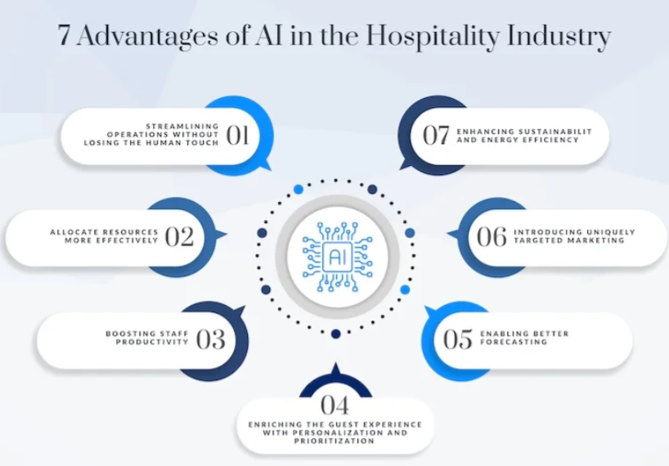
Figure 1: Advantages of the Hospitality Industry
(Source: Canarytechnologies, 2024)
AI is also helpful to streamline operations of the hospitality industry effectively as with the help of AI any organisation can design itineraries for its upcoming guests to provide them appropriate travel experience. AI is also capable of forecasting the visiting rates of travellers for a particular hospitality organisation based on analysing market conditions and previous data (Bulchand-Gidumal, 2022). Hence, this AI-powered forecasting process helps hospitality organisations to understand the level of customer influx before the peak season and can become prepared to handle the dynamic demands of those customers effectively.

Impact and importance of AI in the hospitality industry operations
Artificial intelligence utilisation has improved the decision-making capacity of hospitality businesses because now, these businesses could use predictive analytics to understand market changes and scenarios effectively. AI-operated automation has also reduced labour costs in many hospitality organisations which has improved the utilisation level of available resources of the brand by making them cost-effective (Zahidi et al., 2024). Hence, the cost-effectiveness of AI automation can be considered as the major importance of artificial intelligence in the domain of hospitality and tourism.
AI tools also benefited hospitality organisations by resolving customer complaints and overall organisation problems in a faster manner which has improved the overall satisfaction level of customers towards this industry (Lv et al., 2022). AI has also integrated innovation into the hospitality industry by availing advanced features such as virtual tours of a hospitality organisation, smart rooms, robotics as servers, and others (Verma et al., 2022). These are some crucial and innovative features that AI have successfully incorporated in a particular industry. Hence, in the present digitalised world, AI is given extreme value and preference in the hospitality sector.

Implication issues of AI in the hospitality and tourism sector
The implementation of artificial intelligence technologies can face the problem of high initial costs in the tourism and hospitality industry. This high initial cost problem can be observed in AI, such as robotics, smart systems, chatbots, and other popular technologies of this sector (Filieri et al., 2021). Hence, small and medium-sized organisations face the significant problem of investing so much capital in these technologies in the preliminary days due to financial constraints. The lack of skilled employees to handle new updated AI models and machines can be considered another implementation problem of artificial intelligence in the hospitality sector.
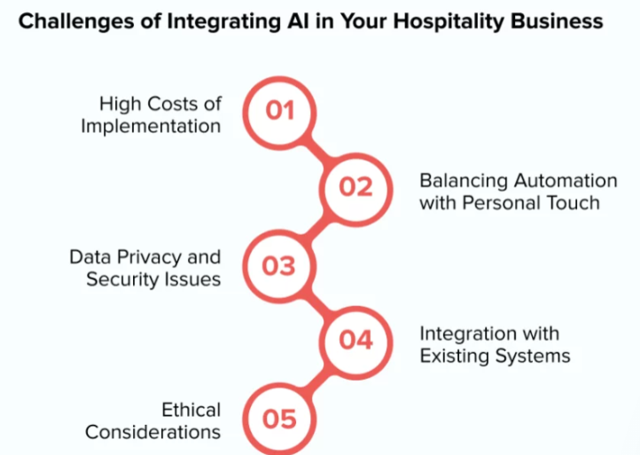
Figure 2: Challenges of Implementing AI in the Hospitality Sector
(Source: Appinventiv, (2024)
The AI system requires knowledgeable and trained professional people to enhance productivity and efficiency of work. On the other hand, after the popularisation of AI utilisation in the hospitality sector, the challenge of data privacy can be observed in this industry (Sawon et al., 2024). AI-operated machines are highly dependent on customer data, company details and other sensitive information which need to be protected from outsiders. However, with increasing numbers of cyber security attacks on different popular organisations of this industry to access sensitive customer and company information, challenges are rising in the use of this brand.

Possible solutions for better AI implication in the tourism and hospitality sector
The hospitality industry needs to train its employees by implementing compulsory training programs in order to establish AI-related knowledge and skills among these employees, which can reduce the chances of mistakes and resistance from the workforce. The implementation of robust security measures to protect customer data from cyber security threats can be a method of reducing the implementation challenge of artificial intelligence (Gaur et al., 2021). The organisation can also follow the domestic and international privacy regulations to avoid legal challenges in future.
The utilisation of AI solutions needs to be selected based on the compatibility of these solutions with the existing systems of an organisation to avoid misunderstanding and increasing complexity problems in the hospitality organisation. On the other hand, a stable balance between human interaction and automation needs to be created in an organisation to incorporate personalised customer experience at a premium level (Ivanov et al., 2022). These are the probable solutions that can be utilised in this industry to incorporate automation and artificial intelligence successfully.

Method

Data Collection Method
While analysing the utilisation effectiveness of artificial intelligence in the hospitality and tourism sector, this paper has selected and implemented the “secondary data collection” method. In the process of time and resource savings during a research process, the frequent utilisation of the secondary data collection process can be observed in the research field (Draper et al., 2021). Therefore, this process has been shown to have the most amount of preference in this analysis of the hospitality sector on the basis of AI utilisation.

Data Analysis Procedure
The application of the "thematic analysis" method to discuss the benefits and challenges of AI in the field of hospitality can be noticed here. The collected qualitative information on AI and its benefits and challenges in the hospitality and tourism sector has been evaluated thoroughly based on its real-time utilisation data along with the perception of customers (Mehraliyev et al., 2022). Therefore, the decision to analyse the accumulated information with the help of appropriate things looks significant in the study.

Tools Or Frameworks
In this study, the popular model named the "PEST framework" has been utilised in order to analyse secondary remission and data about artificial intelligence from the sectors of tourism and hospitality. This framework has been extremely critical for this paper to analyse different external factors, such as political factors, social factors, economic factors, and technological factors, sequentially (Zhao et al., 2023). These have provided the influence of factors on the AI utilisation process in the tourism sector in detail.

Theme impact analysis

Political
Condition
- UK political stability is currently rated at 0.514, which is considered moderate stability (Trading Economics, 2024).
- The government has provided £25 billion so far after the pandemic towards the economy of the sector (GOV.UK, 2023).
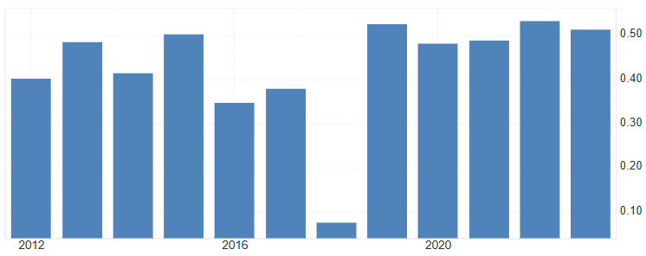
Figure 3: UK political stability index
(Source: Trading Economics, 2024)
Strengths
The UK government is significantly supportive towards the tourism sector of the country providing the sector strengths. The Tourism Recovery Plan considered by the UK government involves providing, tax and loan breaks that can help the industry develop internal financial strengths after the pandemic condition. For instance, the Furlough scheme considered providing £12 billion to the tourism industry to rejuvenate its operations in the region (GOV.UK, 2023).
Weaknesses
The reduced political stability in recent years is reducing the overall support of the government on tourism operations. The recent government also removed tax-free shopping from visitors from abroad which is in turn damaging the UK tourism operations (UK Parliament, 2024). Furthermore, a lack of thought from recovering from the Brexit condition can also be seen in reducing the profitability aspect of tourism operations.
Responses
As a response to the government's actions, the UK tourism industry is considering the expansion of travel conveniences to a multitude of external tourism operations. The industry is promoting visa-free travel agreements in several regions to improve internal travel accountabilities (UK Government, 2024). Further consideration is taken to simplify visa procedures for foreign tourists with the help of AI.

Economic
Condition
- The tourism sector contributed about £106 billion British pounds to the GDP of the country, which is less than the pre-pandemic period (Visit Britain, 2023).
- Spending by overseas tourists in UK tourism incensed to £2.4 billion by December 2022 (ONS, 2024).
Strengths
The main strength is that the demand for UK tourism operations is gradually increasing after the post-pandemic period. The overseas tourists had spent nearly £2.4 billion in the UK tourism operations as of December 2022 which is much greater than the previous year (ONS, 2024). This indicates that there is a growing demand for the industry.
Weaknesses
One weakness is that the demand for tourism operations is gradually decreasing, reducing its contribution to the economy. In 2022, UK resident's visits to tourism operations had decreased from 4.4 million to 4.0 million from the previous year (ONS, 2024). Thus, there is also a negative effect on the economy of tourism operations.
Responses
The UK tourism operations are responding to the economic issues by helping strengthen internal economic conditions. The sector has increased the marginal revenue of the employees working in the sector to £54000. To promote internal economic growth and strengthen internal contribution to the economy, AI-based training is also provided (Visit Britain, 2025).

Social
Condition
- After the pandemic, social demand for tourism in the UK has increased by 95% of than the pre-pandemic stage (Poncio, 2023).
- In 2024, the UK tourism sector catered to 38.7 million visits (Poncio, 2023).
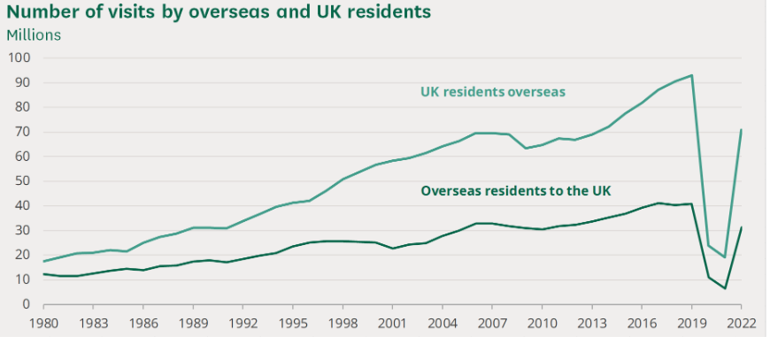
Figure 4: Number of visitors in the UK tourism sector operations
(Source: ONS, 2024)
Strengths
Despite not having fully recovered, the number of tourists and tourism-based social spending is gradually increasing in the industry. In 2024, approximately 38.7 million visitors took the service of UK tourism, which is about 95% of the last seen pre-pandemic stage (Poncio, 2023). Thus, there are significant chances of growth in the industry.
Weaknesses
It has also been found that tourism demand in the UK is highly price sensitive. On one hand, the recent pandemic has reduced the demand for tourism in an overall manner, from which the industry has not yet fully recovered (Foley, 2025). On the other hand, the increasing taxes considered by the tourists in modern operations are reducing international and local demand for UK tourism operations.
Responses
The industry is rethinking its visitor's expenditure considerations and coinciding making more benefits for international tourists and providing benefits to internal tourists (Jones, 2022). The companies are also considering partnerships with other international organisations to cater to increasing tourism demands through AI. For Instance, Jet2holidays is partnering with Marriott Hotels to ensure a collaboration of tourist inflow and accommodation contributing to the UK economy and customer satisfaction at the same time through AI integration (Jet2holidays, 2025).

Technological
Condition
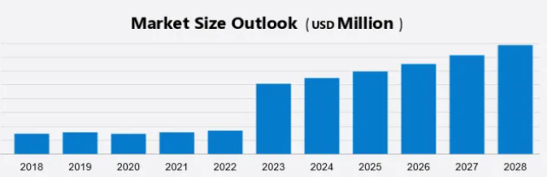
Figure 5: UK Travel technology market size
(Source: Technavio, 2025)
- UK travel technology market size is expected to reach 5.58 billion by 2028, with a growth of 9.16% CAGR (Technavio, 2025).
- 27% of the digital market business of the UK hospitality and tourism industry is subjected to cyber fraud (Wang, 2023).
Strengths
The technology inclusion consideration in the UK tourism industry is constantly increasing, paving the way for a better digital management operation. The travel technology market size in the UK is expected to reach 5.58 billion by 2028, indicating a significant improvement in the inclusion of technology in the market (Technavio, 2025).
Weaknesses
With the increasing inclusion of technology, the sector is becoming increasingly prone to cyber threats. About 27% of the industry operations are subjected to cyber-attacks (Wang, 2023). This can lead to data leakage and customer inconveniences, reducing customer satisfaction.
Responses
The tourism industry is developing cybersecurity policies and including security software to fend off the upcoming threat. For instance, Marriott has experienced cyber threats and has implemented proper AI technology to guard the RDP ports and include threat detection software for better customer service and satisfaction (Young, 2021).

Conclusion
Concluding on the proposed analysis, it can be said that AI application in UK tourism operations is of huge importance. Through the use of AI, the UK travel industry is promoting visa-free internal tourism operations, providing AI training to employees, managing accommodations and creating cybersecurity measures to ensure better management.

Recommendations

Involving personalisation concerns through AI
The tourism industry must consider more concrete personalisation accountability with the help of AI to consider a more precise service delivery as per individual concerns. The UK tourism operations already account for an AI-based training development for better implication. This implication action can be considered with the inclusion of codes for customer personalisation accountability with the help of AI. The inclusion of personalisation will help the AI understand the overall demand of the customers, which can help the industry develop a more customer-centric data set (Babatunde et al. 2024). Tourism operations can build more customised approaches by analysing this data set.

Creating a dynamic pricing concern
Tourism operators should integrate Artificial Intelligence components for generating flexible price structures within their industry. Previous evaluations confirm how the industry explores price adjustments between domestic and foreign visitors to enhance national economic development. The implementation of AI enables better market pattern recognition which supports the creation of adaptive pricing structures (Hassan and Saleh, 2023). A dynamic pricing system enables improved payment flexibility together with season-specific pricing adjustments that better serve customer choices in tour booking and service provision.

Conducting sentiment analysis and analysing the results
AI in the tourism and hospitality industry can also be used to analyse customer sentiment better. AI is significantly helpful in analysing customer buying patterns and evaluating customer needs from the patterns (Biswas and Patra, 2023). However, this need is constantly changing based on the environment, and thus, a constant customer sentiment analysis is necessary to ensure better delivery of the services to the customers. Analysing the results of the sentiment analysis done by AI will provide the tourism industry with a more detailed insight into the changing needs of the customers and help the companies get a better market penetration.

References
Appinventiv, (2024) AI In Hospitality Available at: https://appinventiv.com/blog/ai-in-hospitality/ (Accessed: 23 January 2025)
Babatunde, O., Odejide, O.A., Edunjobi, E. and Ogundipe, O. (2024) 'The role of AI in marketing personalisation: A theoretical exploration of consumer engagement strategies’. International Journal of Management & Entrepreneurship Research (Print) 6(3), pp. 936–949. Available at: https://fepbl.com/index.php/ijmer/article/view/964 (Accessed: 23 January 2025).
Biswas, K. and Patra, Dr.G. (2023) ‘Role of Artificial Intelligence (AI) in Changing Consumer Buying Behaviour’. International Journal of Research Publication and Reviews 04(02), pp. 943–951. Available at: https://www.researchgate.net/publication/368838084_Role_of_Artificial_Intelligence_AI_in_Changing_Consumer_Buying_Behaviour (Accessed: 23 January 2025).
Bulchand-Gidumal, J., (2022) ‘Impact of artificial intelligence in travel, tourism, and hospitality. In Handbook of e-Tourism (pp. 1943-1962)’, Cham: Springer International Publishing. Available at: https://doi.org/10.1007/978-3-030-05324-6_110-1 (Accessed: 23 January 2025)
Calvaresi, D., Ibrahim, A., Calbimonte, J.P., Schegg, R., Fragnière, E. and Schumacher, M., (2021) ‘The evolution of chatbots in tourism: A systematic literature review’, In Information and Communication Technologies in Tourism 2021: Proceedings of the ENTER 2021 eTourism Conference, January 19–22, 2021 (pp. 3-16). Springer International Publishing. Available at: https://doi.org/10.1007/978-3-030-65785-7_1(Accessed: 23 January 2025)
Canarytechnologies, (2024) 7 Key Advantages of AI in Hotels Available at: https://www.canarytechnologies.com/post/advantages-of-ai-in-hotels (Accessed: 23 January 2025)
Doborjeh, Z., Hemmington, N., Doborjeh, M. and Kasabov, N., (2022) ‘Artificial intelligence: a systematic review of methods and applications in hospitality and tourism’, International Journal of Contemporary Hospitality Management, 34(3), pp.1154-1176. Available at: https://doi.org/10.1108/IJCHM-06-2021-0767 (Accessed: 23 January 2025)
Draper, J., Liu, Y. and Young, L., (2021, October) ‘Research methods, data collection, and data analysis in meetings, expositions, events, and conventions journals’, In Journal of Convention & Event Tourism (Vol. 22, No. 5, pp. 429-447). Routledge. Available at: https://doi.org/10.1080/15470148.2021.1906373 (Accessed: 23 January 2025)
Filieri, R., D’Amico, E., Destefanis, A., Paolucci, E. and Raguseo, E., 2021. Artificial intelligence (AI) for tourism: a European-based study on successful AI tourism start-ups. International Journal of Contemporary Hospitality Management, 33(11), pp.4099-4125. Available at: 10.1108/IJCHM-02-2021-0220 (Accessed: 23 January 2025)
Foley, N. (2025) ‘Tourism: statistics and policy’. Available at: https://commonslibrary.parliament.uk/research-briefings/sn06022/ (Accessed: 23 January 2025).
García-Madurga, M.-Á. and Grilló-Méndez, A.-J. (2023) ‘Artificial Intelligence in the Tourism Industry: an Overview of Reviews’. Administrative Sciences 13(8), p. 172. Available at: https://www.mdpi.com/2076-3387/13/8/172/pdf (Accessed: 23 January 2025).
Gaur, L., Afaq, A., Singh, G. and Dwivedi, Y.K., (2021) ‘Role of artificial intelligence and robotics to foster the touchless travel during a pandemic: a review and research agenda’, International Journal of Contemporary Hospitality Management, 33(11), pp.4079-4098. Available at: https://pdfs.semanticscholar.org/8263/1851b42a9f4129c154b0907165ec47a76365.pdf (Accessed: 23 January 2025)
GOV.UK (2023) The Tourism Recovery Plan. Available at: https://assets.publishing.service.gov.uk/media/60c239a8e90e074397d8c8b0/Tourism_Recovery_Plan__Web_Accessible_.pdf (Accessed: 23 January 2025).
Hassan, T.H. and Saleh, M.I. (2023) ‘Investigating the effectiveness of tourism pricing strategies in mitigating post-COVID-19 economic challenges: an attribution theory perspective’. Journal of hospitality and tourism insights. Available at: https://www.emerald.com/insight/content/doi/10.1108/jhti-04-2023-0261/full/html (Accessed: 23 January 2025).
Ivanov, S.H., Webster, C., Stoilova, E. and Slobodskoy, D., (2022) ‘Biosecurity, crisis management, automation technologies and economic performance of travel, tourism and hospitality companies–A conceptual framework’, Tourism Economics, 28(1), pp.3-26. Available at: 10.1177/1354816620946541 (Accessed: 23 January 2025)
Jet2holidays (2025) Marriott Hotels | Jet2holidays. Available at: https://www.jet2holidays.com/hotel-chains/marriott (Accessed: 23 January 2025).
Jones, P. (2022) ‘A Review of the UK’s Tourism Recovery Plans Post COVID-19’. ATHENS JOURNAL OF TOURISM 9(1), pp. 9–18. Available at: https://www.athensjournals.gr/tourism/2022-9-1-1-Jones.pdf (Accessed: 23 January 2025).
Lv, H., Shi, S. and Gursoy, D., (2022) ‘A look back and a leap forward: a review and synthesis of big data and artificial intelligence literature in hospitality and tourism’, Journal of Hospitality Marketing & Management, 31(2), pp.145-175. Available at: https://doi.org/10.1080/19368623.2021.1937434 (Accessed: 23 January 2025)
Mehraliyev, F., Chan, I.C.C. and Kirilenko, A.P., (2022) ‘Sentiment analysis in hospitality and tourism: a thematic and methodological review’, International Journal of Contemporary Hospitality Management, 34(1), pp.46-77. Available at: 10.1108/IJCHM-02-2021-0132 (Accessed: 23 January 2025)
ONS (2024) Tourism Industry - Office for National Statistics. Available at: https://www.ons.gov.uk/businessindustryandtrade/tourismindustry (Accessed: 23 January 2025).
Poncio, M. (2023) 80+ UK Tourism Statistics [2023 update]. Available at: https://www.travelperk.com/blog/uk-travel-tourism-statistics/ (Accessed: 23 January 2025).
PWC (2024) UK Consumers opting for AI to map out their summer breaks. Available at: https://www.pwc.co.uk/press-room/press-releases/research-commentary/2024/uk-consumers-opting-for-ai-to-map-out-their-summer-breaks.html (Accessed: 23 January 2025).
Sawon, M.M.H., Lina, F.Y. and Hossain, M.A., (2024) ‘AI in the Tourism and Hospitality Industry in Bangladesh: Challenges and Ways Forward’, In Impact of AI and Tech-Driven Solutions in Hospitality and Tourism (pp. 84-102). IGI Global. Available at: 10.4018/979-8-3693-6755-1.ch005 (Accessed: 23 January 2025)
Technavio (2025) Travel Technologies Market Analysis - US,China,India,UK,Germany - Size and Forecast 2023-2027. Available at: https://www.technavio.com/report/travel-technologies-market-industry-analysis (Accessed: 23 January 2025).
Trading Economics (2024) United Kingdom - Political Stability And Absence Of Violence/Terrorism: Estimate - 2022 Data 2023 Forecast 1996-2020 Historical. Available at: https://tradingeconomics.com/united-kingdom/political-stability-and-absence-of-violence-terrorism-estimate-wb-data.html (Accessed: 23 January 2025).
UK Government (2024) UK to expand digital travel to more visitors. Available at: https://www.gov.uk/government/news/uk-to-expand-digital-travel-to-more-visitors (Accessed: 23 January 2025).
UK Parliament (2024) Damaging Government action hindering tourism’s post-pandemic recovery, Committee warns - Committees - UK Parliament. Available at: https://committees.parliament.uk/work/1608/promoting-britain-abroad/news/173755/damaging-government-action-hindering-tourisms-postpandemic-recovery-committee-warns/ (Accessed: 23 January 2025).
Verma, S., Warrier, L., Bolia, B. and Mehta, S., (2022) ‘Past, present, and future of virtual tourism-a literature review’, International Journal of Information Management Data Insights, 2(2), p.100085. Available at: https://doi.org/10.1016/j.jjimei.2022.100085 (Accessed: 23 January 2025)
Visit Britain (2023) The value of tourism in England. Available at: https://www.visitbritain.org/research-insights/value-tourism-england (Accessed: 23 January 2025).
Visit Britain (2024) 2024 inbound tourism forecast. Available at: https://www.visitbritain.org/research-insights/inbound-tourism-forecast (Accessed: 23 January 2025).
Visit Britain (2025) The economic contribution of the tourism economy in the UK. Available at: https://www.visitbritain.org/sites/ind/files/2023-08/The%20economic%20contribution%20of%20the%20tourism%20economy%20in%20the%20UK.pdf (Accessed: 23 January 2025).
Wang, C. (2023) Challenges faced by the tourism industry using digital media and technology. Available at: https://medium.com/digital-society/challenges-faced-by-the-tourism-industry-using-digital-media-and-technology-32f677810060 (Accessed: 23 January 2025).
Young, K. (2021) Cyber Case Study: Marriott Data Breach. Available at: https://coverlink.com/case-study/marriott-data-breach/ (Accessed: 23 January 2025).
Zahidi, F., Kaluvilla, B.B. and Mulla, T., (2024) ‘Embracing the new era: Artificial intelligence and its multifaceted impact on the hospitality industry’, Journal of Open Innovation: Technology, Market, and Complexity, 10(4), p.100390. Available at: https://doi.org/10.1016/j.joitmc.2024.100390 (Accessed: 23 January 2025)
Zhao, Y., Mei, X. and Guo, J., (2023) ‘Influence of sustainable environment based on a SWOT-PEST model on sports tourism service integration development’, Sustainability, 15(2), p.1632. Available at: https://www.mdpi.com/2071-1050/15/2/1632/pdf (Accessed: 23 January 2025)

