University of Wales Trinity Saint David
School of Engineering

Analytical Assessment of Engine Internal Components
Aeron Tollett
2305464

BEng Motorsport Engineering
Contemporary Powertrain Design
ACHA6006
1947 words

22/03/2026

Table of Contents
1. Introduction 2
2. Aims and Objectives 2
3. Methodology 3
4. Results and Analyses 4
2. Conclusion 8
3. References 8

Introduction
Modern motorsport powertrains demand components capable of operating reliably under extreme mechanical and thermal loading. As engine speeds, cylinder pressures, and performance expectations continue to rise, understanding the structural behaviour of critical bottom-end components becomes essential for ensuring durability, safety, and competitive advantage. The Ford 1.6 Sigma engine provides a suitable platform for such analysis, offering a representative example of a high-revving, production-based power unit commonly adapted for motorsport applications.
This report investigates the forces, stresses, and fatigue characteristics experienced by key components within the engine’s reciprocating assembly. By combining measured pressure-cycle data with kinematic modelling, the study evaluates how these components respond throughout the operating cycle and how their performance evolves when the engine speed is extended beyond its standard range. Attention is given to the conrod bolts, whose integrity is vital for high-RPM operation.
In addition to assessing existing component behaviour, the report explores design optimisation strategies and compares torque characteristics between different crankshaft configurations. Through this analysis, the study aims to develop a deeper understanding of how engineering decisions influence performance and reliability within contemporary motorsport powertrains.

Aims and Objectives
The aim of this report is to analyse the mechanical loading and structural performance of key bottom-end components within the Ford 1.6 Sigma engine, focusing on their suitability for contemporary high-performance and motorsport applications. By integrating pressure data with engine kinematics, the study seeks to evaluate how operating conditions influence component stresses, fatigue behaviour, and overall durability.
To achieve this aim, the report will pursue the following objectives:
- Calculate the forces acting on the connecting rod midpoint, gudgeon pin, and connecting-rod bolts throughout the engine cycle using supplied pressure data and kinematic formulae.
- Determine the resulting stresses and fatigue safety factors for each component, presenting findings through Goodman diagrams and critically assessing their engineering adequacy.
- Extrapolate engine speed to 9000 RPM through interpolation of velocity data, reassessing bolt safety factors and evaluating the implications for high-speed operation.
- Redesign the connecting-rod bolt geometry to restore or improve the original safety factor under the extended RPM range.
- Compare instantaneous torque characteristics between standard and cross-plane crankshaft configurations, discussing their relative suitability for different powertrain applications.
Together, these objectives support a deeper understanding of component behaviour within modern motorsport powertrains and inform data-driven design decisions.

Methodology
This study adopts a structured analytical methodology to evaluate engine forces, stresses, and fatigue performance using experimentally derived cylinder pressure data and established kinematic relationships. The analysis is conducted using MATLAB or Microsoft Excel to ensure accurate numerical processing and graphical representation.
Initially, cylinder pressure data is aligned with crank angle measurements to determine instantaneous cylinder pressures. Engine geometry parameters, including bore, stroke, and connecting rod length, are applied to kinematic equations to calculate piston motion, velocity, and acceleration. These values are combined with pressure data to determine gas forces acting on the piston, which are subsequently resolved into forces acting on key components such as the conrod, gudgeon pin, and conrod bolts.
The calculated forces are then used to determine stresses within each component. Material properties and geometric assumptions are applied to evaluate normal, bending and shear stresses. Fatigue analysis is conducted using the determination of fatigue safety factors under cyclic loading conditions. This enables an assessment of component durability and expected service life.
To investigate the influence of engine speed, interpolation techniques are applied to extend the dataset to 9000 RPM. Updated engine speed data arrays are used to recalculate forces and stresses, and the resulting fatigue safety factors are compared to baseline conditions. This provides insight into the effects of increased operating speeds on component reliability.
Based on these findings, a redesign of the connecting rod bolts is undertaken. Geometric modifications are proposed and evaluated iteratively to achieve improved safety factors while maintaining practical design constraints.
Throughout the study, graphical analysis is used extensively to support interpretation and critical evaluation of results.

Results and Analyses
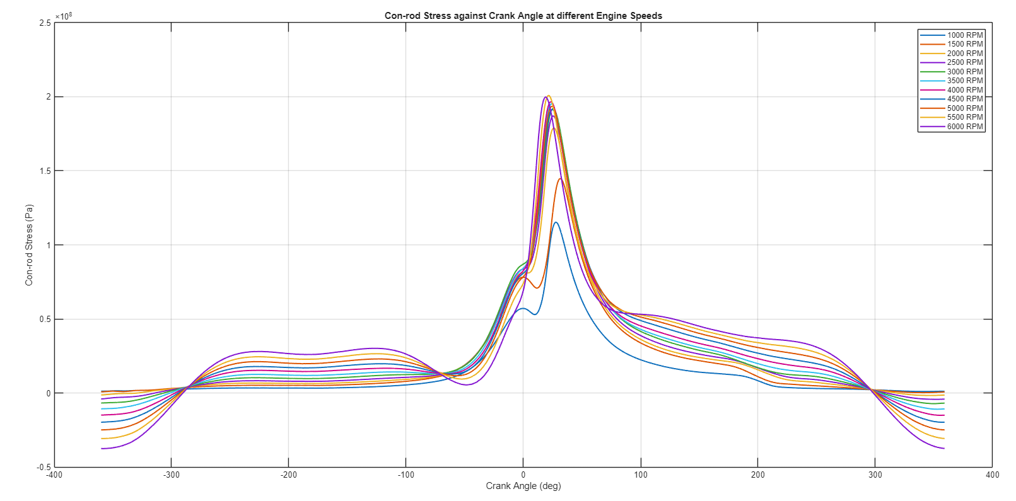
The engine speed data that was measured ranged from 1000rpm to 6000rpm. In this range the following forces on engine components were calculated:
Figure 1 - Graph depicting conrod stress against crank angle

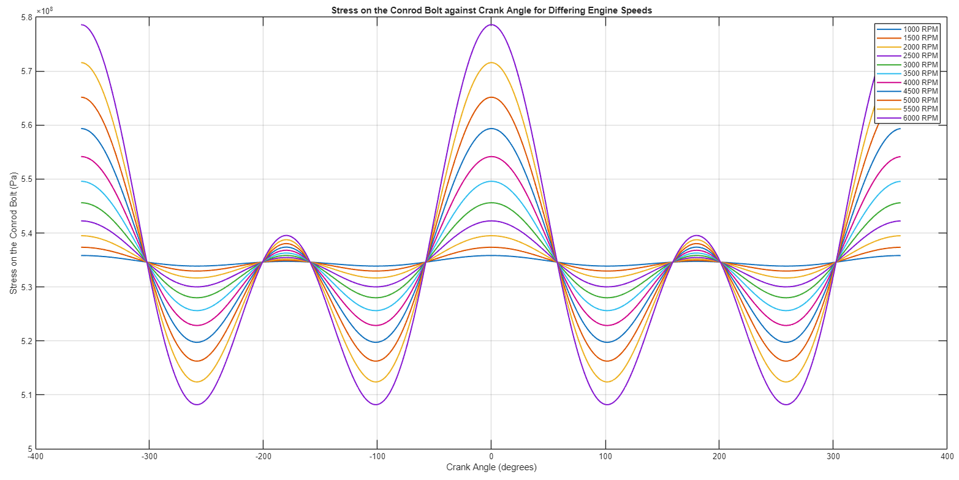
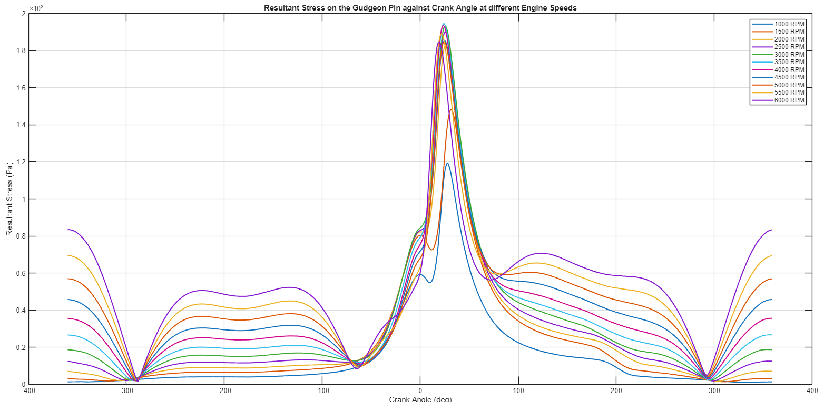
Figure 3 - Stress on the conrod bolt against crank angle
Figure 2 - Graph depicting resultant stress on the gudgeon pin against crank angle
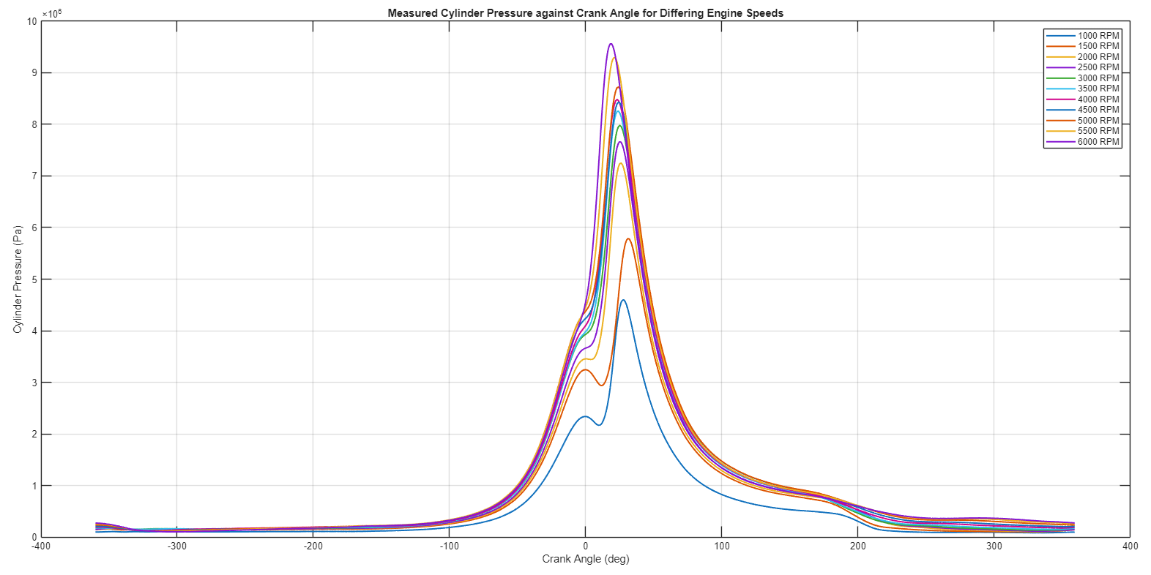
Figure 3 - A graph depicting measured cylinder pressure against crank angle

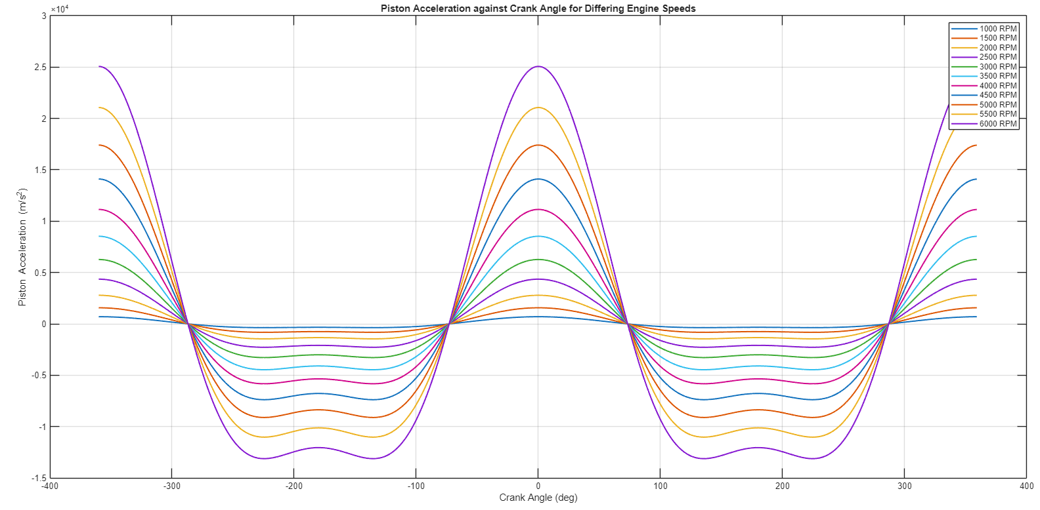
Figure 1 depicts the conrod midpoint stress against crank angle. The crank angle variable ranges from -360° to 360°, to represent all four strokes of a four-stroke engine. The spike in force that begins at approximately 0° can be explained as the combustion/power stroke, which is the point at which fuel and air are ignited. This is caused by a sudden increase in gas force acting on the piston crown. This force is then transmitted through the gudgeon pin and into the conrod itself as a linear force, resulting in increased stress throughout the conrod. This is a common occurrence within internal combustion engines and is the expected result of these calculations. (Heywood, 2018).
Figure 4 - A graph depicting piston acceleration against crank angle
- Figure 2 depicts the resultant stress on the gudgeon pin against crank angle. The similarities between figure 2 and figure 1 are clear to see: they both depict a peak in stress just after TDC resulting from the combustion/power stroke of the engine, they both feature predictable trends at other poin
ts in the cycle. However, there are differences that may be noticed as well. The primary difference is the shape of the graph at various points in the cycle, e.g. between -280° and -80°. This can be explained by the different types of loadings that both components are expected to experience.
The conrod is primarily subject to axial loading because it transmits gas and inertial forces between the piston and crankshaft. Because of this the stress is relatively uniform across the cycle and follows the trend of the pressure data as can be seen in figure 4, including peak stress during combustion increasing at higher engine speeds. (Heywood, 2018)
Figure 2 depicting resultant stress means that it is a combination of bending and shear stress, due to its lateral position between the piston and the conrod. These stresses are combined into resultant stress, which can be used to compare the stresses on the gudgeon pin against those on the conrod. Anywhere the graphs differ in amplitude can be taken to show where the gudgeon pin is experiencing alternative forms of loading such as lateral loading. (Heywood, 2018; Pulkrabek, 2017)
Figure 3 depicts the stress experienced by the conrod bolt against crank angle at differing rpms. The first thing that may be noticed is that the general shape of the lines does not appear to corroborate with figures 1-3. The primary reason for this is that force on the conrod bolt is proportional to piston acceleration, shown in figure 4. The reason for it not being totally the same is again because of the conrod bolt stress calculation’s nature. It is taken as a resultant stress, meaning that it is a combined, concise and compacted view of the stresses experienced by it. The bolt is also expected to experience shear stress from lateral loading, but due to time constraints that could not be depicted. (Heywood, 2018).
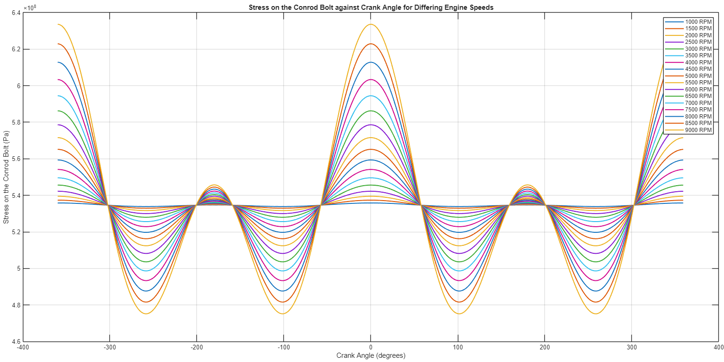
After extrapolating the engine speed data to 9000rpm the stresses and fatigue safety factors were recalculated:
Figure 5 - A graph depicting the stress on the conrod bolt against crank angle for differing engine speeds

Figure 5 depicts the newly extrapolated engine rpm data ranging up to 9000rpm, and the stress on the conrod bolt that it creates. From this graph it was calculated that the Fatigue Safety Factor (FSF) for this M8x1.0 bolt under these conditions, considering stress concentration factors caused by the bolt’s thread, was 0.6608, which indicates that the component would not be able to sustain 1,000,000 cycles, but rather little over 600,000 cycles. This cannot be considered acceptable for a typical conrod bolt.
The primary difference shown here compared to figure 3 is that the peak stress is more exaggerated in this graph. This is due to higher engine speeds causing higher inertia forces on the piston and, by extension, the conrod and conrod bolts. This also causes the FSF to decrease from the 6000rpm example of 1.5167.
Having established that at engine speeds of 9000rpm this conrod bolt wouldn’t be considered acceptable, the next step was to redesign its geometry to allow for greater longevity.
One specific way to increase the fatigue safety factor of a bolt is using what’s called a waisted shank. The bolt is separated into three parts: the thread and the shank. The shank’s diameter is often narrowed, therefore decreasing the stiffness of the bolt as a whole and increasing its fatigue safety factor. (Budynas, J Keith Nisbett and Joseph Edward Shigley, 2020).
Unfortunately, due to time constraints and errors within the calculation process, the desired results were not achieved when reducing the diameter of the waisted shank of the conrod bolts. The total stiffness of the bolt was reduced as a whole, but the fatigue safety factor acted opposite to the desired effect, in that it decreased with decreased stiffness. Possible reasons for this could be inaccuracies when performing the process mentioned in the methodology again for this section of the calculation, which would be entirely down to operational error.

Conclusion
In conclusion, this paper has demonstrated the effects of engine speed and component loading on the fatigue safety factors of the conrod bolt, among other components. By analysing cylinder pressure, crank angle, and engine speed data, it was possible to determine the variation in loading throughout the engine cycle and relate this directly to fatigue behaviour. The results clearly show that increasing engine speed has a significant influence on inertial forces, which scale with the square of angular velocity, and therefore greatly increase the tensile loading experienced by the conrod bolts during operation, particularly near top dead centre.
The paper, however, failed to provide any useful quantitative data regarding the expected improvement in fatigue safety factor when reducing the stiffness of the bolt through geometric modification, such as a waisted shank design. This limits the ability to fully validate the theoretical benefits of increased compliance, which is known to promote a more uniform stress distribution and reduce peak alternating stresses. As a result, the modified bolt design, with a calculated fatigue safety factor of approximately 0.66, would not be expected to survive high-cycle fatigue conditions, particularly at an engine speed of 9000 rpm, where the frequency and magnitude of loading cycles are significantly increased. Under these conditions, failure would likely occur well before reaching 1,000,000 cycles, indicating that the design is unsuitable for sustained high-speed operation.
In contrast, the results suggest that the bolt would perform more favourably at the original maximum engine speed of 6000 rpm. At this speed, the calculated fatigue safety factor of approximately 1.5 falls within a more acceptable range for high-cycle fatigue applications, indicating that the component would likely achieve the desired service life under these operating conditions. This highlights the critical relationship between engine speed, inertial loading, and fatigue performance, and reinforces the importance of considering realistic operating limits in component design.
Overall, the analysis demonstrates the necessity of balancing performance demands with durability considerations. While increasing engine speed can enhance power output, it imposes significantly greater mechanical demands on critical components such as conrod bolts. Future work should focus on incorporating more detailed material data and experimentally validated fatigue parameters, as well as refining bolt geometry, to better quantify the benefits of reduced stiffness and improve the reliability of fatigue life predictions.

References
Heywood, J.B. (2018). Internal Combustion Engine Fundamentals. 2nd ed. New York: Mcgraw-Hill Education.
Pulkrabek, W.W. (2017). Engineering Fundamentals of the Internal Combustion Engine. India: Pearson.
Budynas, R.G., J Keith Nisbett and Joseph Edward Shigley (2020). Shigley’s mechanical engineering design. 11th ed. New York, Ny: Mcgraw-Hill Education.

