

BA (Hons) Leadership and Management Skills for the Workplace

Student Name: Ana Cojan 2109647

Module: Emergent Leadership Skills in the Workplace

Module code: BMSW6101

Module Lecturer: Dr Toyin Adisa

Title: Leadership in Times of Crisis: A Case Study Analysis of H&M

Abstract
The emerging leadership competencies employed by many organizations have been deliberated in this evaluation. For this analysis, one of the most popular fashion brands in the world, H&M, has been considered. We've spoken about many theories of leadership and told the story of H&M's emergent leadership. By assessing the style's advantages and disadvantages, the company's current leadership approach has been examined. The investigation has led to suggestions for how H&M's existing leadership can be modified, as well as appropriate leadership styles, which the organization has been given.

Table of Contents
Task 1 Individual report 3
1. Introduction 3
2. Brief Introduction to H&M 3
3. Key Leadership Theories/Models/Approaches/Styles 4
4. Emergent Leadership Skills for Decision-Making Amid Uncertainty 8
5. Critique of Leadership Approaches and Styles 10
6. Analysis of Current Leadership Strategies at H&M 12
7. Recommendations for Leadership of Change 13
8. Conclusion 15
Task 2: Reflective Essay: 16
Introduction 16
Conclusion 18
Reference 19

Task 1 Individual report

1. Introduction
This study aims to assess the difficulties encountered by H&M's upper management because of the present economic situation and, more specifically, the COVID-19 pandemic. Alternative solutions to these difficulties are also intended to be suggested by the study. The epidemic has hit many companies and economies hard; H&M, a global leader in fast fashion, is just one of them. In addition to these companies and economies, the epidemic has hit many harder. Having illuminated new leadership talents, the study's findings can aid H&M executives in understanding and assessing different approaches to making tough decisions. This is because novel leadership skills are uncovered by research.

2. Brief Introduction to H&M
H&M plays a significant role due to its worldwide fashion store footprint. Even though, relative to its competitors, the company is relatively new. The company's ascent in this economic field took off in 1947. This notoriety is a result of the company's establishment in 1947 (H&M, 2024). Since the company's quick growth opened new prospects, we were able to accomplish this goal. When these factors are considered, the company's growth over time is quite remarkable. Because more than seventy-four nations have banded together, the organization's day-to-day operations run smoothly. It is feasible to establish a partial connection between the association and this event. This is where the potential arises. Potential causation exists. The link can be established. The company's ability to run efficiently is a result of its vast retail outlet network and continuously updated digital platform. The organisation benefits from both components. The business is able to keep running because of this. Because of this, the company has a better shot of reaching its objectives. Both are essential to the success of the business, and the latter's capacity to grow is dependent on the former. Such shops could be in different countries or even different parts of the same country. Nonetheless, it's achievable. It is quite probable that this will transpire. H&M is commonly perceived as a massive fashion company that caters to a diverse clientele with reasonably priced, eco-friendly goods. (Zaidi, 2021) It is widely believed. Given H&M's massive retail reach and the economic risks, especially considering the COVID-19 epidemic, our analysis will centre on this company exclusively. Before choosing to concentrate on H&M, the writers of this study spent considerable time investigating the company.

3. Key Leadership Theories/Models/Approaches/Styles
Transformational Leadership: One of the most important aspects of this style of leadership is the ability to inspire employees to go above and beyond for their employers. As a result of this, it helps to cultivate a sense of community, makes it easier to achieve goals that are shared by participants, and anticipates a bright future that inspires individuals to act. An enthusiastic declaration of a goal is one way to do this. When transformational leaders are in charge, they inspire their subordinates to make the organisation their top priority (Al-Subaieet et al., 2021). In this manner, transformational leaders are differentiated from typical leaders. Since they have a character that is both inspiring and futuristic, they are able to view things from a variety of different angles. Their inventive thoughts and sense of accomplishment serve as a source of inspiration for everyone in their immediate vicinity. Some leaders may be inspired to undergo personal transformations because of their ability to motivate others to work together and realise their greatest potential (Maisyura, Aisyah, and Ilham, 2022). These CEOs are responsible for overseeing the transition of the organisation as well as its long-term performance.
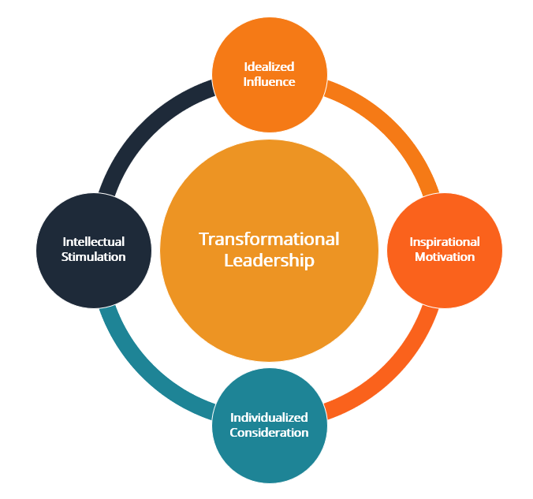
Figure 1: Transformational Leadership
(Source: Al-Subaieet et al., 2021)
Situational Leadership: According to those who advocate for the situational leadership theory that Hersey and Blanchard developed, it is necessary for effective leadership to be present. In this thesis, it is said that it is extremely important for leaders to have the ability to impact the level of preparation of their followers. Leaders that employ this tactic ought to first ascertain whether their followers are mature and prepared before attempting to exert control over them. Because of this decision, they are free to choose the strategy that will be most effective for them. It is common for situational leaders to utilise authoritarian leadership styles when their subordinates lack the confidence to take responsibility for their actions (Setiawan et al., 2021). Children have the potential to gain key life skills as they get older, including the ability to work together and assume responsibility for their actions. One of the most effective ways for leaders to boost morale and productivity is to cater to the requirements of the members of the team.
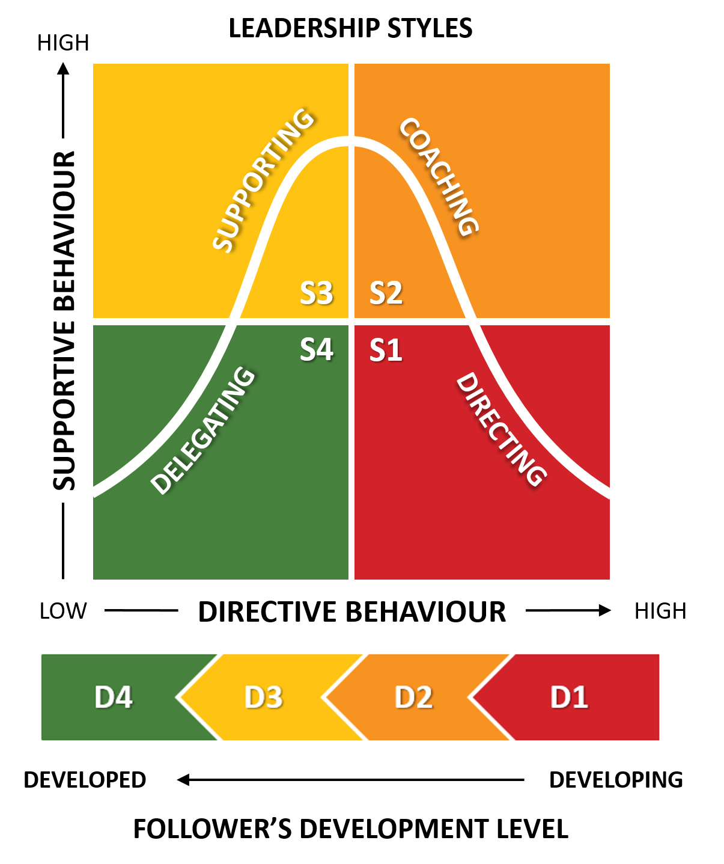
Figure 2: Situational Leadership
(Source: Setiawan et al., 2021)
Adaptive Leadership: It is essential for leaders to have the ability to respond, regardless of the situation. When faced with challenging and unforeseen circumstances, where standard techniques may not be successful, this ability is essential. We are specialists at bringing people together, providing those who have a stake in the outcome with a voice, and cultivating an atmosphere in which everyone feels comfortable asking questions and exchanging ideas. This is what we do as agents of change. As an additional point of interest, they will deal with circumstances that are unknown. When compared to hierarchical institutions, adaptive leadership is distinguished by their decentralised decision-making and accountability structures (Xu et al., 2022). By keeping this in mind, it is possible to effectively manage possibilities and difficulties that were not anticipated. It is possible that leaders who can adapt would be able to build and grow their organisations during times of uncertainty. This is because they will be able to recognise opportunities and derive power from overcoming problems. The ability to find possibilities even during uncertainty is one of the distinguishing characteristics of adaptable leaders.
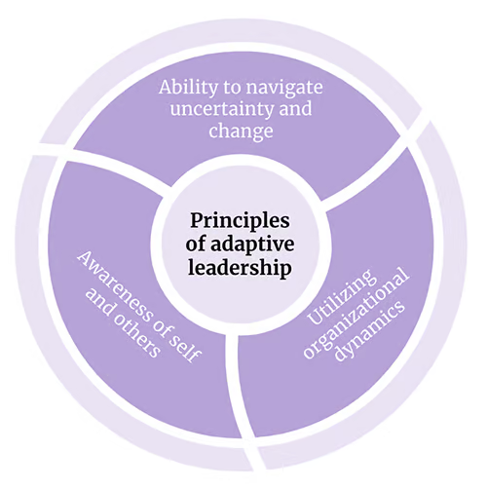
Figure 3: Adaptive Leadership
(Source: Xu et al., 2022)
Servant Leadership: Someone who prioritises the needs of their followers before their own is known as a servant leader. Put another way, a good leader prioritises the needs of their followers over their own. According to Robert K. Greenleaf, who popularised this leadership style, the most important thing is to pay attention to what your followers want and need from individuals kif they want to succeed (Maulana and Maulana, 2021). This management strategy is supported by the foundation and has a substantial impact. If a leader wants to show they are a servant leader, they should ask their employees how they can help. They will primarily be motivated by a desire for their staff to excel in their roles and make meaningful contributions to the organization's objectives. Leaders that practice servant leadership are able to inspire more dedication and enthusiasm from their teams by creating an environment where everyone feels comfortable speaking out and contributing. One good thing that comes out of this is that it helps the organisation expand and last longer.
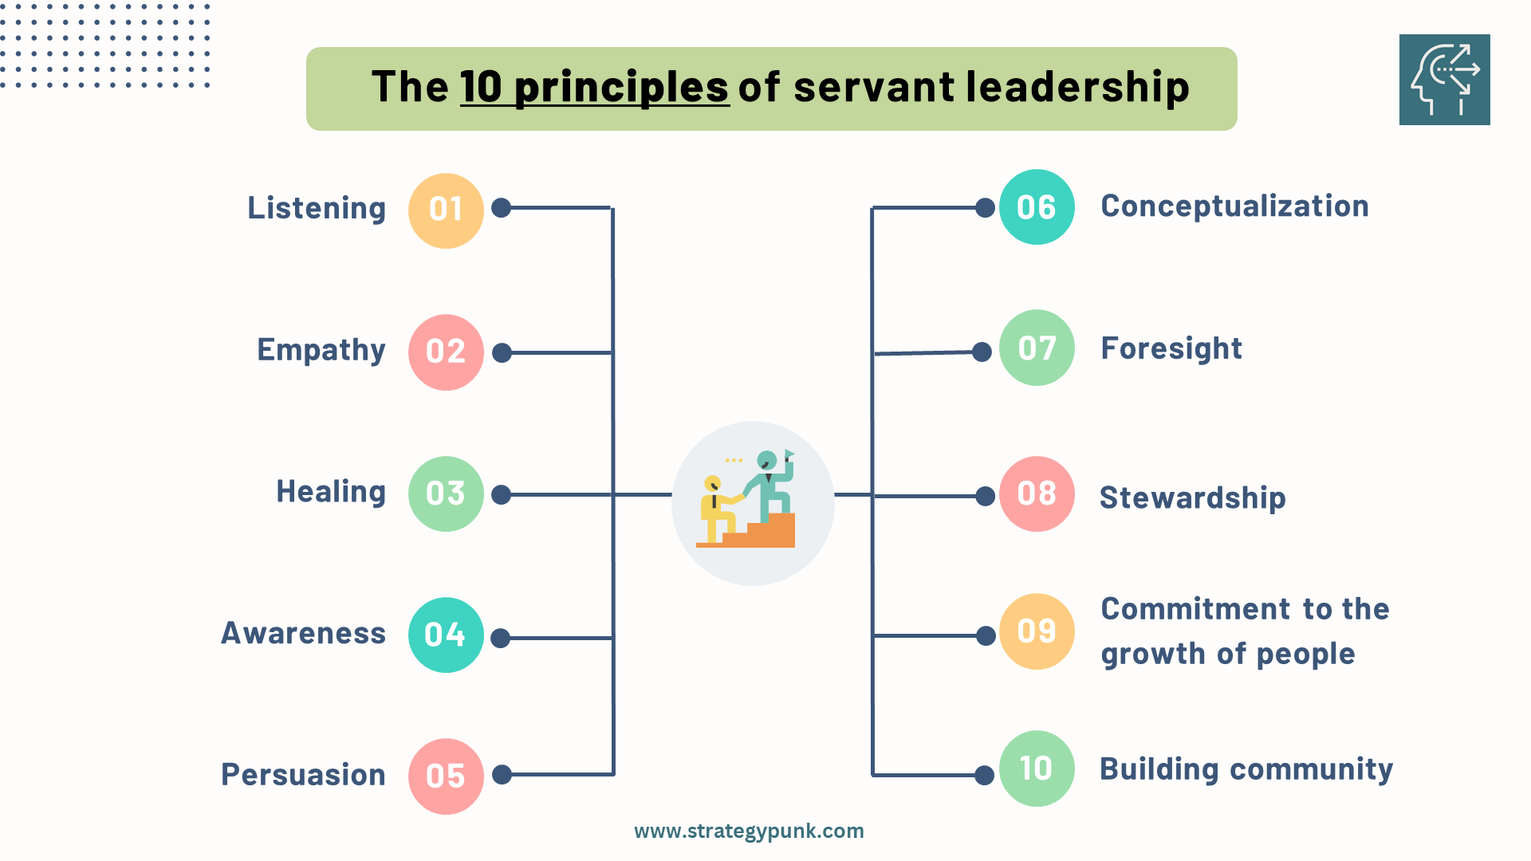
Figure 4: Servant Leadership
(Source: Maulana and Maulana, 2021)

4. Emergent Leadership Skills for Decision-Making Amid Uncertainty
Adaptability:
In times of economic unpredictability, businesses are likely to encounter sudden and unanticipated shifts in their operations. A person who has a leadership position at H&M needs to be able to respond quickly and effectively to the ever-changing demands of the market, the preferences of customers, and other external issues such as regulations and technological advancements. The ability to be flexible and creative requires one to be able to adjust to different situations and be open to discovering new things (Nerantzi, 2020). The leadership of H&M has been able to weather crises and position the company for success by maintaining a close watch on the market and shifting quickly from situation to situation.
Strategic Vision:
When considering the current state of the economy, it is essential for H&M's leadership to have a clearly articulated plan for the company's future planning. It is possible that having a clearly specified strategic aim will contribute to an improvement in your ability to manage resources and make decisions. The management of H&M ought to present views of the company's future that are both optimistic and exciting (McKinsey, 2020). The priorities and strategic objectives that are outlined in this vision ought to be reflective of the concepts and goals that each worker aspires to achieve. Leaders have the ability to motivate all parties involved to work together towards a single objective if they are able to successfully communicate this vision. Aiding one another has the potential to bring individuals closer together and instill in them a feeling of purpose.
Emotional Intelligence:
When confronted with economic uncertainty, workers may experience a range of emotions, including concern, dread, and ambiguity, among others. It is necessary for CEOs and supervisors at H&M to possess high levels of emotional intelligence in order to comprehend and calm employees who are experiencing anxiety (SG, 2022). When customers express their thoughts and concerns, it is essential for every member of the team to be present throughout the process. Leaders who are exceptional are able to motivate their colleagues, establish a personal connection with them, and set the path for a constructive atmosphere in the workplace.
Risk Management:
In order to be successful, executives at H&M need to be able to identify potential dangers and offer remedies once they materialise. While faced with unclear circumstances, leaders need to consider both the present and the future while making judgements. Since they are confronted with perplexing circumstances. Assisting in the identification, mitigation, and monitoring of potential hazards is the establishment of trustworthy risk management rules and procedures (Birkel, and Hartmann, 2020).
Collaborative Decision-Making:
Collaborative decision-making is necessary due to the situation's inherent uncertainty. By being receptive to and thoughtful of different viewpoints, the H&M leadership team can help foster a welcoming environment for employees. The leadership team should carefully assess the present situation in addition to the broader view, which includes any possible dangers, before making any decisions. It is feasible to eliminate obstacles and provide a setting where everyone contributes by facilitating the exchange of information and promoting cooperation across departments (Ainscow, 2020). Attempting it could be doable. Leaders may inspire resilience, engagement, trust, and adaptability among their followers by involving them in decision-making processes. This type of leadership also has the added bonus of making its followers more adaptable and receptive to new ideas.
H&M managers should work on their leadership abilities so they can make reasonable decisions when faced with different levels of uncertainty. Leadership at H&M must focus on developing employees' emotional intelligence, collaboration, risk management, ability to adapt to changing market conditions, and overall vision if the company is to succeed in the long run. For the organization's capacity to make decisions, this is vital. Attempting it could be doable. With this strategy in place, the company will be able to ride out any economic storm.

5. Critique of Leadership Approaches and Styles
Transformational Leadership:
Being in a position of leadership has many advantages, among which are:
Depending on whether their followers are ready to step up and take charge, situational leaders should adjust their strategies accordingly. Although H&M respects team members' individual tastes, this likely won't be enough to address the complicated structural difficulties caused by the economy's volatility. As one would expect, the economy is precariously balanced. Complex and interconnected economic shocks may make decision-making challenging for situational leaders in the absence of a more comprehensive and strategic framework (HBR, 2020). Not to mention that they might be unable to decide what to do. Because it is more difficult to adapt in an uncertain environment, employees are less inclined to be clear and consistent due to the constant need to alter. Employees will most likely lack consistency and precision because of this. Executives at H&M are required to maintain consistency while also demonstrating good situational leadership and adaptability. Additionally, they need to check that this doesn't run counter to the company's long-term objectives.
Situational Leadership:
In situational leadership, leaders change their strategies based on how well their followers are prepared. It is essential for leaders to do this in order for these techniques to work. Although H&M respects team members' individual tastes, this likely won't be enough to address the complicated structural difficulties caused by the economy's volatility. As one would expect, the economy is precariously balanced. Financial shocks can be complicated and interconnected, making decision-making difficult for situational leaders (ET, 2023). This is due to the complicated and interdependent character of the economic shocks. Because it is more difficult to adapt in an uncertain environment, employees are less inclined to be clear and consistent due to the constant need to alter. Employees will most likely lack consistency and precision because of this. Executives at H&M are required to maintain consistency while also demonstrating good situational leadership and adaptability. Additionally, they need to check that this doesn't run counter to the company's long-term objectives.
Adaptive Leadership:
The speed with which a leader can adjust to new circumstances, even when confronted with challenges, is directly proportional to their capacity to garner support and to drive change. Even though it is not as effective as transformational leadership, this style of management works beautifully for H&M, which is a company that is both surprising and fast-paced. Instead of focusing on the larger backdrop, adaptive leadership places more of an emphasis on addressing the specific problems faced by individuals (ET, 2023). Most of the time, they concentrate on short-term objectives rather than their long-term objectives. It is possible that this method of guiding and motivating a group will be successful in the here and now, but it will not achieve the desired results in the long run. Executives at H&M need to possess critical abilities such as the ability to effectively multitask and to lead effectively.
Servant Leadership:
In order to be a servant leader, one must put the requirements of your followers ahead of your own individual requirements. There is a need for an employee agency and prospects for promotion. Even if this strategy has the potential to make H&M a more inviting and inclusive place of employment, there is a possibility that it may be met with opposition (McKinsey, 2020). This is because the firm is now undergoing organisational transformation and is working towards achieving its goals. Under the leadership of a servant leader, the development and contentment of employees takes precedence over the achievement of strategic goals and the achievement of financial success. As a result of the organization's emphasis on empowerment and consensus, there is a possibility that it will become incapable of making decisions or taking on responsibilities. It is the responsibility of H&M's managers and executives to motivate their employees to meet the company's goals and standards of performance. The only way to accomplish this goal is through the use of servant leadership and concentration on results.

6. Analysis of Current Leadership Strategies at H&M
Strengths:
Emphasis on Sustainability:
H&M satisfies the increasing demand for environmentally friendly items since they prioritise ethics and the environment. To lessen its effect on the environment, the corporation adopts several strategies. Sustainable practices encompass a wide range of actions, such as reducing waste, increasing energy efficiency, and creating more circular fashion processes (Sanchez‐Planelles, Segarra‐Oña, and Peiro‐Signes, 2022). H&M has improved its reputation and drawn in more environmentally concerned consumers as a result of its sustainability initiatives. The result has been customer retention and competitive advantage for the business.
Digital Transformation Efforts:
Despite the COVID-19 outbreak, H&M was able to respond to customers' evolving demands through digital transformation. The business has put money into digital marketing, e-commerce platforms, and technology in order to boost online sales (Kadir, and Shaikh, 2023). By completely embracing digital innovation, H&M has broadened its sales channels, diversified its revenue streams from brick-and-mortar stores, and capitalised on online purchases. With its income up, the company has been able to ride out the storm of online shopping.
Commitment to Diversity and Inclusion:
The creative and innovative spirit of H&M is encouraged by the company's openness to and pursuit of different viewpoints. The firm has tried to reflect the ethnic diversity of its global customers in its leadership, advertising, and workforce (Kele, and Cassell, 2023). The objective of these endeavours is to promote a more diverse workforce. When H&M workers feel valued and empowered, they are more inclined to put in extra effort. There is a higher probability of innovation and financial success for the company.
Limitations:
Reliance on Physical Stores:
H&M is vulnerable to shifts in foot traffic and limitations on in-person purchases because their leadership approach is based around physical presence. Due to consumers being wary of shopping online, staying home, and being quarantined, traditional stores have been impacted hard by the COVID-19 pandemic. Despite its success on the internet, H&M is still challenging itself in regions with inadequate infrastructure or low e-commerce penetration to minimise its need for physical stores.
Supply Chain Disruptions:
H&M is struggling to meet consumer demand and run smoothly due to issues with their logistics and supply chain. H&M's global supply chain and manufacturing have been impacted by factory closures, shipment delays, and raw material shortages caused by the pandemic. Profitability, sales success, and customer satisfaction are all affected by issues with incorrect inventory management, late deliveries, and price increases (Santos, Sampaio, and Alliprandini, 2020). Management at H&M must strengthen their supply chains and institute resilience measures if the company is to maintain operations operating efficiently and reduce operational risks to a minimum.
Leadership Structure Agility:
It is possible that H&M's leadership may struggle to adapt to the changing market realities. For a while, the company's bureaucratic decision-making and hierarchical structure can make it hard to identify changes in consumer tastes, competition, or the industry as a whole. To keep up with the fast-paced retail market of today, leaders must be agile and flexible. In order to stay ahead of the competition and seize new opportunities, H&M needs to create a culture that encourages innovation, risk-taking, and constant growth among its leaders (Azeem et al., 2021). Leadership of strategic transformation and informed decision-making should be delegated to every member of staff.

7. Recommendations for Leadership of Change
Invest in Digital Innovation:
H&M's investment in e-commerce technologies and expertise may improve online shopping and store dependence. This should boost business. Augmented reality enables virtual try-ons. These technologies have also improved the company's website and mobile app and provided customised recommendations and targeted ads using advanced analytics. The organisation prioritises customer satisfaction in all these areas. H&M has used digital innovation to expand their consumer base and enhance their relationship as online shopping has grown (McKinsey, 2022). This is why its sales have soared and it can compete in internet retail. This achievement should impress the company.
Enhance Supply Chain Resilience:
The supply chain must be strengthened to reduce uncertainty. Some recommend H&M diversify its supply chain and apply stringent risk management to reduce delays. Backup planning and alternative suppliers may be needed during outages. This may arise alongside tools for identifying and assessing natural disasters, pandemics, and geopolitical turmoil. They may be right about one. Some believe data analytics and cutting-edge tech can help H&M better understand its suppliers (Modi, and Zhao, 2021). The advice is that. Thus, the company can monitor threats and respond quickly. H&M may strengthen supplier chains. Company productivity, cost, and customer happiness can be improved. Swedish clothing retailer H&M.
Foster Agile Leadership:
Every H&M employee must be innovative and adaptable. This can be achieved by encouraging workplace adaptability and quick thinking. H&M might use this to improve their agility leadership. These opportunities may inspire risk-taking, learning from mistakes, and a development attitude (Ciranka, and van den Bos, 2021). We offer all of these. Departments can also share information. Departmental cooperation is possible. H&M leaders may set an example by being open to feedback, questioning standards, and paying attention to detail. Everyone can learn and utilise it to solve problems. H&M stays ahead of the retail competition by developing flexible leadership. This allows them to quickly adjust to market changes, seize new opportunities, and outperform competition.
Prioritize Employee Well-being:
Employee happiness should be a company's top priority. H&M should prioritise mental health and welfare for its employees, especially in difficult times. Thus, the corporation can help its workers. Helping necessitates it. This wider issue includes improving wellness programmes and treatment, fostering work-life balance, and offering more flexible work schedules. This group includes these items. Employees should access H&M on demand. Financial performance, prospects, and organisational changes will be communicated to employees. Engaging H&M employees in their well-being boosts morale, engagement, and productivity. The result will be a strong, resilient workforce that can overcome any challenge. Employees will be more prepared to help the company succeed.
Strengthen Stakeholder Engagement:
H&M's resilience and long-term connections depend on its ability to communicate and collaborate with diverse partners. Companies' aims will be easier to achieve. Business associates, vendors, and residents are stakeholders. This includes stakeholder input on crucial decisions and actions, regular communication, and stakeholder events. These are some possible inclusions. This package may not include everything on this list. For sustainability and corporate social responsibility, H&M should participate in major collaborations and initiatives that benefit stakeholders and shareholders (Galica, 2022). This is the only way H&M can show its commitment to these values. This is H&M's duty. H&M can boost trust, reputation, and brand loyalty by involving stakeholders in decision-making. This will help the company succeed and expand.

8. Conclusion
Effective leaders are proactive, adaptable, and caring. They won't be disaster-ready till then. The final word after all the argument. H&M can succeed if its top management learns leadership and studies the sector. This can only happen if they continue. Despite economic and COVID-19 worries, this remains true. The truth is this. For sustainable development, this can help. H&M says one of the best ways to weather a storm is to reflect on past mistakes and avoid repeating them. This is a safe floatation method. One of the most crucial procedures. Just to reiterate, the company took this position.

Task 2: Reflective Essay:
Through Gibbs’ model of reflection, the following personal reflection has been provided on how the leadership skills have been developed by the author. Six stages of the Reflective model include – Description, Feelings, Evaluation, Analysis, Conclusion, & Action Plan.
Description:
In this reflective essay, I want to highlight all the ways that working on this project has boosted my career. Given my extensive knowledge of the organization's inner workings and outside factors, I solemnly swear to be accountable for every leadership decision and action I take. Studies of the company's external environment will serve as the basis for this strategy. In addition, I will describe in detail how I was able to get these abilities and understanding. I will take stock of my skills in relation to the current situation and figure out if I can handle the leadership responsibilities. This way, I can see how well I'm doing. All of the aforementioned tasks will be executed simultaneously with this project. I will evaluate my potential as a leader by making use of standard procedures and models.
Feelings:
Throughout my academic journey, I have been introduced to various leadership models, concepts, and strategies that have great promise for the business sector. To back up my claim, I will explain how transformational leadership, according to my understanding, prioritises collaboration to accomplish goals. In my professional experience, I have found that the most effective way to motivate employees to work hard and accomplish goals is to have a strong business culture and an exciting vision. This tactic allowed us to reach this agreement. I was able to achieve my objectives because of this realisation.
Analysis:
Additionally, I have read up on situational leadership, which proposes that leaders should adapt their strategies based on the level of preparedness of their followers. This notion was examined by me. I conducted the research independently. Based on my findings, this theory is valid. Expanding my research into this fascinating field was also on my mind. This method has helped me to appreciate the value of adaptable leadership. Thus, study is necessary to develop techniques for handling the numerous team dynamics that could arise at any given time (Maulana and Maulana, 2021). There is a constant flux in these dynamics.
The idea of servant leadership, which stresses the need of assisting and empowering others, is another one that I have learned. Something I picked up in class. All of this is rooted in my own life experiences. The foundation of all this is my life's experiences (ET, 2023). I am fully prepared to make sensible decisions thanks to the wisdom I have gained from life's experiences. The method's results stress the value of humility, compassion, and helping people in need. The reason behind this is that these traits reflect the mindset of exceptional leaders. I share the view that every employee has a right to feel appreciated and valued while on the job.
Evaluation:
The importance of flexible leadership in an unpredictable and ever-changing world is something I've learned the hard way through my life's experiences. This understanding led to this realisation. My experience with this approach has taught me the importance of empowering stakeholders, mobilising resources, and encouraging innovation to drive organisational transformation. My decision prompted this observation. Taking stock of my abilities and shortcomings in the context helped me better understand my leadership role and the duties that came with it. During the test, I became aware of this. When I was reviewing, I saw how useful this data was.
I am able to encourage and inspire people because of my excellent communication skills, both in writing and in person. These abilities enable me to express myself precisely. This is one of the numerous aspects that make me who I am. Because of my leadership skills, my team now feels like we're part of something bigger, and we take great satisfaction in the work we've accomplished. The key to our success was my capacity to inspire my staff. Because of this, the team is more focused than before on achieving their objective.
Quickly analysing situations, recognizing potential dangers, and making well-informed choices are all within my capabilities. My analytical and problem-solving abilities allow me to identify problems and assess challenging situations. With this skill, I am able to evaluate difficult situations. The organisation has been able to accomplish its strategic goals and deal with uncertainty because of this expertise. They came to that conclusion as a group.
Conclusion:
Thanks to this reflective essay, I was able to assess my module knowledge and leadership abilities. The opportunity to take part is fantastic. Being a part of it was a blessing. The opportunity to take part is fantastic. If I want to grow as a leader, I need to take stock of my abilities and figure out where I can make improvements. I can better myself now that I am aware of my capabilities and limitations. I am fully aware that my current situation is a result of my split personality traits. Now that we've signed this agreement, I'm ready to lend a hand as the company adapts to the dynamic business environment. The business arrangement is the sole reason this will transpire.
Action Plan:
I need to work on my time management skills and my ability to create reasonable goals for myself. In these areas, I am aware of my shortcomings. Allocating responsibilities to others is not always easy for me. This is the necessary step in this case. Because it reduces team performance, micromanagement is harmful (HBR, 2020). This is feasible because it was ever offered. Also, when I'm nervous, I have a hard time setting priorities and staying on track.
Improving my abilities to assist the development of others is one of my long-term objectives. In my opinion, this is crucial if we wish to leverage other viewpoints and areas of expertise to accomplish our objectives more quickly. I am fully aware of how important this is. Making the office a welcoming place where people feel comfortable voicing their opinions is another one of my goals. I accomplish this by facilitating teamwork. As far as its probable significance is concerned, I am aware of this.

Reference
Ainscow, M., 2020. Promoting inclusion and equity in education: lessons from international experiences. Nordic Journal of Studies in Educational Policy, 6(1), pp.7-16. Available at: https://www.tandfonline.com/doi/full/10.1080/20020317.2020.1729587
Al-Subaie, A.A., Faisal, M.N., Aouni, B. and Talib, F., 2021. A strategic framework for transformational leadership development in megaprojects. Sustainability, 13(6), p.3480. Available at: https://www.mdpi.com/2071-1050/13/6/3480
Azeem, M., Ahmed, M., Haider, S. and Sajjad, M., 2021. Expanding competitive advantage through organizational culture, knowledge sharing and organizational innovation. Technology in Society, 66, p.101635. Available at: https://www.sciencedirect.com/science/article/abs/pii/S0160791X2100110X
Birkel, H.S. and Hartmann, E., 2020. Internet of Things–the future of managing supply chain risks. Supply Chain Management: An International Journal, 25(5), pp.535-548. Available at: https://www.emerald.com/insight/content/doi/10.1108/SCM-09-2019-0356/full/html
Ciranka, S. and van den Bos, W., 2021. Adolescent risk-taking in the context of exploration and social influence. Developmental Review, 61, p.100979. Available at: https://www.sciencedirect.com/science/article/abs/pii/S0273229721000344
ET, 2023, “Adaptive Leadership: Navigating Change with Confidence”, Available at: https://economictimes.indiatimes.com/jobs/c-suite/adaptive-leadership-navigating-change-with-confidence/articleshow/104706979.cms?from=mdr [Accessed on 12th March 2024]
ET, 2023, “Leadership Styles in Crisis Management: What Works Best?”, Available at: https://economictimes.indiatimes.com/jobs/c-suite/leadership-styles-in-crisis-management-what-works-best/articleshow/104730184.cms?from=mdr [Accessed on 12th March 2024]
Galica, J., 2022. Corporate Social Responsibility (CSR) as an image building tool in fast-fashion industry on the example of H&M Group (Bachelor's thesis). Available at: http://dspace.wsb-nlu.edu.pl/handle/11199/10631
H&M, 2024, “About us”, Available at: https://hmgroup.com/about-us/ [Accessed on 12th March 2024]
HBR, 2020, “5 Principles to Guide Adaptive Leadership”, Available at: https://hbr.org/2020/09/5-principles-to-guide-adaptive-leadership [Accessed on 12th March 2024]
Kadir, S. and Shaikh, J.M., 2023, January. The effects of e-commerce businesses to small-medium enterprises: Media techniques and technology. In AIP Conference Proceedings (Vol. 2643, No. 1). AIP Publishing. Available at: https://pubs.aip.org/aip/acp/article-abstract/2643/1/050078/2872720/The-effects-of-e-commerce-businesses-to-small
Kele, J.E. and Cassell, C.M., 2023. The face of the firm: the impact of employer branding on diversity. British Journal of Management, 34(2), pp.692-708. Available at: https://onlinelibrary.wiley.com/doi/full/10.1111/1467-8551.12608
Maisyura, M., Aisyah, T. and Ilham, R.N., 2022. Transformational leadership in organizational transformation. Jurnal Ekonomi, 11(03), pp.478-488. Available at: https://ejournal.seaninstitute.or.id/index.php/Ekonomi/article/view/719
Maulana, A. and Maulana, R., 2021. When the Leader is Born as A Competitor (WLBC). UPI YPTK Journal of Business and Economics, 6(3), pp.98-106. Available at: https://jbe-upiyptk.org/ojs/index.php/jbe/article/view/12
McKinsey, 2020, “For H&M, the future of fashion is both ‘circular’ and digital”, Available at: https://www.mckinsey.com/industries/retail/our-insights/for-h-and-m-the-future-of-fashion-is-both-circular-and-digital [Accessed on 12th March 2024]
McKinsey, 2020, “The State of Fashion 2021”, Available at: https://www.mckinsey.com/~/media/mckinsey/industries/retail/our%20insights/state%20of%20fashion/2021/the-state-of-fashion-2021-vf.pdf [Accessed on 12th March 2024]
McKinsey, 2022, “The State of Fashion 2022”, Available at: https://www.mckinsey.com/~/media/mckinsey/industries/retail/our%20insights/state%20of%20fashion/2023/the-state-of-fashion-2023-holding-onto-growth-as-global-clouds-gathers-vf.pdf [Accessed on 12th March 2024]
Modi, D. and Zhao, L., 2021. Social media analysis of consumer opinion on apparel supply chain transparency. Journal of Fashion Marketing and Management: An International Journal, 25(3), pp.465-481. Available at: https://www.emerald.com/insight/content/doi/10.1108/JFMM-09-2019-0220/full/html
Nerantzi, C., 2020. The use of peer instruction and flipped learning to support flexible blended learning during and after the COVID-19 Pandemic. International Journal of Management and Applied Research, 7(2), pp.184-195. Available at: https://www.ceeol.com/search/article-detail?id=883236
Sanchez‐Planelles, J., Segarra‐Oña, M. and Peiro‐Signes, A., 2022. Identifying different sustainable practices to help companies to contribute to the sustainable development: Holistic sustainability, sustainable business and operations models. Corporate Social Responsibility and Environmental Management, 29(4), pp.904-917. Available at: https://onlinelibrary.wiley.com/doi/abs/10.1002/csr.2243
Santos, V., Sampaio, M. and Alliprandini, D.H., 2020. The impact of product variety on fill rate, inventory and sales performance in the consumer goods industry. Journal of Manufacturing Technology Management, 31(7), pp.1481-1505. Available at: https://www.emerald.com/insight/content/doi/10.1108/JMTM-06-2019-0213/full/html
Setiawan, R., Cavaliere, L.P.L., Navarro, E.R., Wisetsri, W., Jirayus, P., Chauhan, S., Tabuena, A.C. and Rajan, R., 2021. The impact of leadership styles on employees productivity in organizations: A comparative study among leadership styles. Productivity Management, 26(1), pp.382-404. Available at: https://papers.ssrn.com/sol3/papers.cfm?abstract_id=3875252
SG, 2022, “The future of work”, Available at: https://peppermintwellness.co.uk/wp-content/uploads/2022/04/Future-of-work_how-to-be-an-organisation-that-thrives_Laura-Lyon-Trends.pdf [Accessed on 12th March 2024]
Xu, N., Ghahremani, H., Lemoine, G.J. and Tesluk, P.E., 2022. Emergence of shared leadership networks in teams: An adaptive process perspective. The Leadership Quarterly, 33(6), p.101588. Available at: https://www.sciencedirect.com/science/article/abs/pii/S104898432100093X
Zaidi, U., 2021. Analysis of Consumers' Attitudes Towards Sustainability Communication of H&M. Available at: https://www.diva-portal.org/smash/record.jsf?pid=diva2%3A1594131&dswid=7395

