Changemakers,
Exhibition Scrapbook.
Darren Tierney
14/11/2022
Level 5
Introduction to the object-
I was introduced to the ‘Clappers’ as my object of focus for the exhibition, the clappers are from ancient Egypt, 6th Dynasty of the middle kingdom (2395-2181 BC). My first immediate impressions were that they had been used in a ritualistic setting and that they are also constructed out of wood. I took measurements of the clappers and sketched them into a notebook and made assumptions on the properties of the items. The key qualities I added into the sketch. I had recorded only the right hand, but the same is applicable for the left, though there are few minor differences, they closely mirrored each other. The clappers had a miniscule difference in length width and height from one another, they were both extremely polished items, smooth to the touch, and it felt like they were something that could have been manufactured recently. The arm pieces of the clappers had no intricate design visible, if it had in the past, it has long worn away, the hands themselves are the only detailed thing that we find on the object. On the end of the fingers, I found a residue which may have been a resin/paint to add charm to the object, or it could be dirt. The arms of these clappers may have been to scale for the period due to a lack of modern-day nutrition, although I had been informed that the hands had to be made at a smaller scale. What was found in assessing a replica, bigger hands increased the risk of the item shattering.
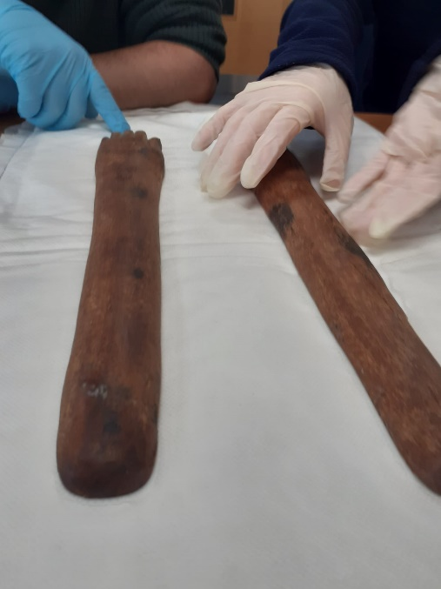
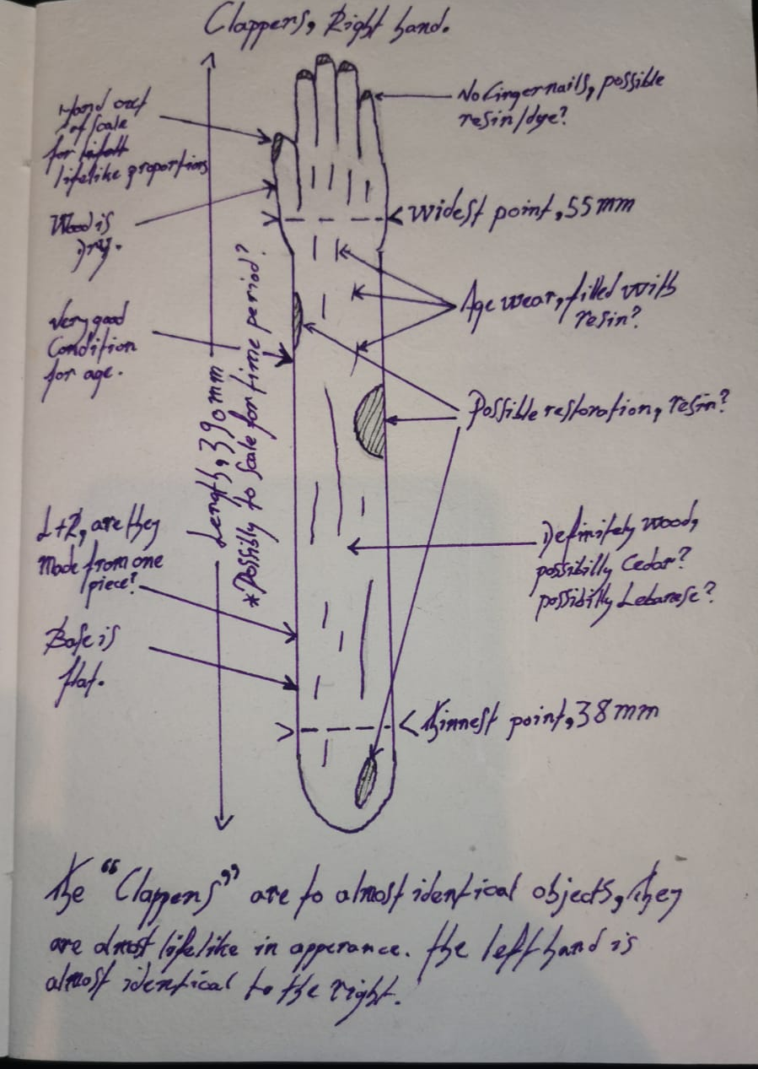

With this item we were given an accompanying handling checklist, to read over before the handling of the items, a precaution to make sure the item is not damaged while inspecting and handling it. Some of the key questions that were applicable for this piece I noted down in my notepad.
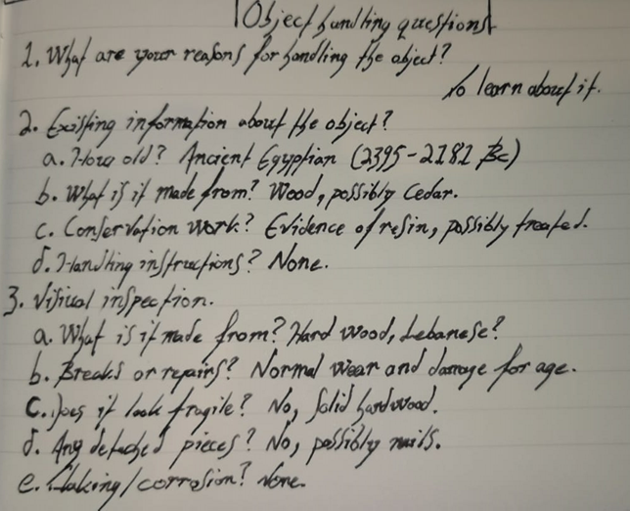

During the inspection of the object, I took a handful of closer photos that I thought would be of note to the research of the item for the exhibition, as well as a ‘professional’ photo for the item to use with the YMT proposal.
The photo on the right shows the
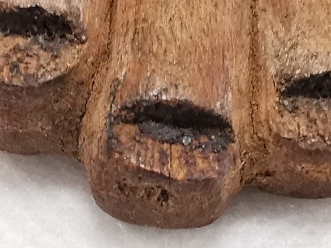
fingernails up close, in this picture
you can see a residue left from either resin,
or possibly dirt. In the one below you
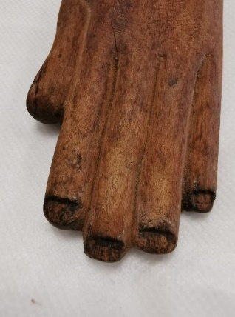
can see the color difference of the hands
and the nails.

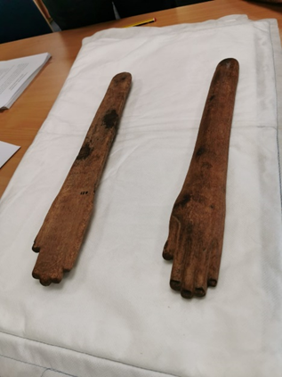

In this photo we flipped the right arm, the difference
in properties is apparent. This side is completely flat and
has no defining features, the stains of a substance on
both arms is visible. These stains seem to resemble
the material used on the fingernails, whether it is
deliberate or coincidence is up to speculation.

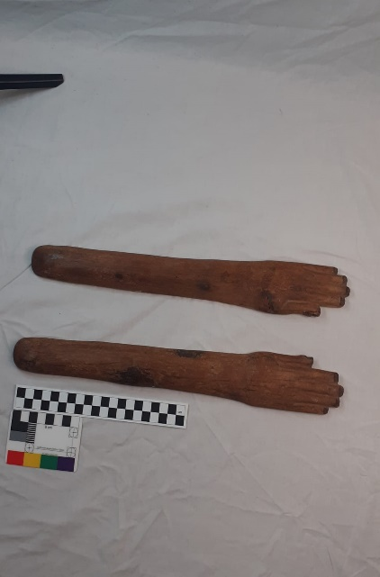

This is the ‘Professional’ shot of the clappers that was
taken with a light-box. This is to be used in the
proposal to the YMT, we used a scale for the object so
the size is easily recognised.

The next task at hand was the designing and research of the label. The label would be displayed with the item to give people a quick summary on the item itself. The 50 word limit other than the tombstone information was a challenge to keep it short, accesible and fun. To accomplish this, I had to do some research on the item and put it in a way that is easily read. In my research I found the most interesting parts were about the warding of evil spirits and the focus of the item having a musical, ritualistic function, it is with these parameters I decided to focus my exhibition on. This is what I ended up with-

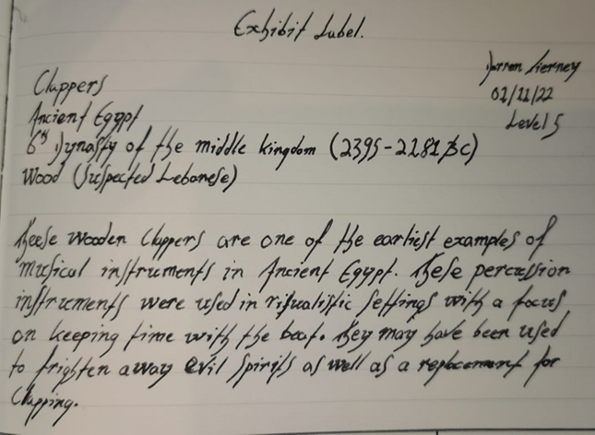

As I thought about the process that the exhibition would need to form, I had a few ideas and directions to take the final vision towards. In the end I decided that my exhibition was to be focused mainly on the music of ancient Egypt, although there are no scores available to reference, we find lyrics available and we know what instruments they used in their kingdom. From this people have theorised what the sound of their music was, and my exhibition will be based on those assumptions. Although the music itself will be inaccurate, the sounds that are produced will be authentic.

In researching the different instruments found in ancient Egypt, I found that due to the basic nature of the clappers, all of the possible instruments from the ancient period of Egypt were most likely part of each lifetime. So I researched objects that would fit in my overall theme of Egyptian sounds and music.

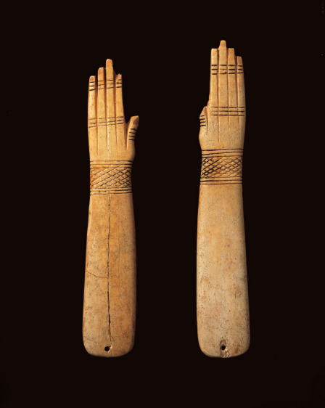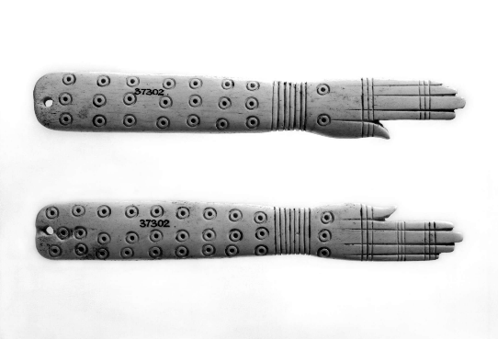

Firstly I researched a bit more on the clappers and found many examples of different designs and materials. The difference in materials and intricacy of the item seems to point in the direction of wealth, as the pharoahs personal musicians would have something to a much higher standard than that of the nobility and peasantry, but in some cases it has been suspected the simpler clapper design has its merits in sound quality. On the left is a picture of a pair of bone clappers taken by the ‘Horniman Museum and Gardens’. They date to the 18th Dynasty (3,500 years ago) and are much smaller than the wooden ones I inspected, they are only 170mm at the longest measurement. On the right we find another pair of bone clappers in the collections of the British Museum, once again these bone clappers are on the smaller side coming in at 173mm at the longest measurement. These are much more decorated than the pair of wooden clappers and the bone clappers previous to this one. Both of these clappers have small holes for string so they can be played with one hand.

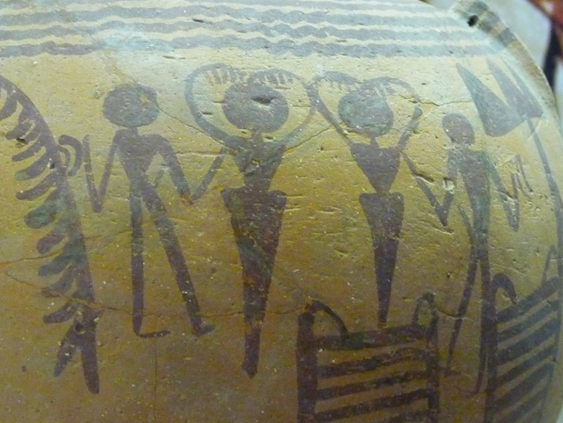

Here is a picture of people playing
the clappers in a ceremonial setting,
You can see two men on the outside
of the central figures that seem to
have extra long arms, these are
presumed to be clappers.
With the poses of the people you can
discern they were used within some
form of dancing ceremony.

The next few instruments that I researched are to be support for my main exhibition, there are a vast variety of different instruments used. I will only focus on the ones that I know exist in historical collections, and that would be easy to obtain a sound sample from, or a replica made.

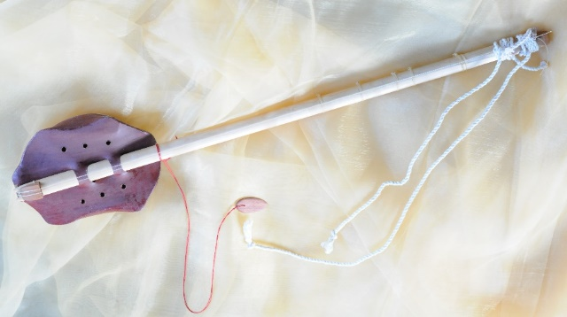

The Picture on the right is an ancient
Egyptian lute which is an instrument
that is held by the forearm and
plucked, possibly with a shard
of bone, similar to a modern day
guitar.

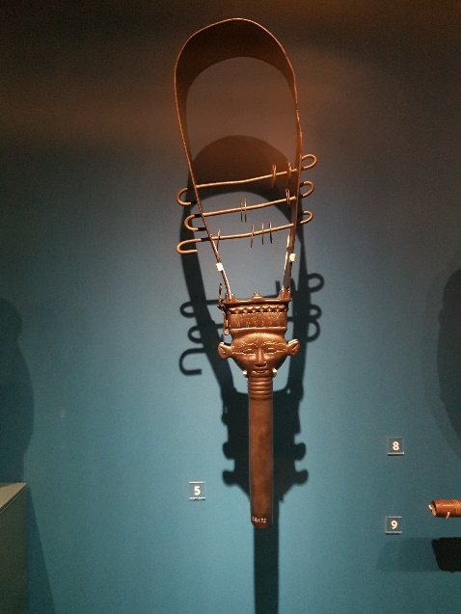

This picture is of another percussion instrument
called the sistrum. This sistrum is made of bronze
and there are many examples of replicas being
played, it is noted that it is similar to a tamborine,
its sound said to be quite close to the ‘hissing’ of a snake.
This example is from the Late Period, 664-332 BCE.

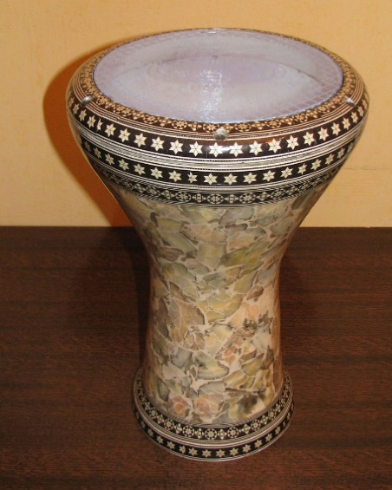

This is a modern Egyptian version of the goblet drum,
made from a skin of an animal the drum was common
place in the late Kingdom and is still used in Egyptian
folk music today.

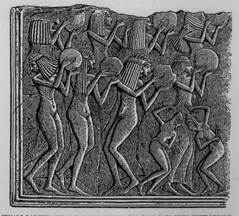

Here is an Egyptian carving or painting depicting
the use of the goblet drums use in music, it
portrays many female musicians performing
in a ritual of dance.

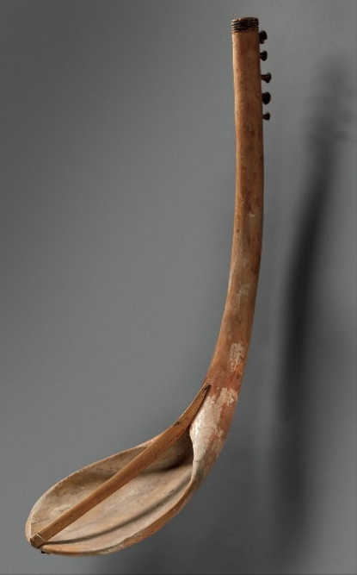

On the left is a picture of an ancient Egyptian ‘bow harp’,
it had five strings attatched to the base that would have
resonated a piece of animal skin. This bow harp is from
2030-1640 BCE.

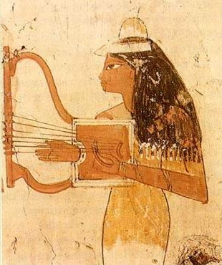

The ancient Egyptian ‘lyre’ is a harp like instrument,
there is many examples of this instrument being
played throughout Egypts history. The image on the
right is a relief of an ancient Egyptian playing a lyre.

This concludes the research I will take on the different instruments that the Egyptians had available at their disposal, the next step in the goal to actualise an exhibition is to send off a request/proposal.

The next assignment was a proposal to the York Museum for the exhibition, in this process I researched ways to build a theme to include in my pop-up exhibition. I had already settled on a music theme, and it seemed to be suited to be placed in the York Art Gallery. Finding other art galleries with music exhibition are rare, but it Is a concept that is in place in those few. The current exhibitions (as of 14/11/2022) have no focus or theme on music whatsoever, so adding something new to the museum may increase the number of patrons and possibly donators. The image below shows the first page of the proposal for the exhibit.
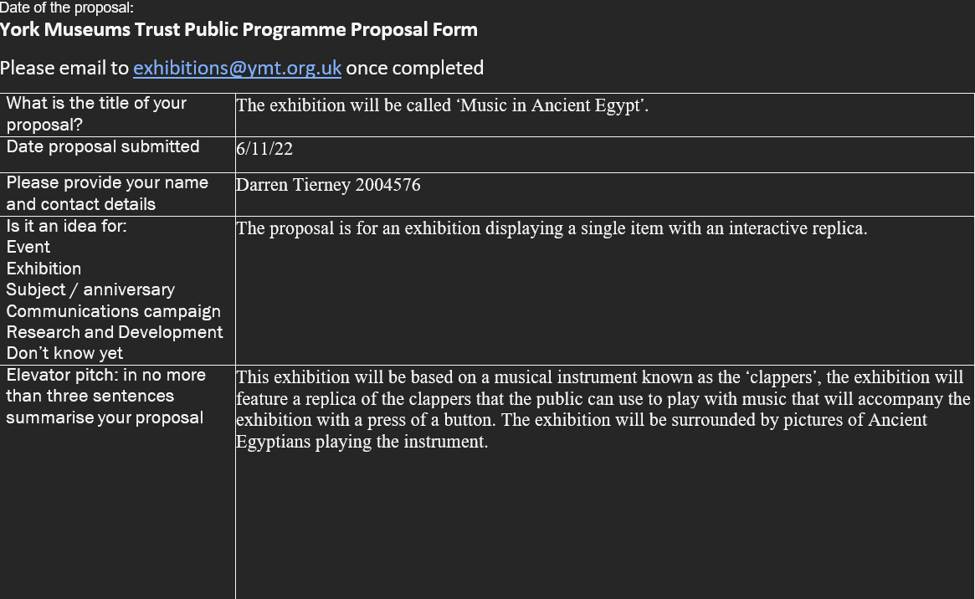

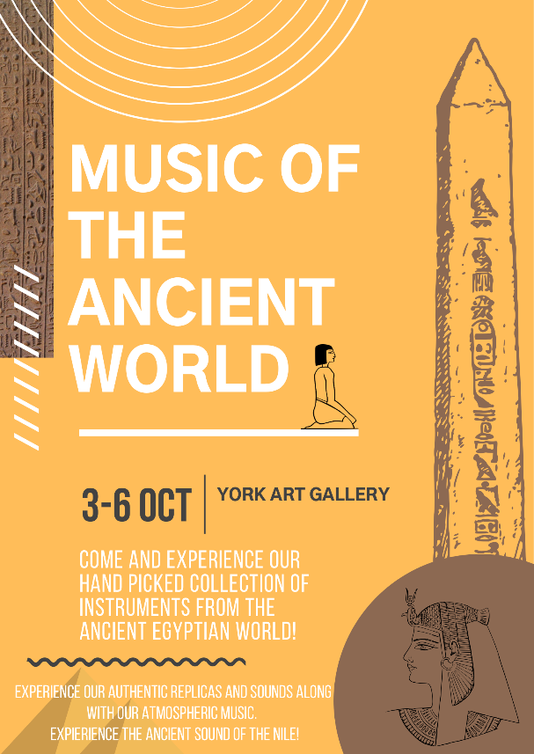

The next assignment was a mock social
media post to advertise the exhibit,
I had many choices to make but ultimately,
I went with designing a poster.
In this I researched other posters that were made for
exhibits by other museums and art galleries.
I found that within art galleries a simple and aesthetically
pleasing design was favoured more than simply a
poster with an image with a block of text,
so, I chose to do something similar.

Outline of Exhibit-
Title of exhibition- Music in the ancient world.
The exhibition will be a display of the clappers with accompanying replicas, there will be ‘authentic’ ancient Egyptian sounds in the form of music that will alternate between tracks to increase variation. All the exhibits will feature replicas, and if unable (i.e., the flimsy and expensive nature of the lyre) there will be a keyboard replacement with the sounds loaded on. The clapper’s exhibition will be the centrepiece of the exhibit and surrounded with other displays of instruments that follow the same theme of music and the ability to try out replicas. The walls will be covered in art that shows people playing these instruments. The room will be tinted a warm yellow, to replicate the sandstone of the paintings to give it a colour theme that will make a more memorable experience for children and adults alike.
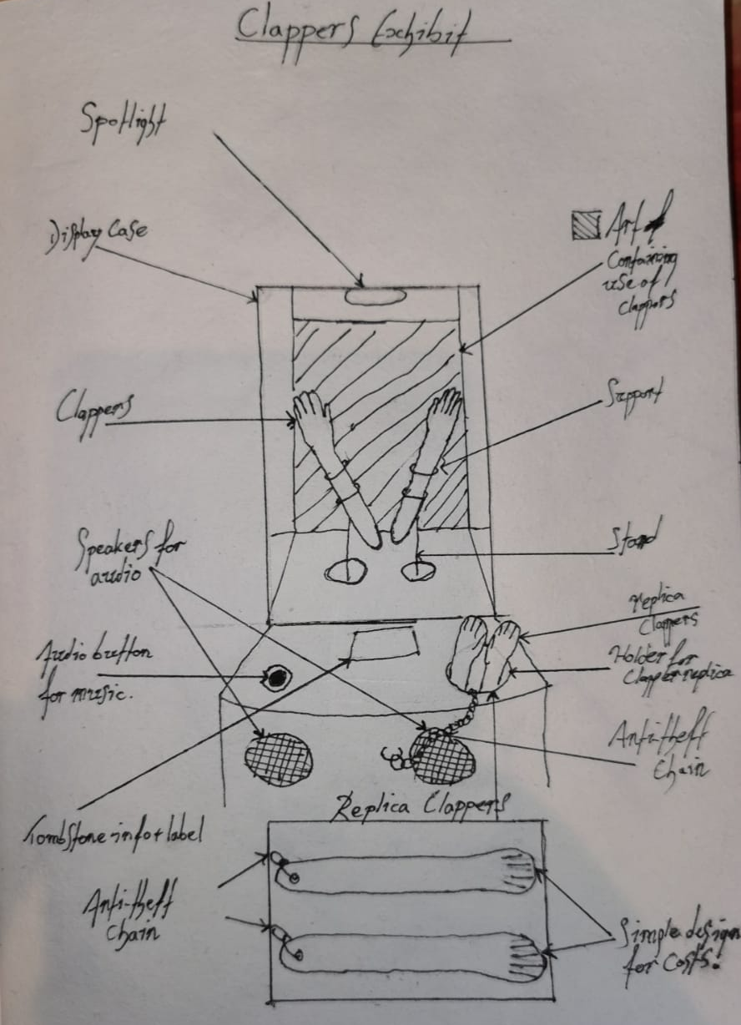

Here is an example of the clappers exhibit, if it is difficult
to get all the instruments with this collection then a
simple speaker and button system to use just the music
for the one exhibit. The following design would be
applicable to all of the accompanying exhibits.

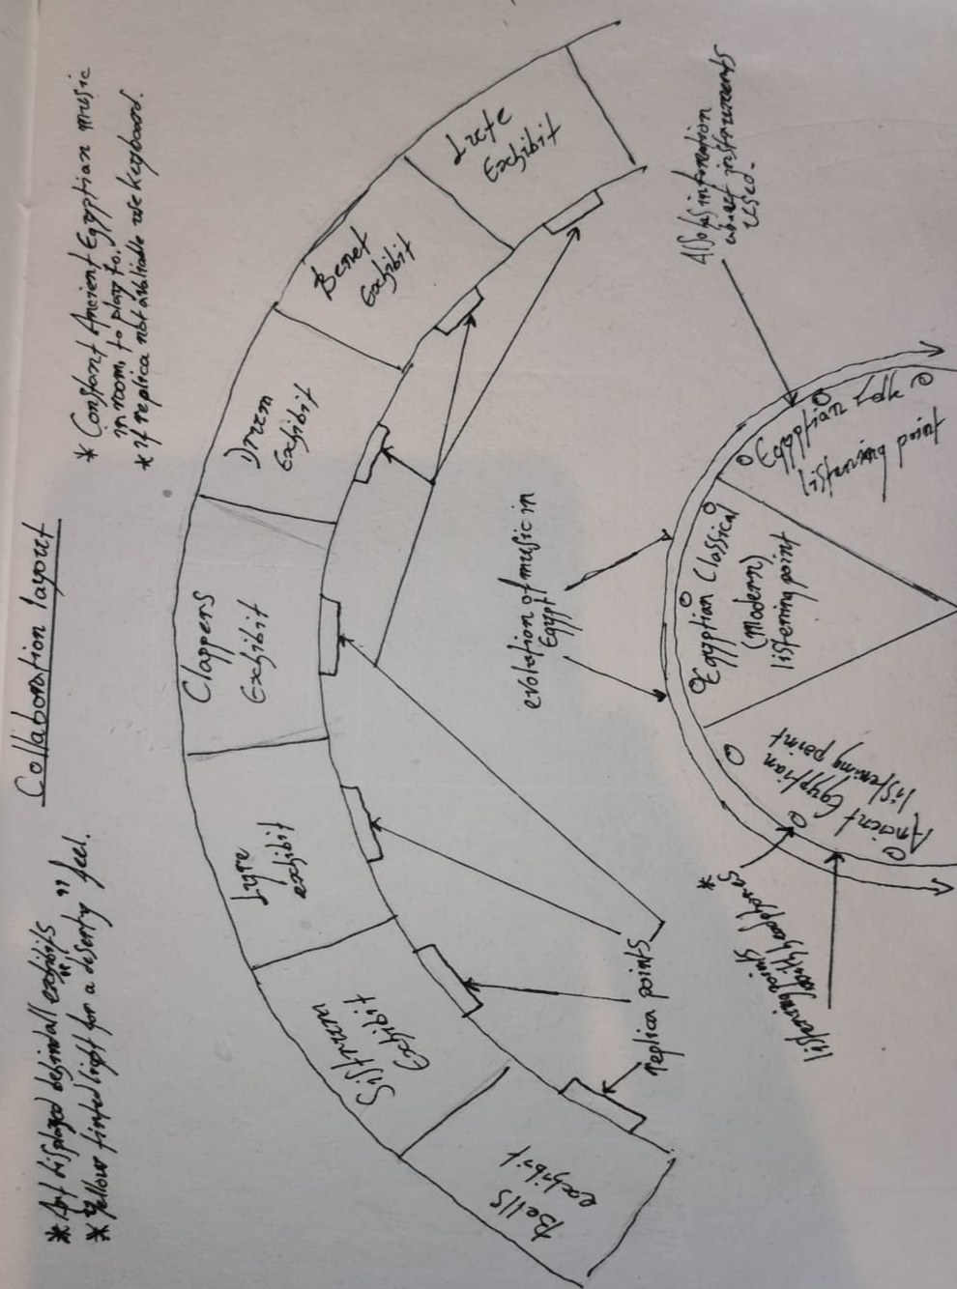

This is the layout of the theorised exhibit with
accompanying collections, and a checklist.
At the bottom of the exhibition plan there is a
section with headphones where you can listen to
different pieces of Egyptian music, ranging from
Ancient, to modern day classical, to modern day
folk. This will show a timeline of music, and
show how some of the instruments are still
in use today even if they have evolved.

Bibliography

Main Sources-
Keddie Sofie (2021), CCM-2018.994, Clappers
Earp Lilian (2020), CCM-2018.994, Clappers
Clarke Tom (2021), CCM-2018.994, Clappers
Zinn Katarina. Personal Communication. (2022)
Secondary Sources-
‘English translation of ancient Egyptian song at the Golden Parade’, EgyptToday <https://www.egypttoday.com/Article/4/100578/English-translation-of-ancient-Egyptian-song-at-the-Golden-Parade> [accessed 15 November 2022]
Images-
‘Show Me: Bone Clappers’, Show Me <https://show.me.uk/collection/bone-clappers/> [accessed 15 November 2022]
Bartle Oliver (2022).
Tierney Darren (2022).
‘clapper | British Museum’, The British Museum <https://www.britishmuseum.org/collection/object/Y_EA37302> [accessed 15 November 2022]
‘ANE TODAY - 201801 - The Earliest Music in Ancient Egypt - American Society of Overseas Research (ASOR)’, American Society of Overseas Research (ASOR) <https://www.asor.org/anetoday/2018/01/earliest-music-egypt/> [accessed 15 November 2022]
Miate, Liana, ‘Egyptian Bronze Sistrum’, World History Encyclopedia, 19 May 2017 <https://www.worldhistory.org/image/6671/egyptian-bronze-sistrum/> [accessed 15 November 2022]
‘Music in Ancient Egypt’, Index of / <https://exhibitions.kelsey.lsa.umich.edu/galleries/Exhibits/MIRE/Introduction/AncientEgypt/AncientEgypt.html> [accessed 15 November 2022]
<https://www.metmuseum.org/art/collection/search/544242> [accessed 15 November 2022]
‘An Introduction to Ancient Egyptian Music’, Egypt Travel Guide - Tour Egypt <http://www.touregypt.net/featurestories/music.htm> [accessed 15 November 2022]

Keddie S. (2021), CCM-2018.994, Clappers; Clarke Tom (2021), CCM-2018.994, Clappers
Zinn K. (27/10/2022) Personal Communication
Tierney D. (2022), Diagram of the right clapper hand
Bartle O. (2022), Clappers
Tierney D. (2022), Object handling questions
Tierney D. (2022), Nails
Tierney D. (2022), Macro of nails
Tierney D. (2022), Right arm flipped
Tierney D. (2022), Lightbox Photo
Tierney D. (2022), Object Label
L ‘English translation of ancient Egyptian song at the Golden Parade’, EgyptToday <https://www.egypttoday.com/Article/4/100578/English-translation-of-ancient-Egyptian-song-at-the-Golden-Parade> [accessed 15 November 2022].
Earp, L. (2020), CCM 2018.994 Clappers
Web Image, ‘Show Me: Bone Clappers’, Show Me <https://show.me.uk/collection/bone-clappers/> [accessed 15 November 2022].
Web Image, ‘clapper | British Museum’, The British Museum <https://www.britishmuseum.org/collection/object/Y_EA37302> [accessed 15 November 2022].
Web Image, ‘ANE TODAY - 201801 - The Earliest Music in Ancient Egypt - American Society of Overseas Research (ASOR)’, American Society of Overseas Research (ASOR) <https://www.asor.org/anetoday/2018/01/earliest-music-egypt/> [accessed 15 November 2022].
Web Image, ‘ANE TODAY - 201801 - The Earliest Music in Ancient Egypt - American Society of Overseas Research (ASOR)’.
Web Image, Liana Miate, ‘Egyptian Bronze Sistrum’, World History Encyclopedia, 19 May 2017 <https://www.worldhistory.org/image/6671/egyptian-bronze-sistrum/> [accessed 15 November 2022].
Web Image, Photograph, Rani777, Darbouka égyptienne (tabla) (08/01/2008) [Accessed 15/11/2022]
Web Image, ‘Music in Ancient Egypt’, Index of / <https://exhibitions.kelsey.lsa.umich.edu/galleries/Exhibits/MIRE/Introduction/AncientEgypt/AncientEgypt.html> [accessed 15 November 2022].
Web Image, <https://www.metmuseum.org/art/collection/search/544242> [accessed 15 November 2022].
Web Image, ‘An Introduction to Ancient Egyptian Music’, Egypt Travel Guide - Tour Egypt <http://www.touregypt.net/featurestories/music.htm> [accessed 15 November 2022].
Tierney D. (2022), YMT Proposal
Tierney D. (2022), Exhibition Poster
Tierney D. (2022), Clapper Exhibit
Tierney D. (2022), Collections Exhibit

