

Student name: Monalene Anne Ho
Student ID: 2311680
Lecturer’s Name: Lou Wells
Module name: Psychopathological Classifications and Provisions
Module code: (BMHP6029_LON)
Acknowledgement of the use/non-use of AI: I confirm that I have not used any ai tools in the research and creation of this assignment. I confirm that I have not presented any AI generated materials as my own work. I confirm I have copies of my drafts, notes and other resources I used, which I may be asked to provide in evidence.

Understanding Schizophrenia

Introduction  Schizophrenia is classified under psychotic disorders in the ICD-11, characterized by distorted thinking, perception and emotion (World Health Organization, 2023).  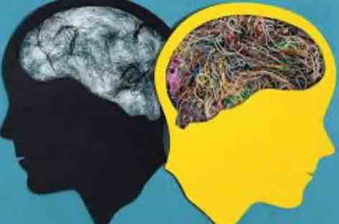(Hardie, 2021)  A long-term mental disorder that alters how people interpret reality, causing hallucinations, delusions and disorganized thought. It is recognized as a neurodevelopmental and neurochemical condition linked to dopamine imbalance (NICE, 2022; McCutcheon et al., 2019).  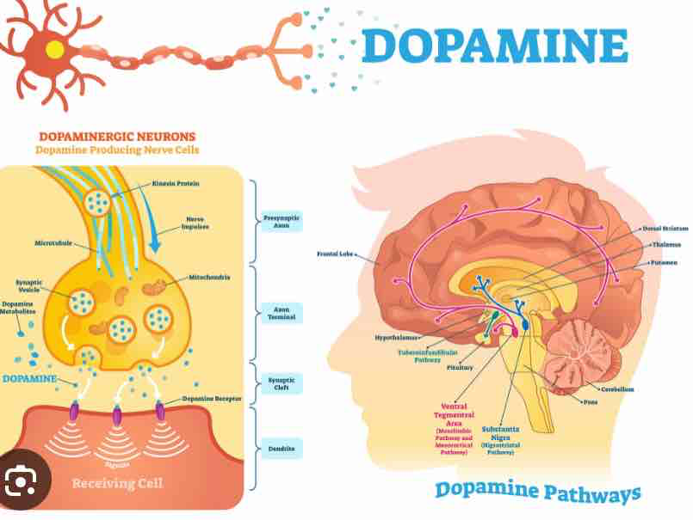(Hardie, 2021)  In England, schizophrenia affects about 0.7 % of adults (1 in 100 people) and around 24 million people worldwide, making it a major public-health concern (NHS Digital, 2023; WHO, 2023).  (Hardie, 2021)  Historical perspectives and treatments  In the 19th century, schizophrenia was seen as madness.People were confined under the Lunacy Act 1890 with little understanding of brain function (Shorter, 2018).  (Hardie, 2021)  By the 1950s, treatments such as insulin coma therapy, ECT, and early antipsychotics were used (Jones and Harrison, 2019).  The Mental Health Act 1959 introduced community-based care and recognised patient rights (The King’s Fund, 2021).  Today, modern therapies and rights-based care reflect a shift from control to compassion (Mind, 2023).  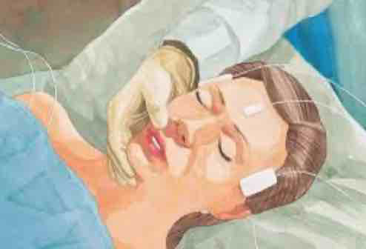(Hardie, 2021) |  | Definition  Schizophrenia is a primary psychotic disorder distinguished by disruptions meaning persistent hallucinations, delusions and disorganized thinking that are not caused by mood disorders, anxiety, or personality disorders. Its core features reflect abnormalities in brain development and dopamine signaling, making it fundamentally different from conditions driven by mood, fear, or trauma (Jones & Harrison, 2019; Owen & Zammit, 2020).  (Hardie, 2021)  Causes  Brain structure differences such as reduced grey matter and disrupted frontal-lobe function have been consistently linked with schizophrenia (McCutcheon, Reis Marques & Howes, 2019).  Dopamine dysregulation, particularly excess dopamine activity in mesolimbic pathways, contributes to hallucinations and delusions (Howes & Kapur, 2019).  Genetic vulnerability: risk rises to around 10% with a first-degree relative affected; Strong genetic risk, strong hereditary association (Owen & Zammit, 2020).  Environmental risks: prenatal infections, childhood trauma, chronic stress, cannabis misuse and social deprivation all increase vulnerability (NICE, 2022).  Multifactorial: schizophrenia emerges from the interaction of biological predisposition and environmental stressors (NICE, 2022; McCutcheon et al., 2019).  No single cause- schizophrenia results from biological and environmental interaction (NICE, 2022).  Brain structure changes such as reduced grey matter suggest disrupted neurodevelopment (McCutcheon et al., 2019).  Dopamine imbalance linked to hallucinations and delusions (Howes & Kapur, 2019).  Environmental triggers include prenatal infection, trauma, stress and cannabis misuse (NICE, 2022). |  | Current services and treatments  Modern care follows a biopsychosocial model, combining medication, therapy and social support (WHO, 2023).  NICE (2022) recommends antipsychotics with CBT-p and family therapy.  Early Intervention in Psychosis (EIP) services offer fast community help to prevent relapse (NHS Digital, 2023).  Policies emphasize recovery, co-production, and inclusion, though funding and stigma remain challenges (The King’s Fund, 2021; Mind, 2023).  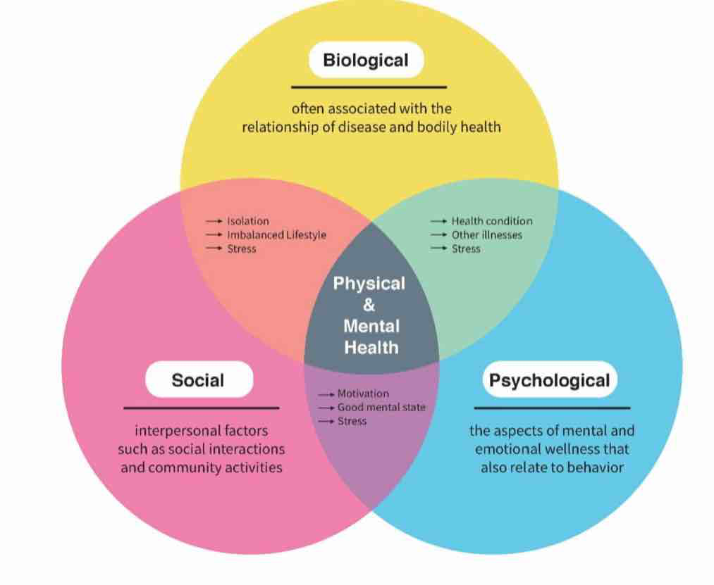(Hardie, 2021)  Recommendations  Expand EIP and community-based support nationally (Fusar-Poli, 2021).  Provide family education and carer involvement in all trusts (NICE, 2022).  Combine medication with evidence-based psychological therapies (Roberts, 2021).  Improve access to long-acting injectables and physical-health checks (Emsley et al., 2023).  Address social determinants such as housing, poverty and stigma (Mind, 2023; The King’s Fund, 2021).  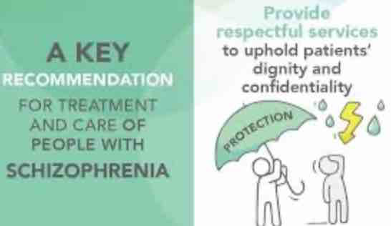(Hardie, 2021)  Conclusions  Schizophrenia is a complex brain-based disorder influenced by genetics and environment.  The UK’s journey from asylums to recovery-focused care shows major ethical and scientific progress.  Early intervention, personalized therapy and sustained investment are vital to ensure equality, dignity and long-term recovery.  (Hardie, 2021)
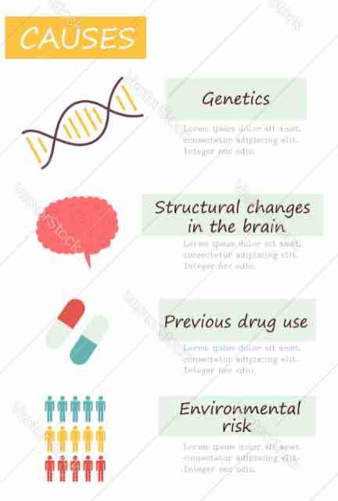(Hardie, 2021)
Symptoms
Positive symptoms:
- Hallucinations, most commonly hearing voices (WHO, 2023).
- Delusions, including paranoid or grandiose beliefs (WHO, 2023).
- Disorganised thinking or speech, making communication difficult (NICE, 2022).
Negative symptoms:
- Lack of motivation and reduced activity (NICE, 2022).
- Flat or limited emotional expression (WHO, 2023).
- Social withdrawal and reduced self-care (NHS Digital, 2023).
Cognitive symptoms:
- Poor concentration and distractibility (NICE, 2022).
- Memory difficulties and slower information processing (McCutcheon et al., 2019).
- Impaired decision-making and problem-solving (NICE, 2022).
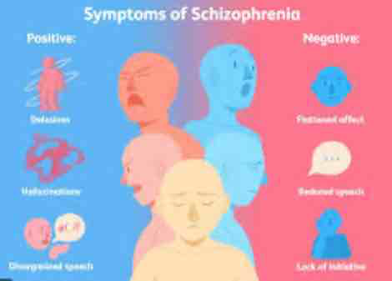(Hardie, 2021)

Diagnosis
Diagnosed using ICD-11 criteria (6A20): persistent psychotic symptoms such as hallucinations, delusions or disorganised thinking for ≥ 1 month (World Health Organization, 2023).
Requires a comprehensive psychiatric assessment, including mental state examination and functional impact (NICE, 2022).
Clinicians must exclude other causes such as substance use, neurological illness or mood disorders before confirming schizophrenia (NICE, 2022).
Use of structured tools like the Positive and Negative Syndrome Scale (PANSS) can help measure symptom severity (NICE, 2022).
Collateral information from family or carers improves diagnostic accuracy and early detection (NHS Digital, 2023).
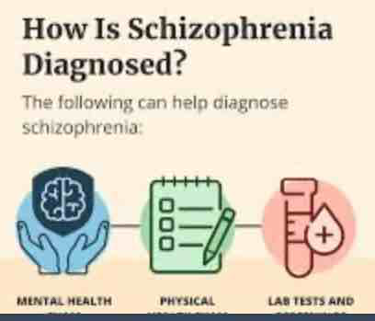(Hardie, 2021)

References
Emsley, R., Chiliza, B., Asmal, L. and Harvey, B.H. (2023) ‘Long-acting injectable antipsychotics in schizophrenia’, BJPsych Open, 9(3), e94.
Fusar-Poli, P. (2021) ‘Integrated early intervention for psychosis: a critical review’, The Lancet Psychiatry, 8(1), pp. 65–75.
Hardie, M. (2021). Three aspects of health and healing: The biopsychosocial model in medicine. [online] Department of Surgery. Available at: https://surgery.wustl.edu/three-aspects-of-health-and-healing-the-biopsychosocial-model/.
Howes, O. and Kapur, S. (2019) ‘The dopamine hypothesis of schizophrenia: version III’, Schizophrenia Bulletin, 45(1), pp. 20–25.
Jones, R. and Harrison, P. (2019) Understanding Psychotic Disorders. Cambridge: Cambridge University Press.
McCutcheon, R.A., Reis Marques, T. and Howes, O.D. (2019) ‘Dopamine and the pathophysiology of schizophrenia’, Nature Reviews Neuroscience, 20(9), pp. 467–482.
Mind (2023) Living with Schizophrenia. London: Mind. Available at: https://www.mind.org.uk (Accessed: 17 November 2025).
National Institute for Health and Care Excellence (NICE) (2022) Schizophrenia: Diagnosis and Management (CG178). London: NICE. Available at: https://www.nice.org.uk/guidance/cg178 (Accessed: 17 November 2025).
NHS Digital (2023) Mental Health Bulletin: Adults with Schizophrenia in England, 2023. Leeds: NHS Digital. Available at: https://digital.nhs.uk (Accessed: 17 November 2025).
Owen, M. and Zammit, S. (2020) Schizophrenia and Genetics. London: Routledge.
Roberts, G. (2021) Recovery from Severe Mental Illness. London: Palgrave Macmillan.
Shorter, E. (2018) The History of Psychiatry: From the Asylum to the Brain. Oxford: Oxford University Press.
The King’s Fund (2021) Community Mental-Health Services in England. London: The King’s Fund. Available at: https://www.kingsfund.org.uk (Accessed: 17 November 2025).
World Health Organization (WHO) (2023) ICD-11: 6A20 Schizophrenia. Geneva: World Health Organization. Available at: https://icd.who.int (Accessed: 17 November 2025).

