DS 1 Template

My Screenshots/Photos
- Please add 4–6 screenshots or photos of your digital life.
- You can use your phone or laptop.
- For each screenshot, write one or two sentences explaining what it shows.

Screenshot/Photo 1
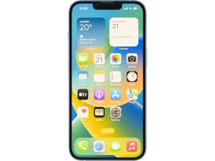
- My main digital tool that I use daily, is an apple Iphone. I use this phone for online banking, online research, communication. I feel good at all these task as I am competent with my iPhone, I know how to use its feature to deal with the task at hand. I want to improve on my research skills, to enhance my ability to conduct work in a productive and efficient way.

Screenshot/Photo 2
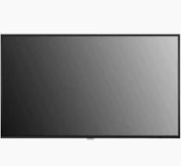
- My second digital tool, which I am most familiar with is my television. I use this tool to conduct research on YouTube. I sometimes use my television to do research on the internet. I also use my tv to play games, watch sports and movies. Theses skills matter as it allows me to draw creative ideas, from different content I consume. Which will allow me to have a better understanding in the future, and allow me to make better decisions.

Screenshot/Photo 3
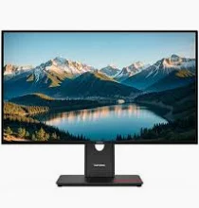
My digital tool of choice is a personal computer. I feel good at using a PC, as it allows me to complete my university assignments. PCs also allow me to do research, send emails, receive emails. My university also has a database online which I can access via my PC. I need to improve on my overly knowledge of using PCs, which will allow me to use a PC to its best ability, which will make me conduct work efficiently.

Screenshot/Photo 4
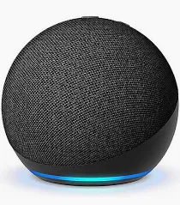
- My digital tool is an alexa. I use this to listen to music, to find out the time, also to understand local weather forecasts. I can improve with this product by using the other features it has, this will help my as it will give me a widen opportunity to use my alexa for different features.

Screenshot/Photo 5
[Insert Photo/Screenshot below]

[Write what this shows of your digital life]

Screenshot/Photo 6
[Insert Photo/Screenshot below]
[Write what this shows of your digital life]

My Short Reflection
- Write 5–8 simple sentences about your digital life.
- You can use the sentence starters below if helpful.

Sentence starters
- I use digital tools to …
- I feel confident when I …
- I want to improve …
- I often use these tools: …
- I sometimes feel nervous about …
- I hope this module will help me …
- Digital skills are important for me because …
You can write more if you want.

Submission Checklist
Before you submit, please check:
​​​ ☐ I added 4–6 screenshots
☐ I wrote short sentences for each screenshot
☐ I wrote my short reflection
☐ My work is my own
☐ My file opens correctly
​​☐ My file opens correctly

