Name Matt Gaff
Student Number 2203979

Human Evolution and the Origins of Modern Human Behaviour

Practical exercise 2023

Please indicate your response clearly

Looking at faces 1
Look at the following images and then compare them to the list below. Indicate clearly (circle or highlight) the name of the early hominin skull you believe this to be.
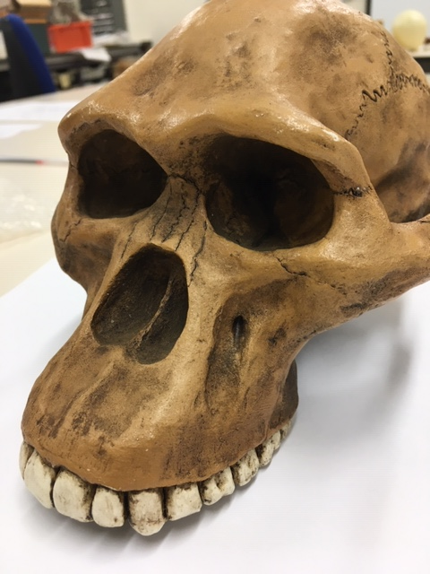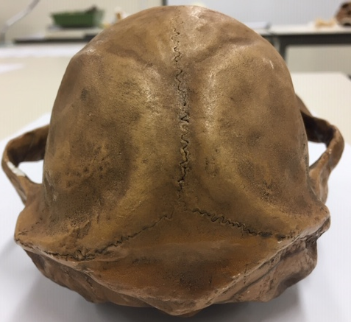

Chimpanzee

Australopithecus afarensis

Australopithecusafricanus

Australopithecus robustus

Homo habilis
Looking at faces 2
Look at the following images and then compare them to the list below. Indicate clearly (circle or highlight) the name of the early hominin skull you believe this to be.
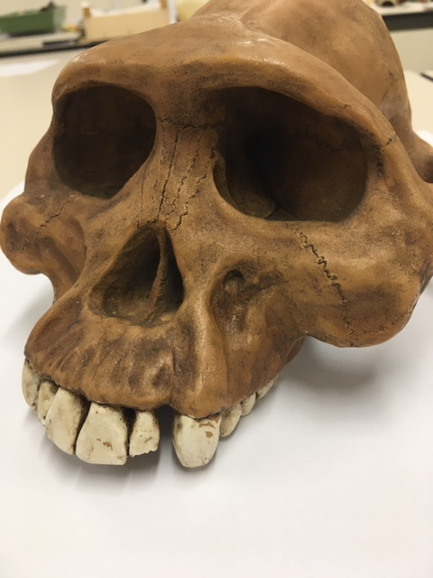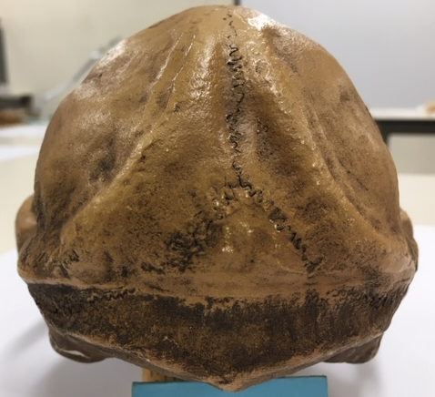

Chimpanzee

Australopithecus afarensis

Australopithecusafricanus

Australopithecus robustus

Homo habilis

Looking at faces 3
Look at the following images and then compare them to the list below. Indicate clearly (circle or highlight) the name of the early hominin skull you believe this to be.
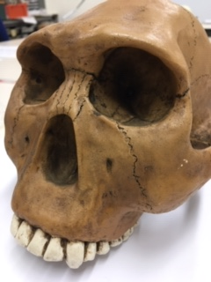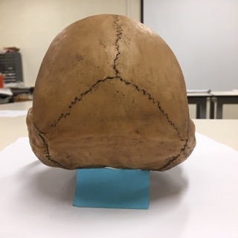

Chimpanzee

Australopithecus afarensis

Australopithecusafricanus

Australopithecus robustus

Homo habilis
Maxilla (upper jaw): Identify the species these belong to
A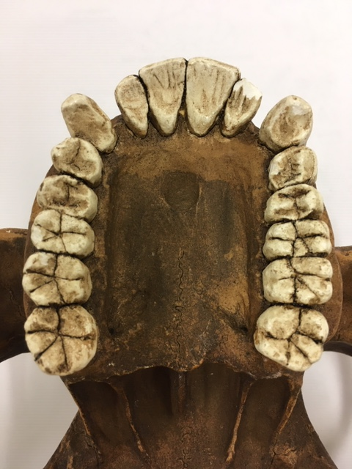B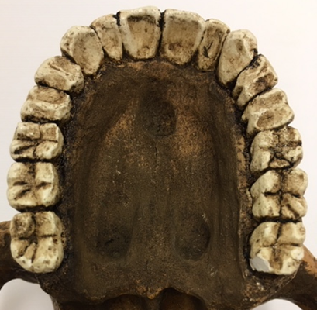
A Middle Australopithecus afarensis B Modern Human
Top row left Chimpanzee, Middle Australopithecus afarensis, Right modern human
Lower row Left Australopithecus africanus, Right Australopithecus robustus
Indentify the skull to genus and species level
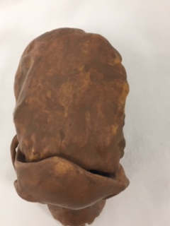
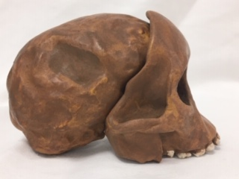
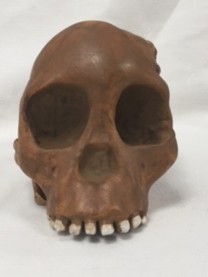
Answer Australopithecus africanus
Indentify the skull to genus and species level
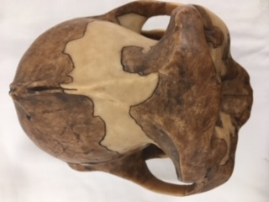
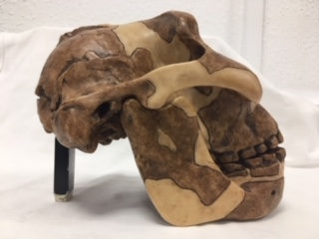
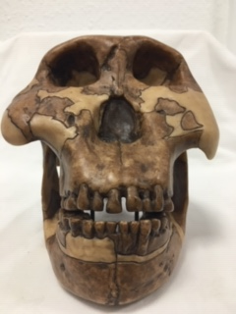
Answer Australopithecus Robustus
Identify the hominin skull to genus and species level
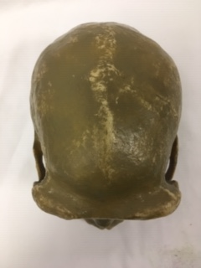

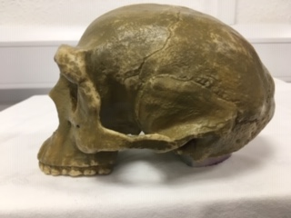

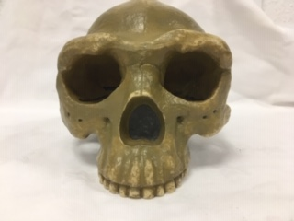
Answer Homo Erectus
Indentify the skull to genus and species level
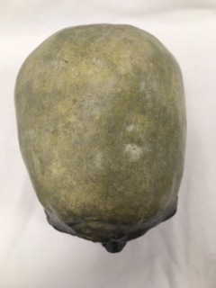
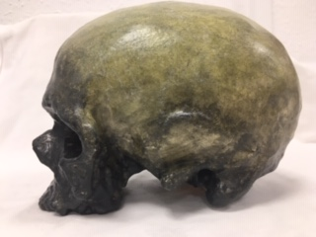
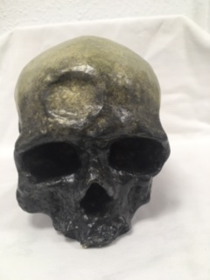
Answer Homo Sapien/ Cro-Mangon
Identify, compare and contrast these two mandibles. Use the illustration below to help if you need to.
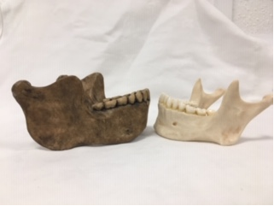
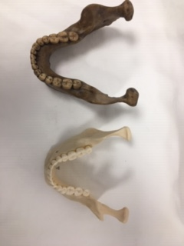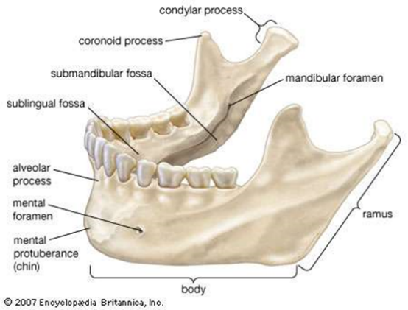

Answer: Larger teeth in older mandible, Homo heidlebergensis. The Homo heidlebergensis is more robust compared to the Homo sapien mandible. The Homo heidlebergensis is larger compared to Homo sapien mandible. Thicker Mandible in the Homo heidlebergensis and a thicker Coronoid process and a smaller candylar process compared to Homo sapien. Both have no gaps in teeth. However, Homo sapien has a mental protuberance whereas the Homo heidlebergensis has no mental protuberance. The Homo heidlebergensis has larger teeth than the Homo sapien.

Stone tools and tool technology: How to tell a stone is worked.
What features suggest this stone has been worked (knapped)?
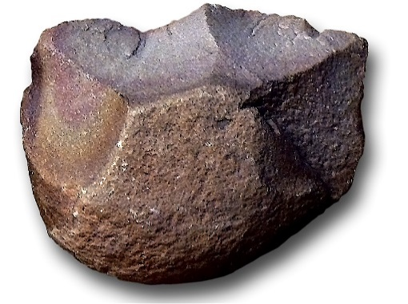
Answer Evidence of Flake scars are seen on the stone showing where the stone has been hit. The Bulb of Percussion can be seen as well as the flake scars going in different directions which disputes the idea of natural breakage.

Features of stone tool flaking: identify features 1-5

1. platform
2. Point of percussion
3. Bulb of percussion
4.Fissures
5.Ripples

Stone tools and tool technology: Stone tools not to scale
Below left: Oldowan Below Right: Acheulean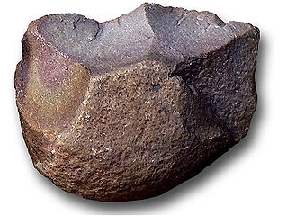 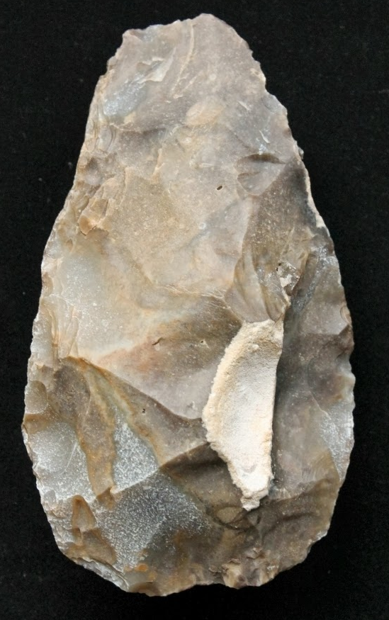
Images taken from https://images.search.yahoo.com

Task: Compare and contrast these two stone tools
The Acheulean shows massive amounts of Flake scars. The Oldowan is simple and known to be early Homo material. The Acheulean is more complex and shaped to an oval shape whereas the Oldowan still keeps it is shape with a few modifications caused by the knapping. No core text seen in the Acheulean. The Acheulean is seen to be in a pear shape and more complex compared to the Oldowan. The Acheulean is elongate, Thick one end and, unlike the Oldowan, the Acheulean has been knapped at the area where the hand is placed.

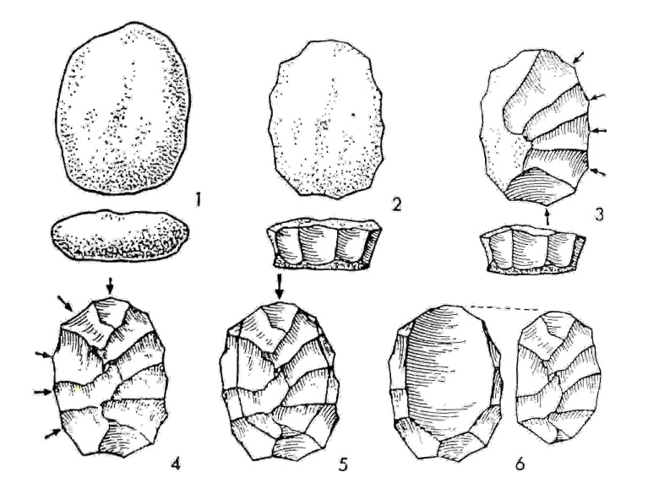
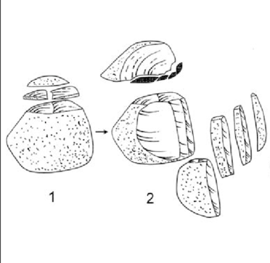
Above left: Levallois Technique and above right: Upper Palaeolithic blade technology

Task: Imagine you are a mobile Hunter-Gather-Forager, briefly outline why these (Middle and Upper Palaeolithic) technologies would be seen as an advantage above the Oldowan and Achulean
With the Levallois Technique, you can have more blades from one core. All flakes are effective and sharp and can be used. Both are small and easy to transport and carry around. When making the Oldowan and the Achulean, there is more flakes but unlike the Levallois Technique and the Upper Palaeolithic blade technology, the flakes are unable to be made into another blade. Massive increase in cutting edge so more stone flakes then the Achulean, could carry core around to reuse the flakes.

