DESIGN AND IMPLEMENTATION OF A RELATIONAL DATABASE SYSTEM

Table of Contents
1. Introduction 3
2. Conceptual Database Design (ERD) 3
2.1 Identified Entities 3
2.2 Relationships and Cardinality 4
3. Logical Design and Relational Schema 4
4. Normalisation Process 5
4.1 Unnormalized Form (UNF) 6
4.2 First Normal Form (1NF) 6
4.3 Second Normal Form (2NF) 6
4.4 Third Normal Form (3NF) 7
5. Sample Data Population 8
6. Query Development 8
7. Testing and Validation 9
8. Design Decisions 10
9. Challenges 10
10. Future Work 10
11. Conclusion 11
Reference List 12

1. Introduction
Relational database systems are important in the effective and secure management of organised organisational information. MediLink Pharmacy needs a database that would be able to store and process the information concerning patients, doctors, pharmacists, prescriptions and medicines. A good database design guarantees data integrity, reduction of redundancy as well as effective and accurate reporting. Reliable relational systems can only be developed through going through conceptual and logical modelling stages (Shin et al. 2025). Moreover, logical database design has a direct effect on the performance, storage and query complexity (Taipalus, 2025). The assignment is a design, normalisation and implementation of relational database system as suited to the pharmacy management operations.

2. Conceptual Database Design (ERD)
The conceptual database design converts organisational requirements into organised entities known as attributes and relationships that effectively reflect real-life operations. The conceptual model used to develop in the case of MediLink Pharmacy was created to help depict the interaction of the patients, doctors, pharmacists, prescriptions and medicines in the process of dispensing. The conceptual, logical and physical phases should have a clear transition to prevent the structural inconsistencies and modelling errors (Shin et al. 2025). The whole database system is thus based on the Entity Relationship Diagram (ERD) and business rules are well visualised prior to being implemented.

2.1 Identified Entities
The scenario identified six central objects, namely: Patient, Doctor, Pharmacist, Prescription, Medicine, and Prescription_Details.
The Patient entity holds contact and demographic data needed to track prescriptions. The Doctor entity contains the records of the prescribing professionals and their specialisation. The Pharmacist entity denotes employees charged with the dispensing of medication. The Prescription entity is a transactional document connecting the patients, physicians and pharmacists. The medicine entity presents data on the inventory like category, cost, and quantity. Lastly, Prescription Details is an associative table, which documents individual medicines that are a part of each prescription.
Attributes are part of each entity defining their uniqueness. Primary keys (PK) ensure that one(PK) exists only once and foreign keys (FK) provide referential integrity between entities. With structured relational modelling, data consistency, maintainability and scalability are better in a transactional system (Azuddin et al. 2025).
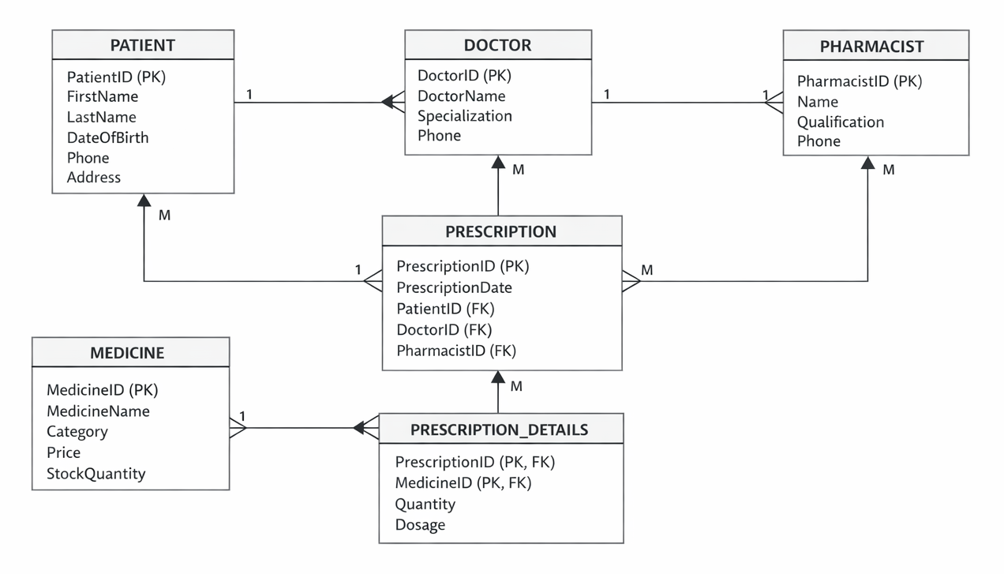
Figure: Entity Relationship Diagram
(Source: Self-Created)

2.2 Relationships and Cardinality
The ERD defines some one to many relationships: a patient may have many prescriptions, a Doctor may have many prescriptions and a Pharmacist may process many prescriptions. There is also a many to many relationship between Prescription and Medicine because the Prescription might have many medicines and a medicine might be used in more than one Prescription. This many-to-many relationship is solved by the associative entity Prescription_Details, with the help of which it is possible to correctly track the dosage and the quantity. Associative entities are well-known as best practice in relational modelling as it enables flexibility and does not compromise data integrity (Deshpande, 2025).

3. Logical Design and Relational Schema
The conceptual model was then converted into a relational schema as per the standard schema mapping rules after the development of the Entity Relationship Diagram. Every entity in the ERD transformed into a corresponding relational table and the relationship was implemented through primary and foreign key constraints. The logical database design is important in calculating the size of the database, complexity of queries, efficiency of storage and the overall performance of the system (Taipalus, 2025). Thus, the right distribution of the attributes was also thought over the key choice and the enforcement of referential integrity constraints.
The resulting relational schema is as follows:
Table Name | Attributes
PATIENT | PatientID (PK), FirstName, LastName, DateOfBirth, Phone, Address
DOCTOR | DoctorID (PK), DoctorName, Specialization, Phone
PHARMACIST | PharmacistID (PK), Name, Qualification, Phone
PRESCRIPTION | PrescriptionID (PK), PrescriptionDate, PatientID (FK), DoctorID (FK), PharmacistID (FK)
MEDICINE | MedicineID (PK), MedicineName, Category, Price, StockQuantity
PRESCRIPTION_DETAILS | PrescriptionID (PK/FK), MedicineID (PK/FK), Quantity, Dosage
The key attributes in this type of structure are primary keys which are used to identify each record and foreign keys are used to enforce reference integrity among the related tables. The many-to-many relationship between medicines and prescriptions is solved using the associative table PRESCRIPTION_DETAILS that has a composite primary key. This structure reduces redundancy, eliminates anomalies that may occur in updating and facilitates effective retrieval of data with structurally related association.

4. Normalisation Process
Normalization is a method of organising the data in the relational databases to reduce redundancy and remove anomalies to the maximum. Data consistency is available through proper normalization, and structural efficiency is guaranteed (Swathi, 2020). However, database designers should find a balance between the notion of normalization and the concept of performance because excessive levels of decomposition can lead to a higher number of join operations and an impact on the efficiency of queries (Ajayi et al. 2025). It was changed into a third normal form (3NF) to the medilink pharmacy database gradually as Unnormalized Form (UNF).

4.1 Unnormalized Form (UNF)
In the first unnormalized design, repeats of medicine attributes were placed in one row in the prescription records and this includes Medicine1, Medicine2 and Medicine3. The format was redundant since more than one drug prescription was attached in a single record. Consequently, the anomalies during the insertion might take place in case of the new medicine to be added with the incomplete prescription information. Abnormalities of updates were also a possibility, as altering the medicine details had to be viewed as alterations in several fields. There are also chances of losing valuable information in case an important data was deleted by mistake. Thus, the UNF structure was not atomic and was against the key relational database principles.
Unnormalized Form (UNF) Structure
PrescriptionID | PatientName | DoctorName | PrescriptionDate | Medicine1 | Dose1 | Quantity1 | Medicine2 | Dose2 | Quantity2
1 | John Smith | Dr. Harris | 01-04-2024 | Amoxicillin | 500mg | 30 | Paracetamol | 500mg | 20
2 | Mary Johnson | Dr. Patel | 03-04-2024 | Ibuprofen | 200mg | 14 | — | — | —
3 | David Lee | Dr. Harris | 05-04-2024 | Aspirin | 100mg | 10 | Lisinopril | 10mg | 30

4.2 First Normal Form (1NF)
In order to attain First Normal Form, repeating groups were eliminated, and it was also made sure that only atomic values were present in each attribute. Rather than having many medicines in a single prescription record, the medicine was being registered as a separate row and connected to its corresponding prescription. This reorganization removed recurring columns and made sure that each field contained only one value. This led to more organised data and easier querying data. A 1NF goal enhanced the understanding of the structure and minimized insertion anomalies. But still, there were partial dependencies that required additional normalization in order to improve the relational integrity and efficiency.

4.3 Second Normal Form (2NF)
The second normal form was obtained by doing away with partial dependencies in tables that had composite primary keys. The composite key in the case of prescription-medicine relationship was PrescriptionID and MedicineID. Any one attribute that was dependent on all of this composite key was split into its own table. As an example, the information about patients and doctors was stored separately in separate tables, not in prescription records. This made sure that all the attributes that were not key were fully dependent upon the whole primary key. The 2NF helped to decrease redundancy and enhance consistency but yet again, transitive dependencies had to be refined to reach full normalization.

4.4 Third Normal Form (3NF)
Attainment of the Third Normal Form was made by eliminating transitive dependencies where the non-key attributes were only dependent on the master key. As an example, all the information about doctors was kept in the DOCTOR table and information about patients was kept in the PATIENT table. This avoided the indirect dependencies among the non-key attributes. Swathi (2020) says that 3NF can guarantee structural integrity by removing redundancies and ensuring no update anomalies. The final schema thus met all normalization requirements namely, repeating groups (1NF) do not exist, partial dependencies (2NF), and transitive dependencies (3NF). It offers a facility that facilitates effective storage, precision and sustainability.
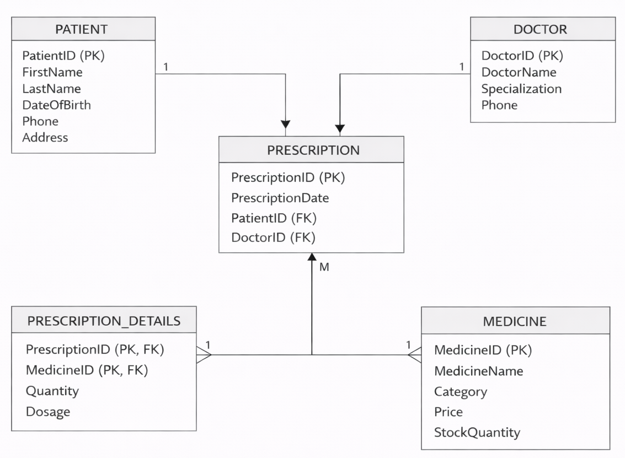
Figure: 3NF Structure
(Source: Self-Created)

5. Sample Data Population
Each of the relational tables was filled with sample records to mimic operations of a real pharmacy and ensure structural correctness. It was not investigated further and the database was filled with five patients, three doctors, five medicines and five prescriptions, as well as the corresponding entries in the Prescription_Details table to represent medicine allocations. This data set was used to test one to many and many to many relationships in the system. The use of sample data in the practical support helps to check the theoretical principles of database design and proves its functionality (Azuddin et al. 2025). The primary key constraints were used to make the records unique, whereas the foreign key constraints maintained the referential integrity between all tables related to the key.

6. Query Development
There were five designed queries used to elicit operational information out of the database. These were accessing the prescribed medicine of a particular patient, listing prescribed medicine of a given doctor, aggregate functions- showing the total cost of a given prescription, low-stock medicines, and prescription handled by the pharmacists. Such queries facilitate medical tracking, auditing, inventory control and accountability. An efficient query design will minimize Oracle complexity and increase the reactivity of the system (Taipalus, 2024). Besides, database organization is directly associated with the speed of execution and performance efficiency (Taipalus, 2025). The queries have proved to have efficient relational joins and proved the integrity of the database schema.
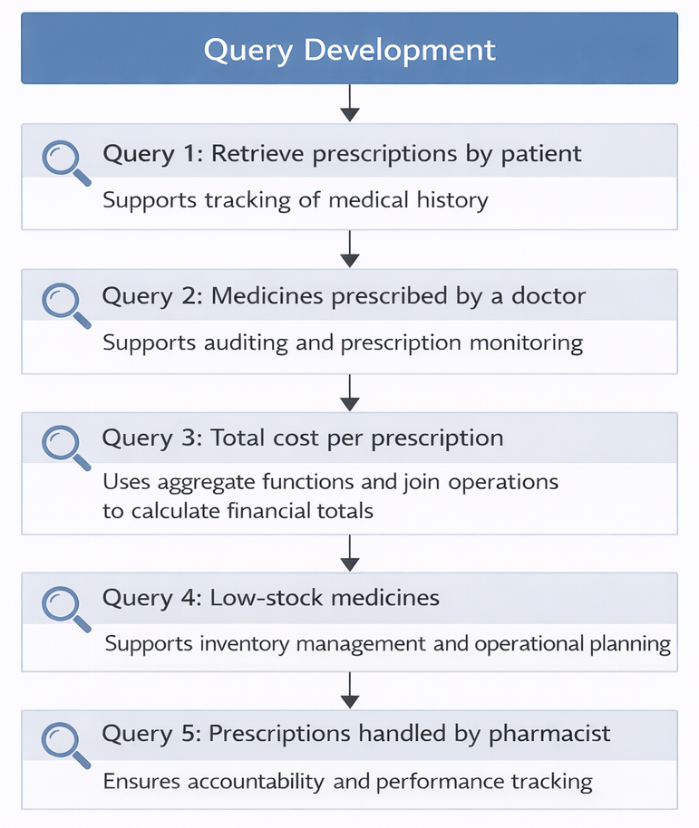
Figure: Query Development
(Source: Self-Created)

7. Testing and Validation
The system validation was done to make sure that no functional or structural requirements were not fulfilled. Primary key limitations were also carried out to ensure uniqueness of records whereas foreign key implementation reinforced referential integrity across committed tables. The constraint of the null values was used on obligatory attributes like identifiers and medicine names. Quantity of stock was screened to exclude invalid records and aggregate checks were handled to ensure financial correctness. The design of the logical database has a direct influence on the relational systems in terms of performance and energy efficiency (Taipalus, 2025). Also, the normalization process minimizes the redundancy, which increases the stability of performance and minimizes the risk of data inconsistency (Ajayi et al. 2025).

8. Design Decisions
The important design roles were to make sure that the design was structurally correct and maintainable over a long period of time. The associative table Prescription_Details was introduced to ensure that the many-to-many relationship between medicines and prescriptions was resolved according to the existing rules of relational modelling (Deshpande, 2025). This associative entity had composite primary keys that enforced the uniqueness. Normalization Principles were adhered to by separate entities to ensure redundancy was eliminated. Rational modelling is effective in increasing the level of scalability, functionality, and maintainability of transactional systems (Azuddin et al. 2025). These selections indicate the best practices in contemporary architecture and performance-based system design in the databases (Khan et al. 2023).

9. Challenges
There were a number of issues witnessed when developing a database. The shift towards conceptual ER modelling to logical relational schema had to be made carefully, through the interpretation of relationships and dependencies (Shin et al. 2025). To be completely able to comply with the Third Normal Form required systematic analysis of possible transitive dependencies. Also, there was a need to weigh normalization against performance criteria because over-normalization could lead to the complexity of the joins (Ajayi et al. 2025). By overcoming these obstacles, more knowledge was gained on the concept of database design and increased the robustness of the system. The refinement process made the modelling more precise, as well as maintained integrity and efficiency requirements.

10. Future Work
Further improvements may include more system functionality and scalability. The alert systems on stock levels could be automated to alert the pharmacists when the stocks are below certain set levels. Tracking of expiry dates would enhance the management of safety and compliance. Role based authentication would enhance data security and the control of access. Representation of optimisation of performance by indexing strategies would also increase speed of query execution. Also, a scalable cloud SQL would be a better option as migrations would enhance scalability and availability. The current database systems are embracing the distributed and cloud-enabled database system more frequently to improve the performance and flexibility (Khan et al. 2023). Such advancements would help sustainability in the long run and efficiency in operations.

11. Conclusion
Structured relational modelling principles were very effective in designing the MediLink Pharmacy relational database system and providing an effective implementation of the system. Data was seen to be free of redundancy through the use of ERD creation, transformation of schema, and normalization to 3NF. Logical database design is an important resource in terms of performance, storage efficiency and query optimisation.
The constraint and referential integrity were properly enforced, which was tested and validated. The last system reflects the successful implementation of the relational database theory into the realistic pharmacy management setting.

Reference List
Ajayi, W., Okesola, K., Nteziryayo, D., Odo, F. and Akpan, A.U., 2025. Relational Database Normalization vs Denormalization: A Performance Perceptive. Asian Journal of Electrical Sciences, 14(2), pp.53-66.
Azuddin, M., Yusup, M., Setiyowati, H., Wibowo, S., Suwita, J., Basuki, S. and Astuti, E.D., 2025. Design and implementation of a relational database for an academic information system. International Transactions on Artificial Intelligence, 3(2), pp.171-180.
Deshpande, A., 2025. Beyond Relations: A Case for Elevating to the Entity-Relationship Abstraction. arXiv preprint arXiv:2505.03536.
Khan, W., Kumar, T., Zhang, C., Raj, K., Roy, A.M. and Luo, B., 2023. SQL and NoSQL database software architecture performance analysis and assessments—a systematic literature review. Big Data and Cognitive Computing, 7(2), p.97.
Shin, S.S., Lin, Y.S., Chen, Y.C. and Chiou, W.R., 2025. Difficulties in understanding the transition between database design stages: An experiment from a semantic distance perspective. Journal of Engineering Education, 114(4), p.e70038.
Swathi, P., 2020. A Study on SQL-RDBMS Concepts and Database Normalization. JASC: Journal of Applied Science and Computations, 7, pp.127-131.
Taipalus, T., 2024. Database management system performance comparisons: A systematic literature review. Journal of Systems and Software, 208, p.111872.
Taipalus, T., 2025. On the effects of logical database design on database size, query complexity, query performance, and energy consumption. arXiv preprint arXiv:2501.07449.

