Craig Davies (1550312)
1550312@student.uwtsd.ac.uk
13/3/26
Abstract
In 2025, CWL1 recorded 17,309 conveyor jam events, producing a JAM DPMO of 519.54. Amazon's Global Jam Reduction initiative requires a reduction to below 105 DPMO an 80% reduction in jam frequency relative to throughput
Advanced Manufacturing Operations, BEng Engineering Management
Quality & Business Improvement
ACMA4038
Quality Improvement Plan Using Basic Quality Tools - JAM DPMO Analysis, Improvement Planning, and Performance Monitoring

Contents

Executive Summary
1. Introduction
1.1 Site Overview and Operational Context
1.2 Problem Statement
1.3 Report Scope and Structure
2. Quality Tools Analysis
2.1 Key Quality Challenges
2.2 Recommended Quality Tools
2.2.1 Tool 1: Pareto Analysis
2.2.2 Tool 2: 5 Whys Root Cause Analysis
2.3 Summary of Recommended Tools
3. Improvement Plan
3.1 Improvement Objectives
3.2 Improvement Initiatives
4. Prioritisation and Justification
4.1 Prioritisation Framework
4.2 Prioritised Ranking Summary
5. Monitoring and Key Performance Indicators
5.1 KPI Framework
5.2 Governance Structure
6. Barriers and Mitigation Strategies
6.1 Key Barriers and Mitigations
7. Conclusions and Next Steps
References

Executive Summary

CWL1 is an Amazon Sortable Fulfilment Centre in Swansea, South Wales, operating approximately 142,000 m² of floor space across over 5 km of conveyance infrastructure. The Reliability Maintenance and Engineering (RME) department comprises 39 personnel across four shifts on a 4on/4off rotation.

In 2025, CWL1 recorded 17,309 conveyor jam events, producing a JAM DPMO of 519.54. Amazon's Global Jam Reduction initiative requires a reduction to below 105 DPMO an 80% reduction in jam frequency relative to throughput. This report presents a structured, evidence-based programme to achieve that target.

Key Findings:

Two SCADA screens PLC03 Post SLAM and Merge and PLC01 SLAM Infeed account for 72.97% of all 2025 jam events
Three SCADA tags SLAM307, SLAM306, and SLAM305 contribute 37.32% of total site jams
The WL15 Divert Lane records an extreme DPMO of 17,206.88, approximately 164 times the target threshold
Mean Downtime (MDT) per jam ranges from 1.98 to 17.09 minutes, indicating multiple distinct failure modes
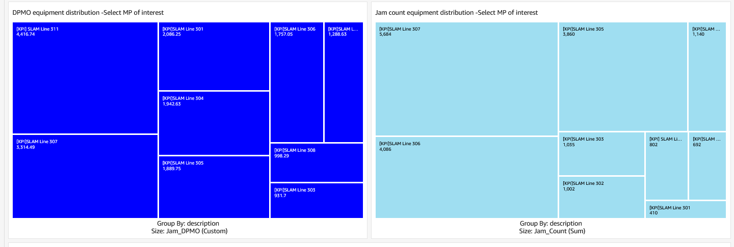

Recommended Approach: Heat Map approach to identify priority assets, followed by 5 Whys Root Cause Analysis to determine verified root causes at each location. To utilise the Jam Create a visual Jam Heatmap off SCADA - The Jam Heatmap will then overlay jam metrics on SCADA images using: SCADA historical alarms and set for the whole of 2025 and project-specific dataset mapping screen locations and positions this then gives visual representation where the team can actively go outside to site see what the true cause is then complete the 5why
The visualisation process, combines alarm data with screen position coordinates, creates heatmap effect using scatter plot visualization and displays jam frequency and intensity on SCADA layout the figure below highlights a common jam area across all slams which is clear to see instantly and points the team in the right direction to rectify
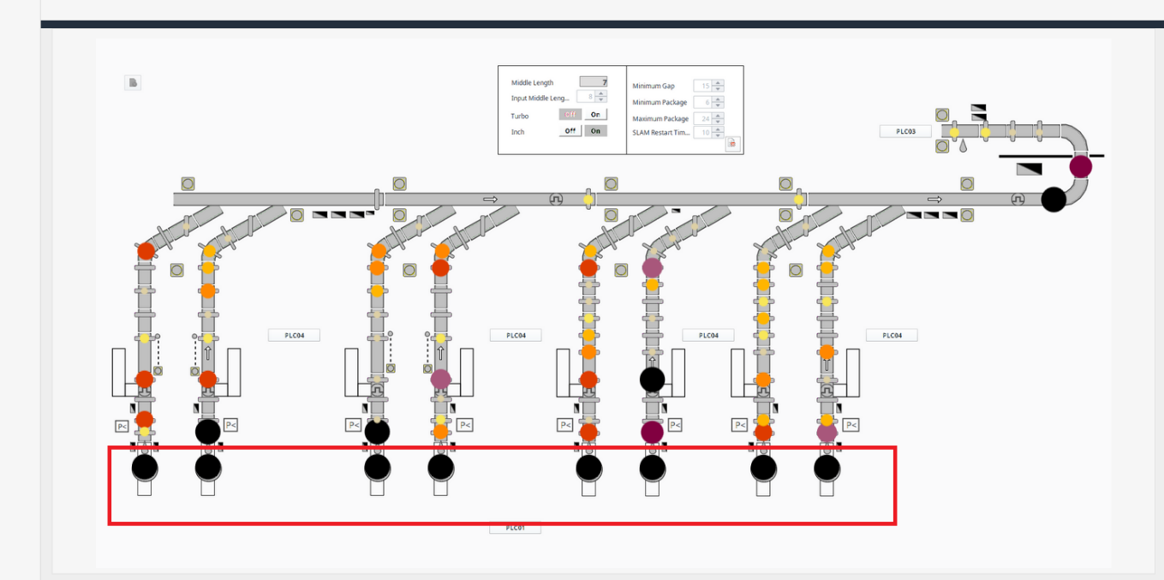

Programme Summary: Five structured initiatives spanning twelve months, targeting an interim DPMO of ≤ 300 at Month 6 and a final target of < 105 at Month 12. The highest priority interventions are analytical and controls-based activities within existing RME capability, requiring no extraordinary capital investment in early phases.

1. Introduction

1.1 Site Overview and Operational Context

CWL1 is an Amazon Apparel and Sortable Fulfilment Centre located in Swansea, South Wales. Operating approximately 142,000 m² of useable floor space, it was among the first Amazon fulfilment centres to open in Europe and has undergone several buildout phases, most recently converting back to sortable operations.

The site operates a Vanderlande EAE/VDL Tray Sorter system controlled via the Amazon Warehouse Control System (), alongside Flow Sortation, multiple SLAM (Scan, Label, Apply, Manifest) lines, and over 5 km of conveyance infrastructure including belt conveyors, merge points, divert lanes, and vertical transport systems.

The RME department comprising 39 personnel across four shifts on a 4on/4off rotation is responsible for the maintenance, reliability, and continuous improvement of all mechanical and electrical systems across the site.

1.2 Problem Statement

The primary quality challenge is the frequency of conveyor jam events, measured using JAM DPMO raw data: Appendix1

In 2025, CWL1 recorded 17,309 jam events, yielding a JAM DPMO of 519.54 against a target of 105 DPMO a performance gap of 79.8%. Closing this gap is the central challenge this report addresses.

1.3 Report Scope and Structure

This report covers five substantive areas:

Section 2 Quality tools selection and justification
Section 3 Structured improvement initiatives with timelines and responsibilities
Section 4 Prioritisation framework and ranked improvement opportunities
Section 5 KPI framework and performance governance
Section 6 Barriers to delivery and mitigation strategies

All data is drawn from the Jam Heatmap SCADA and JamDailyIntlOEE reporting sheets for CWL1, covering January to December 2025.

2. Quality Tools Analysis

2.1 Key Quality Challenges

Analysis of SCADA and DPMO Equipment Distribution data reveals that jam events at CWL1 are concentrated, patterned, and measurable:

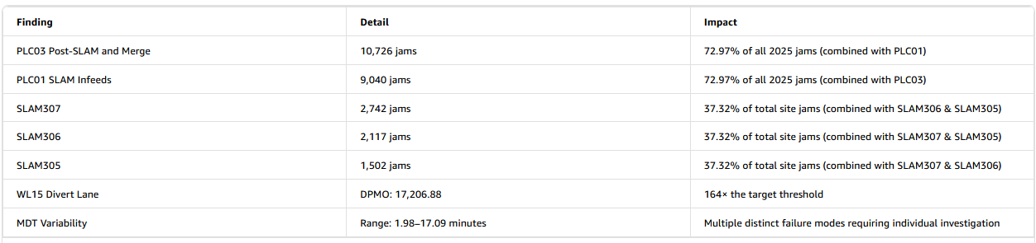
These characteristics make the problem highly amenable to structured quality improvement methodology.
Key Takeaways
- Top two areas PLC03 Post SLAM and Merge and PLC01 SLAM Infeed account for nearly threequarters of all jams, making them the clear priority for reduction efforts.
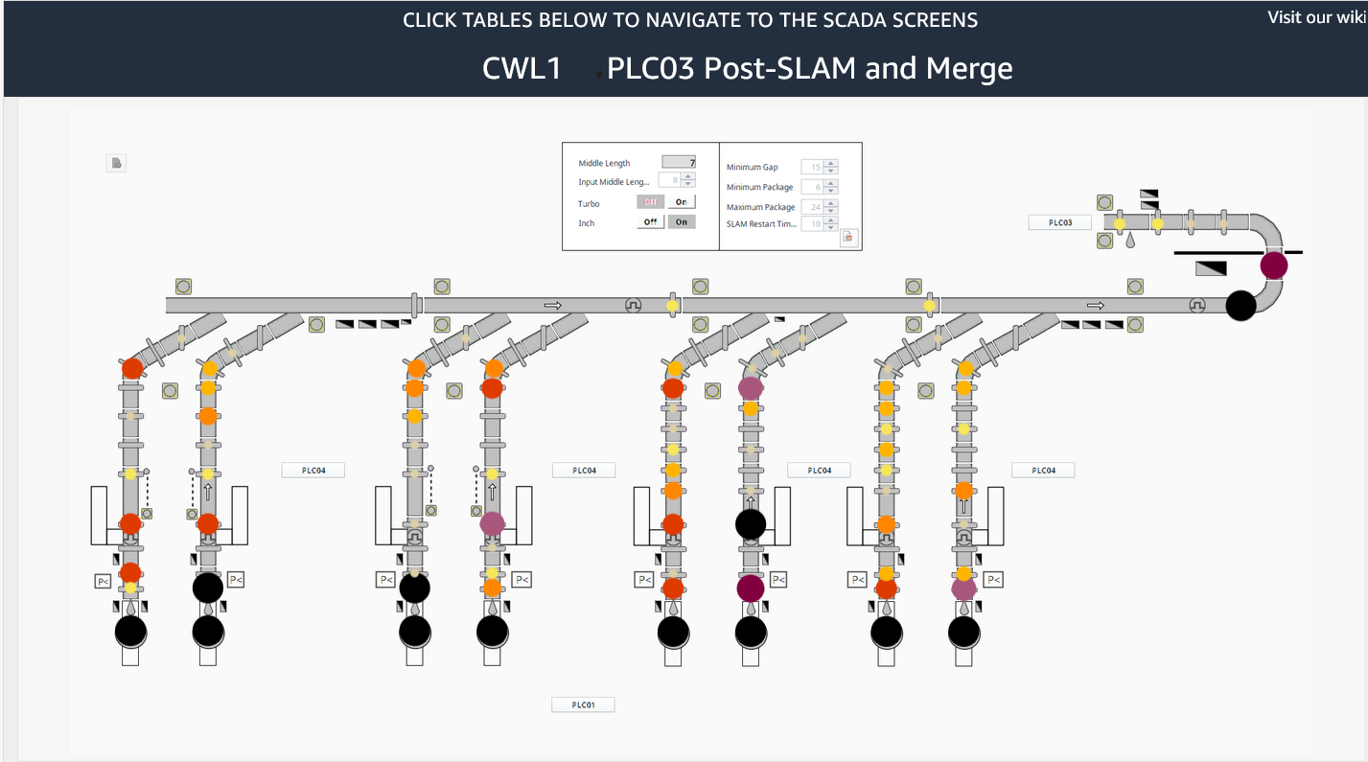
- The three SLAM units (307, 306, 305) alone drive over a third of total site jams.
- WL15 Divert Lane is a significant outlier at 164× the target DPMO, warranting urgent focused investigation.
- The wide MDT range (1.98–17.09 min) suggests multiple root causes rather than a single failure mode.

2.2 Recommended Quality Tools

2.2.1 Tool 1: Pareto Analysis (Pareto Chart)

What It Is

Pareto Analysis applies the 80/20 principle to rank defect sources by frequency or impact, producing a combined bar and cumulative line chart. It is a foundational tool within the Define and Measure phases of the DMAIC improvement cycle.

Why It Is Suitable?

The available SCADA data is already segmented by screen, tag, area, and subarea precisely the structure Pareto Analysis requires. The data already demonstrates a clear Pareto distribution, as shown in Table 2.1.

Table 2.1: Preliminary Pareto Distribution CWL1 2025

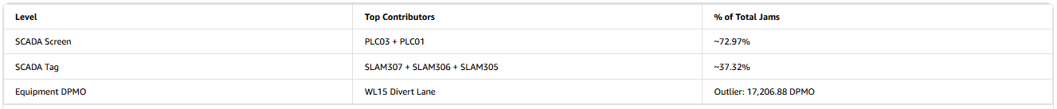
Deep dive and pareto the actual measuring points via the pareto method

With a fixed RME headcount of 39, targeted prioritisation is operationally essential. Pareto Analysis provides the framework to identify which assets must be addressed to achieve the 80% DPMO reduction efficiently.

How It Should Be Applied

Three sequential layers are recommended:

Layer 1 By SCADA Screen: Rank all screens by total jam count to confirm priority areas
Layer 2 By SCADA Tag / MHE ID: Drill into priority screens to identify specific equipment, cross-referenced with DPMO values to isolate outliers
Layer 3 By Time Period: Identify temporal concentration patterns, particularly around peak throughput periods

2.2.2 Tool 2: 5 Whys Root Cause Analysis
The 5 Whys is an iterative interrogative technique from the Toyota Production System, involving repeated "Why?" questioning until the root cause of a failure is identified rather than its symptoms. It is simple, effective, and produces concise documented outputs suited to shift based operational environments.

Why It Is Suitable
Three factors make the 5 Whys particularly appropriate for CWL1:
1. High MDT variability indicates multiple distinct failure modes requiring individual investigation
2. Jam concentration at specific, identifiable equipment nodes enables precise problem statement definition
3. The four shift RME structure requires investigations that are efficient, transferable, and well documented

5 Why Analysis – SLAM307 (2,742 Jams)

Problem Statement: SLAM307 generated 2,742 jam events during 2025, making it the single highest jam-contributing asset at CWL1.

Why 1
Why did SLAM307 generate 2,742 jams? → Packages repeatedly misaligned at the pack feed merge point

Why 2
Why were packages misaligning? → Inconsistent package spacing on the upstream conveyor

Why 3
Why was spacing inconsistent? → Upstream accumulation conveyor operating at incorrect speed ratio

Why 4
Why was the speed ratio incorrect? → A parameters change during a Q1 2025 software update was not validated

Why 5
Why was it not validated? → No formal change management protocol was used for parameter updates — although available through the RME MCM Guide

Root Cause
Absence of enforced change management protocol for any parameter modifications
Corrective Action
Implement and audit the RME Change Management Protocol (INI04) to ensure all future parameter changes are formally reviewed, tested in a non-production window, and validated against DPMO baselines before go-live.

This example demonstrates that the root cause may reside in a process governance failure rather than a mechanical fault that maintenance inspection alone would not have identified. Where multiple contributing factors are found, findings should be consolidated into an Ishikawa (Fishbone) Diagram across the six standard categories: Machine, Method, Material, Man, Measurement, and Environment.

2.3 Summary of Recommended Tools
Table 2.3: Summary of Recommended Quality Tools

Pareto Analysis identifies where to focus; 5 Whys determines why the problem exists there. Together they form a coherent, sequenced analytical framework consistent with Lean Six Sigma best practice.

3. Improvement Plan

3.1 Improvement Objectives

The CWL1 Jam Reduction Programme has established seven clear objectives to drive site performance from its current baseline towards target levels:
The programme's primary objective (OBJ01) is to reduce the overall site JAM DPMO (Defects Per Million Opportunities) from a baseline of 519.54 to below 105 DPMO, representing a reduction of approximately 79.79%. To achieve this, several targeted sub-objectives have been defined. The most urgent is OBJ02, which addresses the WL15 Divert Lane - currently an extreme outlier at 17,206.88 DPMO - with a target to bring this below 500 DPMO. The two highest-volume jam areas are also targeted directly: OBJ03 aims to reduce PLC03 post-SLAM jam events from 10,726 to fewer than 2,500, whilst OBJ04 targets PLC01 SLAM Infeed, reducing from 9,040 to below 2,000 jams. At the individual asset level, OBJ05 focuses on the three highest-contributing SLAM units - SLAM307, SLAM306, and SLAM305 - which collectively recorded 6,361 jams, with a target to reduce this to below 1,500. Beyond jam frequency, OBJ06 addresses Mean Downtime (MDT) variability, which currently ranges from 1.98 to 17.09 minutes, with the goal of achieving a consistent MDT of less than 5 minutes - indicating standardised failure response and resolution. Finally, OBJ07 mandates the implementation and active auditing of the RME Change Management Protocol, which is currently in place but not being followed correctly

3.2 Improvement Initiatives

Five initiatives are defined across a twelve-month horizon:

INI01 Pareto Driven Baseline Establishment (Weeks 1–4)
Complete the three-layer Pareto Analysis, produce a validated Priority Asset Register for the top 15 jam contributing assets, and issue a baseline report to site leadership and the Global Jam Reduction programme team. This establishes the analytical foundation for all subsequent initiatives.

Key Roles: RME Manager (sponsor); RME Automation Engineer (lead); Automation Engineer Apprentice (data support); Shift Team Leaders (validation)

INI02 Targeted Root Cause Investigations (Weeks 2–8)

Conduct structured 5 Whys investigations for the ten priority assets listed below, producing a Root Cause Register and interim findings report within eight weeks of programme commencement.

Priority Assets (in order):
- 2. SLAM307 (2,742 jams)
- SLAM306 (2,117 jams)
- SLAM305 (1,502 jams)
- VNA Induct (DPMO: 5,122.37)
- SLAM06 Tote Feed Line (DPMO: 5,229.55)
- SLAM05 Tote Feed Line and Nerak (DPMO: 5,039.90)
- SLAM07 Tote Feed Line (DPMO: 4,324.71)
- P2 Infeed 1 Start Line (DPMO: 3,889.79)
- P3 Infeed 1 Start Line (DPMO: 3,228.36)

INI03 Engineering Interventions at Priority Assets (Weeks 4–16)

Implement root cause matched engineering and process corrections for each priority asset. Anticipated intervention categories include:

WL15 Divert Lane: Full mechanical inspection; replace worn components; recalibrate gap control and photo eye sensors; 30day enhanced monitoring postintervention
SLAM Tote Feed Lines (05/06/07): Audit tote induction rates and gap control settings; inspect Nerak elevator on SLAM05; verify physical alignment of each SLAM unit
SLAM Lines 307/306/305:
Review conveyor speed, gap control, and accumulation parameters; inspect merge points for wear and misalignment
VNA Induct and P2/P3 Infeed Lines: Review induction rates and package presentation standards; inspect belt surfaces and transition plates

Postintervention, DPMO for each asset is monitored weekly for a minimum of four weeks.

INI04 RME Change Management Protocol (Weeks 6–12)

Design and implement a formal change management and post change verification protocol for all parameter updates, addressing the systemic governance gap identified through the 5 Whys analysis. No parameter changes should be made without this protocol in place.

INI05 Structured PPM Programme (Weeks 8–24)

Develop and implement a data driven Planned Preventive Maintenance schedule for all top10 DPMO assets, replacing the current reactive maintenance approach with scheduled, evidence-based interventions.

4. Prioritisation and Justification

4.1 Prioritisation Framework

Improvement opportunities are evaluated using a weighted scoring framework across four criteria:

Table 4.1: Prioritisation Criteria and Weightings

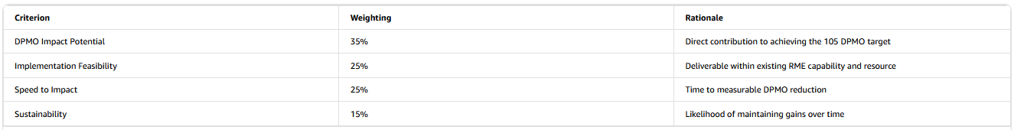
Each opportunity is scored 1–5 per criterion, with a composite weighted score calculated.

4.2 Prioritised Ranking Summary

Table 4.2: Prioritised Improvement Opportunities

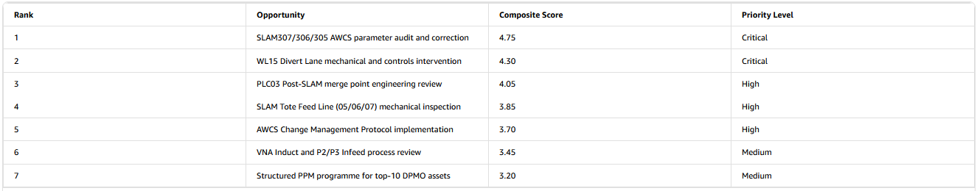
The SLAM307/306/305 parameter audit ranks highest due to its combination of high DPMO impact potential, low implementation cost, and rapid expected time to measurable improvement. The WL15 Divert Lane intervention ranks second due to its extreme DPMO outlier status, despite higher implementation complexity. The Change Management Protocol, while lower in immediate DPMO impact, is essential for sustaining all other gains and must be implemented before any parameter corrections are made.

5. Monitoring and Key Performance Indicators

5.1 KPI Framework

Sixteen KPIs are defined across three monitoring layers:

Table 5.1: KPI Framework Summary

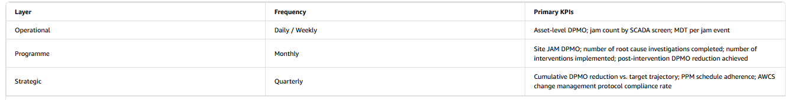
Add Snip from DDD and Data Showing how
Primary Target KPI: Site JAM DPMO

Interim target: ≤ 300 DPMO at Month 6
Final target: < 105 DPMO at Month 12

5.2 Governance Structure

Table 5.2: Performance Review Governance

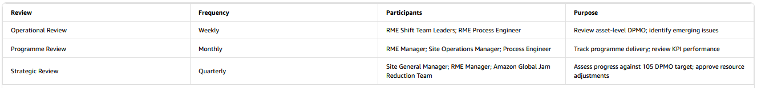

6. Barriers and Mitigation Strategies

6.1 Key Barriers and Mitigations

Table 6.1: Barrier Summary Matrix

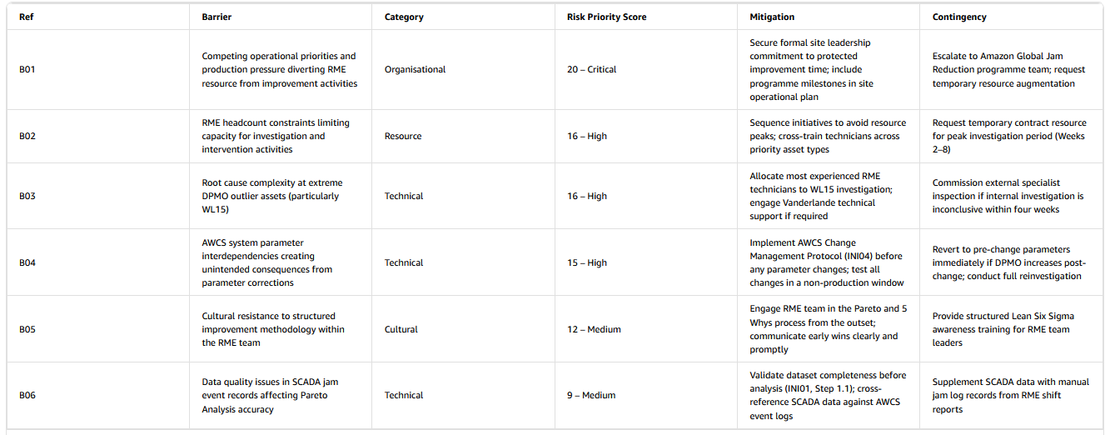

7. Conclusions and Next Steps

7.1 Summary of Findings

CWL1's 2025 JAM DPMO of 519.54 represents a significant performance gap against the Global Jam Reduction target of 105 DPMO. However, the data clearly demonstrates that this gap is driven by a small number of identifiable, addressable assets and process areas. The vital few contributors PLC03 Post SLAM and Merge, PLC01 SLAM Infeed, SLAM307/306/305, and the WL15 Divert Lane account for most jam events and represent the highest leverage intervention points.

The recommended analytical approach Pareto Analysis followed by 5 Whys Root Cause Investigation provides a coherent, evidence-based framework for identifying and addressing the root causes at each priority asset. The five improvement initiatives defined in Section 3 are sequenced to deliver early DPMO reductions while embedding the systemic controls necessary to sustain performance gains over time.

7.2 Recommended Next Steps

The following actions should be initiated immediately upon approval of this report:

1. Week 1: RME Manager to formally present the baseline findings to site leadership and secure commitment to protected improvement resource
2. Week 1: RME Process Engineer to begin data extraction and validation for INI01 Pareto Analysis
3. Week 2: Convene the first 5 Whys investigation team for the WL15 Divert Lane
4. Week 4: Complete the Priority Asset Register and distribute to all four RME shifts
5. Week 6: Begin drafting the Change Management Protocol (INI04) this must be completed before any parameter corrections are made
6. Month 3: Issue the INI02 Interim Findings Report to site leadership and the Amazon Global Jam Reduction programme team

7.3 Call to Action

The evidence presented in this report demonstrates that the CWL1 JAM DPMO reduction target is achievable within twelve months. The highest priority interventions require no extraordinary capital investment they are analytical and controls based activities within existing RME capability. The data is available, the methodology is proven, and the programme is ready to commence. Site leadership commitment to protected improvement resource and immediate initiation of the Pareto baseline and 5 Whys investigations are the critical enabling conditions. The programme should begin without delay.

References

Amazon Fulfilment Technologies and Robotics (2025) JamDailyIntlOEE reporting sheet CWL1 2025. Internal document. Amazon.com, Inc.
Amazon Fulfilment Technologies and Robotics (2025) Jam HeatmapSCADA reporting sheet CWL1 2025. Internal document. Amazon.com, Inc.
Bicheno, J. and Holweg, M. (2016) The lean toolbox: a handbook for lean transformation. 5th edn. Buckingham: PICSIE Books.
George, M.L., Rowlands, D., Price, M. and Maxey, J. (2005) The lean six sigma pocket toolbook. New York: McGraw-Hill.
Ishikawa, K. (1990) Introduction to quality control. Tokyo: 3A Corporation.
Ohno, T. (1988) Toyota production system: beyond large-scale production. New York: Productivity Press.
Pyzdek, T. and Keller, P. (2014) The six sigma handbook. 4th edn. New York: McGraw-Hill.
University of Wales Trinity Saint David, School of Engineering (2017) Technical report guidelines. Version 1. Swansea: UWTSD.

Appendices
Appendix 1 Raw Jam Data 2025

