Module Name: Changemakers: Creativity and Value Creation
Assignment Title: Assignment 1: E-portfolio
Student number: 1902571
Course Title: Creative Computer Games Design

Content Page:
E-portfolio link
Mind map
Image Based Video Presentation
Video Presentation
Academic Poster

E- portfolio link: Please hold ctrl + Left click on mouse to open hyperlink
https://1902571.wixsite.com/changemakers
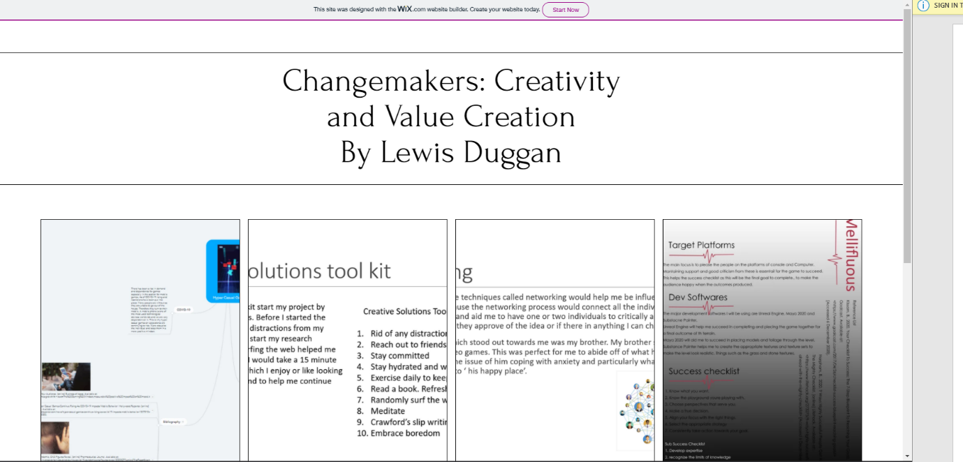
Task 1- Mind Map
https://1902571.wixsite.com/changemakers/post/how-to-wear-monochromatic
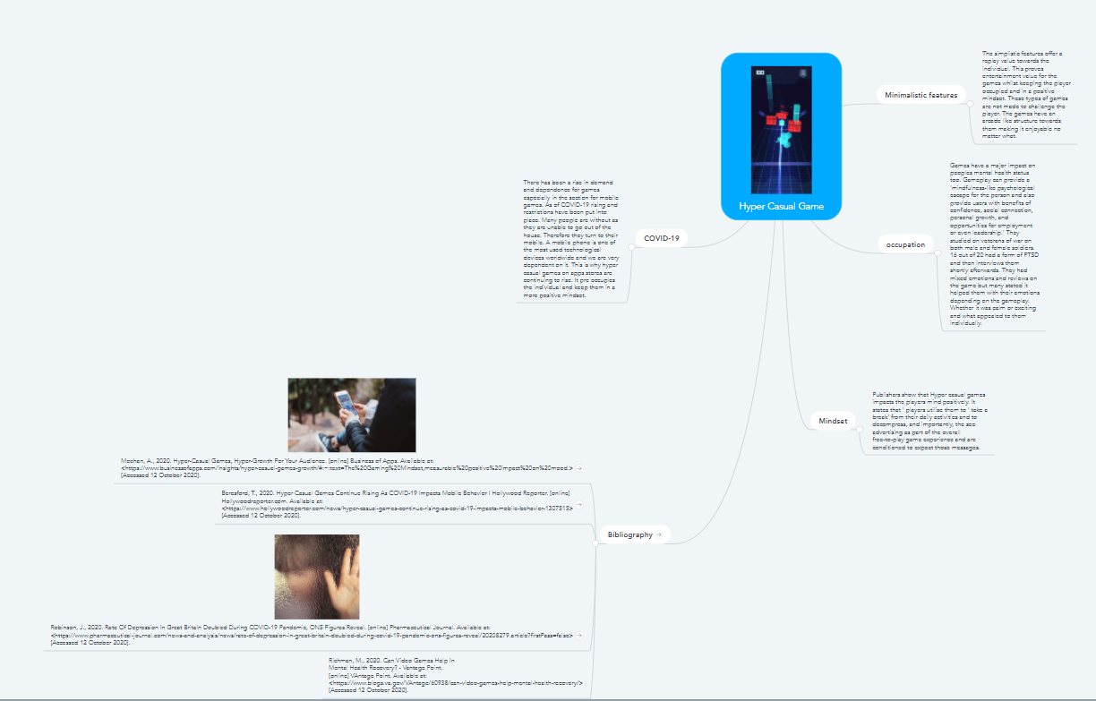

Task 2: Image Based Video Presentation
https://1902571.wixsite.com/changemakers/post/a-new-take-on-denim
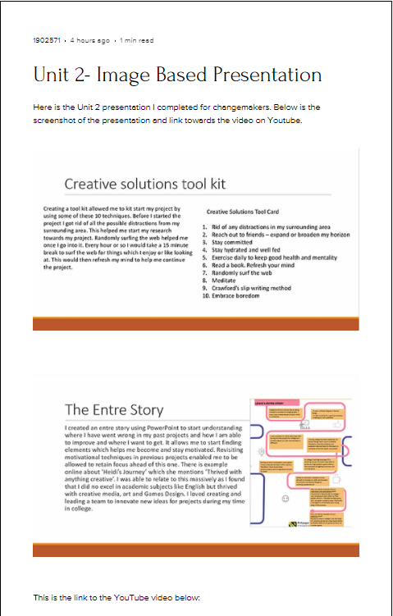

Unit 3- Video Presentation
https://1902571.wixsite.com/changemakers/post/5-staple-items-for-autumn
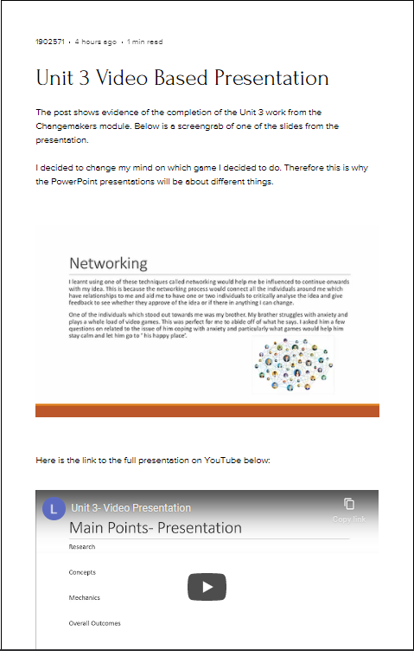

Unit 4- Academic Poster
https://1902571.wixsite.com/changemakers/post/timeless-summer-items-every-closet-must-have


