

ACCA7002 Abertawe Leisure Centre Design & Implementation

Report

MODULE NAME: Database Systems
MODULE CODE: ACCA7002
NAME: Xi Wang
STUDENT NUMBER: 2212532

Abstract

Abertawe Leisure Centre (ALC) launched its membership service for the public. They provide the general public with a membership program. Their database has been optimized and modified to match their new requirements, including Rollback, Commit, Functions, Triggers, Procedures, Transactions, and Indexing, due to the growing number of users and the complexity of their business.
Table of Contents
Abstract 2
1. Introduction 4
2.Database design 4
2.1 Postgresql 4
2.2 Table design 4
2.3 Primary key 7
2.4 Foreign key 7
2.5 Check 7
3. Insert and Update 8
3.1 Triggers with an auditing feature 8
3.2 Function 10
3.3 Insert and update 11
4. Transactions and index 11
5.Conclusion 15
References 16

1. Introduction
The public can enroll in a membership program at the Abertawe Leisure Centre (ALC). The Center's present database provisioning would not be able to satisfy the needs of their business model due to the expansion in the number of customers and the intricacy of their industry. In order to accommodate their increased requirements, we changed and streamlined their database, including rollbacks, commits, functions, triggers, procedures, transactions, and indexes.

2.Database design

2.1 Postgresql
Postgresql is an open source database management system. It is ACID compliant and strong. Due to its distinction from other database management systems like MySQL, Postgres is an Object-Relational Database Management System (ORDBMS). Object-oriented programming and relational database management systems are combined in ORDBMS. The data kinds are the first significant distinction (Riggs et al., 2015). In addition to adding additional types that are not supported by standard SQL relational databases, postgresql supports all ordinary SQL data types. For instance, Postgres is capable of supporting both XML and JSON data types. Additionally, it can support types like ranges, combinations, and arrays.

2.2 Table design
The paradigm, and particularly the three paradigms for the database, is a crucial aspect of database architecture that cannot be overlooked. Indicating the degree of rationalization of the connection between traits within a relationship, a paradigm is a collection of relational patterns that adhere to a given level. The third paradigm (also known as the Third Normal Form, or 3rd NF), which states that all data pieces in the table must be independent of one another and uniquely recognized by the main keyword, is the most crucial aspect to be aware of. In other words, some data components in the table that depend on other non-keyword data elements must be removed for a data structure that meets the second NF. In this case, Abertawe Leisure Centre (ALC) should use 5 entities, which are classes, member type, membership and instructor. The relationship can be show as figure 1

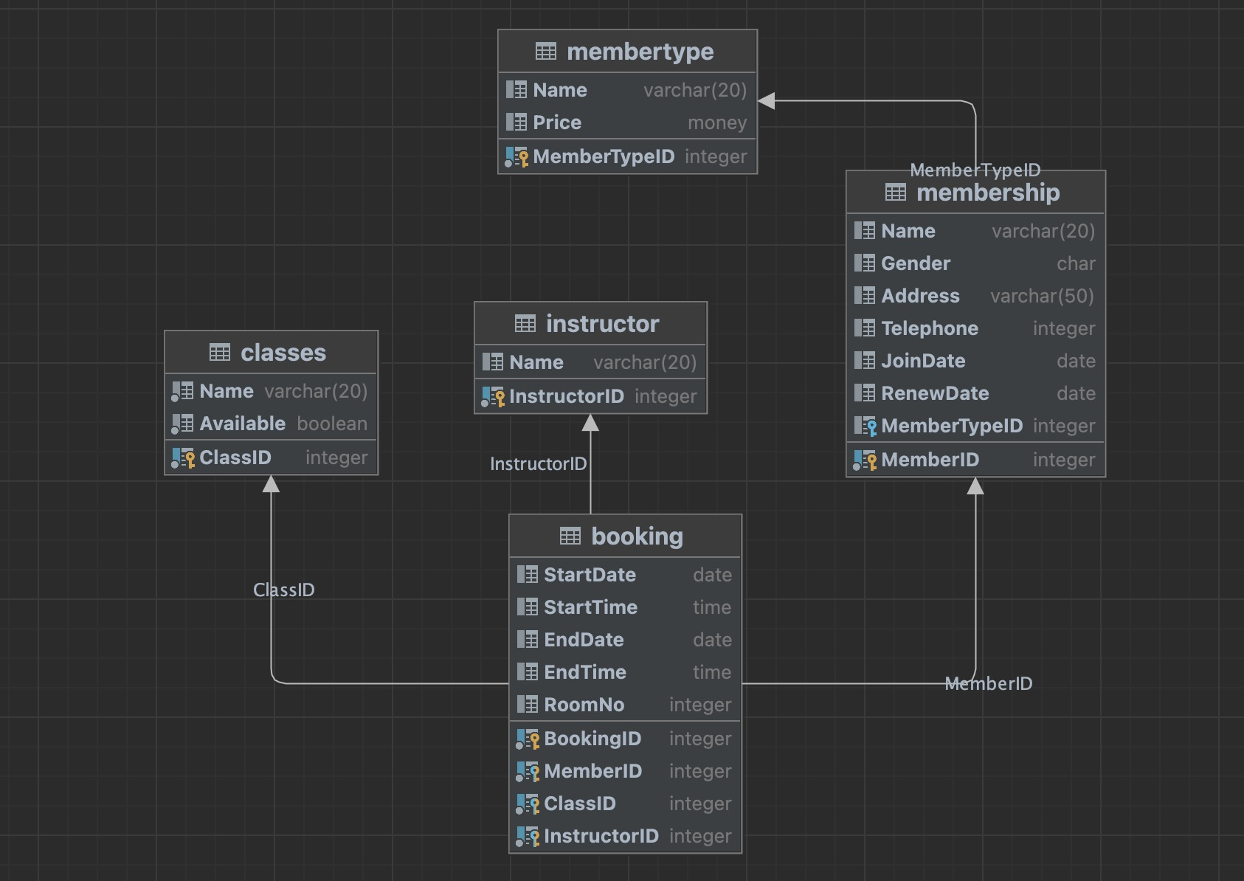
Figure 1. relationship of entirties

create table membertype
(
"MemberTypeID" integer not null primary key,
"Name" varchar(20),
"Price" money
);

create table membership
(
"MemberID" integer not null primary key,
"Name" varchar(20),
"Gender" char check ("Gender" = ANY (ARRAY ['F'::character(1), 'M'::character(1)])),
"Address" varchar(50),
"Telephone" integer,
"JoinDate" date,
"RenewDate" date,
"MemberTypeID" integer references membertype
);

create table public.classes
(
"ClassID" integer not null primary key,
"Name" varchar(20) not null,
"Available" boolean default false not null
);

create table public.instructor
(
"InstructorID" integer not null primary key,
"Name" varchar(20)
);

create table public.booking
(
"BookingID" integer not null,
"MemberID" integer not null references public.membership,
"ClassID" integer not null references public.classes,
"StartDate" date,
"StartTime" time,
"EndDate" date check ("EndDate" >= "StartDate"),
"EndTime" time,
"RoomNo" integer,
"InstructorID" integer not null references public.instructor,
constraint booking_pk primary key ("BookingID", "MemberID", "InstructorID", "ClassID")
);

2.3 Primary key
An efficient relational database is put together from numerous tables using primary and foreign keys. The performance and availability of a physical database are significantly impacted by the design of both main and foreign keys. The main key plays a fundamental role in relational databases (Obe & Hsu, 2017). It serves as the physical database schema's cornerstone. At the physical level, the primary key is solely used to uniquely identify a row and to identify an entity that may be effectively referred by a foreign key. A record in a relational database contains numerous attributes, and if one of the attribute groups (notice the group) identifies a record in a certain way, it might serve as the primary key.

2.4 Foreign key
A public keyword is referred to as a foreign key for another connection if it serves as the relationship's primary key. Therefore, a foreign key is a crucial link between two relationships. A table is referred to as a master table if it uses a foreign key from another relationship as its primary key, while a table that uses the same foreign key is referred to as the master table's slave. Another name for a foreign key is a foreign key.

2.5 Check
You can establish a requirement that a field's value must meet using the CHECK constraint kind of constraint. A Boolean expression is used by a CHECK constraint to determine a field's value. PostgreSQL will insert the value or update it if the field passes the test. The following are the limitations associated with the CHECK constraint: Each database has a different constraint name. For the equivalent ignore statement, the check constraint is not valid, but it is valid for insert, update, replace, load data, and load xml statements. Not all functions can be used, for instance, the ambiguous functions NOW(), CONNECTION ID(), and CURRENT USER (). not applicable to saved functions and stored procedures.

3. Insert and Update

3.1 Triggers with an auditing feature
When a certain event occurs, such as the insertion, update, or deletion of data from a table, or the execution of a DDL statement that is triggered by the execution of an operation such as the insertion, update, deletion, query data, etc., a trigger can carry out specific operations on database objects according to the event (Kaur & Shaik, 2016). PG's triggers are separated into two categories based on the various triggering events: trigger, regular trigger, triggered by DML operations, like table insertion, update, and data deletion operations Event Triggers, or event triggers, are events that are brought about by DDL and other events, such as the creation of tables, the deletion of tables, and other actions. Triggers are also categorized differently across various databases. No matter how they are split, the majority of them can match to PG's triggers, for instance, Oracle is divided into DML Trigger and System Trigger, while SQL Server is divided into DML Trigger, DDL Trigger, and Login Trigger.

-- function for trigger
create or replace function f_audit_member_insert()
returns trigger
language plpgsql
as $$
begin

insert into member_audit(operationType,memberID,name,gender,address,telephone,joinDate,lastRenewalDate,memberTypeID,createDate)
values('INSERT',NEW.memberID,new.name, new.gender,new.address,new.telephone,new.joinDate,new.lastRenewalDate,new.memberTypeID,current_date);
return new;
end;
$$;
create or replace function f_audit_member_update()
returns trigger
language plpgsql
as $$
begin

insert into member_audit(operationType,memberID,name,gender,address,telephone,joinDate,lastRenewalDate,memberTypeID,oldMemberID,oldName,oldGender,oldAddress,oldTelephone,oldJoinDate,oldLastRenewalDate,oldMemberTypeID,createDate)
values('UPDATE',NEW.memberID,new.name, new.gender,new.address,new.telephone,new.joinDate,new.lastRenewalDate,new.memberTypeID,old.memberID,old.name, old.gender,old.address,old.telephone,old.joinDate,old.lastRenewalDate, old.memberTypeID,current_date);
return old;
end;
$$;
create or replace function f_audit_member_delete()
returns trigger
language plpgsql
as $$
begin

insert into member_audit(operationType,oldMemberID,oldName,oldGender,oldAddress,oldTelephone,oldJoinDate,oldLastRenewalDate,oldMemberTypeID,createDate)
values(TG_OP,old.memberID,old.name, old.gender,old.address,old.telephone,old.joinDate,old.lastRenewalDate, old.memberTypeID,current_date);

return old;
end;
$$;

3.2 Function
Functions are another name for stored procedures. PostgreSQL stored procedures are a collection of SQL and procedure statements that are saved on the database server and can be called using SQL dialogs. Procedural statements include declarations, assignments, loops, and control flow. Functions have the advantage that they are already built after the first call and do not require further compilation for subsequent calls. This lowers the communication overhead between the application and the database server and enhances the database's overall speed. Realize a set of business logic that is shared by several applications to simplify application development and guarantee consistency of usage. Protect the usage of data in stored procedures, separate the application's access to data permissions, and bolster the administration of database permissions at a more granular level. separating the business from the application Only the stored procedure's definition must be modified when the business requirements are revised; the application need not be. Keep database metadata safe. While employing stored procedures hides the database table structure from the application, directly querying the database using SQL statements exposes metadata and reduces security.
create function f_enroll_member_count(p_classID int)
returns int
language plpgsql
as
$$
declare v_result int;
begin
-- the number for specific class enrolled;
select count(*) into v_result from booking where classID=p_classID;
return v_result;
end;
$$;

3.3 Insert and update
INSERT INTO membertype(membertypeid, name, price) VALUES (1, 'Week Day', '550.00');

INSERT INTO instructor(instructorid, name, gender) VALUES (1, 'Buddie', 'F');

INSERT INTO classes(classid, name) VALUES (1, 'Squash');

INSERT INTO instructor(instructorclassid, instructorid, classid) VALUES (5, 3, 5);

4. Transactions and index
The ALC database designs the following entities memberType, member, enroll, bookclass, classes, instructor, and the audited entity member_audit. Each member can select the member Type, member Type Includes a Week Day (£550 pa), Weekend (£800 pa), and All week (£1, 200 pa) for the three types, So design the name and Price properties of the memberType entities used to save the content of the member type, The id indicates the primary key, The primary key of the memberType entity in the Member entity, Thus the Member entity and member type can achieve a many-to-one relationship, This design can satisfy the requirements of 3 NF, Without designing member type entities, multiple Week Day (£550 pa) will occur in the member entity, Weekend (£800 pa), All week (£1, 200 pa) thus does not meet the 3 NF requirements, So you need to design the member type entities. In a set of relations, it represents information in the ER conceptual model which has been through the normalization stage of the third form of NF, while the procedural phase implements the constraints implied in the conceptual model(O. Signore,1996).

Member Entities include the name as required, gender, address, telephone, join date, last renewal date member type Property, The ID acts as the primary key, The types of gender in entity member are only Female and Male, So with F for the Female, M representation Male, So design gender for a char length of 1, And use check constraints to guarantee that the data can only be F or M, No other data is allowed, Ensure the uniformity of the data, member tyep Setting to foreign key constraints ensures data integrity. Create an index on the name property that guarantees a quick search while searching for a name.
Entity instructor does not have special required properties, but I think each instructor should have an ID representing the primary key, name, gender attribute, gender design check constraints, ensure that data only F and M data, other data does not meet the conditions to insert when the update will fail.
Entity classes needs attribute id to do the main key and name, name attribute used to save the class content Squash, Tennis, 5 a Side Football, Badminton, Netball, etc.;
Entity instructorClass is the relation table as entity class and entity instructor because All classes are run with a qualified instructor. An instructor can be qualified for one or more types of activity. So each classes will have multiple instructor, instructor will have multiple classes, so they are many-to-many relationships, this property needs to add a foreign key attribute to reference instructor entities and class entities to guarantee the integrity of the data.
There is a relationship enroll before class and member, each number can join multiple classes, but for a class to be viable it must have at least 6 members enrolled, so there is enroll relationship between them, record the member of enroll each class, and go book before satisfying the number of 6. So in the enroll entity recorded member id and class id, and enroll time, and to set the foreign key constraints on memberid and classid, and enroll entity does not set ID properties, so using memberid and classid as a composite primary key, the advantage of this is to ensure that each member in enroll each class only enroll once, avoid member repeat enroll the same class.

Booking Entity is record book those class, These classes are born after meeting the class to be viable it must have at least 6 members enrolled condition, The entity contains properties with the member id, class id, start date, end date, start time, end time, And room no, In addition, in member id and class id, foreign key constraints are also required to ensure the data integrity.
Entity member_audit is the operation of insert, delete and update done by member as an audit table. Each operation will record the type of operation, so the operationType attribute sets check constraints to ensure that operationType only exists in INSERT, UPDATE and DELETE. In addition, the data and time of the insert were recorded during the insert. Create an index on the property start date, and you can quickly install the start date Search when looking for a book class.

There is a requirement for class to be viable it must have at least 6 members enrolled in the demand. So create method f_enroll_member_count, which passes in a parameter class id, searches for how many individual enroll s in this class id according to the incoming class id, and returns the number of corresponding class enroll.

When the update operation occurs in the member table, t_member_update will be triggered, the trigger will implement the method f_audit_member_update, this method implements when the table member found update operation, the old data before update and the new data after update are saved in the audit table, so that you can know which data update modified, and can modify the previous specific vALCe. And the record operation type is a UPDATE.
When the operation of delete occurs in member table, t_member_delete will be triggered, and this trigger will execute method f_audit_member_delete. This method implements that when table member finds the operation of delete, the data of delete will be saved in the audit table. And record the time of the deletion. And operationType were recorded as the DELETE.
The stored procedure p_enrollClass is performed by operating member at enroll class. This stored procedure will insert memberid and classid in table enroll and the current date of the database as enroll.

The stored procedure p_add_member adds data to table member, and when the administrator needs to add member to add data to table member. This stored procedure requires the incoming parameters memberID, name, gender, address, telephone, joinDate, lastRenewalDate, memberTypeID, etc. These parameters are then inserted into Table member, the commit data.
The stored procedure p_update_member is the data for the administrator to modify the member. When the member needs to modify the data, the administrator can use the stored procedure to modify it. Need the incoming parameters member id, name, gender, address, telephone, joinDate, lastRenewalDate, memberTypeID, modify the data in Table member according to these incoming parameters, and then submit the data.

Stored procedure p_del_member, change the stored procedure to realize the administrator to delete member data, when the member needs to cancel the stored procedure is executed, you need to pass in the parameter member id, and then delete the data in table member according to the parameter memberid. Submit data.

INSERT INTO instructorclass VALUES (20, 10, 1);
-- test primary key constraints
-- instructor 10 have exists.
INSERT INTO instructorclass VALUES (10, 10, 1);

-- g.
-- test transaction
select * from membershipwhere memberID=8;
-- test rollback,
-- the update will be failed.
update membershipset name='Zhang' where memberID=8;
rollback;
select * from membershipwhere memberID=8;

-- test commit
-- the update will be success.
update membershipset name='Zhang' where memberID=8;
commit;
select * from membershipwhere memberID=8;

The above examples are just the tip of the iceberg, but from them we also see the advent of the database era, the rapid development of the database (Schönig, 2019). Database systems in the software industry in an unshakable position, with the ecological richness of all walks of life, there will be more enterprises rely on database systems, but also look forward to the future of database systems will have a more extensive application.

5.Conclusion
Abertawe Leisure Centre (ALC) launched its membership service for the public. They provide a membership program to the general public. Due to the increasing number of users and the complexity of their business, their database has been upgraded and improved to meet their current needs, including Rollback, Commit, Functions, Triggers, Procedures, Transactions, and Indexing.

References

Joseph M. Hellerstein, Michael Stonebraker and James Hamilton (2007), "Architecture of a Database System", Foundations and Trends® in Databases: Vol. 1: No. 2, pp 141-259.

O. Signore, M. Loffredo, M. Gregori, and M. Cima, “Reconstruction of ER schema from database applications: a cognitive approach,” in Entity-Relationship Approach — ER ’94 Business Modelling and Re-Engineering, vol. 881, P. Loucopoulos, Ed. Berlin, Heidelberg: Springer Berlin Heidelberg, 1994, pp. 387–402.

Riggs, S., Ciolli, G., Krosing, H., & Bartolini, G. (2015). PostgreSQL 9 administration cookbook. Packt Publishing Ltd.

Obe, R. O., & Hsu, L. S. (2017). PostgreSQL: up and running: a practical guide to the advanced open source database. " O'Reilly Media, Inc.".

Kaur, M., & Shaik, B. (2016). PostgreSQL Development Essentials. Packt Publishing Ltd.

Ferrari, L., & Pirozzi, E. (2020). Learn PostgreSQL: Build and manage high-performance database solutions using PostgreSQL 12 and 13. Packt Publishing Ltd.

Schönig, H. J. (2019). Mastering PostgreSQL 12: Advanced techniques to build and administer scalable and reliable PostgreSQL database applications. Packt Publishing Ltd.

