Student Name: Silvia Karova  Student ID: 2221481  Module Title: Foreign Language & Cultural Awareness  Module Code: BMIH 5003  Lecturer: Heidi Prosser | 
ASSIGNMENT 1: PORTFOLIO
(4 Components)

Component 1: Professional Reflection (500 words +/- 10%)

Weighting: 25%
Scenario
While working in a restaurant during the breakfast service, a cultural misunderstanding was observed. The misunderstanding was between a guest and an F&B employee. The guest had limited English proficiency. He ordered scrambled eggs with toast but he was not so satisfied upon receiving the dish. The guest actually expected a dish with variations. He also wanted the dish to be varied with spices and herbs which is quite common in his home country.
Explanation of Cultural Misunderstanding
Cultural misunderstanding is one of the most pressing challenges in the multilingual or multicultural situations. The situation also expressed the potential for cultural understanding and confusion in the culinary expectations (Abramson and Moran, 2018). The guest actually assumed a universal understanding about the dish which led to disappointment when faced with a more conventional version. This particular misalignment between the hotel breakfast and the specific cultural preferences of the guest actually displayed the significance of maintaining diverse culinary backgrounds while dealing with people from different cultural backgrounds.
Personal Reflection
Multicultural or multilingual environment can be quite challenging for the business organisations working within the hotel and restaurant industry. Considering the situation described above, it is necessary to enhance the cultural sensitivity and communication skill in the most effective and efficient manner so that the problems can be proactively solved. First of all, it is necessary to enquire about the preferences of the guests so that a better understanding about the culinary expectations of them can be developed by the F&B employees. In such cases, it is also necessary for the employees to have the patience and understanding about the way of dealing with the people from different cultural backgrounds or different language backgrounds as well. Such attempt of inquiry serves as the practice solution to the problems described earlier (Becker, 2020). Adopting the communication styles to effectively and efficiently accommodate the language barriers is also necessary to deal with the problems identified earlier. The use of simpler language and visual aids can also help prevent any particular case of misunderstanding or confusion in communication. This particular scenery of also substantially focused on the significance of going beyond a superficial knowledge about the cultural differences. It is also necessary for the employees to emphasize on the complications of different and dining expectations in the hotel and restaurant business (Chandan Maheshkar and Sharma, 2023). It is also necessary to properly acknowledge that what may seem quite ordinary in one culture can have significant value in another culture. I also think that the focus of the international organisations should be on the development of understanding that will recognise the differences existent in the multicultural business environment so that the employees working within the restaurant can serve the people from different cultural or social backgrounds. For the purpose of preventing such peace understanding I am committed to developing a more proactive and effective approach so that the guest interactions can be effectively and efficiently maintained. I also recognise the role of cultural humility in the prevention of misunderstanding as well. This experience has prompted me to view as opportunities for growth.

References:
Abramson, N.R. and Moran, R. (2018). Managing Cultural Differences: Global Leadership for the 21st Century. 10th Ed. ed. Abingdon: Routledge.
Becker, K. (2020). Culture and International Business. Mumbai: Jaico Pub. House.
Chandan Maheshkar and Sharma, V. (2023). Handbook of Research on Cross-culture Business and Management. Vernon Press.

Component 2: Training Plan (500 words +/- 10%)

Weighting: 25%

Identified cultural misunderstanding (in a few words)
The misunderstanding was between a guest and an F&B employee. The misunderstanding took place because of the communication gap and due to an inability to understand the multilingual aspects.
Training plan (Why/What//Who/Where/When):
Why:
Cultural competence is one of the most vital skills for the employees working in various multicultural business environments (Ching-Hwang, 2019). This training will help the employees about generating certain types of skills and knowledge so that diverse cultural expectations can be effectively and efficiently handled by the employees. Fostering a more inclusive and welcoming dining experience can be done.
What:
The training plan will encompass a two-day program which will cover key aspects:
1. Gaining knowledge and understanding about cultural diversity in hospitality
2. Learning different types of the intercultural communication techniques and strategies
3. Cross-Cultural Culinary Awareness and understanding (Cutler, 2022)
4. Practical Application through analysing the most relevant Case Studies and Role-Playing techniques as well
5. Team Building techniques for developing Cultural Inclusivity

The plan will also incorporate different types of post training support by offering continuous learning resources, feedback mechanism and improvement strategies for the employees as well.
Who:
The target audience for the training plan will be all the F&B employees including the servers, chefs, kitchen staff and also the managerial employees. Keeping the entire team involved with the training session will ensure a comprehensive and collaborative approach for maintaining cultural competence.
Where:
The training sessions will take place at the level 4 placement hotel. Classroom style sessions will be held in a specific training room with several practical components (Christiansen, John David Branch and Karmowska, 2020). Culinary workshops and role-playing, will also be conducted in the F&B areas in the restaurant.
When:
Day | Time | Session | Activity
Day 1 | 9:00 AM - 12:00 PM | Developing understanding Cultural Diversity in Hospitality | - Overview of cultural dimensions in various cultures by Hofstede  - Discussion on the cultural impact in the F&B service
Day 1 | 1:00 PM - 4:00 PM | Intercultural Communication Techniques | - Practical strategies and practices for effective communication  - Role-playing sessions and scenarios to effectively and efficiently simulate interactions
Day 1 | 6:00 PM - 8:00 PM | Evening Culinary Workshop (Optional) | - Exploration of global culinary traditions  - Hands-on and practical culinary workshop featuring diverse cuisines and cultural dishes
Day 2 | 9:00 AM - 12:00 PM | Practical Application through Case Studies | - Analysis of the real-life case studies and situations as  - Group discussions on different types of proactive strategies
Day 2 | 1:00 PM - 4:00 PM | Guest Interaction Role-Playing | - Interactive role-playing exercises  - Feedback and critique sessions
Day 2 | 6:00 PM - 8:00 PM | Team Building for Cultural Inclusivity | - Team-building activities to foster collaboration  - Discussions on sharing cultural experiences
Post-Training | Ongoing | Continuous Learning Improvement | - Distribution of learning resources among the participants  - Implementation of feedback mechanisms  - Periodic reviews and adjustments

This table has outlined a two-day training plan, specifying the sessions, activities, and the timeframes as well. This comprehensive training plan will help to empower the Level 4 Placement Hotel staff with the skills and knowledge necessary for effectively and efficiently navigating the complexities of cultural diversity.

References:
Ching-Hwang, Y. (2019). Ethnic Chinese business in Asia : History, culture and business enterprise. Singapore: World Scientific Publishing Co Pte Ltd.
Christiansen, B., John David Branch and Karmowska, J. (2020). Cultural Factors and Performance in 21st Century Businesses. IGI Global.
Cutler, J. (2022). The Cross-cultural Communication Trainer’s Manual. Gower Publishing Company, Limited.

Component 3: Student Self-Reflection (500 words +/- 10%)

Weighting: 25%
Following is a reflection on cultural awareness in the hospitality industry based on the scenario mentioned earlier.
Introduction:
In contemplating my journey of developing my skills within the hospitality industry, I think utilising the gives Gibbs’ Reflective Cycle will be proper (Williams and Spiro, 2020). This model has several basic stages including description, feelings, evaluation, analysis, conclusion and action plan. This will profile a comprehensive Framework for providing a critical reflection on the experiences and learning.
1. Description:
My understanding about cultural awareness in hospitality industry was somewhat superficial. My perspective about the significance of language was superficial as I thought that language could only be used as the primary means of communication (Deresky, 2017). My interactions with the global guests are often centred around some basic courtesy which also lacked in-depth appreciation for recognising the impact of cultural aspects on their overall experience as well.
2. Feelings:
As I got involved in a diverse hospitality setting and also encounter to guests from different cultural backgrounds, I came to know that my limited cultural awareness could substantially affect seamless interaction in my service. Feelings of frustration and specific desire for improvement emerged as I became able to recognise the potential for maintaining enhanced guest satisfaction through a more pragmatic understanding of cultural preferences and values as well.
3. Evaluation:
The most important aspect in my self-development journey took place when I encounter to the scenario in the restaurant as discussed earlier. That this satisfaction expressed by the guest was because of different cultural expectations. The variation in the cultural expectations and associated misunderstanding acted as a wake-up call for me to understand the specific importance of developing cultural understanding of different cultures. I reached the conclusion that having proper realisation about cultural awareness not only helps to avoid mistakes but also substantially contributes to a more enriched and personalised guest experience in the restaurant service activities.
4. Analysis:
Analysing the entire experience through the lens of academic literature, I understood the profound impact of cultural dimensions on the maintenance of guest satisfaction in the restaurant business. It is necessary for the employees to have advanced level of cultural awareness so that the complications of global cuisines and communication dynamics can be effectively understood by the employees.
5. Conclusion
So, it is quite clear that my evolving understanding about cultural awareness within hospitality industry actually culminated in the realisation that it is not only a skill but also a practical mind-set. It is also necessary to acknowledge the importance of embracing cultural diversity as one of the most integral elements in delivering quality service.
6. Action Plan
I have the plan to get involved in further training and attend various workshops about multicultural workplace context so that I can develop cultural competency and advance communication skill in my area of employment. I will also try to actively seek feedback from both guests and colleagues so that my cultural competencies can be refined in the most effective and efficient manner (Boella, 2021). Through experiences, academic insights, I have come to appreciate the profound impact of developing cultural awareness on guest satisfaction in the hospitality service.

References:
Boella, M.J. (2021). Human resource management in the hospitality industry. Cheltenham: Stanley Thornes.
Deresky, H. (2017). International Management : Managing across Borders and cultures; Text and Cases. 9th ed. Boston, Mass. U.A.: Pearson.
Williams, K. and Spiro, J. (2020). Reflective writing. 2nd ed. Houndmills, Basingstoke, Hampshire ; New York: Palgrave Macmillan.

Component 4: Training Presentation (6 Slides)

Weighting: 25%

Welcome, team! Today, we’re diving into the exciting world of multilingualism and why it’s a game-changer for the entire hospitality industry and also to our hotel. Let’s explore how language awareness skills can elevate our guest experiences and improve our profitability and sustainability as well.
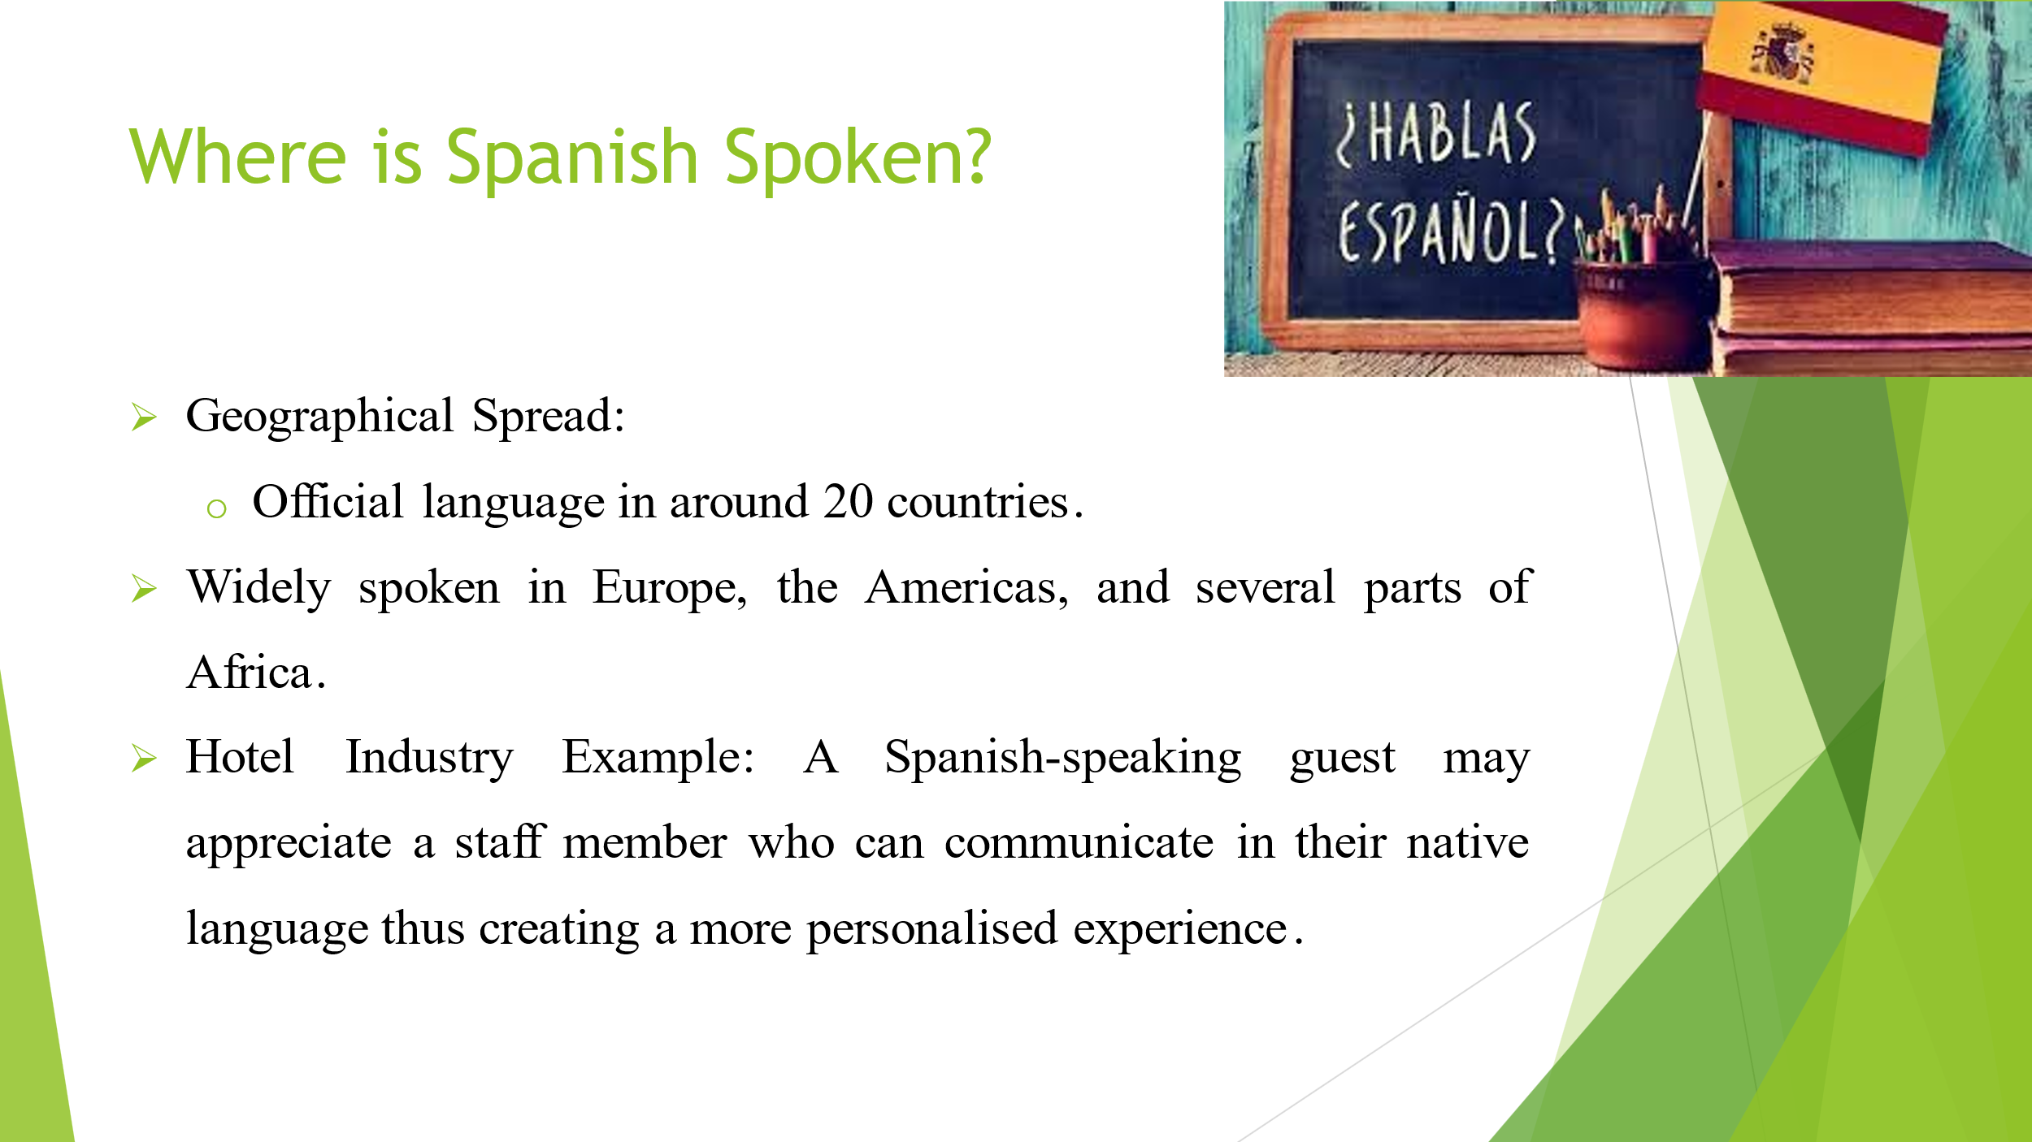
Imagine a guest arriving from Spain or Latin America. Speaking their language not only makes them feel at home but also fosters a deeper connection, making their stay truly memorable. So, it is quite clear that multiculturalism can solve the problems in the most effective and proactive manner for the people involved in the competitive hospitality industry around the whole world.
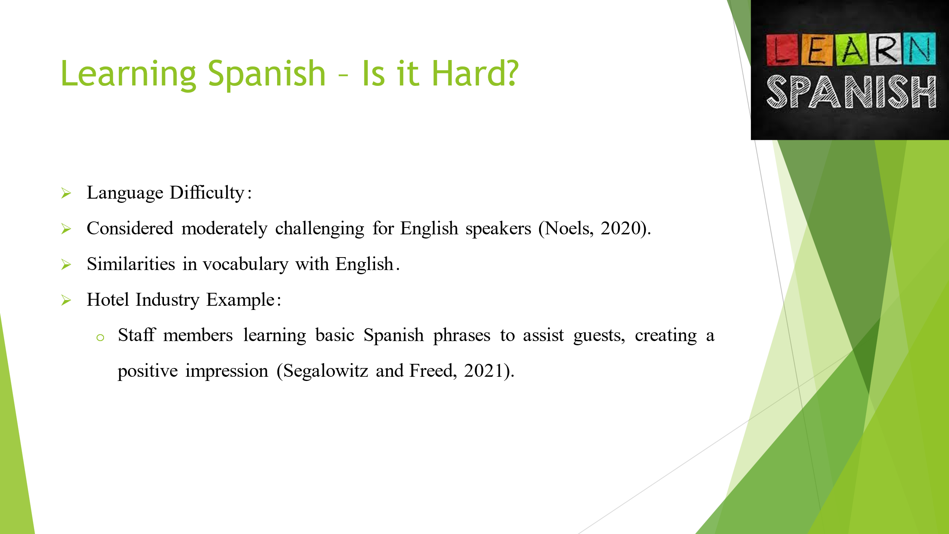
Spanish is an official language in more than 20 countries around the whole world. It is also spoken in Europe, America and also in several areas of Africa as well. Let’s consider a scenario – a guest from Colombia checks in. Imagine the delight on their face when our front desk staff talks with them in Spanish, making them feel not just welcomed but truly understood.
Though learning Spanish might seem challenging for English speaking people but learning Spanish does not have to be daunting at all. Our team is encouraged to effectively and efficiently embrace the challenge, starting with simple phrases and words. Think of it as adding a valuable tool to the hospitality business operations.

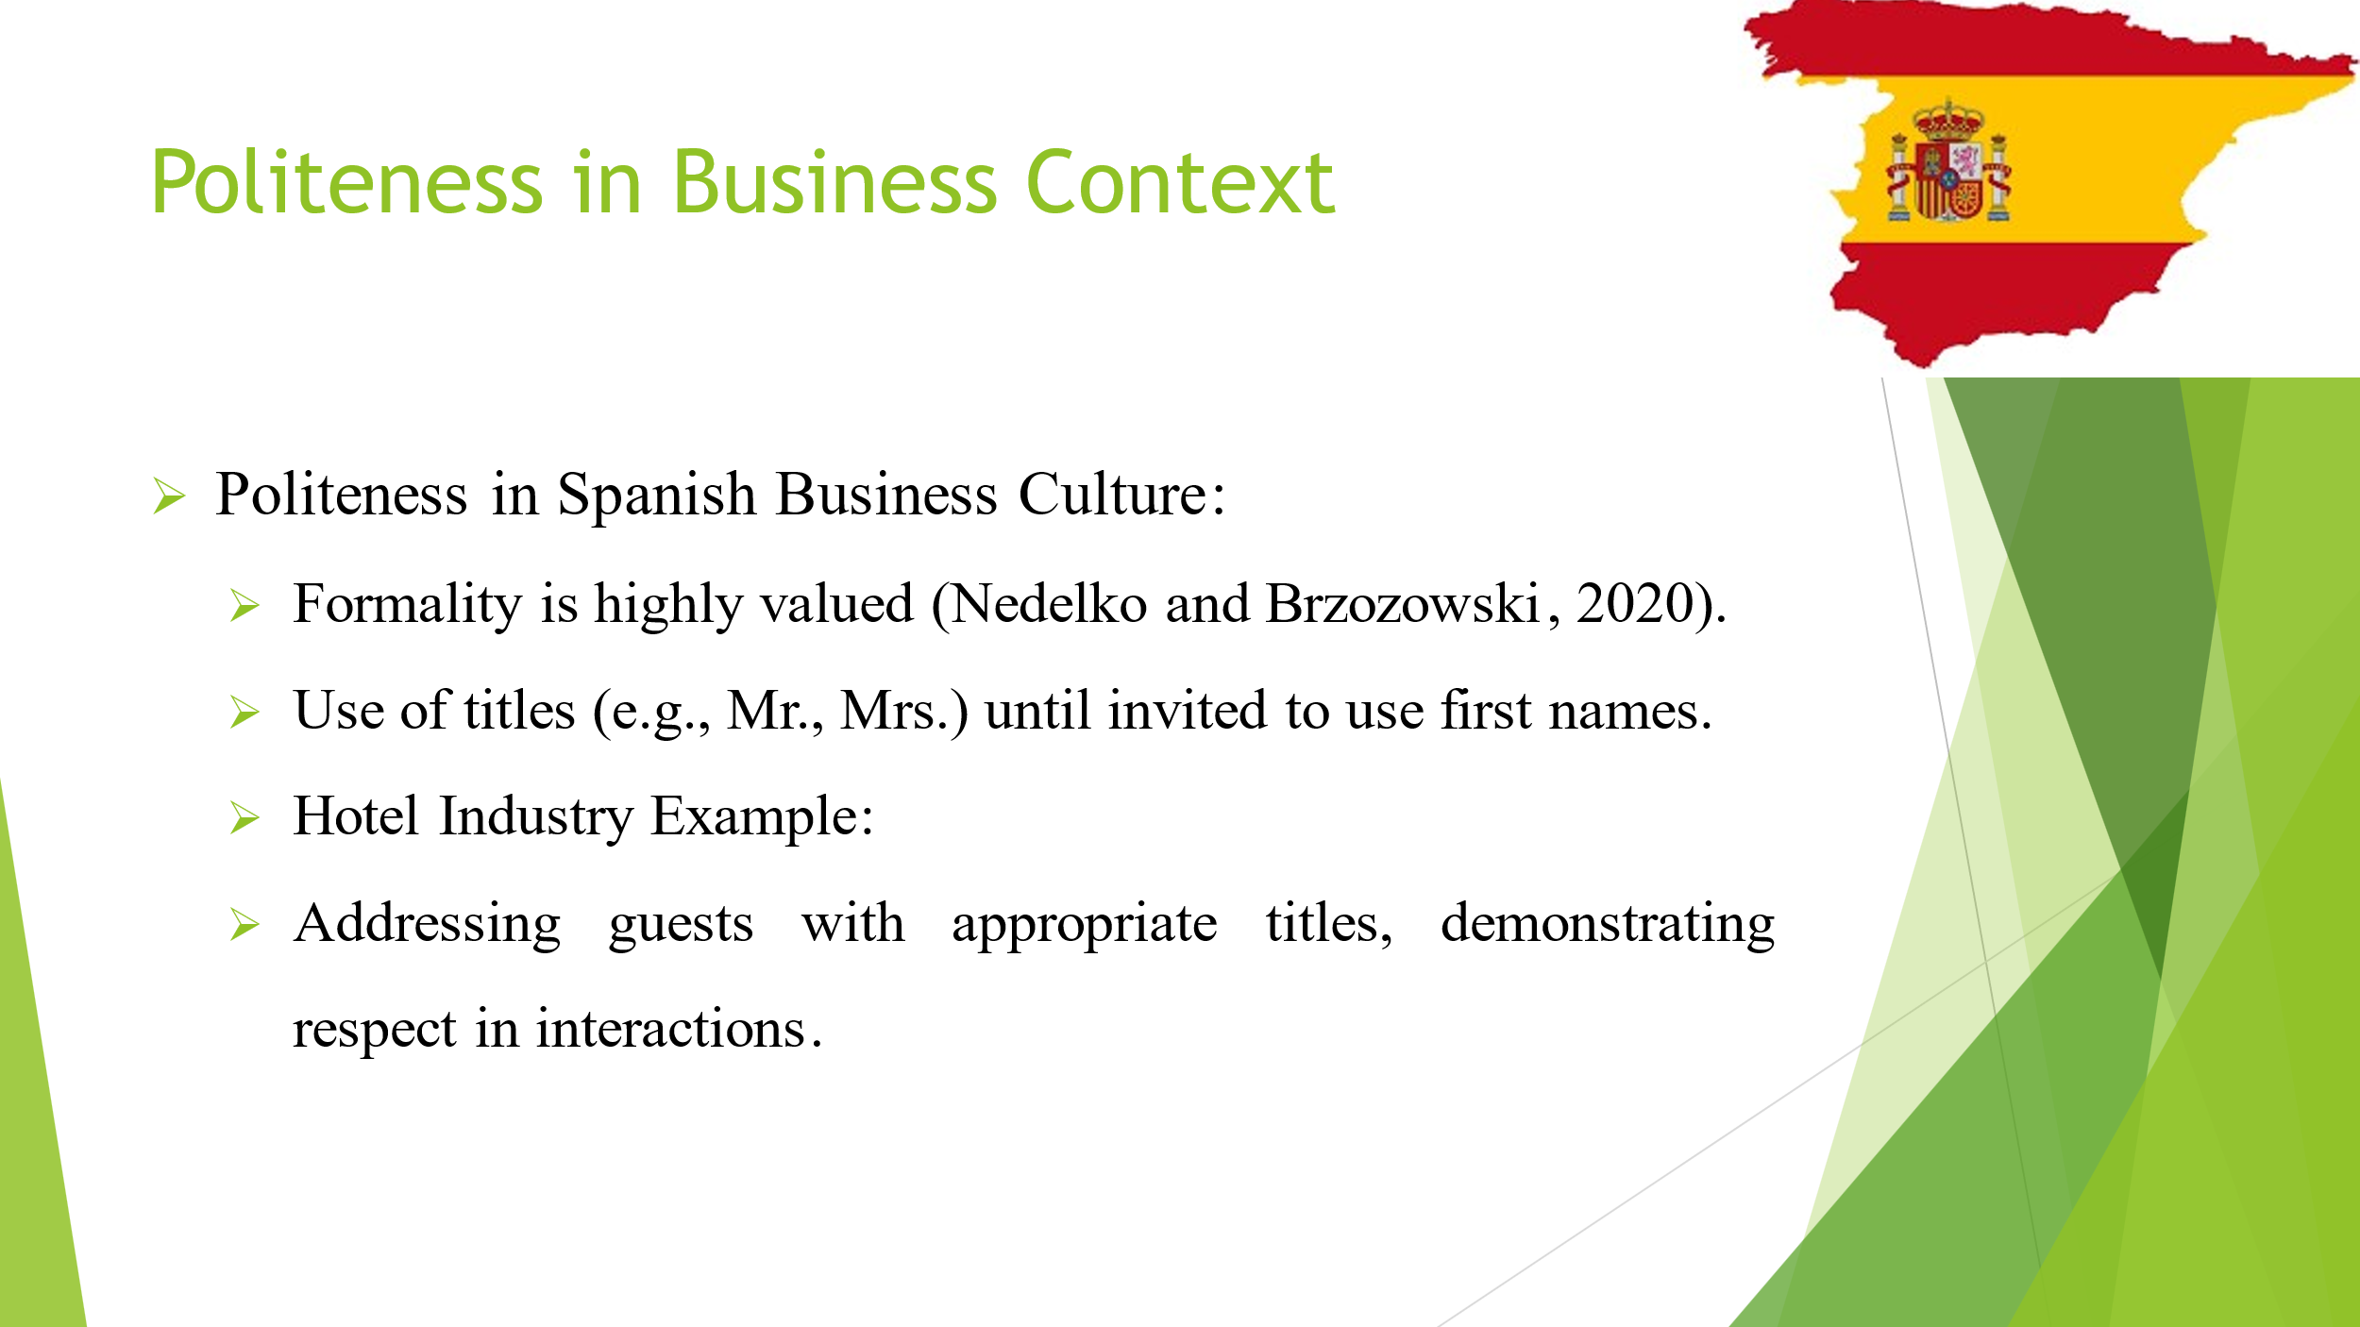
Understanding cultural nuances is a basic key. In Spanish-speaking cultures, formality is a sign of respect. Imagine the positive impression when we address our guests with the courtesy they value.

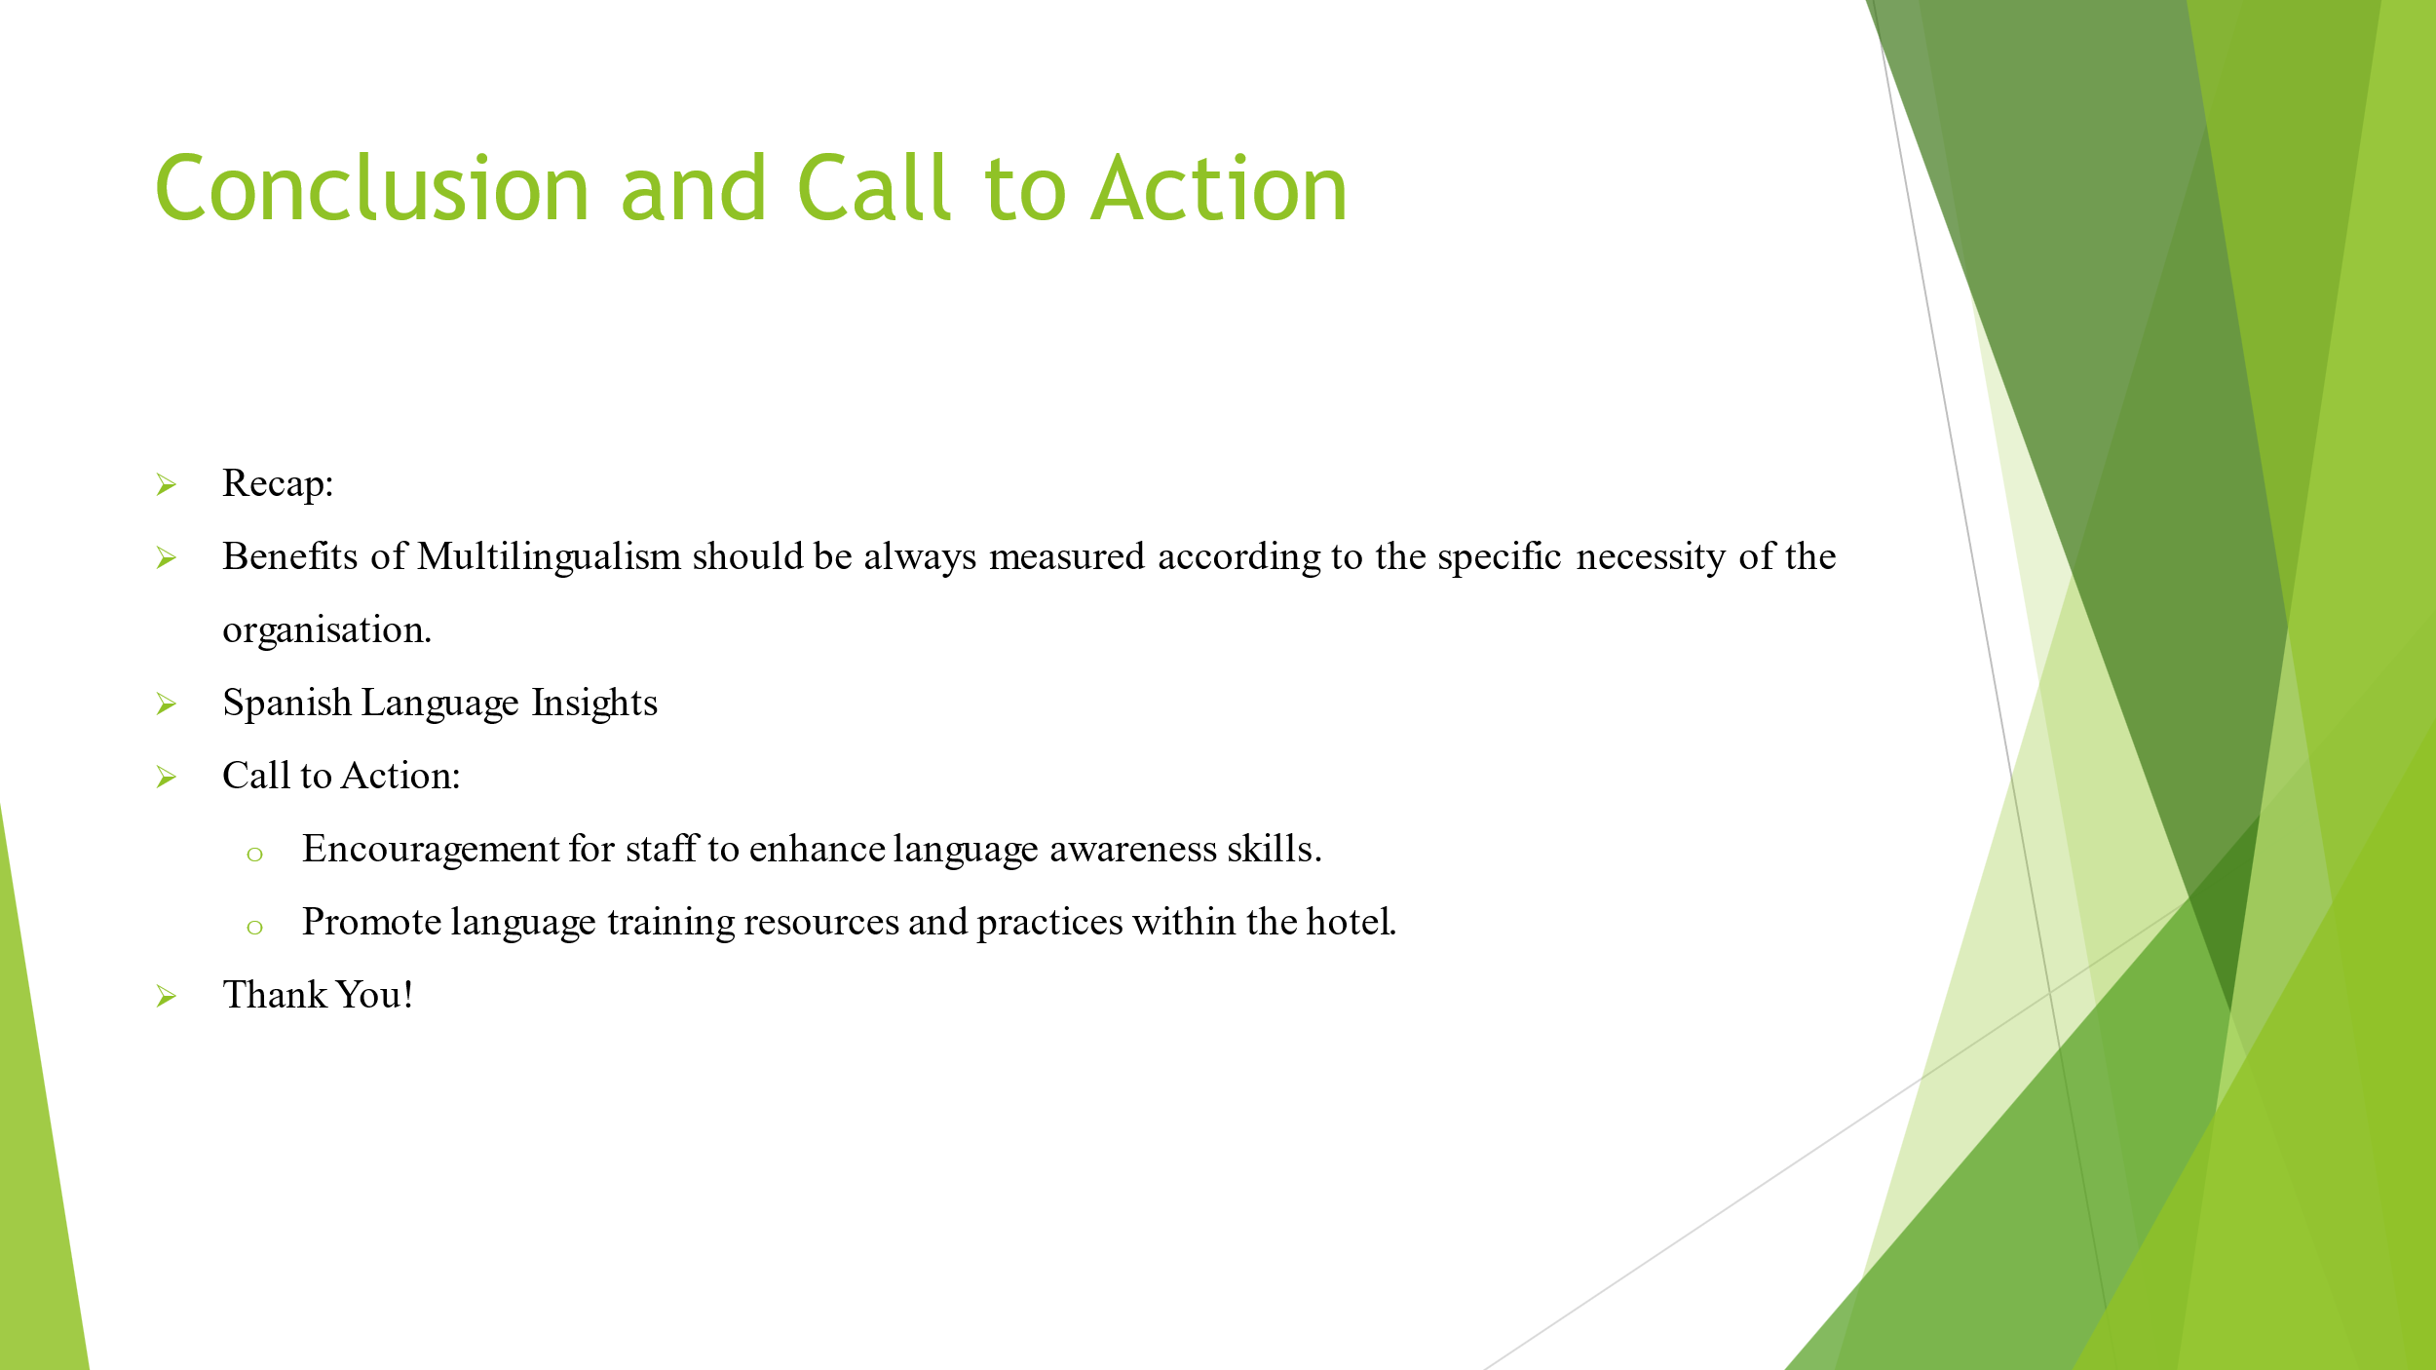
As we wrap up, let’s take this knowledge forward. Let’s empower ourselves with language skills that go beyond words. Let us create connections and elevate our service to new heights. The focus of the organisation should be on the uplifting of the cultural competency of the employees so that they can handle scenarios in multicultural workplace and environment as well.

References (no screenshots):
- Hampden-Turner, C. and Trompenaars, F. (2020). Riding the Waves of Culture. 4th Ed ed. London: John Murray Press.
- Hofstede, G. and Minkov, M. (2010). Cultures and organizations : software of the mind : intercultural cooperation and its importance for survival. 3rd ed. New York ; London: Mcgraw-Hill.
- Nedelko, Z. and Brzozowski, M. (2020). Recent advances in the roles of cultural and personal values in organizational behavior. Hershey, PA: Business Science Reference, an imprint of IGI Global.
- Noels, K.A. (2020). Learning Spanish as a Second Language: Learners’ Orientations and Perceptions of Their Teachers’ Communication Style. Language Learning, 51(1), pp.107–144. doi:https://doi.org/10.1111/0023-8333.00149.
- Segalowitz, N. and Freed, B.F. (2021). CONTEXT, CONTACT, AND COGNITION IN ORAL FLUENCY ACQUISITION: Learning Spanish in At Home and Study Abroad Contexts. Studies in Second Language Acquisition, 26(02). doi:https://doi.org/10.1017/s0272263104262027.

