
Student’s Name: Md. Shajal Mia
Student ID: 2437642
Module Name: Marketing Management
Module Code: LCMB7024
Lecturer's Name: Dr Laila Maazouz (London)
Poster: Marketing Strategy Pitch
Term 1

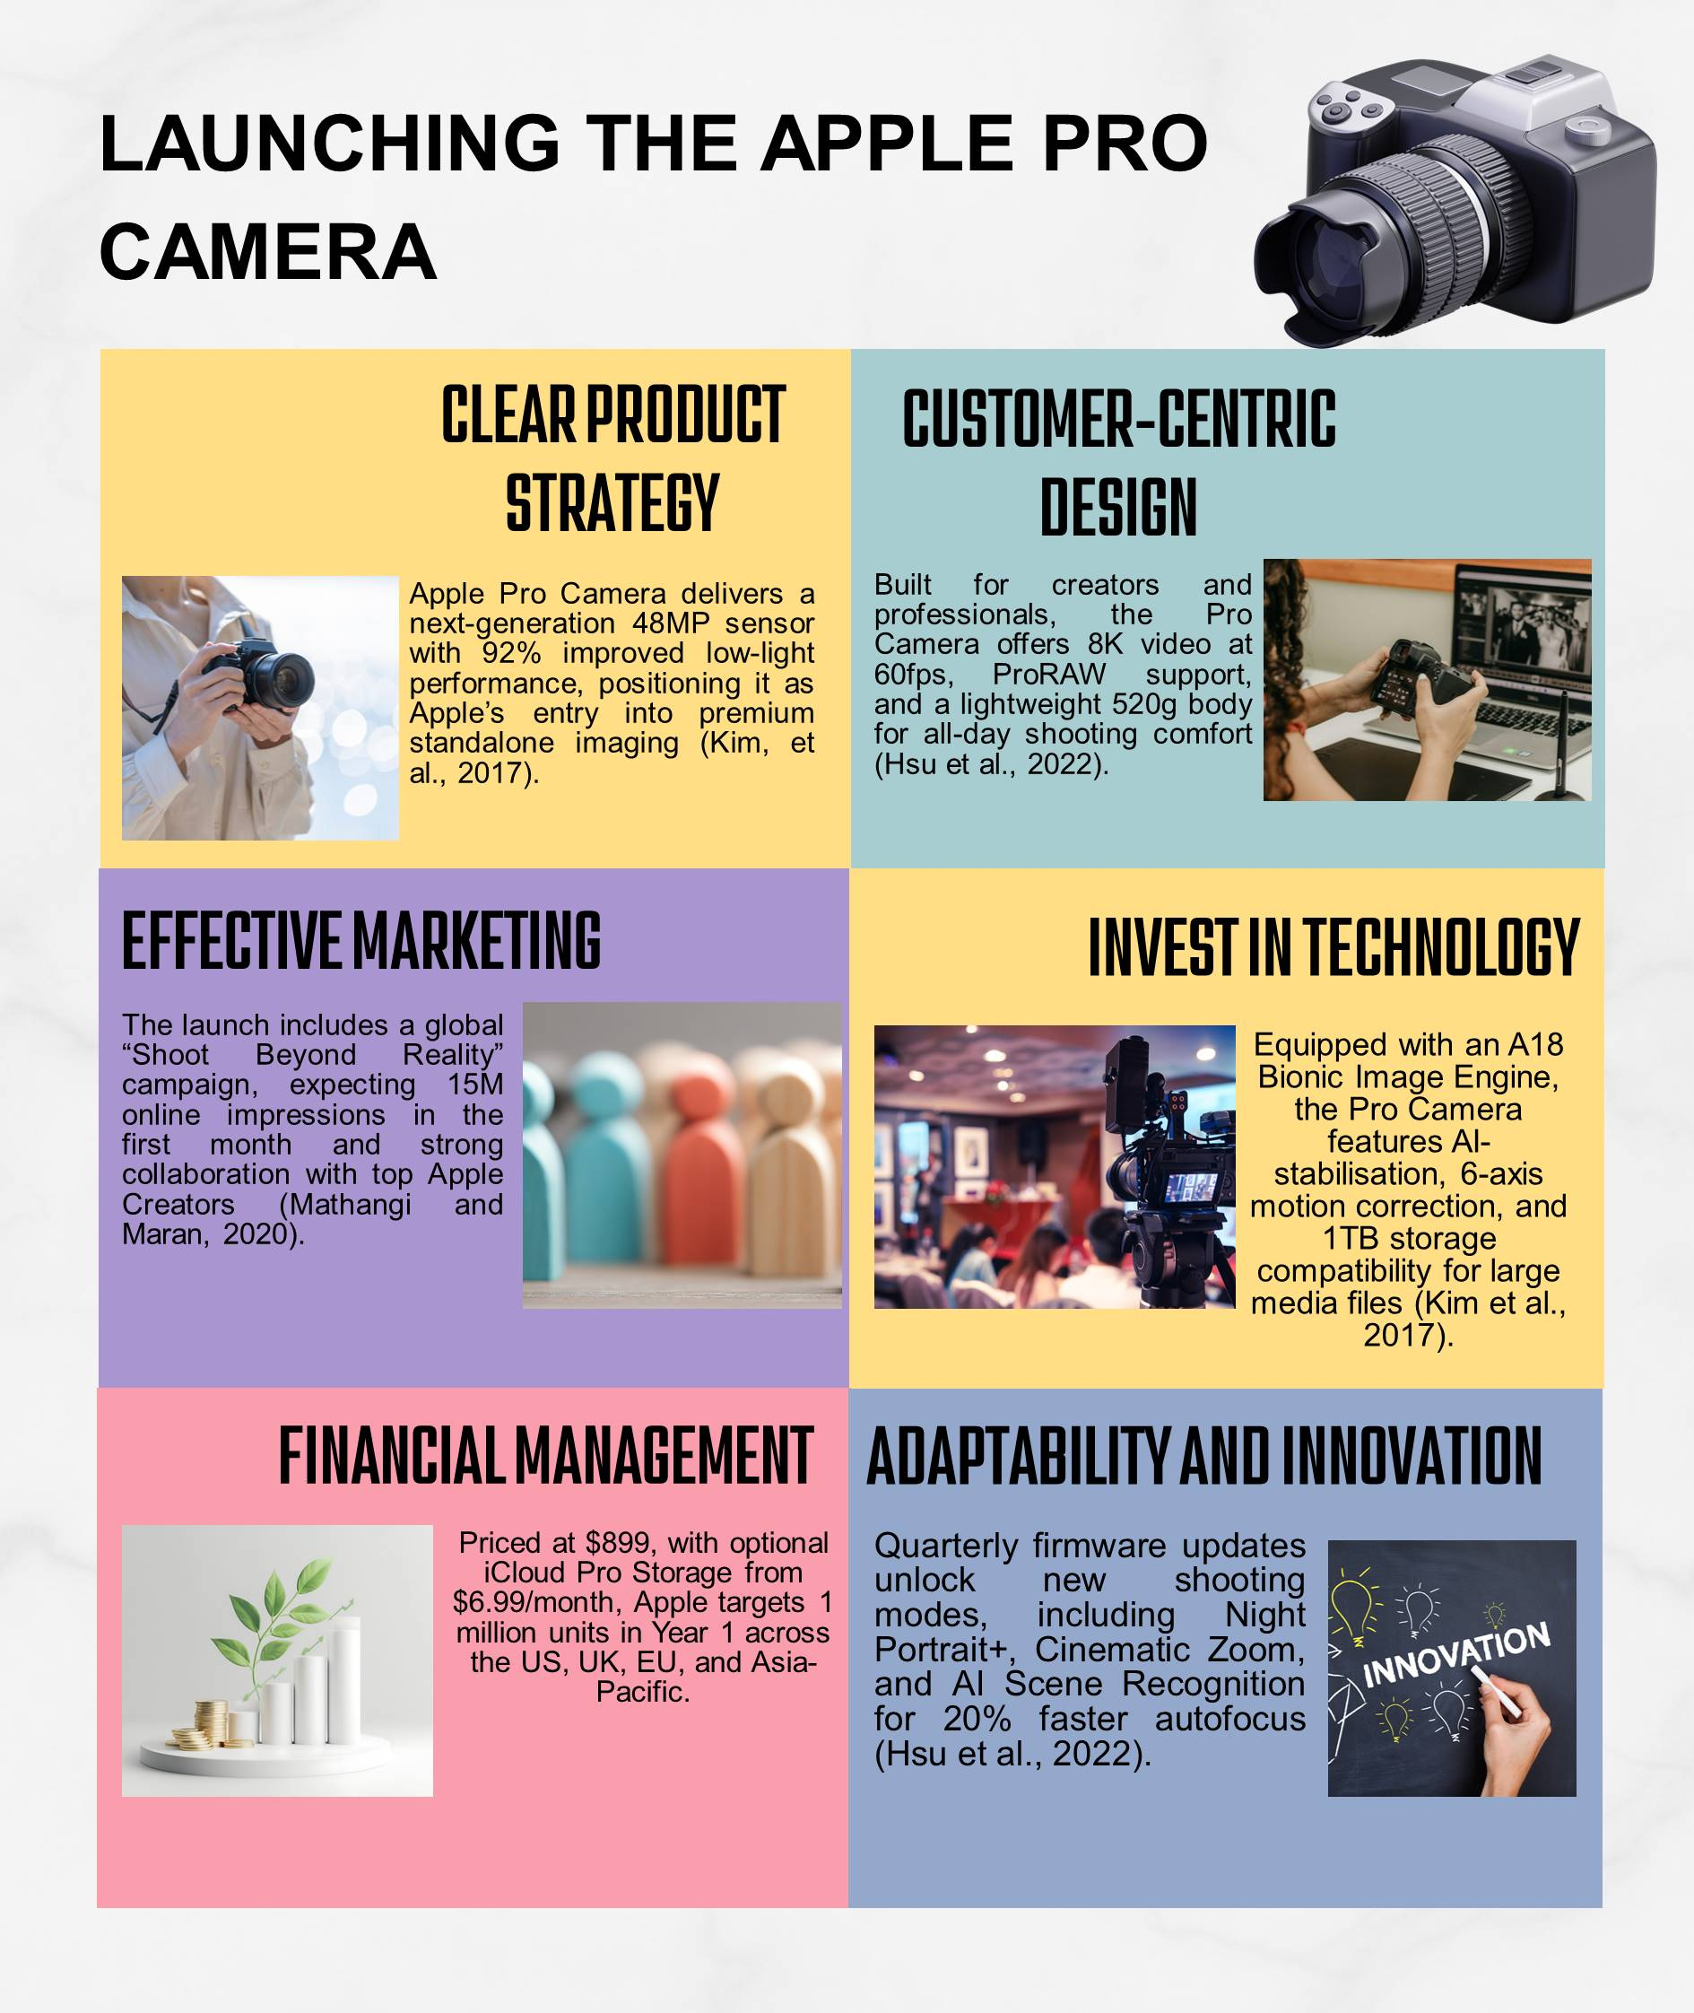

References
Kim, J., Jun, S., Jang, D.S. and Park, S., 2017. An integrated social network mining for product-based technology analysis of Apple. Industrial Management & Data Systems, 117(10), pp.2417-2430.
Hsu, T.H., Her, S.T., Chang, Y.H. and Hou, J.J., 2022. The application of an innovative marketing strategy MADM model-SIVA-need: A case study of apple company. International Journal of Electronic Commerce Studies, 13(1), pp.33-67.
Mathangi, S. and Maran, J.P., 2020. A study on apple ber to identify the suitability of new product development. Plant Sci. Today, 7(1), pp.61-69.

