Executive summary
In this report, I will provide the importance of cultural intelligence in a hotel showing how a guest from China would like to experience their visit to a hotel in the UK. This handbook is for staff to become successful in delivering their service. Having good cultural intelligence in staff members will enable a hotel to real its goals as they can fulfil their guests' needs in a better way.

Introduction
Hotels have a queue of rules to be maintained for its swift processing, and cultural intelligence of its staff and their cultural sensitivity is inevitable for understandable relationship development between the visitor and the hotel. This handbook will follow the Hofstede Model to examine. It is a framework, which is used to understand the difference in culture across countries around the world. The report will focus on the application of the Hofstede model. We will see how different nationalities can relate and the ways employees and management can harmoniously co-exist and can handle the needs and demands of these dominant groups.
What is cultural intelligence?
Cultural intelligence can be defined as a unique quality in a staff that enables him/her to relate to the cultural diversities hotels face and having an efficiency to properly work under those diversities.
It's a process where people slowly gain a new perspective and insight into new professional methods and language that will allow them to create better solutions when it comes to cross-cultural situations. Individuals with a high level of cultural intelligence will be able to accomplish goals in a respectful and effective way no matter which culture they are exposed to.
Benefits of Cultural intelligence in a hotel staff:
- It will help the visitors to feel at home.
- Different cultures breed different traditions which have their own sense of respect and regard. Having knowledge of diversity will help to behave in the most fitting way to the visitors.
- It can act as a boost to business competitions, as cross-cultural skills are one of the requisites in the hotel business.
- The more Cultural intelligence is introduced in a hotel the easier it will be to solve any problem aroused in terms of language, religion, or tradition.

Country A Hotel
The hotel is located in the heart of the United Kingdom. British culture has a rich history in its roots and consists of 4 different countries, each having a diverse culture. It is one of the most famous and influential countries in the world. And most of it has been translated from the Christian religion.

Country B
The guest's country is China. It is a vast country and has the highest population in the world. Some of the most common parts of Chinese culture include visual arts, literature, architecture, music, religion, and psychology (Zimmermann, 2017).

One of the biggest problems Chinese tourists face in hotels outside the country is their communication. Communication is undoubtedly an issue that is very difficult to solve. A survey by Chinatouriststar found that 28 percent of Chinese visitors said that communication was the biggest problem (Chinatouriststar, 2018). However, we are going to focus on a cultural misunderstanding. In that survey of 2018 by Chinatouriststar, 16 percent of Chinese visitors said they experienced cultural misunderstanding. That's why now I will use Hofstede Insights to compare the cultural difference between the two countries. It is a great resource to understand cultural differences in the hotel industry (HOFSTEDE, n.d.).

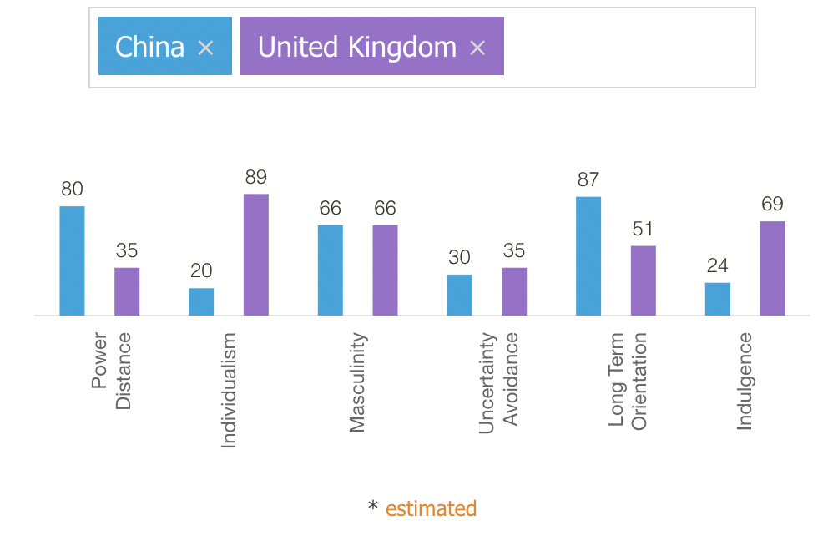

- Power Distance Index
Index power difference refers to the degree of inequality between people with power and without power. A high PDI score means people understand their place and are happy with the hierarchical distribution of power. A low PDI score indicates that people do not want cases where power is not distributed equally. UK has a much higher PDI score than China. This indicates supervisors and employees are considered almost equals in China (Anon., n.d.).

- Individualism
This sector indicates the strength of ties people have with themselves in society. China has a meager individualism score compared to the UK. Therefore, it indicates that people work for intrinsic rewards. They've emphasized maintaining a good harmony among members of the same group and avoiding any moral issues.

- Masculinity
Masculinity Portrays the distribution of responsibilities and roles between women and men. Here both the countries have the same score.

- Uncertainty Avoidance
This path shows how good people can survive with anxiety. The United Kingdom and China have almost similar uncertainty avoidance scores. Both have a low uncertainty avoidance score which means they are more open to changes and innovations and are generally more inclusive. They incline and more towards open-ended learnings.

- Long term orientation
China has a much higher long-term orientation compared to the UK. Therefore, people of China are more modest they emphasize virtues and obligations.
- Indulgence
This dimension is a little bit new and hence has less data. from the above bar chart, we can see that the people of the United Kingdom have higher indulgence than China. This indicates more people are pessimistic and rigid in behaviour.

Enhancing Cultural Intelligence:
It's a matter of time to develop cultural intelligence. One himself will get along with a variety of cultural differences. But there are some specific ways of fastening the method:
- The staff should try to involve themselves in the cultural difference exposure daily.
- Avoid stereotyping strictly. Stereotyping can negatively impact certain conditions that should not be seen as the true aim from a visitor's point of view.
- Making a common ground: Staff should work hard to find mutual likes and dislikes, which helps develop an understanding.
- Staff needs to be very accepting. Because as different cultures will have different perspectives, it'll be hard to find a perfect match unless the staffs

Some Do’s and Don’ts for the staffs:

Do’s | Don'ts
Perform your duties according to the hotel guidelines set by the authority to avoid confusion. Hotel should have free WIFI and Chinese Union pay or Alipay as payment facilities. | Never ask for tips unless offered. As in some cultures like Chinese its rude to ask and in contrast in USA its rude not to tip.
Behave and deal with visitors of all genders with professionalism. | Be honest and punctual to work and don’t give special treatment to ladies.
Respond immediately to any kind of call. Be attentive to the details with Chinese guests. The hotel room should have Toothbrush, slippers and razors. Tea kettle and tea should also be included. | Some basic prohibitions such as Gambling, smoking, drugs, drinks, chewing gums should be prohibited.
Always greet the guests at every encounter like “Good morning”, “Good evening”  If staff knows a Chinese or Mandarin they should be put on welcome committee. | Don’t use number 4 as it means death in Chinese language. So, no four number saying out loud and don’t put Chinese guests on fourth floor. Never put any guests’ belongings at the back of the house service area.
Stand straight showing a gesture of respect without leaning on walls or anything else. Have a smile on your face. | Never lose your temper with Chinese delegation.
Report the supervisor immediately if anything feels off about any visitor or even any other staff. | Do not keep your hands in your pocket while talking or doing anything.
Respect and accept all | Do not support one visitor biasedly in Infront of others.
Perform the duty in the only area you get advised to unless otherwise by the supervisor. | Try not to be absent from duty without any proper reason or emergency.

Conclusion:
So, it’s fairly important that each and every staff member has a good understanding of what cultural intelligence represents. They should be good at implementing it to avoid any kind of misunderstanding.

Reference
Anon., n.d. Hofstede's Cultural Dimensions. [Online]
Available at: https://www.mindtools.com/pages/article/newLDR_66.htm
Chinatouriststar, 2018. Chinatouriststar. [Online]
Available at: https://chinatouriststar.com/how-can-you-improve-the-experience-of-chinese-guests-in-your-hotel/
[Accessed 2021].
HOFSTEDE, G., n.d. Hofstede's Cultural Dimensions. [Online]
Available at: https://geerthofstede.com/
Zimmermann, K. A., 2017. Chinese Culture: Customs & Traditions of China. [Online]
Available at: https://www.livescience.com/28823-chinese-culture.html
[Accessed 2021].

