Network configuration SyStems
Elena Magher
Practical Demonstration:

Task 2 :
I had a laptop Hp 8 GB where some virtual machines require at least 4 core (4GB Ram left with not much for your functional CPU running in slow motion , where I wait 3 h for installing a win server ) so I buy apple .
Nevertheless , to run a program with Virtual machine we need 16GB .
A virtual machine of B-Dc created into Apple silicon . Virtual machine Oracle with ISO fille . On macOS is running with arm64 instead iso.
A machine Virtual Machine UTM can be a bit different of creation
A share point of ow I did install from assignement1 where require lot of attention https://uowtsd-my.sharepoint.com/:f:/g/personal/2426374_student_uwtsd_ac_uk/IgDkKUmPk1waQIQ42rebmEwmARv-cjbXI9cWS84_2YSjwEI?e=GIaV5M
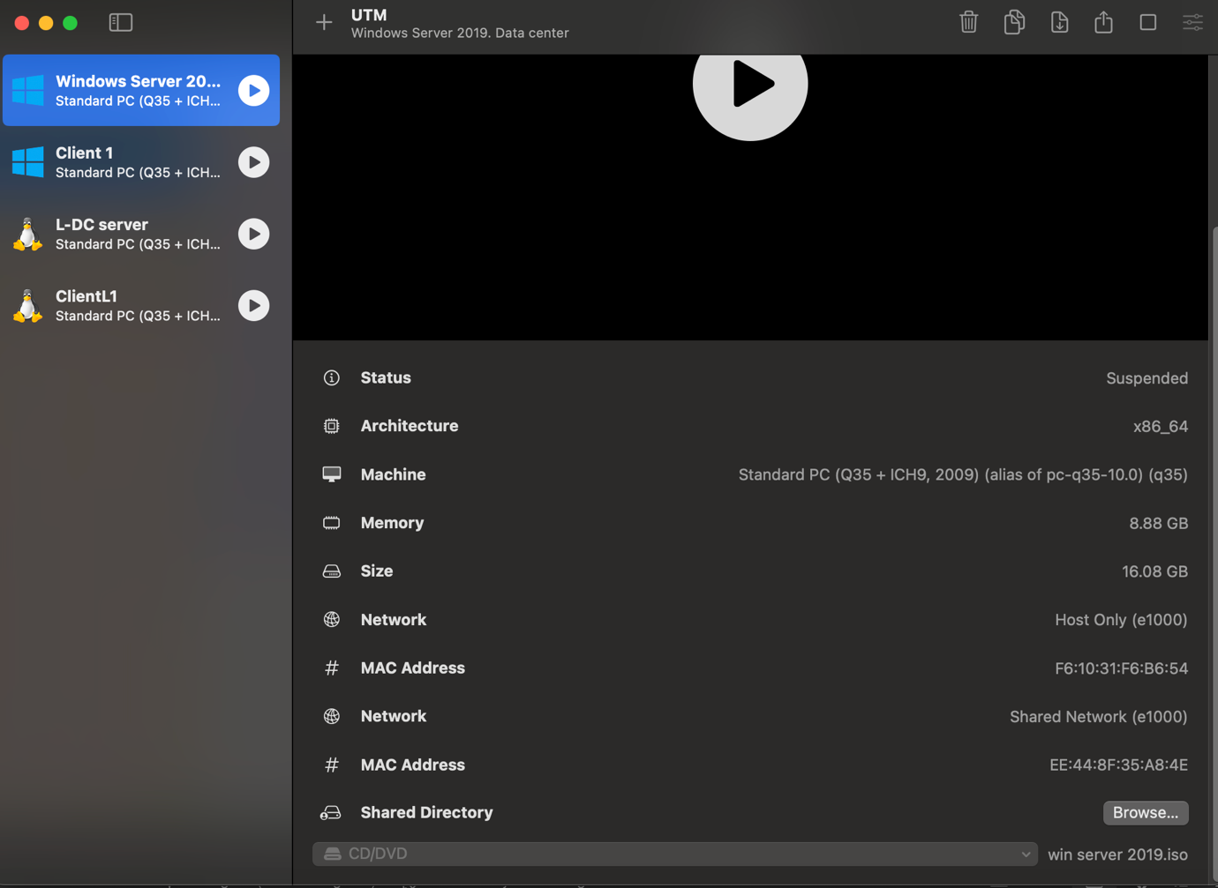
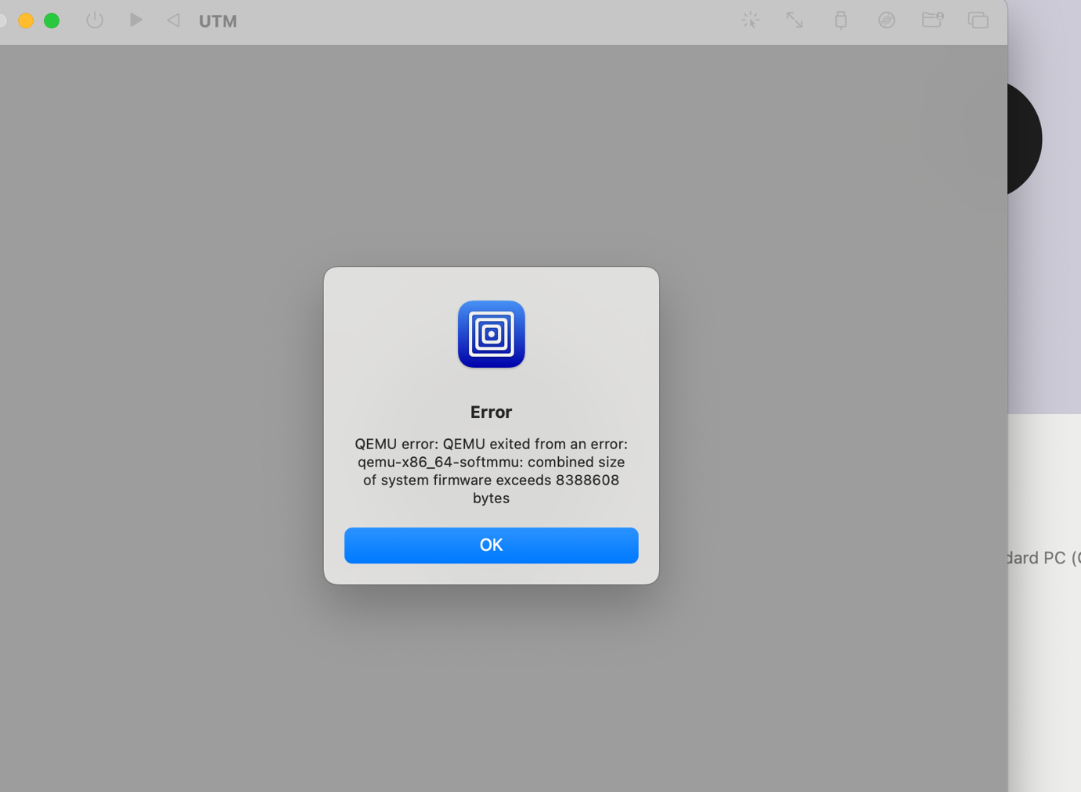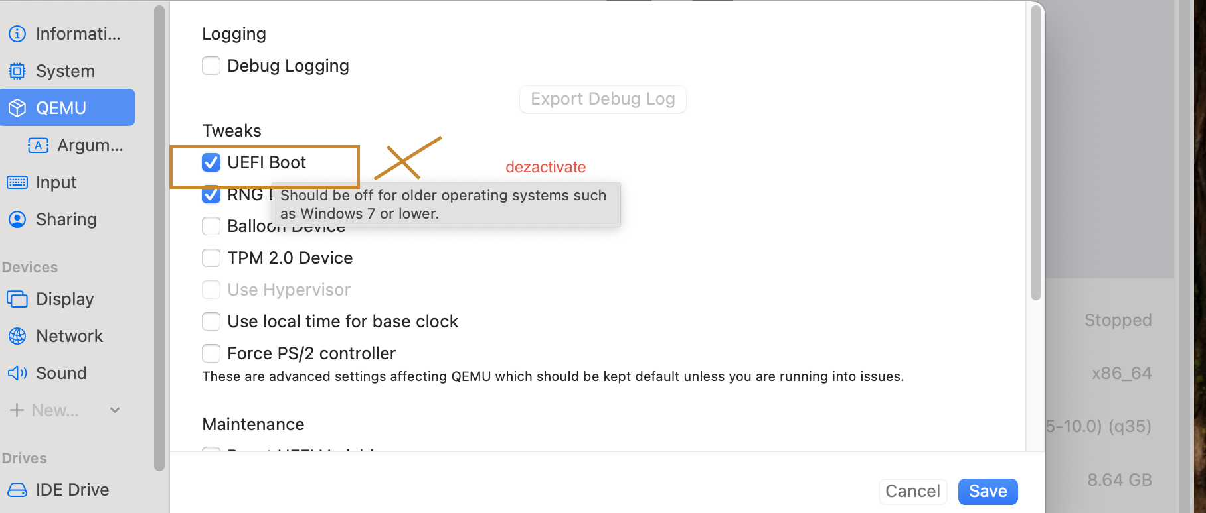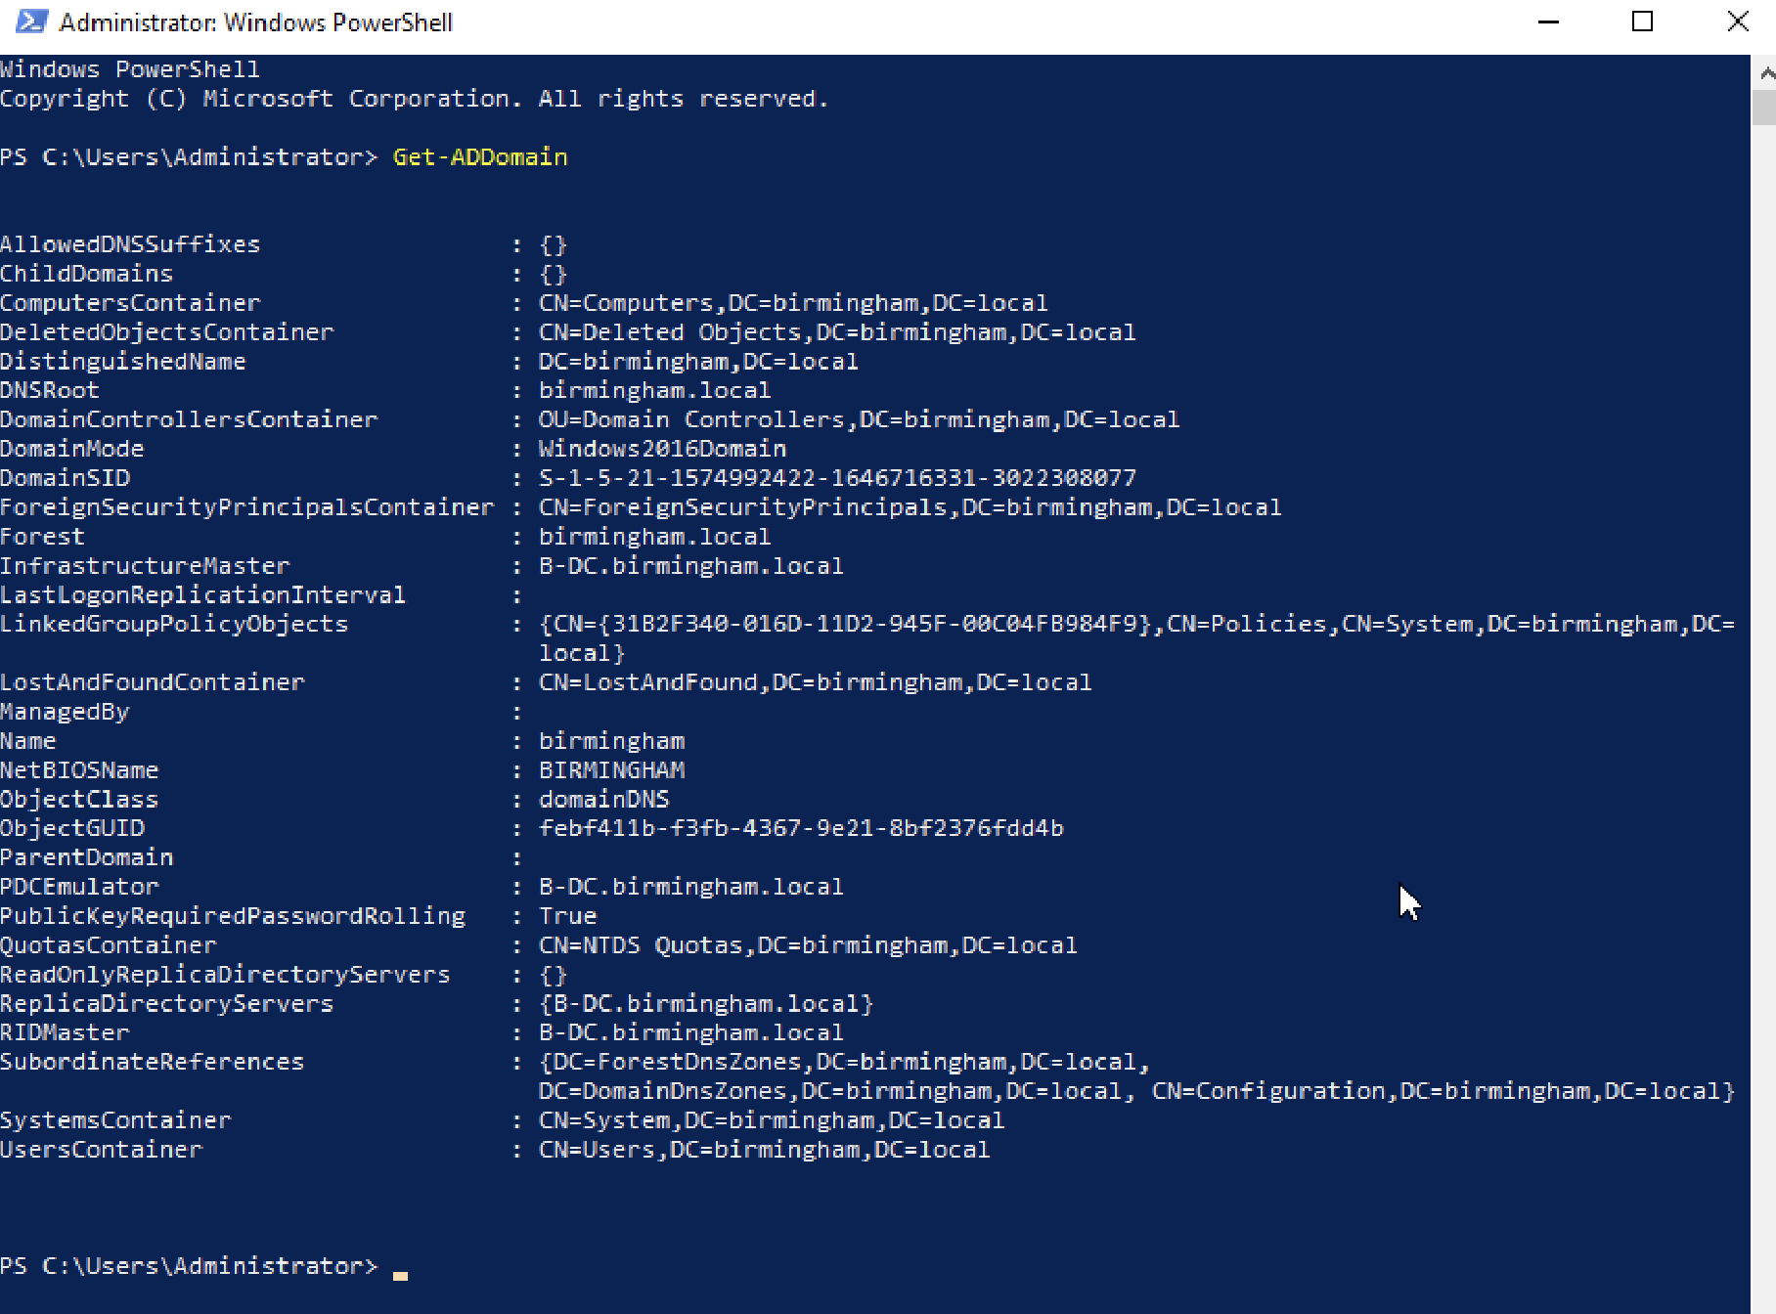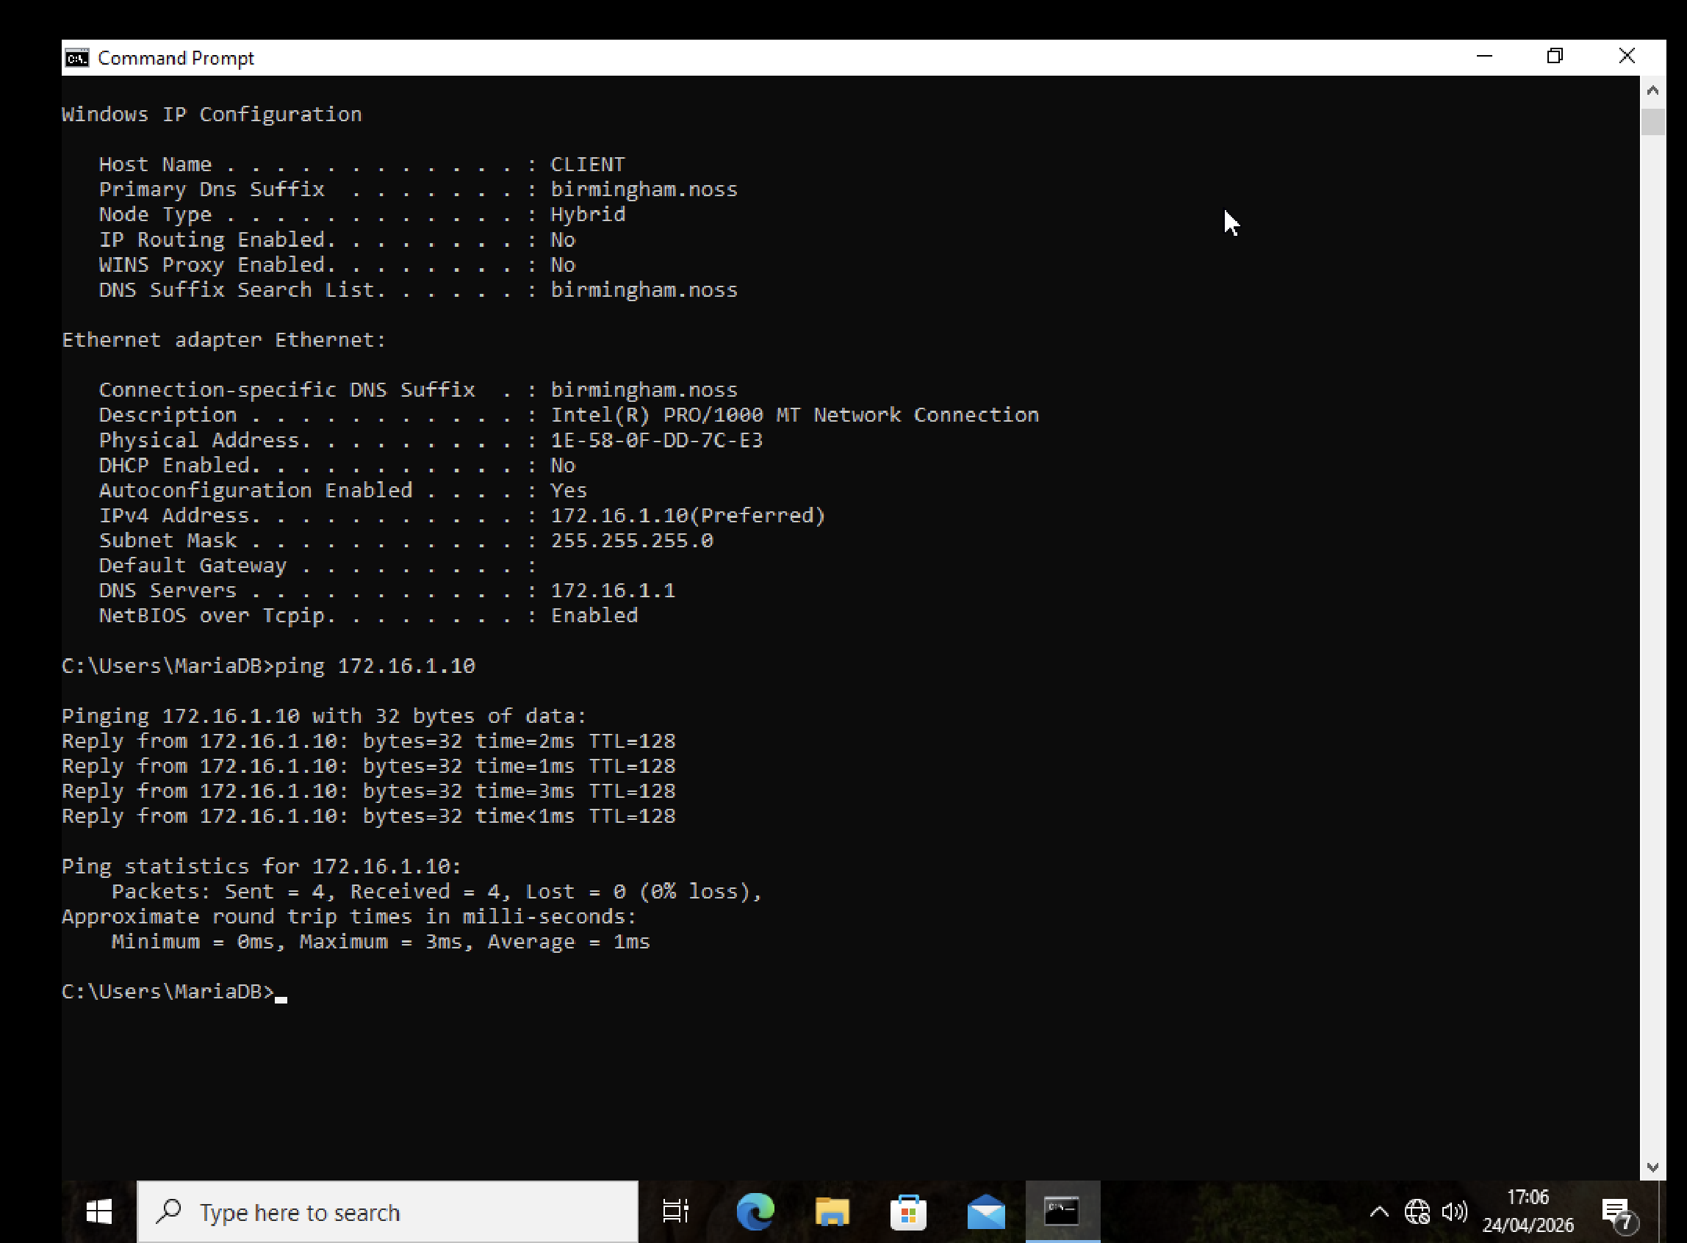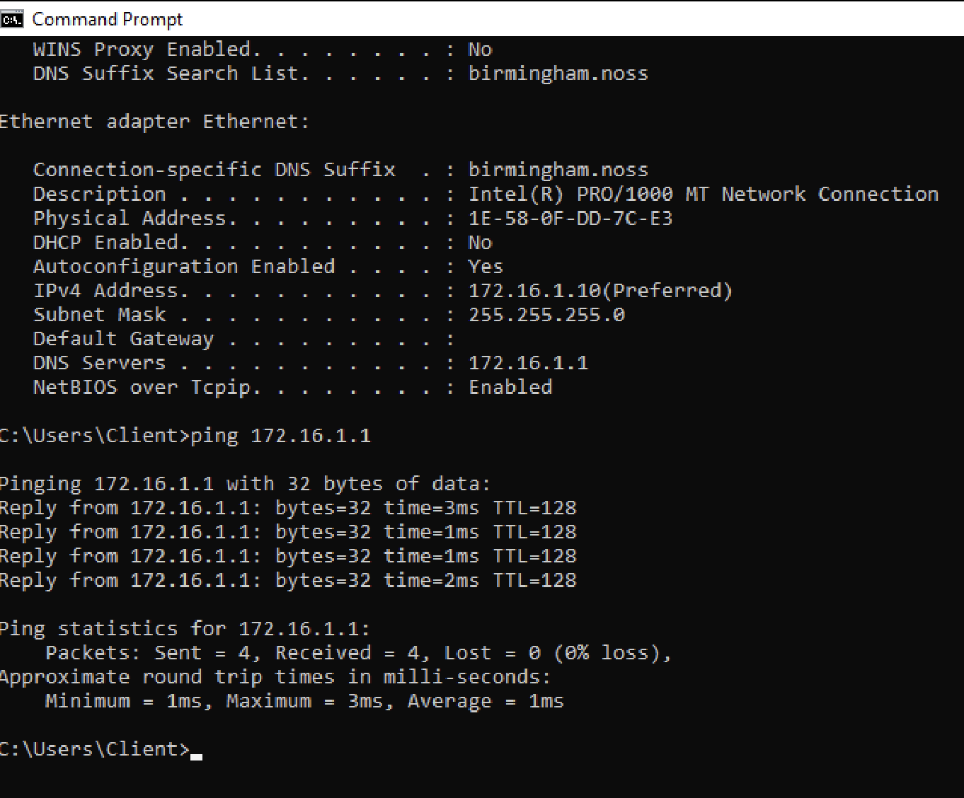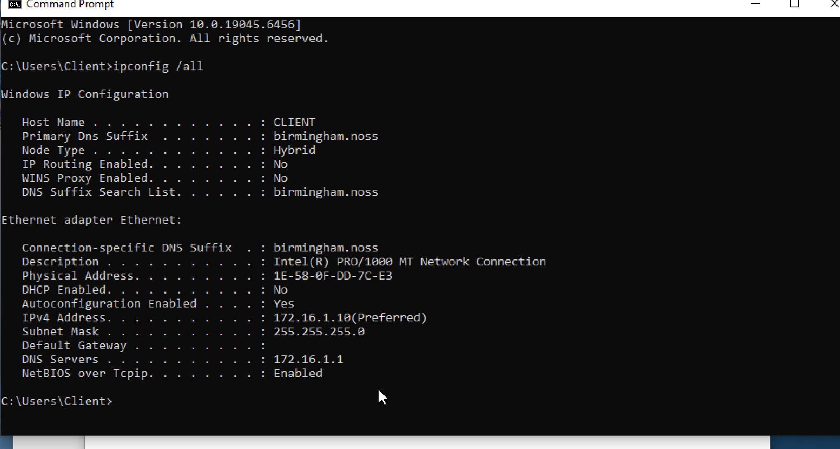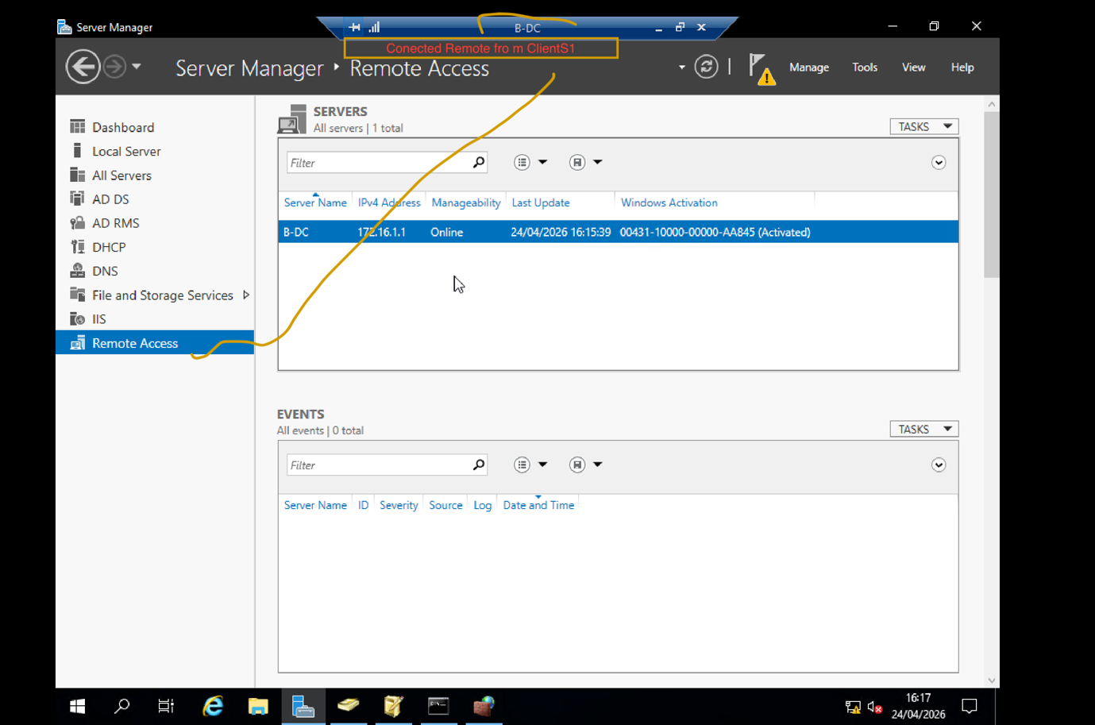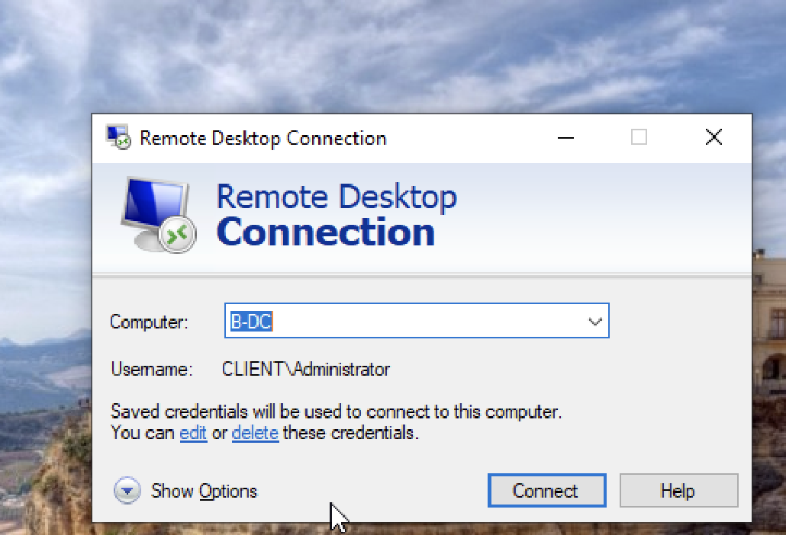
Ping command connecting Birmingham to London. In simple words ping command act as : “is somene at home? Yes! “ Where yes means reply that works 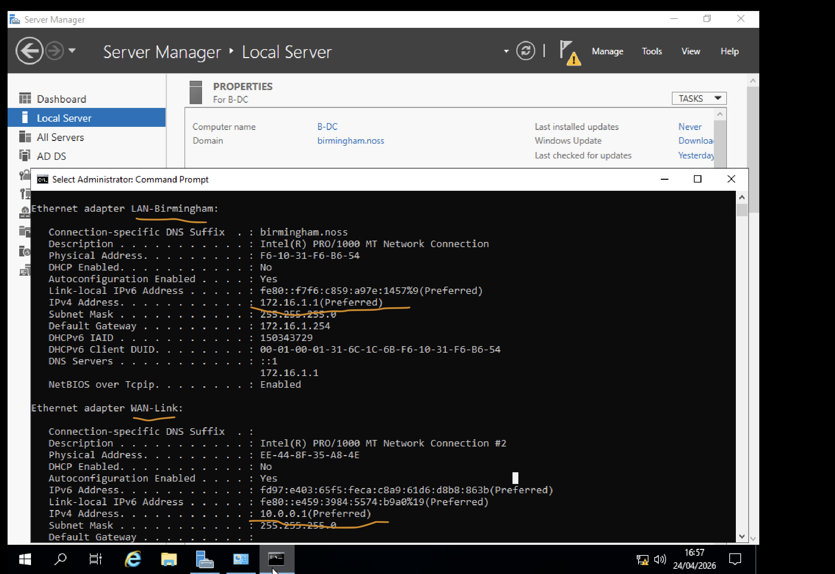
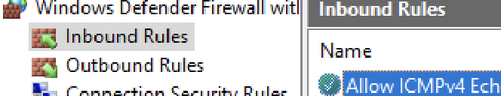To work properly (connection network, share point network, IPV4 where we do need to install manually) we need to install Rule for Windows Defender 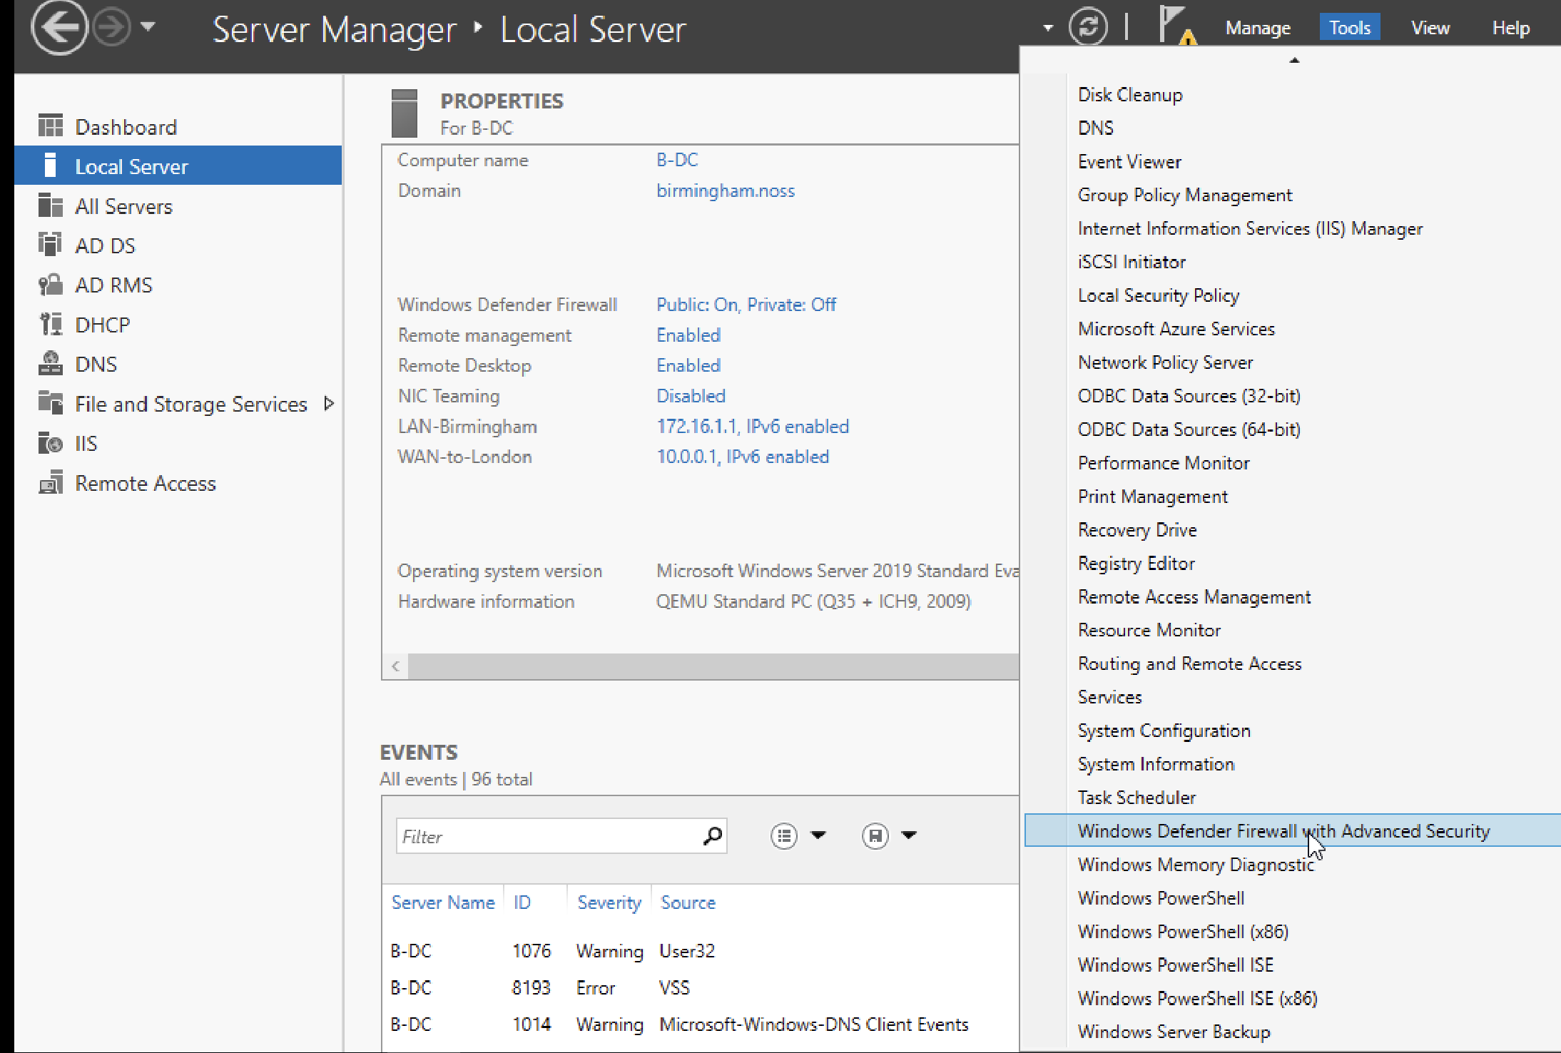

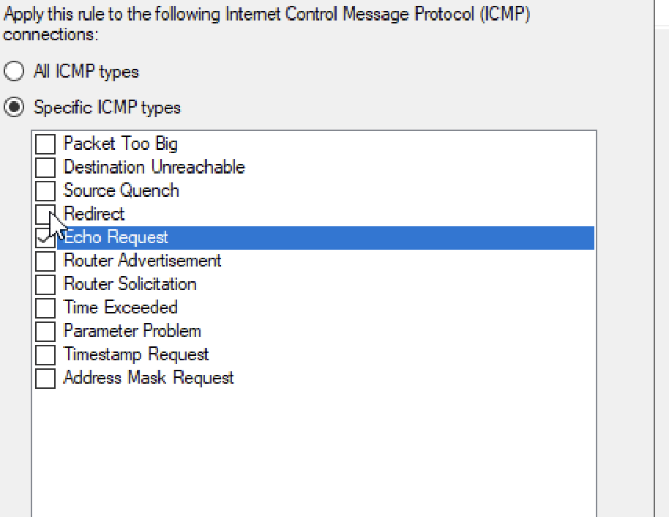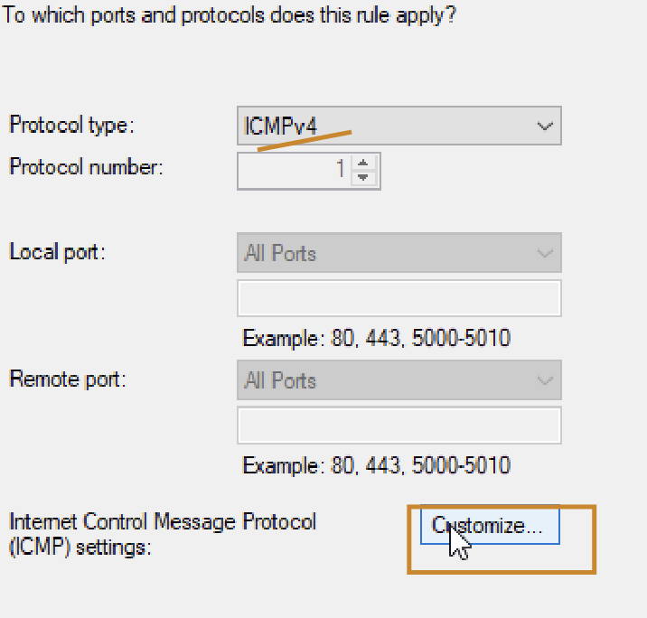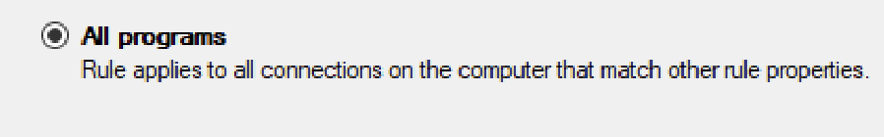
Network in Active directory
Hardware network :
I UTM machine for network we do have the following options:
Network Mode : VLAN = Split network into smaller groups where requirea Port + UDP or TCP
Troubleshooting L-DC to b-Dc + Client won’t work because we do not have/don’t know in coursework the port 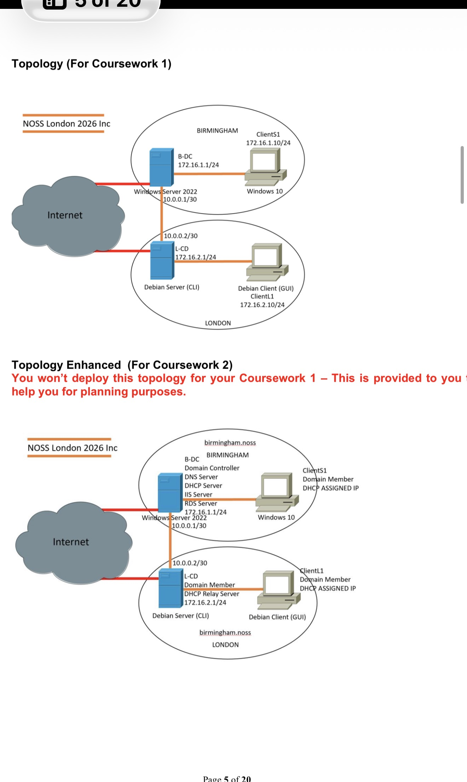
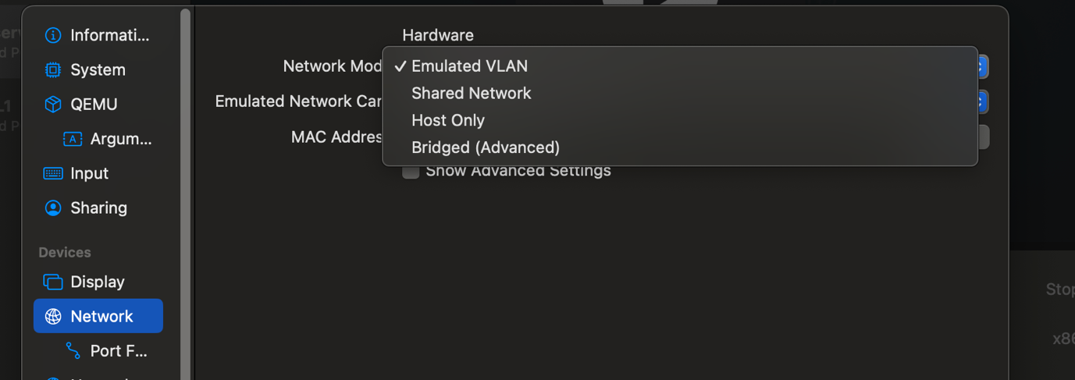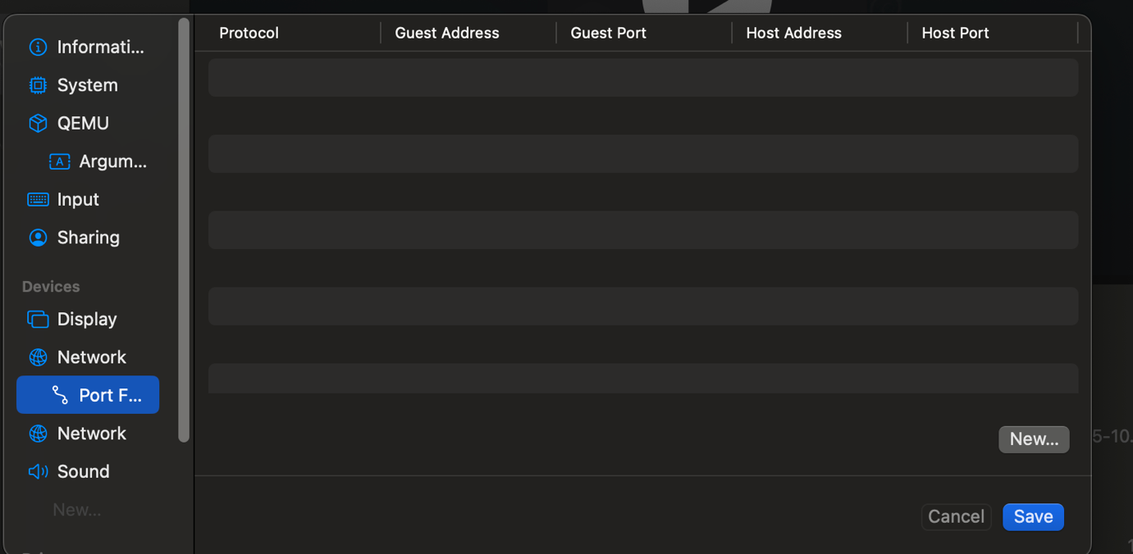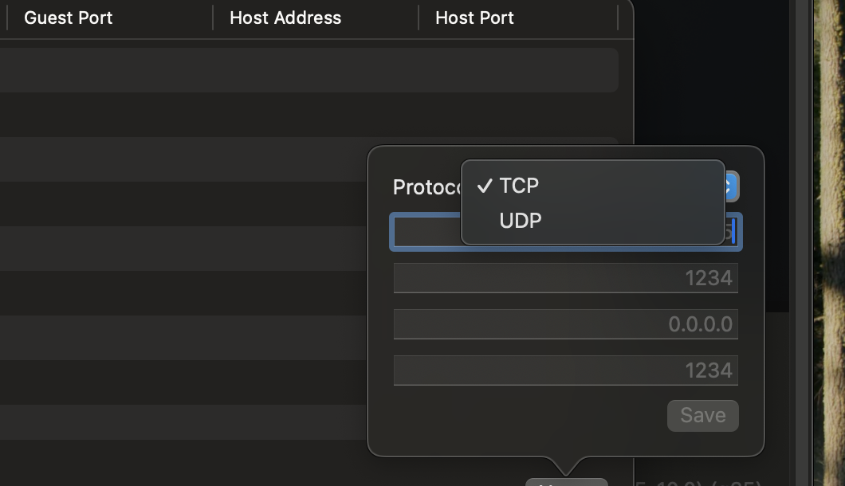
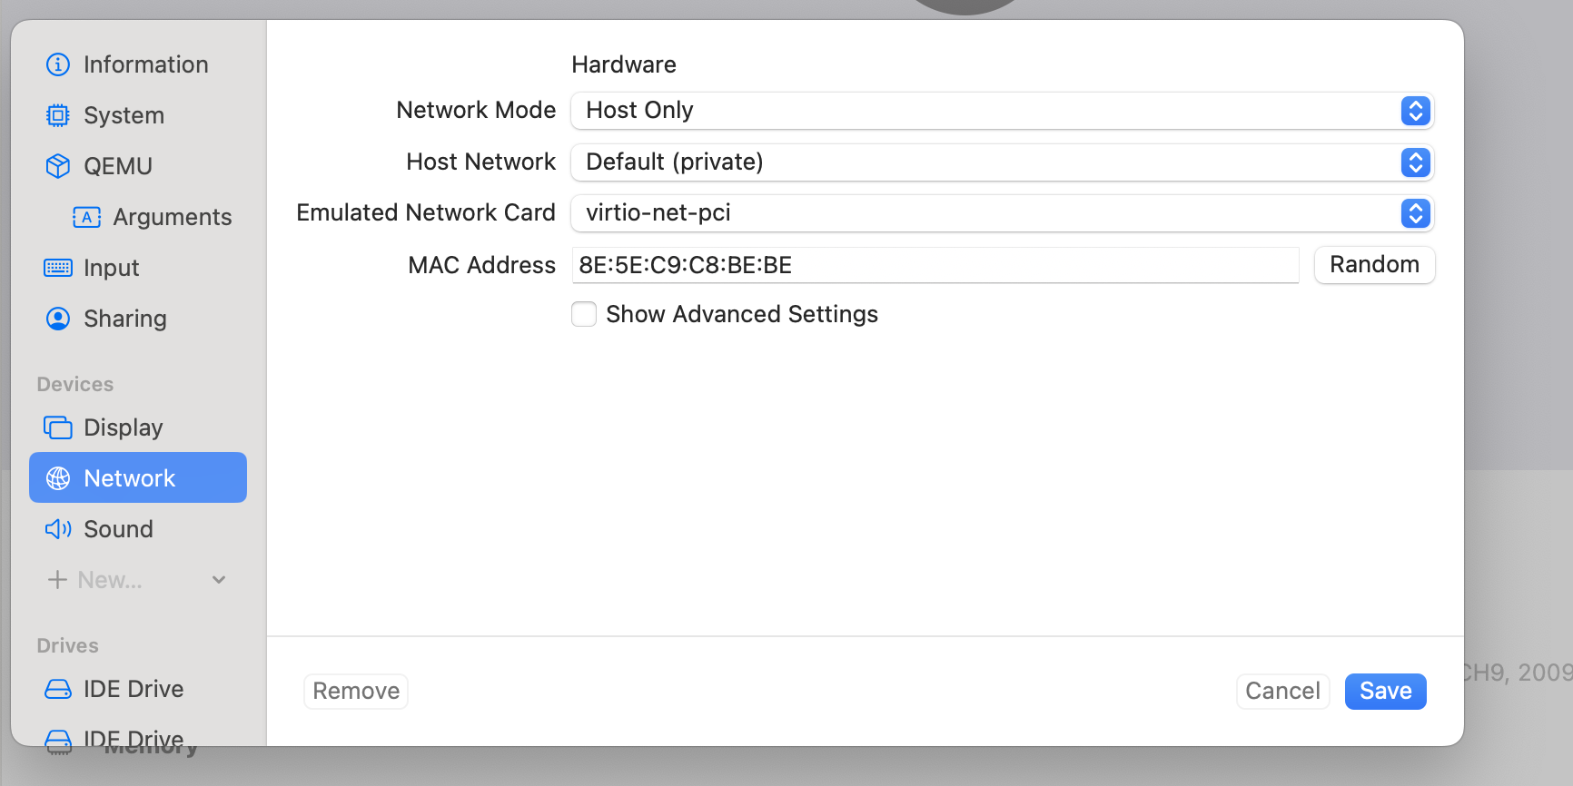
Host Only I did used as B-DC where talks only with host. `no internet
Shared to London-VM uses host internet. Can go out, not reachable from outside
Bridged acts like real devices on network .Gets its own IP ( I did used when I finish installed the software because till I set up I do need automatic internet network for update the software as Windows client 2010 update as Edition able to join in Domain)

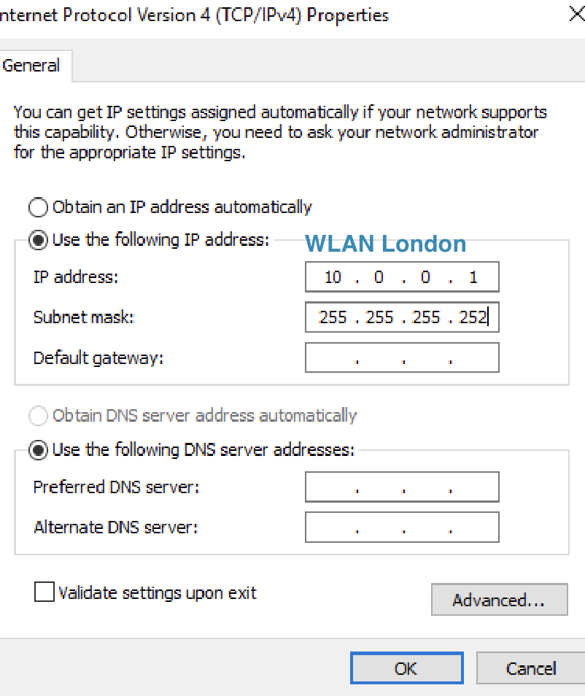
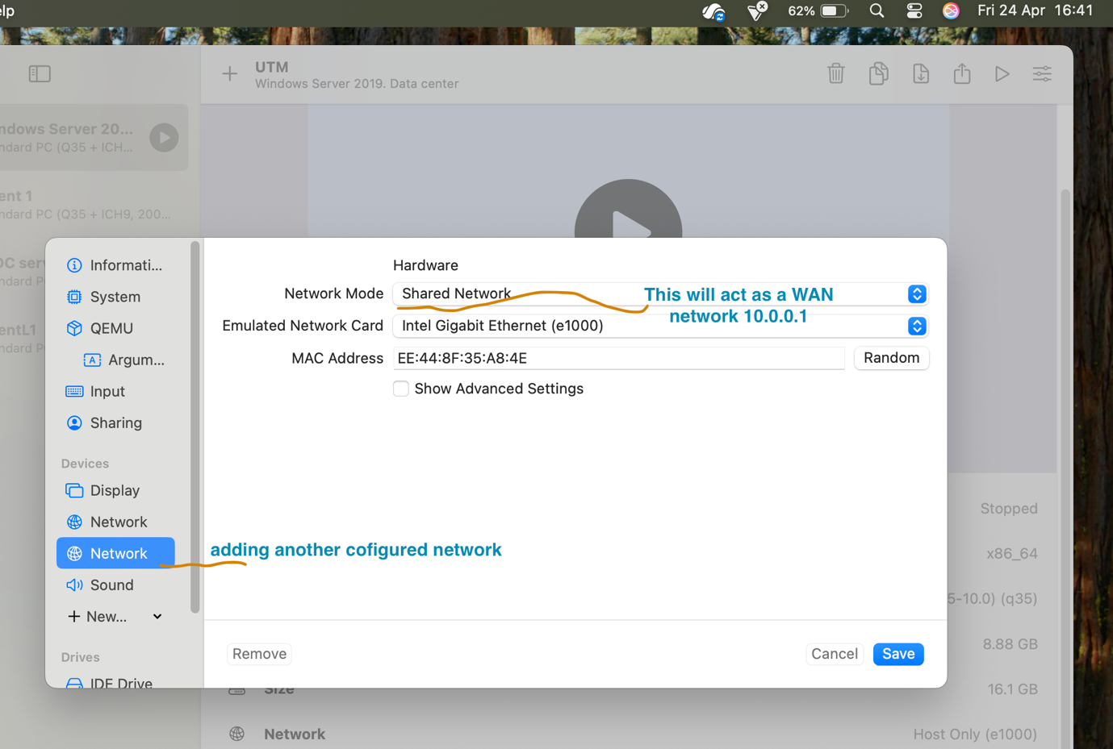
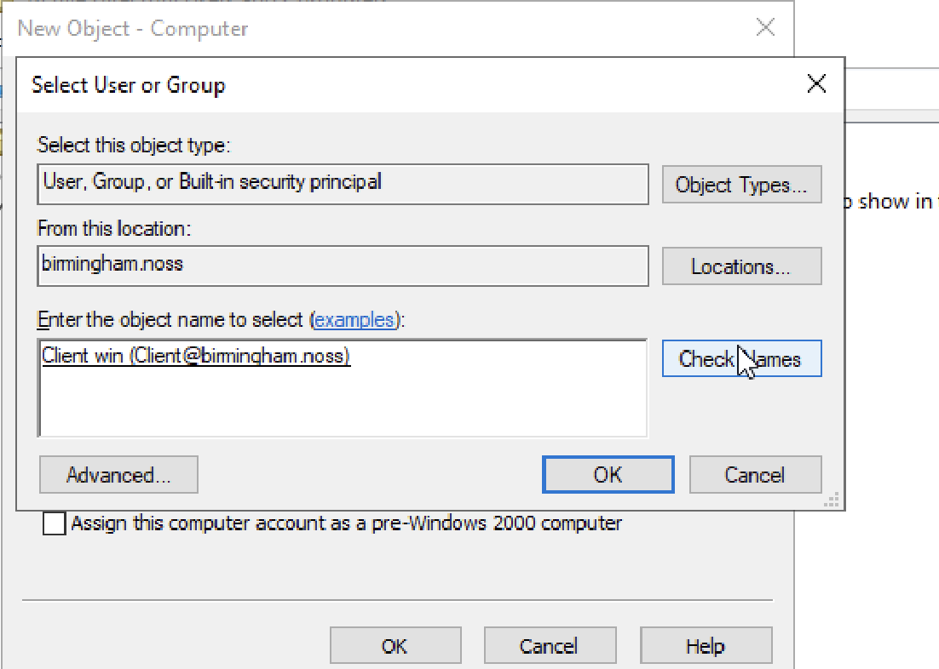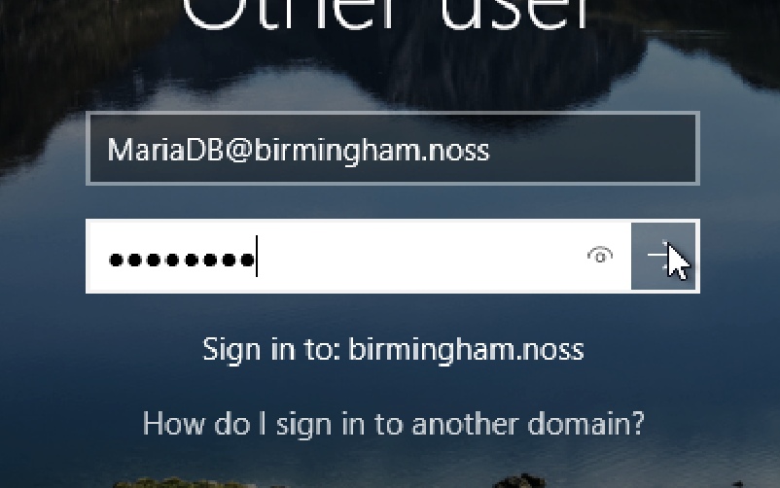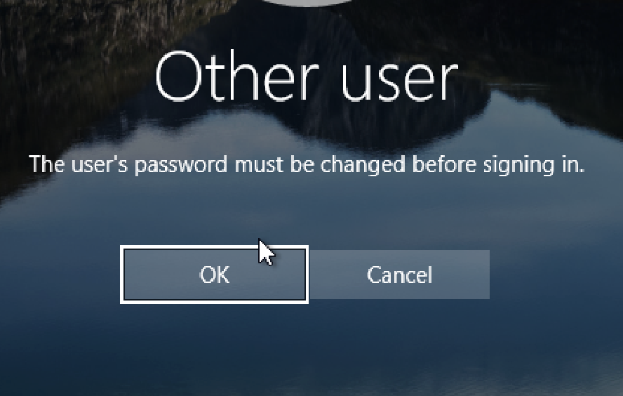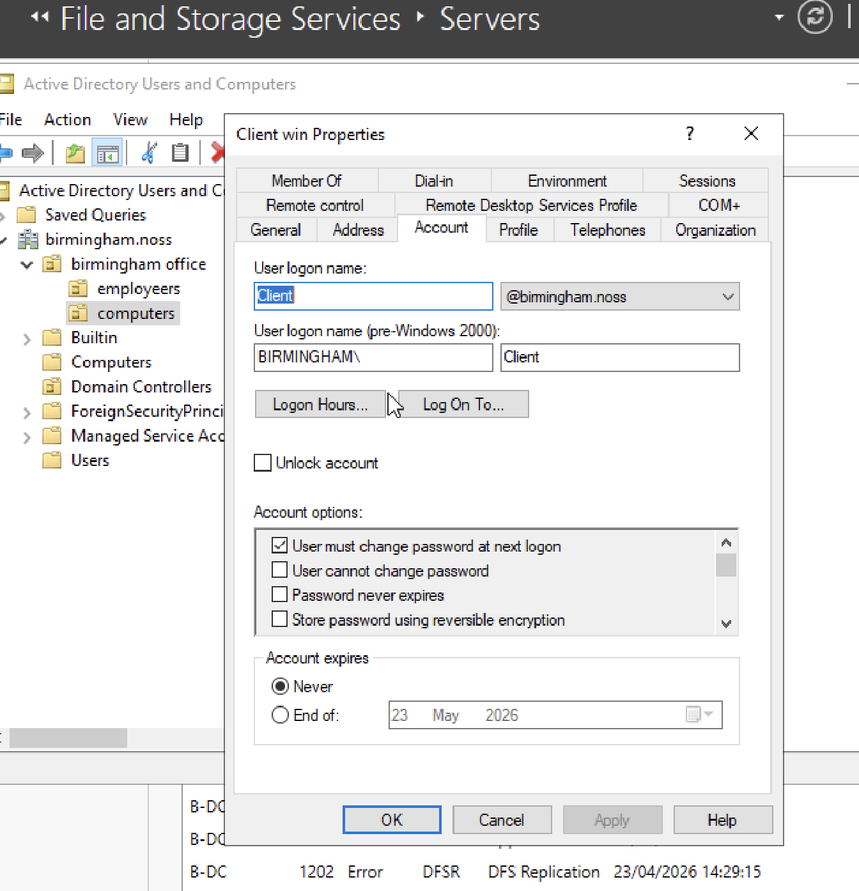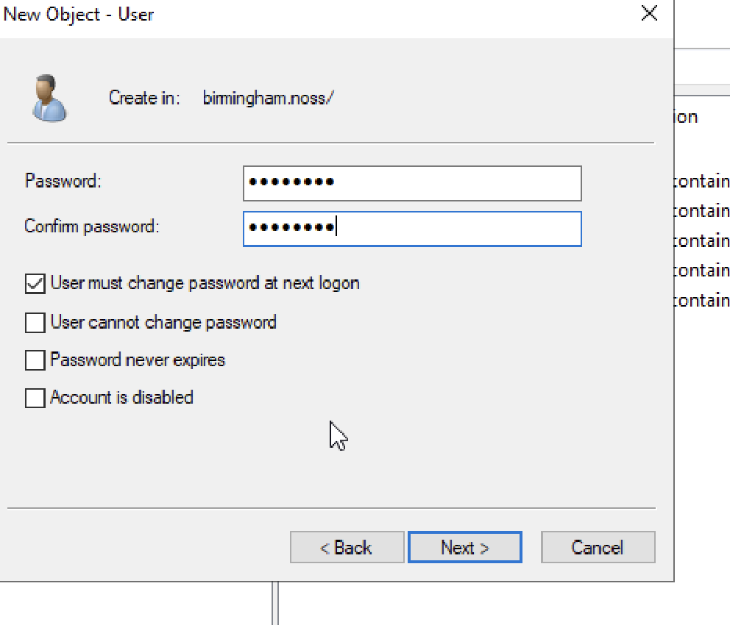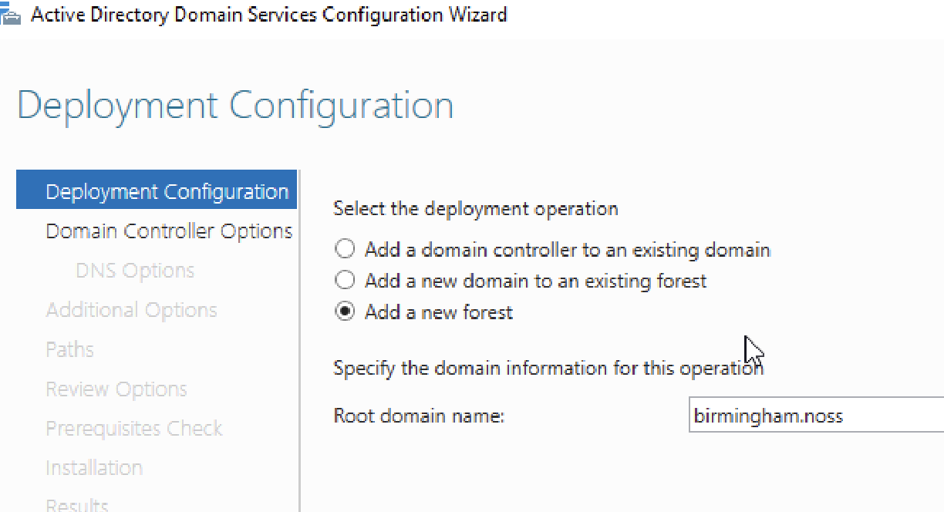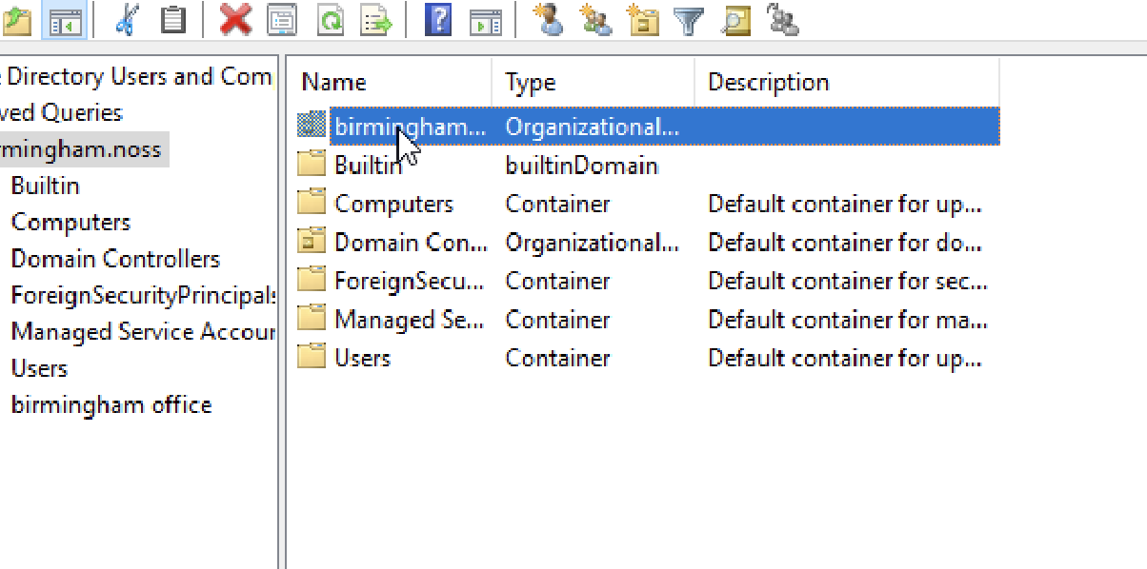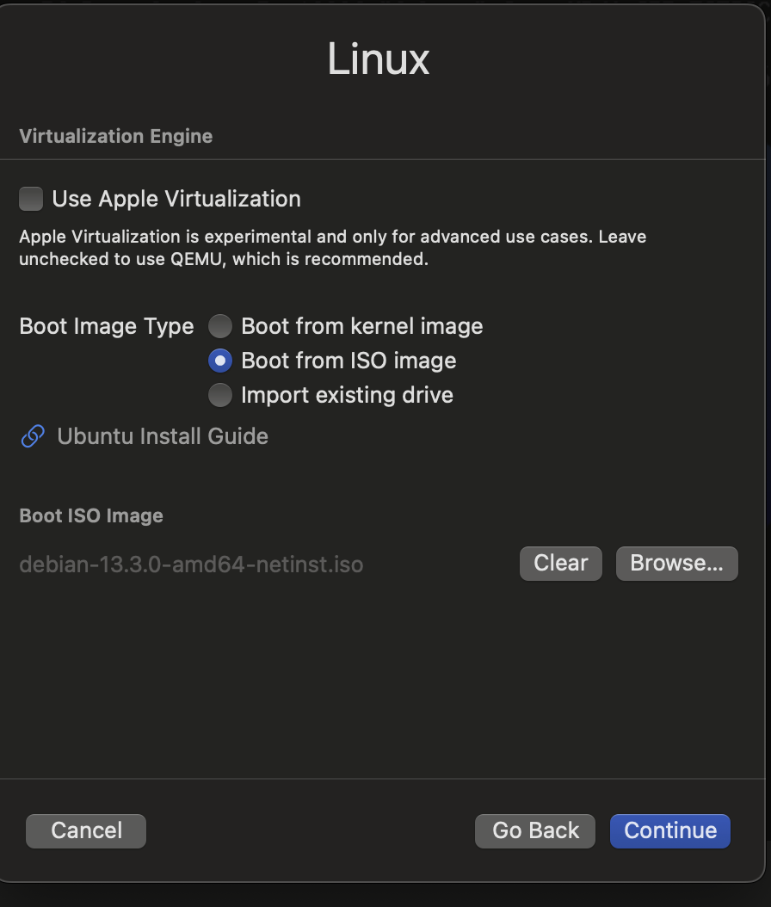
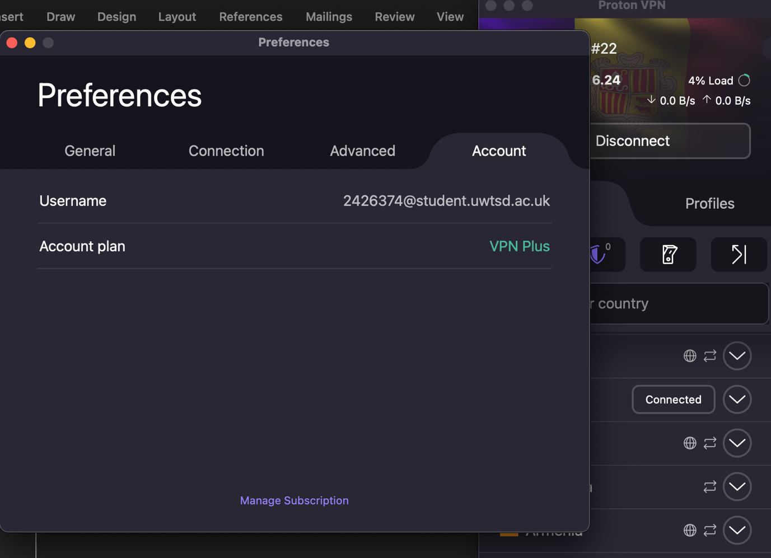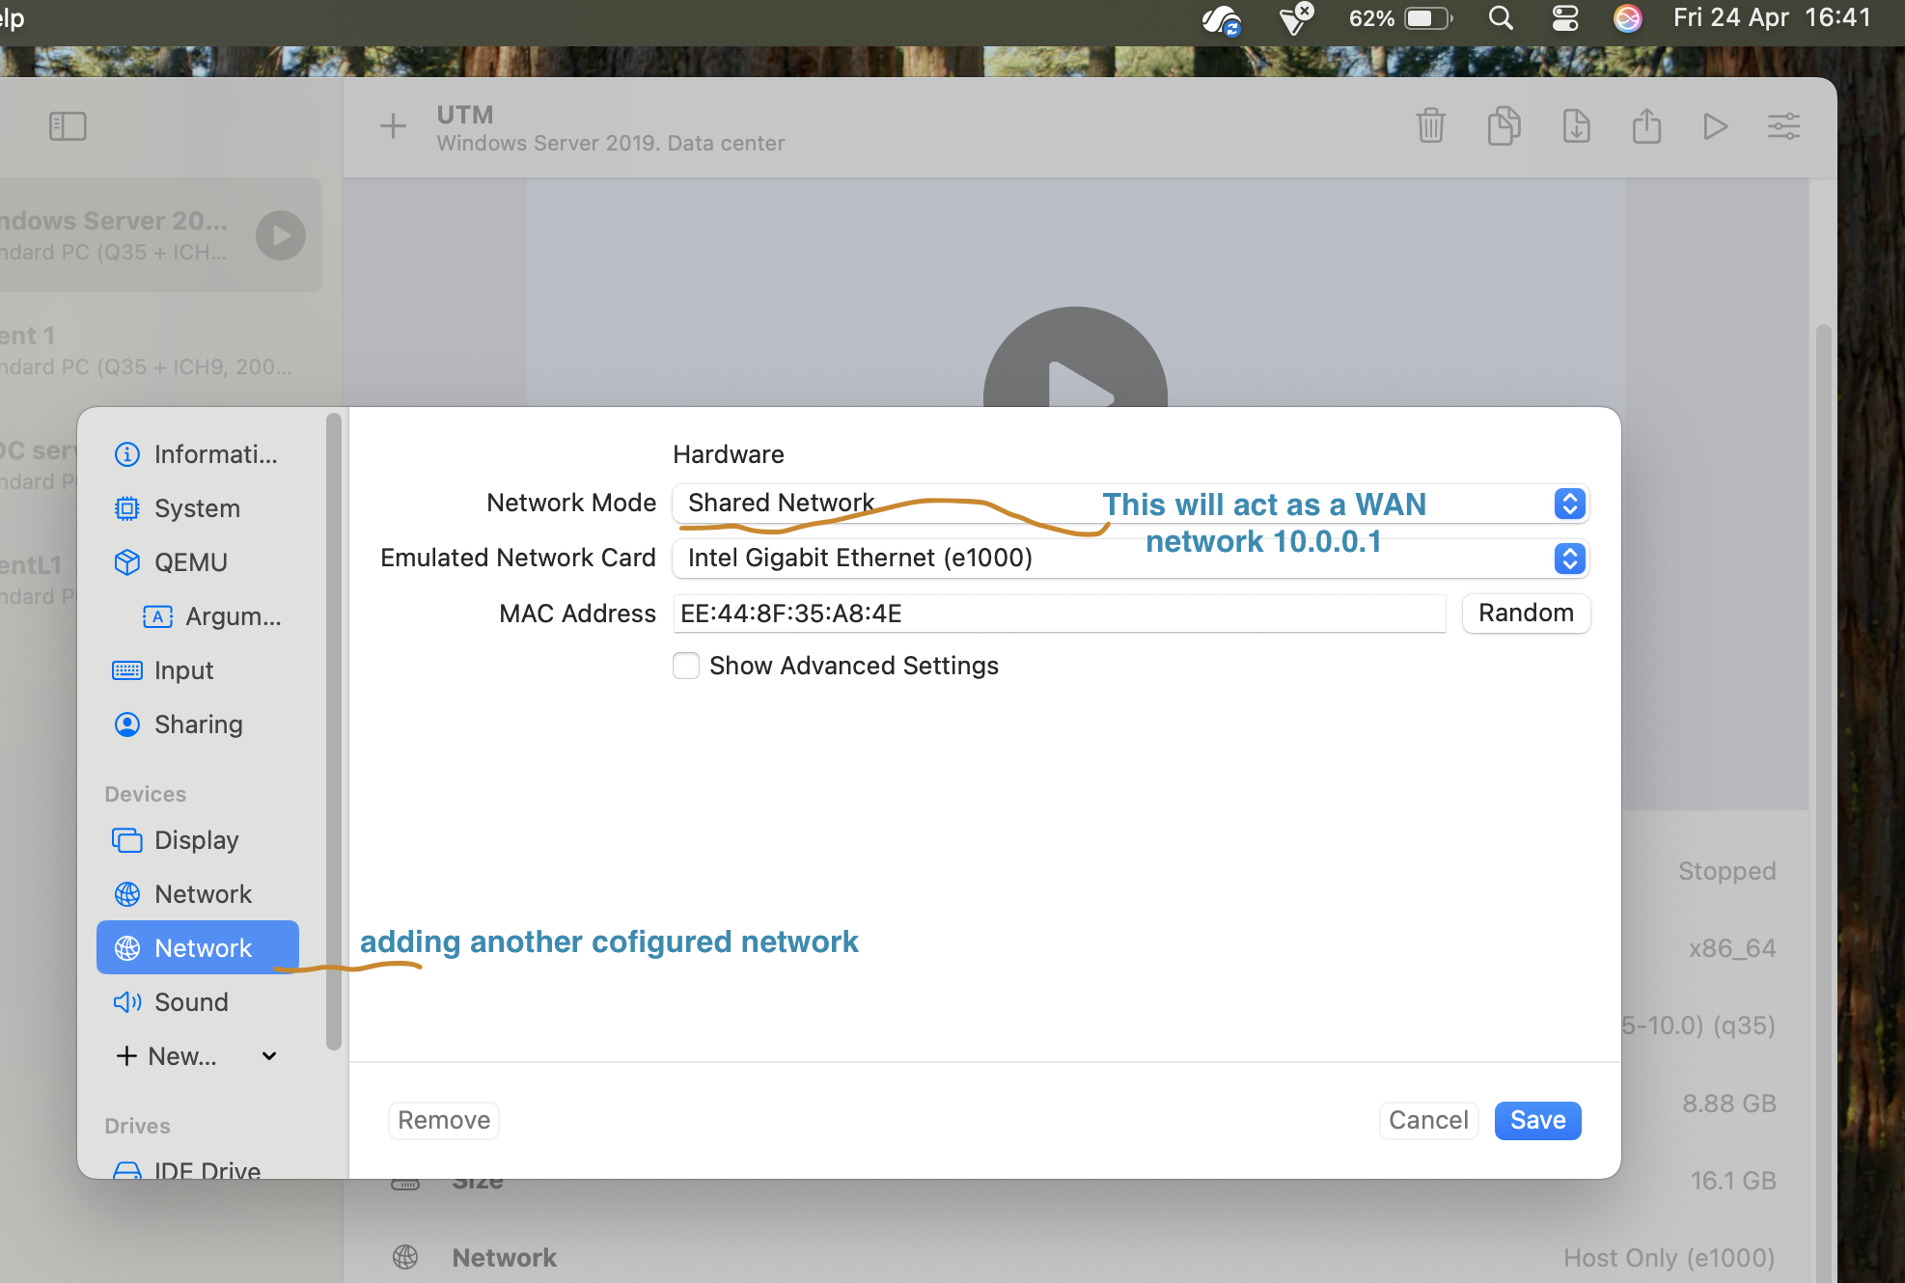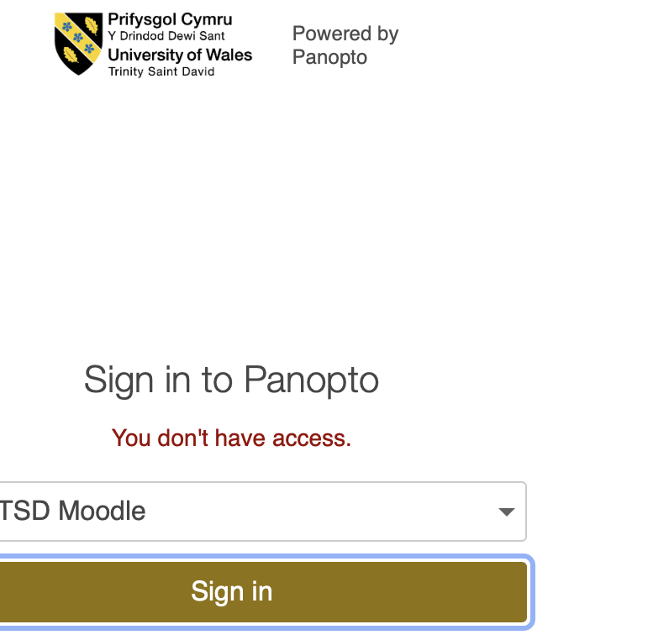
Labs at home https://uowtsd-my.sharepoint.com/:f:/g/personal/2426374_student_uwtsd_ac_uk/IgB6c6WN1rlWQafA6anax-gkAbvfo_bNithtXyqMasV_oMQ?e=T37E3f

