What is The Most Effective Way To Motivate Staff?

Name: Ilinko Ignatov
Student ID: 2120209
Lecturer Name: Doreen Nyaa Amundam
Module Name: BMSW4001_ BIRM, Academic and Employability Skills

University of Wales Trinity Saint David 16/02/2022

Introduction
The employee motivation is a well-researched topic nowadays. Companies conspired that there are factors of motivation that can support employee while working and lead to higher performance. But it is not that easy to motivate the team, it should be identified the factors and in what certain situation can be applied. Also, should be considered its drivers and challenges, of each factor.
This study is aims to present an overview of some of the factors and to give a recommendation of the most effective one. It is ,also providing studies from other researches, to demonstrate the relevant between each research.

Table of Contents
Introduction 3
Motivation 3
Pay 4
Its Drivers 4
Its Challenges 4
Recognition and Awards 5
Its Drivers 5
Its Challenges 6
Additional Holiday 6
Its Drivers 6
Its Challenges 6
Good Working Condition 7
Its Drivers 7
Its Challenges 7
Conclusion 7
Recommendation 8
Reference 8

Motivation
Motivation can be defined as some reason to an individual to do something. As it is defined in “Designing and Aligning Employee Benefits Globally” (Cedric NG M. S., 2018) motivation factors are needed so that an employee can be motivated and therefore to lead into higher performance. There are two different types of Motivation in Figure 1 and types are
Figure 1

expanded in more details in Table 1 :

Table 1: Examples of external and internal motivations (Arredondo, P. 1996).
External Factors | Internal Factors
Competition | Growth and expansion goals
Economic downturn/upturn | Organizational mission/values
Demographic changes | Organizational climate
Emerging markets | Employer/customer satisfaction
Image | Employee/management development
Investor/donor satisfaction | Continuous improvement
Government regulation | Progressive thinking
Political correctness | Profitability
Production | Performance
Profitability | Complaints
Lawsuit

The motivation factors this report consider are
- Pay
- Additional Holiday
- Recognition and Award
- Good Working Condition.

Pay
Ogbonnaya, C., Daniels, K., and Nielsen, K. published a study on how incentive pay affects employee’s job satisfaction. The study showed that performance related to pay was positively effecting the employee’s job satisfaction and organizational commitment (Cedric NG M. S., 2018).

Its Drivers
The drivers of the pay factor of motivation can be the individual’s needs. The individual can consider its own needs to lead to self-motivation. Service-related pay consists of consolidated fixed increments on a pay scale or pay spine that are proportional to time on the job. It was a common component of many public- or voluntary-sector organisations' pay schemes, and it is frequently supported by unions since it is seen to be fair and not subject to the individual and sometimes biassed judgement of management. It is less difficult to manage than variable compensation based on performance, contribution, competence, or skill; in fact, it is not required to be controlled at all. However, it fails to notice distinctions in performance and is known as "the gift that keeps on giving." It has also grown less popular, having been phased out of the Civil Service, for example, because it might be perceived as discriminatory.

Its Challenges
According to Armstrong, M. and Brown, D. (2019) the pay should be considered as a service related pay so, the employee feel threatened equally. Several studies shows that pay can be short-term factor of motivation. Therefore the challenges can be that every employee is under the influence of different factors. Paying employee for good performance to accomplish a task that the individual otherwise will do it voluntarily may lead to low motivation and poorer performance because of respect of the rewarded activity (Dahlgaard-Park, S. M. 2015).

Recognition and Awards
This is one of the factors that motivate an employee and helps in improving productivity and committed to a job. Appreciation plays a key role in the workplace by creating a positive organizational culture and strengthening relationships (Indeed, 2021).
Why to show appreciation in the work place?
- Improves productivity
- Improves workplace moral
- It keeps team engaged
- Help build staff loyalty

Its Drivers
Reward is a difficult area, although it can be claimed that any reward management system has three drivers, as indicated in Figure 2:
Figure 2: Three key reward drivers (Armstrong, M. and Brown, D. 2019 p. 4)
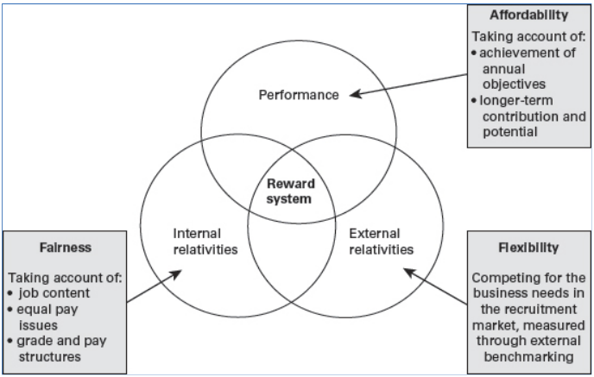
Internal concerns about justice and relativity, aided by job assessment systems and grading frameworks. External considerations of market pay rates, to enable the employer to recruit and retain employees, assisted by internal pay levels and ranges and performance-related factors linked to ensuring the delivery of the organization's strategic goals and ensuring pay budgets are affordable, as well as rewarding and recognising employee performance.

Its Challenges
According to Phillips, H. et al. (2017), the most difficult difficulty may be determining what can be considered as conduct for recognition and what may be recognised as part of a work obligations.

Additional Holiday
Additional holiday is a top-up pay to an employee to show appreciation for every served year. In United Kingdom the statutory annual leave is 28 days each year, shows in Table 2 (Cedric NG M. S., 2018 pp 55). But can be lees depending on the hour working. The minimum additional holiday given can be 20 days.
Table 2
Annual Leave
Countries | Statutory | Labour Law provision
Australia | 4 weeks | 4 weeks for each year of service
Brazil | 30 days | 30 days
China | 7 -15 days | 7 -15 days depending on length of service
India | 12 days | 1 day for every 20 days’ work, which is around 12 days a year.
France | 30 calendar days | The law provides five weeks of paid vacation (30 calendar days plus Sundays).
Germany | 20 – 24 days | 24 working days for a six-day week. 20 working days for a six-day week
Singapore | 7 – 14 days | 7 – 14 days depending on length of service
South Africa | 21 days | 21 consecutive calendar days’ paid leave per year
South Korea | 15-25 days | 15to 25 days depending on year of service
United Arab Emirates | 30 days | 30 days in a year if service more than 1 year
United Kingdom | 28 days | 28 working days in annual leave each year
Unites States | NA | Federal law does not require employers to provide vacation benefits.

Its Drivers
Additional holiday drivers can be lead from the organization and to offer that to the employee. Additional holiday is important for many employees. It is a reward for each year of service. After returning to work an individual may feel more active and energised and engaged.

Its Challenges
It may be the benefits packages that employees receive from an organization or company. The “benefits coasting" is defined by the development and success of the company, and how much can offer to create a successful system of employee benefits (Cedric NG M. S., 2018 pp 90).

Good Working Condition
Many studies defining good working condition as a physical element of employee motivation. Many employees reported that good working conditions or environment is one of the factors of motivation, and can cause comfort and keep the employees engaged (Setiyani, A. et al. 2019).

Its Drivers
Drivers of good working condition or of an motivating environment can be every element that is considered in the motivational environment. The motivational environment can be for instance Leadership, Work Ethics and Shared Value System (Prof Coetzee, “no date”) as cited by Venter, J. (2011).

Its Challenges
The companies staff can be affected from the working conditions or from the environment. The challenges can be a lot, but the most challenging can be to create these good working condition or environment. Therefore the changes in the work environment can lead to comfort and engaged people. The changes may not be accepted from every single employee as it can be seen in the research from IDX (2016) cited by Riyanto, S., Sutrisno, A., and Ali Hapzi (2017).
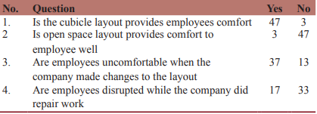

Conclusion
Based on provided relevant researches and the presented evidence can be considered that motivation is a significant part of the Individual personnel and professional growth. The factors considered early in the report are may be the most common and researched ones. Each employee has different factors of motivation. Each factor can be applied in certain situation to have effect on an employee.

Recommendation
The study has defined the factors of motivation through providing an basic overview of the researched topic, each factor’s drivers and challenges. Therefore Companies must follow a strategic way to create a successful employee benefit system. According to companies’ employee surveys the ranked options bellow starts with the most effective one:
- Recognition and Reward
- Pay
- Additional holiday
- Good working conditions

Reference
Armstrong, M. and Brown, D. (eds.) (2019) ’Reward Management’ Armstrong’s Handbook of Reward Management Practice: Improving Performance Through Reward. 11th edn. London: Kogan Page, Limited, p. 246.
Arredondo, P. (1996). ‘Recognising the Motivating Factors’, Successful Diversity Management Initiatives: A Blueprint for Planning and Implementation. p. 48. Thousand Oaks: SAGE Publications
Cedric NG M. S. (2018) Designing and Aligning Employee Benefits Globally. pp. 7-9, 55, 90 .
Dahlgaard-Park, S. M. (ed.) (2015) The SAGE Encyclopedia of Quality and the Service Economy. Thousand Oaks: SAFE Publications, Inc.
Indeed (2021) Factors of Motivation: Definition and Examples Available at: Factors of Motivation: Definitions and Examples | Indeed.com (Accessed: 19 March 2022).
Riyanto, S., Sutrisno, A., and Ali Hapzi (2017) ‘The Impact of Working Motivation and Working Environment on Employees Performance in Indonesia Stock Exchange’, International review of management and marketing, 7(3), pp. 342-348.
Setiyani, A. et al. (2019) ‘THE EFFECT OF WORK ENVIRONMENT ON FLEXIBLE WORKING HOURS,EMPLOYEE ENGAGEMENT AND EMPLOYEE MOTIVATION’, International review of management and marketing, 9(3), pp. 112-116 doi:10.32479/irmm.8114.
Venter, J. (2011) ‘Creating a motivational environment’, Accountancy SA, pp. 50-51. Available at: Creating a motivational environment - an issue - ProQuest (Accessed: 3 April 2022).

