
LCBM7002
DAVID COKER
FINANCIAL MANAGEMENT
EMILY RODRIGUES ABREU
2327330
WORD COUNT:

Part A - Introduction to Walgreens Boots Alliance, Inc (WBA): (580 word roughly)
Industry:
Walgreens Boots Alliance, Inc. (WBA) is a well-known participant in the healthcare sector, running a complex business that includes wellness, health, and pharmaceutical items. Established in 2014 because of the merger of Alliance Boots and Walgreens, WBA has grown to become a major player in the global healthcare industry, offering a wide range of products and services and operating in many countries.
Business Model:
WBA serves millions of clients globally through the thousands of Walgreens and Boots locations it runs as part of its core retail pharmacy business. These pharmacies provide a large selection of over-the-counter pharmaceuticals, prescription meds, cosmetics, health care items, and other services. With services including prescription refills, vaccinations, health screenings, and pharmacist consultations, WBA's retail pharmacies are positioned as easy-to-get locations for customers looking for healthcare solutions.
Marketplace:
WBA's business plan incorporates distribution networks and e-commerce in addition to traditional brick and mortar retail. The business runs online stores where clients can order prescription drugs and medical supplies for pickup or delivery. WBA also uses its broad distribution network to provide pharmacies, other shops, and healthcare professionals with medications and medical supplies.
Major Competitors:
WBA competes against competitors like CVS Health Corporation, Walmart Inc., and Amazon.com Inc. in the very competitive healthcare sector. Due to competition from these rivals for market share in e-commerce, retail pharmacy, and healthcare services, WBA is forced to constantly innovate and set itself apart from the competition. The core of WBA's competitive strategy is its emphasis on delivering individualised customer experiences by using technology and data analytics to customise services and product suggestions to meet the demands of specific customers.
Major Events (5-year timespan):
2019: WBA announced a strategic partnership with Microsoft to develop new healthcare delivery models, improve patient engagement, and enhance the efficiency of healthcare delivery (Wickware, 2019).
2020: Amid the COVID-19 pandemic, WBA saw increased demand for pharmaceuticals and healthcare products, leading to a surge in sales across its retail stores and online platforms alongside other companies (Kalish, 2022).
2021: WBA announced plans to divest its Alliance Healthcare business to AmerisourceBergen Corporation for $6.5 billion in cash and stock. This move aimed to streamline its operations and focus on its core retail pharmacy business (Samuel, 2021).
2022: WBA faced legal challenges related to opioid distribution practices, with several lawsuits filed against the company by states and local governments alleging its role in fuelling the opioid crisis. It was reported that the medication in question was falsely marketed, and the affects (long-term and short-term) were not presented appropriately to the consumers of this pill. Walgreens have paid $230 billion to the San Francisco state to settle the case. The company announced initiatives to address opioid abuse and support affected communities (Ivanova & Weicher, 2023).
2023: On the 23rd October, WBA appointed Tim Wentworth as the new CEO, marking a leadership transition aimed at driving growth and innovation in the rapidly evolving healthcare industry. The WBA focus was to appoint a new CEO with extensive healthcare understanding and experience (WBA, 2023).
In conclusion, Walgreens Boots Alliance, Inc. continues to be a powerful force in the healthcare sector, generating value for its stakeholders using its broad retail footprint, digital capabilities, and dedication to customer-centricity. WBA is committed to its goal of giving customers all around the world easily accessible, reasonably priced, and high-quality healthcare products and services, even in the face of obstacles and strategy shifts.
Glossary:
Operating Income: Profit after deducting (wages, depreciation, cost of goods sold [COGS])
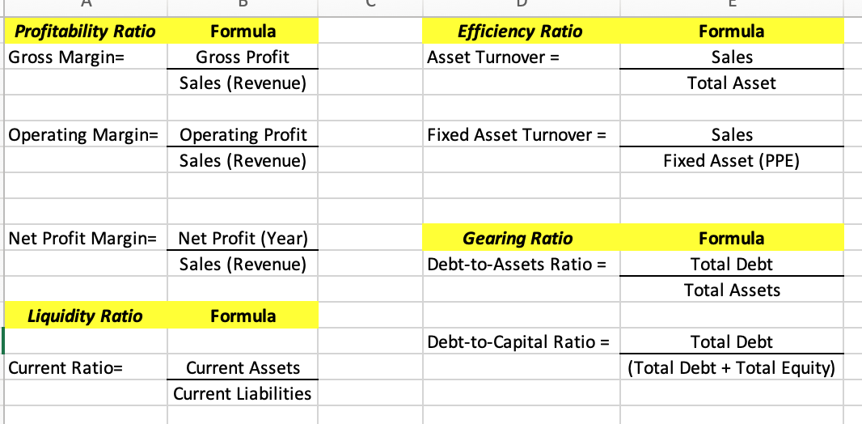
CVS (2023) – Comparison for Competitor Company
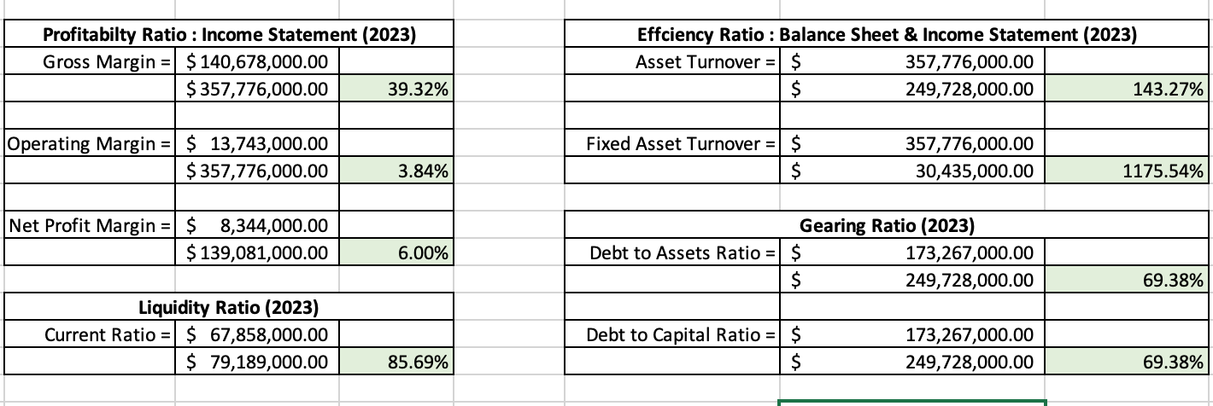
Part B - A Critical Review Of The Company’s Financial Performance:
WALGREENS – Financial Performance
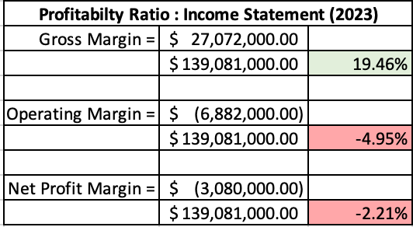
Table 1.1 – Profitability Ratio
A profitability statement is very important to display how well a company’s earnings are over a certain period.(REFERENCE) There are 3 main ratios in which a company may use to assess the company’s current profitability statement, these are Gross Margin, Operating Margin and Net Profit Margin. From the latest income statement provided (see table 1.1), WBA saw a fluctuating year. According to the gross margin, WBA saw a 19.46% percentage which means that per sales dollar, roughly 20 cents was available to during the year of 2023. This is lower than 2022, which sat at roughly 21.30%, meaning 21 cents of per sales dollar to pay towards fixed costs. However, looking at the Operating Margin, the income statement (see table 1.1) is at a negative balance. The company's operating margin of -4.95% means that for every dollar of revenue, operating losses totalled 4 cents. This negative operating margin indicates that throughout the time, the company's operational costs—which include costs for manufacturing, administration, and overhead—exceeded its income. Furthermore, the net profit margin of -2.21% signifies that the business incurred a net loss equal to 2.21% of its total revenue after deducting all expenditures, such as interest, taxes, and other expenses related to operations. This indicates that there was an overall net loss for the company because of its expenses exceeding its revenue.
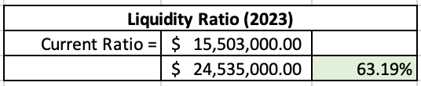
Table 1.2 – Liquidity Ratio
A liquidity ratio known as the current ratio assesses a company's capacity to settle short-term debt or bills that are due within a year. It provides information to analysts and investors on how a business might maximise its current assets on the balance sheet to pay down its current debt and other payables.(REFERENCE) WBAs has roughly $0.63 in current assets available to fulfil its commitments for every dollar in current liabilities, according to the current ratio of 63.19% (0.632). WBAs current ratio for the financial year falls below 1.0 (see table 1.2) this may show implications for the company as a value above 1.0 tends to be considered favourable. A current ratio less than 1.0, on the other hand, indicates that the company's current liabilities are more than its current assets, which raises questions about its capacity to pay short-term debt using its current assets. Additionally, a low current ratio could be a sign of liquidity issues, making it more difficult for the business to finance ongoing operations, settle debt, or seize expansion prospects. Comparing it to the previous year, there was a slight decline with 2022 presenting a ratio value of 74.84% (0.7480.)
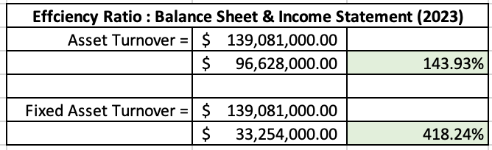
Table 1.3 – Efficiency Ratio

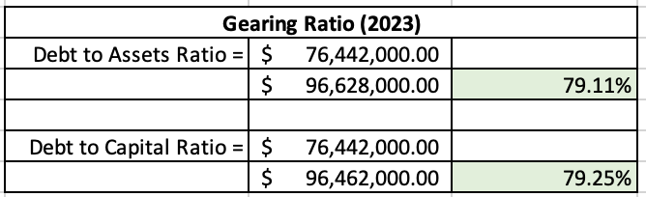
Table 1.4 – Gearing Ratio

References:
Ivanova, I. and Weicher, C. (2023) Walgreens to pay San Francisco $229 million over opioid crisis, CBS News. Available at: https://www.cbsnews.com/news/san-francisco-opioid-settlement-walgreens-229-million/
Kalish, I. (2022) Global Powers of retailing 2022, Global Economic Outlook. Available at: https://www2.deloitte.com/content/dam/Deloitte/at/Documents/consumer-business/at-global-powers-retailing-2022.pdf
Samuel, S. (2021) Walgreens Boots Alliance divests wholesale business, The Institute of Grocery Distribution . Available at: https://www.igd.com/Commercial-Insight/Retail-Analysis/Markets/Articles/Walgreens-Boots-Alliance-divests-wholesale-business/33471#:~:text=Walgreens%20Boots%20Alliance%20(Walgreens)%20is,in%20a%20%246.5bn%20deal.
WBA. (2023) Walgreens Boots Alliance appoints Tim Wentworth as chief executive officer, Walgreens Boots Alliance. Available at: https://www.walgreensbootsalliance.com/news-media/press-releases/2023/walgreens-boots-alliance-appoints-tim-wentworth-chief-executive#:~:text=–%20Oct., Officer%2C%20effective%20on%20October%2023.
Wickware, C. (2019) Walgreens Boots Alliance partners with Microsoft to develop ‘new healthcare delivery models’, The Pharmaceutical Journal. Available at: https://pharmaceutical-journal.com/article/news/walgreens-boots-alliance-partners-with-microsoft-to-develop-new-healthcare-delivery-models

