Certificate of Higher Education Skills for the Workplace
: 1532

9TH FEB
the decline of the retailer wilko
PROBLEM SOLVING AND INNOVATION (BMSW4014)

UNIVERSITY OF WALES TRINITY SAINT DAVID
Student name: Amalia-Carmen Filimon
Student number: 2245302

Word Count: 1571

Abstract

The report investigates why retailer Wilko has been doing poorly. Even though it's been around a long time and sells a variety of things, Wilko has been having a hard time. One big reason is that its stores are old-fashioned and not in good places. Also, Wilko hasn't been selling stuff online very well, and the COVID-19 pandemic made things worse by forcing some stores to close. This affected not just the people who worked there, but also the areas where the stores were. To fix these problems, Wilko needs to change with the times, like by selling more online and putting stores in better locations. They also need to be ready for changes in the rules and economy. If they do these things right, Wilko can bounce back and do well in the future.

Table of Contents
Abstract 1
Introduction 3
Main findings 4
Nature 4
Scope 4
Impact 5
SWOT analysis 5
PESTLE analysis 6
Conclusion 8
Appendices 9
SWOT analysis 9
PESTLE analysis 10
Reference list 11

Introduction

The report investigates why retailer Wilko has been doing poorly. Even though it has been around a long time and sells a variety of things, Wilko has been having a hard time. One big reason is that its stores are old-fashioned and not in good places. Also, Wilko hasn't been selling stuff online very well, and the COVID-19 pandemic made things worse by forcing some stores to close. This affected not just the people who worked there, but also the areas where the stores were. To fix these problems, Wilko needs to change with the times, like by selling more online and putting stores in better locations. They also need to be ready for changes in the rules and economy. If they do these things right, Wilko can bounce back and do well in the future.

Main findings

Wilko is a store that has been around since 1930, selling all kinds of stuff for your home, pets, and garden (Wilko, 2023). Their big problem is they need to catch up with how people shop nowadays, especially online, and fix their stores' locations, which are not very good.
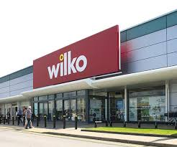

Nature
The main issue for Wilko is where its stores are and how it's not adjusting to what people want. Many of its 408 stores are inexpensive places that are not popular anymore (BBC, 2024). This made it hard for Wilko to make money, especially since it deals with cheap products that do not make a lot of profit. Experts say Wilko also did not do well online. Nowadays, many people shop online, but Wilko keeps relying on its physical stores. As per BBC (2024), the problem was, that these stores had cheap things but not many shoppers. Wilko's trouble comes from a mix of things, having stores in the wrong places, sticking to old-fashioned ways of doing business, and not keeping up with how shopping is changing. To do better in the future, companies like Wilko need to always think about what customers want, try new ideas, and look at what's happening in the market to make smart choices.

Scope
Wilko faced a big problem because of a mix of issues. First, COVID-19 impacted businesses everywhere, including Wilko, with stores closing and fewer people shopping (McPhail et al., 2024). Then, some people blamed the managers for not making smart decisions and not seeing the problems coming. Others pointed fingers at the owners, saying they were only thinking about making money quickly instead of what was best for the company in the long run. There were also problems with how the company's finances were checked, which might have hidden how bad things were. These problems together led to Wilko having to shut down most of its stores, risking thousands of jobs. To avoid this, Wilko needed to be better prepared for tough times like COVID-19, make smarter choices about its future, and have better checks on its money situation (Wilkinson et al., 2020). This shows how important it is for businesses to tackle problems head-on and make wise decisions to stay afloat.

Impact

Wilko's problems had big effects all around. First, lots of people lost their jobs because stores closed down. This made life uncertain and tough for them and their families (Loustaunau et al., 2021). Also, when stores shut, it hurt the areas where they were because fewer people went shopping there. This meant other businesses nearby might struggle too, and more people could lose their jobs. Plus, Wilko not being able to pay its bills also hurt the companies that supplied it with goods. They might lose money too, making things hard for them. Lastly, Wilko's troubles showed other stores that they need to be smart and ready for changes in the market to avoid the same fate. Overall, the problems at Wilko affected lots of people and businesses, and it taught everyone a valuable lesson about being prepared and flexible in the ever-changing world of retail.

SWOT analysis

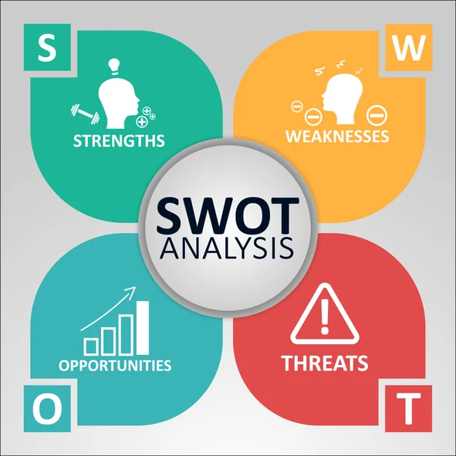

Wilko has faced a big problem leading to its decline, which eventually led to administration. This issue can be traced back to several factors found in the SWOT analysis. One major issue is that Wilko's store locations are not very efficient, which means they might not make enough money to stay open (Guardian News, 2024). This could be because they did not plan their locations well or didn't change with how the market was evolving. Also, Wilko mainly relies on physical stores, which used to be a good thing because they are well-known and have lots of stores. However now, with more people shopping online, this has become a weakness. They might have missed out on chances to adapt to online shopping trends, which hurt their ability to make changes and stay competitive (Sneader and Singhal, 2021). There are some good opportunities too. For example, online shopping is growing, and Wilko could get more involved in that. They could also try selling different kinds of products to attract more customers. Overall, by working on these areas from the SWOT analysis, like improving stores and getting better online, Wilko can try to fix its problems and do better in the future.

PESTLE analysis

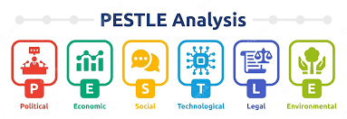

Political: Political factors like government rules and laws can affect how Wilko runs its business. For example, if taxes go up, it might make it harder for Wilko to make money. And if there are strict laws about how many hours’ employees can work, it could affect how Wilko schedules its staff. Good policies from the government might help Wilko grow and do better online, but bad ones could make things harder (Mayhew and Anand, 2020).
Economic: Economic factors, like how much money people have and how much they spend, directly impact Wilko's sales. If times are tough and people do not have much money to spend, Wilko might not make as much profit. However, when things are good and people have money to spend, Wilko might have more chances to grow (Mayhew and Anand, 2020).
Socio-Cultural: Social factors, such as what people like to buy and how they live, can affect what Wilko sells. For example, if more people are interested in eco-friendly products, Wilko might want to sell more of those (Koch, Frommeyer and Schewe, 2022). Thus, if Wilko keeps up with what people want, they might retain customers.
Technological: Technological factors, like new inventions and how people use technology, are changing how Wilko does business. If Wilko does not use new tech like online shopping, it might fall behind competitors. However, if they keep up with the latest technology, they could improve how they sell and make customers happier (Alzoubi et al., 2022).
Legal: Legal factors, such as following the law and making sure customers are protected, are important for Wilko (Aljeraisy et al., 2021). If they do not follow the rules, they could get into trouble. Also, new laws about the environment might make Wilko change how it does business.
Environmental: Being eco-friendly and following green rules, are becoming more important for Wilko (Mukonza and Swarts, 2020). If they do not care about the environment, they might lose customers who do. If they show they care and use sustainable practices, they could attract more customers who like that.
Although the bigger environment offers both chances and hurdles for Wilko, it's essential for them to strategically match up with favourable aspects like technological progress and changes in population trends. At the same time, it's crucial for them to effectively deal with challenges such as economic slumps and changes in regulations. This strategic approach is vital for solving the main issue and securing ongoing success in the long run.

Conclusion

In conclusion, the decline experienced by Wilko is a complex issue influenced by various internal and external factors. The company encountered difficulties related to ineffective store locations, reliance on traditional business models, and an inability to adapt to shifting consumer preferences, compounded by the challenges brought on by the COVID-19 pandemic. These hurdles led to financial struggles, store closures, and job losses. However, there are opportunities to capitalise on technological advancements, demographic shifts, and the growth of online retail. Wilko must align its strategies with favourable factors while effectively addressing obstacles such as economic downturns and regulatory changes. By implementing proactive measures such as improving store efficiency, strengthening its online presence, and diversifying its product offerings, Wilko can navigate the competitive retail landscape and emerge stronger in the future.

Appendices

SWOT analysis

Strengths | Weaknesses
- Wide product range  - Established brand  - Strong customer base  - Affordable prices | - Inefficient store locations  - Reliance on brick-and-mortar stores  - Limited online presence  - Low profit margins on bargain products
Opportunities | Threats
- Growth of online retail  - Expansion into new markets  - Diversification of product offerings  - Improving supply chain efficiency | - Economic downturn impacting consumer spending.  - Increased competition from online and brick-and-mortar retailers  - Changing consumer preferences towards convenience and online shopping  - Rising operational costs

PESTLE analysis

Element | Factors | Impact
Political | Government Policies, Brexit and industry regulations. | Can impact taxation, labour laws, and trade agreements.
Economic | Inflation, Cost of living. | Affects purchasing power and demand for products.
Socio-Cultural | Consumer Taste and Preferences. | Influences consumer preferences and shopping behaviours.
Technological | Artificial Intelligence and Security. | Shapes the way businesses operate and interact with customers.
Legal | Employment law Common law and Local labour law. | This can lead to legal challenges or opportunities for growth.
Environmental | Environmental restrictions are imposed by the government and local people. | Requires businesses to adopt eco-friendly practices and manage environmental risks.

Reference list

Aljeraisy, A., Barati, M., Rana, O. and Perera, C., 2021. Privacy laws and privacy by design schemes for the internet of things: A developer’s perspective. ACM Computing Surveys (Csur), 54(5), pp.1-38.
Alzoubi, H., Alshurideh, M., Kurdi, B., Akour, I. and Aziz, R., 2022. Does BLE technology contribute towards improving marketing strategies, customers’ satisfaction and loyalty? The role of open innovation. International Journal of Data and Network Science, 6(2), pp.449-460.
BBC, 2024. What went wrong at Wilko? [Online] Available at:https://www.bbc.com/news/business-66394238 [Accessed on: 7 February 2024]
Guardian News, 2024. Wilko to close ‘majority of stores’ with loss of thousands of jobs. [Online] Available at: https://www.theguardian.com/business/2023/aug/23/wilko-close-majority-stores-loss-thousands-jobs-retailer-uk [Accessed on: 7 February 2024]
Koch, J., Frommeyer, B. and Schewe, G., 2022. Managing the transition to eco-friendly packaging–An investigation of consumers’ motives in online retail. Journal of Cleaner Production, 351, p.131504.
Loustaunau, L., Stepick, L., Scott, E., Petrucci, L. and Henifin, M., 2021. No choice but to be essential: Expanding dimensions of precarity during COVID-19. Sociological Perspectives, 64(5), pp.857-875.
Mayhew, K. and Anand, P., 2020. COVID-19 and the UK labour market. Oxford Review of Economic Policy, 36(Supplement_1), pp.S215-S224.
McPhail, R., Chan, X.W., May, R. and Wilkinson, A., 2024. Post-COVID remote working and its impact on people, productivity, and the planet: an exploratory scoping review. The International Journal of Human Resource Management, 35(1), pp.154-182.
Mukonza, C. and Swarts, I., 2020. The influence of green marketing strategies on business performance and corporate image in the retail sector. Business strategy and the Environment, 29(3), pp.838-845.
Sneader, K. and Singhal, S., 2021. The next normal arrives: Trends that will define 2021--and beyond. New York, NY, USA: McKinsey.
Treffinger, D.J., Isaksen, S.G. and Stead-Dorval, K.B., 2023. Creative problem solving: An introduction. Routledge.
Wilkinson, A., Ali, H., Bedford, J., Boonyabancha, S., Connolly, C., Conteh, A., Dean, L., Decorte, F., Dercon, B., Dias, S. and Dodman, D., 2020. Local response in health emergencies: key considerations for addressing the COVID-19 pandemic in informal urban settlements. Environment and urbanization, p.095624782092284.
Wilko, 2023. Our History. [Online] Available at: https://www.wilko.com/en-uk/corporate/our-history [Accessed on: 7 February 2024]

