4/28/2026
Software solution for business
Portfolio Report on Contemporary Software Applications for Business

Module NaMe: Software solutions for business
Module Code: ACCA 4026
Lecturer: Anum Paracha
University of WALES TRINITY saint david (London Campus)



Student Name: Mesfin Tezera
Student ID:2510889
Table of Contents
Introduction 2
Main Body 2
Task 1 2
e-Commerce Website builders/software solutions 2
Task 2 2
Mind-map of Contemporary Software Applications 2
Task 3 3
Office Applications for Creating, Storing, Presenting, and Analysing Data 3
a. 3
b. 3
Task 4 3
Communication and Collaboration applications 3
a. 3
b. 4
Conclusion 4
References 4
Appendices 4

Task 1. E-commerce website builders/software solution

Introduction

Several popular e-commerce website builders are used today to help businesses sell products online. These include famous platform like Shopify, Wix, Equid, Big Cartel, WooCommerce, Squarespace, and big commerce. Each of these solutions offers different tools to help sellers manage their stores, process payments, and reach customer across the world.

Task 1. E-commerce website builders/software solution


Shopify remains the business criteria for committed online shopping. It is an application as an aid system specifically engineered for high-volume retail. Key Features are: It includes a proprietary payment gateway (Shopify Payments), comprehensive stock control inventory management, and a robust App Store for extended functionality (e.g., advanced SEO or drop shipping). the platform anyone can use it easily. On this site there are many advantages and choice for customer, such as lots of functions such as easy payment. This e-commerce business has huge impact on today’s market since much of buying and selling product has moved online this platform pays a high role for sellers and consumers [1].
This platform is suitable for everyone who want to use it, and it can be changed to make suitable to function according to business requirements for sellers. The website is very straightforward to use it and to change anything, for example product price and availability online, and it offer all types of necessary functionality without any problem. Shopify is the longest-running and most communally trusted and adapted e- commerce platform. This platform is very easy to use it because it follows that low-code tools reduce that reduce the need for technical skills in the first place.


Wix is a flexible website builder that has evolved from a simple drag-and-drop tool into a powerful e-commerce contender, particularly for small-to-medium enterprises (SMEs).
Key Features: Its "Wix Stores" module allows for easy product listing, secure checkouts, and multi-channel selling (e.g., Instagram, Amazon).
On other hand, this platform can make increasingly big financial profit [2]. Today it is growing number of online shopping stores for customers crated many of online platforms such as WIX. Wix is one of the important platforms for e-commerce online shopping. This platform is easy to use in terms to sale or buy products online. This website it has been growing now, and an increasing number of people are using it. Many companies and individuals are using this platform recently for their business needs. So many sellers choose the right e-commerce plats form such as WIX.
The number of people who use e-commerce for their business is growing, and the same time the wix website is playing huge role [3].
Wix is also the same shoplifty in that it does not need to use the platform, since it’s a software application that enables business to set up and manage an online store also, the application come with necessary tools required by market to sell their products. It helps business runners to review their store performance and manage all the necessary stuff used to run the business, such as product pricing and promotions.
Wix and shopify have created global marketing opportunities the make it much easier for e-commerce users to became successful. These websites especially help people with disabilities by allowing them to shop easily from home improve their quality of life.

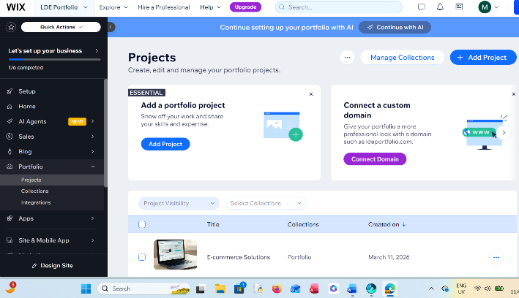 Figure 1: Adding a product or applicate to Wix

mind map is visual chart used to arrange information, ideas, or assignment around a single central thought. Unlike traditional linear recording, which follows A to Z sentence
structure, a mind map radiates outward from the centre using branches, keywords, symbols, and colours. This structure copies the mind’s normal way of processing information through organization instead of direct writing. Through mind mapping, students can demonstrate their ideas clearly also solve complex argument in single mind mapping structures. Additionally, students can develop an argument map and then shared their work to stimulate discussion about the business problem to be solved and appropriate business decisions to make. therefore, mind mapping can be beneficial when it comes decision making on certain business issues by providing clarity and visualizing outcomes. When used at business making and decision-making point mind mapping can enhance business decision making skills so that area so the right decision. Can be made in many situations as evidenced by introductory business course [4].
mind mapping was created by Tony Buzan in the 1970s to organize information using colourful keywords and images. It is a very helpful method for students and professionals to study written materials more effectively [5].
By using branches to connect related to concept which support day to day business in organization it or fill full balance what is needed by visualizing the big pictures. Business owners can identify resources that could be make a risk in the business also mind mapping can boost the productivity in organization business sectors. the same time, it makes it easier for companies to recall that has been discussed issues. Mind mapping also helps but collaborate teamwork by putting everyone who precept in project to see what they exactly put forward for that business growth.
Mind maps organize complex issues better than simple lists.
In its basic form, how is mind mapping work is simplest way is a groping of ideas that have been put into the format of a visual diagram. Starting with a central idea or topic in the middle of the map, section project from the centre containing further themes and concepts to be explored – typically in the form of words, short phrases, and images. This gives mind maps a natural organizational structure.
In a mind map, information is structured in a way that mirrors exactly how the cognation brain – in a radiant rather than linear manner. It literally ‘maps’ out your thoughts, using associations, integration, and triggers to stimulate further ideas. They make it easier to extract your ideas from your head into something visible and structured.
study indicates that the brain likes to work based on organization, and it will connect every idea, memory or piece of information to tens, hundreds and even thousands of other ideas and concepts. This is why mind maps are beneficial for countless tasks.
Below, we will critically discuss how you can use mind maps to aid in various processes, such as memorizing information, conducting presentations and solving problems [6].

Task 2 B. Mind-map of contemporary software applications

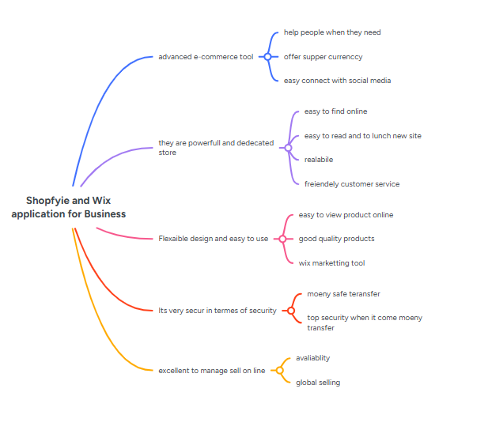Figure 1. This mind map shows my business structure and how I use shopify and Wix.
https://mm.tt/map/3956002289?t=0D3kU3HC40

Task 3. Office Applications

Microsoft Word is the famous word processing application used by millions of businesses across the world. Besides writing, this application from Microsoft can perform many other tasks, Such as preparing legal documents, calendars, newsletters, project proposals, and many other tasks. The benefit of a Word document is that you can write, edit, and publish most of the business documents using this platform with the utilization of its features. They are the most popular and widely used writing software in world because the software is readily available in different versions, especially for home, office, and school uses. However, this software’s limitation could be that it is hard to design a challenging layout.
[7] . The benefits of word are significant. they give huge for instance they help the environment by not cutting trees for paper production. in this way, the world stops or decrease the number of trees come down in terms of making hard paper, this only helped
the world to reduce the climate change which effects our planet. Their major feature is you can make paragraphs, spacing, pages, and text sizes easily. By moving towards a paperless office environment, Word allow for digital archiving and cloud -based sharing, which means a document can be sent across the globe in second without ever needing to be printed. This digital workflow also be saves physical storage space and reduce the cost associated with ink, printers, and postal service.
Microsoft 365 improves English skills, and Microsoft Word is a key example. This software makes it easier for students to write and develop their creative skills. Because of this, the author wants to study the impact of using this application. Microsoft Word includes various features and built-in artificial intelligence that make word processing faster and more efficient. It also contains security functions to protect information within documents. Research shows that Word features include automatic script tracking, the Editor tool for AI-based suggestions, and Track Changes to record edits. It also supports reference management tools like Mendeley for citations and uses advanced security methods like cryptography to keep document content safe.
This project is an instructional workshop designed to teach basic Microsoft Word skills to college students in China through distance learning. The author uses the basic principles of distance education to build a workshop website. The project covers the history and definition of distance learning, its advantages and limitations, and a full lesson plan with goals and evaluations. It includes eight appendices and a dedicated webpage featuring a syllabus, schedule, assignments, and tests [8] .of their content rather than the mechanics of the software. The teaching of this skill is crucial because word has become a prerequisite in the global job market. Knowing how to use styles for constant formation or how to insert a table of content automatically can save hours of manual labour allowing students and professionals to focused more on the quality.

1 | Series 1 | Series2 | Series3
2 Category1 | 4.3 | 2.4 | 2
3 Category2 | 2.5 | 4.4 | 2
4 Category3 | 3.5 | 1.8 | 3
Figer 1: this MS word converting numbers to data

Microsoft power point is a versatile software designed to create engaging slideshows for business, education, and training. One of its Major features is the ability to easily embed multimedia content like videos, audio and screen recordings directly into slides. It also allows users to present complex data through clear charts and graphs without needing advanced design skills. Another powerful tool is the “presenter view”, which lets the speaker see their private notes on one screen while the audience only sees the slides on a projector. This dual display capability is a significant benefit because it helps deliver a polished, confident speech while maintaining the audience’s attention through vibrant visuals rather than dense reports.
However, there are several limitations to consider when using Microsoft power point [9].
A common issue is that audiences often read a head and finish the slide before the speaker even start talking, which can ruin the surprise of new information. In classroom, overreliance on slides can distract students and take their focus away from the teacher. To fix this, users should follow a “less is more” philosophy by using minimal words and striking images. Fourthermore, Microsoft power point files can become very large and difficult to email, especially when they include high -definition videos. There is also a risk of technical failures, such as videos not playing or slides looking different on another computer. Being well-prepared and having a backup plan is essential for any successful presentation.

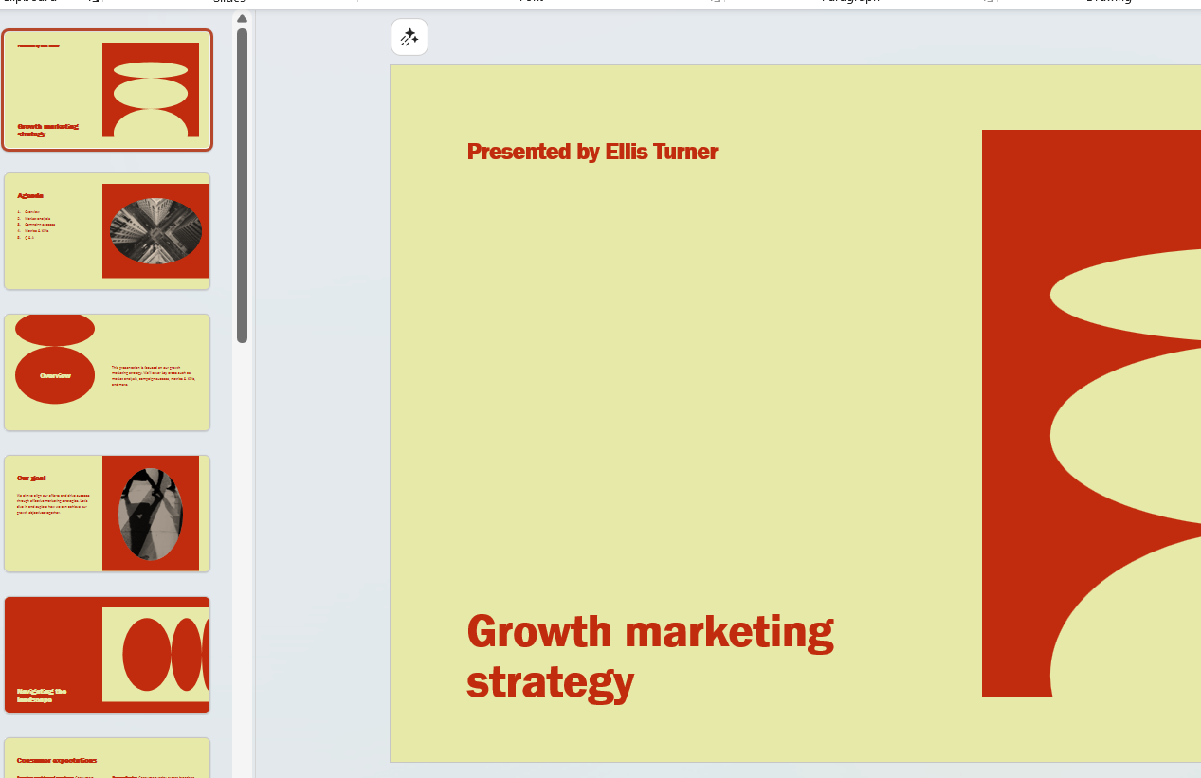
Figure 2: This is Power point for just demonstration

Microsoft Excel is famous computer program used for making and managing spreadsheets. It is like a digital paper with many small boxes called cells, which are organized. called cell, which are organized into rows and columns. One of the major features is that it can do math almost instantly. You can write simple rules, called formula, to add, subtract, or even do very hard calculations. It also has especial tools like pivot Tables to summarize a lot of information and chart to turn boring numbers into colourful pictures. Another great feature is that it can now be used on the internet, allowing many people to work on the same file at the same time from different places. [10]
The benefits of using this program are very clear. It helps you organize data, so it is easy to read and understand. Because the computer does the math, there are fewer mistakes than when doing it by hand, which save a lot of time. It is also very flexible, meaning you can use it for simple things like a shopping list or very big things like a business budget. Many jobs around the world use it, so learning how to use it is a great skill for your career. It also keeps your information safe with passwords and lets your work on the internet, so you do not lose it.
However, there are some limitations to keep in mind. If you try to put too much information into one file-like millions of rows the program can became very slow or even stop working. It is also quite easy to make a small human error, like typing one wrong number, which can mess up all the other results. While simple tasks are easy to learn, some of the advanced parts can be very confusing and take a long time to master. Finally, it is not always the best tool for high level security or very complex scientific research because it was originally made for basic office work.

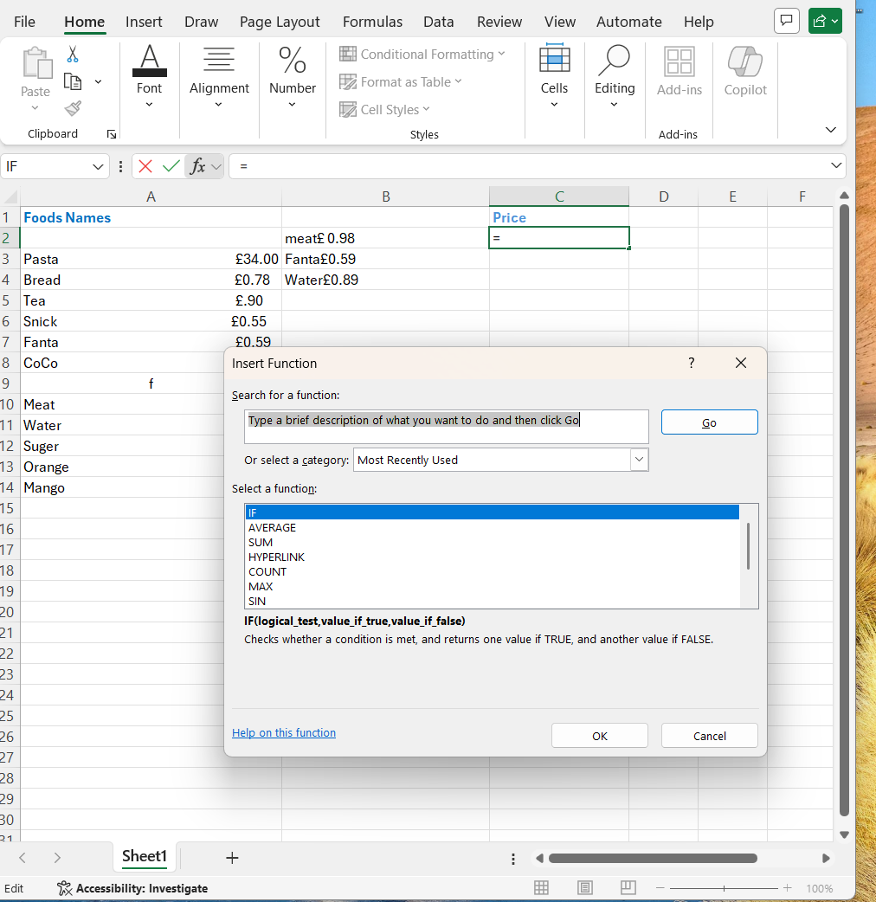
Figure 1: This Excel spreadsheet demonstrates the process of calculation the total value of my project items.
Microsoft Access is a relational database management system designed to help small and medium -sized organizations, such as schools and local business, manage their data effectively. It serves as a powerful middle ground between simple Excel spreadsheet and complex enterprise database. By using a friendly graphical interference and helpful “wizard” users can easily create tables, forms, and report to orgone information without needing deep technical knowledge. A major benefit of access is Rapid Application Development” which allows users to quickly build prototypes and custom tools for data entry. For advanced users, it supports programming languages like VBA to create automated professional solutions. It can operate as a standalone system on one computer or work across a local network for small groups. However, Access has specific limitation. It is best suited for low-volume data and generally supports a maximum of twenty simultaneous users. It lacks the advanced security and transactions tools found in large system like Oracle. When a business grows and its data requirements became too massive, organizations often “up-size” their projects to more powerful platform like Microsoft SQL Server. Despite these bounder [11].

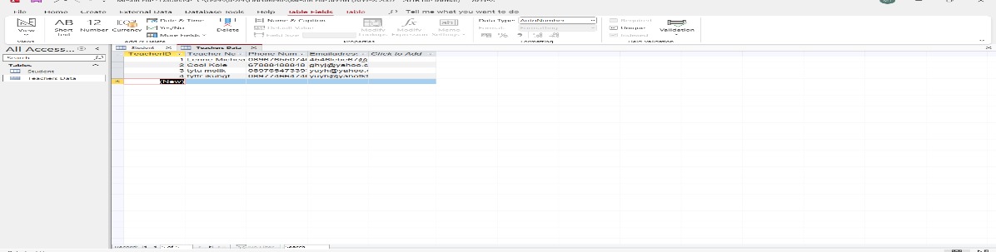
Figure 1: this image shows adding a new teacher to the database, including their ID, email, and phone number.

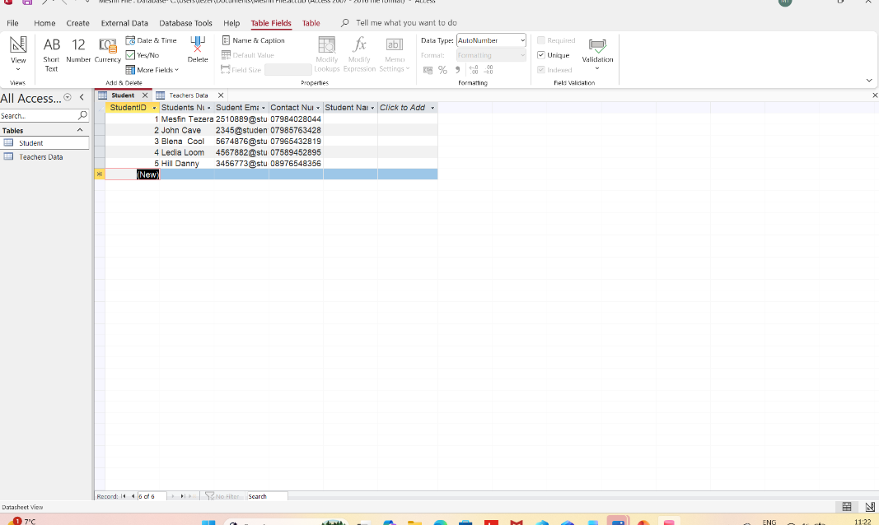
Figure 2: This shows adding student entities to the database, with their ID. email. And phone number.

Task 3(b) IF Function in MS Excel

- 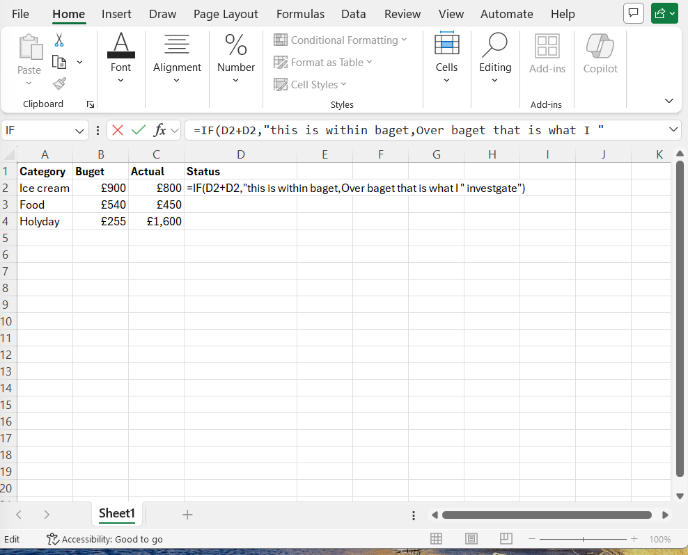
Fuger 1 This image shows entering data into an Excel and using the IF formula to categorize it.

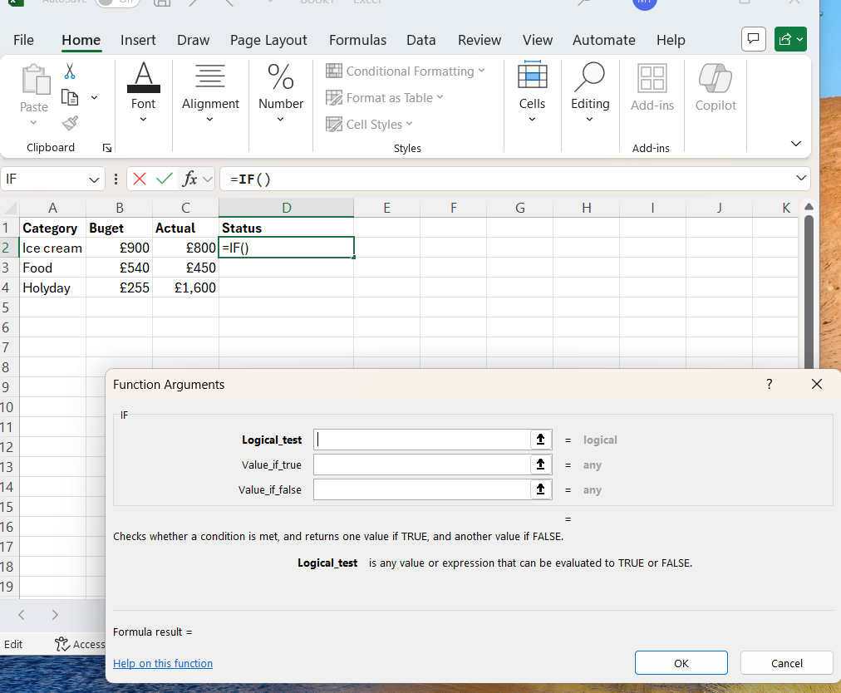
Fugier 2: This image shows me using the If formula to check if the budget is correct

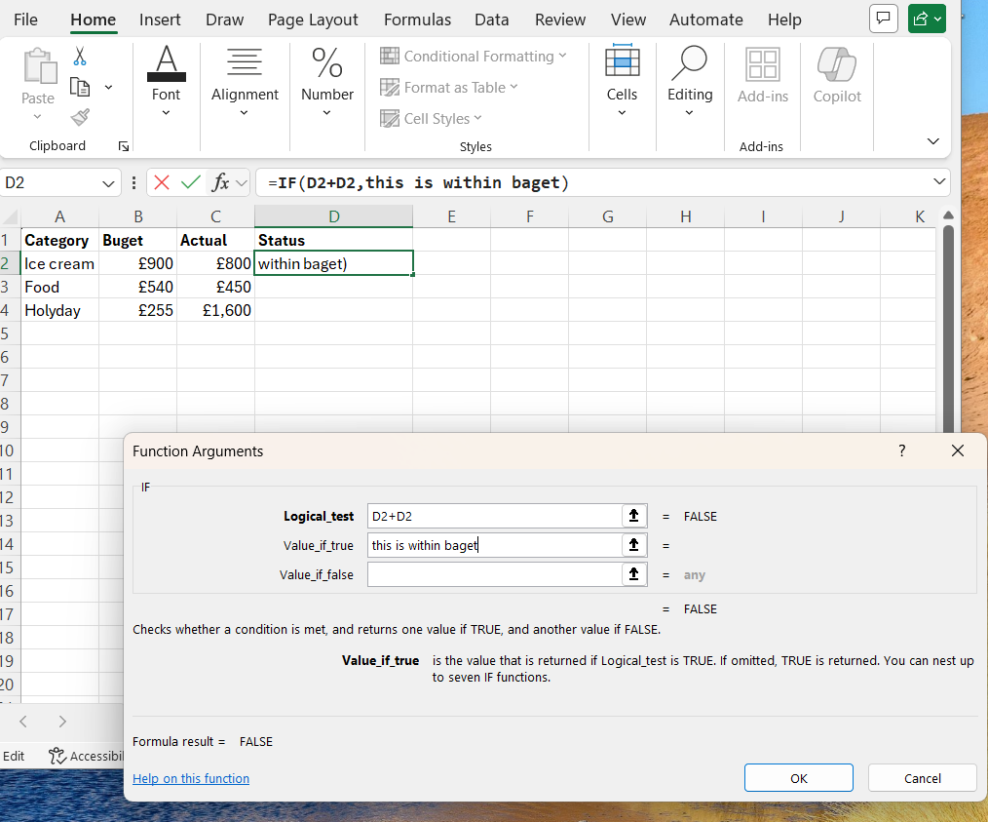
Figure 3: This image shows the completed IF function, including the logical test and the true and false
values.

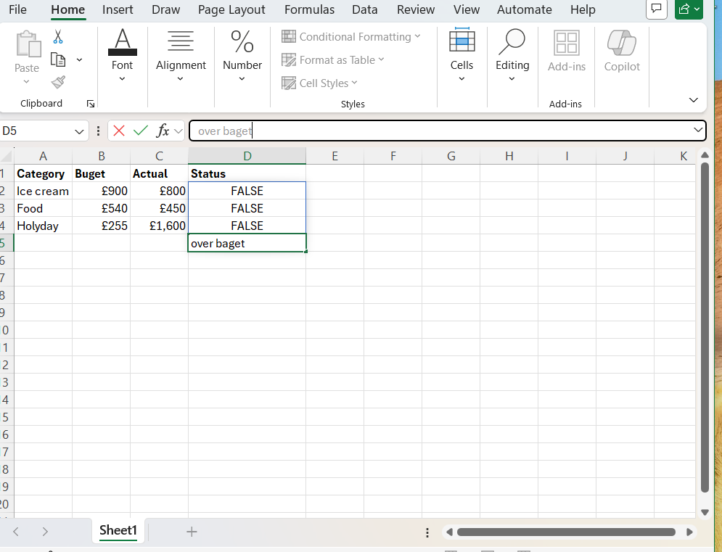
Figure 4: Excel shows that my spending is over budget, so the result is “false”.

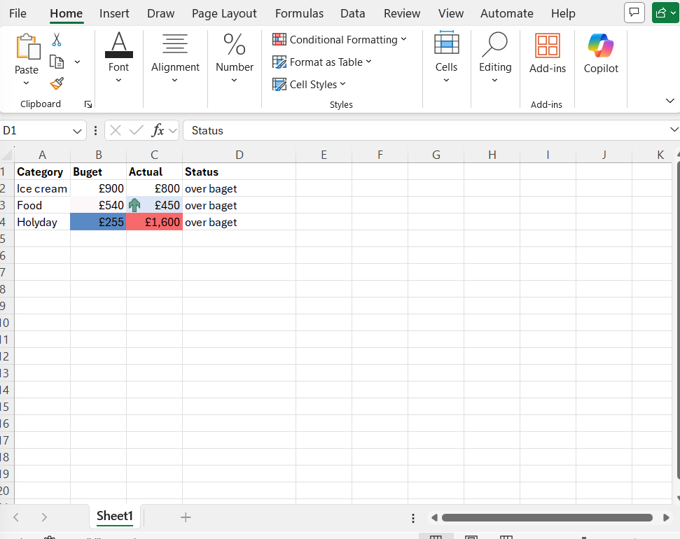
Figure 5: The IF formula returns “False”, because the actual costs are higher than the budget.

VLOOKUP, Pivot Table, Goal Seek in MS Excel,

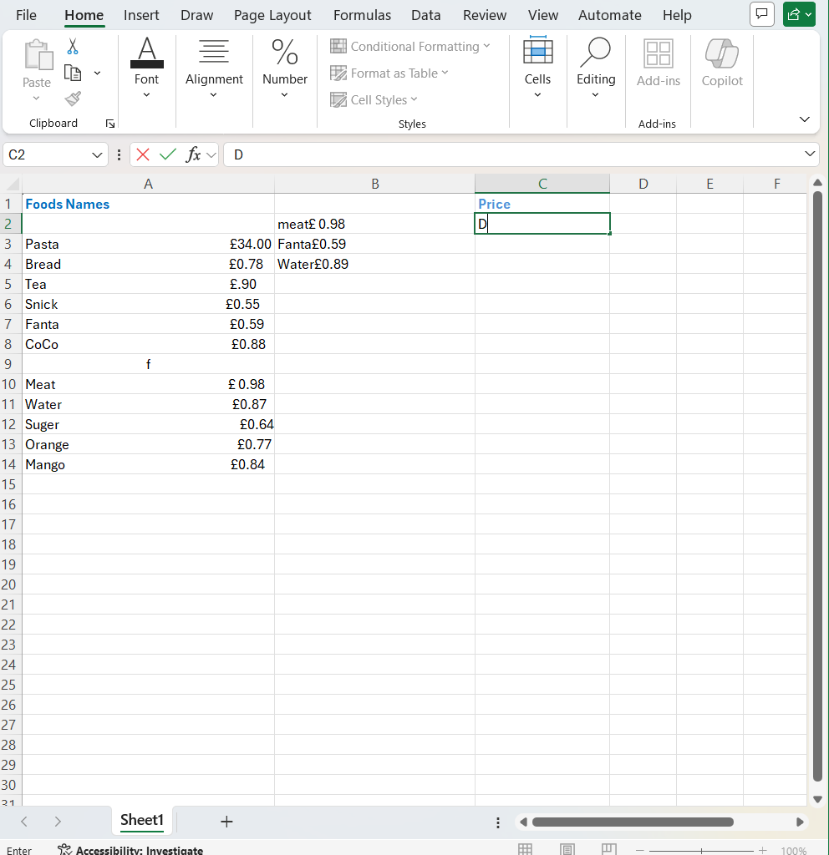Figure 6: I made this spreadsheet to calculate the actual of specific items

t
Figure 8: I used a VLOOKUP and drop-down menu to find the price of “water” and other items.

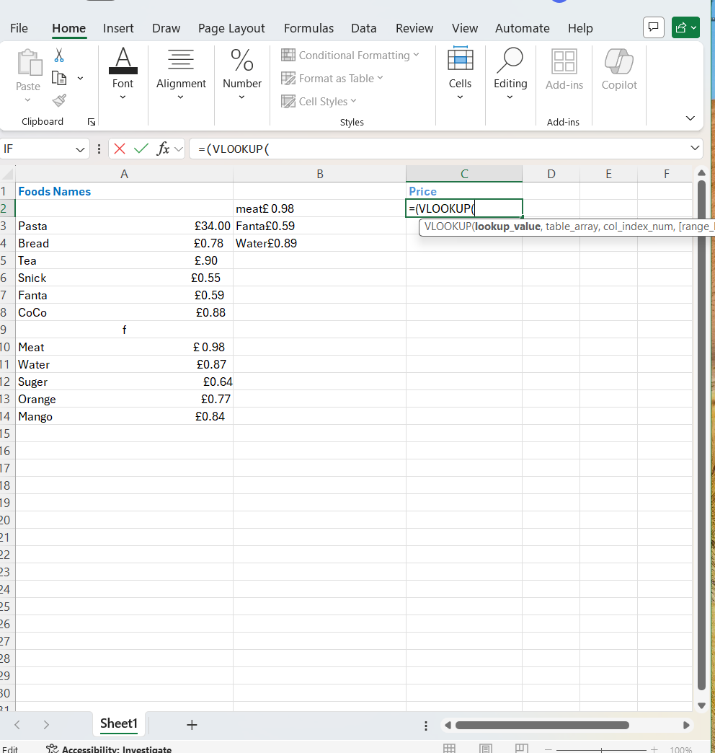Figure 9: I used the “VLOOKUP function” to find the cost of water in the food table.

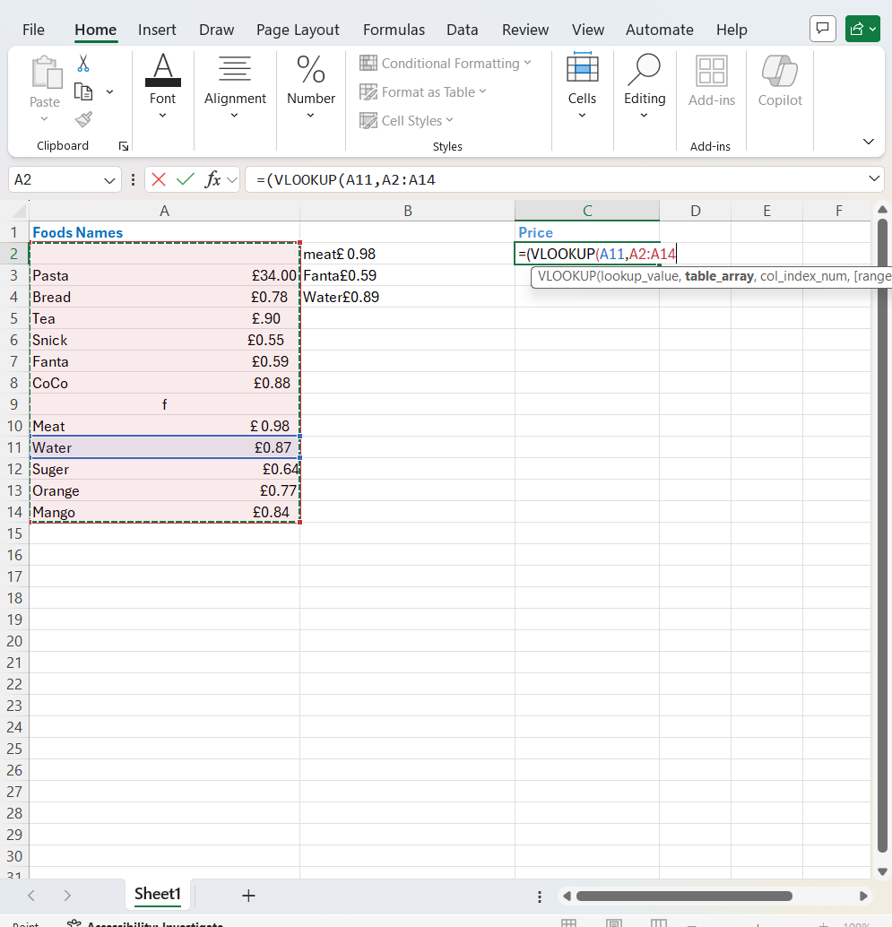Figure 9: This shows me selecting the full product range to find the cost of water.

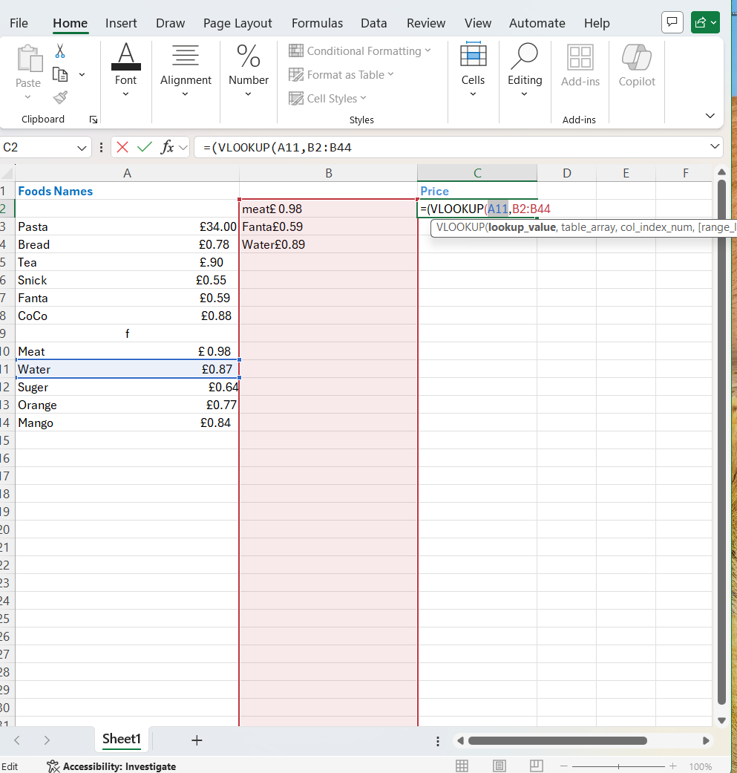
Figure 10: This image shows the lookup function finding the price after selecting the data range.
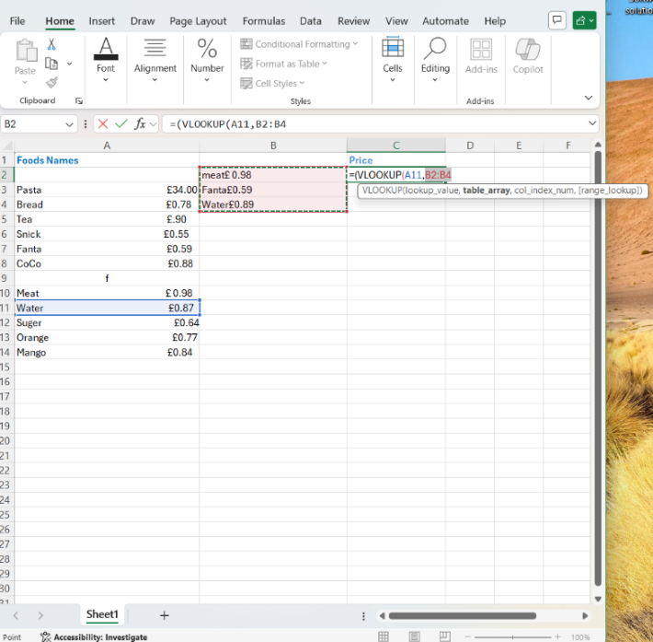
Figure 11: The VLOOKUP found the price of water (0.89). you can see the correct value in the formula bar.

Figure 12: The VLOOKUP correctly shows the price of water as £0.89 in the cell.

Task 4. Communication and Collaboration applications

4a

Microsoft Teams is communication platform on different ways such as chat and meeting also sometimes for meeting purpose used video communication. This application has been designed to bring people together especially at workplace for important decision making without interrupting from outside noise. There are some key features this platform allows people to those are such as chat, have conversations in group or sometimes in one to one also with platform you can make meetings by screen sharing with other people you can also call with Microsoft team [12] .
Microsoft team can help distance learners especially among student they can share dates and many students already start agreeing that this platform Microsoft team give them in real time collaboration because this style of hybrid learning and teaching give them significant work to do. Microsoft team has been used many places such as schools right now in some case this platform create and act as physical teacher and teach students this is the features of this application it has been changing the way education given in past and replacing some areas especially for distance learners because its became educational tool this Microsoft team reshaping the way we learn in future because many educational material are moving online became virtual [13].
There are other security features such as Includes features like branding to prevent loss of information and sensitivity identity or data protection Also Microsoft team allowing users to communicate via instant messaging
[14]. Beyond the cooperate world, MS Teams has also been widely adopted in education as a digital hub for e-learning. The feature of MS Teams, in terms of virtual collaboration, its role as an information system, and its effectiveness in professional and academic setting. Additionally, for comparative context, on other hand Google meet as alternative high -quality video conferencing service used in similar remote learning environment.
MS Team empowers organization to create virtual workspace that facilitate teamwork and knowledge sharing. It is a vital tool for large companies, remote employee, and sizable teams. The platform office applications, such as planner, one note, and Excel, allowing for a unified workflow. The key features of MS Teams are persistent communication and support for chat room one on one instant messages, and group conversations. Also support with clear high-quality audio and video call with screen sharing options during virtual meeting. The same time it helps to able to work simultaneously on files internal and external partners. When it comes security protections like bringing to prevent information loss and sensitivity labels for data protection its very save.MS Team integrations with other software apps it is allowed to integrate easily.
Distance learner interacts by creating a virtual physical presence for teaches. Features such as video, emojis, and breakout rooms contribute significant to student engagement and provide a stress-free environment, particularly for introverted students.
The private chat feature is notable for reducing language avoidance and fooling students to receive direct feedback on writing. This allows for an iterative process where students and immediately respond to teacher comments and revise drafts in real time. To maximize academic achievement, it is recommended that institutions train academic staff in these interactive digital tools to foster an immersive learning environment.
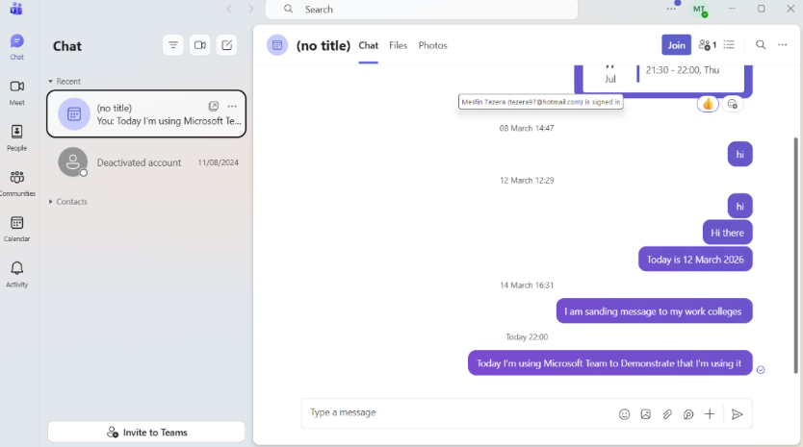Figure 1: This image demonstrates using Microsoft Teams for real-time communication

Task 4b

Google Meet is a good quality video conferencing service, developed by google. You can share videos and you can host meetings at the same time. You can also share your screen. You do not need applications to download google met. Instead, you can easily use a web browser, because it has nothing to do with wireless connection; but its clouds base is easy to use.
Google meet helps its student shows that most participants viewed Google Meet as beneficial for remote learning, with positive impacts on engagement and academic performance. Google Meet is generally effective in supporting remote learning also faces challenges that need addressing. Enhancing user experience through improved technical support and training could further benefit online education. Its contribution to academic performance, and the overall satisfaction of users many ways [15].
Google Meet application is more effective than other learning application media. The use of Google Meet that students and teachers are interested in certainly supports effective online learning during the Covid-19 pandemic because students are more controlled in synchronous learning and teachers are more creative because of the features that support the Google Meet platform. The stages of online learning, from planning, and implementation, to evaluation through the Google Meet platform, can be very well facilitated. Thus, teachers can use Google Meet as an alternative platform to support online learning because it is relevant and integrated with other learning support features. [16].
As one of most widely utilized virtual platform in school, googol meet (formerly known as googol Hangouts meet) was the subject of descriptive research aimed at determining its effectiveness for social studies learners during the global health cresses. The interface allows dozens of participants to interact face-to face from any location with an internet connection. Because the platform is lightweight and fast, it simplifies meeting management even with large groups. Amidst the shift to distance learning necessitated by close-connect restriction, platform like Google meet Zoom, and Skype have become essential, providing the necessary connection to maintain education and professional standards globally [17].

Task 4 a I used Slack to describe as Communication

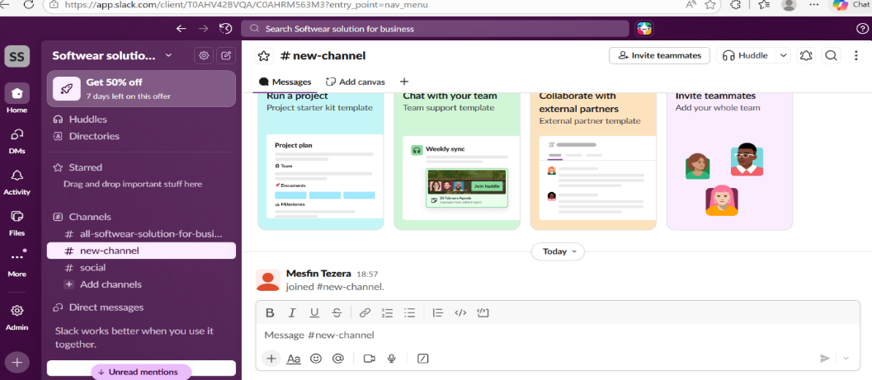Figure 1. This Slack interface shows how to create a new channel for team collaboration and networking.

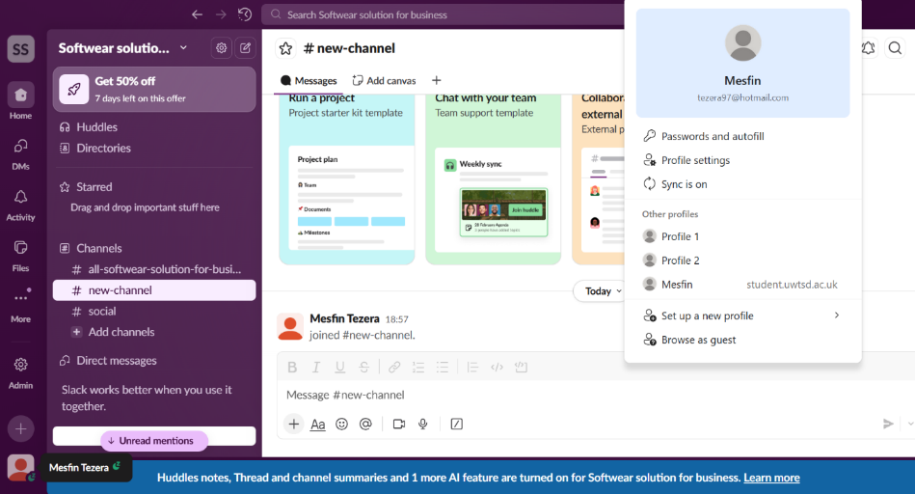
Figure 2: This I Slack image shows the feature used to create a new channel for team collaboration

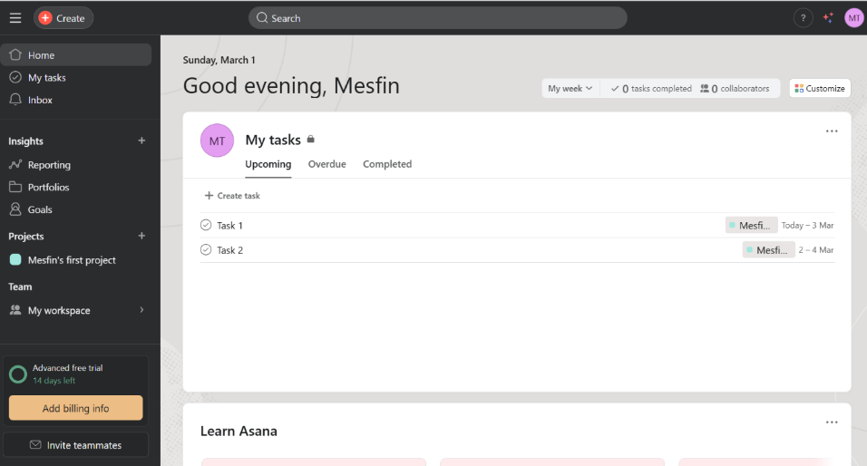Figure 3: This messaging panel shows how I prepare and organize my daily tasks.

Task 4 (4b2) I used Asana for Collaboration

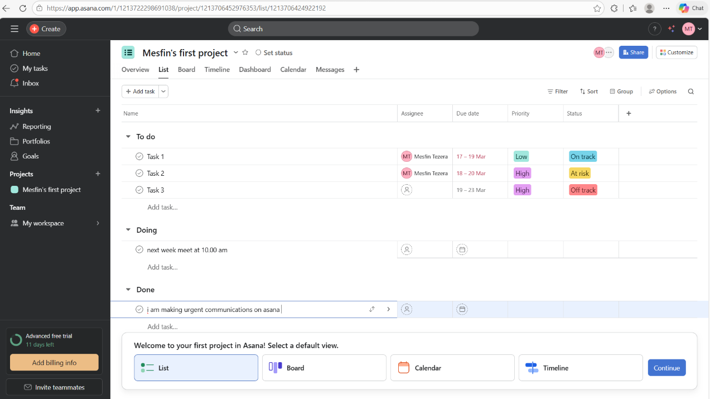
Figure 1Step 1: We move from Slack to Asana to organize the project structure.

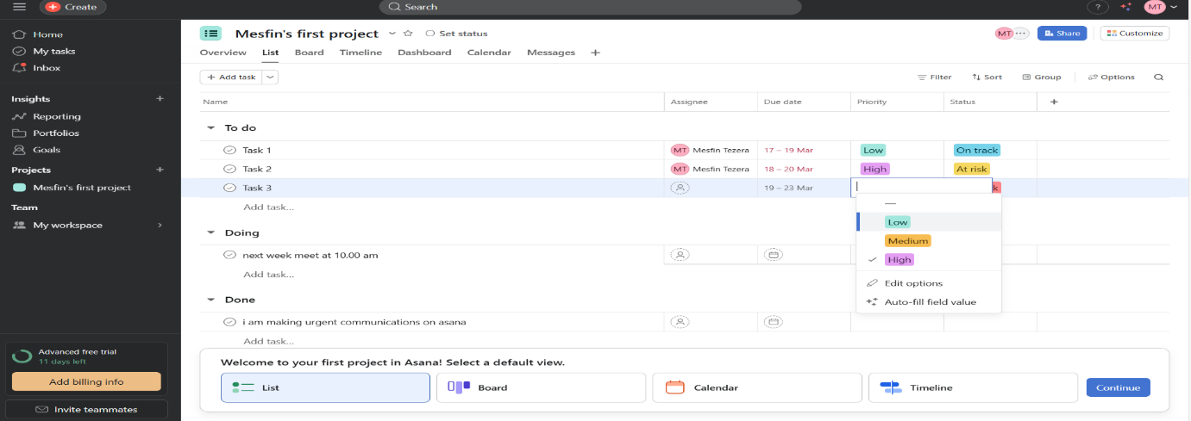
Figure 2: Step 2 A Tasks Assigned and project workflow is now active

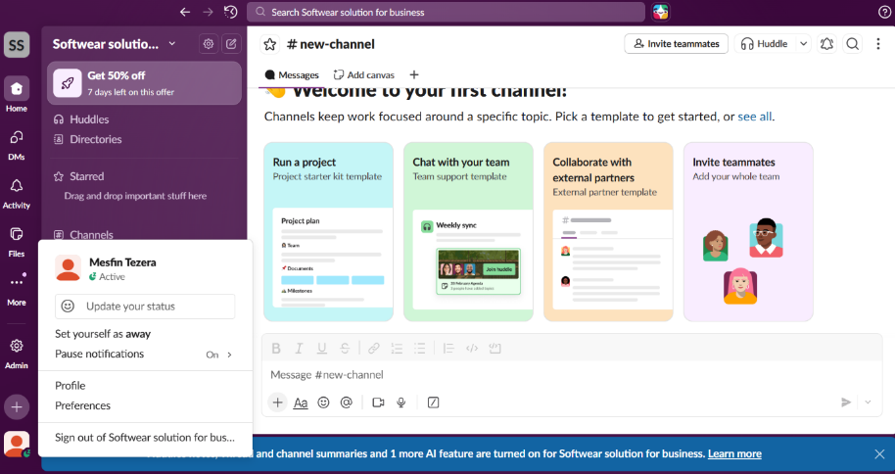
Figure 3: step 3 In this screenshot I am looking individual who have an issue to solved

.

.

Conclusion

This course changed my view on technology by teaching me that mastering tools like Excel is essential for staying competitive. Using mind mapping and collaborative platform has boosted my confidence and prepared me for the modern workplace. These skills now provide a strong foundation for my future career and long-term Perfessional growth.

References

[1] | B. K. S. Gsry Dushnitsky, “Low-codeenterpriceship shopyify and the alternative path to growth,” Low-codeenterpriceship shopyify and the alternative path to growth, vol. 16, p. 258, 28 May 2021.
[2] | M. A. Maria, “Softwear technologies for the management of modern E-commerce business solution,” Bucharest, 2019.
[3] | A. R. Srinagar, “InternationalJurnnal of multidecplinary education resarch,” InternationalJurnnal of multidecplinary education resarch, no. 2277-7881, 2018.
[4] | Gargouri, . C. N. and M. K. , “An Experiment in Mind-Mapping and Argument-Mapping: Tools for Assessing Outcomes in the Business Curriculum,” e-Journal of Business Education and Scholarship of Teaching, v11 n2 p39-78 2017, vol. 1, no. EISSN-1835-9132, p. 19, 2017.
[5] | S. Edwards and . N. Cooper, “Mind mapping as a teaching resource,” The clinical teacher, vol. 7, no. 4, pp. 236-239, 17 11 17 November 2010.
[6] | L. Cunnah, “Why mind mapping works: the benefits of mind mapping,” 10 January 10 January 2020. [Online]. Available: https://www.ayoa.com/ourblog/why-mind-mapping-works-the-benefits-of-mind-mapping/. [Accessed 28 02 2026].
[7] | Rahul, “Top 3 benefits of microsoft word procesing,” 22 2 206. [Online]. Available: https://inputix.com/blog/top-3-benefits-of-microsoft-word-processing/. [Accessed 22 2 2026].
[8] | U. o. N. Iowa, “Microsoft Word Basic Skills Workshop,” application/pdf, 15 03 2001.
[9] | I. H. N. 2. M. A. H. A. Abuobieda Bala Abusharib1, “Limitations and Pitfalls of PowerPoint Presentations:,” 26 3 2015. [Online]. Available: https://d1wqtxts1xzle7.cloudfront.net/37188148/Limitations_and_Pitfalls_of_PowerPoint_PresentationNajran_University_Medical_Stude. [Accessed 22 2 2026].
[10] | M. R. R. M. P.-A. Rubén Alcaraz-Martinez, “Can we create accessible charts with Microsoft Excel?: a review of possibilities and limits, with a special focus to users with low vision,” 19 06 2024.
[11] | M. Heron, “Open source and accessibility: advantages and limitations,” Open source and accessibility: advantages and limitations, vol. 1, no. 1, 2013.
[12] | T. J. o. F. y. network, “Blending Microsoft Teams with Existing Teaching Environments to Increase Access, Inclusivity and Engagement,” Lewis A Baker, Carol Spencely, vol. 3, p. 1, 2020.
[13] | M. Mcguire, “Four Laws of microsoft team,” Four Laws of microsoft team, no. 1539-7785, p. 1, 2022.
[14] | A. Chaushi, M. Nastwska and T. Veseli-Kurtishi, “MS Teams for Virtual Collaboration,” MS Teams for Virtual Collaboration, p. 1, 13 03 2024.
[15] | B. G. Khalili, T. Quraishi, M. Ahmad and R. Ahady, “Revolutionizing remote learning: A case study of google meet at an online university,” Tech Learning, vol. 1, no. 1, p. 1, 2024.
[16] | P. R. yidi, P. Aci, E. Yosep and A. Thomas, “The Online Learning Creativity Using the Google Meet Platform in Vocational High Schools,” vol. 18, Negeri Kerinci, Fakultas Tarbiyah dan Ilmu Keguruan IAIN Kerinci, 2022, pp. 111-121.
[17] | J. E. P, T. Laura Fe A., . E. Jhon M and S. M. Alluiza Joy, “International Journal of Research Publication and Reviews,” Google Meet: An Online Platform for Class Discussion, vol. 3, no. 2582-7421, pp. 3984-3994, 05 2022.

===========================END================================

