DS 1 Template

My Screenshots/Photos
- Please add 4–6 screenshots or photos of your digital life.
- You can use your phone or laptop.
- For each screenshot, write one or two sentences explaining what it shows.

Screenshot/Photo 1
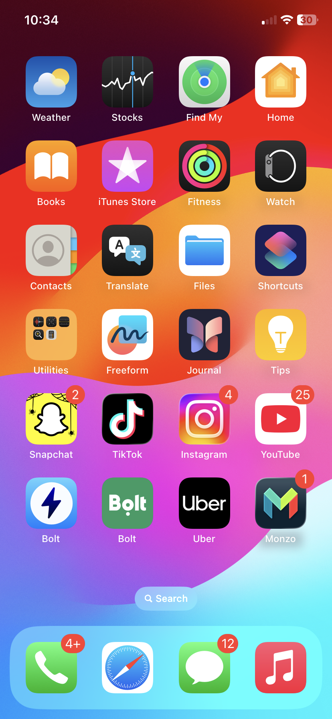
This shows the apps on my phone. I use most of these apps in my digital life, such as social media to communicate with others. I also so use my banking app to manage my money and spends. I can improve on the organisation of the apps.

Screenshot/Photo 2
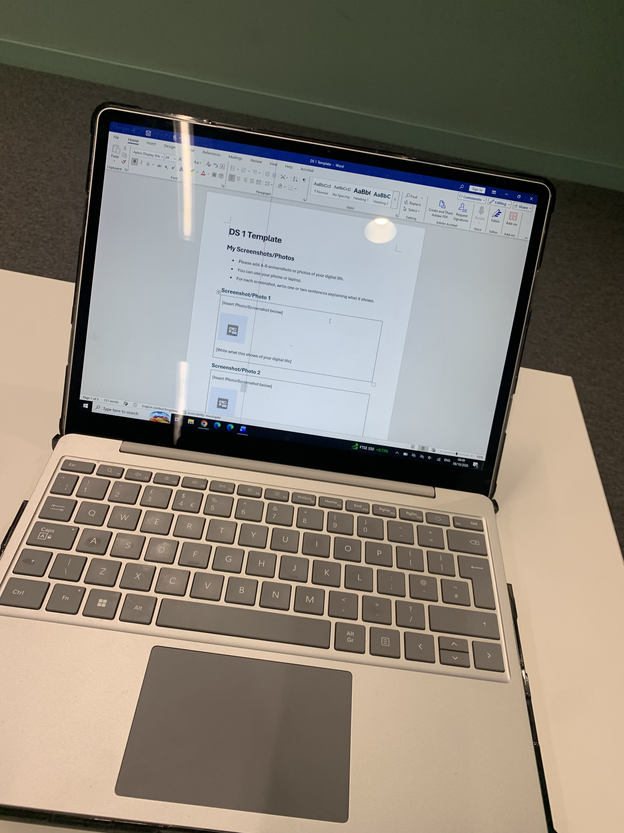
This shows a picture of my laptop. I use this often in my digital life for things such as emailing, researching, writing up assessments etc.

Screenshot/Photo 3
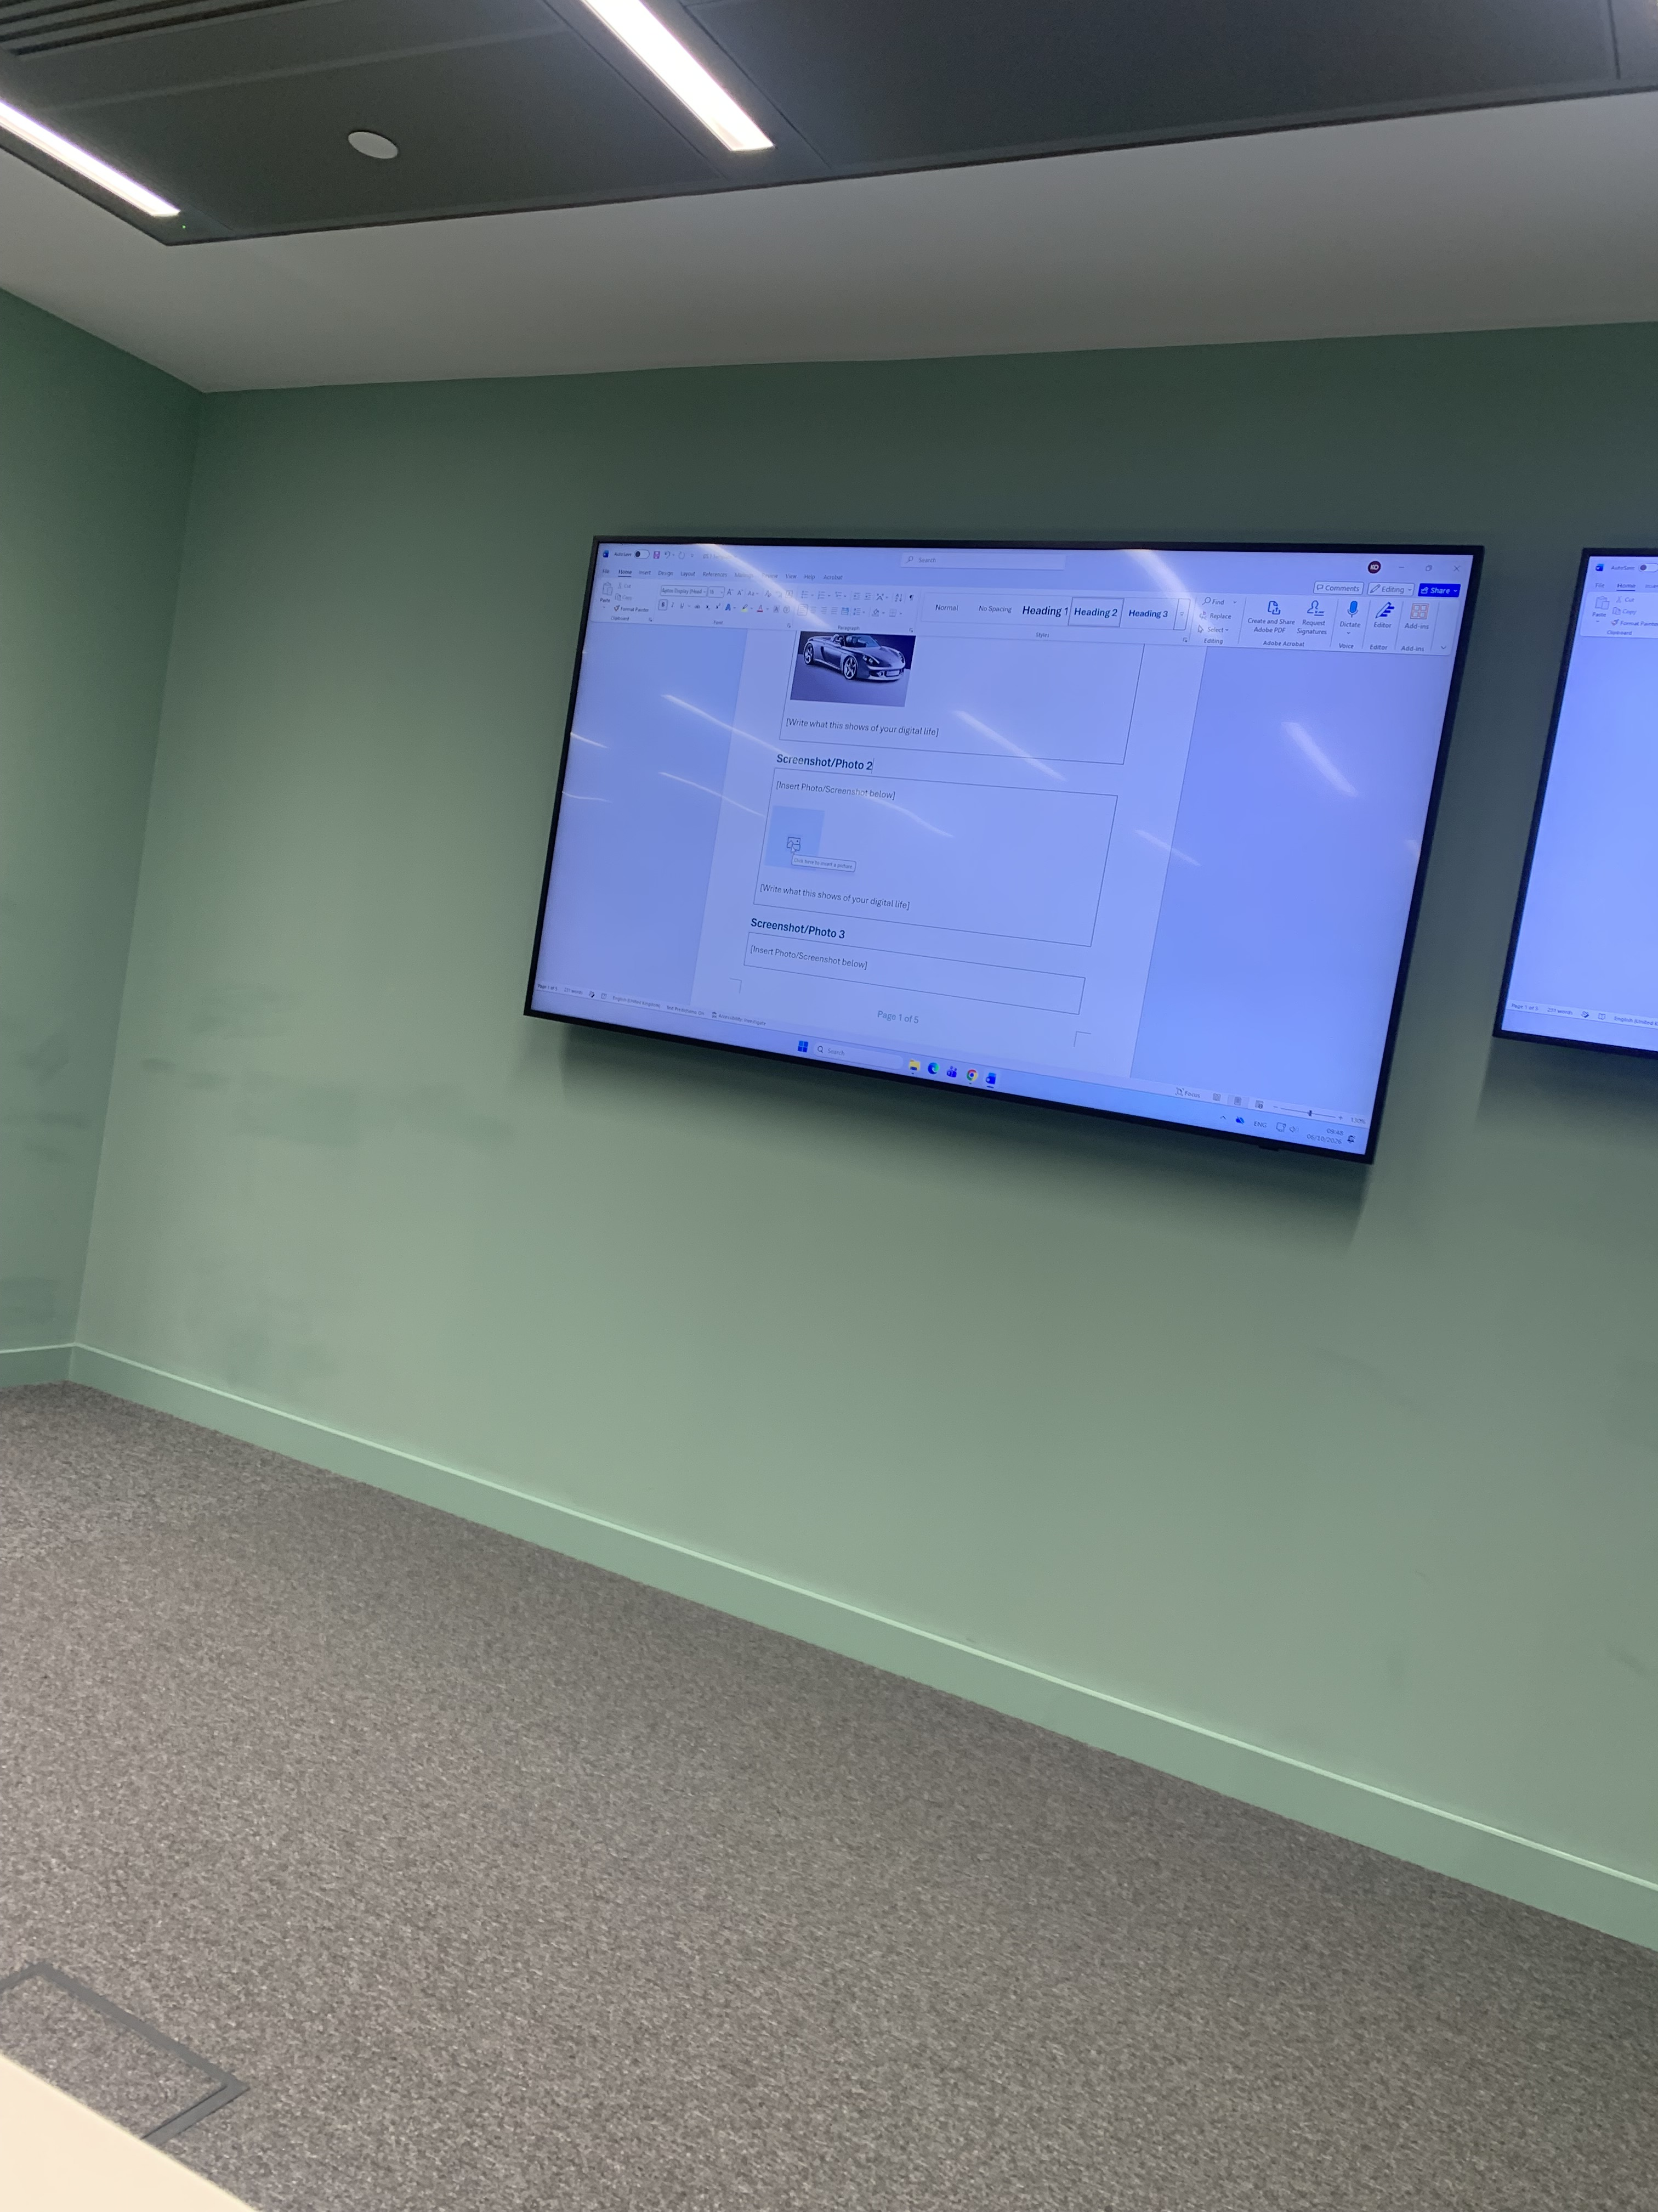
This is a picture I took of the monitor in my classroom. In my digital life this is used to show information to me, give me questions to answer or even videos could be put on there to obtain more knowledge.

Screenshot/Photo 4
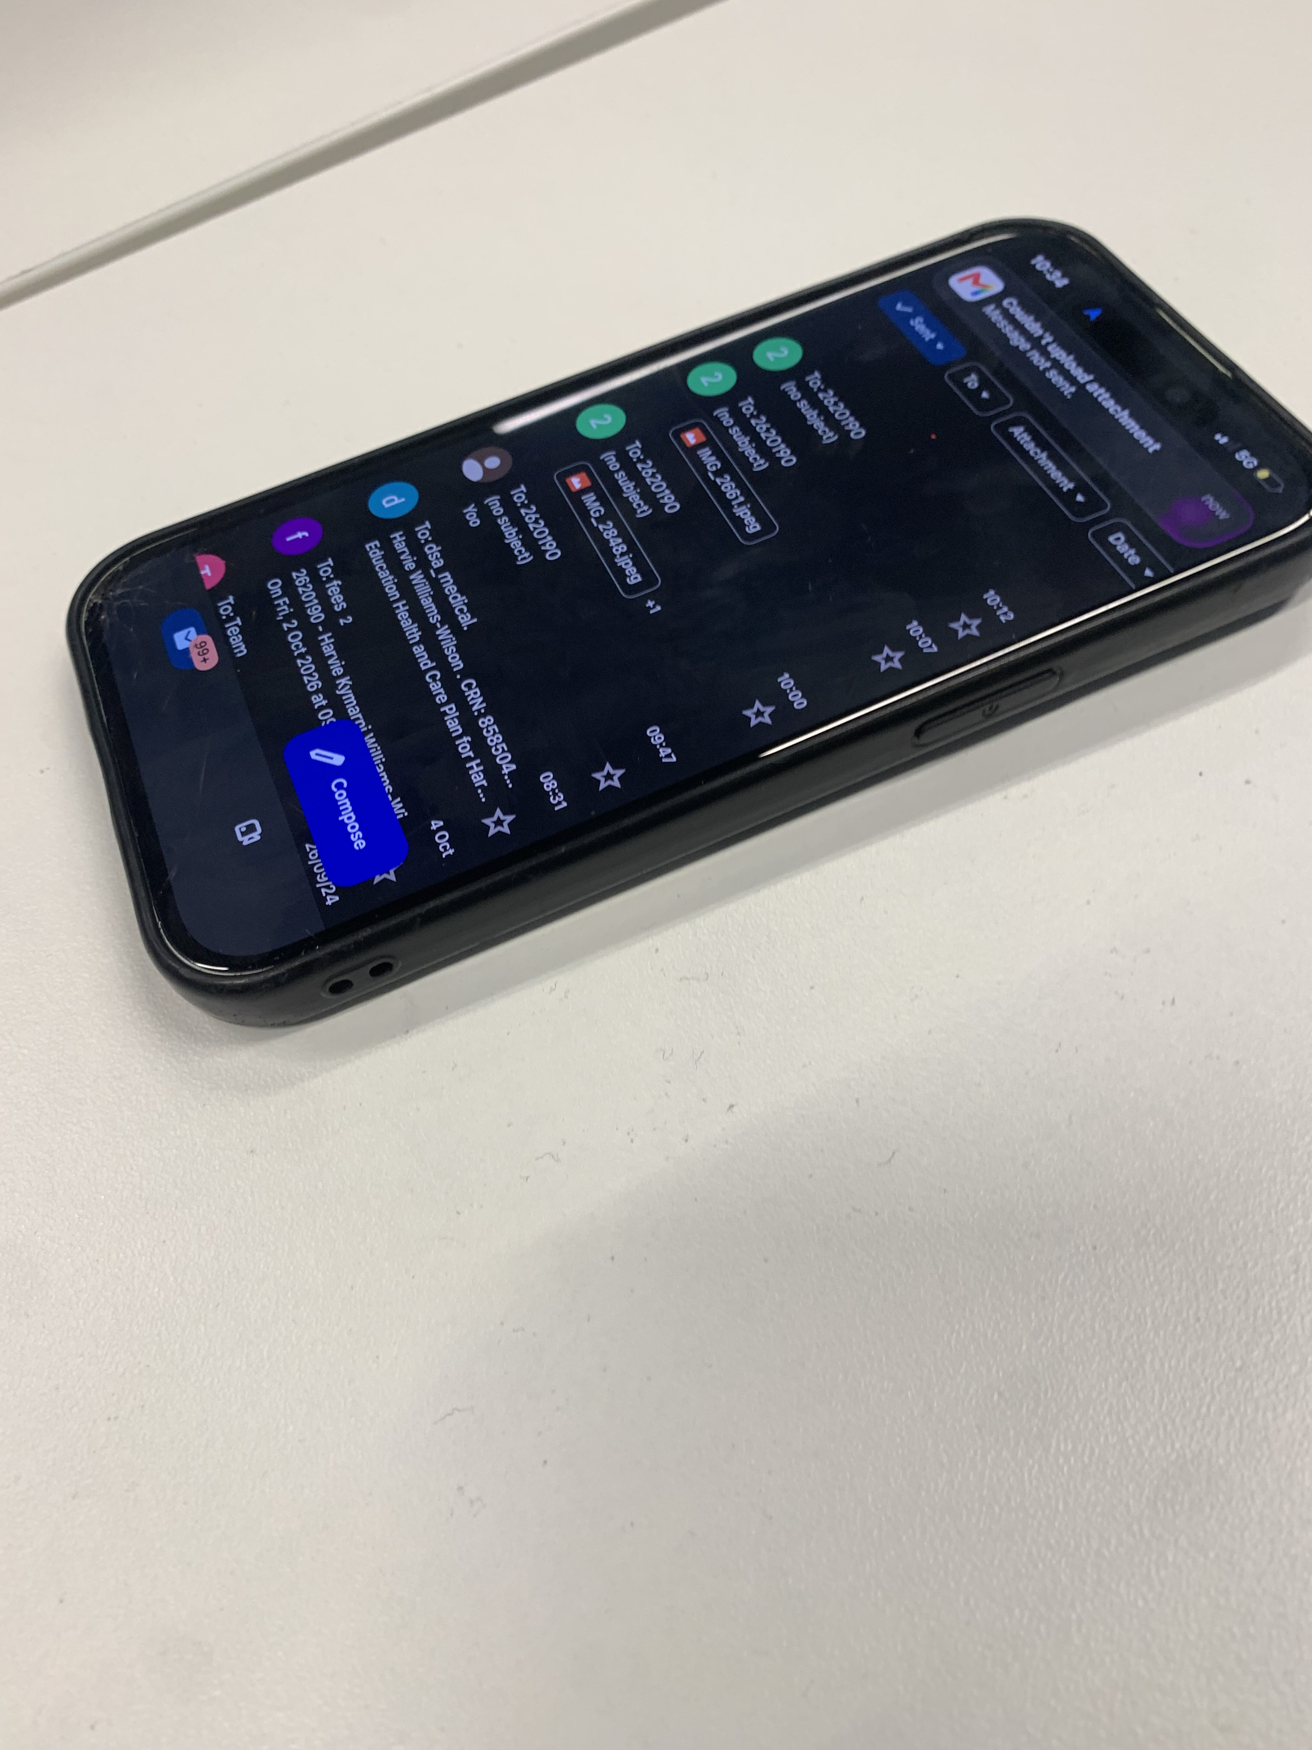
This picture is of my phone. I use my phone in my digital life every day. It can be used to call/facetime, email, connect through social media, play games and take pictures.

