Miguel Richards (2515293)

13/11/2025
Introduction to web and database concepts

HTML & CSS Web Development

Table of Contents
Introduction 1
Requirements 1
Implementation 450-600 2
Home Page 2
History Page 3
About Page 5
Validation 6
Evaluation 900-1000 7
Key Concepts in Web Development 7
Usability 7
Accessibility 7
Search Engine Optimisation (SEO) 8
Evaluation of My Website 8
Usefulness (Usability, Utility, and Content) 8
Search Engine Optimisation (SEO) 9
Accessibility 9
Comparison of Two Live Websites 10
Usability Comparison 10
Accessibility Comparison 10
SEO Comparison 10
Mobile Responsiveness Comparison 11
Overall Conclusion 11
Conclusion 100-150 11
References 11
Appendices 13
Home page code 13
History page code 15
About page code 18
CSS code 21

Introduction
This report presents the design of a website that I have created dedicated to Manchester united football club. We will also consider key web development concepts including usability, accessibility and SEO. Finally, we will consider two live football club websites to see how these concepts are used on live websites.

Requirements
The website that I have created is a website about my personal favourite football club- Manchester United, its main purpose is to inform the users about the club’s history, achievements and other useful information. The website gives visitors an overview of the club’s background as well as providing practical information and resources such as link to official ticket store and an embedded google maps pin showing the location of the Manchester united football stadium - Old Trafford. These features make the site educational but also useful, making it appealing to users that are supports of the club or those who are interested in learning more about it
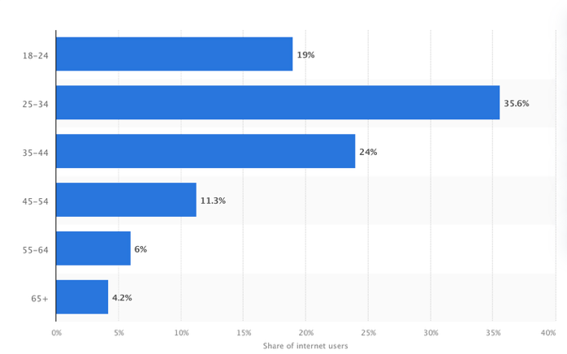
The target audience for the website includes current supporters, potential new fans and individuals interested in learning about Manchester United’s history, players and those who are just interested in useful links. Technically anyone at any age can be a fan or be interested in Manchester united, football is a sport that is enjoyed all around the world and a lot of people are interested in it. Also, the age of fans has no limits the oldest Manchester United fan is 100 years of age[ 1], but the primary target audience for this website will be those from the age range of 16-65. This range was chosen because according to statista.com over 95% of internet users are under the age of 65[2] as we can see in the table on the right[3]. Designing the website to be suitable for this demographic makes sure that the content is relevant and accessible to most of the users who are likely to visit the website.

Also, Research shows that around 66% of the clubs’ fans are male [4], and because the club is based in the United Kingdom, the content is primarily targeted towards a British male audience. However, the design is still inclusive and easy to navigate for all users regardless of their gender or nationality. The Site follows a clear and simple structure, making sure that usability is present for both experienced web users and inexperienced web users who want to find information quickly and easily

Implementation 450-600

Home Page
This is the home page of my website, here we learn a little bit about the club and attempt to engage the users so that they want to look through the rest of the website.
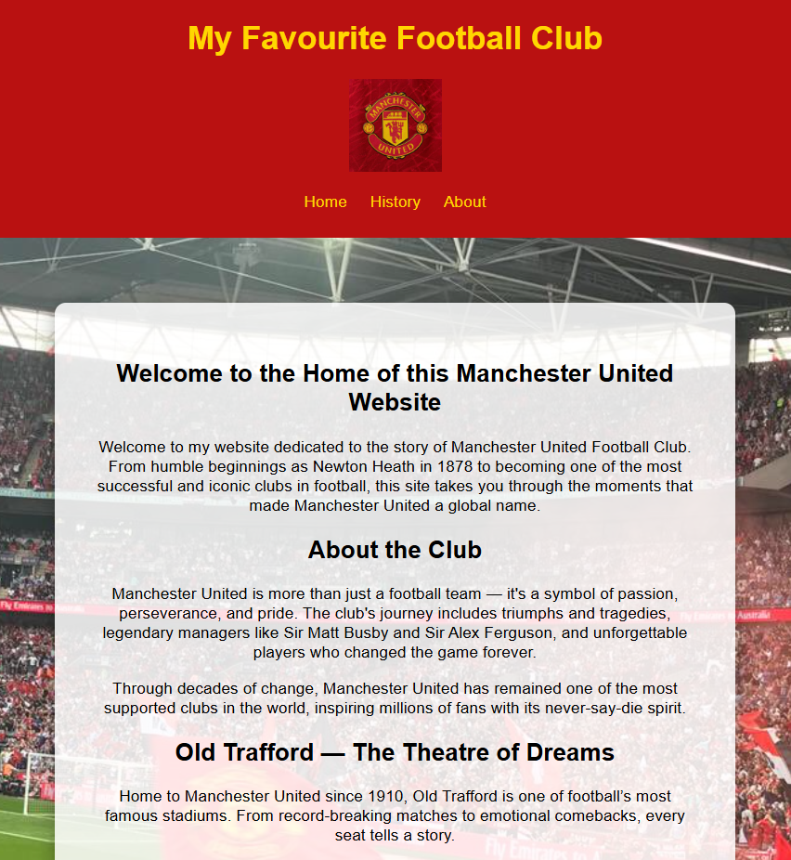
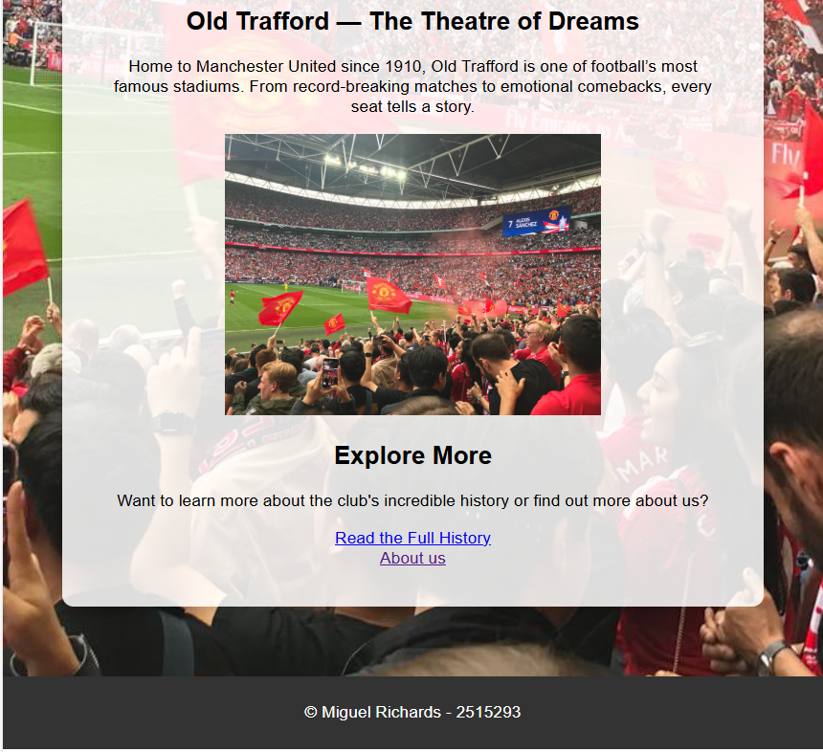
[5] [6]

History Page
Here is my history page, this page talks about how man united have succeeded throughout their history. I have not screenshotted the whole page because it is quite long, but here I have used a flex container which allowed me to layout the page so that the users can understand what image links to what text.
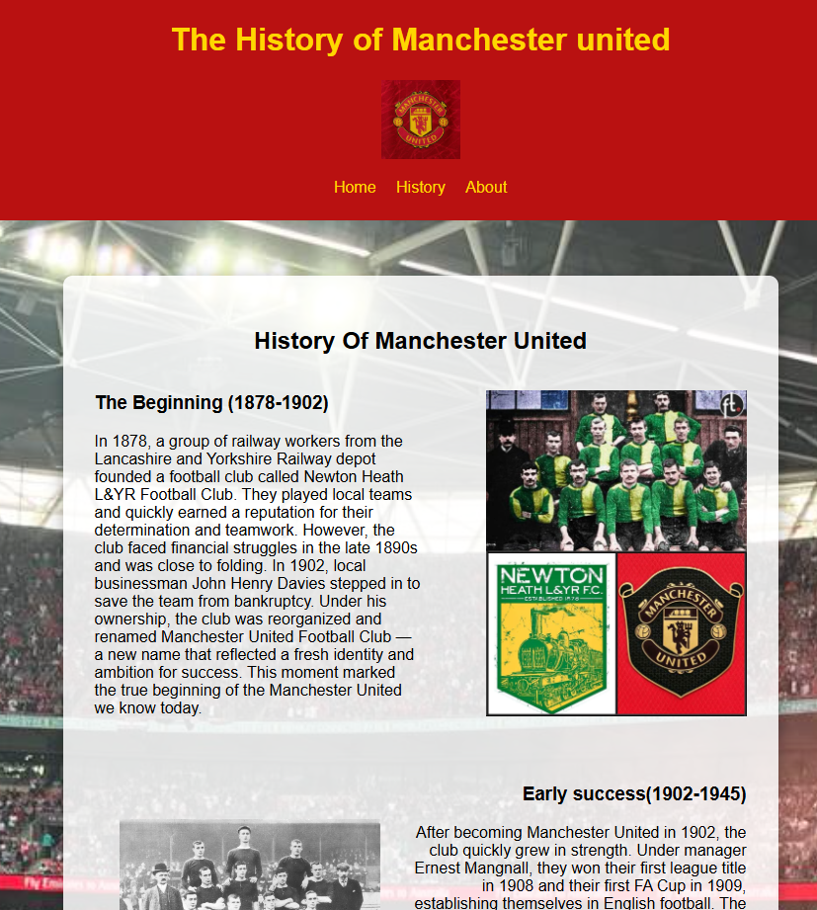
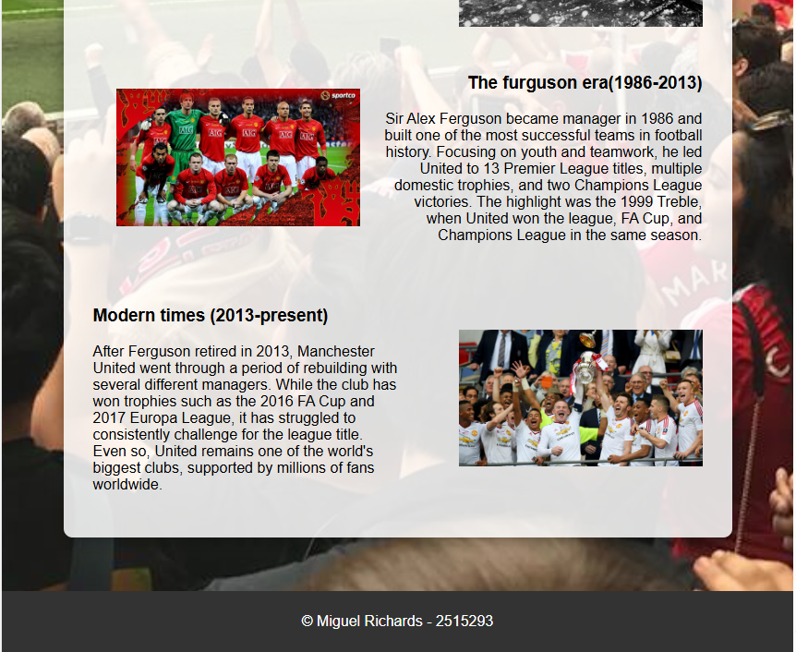
[7] [8][9][10][11][12][13]

About Page
Here in the about page, I am sharing useful information and external links to useful pages for my target audience. I have also embedded a google maps iframe which locates old Trafford(Manchester United football stadium)
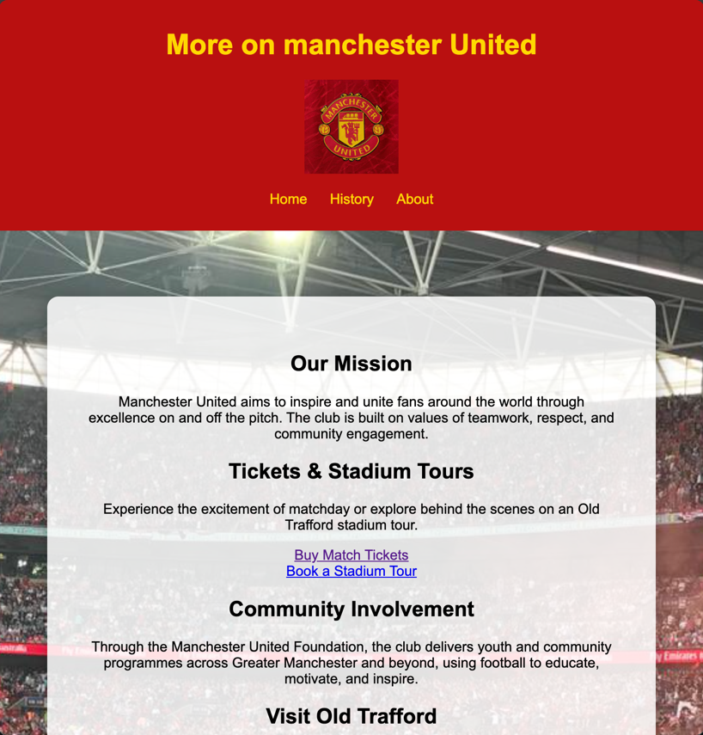
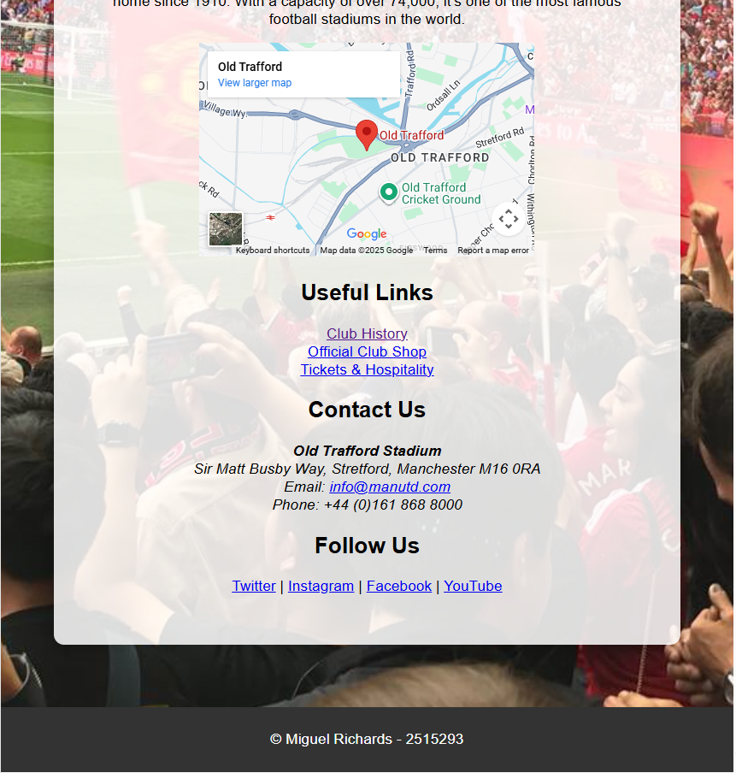

Validation
To validate my HTML and CSS files for my website I used W3c validator tools. The HTML verification was done using (http://validator.w3.org/), this analyses the structure and the syntax of the HTML document. Here below we can see the single error that the validator picked up. This issue was related to an image width element, according to the validator what I had done wrong is that I had used a percentage value (width 60%) instead of using a number pixel value (e.g. 250PX). Although the validator flagged an error, I had used the percentage value on purpose so that the image could be scalable, so no matter what the size of the page the width would be 60% of the dedicated area It was in, meaning that it would suit all devices and browser sizes. This improves the accessibility and the design consistency. So, for this reason, I decided not to change the code.
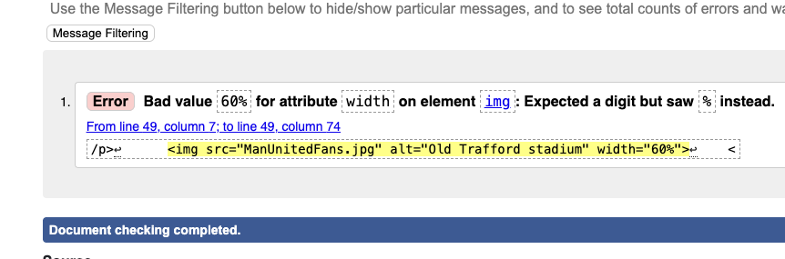

The CSS was validated using the W3C CSS validation service (http://jigsaw.w3.org/css-validator/) This tool also checks the syntax but also checks for incorrect properties. My style sheet passed the validation with no errors or warnings, this confirms that my website follows web standards the screenshot below shows that I had no errors.
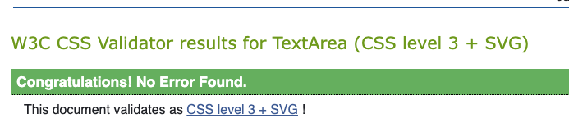
Overall, the validation showed that my code has no errors(without being expected) and meets the general standard of code.

Evaluation 900-1000
This section evaluates the overall quality of my Website. Starting with explaining the 3 key concepts, usability, accessibility and search engine optimisation (SEO). Then we will analyse my website and how it meets these 3 key concepts. We will conclude with comparing two existing websites.

Key Concepts in Web Development
The three concepts of web development we will be considering are usability, accessibility and SEO, together these three concepts ensure that a website is easy to use and visible to search engines, improving user experience and site traffic.[14]

Usability
Usability is a very important aspect of website development, it focuses on how easy a user can interact with a website which involves how easy it is to navigate, clear content and how fast people can accomplish their desired tasks. Research shows that websites with good usability reduces the user’s frustration, minimizes errors the users make and requires less thinking effort to use the site [15]. This means the website should be intuitive, the information on the website should be structured in a logical way and elements that are interactive, like links, should be clear. When considering usability, a website makes sure that the user will have a pleasant experience using their website.

Accessibility
Accessibility is also a very important aspect of web development. Website accessibility refers to designing a website in a way so that all users, including people with disabilities can use. That includes using certain features that would benefit someone with a disability such as screen readers, alt texts and making sure there is a good colour contrast. We want to make sure that our website is available to all and using accessibility allows us to do that. Research shows that worldwide there are over 180 million people who are visually disabled and over 250 million who have a hearing disability and throughout history disabled people have been segregated and not able to do certain simple tasks that a person without a disability would be able to do, simply because of bad design [16]. Making sure that accessibility is implemented is vital.

Search Engine Optimisation (SEO)
Search engine optimisation is structuring and writing the webs content in a way that improves the websites visibility on search engines like google, safari, etc. good SEO involves making good use of descriptive HTML elements such as meaningful page titles, meta descriptions and images that are tagged properly so that the search engine can understand what content is on the page to share it to the right people. Including keywords that are relevant to the subject will make it more likely that the site ranks hire among other websites that also discuss the same/similar subject. According to a credible web development book source, these on page SEO techniques are vital because they directly influence how the search engine understands the website and how high they will rank It among other sites, which will affect how easily the site can be found by users.[17]

Evaluation of My Website
Now that those three concepts have been considered we can see how I have applied them in my website. This section will assess how effective the website is in terms of its design, functionality and user experience. This will help us to see its strength and areas it can improve.

Usefulness (Usability, Utility, and Content)
For my websites usefulness there are many positives to talk about. My navigation is good with a clear menu structure that gives the users clear options to navigate to different pages, it is also quick and easy to find easy to find information because all page titles and headings are very self-explanatory. The functionality of the website is also good, I have embedded a google maps Iframe locating the Manchester United stadium which the user can quickly access. I have also included Multiple links to external Websites that are working and clear. My website also has good readability. I have used consistent fonts and font sizes and made sure that there is spacing between different subjects to differentiate different topics. Images also scale well so they adapt well to different devices and browser sizes making it usable to all devices.

All with the things I have done well there are areas where the usability could be improved to potential slightly increase navigation speed and make the content slightly more engaging. For the navigation I could have potential added a search feature which would have allowed for the users to directly find what they are looking for. For the content I could have included a video, videos are very engaging and entertaining for users so that could have improved the content.

Search Engine Optimisation (SEO)
One way my websites uses good SEO is by using clear and descriptive page titles and headings. Each page has a meaningful title, for example my history page is titled “Manchester United History”, this is a simple title, and it helps search engines to understand the purpose of that page. All my images include alt texts which gives search engines more information.
One way I could improve my SEO is by adding a meta description into my website, adding a meta description would help the search engines to understand better what the purpose of each page is, users would then be able to read this and be encouraged to click on my website.

Accessibility
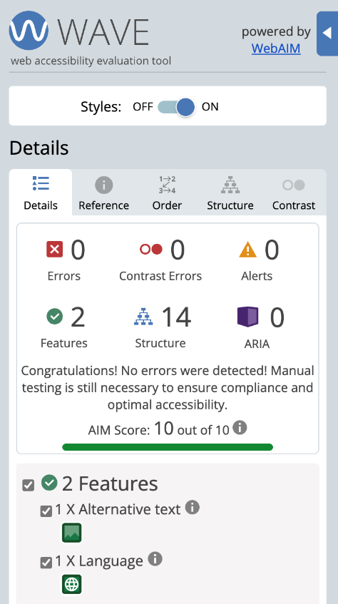
My webpage contains many accessibility features that make sure its usable for all users. I used alt texts for images so that people with screen readers can understand the context when I’m referring to an image and for people who are on devices that can’t register images. I also chose a strong colour contrast, this allows people with visual impairment to be able to see the content properly. I also make sure that all content is scalable, this allows users on any device to be able to enjoy the content, but also if people increase the text size of their browser all my content scales so that the web browser is still usable when zoomed in. As we can see on the right, I used an accessibility checker to make sure that my website followed general web accessibility standards, and I received no errors or alerts. This shows that I have completed the website to a good accessibility standard.
I still feel that I could improve on the accessibility by adding keyboard-only navigation making sure that all users can move through the website without a mouse. But overall, the website meets basic accessibility standards.

Comparison of Two Live Websites
The two websites I have decided to compare are arsenal.com and manUtd.com. comparing these two websites will help to better understand how web development principles are applied on high traffic websites.

Usability Comparison
ManUtd.com – The website has a lot of interactive content such as videos, news and live updates of game scores and transfers. Even though this makes the website engaging, the homepage feels very busy and some information can be hard to find, if you are trying to quickly access it.
Arsenal.com – This website has a clearer design and simpler navigation, this makes it easier for users to find information quickly, there is less engaging content, but this improves the overall usability
Overall, we have learned that too much of something good can become bad, ManUtd.com has too much content which lessens the usability. Arsenal.com has better usability for the public, but manUtd.com is more suited for fans.

Accessibility Comparison
ManUtd.com – The website has high colour contrast, this helps to improve the readability but, some text is written over images, and some images do not have well described alt text.
Arsenal.com – this website has more consistent font sizes, better spacing, clearer buttons and links and good colour contrast through the website.
Overall, arsenal.com is more accessible. ManUnited.com could improve alt text and have a clearer layout.

SEO Comparison
ManUtd.com – This website has frequently updated content and they have meta titles that help the search engines to understand and rank the site well but, the heavy media content displayed on the ManUtd.com website can cause the page to take longer to load.
Aresenal.com – This website also has meta titles and the content on this website isn’t as heavy so there are faster loading times, which help SEO performance.
Overall, both sites use good SEO, but ManUtd.com’s website has constant updates may help to have a higher search rank, whereas arsenal.com’s page loads faster which supports SEO.

Mobile Responsiveness Comparison
ManUtd.com – As previously mentioned this website has a lot of content and because of this when the website is accessed on a mobile device users may need to scroll/swipe a lot.
Arsenal.com – Also, as previously mentioned, arsenal’s website has a lot less heavy content and this allows for a cleaner mobile layout and less scrolling/swiping.
Overall, similar to the usability, arsenal provides a smother experience, but ManUtd’s is more suited to the fans who are looking to get live updates.

Overall Conclusion
ManUtd.com focuses more on engaging with fans with videos and by constantly updating the website with scores and transfers. But because of this, navigation and readability slightly harder. Arsenal.com prioritizes usability, accessibility and faster loading times, providing a less engaging content but a better user experience. Both sites are good at SEO.

Conclusion 100-150
In conclusion, the website that I have made uses key web development principles which creates a user friendly and engaging website. Even though those principals have been applied (usability, accessibility and SEO) that does not mean that they cannot be improved. I could do so by adding meta descriptions and adding a bit more engaging content such as videos. Comparing the two lives websites showed how professional websites use these principles to improve their user experience.

References
[1] J. Ganley, “100-year-old Arthur’s red-letter day,” Manutd.com, Apr. 07, 2023. https://www.manutd.com/en/news/detail/100-year-old-man-utd-fan-arthur-lilly-reacts-to-old-trafford-invite-and-sir-alex-ferguson-meeting (accessed Nov. 12, 2025).
[2] A. Petrosyan, “Internet Users by Age Worldwide,” Statista, Jun. 27, 2024. https://www.statista.com/statistics/272365/age-distribution-of-internet-users-worldwide/ (accessed Nov. 12, 2025).
[3] Ani Petrosyan, share of internet users. 27AD. Accessed: Nov. 12, 2025. [Website]. Available: https://www.statista.com/statistics/272365/age-distribution-of-internet-users-worldwide/
[4] Global Web Index, “Manchester United’s Popularity Around the World.” Accessed: Nov. 14, 2025. [Online]. Available: https://insight.gwi.com/hubfs/Manchester-United-Fans.pdf
[5] Manchester United, Scenes at Wembley following @Alexis_Sanchez’s Leveller! 2018. Accessed: Oct. 10, 2025. [Social Media]. Available: https://x.com/ManUtd/status/987735131078225920
[6] SA people news, Man Utd Reaffirms UEFA Commitment Amidst Super League Plans. 2023. Accessed: Oct. 18, 2025. [Website]. Available: https://www.sapeople.com/sport/man-utd-reaffirms-uefa-commitment-amidst-super-league-plans/
[7] ChatGPT, “Conversation with ChatGPT,” Oct. 24, 2025.
[8] Manchester United, “History,” Manchester United, 2024. https://ir.manutd.com/company-information/history.aspx
[9] Worlds Football News, On This day, in 1902, a Side Called Newton Heath FC Were Saved from Bankruptcy When New Investment Came in . 2025. Accessed: Oct. 18, 2025. [Social Media]. Available: https://www.facebook.com/groups/246180665117818/posts/644809598588254/
[10] Wikipedia, The Manchester United team at the start of the 1905–06 season, in which they were runners-up in the Second Division and were promoted. 2025. Accessed: Oct. 20, 2025. [Website]. Available: https://en.wikipedia.org/wiki/List_of_Manchester_United_F.C._seasons
[11] Sky News, Munich Air Disaster: The survivors who never played again. 2018. Accessed: Oct. 20, 2025. [Website]. Available: https://news.sky.com/story/munich-air-disaster-the-survivors-who-never-played-again-11238262
[12] SPORTCO, Manchester United 2008 Champions League Final squad: Where are they now? 2021. [Website]. Available: https://www.sportco.io/article/manchester-united-champions-league-final-squad-2008-969745
[13] THEFA, ROONEY REVELS IN LIFTING EMIRATES FA CUP FOR THE FIRST TIME. 2016. Accessed: Oct. 26, 2025. [Website]. Available: https://www.thefa.com/news/2016/may/21/palace-v-united-reaction
[14] C. Gantt, “The Essential Role of Accessibility and Usability in SEO,” Ckeditor.com, Feb. 25, 2025. https://ckeditor.com/blog/accessibility-and-usability-for-seo/ (accessed Nov. 17, 2025).
[15] Y. Lee and K. A. Kozar, “Understanding of website usability: Specifying and measuring constructs and their relationships,” Decision Support Systems, vol. 52, no. 2, pp. 450–463, Jan. 2012, doi: https://doi.org/10.1016/j.dss.2011.10.004.
[16] S. Hackett, B. Parmanto, and X. Zeng, “A retrospective look at website accessibility over time,” Behaviour & Information Technology, vol. 24, no. 6, pp. 407–417, Nov. 2005, doi: https://doi.org/10.1080/01449290500066661.
[17] E. Enge, The art of SEO. Sebastopol, Ca: O’reilly, 2010, pp. 150–200. Accessed: Nov. 17, 2025. [Online]. Available: https://books.google.co.uk/books?hl=en&lr=&id=CZ-tm_5f4WcC&oi=fnd&pg=PR13&dq=why+website+seo&ots=AjAYRow6Nj&sig=B-ZlkLQXqm1rShxVEKatDYgp3kw&redir_esc=y#v=onepage&q=why%20website%20seo&f=false

Appendices

Home page code
<!DOCTYPE html>
<html lang="en">

<!-- Head section: contains metadata, page title and link to the stylesheet.
The viewport tag makes the website scale properly on all devices. -->
<head>
<meta charset="UTF-8">
<meta name="viewport" content="width=device-width, initial-scale=1.0">
<title>Manchester United Fans</title>
<link rel="stylesheet" href="styles.css">
</head>

<body>

<!-- Header section containing website title, club badge and navigation menu. Excluding the title, this is the same on every page -->
<header>
<h1>My Favourite Football Club</h1>
<img src="ManUnited.jpg" alt="photo of Manchester United badge" style="height: 100px;">
<nav>
<ul>
<li><a href="Home.html"> Home</a></li>
<li><a href="History.html"> History</a></li>
<li><a href="About.html"> About</a></li>
</ul>
</nav>
</header>

<main>

<!-- Page content is kept inside this container for layout purposes -->
<div class="text-holder">

<!-- Homepage introduction section -->
<section>
<h2>Welcome to the Home of this Manchester United Website</h2>
<p>Welcome to my website dedicated to the story of Manchester United Football Club.
From humble beginnings as Newton Heath in 1878 to becoming one of the most successful and iconic clubs in football,
this site takes you through the moments that made Manchester United a global name.</p>
</section>

<!-- Overview section explaining what the club represents -->
<section>
<h2>About the Club</h2>
<p>Manchester United is more than just a football team — it's a symbol of passion, perseverance, and pride.
The club's journey includes triumphs and tragedies, legendary managers like Sir Matt Busby and Sir Alex Ferguson,
and unforgettable players who changed the game forever.</p>

<p>Through decades of change, Manchester United has remained one of the most supported clubs in the world,
inspiring millions of fans with its never-say-die spirit.</p>
</section>

<!-- Section about the stadium with a supporting image -->
<section>
<h2>Old Trafford — The Theatre of Dreams</h2>
<p>Home to Manchester United since 1910, Old Trafford is one of football’s most famous stadiums.
From record-breaking matches to emotional comebacks, every seat tells a story.</p>

<!-- Stadium image set to scale using a percentage width -->
<img src="ManUnitedFans.jpg" alt="Old Trafford stadium" width="60%">
</section>

<!-- Section containing quick links to other pages on the website -->
<section>
<h2>Explore More</h2>
<p>Want to learn more about the club's incredible history or find out more about us?</p>

<a href="History.html">Read the Full History</a><br>
<a href="About.html">About us</a>
</section>

</div>
</main>

<!-- Footer section that appears at the bottom of the page -->
<footer>
<!-- Copyright statement for ownership and validation -->
<p>&copy; Miguel Richards - 2515293</p>
</footer>

</body>
</html>

History page code
<!DOCTYPE html>
<html lang="en">
<head>
<!-- Head section: contains metadata, page title and link to the stylesheet.
The viewport tag makes the website scale properly on all devices. -->
<meta charset="UTF-8">
<meta name="viewport" content="width=device-width, initial-scale=1.0">
<title>Manchester United History</title>
<link rel="stylesheet" href="styles.css">
</head>

<body>

<!-- Header section containing website title, club badge and navigation menu. Excluding the title, this is the same on every page -->
<header>
<h1>The History of Manchester United</h1>
<img src="ManUnited.jpg" alt="photo of Manchester United badge" style="height: 100px;">
<nav>
<ul>
<li><a href="Home.html"> Home</a></li>
<li><a href="History.html"> History</a></li>
<li><a href="About.html"> About</a></li>
</ul>
</nav>
</header>

<!-- Main content area -->
<main>

<!-- as mentioned on the homepages code, this div keeps all the content in a sort of box -->
<div class="text-holder">

<!-- Page section heading -->
<h2>History Of Manchester United</h2>

<!-- Flex container used so text and images line up side by side -->
<div class="flex-container">

<!-- SECTION 1 -->
<section class="section-flex">

<!-- Text block sits on the left due to flexbox layout -->
<div style="text-align: left; max-width: 50%;">
<h3>The Beginning (1878-1902)</h3>
<p>In 1878, a group of railway workers from the Lancashire and Yorkshire Railway depot founded a football club called Newton Heath L&YR Football Club.
They played local teams and quickly earned a reputation for their determination and teamwork. However, the club faced financial struggles in the late 1890s and was close to folding.
In 1902, local businessman John Henry Davies stepped in to save the team from bankruptcy. Under his ownership,
the club was reorganized and renamed Manchester United Football Club — a new name that reflected a fresh identity and ambition for success.
This moment marked the true beginning of the Manchester United we know today.</p>
</div>

<!-- Image positioned to the right of the text using flexbox -->
<img src="Newton Heath.jpg" alt="image of Newton Heath players" style="max-width: 40%;">
</section>

<!-- SECTION 2 -->
<section class="section-flex">

<!-- Image appears on the left for this section -->
<img src="ManUnitedearly success.jpg" alt="early Manchester United photo" style="max-width: 40%; padding: 2rem;">

<!-- Text appears on the right because of the flex layout -->
<div style="text-align: right;">
<h3>Early Success (1902-1945)</h3>
<p>After becoming Manchester United in 1902, the club quickly grew in strength.
Under manager Ernest Mangnall, they won their first league title in 1908 and their first FA Cup in 1909,
establishing themselves in English football.
The following years were tougher, with financial problems and the impact of both World Wars.
Old Trafford, opened in 1910, was even bombed during World War II, forcing the team to play at Maine Road.
Despite these challenges, the club built a strong identity that shaped its future success.</p>
</div>
</section>

<!-- SECTION 3 -->
<section class="section-flex">

<!-- Text block appears on the left -->
<div style="text-align: left; max-width: 50%;">
<h3>The Busby Era (1945-1969)</h3>
<p>When Sir Matt Busby took over in 1945, he focused on developing young players,
leading to the creation of the famous “Busby Babes,” who won league titles in 1956 and 1957.
In 1958, tragedy struck when the team was involved in the Munich Air Disaster,
which claimed the lives of several players and staff. Despite this, Busby rebuilt the side,
and in 1968 Manchester United became the first English club to win the European Cup —
a remarkable achievement that symbolized the club’s strength and resilience.</p>
</div>

<!-- Image sits on the right beside the text -->
<img src="skynews-munich-air-disaster_4213062.jpg" alt="Manchester United Munich plane crash" style="max-width: 40%;">
</section>

<!-- SECTION 4 -->
<section class="section-flex">

<!-- Image on the left for visual alternation -->
<img src="2008ManU.jpg" alt="Manchester United 2008 team" style="max-width: 40%; padding: 2rem;">

<!-- Text on the right side -->
<div style="text-align: right;">
<h3>The Ferguson Era (1986-2013)</h3>
<p>Sir Alex Ferguson became manager in 1986 and built one of the most successful teams in football history.
Focusing on youth and teamwork, he led United to 13 Premier League titles, multiple domestic trophies,
and two Champions League victories. The highlight was the 1999 Treble, when United won the league, FA Cup,
and Champions League in the same season.</p>
</div>
</section>

<!-- SECTION 5 -->
<section class="section-flex">

<!-- Text sits on the left side -->
<div style="text-align: left; max-width: 50%;">
<h3>Modern Times (2013-present)</h3>
<p>After Ferguson retired in 2013, Manchester United went through a period of rebuilding with several different managers.
While the club has won trophies such as the 2016 FA Cup and 2017 Europa League, it has struggled to consistently challenge for the league title.
Even so, United remains one of the world's biggest clubs, supported by millions of fans worldwide.</p>
</div>

<!-- Image appears on the right side -->
<img src="FACupWin.avif" alt="Manchester United winning FA Cup in 2013" style="max-width: 40%;">
</section>

</div>
</div>
</main>

<!-- Footer placed at the bottom of the page on all screens -->
<footer>
<p>&copy; Miguel Richards - 2515293</p>
</footer>

</body>
</html>

About page code
<!DOCTYPE html>
<html lang="en">

<!-- Head section: contains metadata, page title and link to the stylesheet.
The viewport tag makes the website scale properly on all devices. -->
<head>
<meta charset="UTF-8">
<meta name="viewport" content="width=device-width, initial-scale=1.0">
<title>About Manchester United</title>
<link rel="stylesheet" href="styles.css">

</head>

<body>

<!-- Header section containing website title, club badge and navigation menu. Excluding the title, this is the same on every page -->
<header>
<h1>More on manchester United</h1>
<img src="ManUnited.jpg" alt="photo of Manchest united badge" style="height: 100px;">
<nav>
<ul>
<li><a href="Home.html"> Home</a></li>
<li><a href="History.html"> History</a></li>
<li><a href="About.html"> About</a></li>
</ul>
</nav>
</header>

<main>
<!-- This div keeps all the page content centred and in a readable area,
same as on the other pages to keep the website consistent. -->
<div class="text-holder">

<!-- Simple text section describing the mission of the club -->
<section>
<h2>Our Mission</h2>
<p>
Manchester United aims to inspire and unite fans around the world through excellence on and off the pitch.
The club is built on values of teamwork, respect, and community engagement.
</p>
</section>

<!-- Section that contains text and two external links.
Both links open in a new tab using target="_blank". -->
<section>
<h2>Tickets & Stadium Tours</h2>
<p>
Experience the excitement of matchday or explore behind the scenes on an Old Trafford stadium tour.
</p>
<a href="https://www.manutd.com/en/tickets-and-hospitality" target="_blank">Buy Match Tickets</a><br>
<a href="https://www.manutd.com/en/visit-old-trafford/museum-stadium-tours" target="_blank">Book a Stadium Tour</a><br>
</section>

<!-- Standard text section explaining community involvement -->
<section>
<h2>Community Involvement</h2>
<p>
Through the Manchester United Foundation, the club delivers youth and community programmes across Greater
Manchester and beyond, using football to educate, motivate, and inspire.
</p>
</section>

<!-- Section containing text and an embedded Google Maps iframe.
The iframe shows the location of Old Trafford and the part where i say 60% width allows it to scale with the page. -->
<section>
<h2>Visit Old Trafford</h2>
<p>
Known as “The Theatre of Dreams,” Old Trafford has been Manchester United’s home since 1910.
With a capacity of over 74,000, it’s one of the most famous football stadiums in the world.
</p>
<iframe
src="https://www.google.com/maps/embed?pb=!1m18!1m12!1m3!1d9501.208827759834!2d-2.2966183420775317!3d53.463058928449115!2m3!1f0!2f0!3f0!3m2!1i1024!2i768!4f13.1!3m3!1m2!1s0x487bae72e7e47f69%3A0x6c930e96df4455fe!2sOld%20Trafford!5e0!3m2!1sen!2suk!4v1763027986166!5m2!1sen!2suk"
style="border:0; width: 60%; height: 250px;" allowfullscreen="" loading="lazy"
referrerpolicy="no-referrer-when-downgrade"></iframe>
</section>

<!-- Useful links section with both internal and external links -->
<section>
<h2>Useful Links</h2>
<a href="History.html">Club History</a><br>
<a href="https://store.manutd.com/en/" target="_blank">Official Club Shop</a><br>
<a href="https://www.manutd.com/en/tickets-and-hospitality" target="_blank">Tickets & Hospitality</a><br>
</section>

<!-- Contact details formatted using the <address> tag to show official contact info -->
<section>
<h2>Contact Us</h2>
<address>
<strong>Old Trafford Stadium</strong><br>
Sir Matt Busby Way, Stretford, Manchester M16 0RA<br>
Email: <a href="mailto:info@manutd.com">info@manutd.com</a><br>
Phone: +44 (0)161 868 8000
</address>
</section>

<!-- Section linking to social media pages -->
<section>
<h2>Follow Us</h2>
<p>
<a href="https://twitter.com/ManUtd" target="_blank">Twitter</a> |
<a href="https://www.instagram.com/manchesterunited/" target="_blank">Instagram</a> |
<a href="https://www.facebook.com/manchesterunited" target="_blank">Facebook</a> |
<a href="https://www.youtube.com/manutd" target="_blank">YouTube</a>
</p>
</section>

</div>
</main>

<!-- Footer that appears at the bottom of all pages showing ownership -->
<footer>
<p>&copy; Miguel Richards - 2515293</p>
</footer>

</body>

</html>

CSS code
/* Body styling for main page: sets background, font, and flexible layout for central alignment */
body{
margin: 0;
min-height: 100vh;
background-image: url("ManUnitedFans.jpg");
background-size: cover;
background-position: center;
background-repeat: repeat-y;
justify-content: center;
align-items: center;
font-family: Arial, sans-serif;
font-size: clamp(14px,2vw,20px);
display: flex;
flex-direction: column;
}

/* Header styling: sets background color, text color, padding, and centering */
header {
background-color: rgb(185, 17, 17);
color: gold;
padding: 10px;
text-align: center;
width: 100%;
}

/* Navigation menu: removes bullets, aligns items inline, and styles links */
nav ul {
list-style-type: none;
padding: 0;
}
nav ul li{
display: inline;
margin: 0 10px;
}
nav ul li a{
color: gold;
text-decoration: none;
}

/* Main content area: adds padding and centers text */
main {
padding: 20px;
text-align: center;
flex: 1;
}

/* Footer styling: dark background, white text, centered, stays at bottom */
footer {
background-color: #333;
color: white;
text-align: center;
padding: 10px;
bottom: 0;
width: 100%;
margin-top: 0.2rem;
}

/* Image styling: keeps height relative and prevents stretching */
img{
height: fit-content;
}

/* Flex container: layout for multiple items with spacing and wrapping */
.flex-container {
display: flex;
justify-content: space-between;
align-items: flex-start;
gap: 40px;
flex-wrap: wrap;
}

/* Section flex: aligns elements horizontally and vertically within a section */
.section-flex{
display: flex;
justify-content: space-between;
align-items: center;
}

/* Text holder styling: The semi transparent box with all the content in, was made here
the 80% width also allows it to scale to the size of the page */
.text-holder{
background: rgba(255, 255, 255, 0.85);
padding: 40px;
border-radius: 12px;
text-align: center;
box-shadow: 0 4px 20px rgba(0, 0, 0, 0.3);
max-width: 1000px;
width: 80%;
margin: 50px auto;
}

