

PROGRAM NAME: BA BUSINESS MANAGEMENT
MODULE NAME & CODE: MANAGEMENT ECONOMICS (LCBB5003)
ASSIGNMENT TITLE: ASSESSMENT 1

NAME OF LECTURER: JUAN CARLOS
STUDENT NAME AND NUMBER: PAVEL BODUSHKI (2023711)

WORD COUNT: 2,749
SUBMISSION DATE: 05.09.2022

Table of Contents
Task 1 – Description of the business 3
Task 2 – Demand determinants 4
Task 3 – Elasticity of demand 9
Reference list 14

Task 1 – Description of the business
British American Tobacco (BAT) is the selected organisation. The company began operations in 1902 and is currently one of the oldest tobacco producers globally (BAT, 2022). BAT is an industry leader in the production of products containing cigarettes, tobacco and other forms of nicotine (BAT, 2022). In 2022, the business has established itself as the world's leading manufacturer of cigarettes in terms of sales. The success of BAT can be clearly seen from its market capitalisation exceeding £77 billion, as well as the annual revenue of more than £26 billion (Reuters, 2022). Moreover, the corporation oversees activities in more than 180 countries which indicate its global dominance (BAT, 2022).
BAT operates under a diverse range of brand names, including Dunhill, Pall Mall, Vype, Lucky Strike, Rothmans and others (BAT, 2022). Through the implementation of a forward-thinking and motivational corporate strategy that was designed by the company's CEO Jack Bowles, the organisation is committed to the creation of more pleasurable and less dangerous products; thereby, meeting changing consumer demands (BAT, 2022).
The selected product is Rothmans. The brand was acquired by BAT in 1999 at a cost of $7.55 billion (CNN Money, 1999). At the time of acquisition in late 1990s, Rothmans held a market share of 4% in the global tobacco market; thereby, being the 4th most popular brand worldwide (LLA, 2019). Rothmans was established in 1890 in UK (LLA, 2019). Its popularity gradually grew as a result of the company’s ability to supply high-quality tobacco initially to premium consumers and then expanding to the mass market (LLA, 2019). The company became one of the first tobacco public companies in 1929 by having production and distribution capacity to regularly supply 100,000 tobacco consumers (LLA, 2019). Nowadays, Rothmans remains a popular brand in the UK; thereby, being a strategically important brand for BAT. As shown below, the number of Rothmans’s users in the UK has been gradually increasing in the last five years (Statista, 2021). In total, 480,000 consumers purchase the products of Rothmans in the UK and the popularity of the premium quality Rothmans Blue brand is worth being noted, especially given the mature status of the tobacco sector (Statista, 2021).

Figure 1 – Rothmans consumers in UK (thousands)
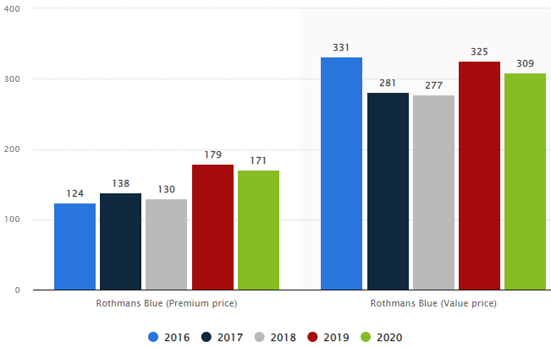
Source: Statista (2021)
Considering the history, product characteristics and market performance of Rothmans, it appears to be a quite relevant product for further analysis.

Task 2 – Demand determinants
The demand curve illustrates the market demand and slopes in a descending direction (fig. 1). It is a representation of all quantities that are wanted at a particular price level. The price level is plotted along the vertical axis, and quantity is plotted along the horizontal axis (Sloman et al., 2013). The trend in the other direction is consistent with logic given that higher prices are connected with fewer quantities being sought and vice versa (Sloman et al., 2013).

Figure 2 – Movement along the demand curve
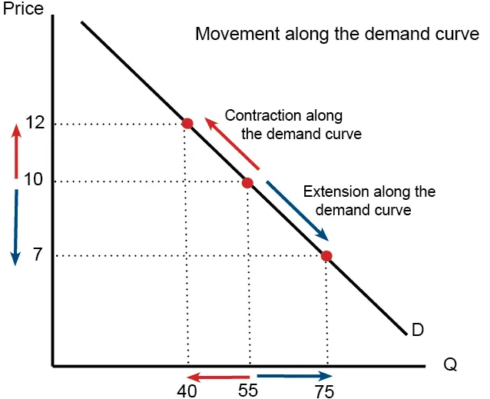
Source: Pettinger (2019)
The relationship between supply and demand is an important factor in determining both the market pricing and the total quantities produced. The point at which the supply and demand curves meet is known as the equilibrium point (Sloman and Jones, 2011). Market equilibrium also ensures the absence of market inefficiencies expressed through product shortages or excesses.

Figure 3 – Market equilibrium according to the supply-demand interaction
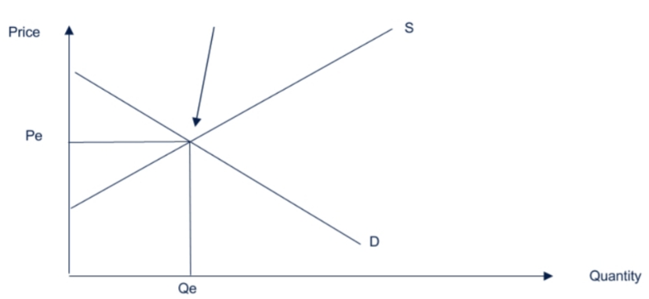
Source: Gillespie (2013)
The research attention hereafter is placed on understanding the determinants affecting the demand for Rothmans. To begin with, the price of substitutes should be understood, as changes in the prices of substitutes may largely determine the demand for Rothmans, as consumers could face alternative choices (Krugman and Wells, 2017). In general, cheaper substitutes mean a decreased demand for Rothmans and the vice versa – costly substitutes tend to stimulate the demand for the product under consideration (Krugman and Wells, 2017). Traditional cigarettes have several alternatives, such as electronic cigarettes, hand-rolling tobacco, heated tobacco products (IQOS), chewing tobacco, cigars, herbal smoking products and others. The duty rate of hand-rolling tobacco, which is a popular alternative of conventional cigarettes, is projected to increase at a rate of 4%-6% above the retail price index (RPI) inflation (UK Government, 2021). This is much higher than the RPI+2% used to as a benchmark for cigarette price adjustment (UK Government, 2021). Thus, the sharp increase in complimentary products’ prices could be considered as a demand booster for Rothmans
The second determinant refers to the price of compliments or products which are simultaneously used with cigarettes. Increases in the compliments’ prices have a negative effect on the considered product – Rothmans. And the opposite, cheaper compliments may be a factor for a higher consumer demand for cigarettes (Krugman and Wells, 2017). The process of smoking is typically simple and does not involve complimentary products except for matches and lighters. Considering the low and stable prices of matches and lighters (typically less than £1 per unit), their effect on the demand for Rothmans is quite insignificant from an economic point of view. In addition, coffee and alcohol may be considered as complimentary items; however, it is difficult to accurately quantify the price relationship with Rothmans.
The third factor under consideration is consumer income. Typically, higher income is seen as a factor for higher demand (Sloman and Jones, 2011). There are certain exclusions; however, especially in terms of Giffen goods. The demand for Giffen goods is adversely affected by income increase. Another specific case is also evidence in the case of luxury goods where demand tends to increase after surpassing a certain level of income (Krugman and Wells, 2017). For the purposes of the current analysis, Rothmans is considered as a normal good; hence, income increases should deliver higher demand, if the ceterus paribus condition holds (Krugman and Wells, 2017). The aggregate income level in the UK may be evaluated by considering the changes in the gross domestic product (GDP) per capita. As shown below, the pandemic led to unprecedented decrease of national GDP in 2020 (-10%); however, an economic recovery has taken place in the last two years (ONS, 2022). Thus, the income level has managed to almost restore its pre-pandemic peak value. The recent increase in the real per capita income is then seen as a positive demand factor in the case of Luck Strike.
Figure 4 – Per capita income in the UK
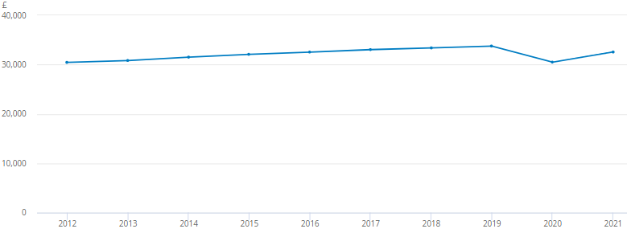
Source: ONS (2022)
Fourth, consumer tastes and preferences are also suggested to affect the demand for products (Krugman and Wells, 2017). In the UK, the share of people, who smoke, has experienced a consistent decline in the last decade (UK Government, 2019). The shrinking preferences for smoking have been explained by the increased health consciousness of UK consumers. The trend is expected to continue in foreseeable future, as only 5% of the UK population is expected to smoke by year 2030 (UK Government, 2019).
Figure 5 – Smoking prevalence in the UK
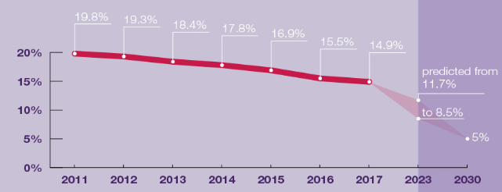
Source: UK Government (2019)
Nevertheless, consumer preferences may be quite changeable. For example, the demand for cigarettes increased by 0.5% in 2021 – the first instance of growth in many years (Hegarty, 2021). The reverse in consumer preferences may be explained by the temporary effect of the pandemic, which made more consumers seek for alternatives to cope with the mental issues and anxiety during the lockdowns, as well as the decrease in illicit cigarette trade during the lockdowns (Hegarty, 2021). In addition, data by ONS (2021) show a stagnant number of smokers in the UK (5.5-5.7 million users); hence, indicating the existence of a mature market. Considering this, future changes in consumer preferences should be carefully examined in order to more accurately assess demand.
Fifth, the role of expectations should be acknowledged, as well. Expectations for higher prices (inflation) may counter-intuitively lead to a spike in demand, at least in the short-term. This is the case, as consumers purchase more products in order to avoid paying the expected higher prices in the future (Sloman et al., 2013). The opposite relationship is also valid. Expectations for price declines may lead to a temporary decrease in demand regardless of the more affordable lower prices (Krugman and Wells, 2017). In this light, the management of expectations could be a key short-term demand determinant. In the UK, a tobacco duty escalator exists – a policy which automatically increases the price of cigarettes at a rate determined by the level of RPI + 2% (UK Government, 2021). Thus, tobacco prices are adjusted upward each autumn. The policy also leads to expectations among consumers who are more likely to purchase higher volumes prior to the enforcement of the projected price adjustment.
Last, but not the least, demographic trends also play a key role in demand determination. It should be pointed out that demographic trends tend to be slow and usually relate to long-term time horizons (Krugman and Wells, 2017). In the UK, the population increases at a rate of approximately 400,000-500,000 people each year (Focus Economics, 2022). The trend has been consistent in the last several years and there are no reasons to reverse any time soon due to positive migration and extended life expectancy. As a result, demographic dynamics suggest higher demand for smoking due to the larger population size, if all other factors are kept constant.
The information from figure 1 shows that 490,000 people in UK purchase the two most popular varieties of Rothmans (Statista, 2021). In terms of revenue, Rothmans is among the leading tobacco brand with annual sales of £241 million (van Gelder, 2022). A standard pack of Rothmans in UK costs £10.40 (Tesco, 2022). The price may fluctuate depending on the chosen retailer; however, Tesco has a dominant position in the market and its price should be indicative, especially considering the fact that consumers frequently purchase Rothmans from Tesco. As a result, the price per a cigarette is 52p, if assuming the existence of 20 cigarettes in a pack. In quantitative terms, demand is assessed, as follows:
Number of sold cigarettes = £241,000,000/£0.52 = 463,461,538 cigarettes.
Number of sold packages = £241,000,000/£10.40 = 23,173,077 packages.

Task 3 – Elasticity of demand
The degree to which demand is elastic can cause the demand curve to have a variety of slopes. The term "elasticity" refers to a measurement that analyses the links between changes in price and changes in quantity, respectively (Krugman and Wells, 2017). The demand curves with varying degrees of elasticity are shown in Figure 5. Inelastic demand is depicted by the curve D₁, which may be found in the diagram (Gillespie, 2013). The slope of the curve is high because there is a tendency for increases in price to lead to relatively minor drops in the amount that is demanded by consumers. In general, the demand curves for essential items tend to be quite steep, since it is difficult to find suitable substitutes for them. For instance, inelastic demand is observed with some basic types of foods. This is the situation due to the fact that customers are unable to replace the items and considerably reduce the purchased quantities (Gillespie, 2013).
Price adjustments leading to a disproportionally large drop in desired quantities is illustrated by the curve D₃, which exhibits the influence of elastic demand (Gillespie, 2013). Elastic demand is typically connected with things that are not essential for customers; hence, as prices increase, consumers have the ability to simply quit using or substitute these products with something else. For example, luxury goods tend to have elastic demand.
Figure 6 – Analysis of demand elasticity
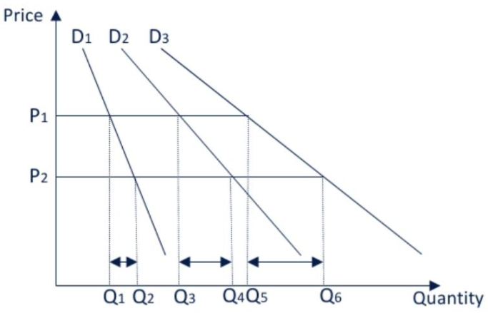
Source: Gillespie (2013)
The substitution effects could reveal more insights regarding the demand elasticity for Rothmans. Research findings by Reed et al. (2013) indicate the existence of relatively inelastic demand for tobacco products. More specifically, 1% increase in price leads to a reduction in sold quantities within the range of 0.35% - 0.78% depending on the particular type of tobacco product that is being taken into account (Reed et al., 2013). The proposed numbers are below 1 which indicates inelastic demand (Samuelson and Marks, 2010). As a result, the change in price is disproportionately large in relation to the reduction in quantity. This may be attributed to the fact that many individuals, who use tobacco, become addicted to the substance. As a result, it is quite difficult to promote positive behavioural changes through higher prices. The majority of consumers does not reduce or quit smoking irrespectively of spiking prices. Very few alternatives are also available to effectively replace the habit of smoking. When seen in this context, tobacco is seen as an indispensable item for smokers - necessity rather than luxury.
This is also reflected in the following chart showing the equilibrium price and quantity of Rothmans in the UK. At the current stage of development, the market price of £10.40 per pack corresponds with the sold quantities of 23,173,077 packs. The market is in equilibrium, since no shortages or excesses of Rothmans are observed. The demand curve remains fairly inelastic in alignment with the earlier findings by Reed et al. (2013). Hence, further price increases are likely to cause a disproportionally small decline in quantities sold.

Figure 7 – Supply, demand and equilibrium conditions for Rothmans in the UK (£, million)
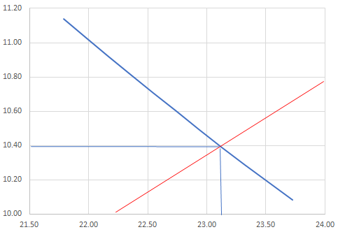
The income effect is also worth being explored in order to determine demand elasticity. The total expenditure for tobacco products in the UK is more than £19 billion per annum (Ash, 2017). This is a negligible amount in comparison to the total national income of more than $2.8 trillion (Focus Economics, 2022). On a per household basis, tobacco costs account for just 1.7% of all costs in a given year (Ash, 2017). This is considerable lower than the share of 3.3% in 1985 (Ash, 2017). Given the fact that the majority of the UK population does not smoke, the proposed numbers may underestimate the actual costs for smokers. Therefore, a more accurate assessment of the real costs could be made by taking into consideration the group of actual smokers only. It is estimated that a regular smoker in the UK typically consumes 11 cigarettes a day or the equivalent of approximately £1800 per year (Ash, 2017). As earlier discussed by ONS (2022), the per capita income is approximately £33,000 per annum (fig. 3). Respectively, a typical smoker in the UK spends 5.5% of the annual income for cigarettes or other tobacco-based products.
This number is quite indicative for the actual costs of smoking for smokers. The share of 5.5% of the total income leaves extra room for additional spending, if tobacco prices are potentially increased. If someone is addicted and cigarettes are seen as an essential product, it would be relatively easy to consider adjustments in the remaining 94.5% of income in order to cover the extra costs of smoking. In this light, accounting for a small share of the total income makes the demand curve more inelastic, as the majority of smokers could be willing to reduce other expenses in order to find extra room for the higher product prices. Hence, Rothmans and other smoking products are also considered as having inelastic demand on the basis of the analysis of the income effect.
Research findings provide some valuable insights regarding the most effective pricing policies. If BAT is a monopoly firm in the marketplace, it may start increasing product prices, as price increases are associated with a disproportionally lower decrease in the demanded quantities. The optimal price could be reached at a higher level where the demand elasticity is equal to 1. In real-life, Rothmans is just one of the many cigarette brands available to consumers. Therefore, Rothmans cannot be significantly more expensive than its competitors, as the monopolistic competition market structure prevents excessive prices due to the high number of firms. Thus, pricing strategies are more sensitive to the level of differentiation and brand value. Under this more realistic scenario, the development of exceptionally quality product, which is unmatched by competitors, could justify higher prices. In addition to all, tobacco products are largely affected by VAT and duties; hence, the price formation process is more complex and not solely dependent on firms, as the government also imposes high taxation. Therefore, finding the optimal pricing could be quite complex in practice due to the numerous factors under consideration and beyond the control of BAT.
To sum up, tobacco and cigarette products in particular appear to have quite inelastic demand on the basis of the substitution and income analysis. If demand elasticity is the only determinant, which should be considered, then Rothmans should be highly priced on the basis of the inelastic demand.

Reference list
Ash (2017) The economics of tobacco, [online] Available: https://ash.org.uk/wp-content/uploads/2019/10/Economics-of-Tobacco.pdf [Accessed: 23 July 2022]
BAT (2022) About Us, [online] Available: https://www.bat.com/group/sites/UK__9D9KCY.nsf/vwPagesWebLive/DO52AD6H [Accessed: 20 July 2022]
CNN Money (1999) Tobacco titans light a deal, [online] Available: https://money.cnn.com/1999/01/11/europe/bat/index.htm [Accessed: 5 September 2022]
Focus Economics (2022) UK Economic Forecast, [online] Available: https://www.focus-economics.com/countries/united-kingdom [Accessed: 23 July 2022]
Gillespie, A. (2013) Business Economics. 2nd edition, Oxford University Press
Hegarty, R. (2021) Tobacco 2021: sales of cigarettes rise for first time in seven years, [online] Available: https://www.thegrocer.co.uk/top-products/tobacco-2021-sales-of-cigarettes-rise-for-first-time-in-seven-years/662874.article [Accessed: 5 September 2022]
Krugman, P. and Wells, R. (2017) Essentials of Economics. 4th edition, New York Worth Publishers, Macmillan Learning
Let’s Look Again (LLA) (2019) King-sized: A history of Rothmans of Pall Mall, [online] Available: http://letslookagain.com/tag/rothmans-cigarettes-history/ [Accessed: 5 September 2022]
Office for National Statistics (ONS) (2021) Smoking prevalence in the UK and the impact of data collection changes: 2020, [online] Available: https://www.ons.gov.uk/peoplepopulationandcommunity/healthandsocialcare/drugusealcoholandsmoking/bulletins/smokingprevalenceintheukandtheimpactofdatacollectionchanges/2020#:~:text=In%20Quarter%201%202020%2C%2013.5,(around%204.9%20million%20people [Accessed: 5 September 2022]
ONS (2022) Gross domestic product (Average) per head, CVM market prices: SA, [online] Available: https://www.ons.gov.uk/economy/grossdomesticproductgdp/timeseries/ihxw/pn2 [Accessed: 23 July 2022]
Pettinger, T. (2019a) Shift in Demand and Movement along Demand Curve, [online] Available: https://www.economicshelp.org/blog/581/economics/changes-in-demand/ [Accessed: 23 July 2022]
Reed, H., Arnott, D. and Langley, T. (2013) The price elasticity of demand for cigarettes in the UK, 2001-2011: Tessa Langley, European Journal of Public Health, Vol. 23, Issue 1, https://doi.org/10.1093/eurpub/ckt123.012
Reuters (2022) British American Tobacco PLC, [online] Available: https://www.reuters.com/markets/companies/BATS.L/ [Accessed: 20 July 2022]
Samuelson, W. and Marks, S. (2010) Managerial Economics, Study Guide. London: John Wiley & Sons
Sloman, J. and Jones, E. (2011) Economics and the Business Environment. Edinburgh, Prentice Hall
Sloman, J., Hinde, K. and Garrat, D. (2013) Economics for Business. Harlow: Pearson
Statista (2021) Leading cigarette brands of Rothmans in Great Britain 2016-2020, by number of users, [online] Available: https://www.statista.com/statistics/307768/cigarette-brands-of-rothmans-in-the-uk/ [Accessed: 5 September 2022]
Tesco (2022) Rothmans King Size Blue 20 Pack, [online] Available: https://www.tesco.com/groceries/en-GB/products/295797843 [Accessed: 5 September 2022]
UK Government (2019) Guidance: Health matters: stopping smoking – what works? [online] Available: https://www.gov.uk/government/publications/health-matters-stopping-smoking-what-works/health-matters-stopping-smoking-what-works [Accessed: 22 July 2022]
UK Government (2021) Policy paper: Changes to tobacco duty rates, [online] Available: https://www.gov.uk/government/publications/changes-to-tobacco-duty-rates/changes-to-tobacco-duty-rates#general-description-of-the-measure [Accessed: 23 July 2022]
van Gelder, K. (2022) Leading cigarette brands in c-stores and independent grocers in the UK in 2021, [online] Available: https://www.statista.com/statistics/1190767/leading-cigarette-brands-in-c-store-and-independent-grocers-uk/ [Accessed: 5 September 2022]

