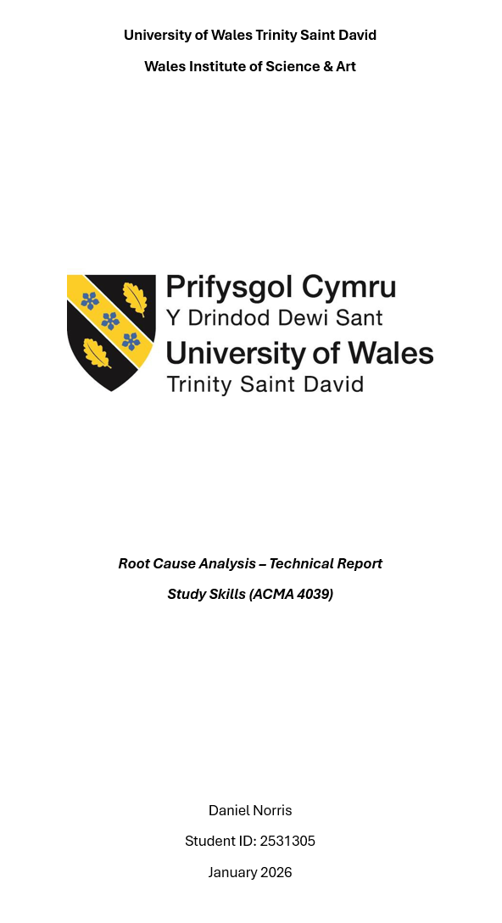

Abstract
This report outlines how risk management is used in manufacturing to improve safety, quality and compliance, with a focus on root cause analysis and evaluating its effectiveness. This was done by conducting an RCA using 5 Why’s and an FMEA. This suggested that the RCA was effective and improved safety and reduced the number of defective products, however, is limited in being a reactive resource.

Table of Contents
Abstract 2
1. Introduction 5
2. Risk Management in Manufacturing 6
2.1 Introduction to risk management 6
2.2 Risk management in manufacturing 6
2.3 Studies found emphasising importance 7
3. Legal and Ethical Considerations 8
3.1 Health and Safety at Work etc. Act 1974 8
3.2 Management of Health and Safety at Work Regulations 1999 8
3.3 IMechE 8
4. Tools for Risk Management 9
5. RCA 10
6. Conclusion 13
Reference list 14

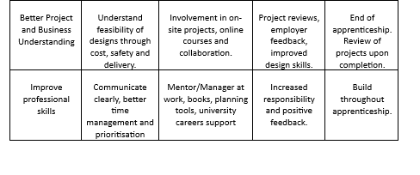
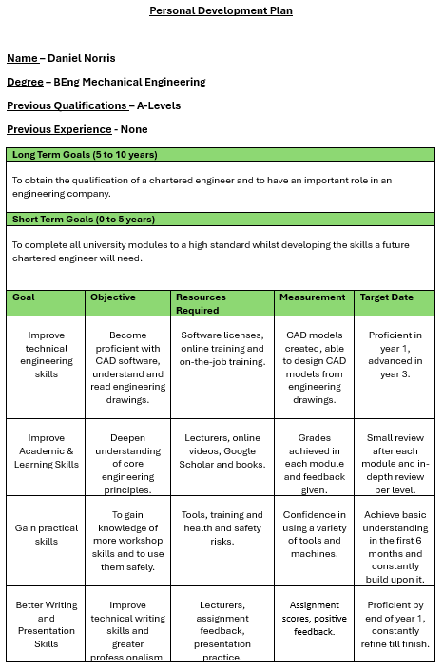

Introduction
In the manufacturing sector, risk management is paramount to engineers. Understanding risk management is simple and this report will outline the key factors which govern and enforce sound engineering practices. Risk management is crucial for engineers, as the decisions made have a direct effect on the safety of employees and users. This report will explain the methods available to manage and eliminate risk, such as conducting an RCA, the intent of this is to investigate how it can be used and how effective it is at resolving the risks found.

Risk Management in Manufacturing

2.1 Introduction to risk management
Risk management is the process of identifying, analysing, and managing both overall risk and individual risk events to ensure success and minimise threats to manufacturing. (Association for Project Management, 2025) However, risk management is more than a concept, it contains principles and a universally applicable framework which can be followed by any business function. This is provided by ISO 31000, the international standard for risk management. (ISO, 2018) This is inherently important to all manufacturing processes due to the high-risk nature of complex processes, mechanical components, strict regulatory standards, and excessive cost of failure. The main feature of risk management in engineering is that it focuses on proactive measures rather than reactive ones.

2.2 Risk management in manufacturing
Manufacturing contains many different elements to consider the risks of, from health and safety, process risks, supply chain risks to quality risks, all of which with varying levels of risk and consequences. Some consequences found from poor risk management can include workplace injuries, product defects, and significant financial losses. These factors have an adverse effect on the business financially and potentially legally yet can be managed and avoided by introducing risk management systems. The outcomes of implementing risk management can reduce accidents and injuries, lower downtime and waste, improve quality and consistency, increased efficiency, and provide the company with legal and regulatory compliance.

2.3 Studies found emphasising importance
A lack of risk management is a big contributor to accidents and flaws within manufacturing. One example of this was found in the Toyota Unintended Acceleration Issue. In 2009 to 2011, cars unexpectedly accelerated and were unable to stop due to issues with the throttle pedal and floor mats (Honaker, 2020). Reports made by the first victims were quickly dismissed by Toyota, suggesting it was user error. Toyota quickly defended themselves suggesting it was not their responsibility, however as more reports came in, they began to investigate the issue and announced nationwide recalls (U.S. Department of Transportation, 2019). Toyota acted reactively to the situation rather than proactively, which led to poor risk management. As a result, they paid $1.2 billion to avoid criminal charges for the lack of transparency with regards to the safety issues they found (ABC News, 2014). In the UK, situations like this are more unlikely due to strict legislations which ensure the products given to the market are safe including the Road Vehicles (Approval) Regulations 2009 and General Product Safety Regulations 2005, these legislations ensure that risk is managed and (Legislation.gov.uk, 2013; GOV.UK, 2023).

Legal and Ethical Considerations

3.1 Health and Safety at Work etc. Act 1974
Risk management is also supported by the Health and Safety at Work etc Act 1974. This legislation outlines the duty of every employer to their employees’ health, safety, and welfare at work (Legislation.gov.uk, 1974). This legislation makes risk management critical within manufacturing, as it requires employers to implement safety measures to control the risk within that environment to protect them from breaching the legislation. The consequences of not following this act can be tremendous, one example of this was found when Cleveland Bridge UK Ltd was fined £1.5 million after an electrician fell to his death due to a lack of maintenance and risk assessments (Singleton, 2022). Alongside other factors, this led to the administration of the business in July 2021 where the business closed for good with debts of over £20 million (BBC, 2021).
3.2 Management of Health and Safety at Work Regulations 1999
Another law which requires the employers to protect the employees is the Management of Health and Safety at Work Regulations 1999, this states that the minimum an employer must do is.
- Identify what hazards can be found within the business.
- Decide the likelihood and the severity of the hazard.
- Take action to remove the hazard or control the risk posed.
(Health and Safety Executive, 2022). This structure is like the decision-making model known as the OODA Loop, which allows engineers to adapt quickly to potential health and safety risks found within the business, and reduce the time of unmanaged risks due to the quick cycles.
3.3 IMechE
The Institute of Mechanical Engineering code of conduct withholds four core principles:
- Practice competency and maintain up-to-date knowledge and skills
- Act with integrity and respect for others
- Promote sustainability
- Exercise engineering leadership.
(Institution of Mechanical Engineers, 2023). Collectively, these principles ensure that risks are managed, as the safety of users and employees are prioritised over any commercial or financial benefit.

Tools for Risk Management
There is an array of methods used to manage risk, the main one focused on this report is a Root Cause Analysis (RCA). RCA is the process of identifying the true cause of a problem to improve manufacturing operations (e Oliveira, Miguéis and Borges, 2022). The benefit to this is that by identifying the source of the problem, changes can be made to remove the systematic issues found and therefore increase efficiency. This links to the IMechE Code of Conduct as more efficient operations lead to less waste, which in turn is more sustainable.
To conduct a thorough RCA, there are multiple ways to analyse the causes of manufacturing imperfections. One way to conduct an RCA is by using 5 Why’s, this is a technique used to identify the root cause by asking ‘Why?’ 5 times to get to an issue which can be acted upon (NHS England, 2015).
Another method often used is Fishbone Diagram, this is used by identifying the different causes of a problem by identifying what steps are taken in each category. The categories considered are Manpower, Machinery, Materials, Method, Measurement and Nature (ASQ, 2024).
A common technique used to manage risk is a risk assessment. A risk assessment is the process of identifying and overcoming hazards by implementing measures to control the risk they pose (UNISON, 2015).
FMEA is the structure used for the RCA in this report. Failure Modes and Effects Analysis give engineers the opportunity to consider what could go wrong, how badly it could go wrong, and what can be done to avoid and mitigate these events (Moultrie, 2024).

RCA
When conducting the RCA, the following steps were taken. Initially, the issue was identified and described, from this, the effects and causes are analysed. Finally, corrective actions are taken and are monitored to ensure the problem does not reoccur.
The 5 Why’s technique was used to find the root cause. This was completed first as it is less time consuming than a Fishbone Diagram, this led to the following questions being asked:
Why are there non-conforming part? – because the assembly is flawed
Why is the assembly flawed? – because some components do not meet the tolerance
Why are components outside the tolerance? – because sub-assembly made a mistake
Why did sub-assembly make a mistake? – because they are using tools incorrectly
Why are they using tools incorrectly? – because of a lack of training or damaged tooling
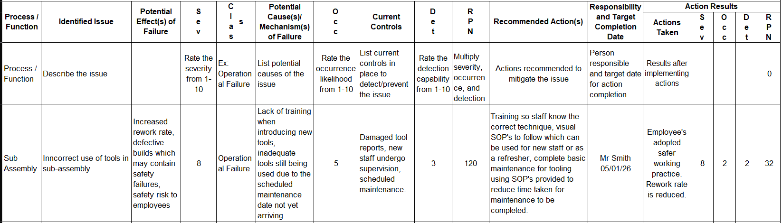
From this the root cause was swiftly identified. In this report, the RCA conducted was done using a FMEA structure, which allocates rankings to 3 categories which is then used to calculate the RPN (risk priority number), this indicates how urgent the issue needs to be resolved, the higher the more severe.
Figure 1 – ‘RCA conducted using FMEA’

Severity:
Severity was given a value of 8 as it poses health and safety concerns. In addition to this, incorrectly using the tools often leads to imperfections in the components, therefore leading to a greater number of non-conforming products, which need reworking.
Occurrence:
Occurrence was given a score of 5 as not all tools were found to be inadequate, this meant that only jobs completed with the faulty tools were likely to be insufficient in quality. Moreover, many employees understood how the tools may negatively impact the work and knew how to mitigate any imperfections.
Detection:
Detection was scored at 3 due to tools often displaying their faults visibly. This meant that they were avoided, however in some circumstances the faults were only noticed once used, this often led to flaws inconsistent with the rest of the part.
RPN:
Once the RPN was calculated it came to a score of 120. Considering the manufacturing environment, this was a low score. In turn, the urgency to get the actions in place weren’t as significant as other RCA’s conducted in the business. However, due to the high severity of the issue it was still conducted.
Examples of tools misused
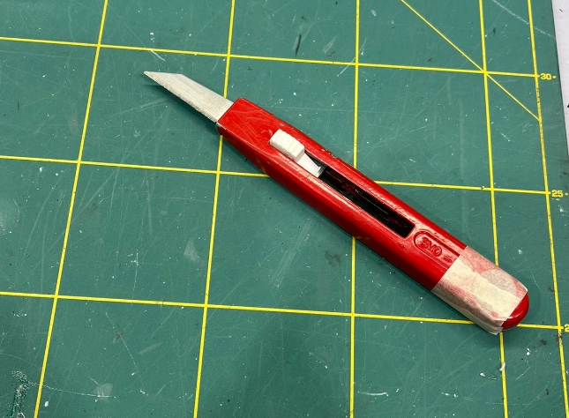

Figure 2 – Cutting knife held together with masking tape

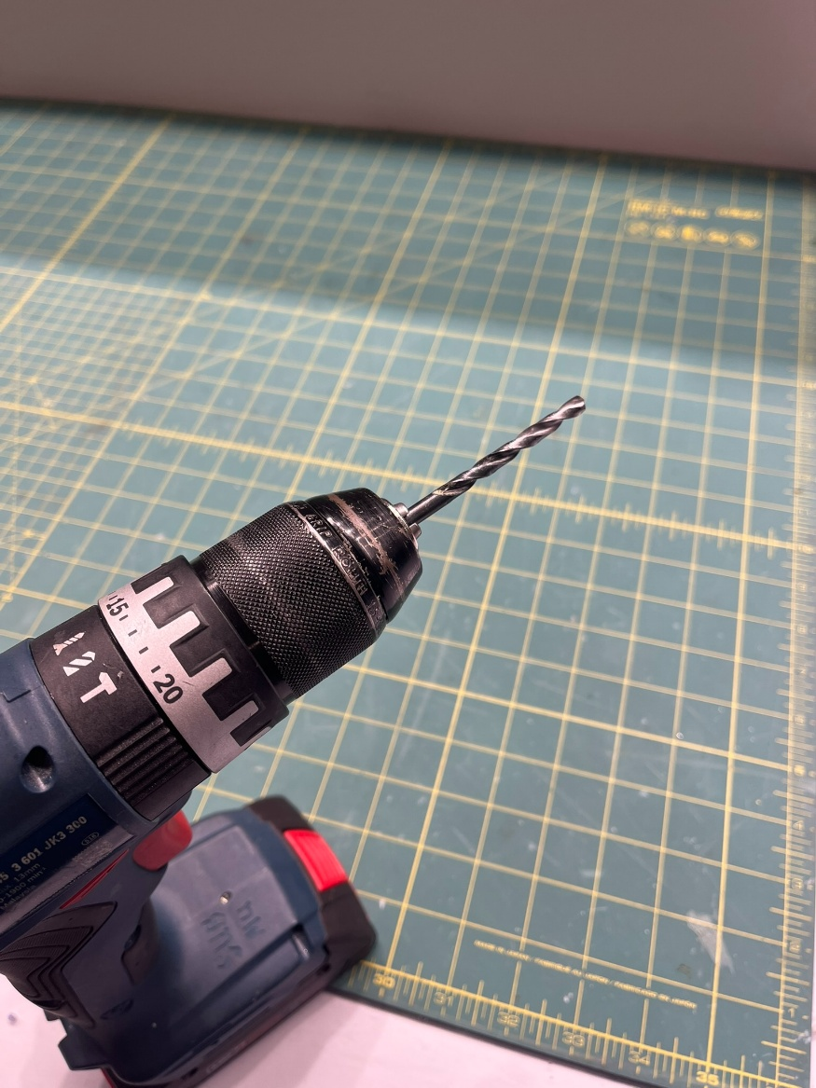
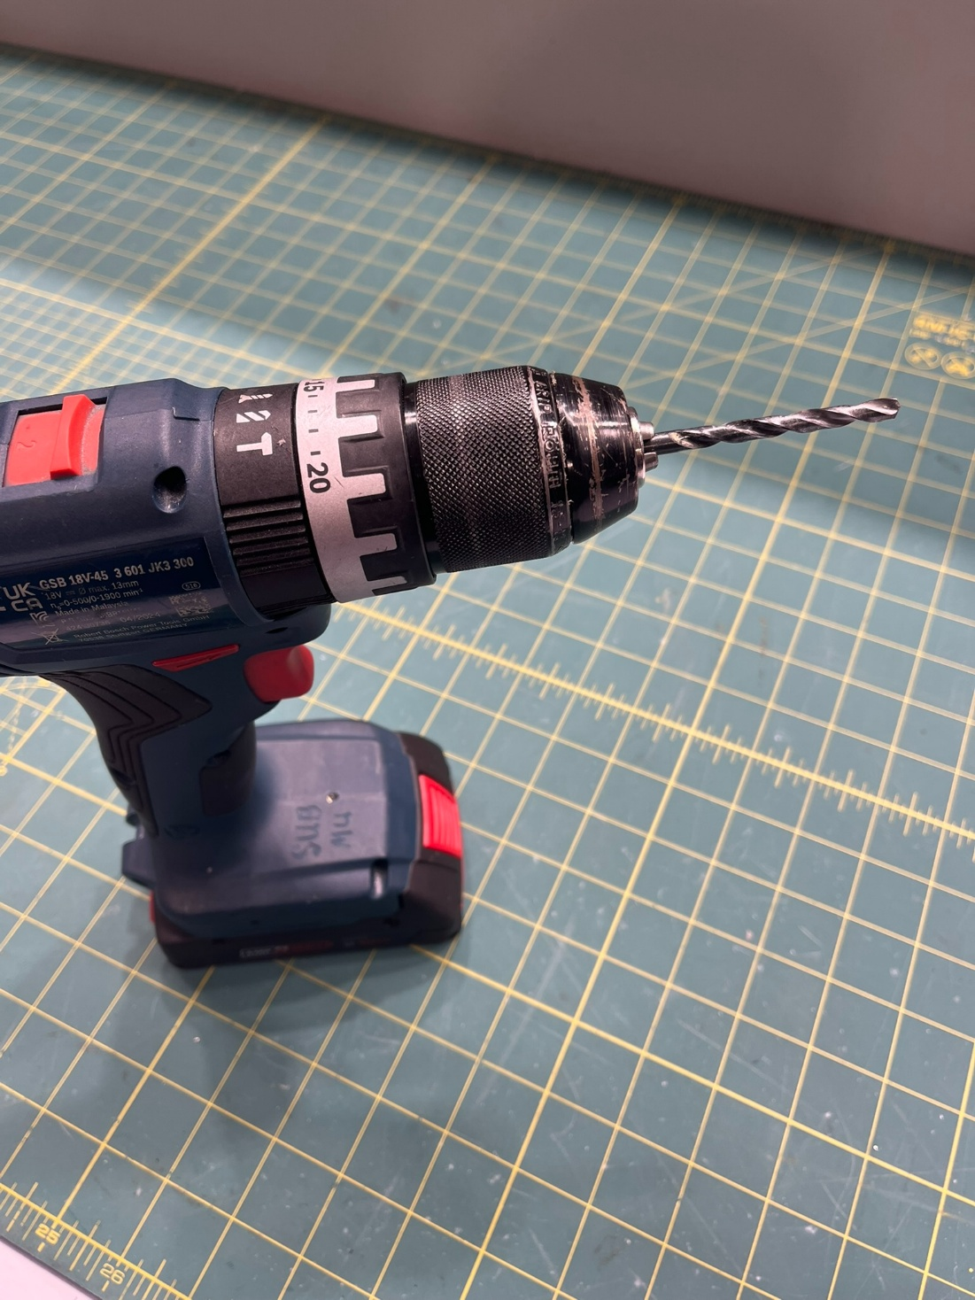
Figure 3 – Drill bit fitted in drill a) left – before training b) right – after training

Corrective Actions:
To reduce the occurrence and detection rate, staff undertook training to ensure they understood how to use each tool properly. SOPs were also created so employee’s had documents which would visibly showcase what proper procedure looks like. These actions ensured that tools were no longer used incorrectly. Furthermore, tools report sheets were created so employees could report missing/damaged tools which would affect their work.
Residual Risk:
Despite the corrective actions implemented, the risk with malfunctioning equipment remains high, due to the health and safety risks associated. However, it could be argued that with proper maintenance, procedure and PPE, all of which have been provided, the likelihood of tools causing this harm is mitigated, although for this report the severity of harm will remain high until proven it can be sustained over a longer period.

Conclusion
As shown in Figure 3, the training proved effective as staff are now using the tools correctly. In addition, the report sheets have been very effective at identifying which tools need attention, the frequency of these reports suggest that some tools, such as pneumatic rivet guns, may need more frequent maintenance than originally appointed.
In conclusion, using RCA for mitigating risk is crucial. However, RCA is a reactive tool whereas risk management should be proactive, combining proactive risk management and RCA is key. This is valuable as it adds improvements in costs, quality, and more importantly to engineers, safety. Although, despite its usefulness in conducting the RCA, most importantly the findings from the RCA must be analysed thoroughly and appropriate actions must be taken to manage the risk it poses.

Reference list
ABC News (2014) Toyota to Pay $1.2B for Hiding Deadly ‘Unintended Acceleration’, ABC News. ABC News. Available at: https://abcnews.go.com/Blotter/toyota-pay-12b-hiding-deadly-unintended-acceleration/story?id=22972214 (Accessed: 19 January 2026).
ASQ (2024) What Is a Fishbone diagram? Ishikawa Cause & Effect Diagram, ASQ. Available at: https://asq.org/quality-resources/fishbone (Accessed: 21 January 2026).
Association for Project Management (2025) What Is Risk management?, www.apm.org.uk. APM. Available at: https://www.apm.org.uk/resources/what-is-project-management/what-is-risk-management/ (Accessed: 13 January 2026).
BBC (2021) ‘Cleveland Bridge: Covid and Political Coup Caused firm’s Failure’, BBC News, 15 September. Available at: https://www.bbc.co.uk/news/uk-england-tees-58570630 (Accessed: 15 January 2026).
e Oliveira, E., Miguéis, V.L. and Borges, J.L. (2022) ‘Automatic root cause analysis in manufacturing: an overview & conceptualization’, Journal of Intelligent Manufacturing, 34(5), pp. 2061–2078. Available at: https://doi.org/10.1007/s10845-022-01914-3.
GOV.UK (2023) General Product Safety Regulations 2005: Great Britain, GOV.UK. Available at: https://www.gov.uk/government/publications/general-product-safety-regulations-2005/general-product-safety-regulations-2005-great-britain (Accessed: 19 January 2026).
GRMI (2025) The Boeing 737 MAX: A Case Study, GRMI. Available at: https://grm.institute/blog/the-boeing-737-max-a-case-study/ (Accessed: 15 January 2026).
Health and Safety Executive (2022) Managing Risks and Risk Assessment at Work, Health and Safety Executive. Available at: https://www.hse.gov.uk/simple-health-safety/risk/index.htm (Accessed: 15 January 2026).
Honaker, B. (2020) What Caused the Toyota Acceleration Problem?, Top Class Actions. Available at: https://topclassactions.com/lawsuit-settlements/consumer-products/auto-news/what-caused-the-toyota-acceleration-problem/ (Accessed: 16 January 2026).
Institution of Mechanical Engineers (2023) Code of Conduct explained - IMechE, www.imeche.org. Available at: https://www.imeche.org/about-us/imeche-governance/governance-and-finance-reviews/code-of-conduct-explained (Accessed: 21 January 2026).
ISO (2018) ISO 31000:2018 Risk management — Guidelines, ISO. Available at: https://www.iso.org/standard/65694.html (Accessed: 13 January 2026).
Legislation.gov.uk (1974) Health and Safety at Work etc. Act 1974, www.legislation.gov.uk. Available at: https://www.legislation.gov.uk/ukpga/1974/37/part/I/crossheading/general-duties (Accessed: 14 January 2026).
Legislation.gov.uk (2013) The Road Vehicles (Approval) Regulations 2009, Legislation.gov.uk. Available at: https://www.legislation.gov.uk/uksi/2009/717/made (Accessed: 19 January 2026).
Moultrie, J. (2024) FMEA (Failure Modes and Effects Analysis), www.ifm.eng.cam.ac.uk. Available at: https://www.ifm.eng.cam.ac.uk/research/dmg/tools-and-techniques/fmea-failure-modes-and-effects-analysis/ (Accessed: 22 January 2026).
NHS England (2015) Five Whys, NHS England. Available at: https://www.england.nhs.uk/improvement-hub/wp-content/uploads/sites/44/2015/08/learning-handbook-five-whys.pdf (Accessed: 21 January 2026).
Singleton, A. (2022) Construction Company Fined £1.5million following Death of Employee, Oakwood Solicitors. Available at: https://www.oakwoodsolicitors.co.uk/news/construction-company-fined-1-5million-following-death-of-employee/ (Accessed: 15 January 2026).
U.S. Department of Transportation (2019) U.S. Department of Transportation releases results from NHTSA-NASA study of unintended acceleration in Toyota vehicles, www.transportation.gov. Available at: https://www.transportation.gov/briefing-room/us-department-transportation-releases-results-nhtsa-nasa-study-unintended-acceleration (Accessed: 19 January 2026).
UNISON (2015) RISK ASSESSMENT, UNISON National. Available at: https://www.unison.org.uk/get-help/knowledge/health-and-safety/risk-assessment/ (Accessed: 21 January 2026).

