VISUAL STUDIES 1/LEVEL 4
M4X01602
SOLO
PROFESSOR SUE WILLIAMS
sue.williams@uwtsd.ac.uk
"Our life is half natural and half technical. Half-and-half is good. You cannot deny that high-tech is progress. We need it for jobs. Yet if you make only high-tech, you make war. So we must have a strong human element to keep modesty and natural life."
Nam June Paik

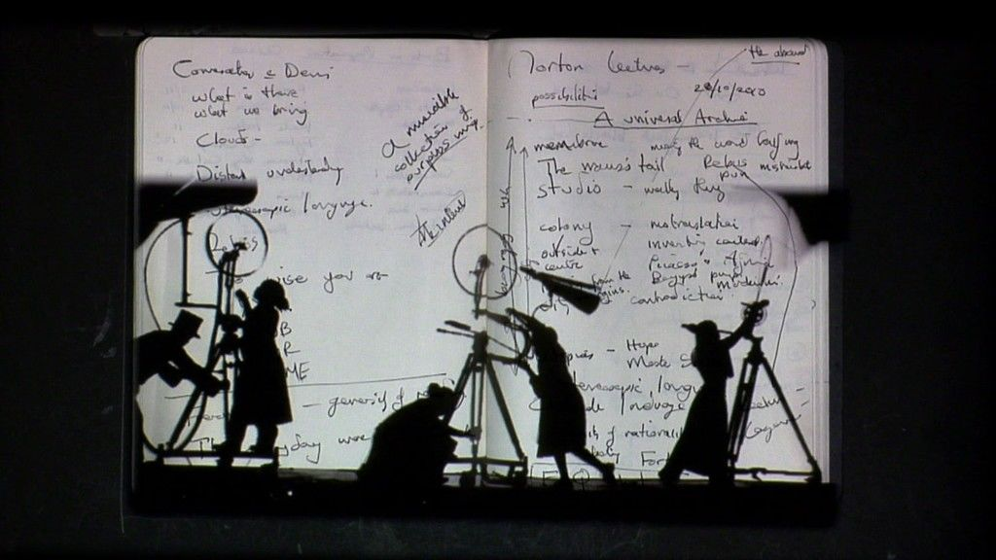
WILLIAM KENTRIDGE

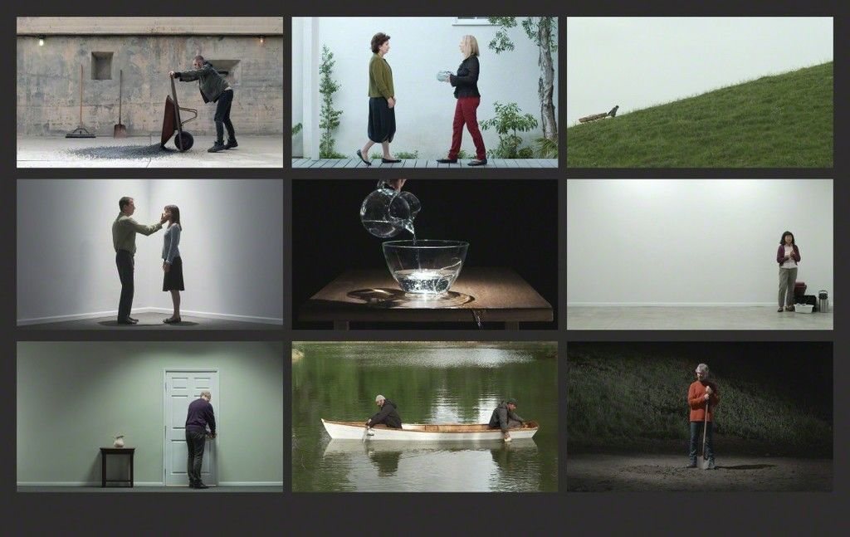
BILL VIOLA

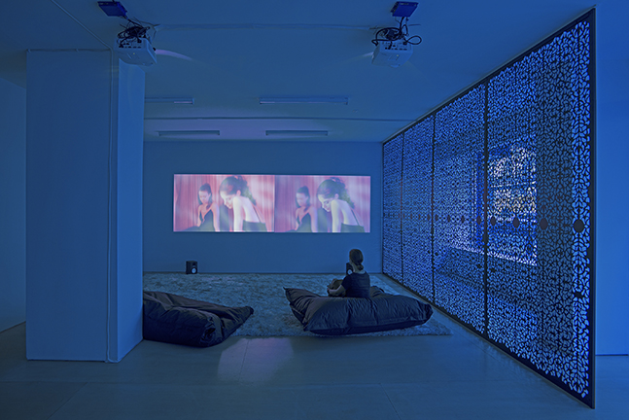
SUE DE BEER

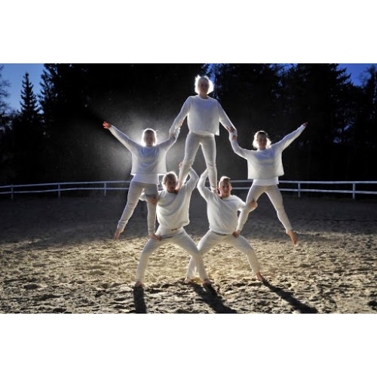
EIJA-LIISA AHTILA

Research the above video artists and consider their work in more detail. Also take a look at a couple of other video artists.

