

BMSW5105
Workplace Culture and its impact on Organisational Efficiency

Student name: IONUT DINU
Student ID:1812392
Lecturer Name: Janet Green
Executive Summary:
This report consists of the organizational culture and structure of a specific organization which is Coca Cola. Coca Cola is one of the famous brands in the world. The organizational culture is different from other organizations. This particular report discusses the organization itself and the organizational structure like- SWOT and PESTEL analysis. SWOT analysis of Coca Cola will help to gather knowledge about the organization's key strengths, weaknesses, opportunities along with their key threats which are a combination of both internal and external factors. PESTEL analysis will help to guide the report about what issues impact the business and its efficiency.

Table of Contents:
Executive Summary: 2
1.0 Introduction: 3
1.1 Background 5
3.0 SWOT Analysis 10
4.0 PESTLE Analysis 14
5.0 Conclusion 18
References: 19
Appendix 21

1.0 Introduction:
Coca Cola is one of the US multinational organization which is currently renowned over the world and it is doing business globally. Coca Cola is known for its non-alcoholic beverage syrup throughout the whole world. Coca Cola is famous in almost every country in the world and it is one of the most famous beverages in the world. This multinational organization’s product was invented by one pharmacist named John Stith Pemberton in 1886. In 1886 the famous beverage formula was sold to another person who is Asa Griggs Candler and later he is the one who incorporated this famous formula into the product in 1892 and named The Coca Cola Company in Atlanta. Coca Cola produces a large number of plastic by 3 million tons of plastics packaging in one year and among them, 110 billion are plastic bottles. Coca Cola uses carbonated water, corn syrup, caramel colour, phosphoric acid, natural flavours, and caffeine as their raw materials.
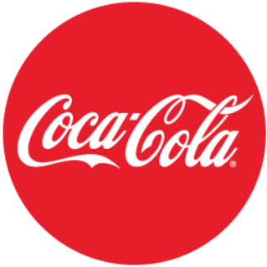
Figure 01: Coca Cola logo (Home, 2020).
From 1889 this highly famous company is distributing its franchise to other organizations to expand their business organizations globally and to increase their business into other countries. The company is based in Atlanta, Georgia but the operations are operated from Delaware. Coca Cola produces a large number of their syrups in each year. In NYSE and DJIA Coca Cola has listed for their stocks. Coca Cola Company is diverse in terms of their employees as they have more than 700,000 employees all over the world along with bottling partners. Coca Cola produces 2800 plus products over 200 countries. Coca Cola's largest component in its business is carbonated drinks as in 2008 the organization sold 78% volume of carbonated drinks. Coca Cola’s smart objectives are like- focusing on eco-friendly production process, increase sustainability, diversify their portfolio and keep customers demand fulfilled and to increase their revenue from 6% to 8% by 2020. Coca Cola beliefs are integrated with some core values like- honesty, integrity, quality, respect, responsibility, accountability and diversibility. Coca Cola has strong beliefs about their leadership style and they follow their leadership very effectively. In the organization the leaders control all of their work and monitor their employees effectively. In terms of following their leadership style the organization follows autocratic leadership style in which the leaders provide the rules and the employees follow them efficiently. The leaders are the main decision maker of the organization. Leadership style is strictly followed in the organization and effectively used in Coca Cola.

1.1 Background
In an organization, the word culture means a lot as it helps to build the business environment along with other things to develop in the business organization. Organizations need culture in the business to support their business organization and to support their structure and strategy. Many organizations fail due to lack of organizational culture and if any organization has a widely strong culture there are mainly three important things that can be happed. One of the employees is aware of the fact that how their top management wants them to react in any situation (Koulouri, 2019). Second, the expected reaction is proper in terms of the situations and lastly, the employees are well aware that their reaction will be rewarded in terms of organizational values.
In terms of building a proper organizational culture, the human resource team plays a vital role in this part as the human resources work with employees and they provide training, organizing to their employees. The selection of providing employees to raise human resources helps to build a proper organizational culture in any specific organization like- Coca Cola. Organizational culture is mainly the beliefs and values along with behaving with others to provide a unique and comfortable environment (Koulouri, 2019). It also consists of the organization's expectations, philosophy, and values which can guide the employees in terms of interacting with the outside world. Organizational culture is mainly based on the cultural beliefs, norms, and customers which are believed to be valid in the organizational environment. Organizational culture also consists of organizational mission, vision, norms, values, structures, systems, and others.
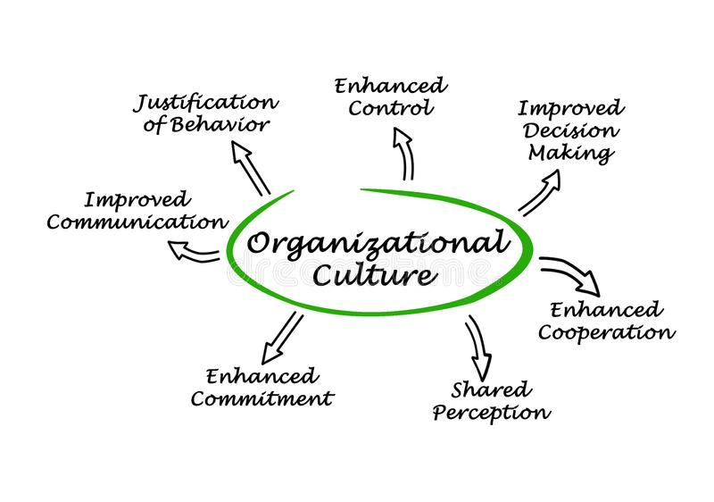
Figure 02: Organizational culture (Organizational Culture Stock Illustrations – 260 Organizational Culture Stock Illustrations, Vectors & Clipart - Dreamstime, 2020).
In organizations how the employees work and behave also is important in organizational culture. Many organization uses different structure to follow the organizational culture strongly. Organizational culture helps to define the system which is followed in the organization and how the system impacts the business environment. It also shows how organizational culture impacts the employee’s behavior in the business organization. It also impacts the employees react and interact with subordinated and their managers and other stakeholders. Again organizational culture provides a brief discussion on the employee's influence on the organizational environment.
In terms of coca cola organizational culture, this organization uses mission driven culture in their organization. This brand’s organization culture reflect the inspiring mind, optimism in the workplace which helps to focus on their mission. Coca Cola’s multi visionary structure in the organizational culture helps them to increase their success. In the organization coca Cola uses demotratic leadership style to expand their business more.
In organizational culture, there can be many drawbacks which can cause issues in the process and those challenges can be difficult to handle and many organizations like- Coca-cola, Pepsi, Google have their own organizational culture but they face difficulties in terms of handling those issues regarding organizational culture (Lange, 2010). For a better understanding of the difficulties some problems regarding organizational culture are provided below:
Difficulties:
Maintaining proper culture in the organization
Maintaining a healthy culture in the organization is difficult and it is one of the major challenges in terms of organizational culture challenges. Sometimes employees cause this type of problem in the organization for example- if any employee faceless satisfactory raise than another employee the behavior might change in the employee and it will impact the rest of the organization. It is not only associated with increasing raise but also other issues can get between this. So maintain a proper culture in the organization is difficult as not every employee thinks and behaves the same.
Reinforcement
In organizational culture, there must be some kind of representative of the company. So for that reason values, ethics, norms, and environment also put an impact on the organizational culture. If any organization's mission and vision are constantly changing it is hard for the employees to keep up with the organization. If the vision and mission are constantly changing of any particular organization motivating the employees will be a tough job to do (Lange, 2010). Changing organizational culture can be cured but constant reinforcement causes damage to the organization.
Gathering all employees together
In any organization, teamwork is highly appreciated and many organizations prefer teamwork for their organization. Many organizations also specifically hire team workers so that the environment is fair enough. Involving all team members in a task helps to gather better results but involving all the members is difficult to handle. Many employees feel demotivated in terms of teamwork. Even some employees are not teamwork as they feel comfortable working alone rather than work with a bunch of people in the organization.
Communication gap
Sometimes in terms of maintaining a proper organizational culture organization faces difficulty like maintaining a proper communication with their employees. In many organizations the structure is the employees will report information to their managers and managers will pass the information toward the top managers. The front line employees do not get the chance to pass information toward the top managers which increases the communication gap in the organizational aspect (Maguire, 2003). Same issues can happen to different way like- the top manager provide a decision to the mid-level managers and the mid-level managers provide the information to the front line employee and in this process, information can get changed which can cause lots of difficulties in the organizational culture.
Recommendations
After discussing the difficulties there are also some recommendations for the organization like- Coca Cola. The recommendations are provided below for better understanding:
Hire employees according to the organizational needs
In terms of hiring many organizations look for employees who are suitable for the position and they mainly focus on the position's duty. But sometimes candidates who are good at their job may not be good for the organizational environment. Those might not effectively handle the organizational culture in the organization. In many cases, it can be seen that good employees create more difficult situations in the organization. For this reason, the leader must ensure to hire the best candidate for the position as well as for the organization. Because in an organization maintaining the culture is important so before hiring employees checking candidates’ backgrounds and understanding the organizational environment is very much needed.
Increasing volunteer initiatives in the organization
For a leader, it is important to develop interaction between the co-workers so that the organizational environment gets improved and an effective organizational culture gets maintained (Maguire, 2003). In many organizations like- Coca Cola, Google leaders motivate the employees to get themselves involve in volunteer works so that their employees are motived enough to help their co-workers in the business organization. Increasing the volunteer work will ensure building relationships between the employees and create a bond in the organization.
Motivating the employees for their accomplishments
Every employee in the organization wants to feel important and for that, they need some motivation from their leaders. In the employee's zeal, around 55% of the employees think recognition in the workplace is very important. Leaders must recognize the employee’s hard work by motivating them and increasing their motivation in the workplace. By that way leaders can create a better environment and the employees will be motivated also. There are many ways to motivate employees in the workplace. Some of the organization prefer incentives and some organizations think employee’s recognition can increase the motivation level. But to effectively understand the employee's motivational level leaders must understand what the employee needs. Some employees feel motivated after praising them and some feel incentives increase their motivational level. So the leaders of the organizations must identify and understand that effectively.
Emphasize on work/life balance
In any organization, the workload can hamper the employee’s motivation and sometimes an intensive amount of workload causes a lack of motivation in the organization. In this growing economy, every organization wants to achieve its target and fulfill its vision into reality and for that reason, employees need to work hard in the organization. Many employees sometimes face issues regarding balancing their work and life. So for a leader, it is important to check and monitor every employee’s work and life balance (Senior and Swailes, 2010). Leaders must create a healthy and flexible environment for the employees and create an emphasis on the employee's work or life balance. Without proper balance, the organizational culture will get hampered the most.
Building a relationship among the co-workers
In the workplace, many employees get along and it creates a good environment for the employees to work in. organizational culture support relationship in the workplace so that one employee can help other employees in the time when they need which increases the motivation for teamwork. In the organization teamwork is must needed task. When an employee's relationship builds the environment gets friendly to work in. leaders must ensure to build relationships among the organizational employees so that it can increase the chances to improve the organizational environment and create good cultural practices inside the organization. In this case, leaders can assign employees together for creating a relationship between which will increase the chances to build relationships among the employees of the organization.
Focusing on employee strengths and weakness
Organizations are mainly run by their employees and management of the organization plays an influential part for the employees. In any organizational culture management or leaders are the first and foremost aspects who can create a good environment for the employees to work in. hiring the right leaders and identifying the employee’s strength is very important. Many organizations for example- Facebook, Google hire leaders who will find out the employee's key strengths in their respected fields and help them to increase their efficiency in their job (Senior and Swailes, 2010). Every leader must identify and understand one employee’s key strengths and weaknesses as this can increase an effective organizational environment. Employee’s strengths and weaknesses can cause an impact on the organizational culture as it is related to the organizational environment. Providing training and development programs can ensure employees' development in the organization and for that leaders must have a keen eye on the employees.

3.0 SWOT Analysis
SWOT-analysis helps to identify key strengths, weaknesses, and opportunities along with potential threats of a particular organization. This SWOT analysis, it reveals how Coca Cola is maintaining its brand's competitive advantage to become the second-largest beverage manufacturer in the world. SWOT-analysis helps to identify the main issues of their company and how those affect the company.
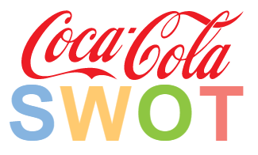
Figure 03: SWOT analysis of Coca Cola (Jurevicius, 2020).
Strengths of Coca Cola (Strategic Factors- Internal)
Strong brand equity and identity
One of the main strength of Coca Cola is they are popular among the people. This brand was created a unique identity among the people and it is one of the topmost selling product in the world along with this strength Coca Cola has established the highest brand equity. In 2011 Interbrand awarded Coca Cola the highest brand equity award (Interbrand's top 100 global brands 2011: Coca-Cola still top but Apple gaining fast, 2020).
Globally recognized brand
Coca-cola is sold in more than 200 plus countries and it serves 9 billion of its product per day. In the global business, the company Coca Cola has presented 500 plus new products like- Diet Coke, Coca-Cola Zero and so on. There are also variations in their products for example- they introduced Coca Cola Vanilla and Coca Cola Cherry.
Highest brand value with a loyal customer base
Coca Cola is considered one of the most emotionally connected brands in the US and the companies brand value high which is their key strength. Coca Cola has the greatest brand association among its customers and its customers are loyal to them also. Coca Cola customers find it difficult to have a substitute for Coca Cola products. Moreover, their customers cost them an increased amount of brand association.
Brand Valuation
As it has been stated that the Coca Cola company ranked 3rd in the Interbrand annual ranking. Coca Cola's brand value is estimated at about $57.3 billion according to Forbes magazine IN 2018. This brand reached to top 7 in the magazine with the largest brand valuation (Badenhausen, 2020).
Leading Market Share
In terms of the market share sector, Coca Cola is leading the beverage market industry for quite a long time. Coca Cola has an increased amount of market share in the market. In March 2019 the market capitalization was $194.156 billion (2020). The main growth of the company is its products like- Coke, Sprite, and Diet Coke and so on.
Enriched distribution network
Coca Cola has an enriched distribution network globally and it has one of the most efficient distribution channels. This company has almost 250 bottling partners globally (2020). Their distribution network is organized which gives them the privilege of being a strong brand globally.
Weaknesses of Coca-cola (Strategic Factor- Internal)
Intense competition with other brands
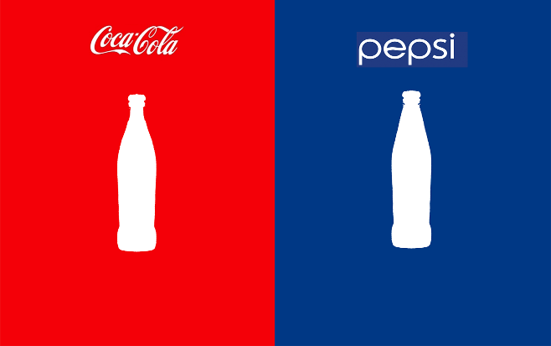
Figure 04: Coca Cola VS Pepsi (Marketing Strategies of Coca Cola and Pepsi: Which one is better? 2020).
Coca cola’s main competition is with Pepsi. Pepsi has been its competitor from the beginning and the aggressive and intense rivalry is Coca Cola's weakness. Pepsi Coca Cola could not be the market leader in the beverage market industry.
Lack of product diversification
Another issue that is their weakness is not having a diverse product range in the beverage industry. Again their most aggressive competitor Pepsi has launched a new product line in their company for example- Lays and Kurkure but Coca Cola is only working with drinks items in which they are lagging behind.
Unhealthy consumption
Their weakness is intact in their product like- Carbonate drinks are one of the major sources of sugar intake and Coca Cola produces carbonated drinks to their customers. By intensive consumption, there might be some health issues like- obesity and diabetes. The use of carbonate beverage is considered as controversial issues of the company.
Opportunities of Coca Cola (Strategic Factor- External)
Offer new product line
In terms of providing healthy food to its customers, Coca Cola has the opportunity to increase its food line and expand into healthy food options like its competitor Pepsi. They can expand into the new product like snack options besides carbonated drinks.
Expanding into developed countries
While expanding globally into the world Coca Cola can do research and expand more in the hot climate regions where the climate is more than another region like in the Middle East and African countries. By expanding geographically focusing on weather will increase their sales as in hot weather the demand for cold beverages is huge.
Provide advanced supply chain and logistics
Coca Cola’s supply chain is costlier than its production as its business is dependent on logistics and supply chain. The cost of transportation is huge in amount and the fuel price is always upward. For these reasons, Coca Cola should improve its distribution channel and come up with an advance system for this issue.
Threats of Coca Cola (Strategic Factor- External)
The controversy of water usage
In many regions, Coca Cola has been faced many problems along with criticism over its water management issues (Jurevicius, 2020). Many groups of people who are mainly social and environment concern groups have stated that Coca Cola has vast usage of water and they are straining water resources form various regions (Doshi, 2020). Again people alleged that they are using pesticides to clear contaminants.
Packaging controversy
Coca Cola faces another threat to their packaging. Forbes magazine enclosed that this organization produces 3 million tons of plastic bottles in their production and they have been criticized for their recycling sources (Farmbrough, 2020). Coca-Cola's yearly plastic creation adds up to about 108bn bottles a year, in excess of a fifth of the world's PET bottle yield of about 500bn bottle a year, as indicated by The Guardian.
Competition
Though Coca Cola has direct competition with Pepsi it also faces competition with Nescafe, Starbucks, Costa Coffee, Lipton, and others also. Competition in the business creates threats for them.

4.0 PESTLE Analysis
For organizations, PESTEL analysis helps to determine the factors which them in their activities and how much external and internal factor affect the business performances. PESTEL analysis helps to analyze the business in terms of entering into a new market. In every business organization, there are the impact of both internal and external environment and many organization faces some difficulties in terms of global business. In 2018 Coca Cola's revenue goes downward. The external forces cause issues in the current global market. In PESTEL analysis different external and internal forces impact are described below:
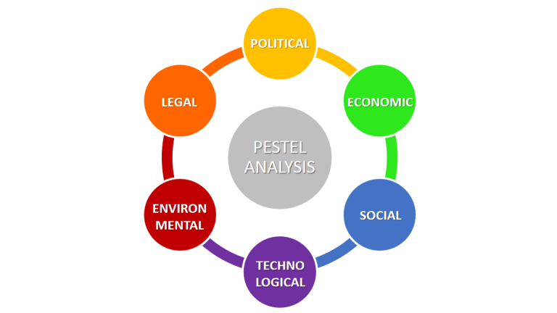
Figure 05: PESTEL analysis (PESTEL Analysis (PEST Analysis) EXPLAINED with EXAMPLES | Arbeit, 2020).
Political Factors
Government policies impact the business of Coca Cola about their sugar and caffeine consumption. In the sector of health, the government has applied laws regarding the disadvantage of carbonated drinks. For the laws the formula needed to be changed in many countries.
Taxes are another political force which impacts the Coca Cola. In the political factor, the tax increase is one of the major problems for Coca Cola. As the company needs to pay a huge amount of taxes in many countries.
Economic Factors
Economic factors impact the business of Coca Cola. For example- water consumption is one of the factors which is affecting this brand economically. In terms of water consumption, the brand needs to finance a huge amount of money to solve the crisis and they also need to identify if their water needs are fulfilled or not. Globally these brands face difficulties as many consumers see the product as the luxury item so the sales volume gets decreased.
The price of raw materials is another important economic factor. Nowadays the increasing pieces of the raw material are creating issues in the business. In this case, Coca Cola can shift its production to another region where it can find the raw materials at a cheap price.
Socio-Cultural Factors
The socio-cultural factor health factor puts much concern and it does affect the business like- Coca Cola as their product is emotionally connected to the consumers but the health issue regarding this drink is real. Nowadays many consumers are shifting their consumption toward energy drinks rather than carbonated drinks and the effect of consuming carbonated drinks for long is obesity and diabetes (Ybema, Yanow and Sabelis, 2011). As Coca Cola is not beneficial to health the consumers are switching to other healthier options.
In this crisis, Coca Cola launched a new product which is Coke Zero and it is consists of low calories. In many underdeveloped countries like- Middle Eastern countries they forbid the consumption of the product as they see the product as an American brand product. There are likewise social issues that are related to Coca Cola. Coca Cola despite everything seeks after creating markets in another region.
Technological Factors
In the recent social media, this brand has established its product very effectively. In the technological factor, social media advertising can be described as the brand as a huge following in social media and their advertisements are highly acceptable to the consumers. They are able to reach mass consumers through social media advertisements. For example- Coca Cola has followers on Facebook, Twitter-like- 108 million and 3.34 million.
Technology like artificial intelligence helps them to operate the data and other operational activities. Because of technological factors, Coca Cola is able to form various methods for its production and other operational activities. Through technological advancement, they are trying to reduce the water crisis problem.
Legal Factors
Laws and regulations are one of the major issues in terms of global business. Like Coca Cola, many other brands face difficulties in these issues. In different countries, the government imposes many laws and regulations in terms of sugar and caffeine usage for that reason the brand needs to customize its formula. Coca Cola needs to follow the rule as the government can take action regarding that issue.
Lately, Coca Cola has faced difficulties in the employee's practice. Many protest from labor unions the brand has faced due to their unfair payment and less standard environment. Those issues about the employees need to be taken care of effectively.
Environmental Factors
Environmental factor has affected the business as they are one of the largest consumers of fresh water. In many countries, Coca Cola has received backlash for using groundwater. For straining groundwater, the brand Coca Cola has faced difficulties in India. The brand needs to come up with an idea to reduce this w1ater crisis issue.
The different climate has been an effective way to benefit the company. In the humid climate, the company product has been biennial. So to gain success the productions can be made into other countries (Ybema, Yanow and Sabelis, 2011).Coca Cola’s one of the smart objective has to go eco-friendly production process. Coca Cola announced that they will recycle the plastic bottles which are used in their production process by 2025 and they also announced water replenishing goal to give back the extensive amount of water they use.

5.0 Conclusion
Organizational culture is the belief, norms, and culture which impact one employee’s behavior. Many organizations follow many kinds of organizational culture and define the impact of organizations. Culture not only creates an impact on the business and its efficiency. Other factors like- internal and external factors cause issues in the business and its structure. To have an effective workplace culture understanding internal and external factors of the business is very important. This report mainly concentrates on the internal, external factors along with strength, weakness, opportunities, and threats of Coca Cola.

References:
- Badenhausen, K., 2020. The World's Most Valuable Brands in 2018. [online] Forbes. Available at: <https://www.forbes.com/sites/kurtbadenhausen/2018/05/23/the-worlds-most-valuable-brands-2018/#aca2e45610c1> [Accessed 30 March 2020].
- Bstrategyhub.com. 2020. [online] Available at: <https://bstrategyhub.com/swot-analysis-of-coca-cola-2019-coca-cola-swot-analysis/> [Accessed 30 March 2020].
- Campaignlive.co.uk. 2020. Interbrand's Top 100 Global Brands 2011: Coca-Cola Still Top But Apple Gaining Fast. [online] Available at: <https://www.campaignlive.co.uk/article/interbrands-top-100-global-brands-2011-coca-cola-top-apple-gaining-fast/1096967?src_site=marketingmagazine> [Accessed 30 March 2020].
- Coca-cola.com. 2020. Home. [online] Available at: <https://www.coca-cola.com/> [Accessed 29 March 2020].
- Doshi, V., 2020. Indian Traders Boycott Coca-Cola For 'Straining Water Resources'. [online] the Guardian. Available at: <https://www.theguardian.com/world/2017/mar/01/indian-traders-boycott-coca-cola-for-straining-water-resources> [Accessed 31 March 2020].
- Farmbrough, H., 2020. Coca-Cola Reveals It Produces 3M Tonnes Of Plastic Packaging A Year In Ground-Breaking Report. [online] Forbes. Available at: <https://www.forbes.com/sites/heatherfarmbrough/2019/03/15/coca-cola-reveals-it-produces-3m-tonnes-of-plastic-packaging-a-year-in-ground-breaking-report/#313cb450670f> [Accessed 31 March 2020].
- Jurevicius, O., 2020. Coca Cola SWOT Analysis (6 Key Strengths In 2020). [online] SM Insight. Available at: <https://strategicmanagementinsight.com/swot-analyses/coca-cola-swot-analysis.html> [Accessed 30 March 2020].
- Medium. 2020. Marketing Strategies Of Coca Cola And Pepsi: Which One Is Better?. [online] Available at: <https://medium.com/@lucygevorgyan12/marketing-strategies-of-coca-cola-and-pepsi-which-one-is-better-34ab13f60e9b> [Accessed 30 March 2020].
- Organizational Culture Stock Illustrations – 260 Organizational Culture Stock Illustrations, Vectors & Clipart - Dreamstime. 2020. Organizational Culture Stock Illustrations – 260 Organizational Culture Stock Illustrations, Vectors & Clipart - Dreamstime. [online] Available at: <https://www.dreamstime.com/illustration/organizational-culture.html> [Accessed 30 March 2020].
- Pinterest. 2020. PESTEL Analysis (PEST Analysis) EXPLAINED With EXAMPLES | Arbeit. [online] Available at: <https://www.pinterest.com/pin/750553094123976352/> [Accessed 30 March 2020].
- Koulouri, A., 2019. Organizational Culture in Healthcare Services: Characteristics, Advantages and Disadvantages. Hellenic Journal of Nursing Science, 12(1), pp.5-12.
- Lange, J., 2010. Human Resource Management In Indonesia. Hamburg: Diplomica Verlag.
- Maguire, E., 2003. Organizational Structure In American Police Agencies. Albany: State University of New York Press.
- Senior, B. and Swailes, S., 2010. Organizational Change. Harlow: Financial Times Prentice Hall.
- Ybema, S., Yanow, D. and Sabelis, I., 2011. Organizational Culture. Cheltenham, UK: Edward Elgar Pub.

Appendix
PESTLE | Impact on Culture | Impact on Performance
Political | Due to political factor change in the formula for some specific region. | Raise taxes creating impact over the overall business performance.
Economic | The high amount of water consumption is causing a problem for the overall population. | The increasing price of raw materials is causing financial problems for Coca Cola's production.
Social | Energy drinks are taking place over carbonated drinks due to health concerns. | For being an American product in the Middle east people are not encouraged to consume the product.
Technological | Because of social media, people know about the product and connecting with the brand more. | Technologies are helping to make strategies for the water consumption issue.
Legal | Employees' payment rate of the brand impact the culture. | Laws regarding caffeine and sugar usage must be met in the production process.
Environmental | Using groundwater causing the problem in the culture and impacting the rest of them for usage. | Switching into another region where the material is cheap can help to increase their production.

