Student: | Charles Gill | Student ID No: | 0250767
Programme: | BSc/HND Computing (All Streams) | Module: | Internet Technology and Security
Lecturer: | Kemi Ademoye | Module code: | ACCA4018
Assignment Title: | HTML & CSS Web Development | Submission: | 23rd July 2019

HTML & CSS Web Development

Contents
Section 1. Introduction 1
1.1 Overview 1
1.2 Definitions 2
Section 2. Requirements 3
2.1 What is the purpose of the Website. 3
2.2 How it should be presented. 3
2.3 Accessibility considerations. 3
2.4 Responsiveness considerations. 3
Section 3. Implementation 3
Section 4. Evaluation 3
Section 5. References 4

Introduction

Overview
This report contains the language, structures and concepts of website design and coding that were outlined through the course of 6 lectures.
- The Hyper Text Mark-up Language (HTML) was introduced as the basis for coding websites. It is not a programming language, it is a text encoded mark-up language.
- Cascading Style Sheets (CSS) provide a structure for assigning attributes to sections of a website’s layout.
- Bootstrap is a CSS framework providing front-end website solutions.
- Accessibility has to be factored into the design of any website, as everyone should have access.
- Responsiveness is discussed as the numbers of different devices that access websites increases, each with their own constraints.
Utilising the above technologies, and adhering to principles of good website design, a website was built that was designed by myself. The report includes the considerations that were taken during this process.

Definitions

CSS | Cascading Style Sheets is a style sheet language used for describing the presentation of a document written in a mark-up language like HTML. [2]
HTML | Hyper Text Mark-up Language, is the standard markup language for documents designed to be displayed in a web browser. [1]
URL | Uniform Resource Locator

Requirements

What is the purpose of the website.
The website is to provide a number of walks within Wales. The walks will be rated by difficulty with a brief outline of the walk displayed. When a walk is selected, a map of the walk and any particular details of the route will be provided. Some actual photos from the walk will be displayed on this page.

How it should be presented.
The initial page should be laid out in the following manner:
A title bar displayed at the top, providing easy links to the various sections of the site.
The main body will include two ways to access walking routes.
- One will be via areas
  - This section of the website will ultimately become more interactive over time, with searches being provided for length, difficulty, area, height as various options that can be used by the user to select a trail to follow. By designing the layout with that in mind the website will retain a familiar feel over time as it progresses and will remain familiar to regular users.
- The other will provide a list of routes unfiltered but with photographs alongside the routes. This ultimately will become unwieldly as the number of routes increases. However, again this section would probably change over time to something akin to a gallery where users can post their photos from walks.
The footer will contain links to the top of the page and plain text links to the different parts of the website.
The above is required to meet the requirements of all good websites that they are accessible and navigation between all sections can be made with minimal user intervention (eg: two mouse clicks to any part).

Accessibility considerations.
Accessibility is defined within Wikipedia as
“Web accessibility is the inclusive practice of ensuring there are no barriers that prevent interaction with, or access to, websites on the World Wide Web by people with disabilities. When sites are correctly designed, developed and edited, generally all users have equal access to information and functionality.” [3]
The website, and all sections should be available to all. Part of this inclusivity is accomplished by utilising design aspects such as alt-text, contrast and headings for images and text on the site providing an easy to navigate layout.
If, ultimately videos and user pictures could be uploaded, everyone with sight would be able to experience the walks also, which would increase the user base of the site. It would be likely to use a video hosting service such as Youtube to hold the videos.

Responsiveness considerations.
The responsiveness of a site is brought about by good design, and utilising features of HTML, CSS and Javascript. These tools allow website layouts that are able to adapt to the size and other constraints of the myriad of devices that can access and display websites. Not only is it the devices that can affect the layout but different browsers can also affect the way that a website looks and is accessed.
To overcome these issues several methods have been utilised, as described below:
Mobile applications – provide a dedicated experience as a mobile app utilising specific capabilities pf a device. However, these require an app developer and a considerable amount of marketing to increase the user base. [4, p. 12]
Adaptive design – build multiple versions of a website, and use server-side detection to present custom code for that device or viewport. (Viewport being the user’s visible area of a web page). However, this requires complicated server-side detection code and multiple sites have to be maintained. [4, p. 12]
The most recent development in this area sees the introduction of responsive design. This type of design means that one site on one domain can be built. The site responds to a user’s viewport by utilising a meta viewport tag and media queries to alter the design as the page gets smaller. However, the big challenge with this type of design is finding the balance between the content for both desktop and mobile due to the vast difference in viewport sizes. [4, p. 12]

Implementation

Screenshots
Index.html:
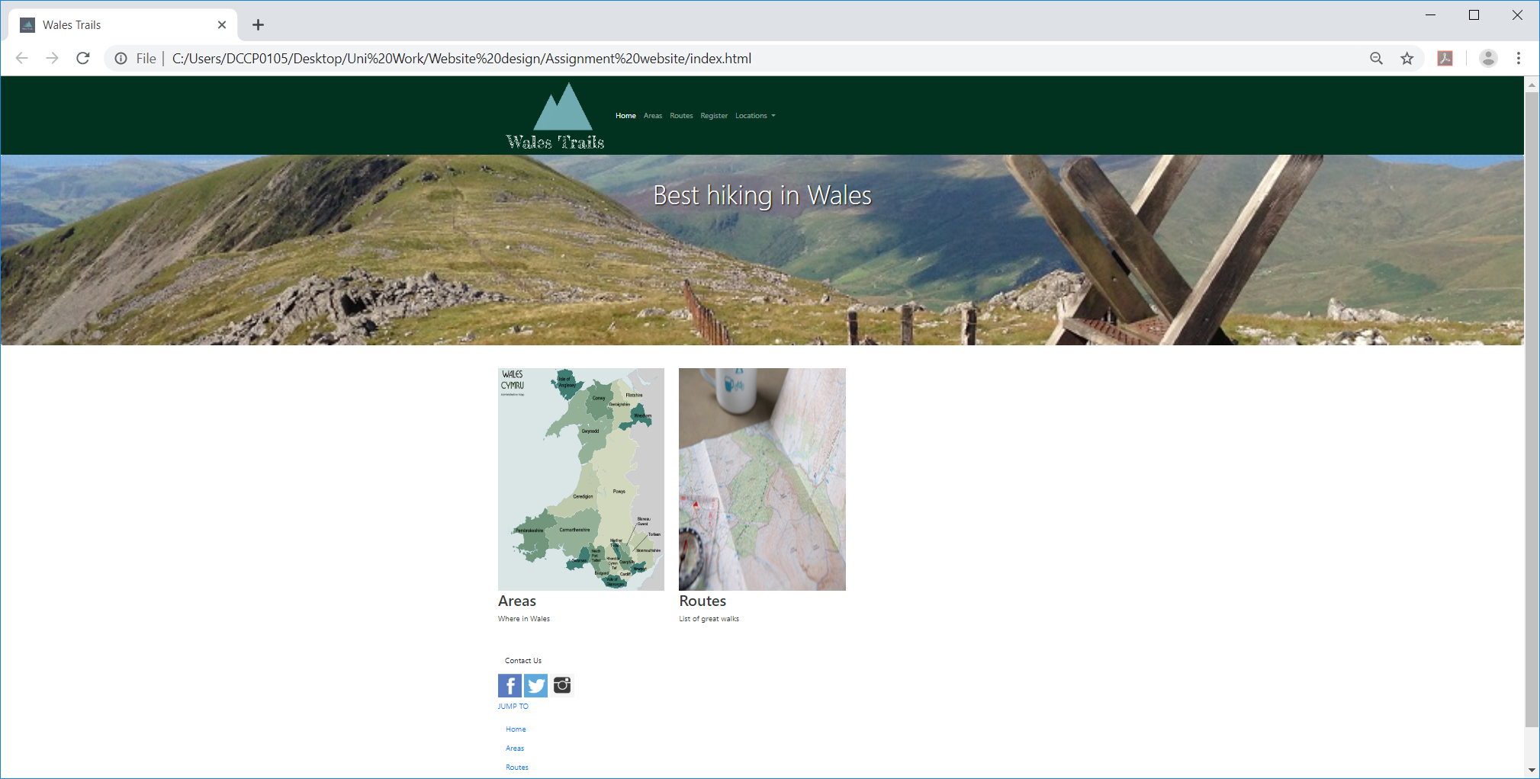

Areas.html
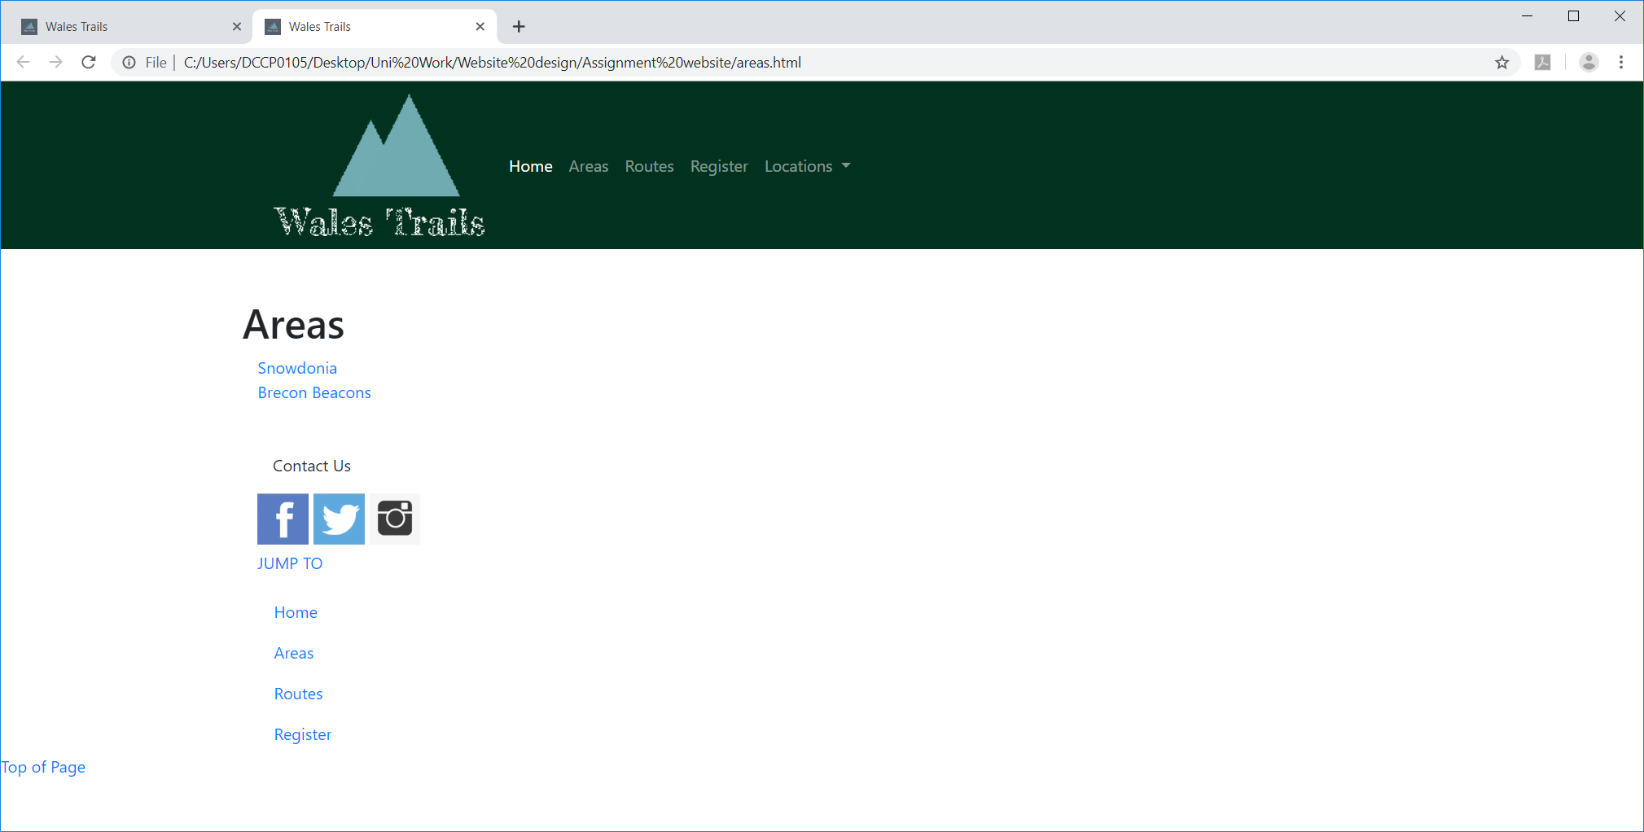
Routes
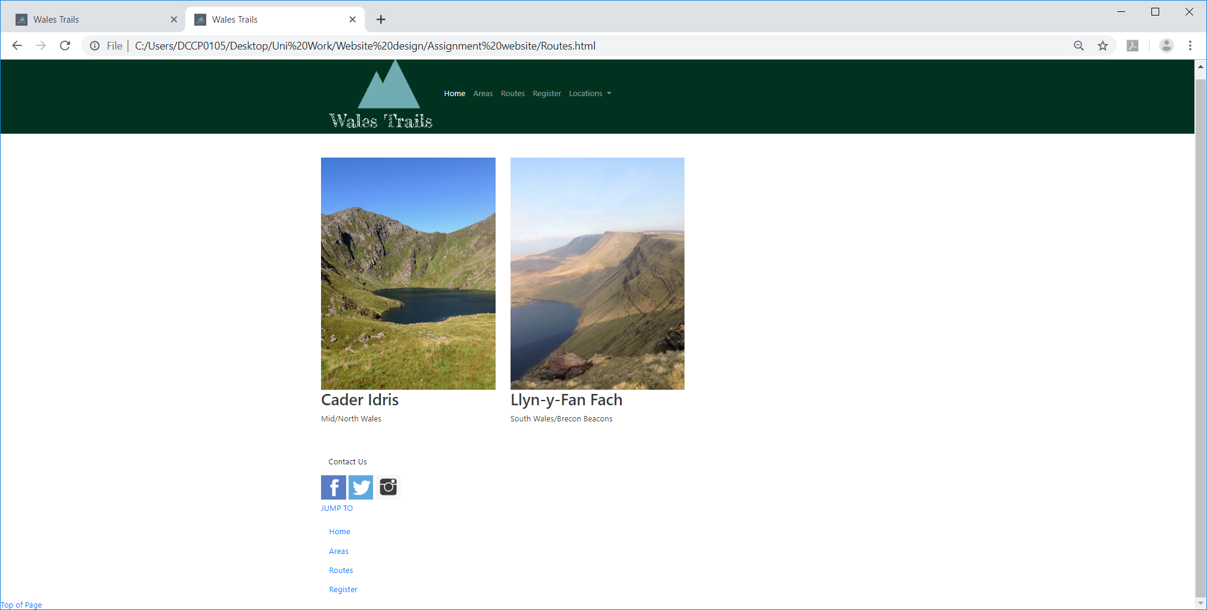

Cader.html
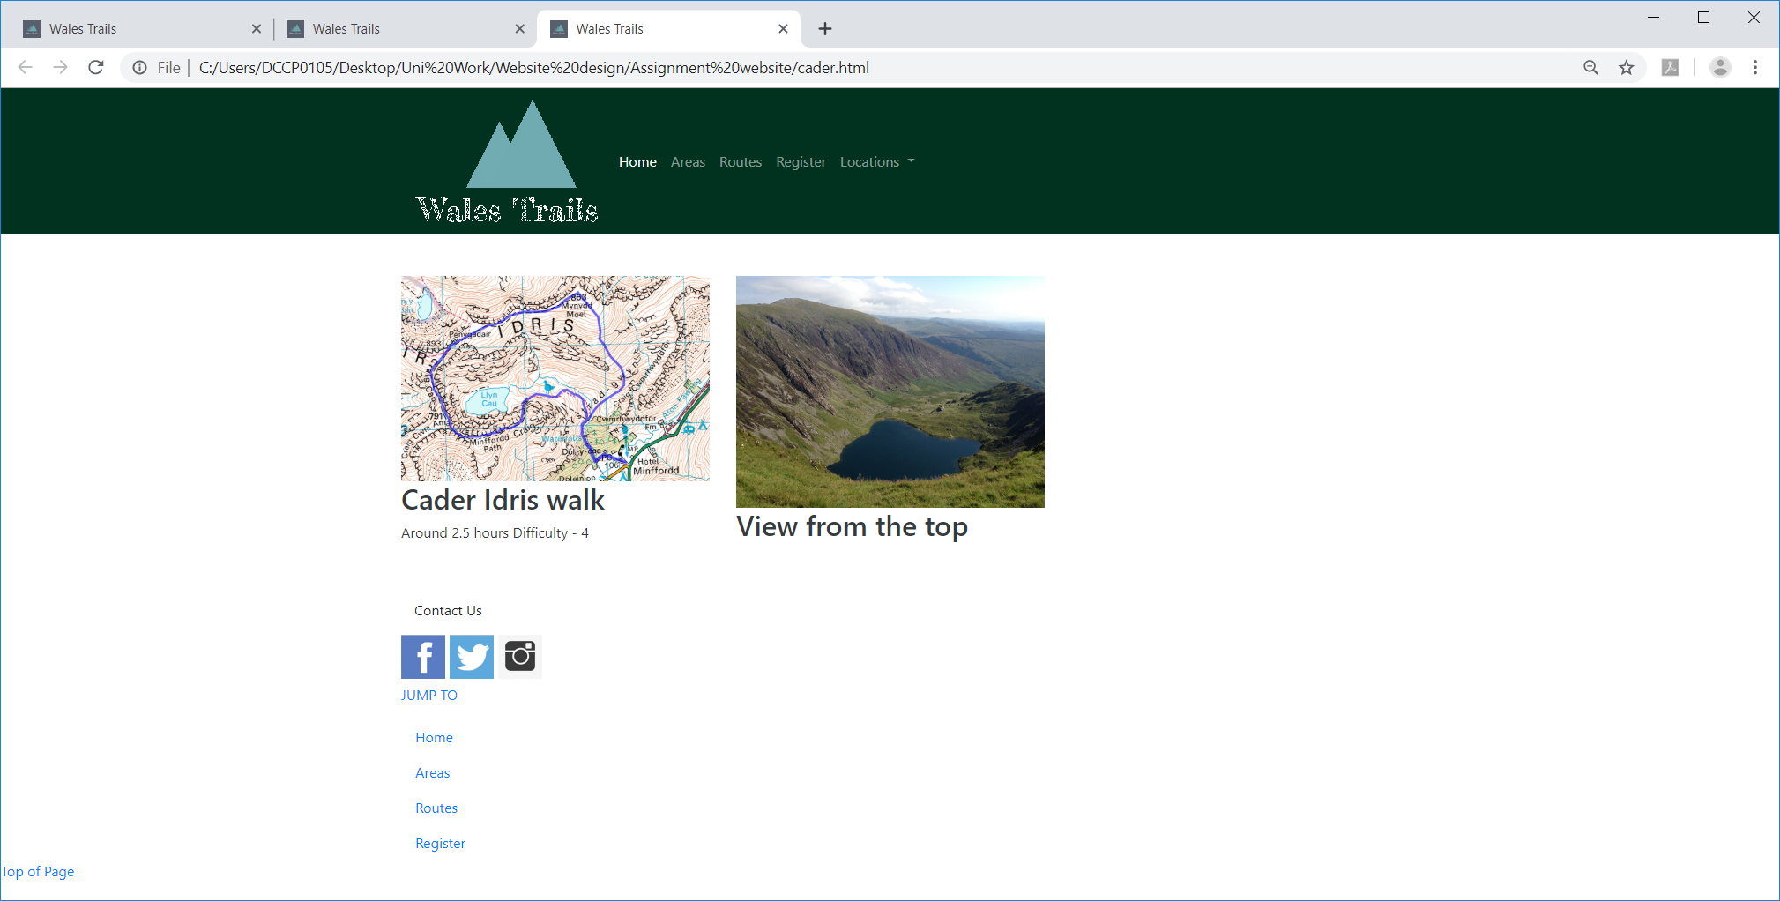
Llyn-y-fan.html
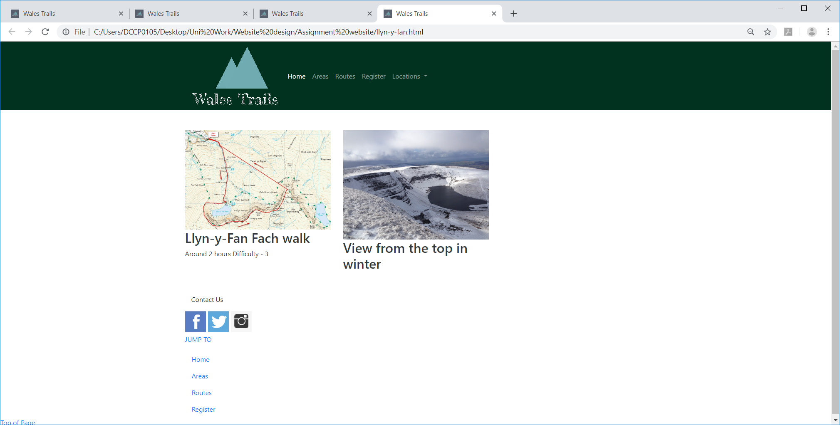

Register.html
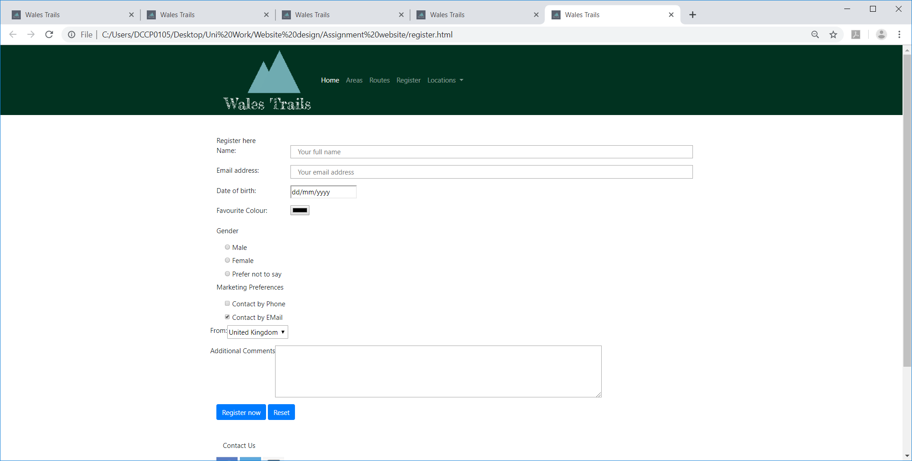
Confirmation.html
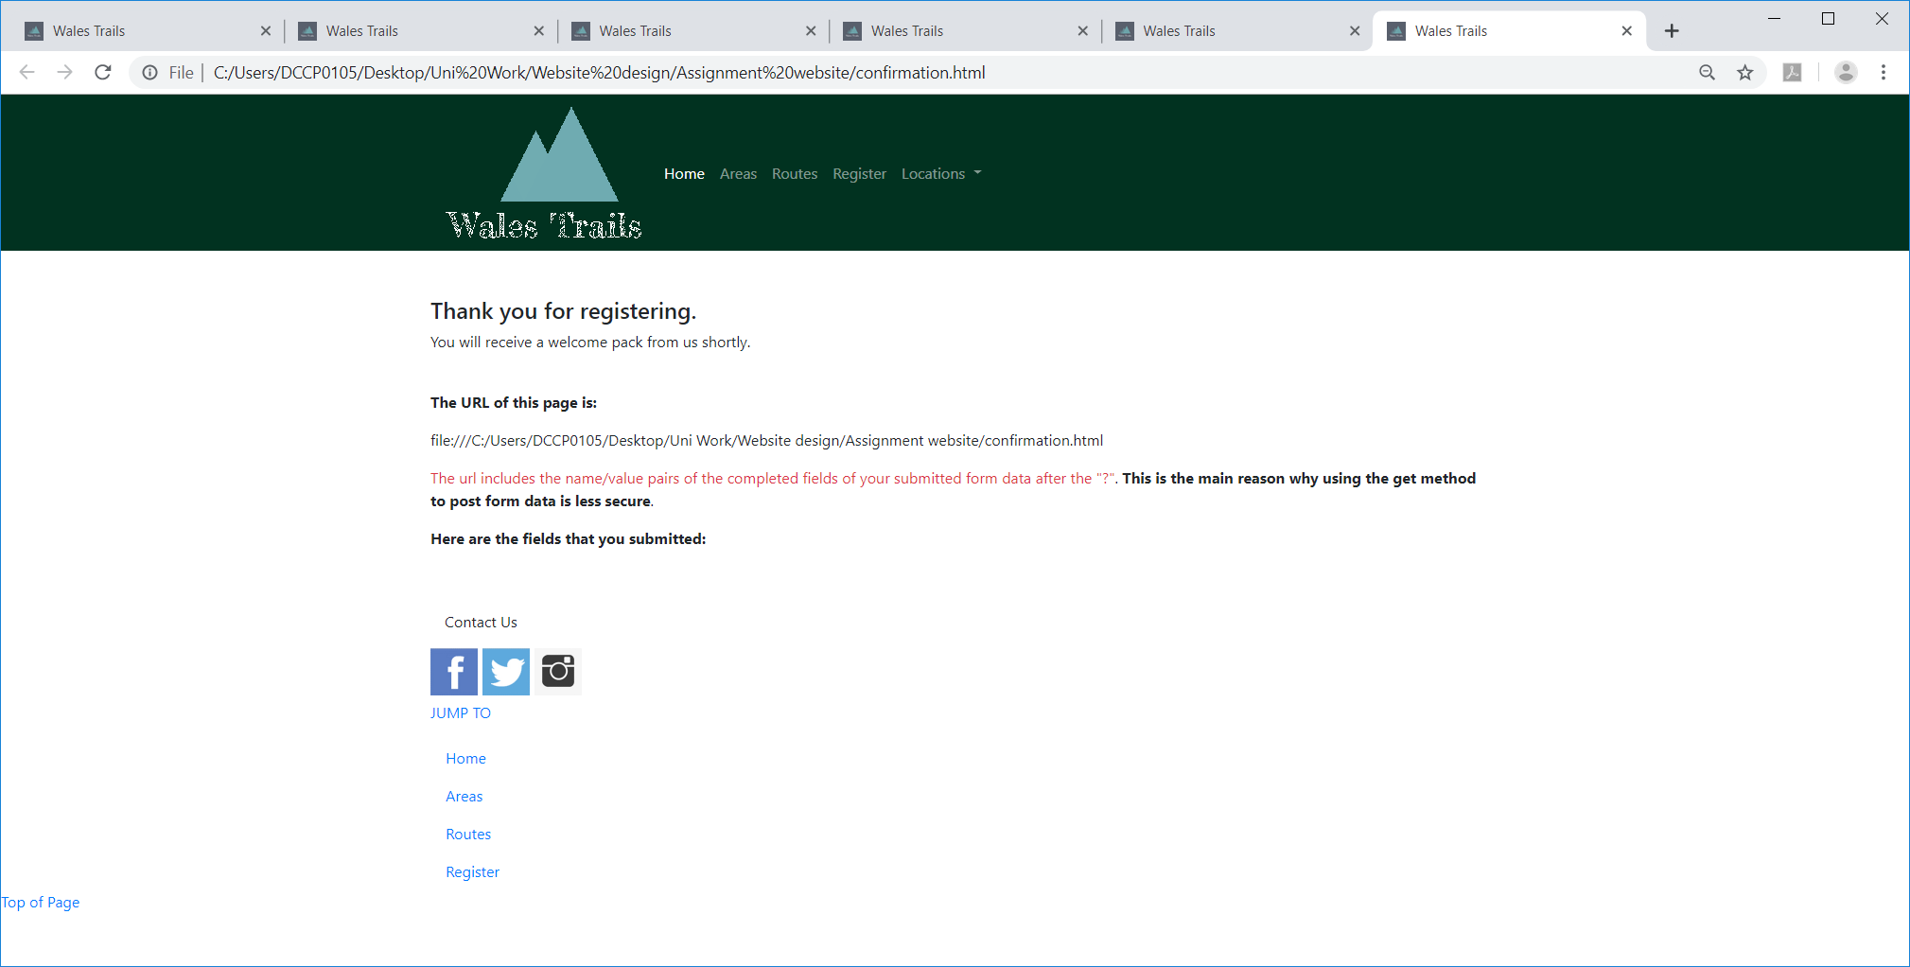

Attributions.html
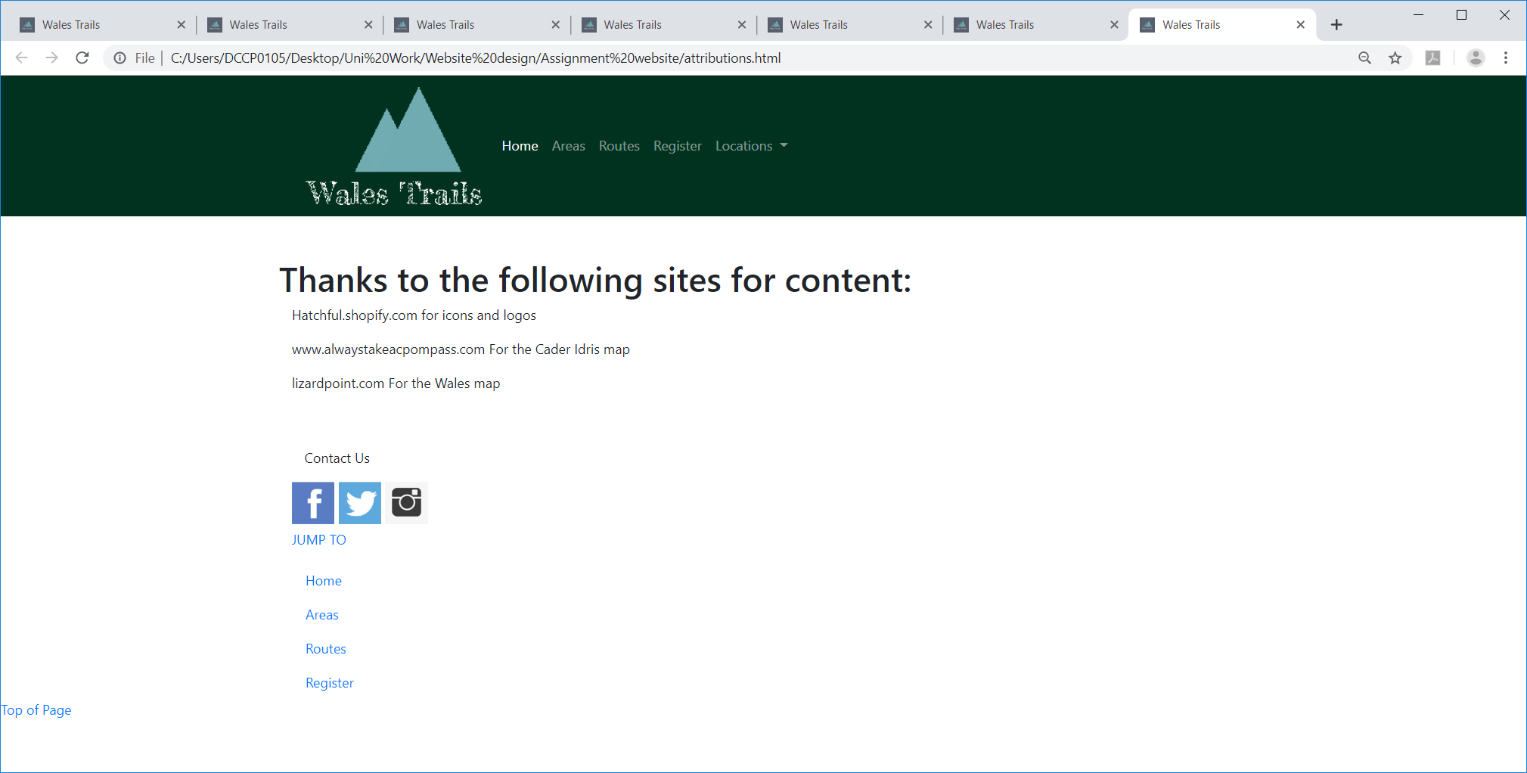

Validation
After validating the index.html file the following errors were reported.
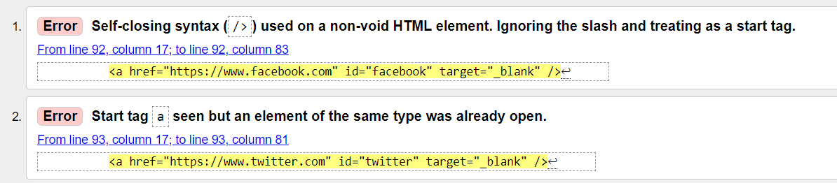
These were repeated a few times over the same section of code as below:
- <footer>↩
- <div class="container">↩
- <div class="row"></div>↩
- <p class="col-12">Contact Us</p>↩
- <nav id="social-media-menu">↩
- <a href="https://www.facebook.com" id="facebook" target="_blank" />↩
- <a href="https://www.twitter.com" id="twitter" target="_blank" />↩
- <a href="https://www.instagram.com" id="instagram" target="_blank" />↩
- </nav>↩
- <div class="row">↩
- <div class="col-12 col-sm-6 col-md-4">↩
- <p class="text-uppercase">Jump to</p>↩
- <ul class="nav flex-column">↩
- <li class="nav-item">↩
- <a class="nav-link" href="index.html">Home</a>↩
- </li>↩
- <li class="nav-item">↩
- <a class="nav-link" href="areas.html">Areas</a>↩
- </li>↩
- <li class="nav-item">↩
- <a class="nav-link" href="Routes.html">Routes</a>↩
- </li>↩
- <li class="nav-item">↩
- <a class="nav-link" href="register.html">Register</a>↩
- </li>↩
- </ul>↩
- </div>↩

A resolution to these errors was not found at this time, putting </a> at the end created further issues and so this would have to be investigated further.

CSS Validation
No errors found on the CSS script.
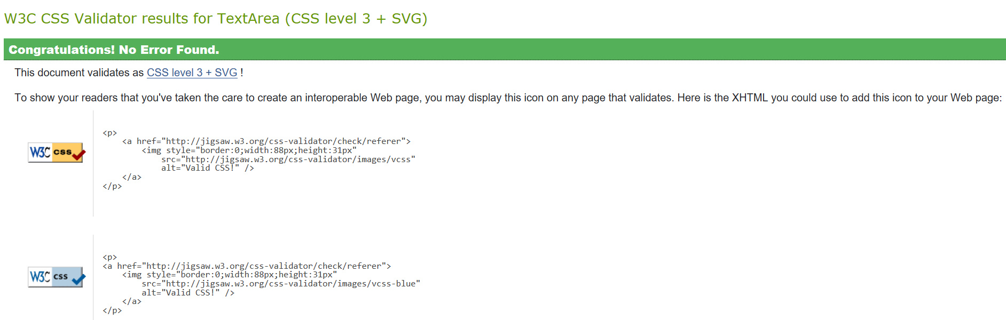

Evaluation
Overall the completed website provides what was intended and also adheres to the design brief to be easily navigable.
All pages are two clicks away from each other and all of the pages are coherent and follow the same style and are aesthetically similar.
The site looks attractive, with good use of colour and pictures.
The information that was detailed is included in that a map of the walk and a picture from that area is available.
Improvements for the future include more detail of the route, including a textual walkthrough. Interactive maps should be used at a few levels. At the top level they would be used to navigate across Wales with markers placed where walking routes have been posted.
At the level of the walks themselves, the maps should be expandable to provide enough detail that the route is explicit.
I would use smaller pictures for the links on the site just to help with smaller devices in displaying the content.
The routes should have a difficulty rating, duration and height as factors that can be searched for. Ultimately the routes would be a searchable database.
From there, I could envisage that users would be able to post their own photos and possibly share Sat-Nav routes over the site.

Search Engine Optimisation:
This is the practice of trying to help your site appear nearer the top of search engine results. [5]
The website built uses:
- Title header with the name of the Website,
  - <title>Wales Trails</title>
- meta-name keywords have been included
  - <meta name="keywords" content="Wales Trails, Hiking, Walking, Wales, Routes, Trails, Country Code" />
in the header and alt-text is used for the images. These are all methods to help provide the search engines with keywords to associate with your site.
Further use of the keywords with the on-screen content cam help your website be selected. To help optimise the keywords used, help is available via the URL: adwords.google.co.uk/select/KeywordToolExternal. It is suggested to use exact match than broad match. [5, p. 481]
An accessibility evaluation of the website was attempted through Google Chrome with the following extensions:
- aXe
- WAVE
- Tota11y
None of the above were able to rate my site. No messages were provided as to why. I have used a white background for the main page and so contrast for the main pages is good. However, for the title options there are two shades of green and the title within the logo has mottled effect letters. I would re-design these aspects for greater clarity.

References

Bibliography

[1] | “Wikipedia - HTML,” 15 July 2019. [Online]. Available: https://en.wikipedia.org/wiki/HTML. [Accessed 21 07 2019].
[2] | “Wikipedia-Cascading Style Sheets,” 14 July 2019. [Online]. Available: https://en.wikipedia.org/wiki/Cascading_Style_Sheets. [Accessed 21 07 2019].
[3] | “Wikipedia - Web Accessibility,” 19 July 2019. [Online]. Available: https://en.wikipedia.org/wiki/Web_accessibility. [Accessed 21 07 2019].
[4] | J. Lett, Bootstrap Quick Guide, Michigan: Bootstrap Creative, 2019.
[5] | J. Duckett, HTML&CSS, Indianapolis: John Wiley & Sons Inc, 2011.

