UNIVERSITY OF WALES TRINITY SAINT DAVID
MSc Data and Artificial Intelligence
Research Methods and Professional Development (ACFA7004)
RESEARCH PROPOSAL
Development of an AI-Assisted No-Code Data Scientist Platform for Automated Machine Learning and Analytics
Submitted By
Gaurav Bansod
Student ID
2519815
Submitted To
Mohamed Ben Farah

Abstract
The rapid growth of AI, Machine Learning and data analytics has transformed organisational decision-making, yet implementing a machine learning workflow still typically requires programming, statistical and data-engineering expertise most non-technical users lack [1], [6]. Existing AutoML and no-code platforms automate parts of this workflow, but recent evidence shows accessibility, transparency and — critically — user trust remain unresolved even in systems purpose-built to address them [2], [19], [20].
This proposal sets out a Design Science Research (DSR) study to develop and evaluate an AI-assisted no-code data scientist platform automating the core data-science stages — ingestion, cleaning, EDA, AutoML model generation, explainable-AI (XAI) reporting, visualisation and real-time prediction — within a single, unified, browser-based interface. The platform's automation is explicitly specified as a deterministic, rule-based recommendation engine with optional LLM-generated phrasing layered strictly on top, rather than an unspecified "AI" claim. A working low-fidelity prototype (illustrated throughout) has already been produced to validate the proposed architecture and user flow ahead of full implementation.
The study follows the DSR methodology of Hevner et al. [12] and process model of Peffers et al. [13], combined with an Agile development strategy and mixed-methods evaluation comprising quantitative performance testing (accuracy, precision, recall, F1-score, RMSE, R²) against controlled, matched baselines, and qualitative usability testing with 12-15 non-technical users using a validated System Usability Scale and reflexive thematic analysis. Python, Streamlit, Scikit-learn, PostgreSQL, Docker and AWS/Streamlit Community Cloud form the core stack.
The anticipated contribution is a transparent and accessible no-code analytics artefact that empirically tests whether audience-calibrated explainability narrows the novice-expert trust gap identified in the most recent human-centred AutoML literature, extending that literature from conceptual guidance to an evaluated artefact.

Table of Contents
Abstract 2
Chapter 1 — Introduction 5
1.1 Context and Background ......... 5
1.2 Research Problem ......... 5
1.3 Research Aim and Objectives ......... 6
1.4 Significance of the Research ......... 6
Chapter 2 — Literature Review 7
2.1 – 2.12 Sub-sections ......... 7–10
Chapter 3 — Research Design and Methodology 11
3.1 Research Design ......... 11
3.2 Research Methods ......... 11
3.3 AI Recommendation and Assistant Mechanism ......... 12
3.4 System Architecture and Prototype Demonstration ......... 12
3.5 Research Strategy ......... 16
3.6 Research Materials ......... 16
3.7 Evaluation Metrics ......... 17
Chapter 4 — Expected Outcomes 18
Chapter 5 — Timeline 19
Chapter 6 — Conclusion 20
References 21

List of Figures
Figure 1: Prototype dashboard overview of the proposed no-code platform
Figure 2: AI-assisted automated data-cleaning module
Figure 3: AutoML model-training and leaderboard interface
Figure 4: Explainable AI (SHAP-based) feature-importance interface
Figure 5: Real-time prediction interface
Figure 6: High-level system architecture of the proposed platform
Figure B1–B5: Additional prototype screens (Appendix B)

List of Tables
Table 1: Comparison of existing no-code / AutoML platforms
Table 2: Research objectives mapped to methods and evaluation criteria
Table 3: Software, frameworks and technologies to be used (Appendix C)
Table 4: Candidate public datasets for experimentation
Table 5: Evaluation metrics
Table 6: Project timeline, milestones and resource allocation

Chapter 1 — Introduction

1.1 Context and Background
AI, Machine Learning and Data Science are transforming decision-making across healthcare, finance, retail, education and manufacturing. Waller and Fawcett [15] argue that big data and predictive analytics are reshaping organisational planning, while cloud computing's growth has removed much of the infrastructural barrier to adopting these techniques at scale [14].
Traditional data-science work follows a broadly standardised sequence formalised in the CRISP-DM model of Wirth and Hipp [6]. Executing this pipeline still assumes programming ability, statistical literacy and feature-engineering experience, and Sculley et al. [16] show that maintaining a production ML system carries substantial hidden technical debt beyond initial model-building.
Automated Machine Learning (AutoML) has emerged in response. Hutter, Kotthoff and Vanschoren [7] define AutoML as automating algorithm selection, feature engineering and hyperparameter optimisation, and Feurer et al. [8] show through auto-sklearn that Bayesian optimisation with meta-learning produces robust models with little manual tuning. A newer generation of no-code platforms — DataRobot, H2O.ai, KNIME, Google AutoML — now exposes these capabilities through graphical interfaces. However, Lindauer et al. [18] argue AutoML research has optimised for predictive performance while under-investing in the human-centred decisions that determine whether non-experts can use these systems responsibly, and recent evidence confirms accessibility, trust and transparency remain unresolved even where explanation methods exist [2], [19], [20] — the gap this research targets.

1.2 Research Problem
Implementing an end-to-end data-science workflow remains difficult for non-technical users, who typically lack the coding and statistical knowledge current pipelines assume [7], [9]. Pletzl et al. [2], assessing commercial no-code AutoML tools, report inconsistent documentation and opaque pre-processing. Thys, Vanacken and Rovelo Ruiz [19] extend this in a 24-participant study, finding that even a guided AutoML prototype left novices with significantly lower trust and process understanding than experienced users, despite both groups completing tasks successfully — indicating that task completion alone is an insufficient measure of accessibility.
A second challenge is explainability. Tantithamthavorn et al. [1] argue XAI techniques must be embedded directly into automated tooling, and Abarca et al. [20] provide direct empirical support: in a controlled study of a no-code explainability module, novices rated SHAP-based explanations as significantly more trustworthy than experts did, suggesting explanation design must be tuned to audience rather than applied uniformly. A third challenge is cost: Rall, Bauer and Fraunholz [4] find subscription pricing and enterprise-first design still leave students and small organisations poorly served.

1.3 Research Aim and Objectives
Research Aim. To design, develop and evaluate an AI-assisted no-code data-science platform capable of automating dataset ingestion, data cleaning, exploratory data analysis, AutoML model training, explainable-AI reporting, visualisation and real-time prediction for users without programming expertise.
Research Objectives
- RO1: Critically review existing no-code and AutoML platforms to identify unresolved limitations in accessibility, explainability and workflow integration.
- RO2: Design a modular, extensible system architecture for the platform.
- RO3: Implement automated data-cleaning and EDA modules driven by a rule-based recommendation engine.
- RO4: Integrate AutoML algorithms and a SHAP-based explainable-AI reporting layer.
- RO5: Develop visualisation dashboards and a real-time prediction interface.
- RO6: Evaluate predictive performance, workflow efficiency and usability via quantitative testing and a user study, including automated-issue detection precision/recall against manually-labelled datasets, and concurrent-user response-time testing to substantiate any scalability claim.
Each objective is measured against the evaluation criteria in Table 2, so the research aim can be assessed systematically.

1.4 Significance of the Research
This research responds to an evidenced accessibility gap [7], [9], and by embedding explainability as a core feature it directly addresses concerns raised by Tantithamthavorn et al. [1] and Abarca et al. [20]. Practically, the platform may help educational institutions, start-ups and small organisations perform advanced analytics without specialist staff. Academically, it operationalises the human-centred AutoML paradigm called for by Lindauer et al. [18] as an evaluated artefact, extending the design-principle work of Thys et al. [19] into an explainability-by-default context, and the working prototype constitutes a design artefact for future DSR in this area [12], [13].

Chapter 2 — Literature Review

2.1 Introduction
This chapter critically reviews AutoML, no-code AI, explainable AI (XAI) and data-science democratisation, weighing each study's contribution against its limitations before positioning the proposed research within the resulting gap.

2.2 Evolution of Data Science and ML Platforms
Wirth and Hipp [6] formalised CRISP-DM as six iterative phases from business understanding to deployment; the model remains foundational but assumes technical competence at every stage. Sculley et al. [16] complicate this further, showing that production ML accrues hidden technical debt well beyond model training — a finding this study treats as a design constraint by scoping automation to include preprocessing and deployment, not just model selection.

2.3 Automated Machine Learning (AutoML)
Feurer et al. [8] demonstrate through auto-sklearn that Bayesian optimisation, meta-learning and ensembling can match manually tuned pipelines with minimal user input; however, their evaluation is purely algorithmic and offers no evidence on whether non-expert users can interpret or trust the resulting models. He, Zhao and Chu [9] corroborate this asymmetry at survey level, finding individual pipeline components increasingly mature while transparent end-to-end systems remain underdeveloped. Lindauer et al. [18] make the strongest critique: the field's benchmarking culture rewards accuracy gains largely invisible to novice users, and they call for evaluation criteria centred on understanding and appropriate reliance rather than leaderboard position alone — a recommendation this study adopts directly by treating comprehension and trust, not only accuracy, as primary evaluation outcomes (Section 3.7).

2.4 Existing No-Code and Low-Code AI Platforms
No-code platforms expose ML automation through graphical interfaces, but with uneven trade-offs. DataRobot offers advanced automation at high enterprise cost [4]; H2O.ai provides distributed computing and partial explainability but assumes prior ML familiarity; KNIME improves accessibility through visual workflows yet still requires scripting for complex pipelines. Pletzl et al. [2] find that even where such platforms claim reproducibility, inconsistent documentation obscures exactly which preprocessing steps were applied — a methodological gap rather than a usability inconvenience, since it prevents independent verification of results. Thys, Vanacken and Rovelo Ruiz [19] provide the most direct counterpoint: their prototype achieved full task completion for novices, yet post-task interviews revealed persistent uncertainty about why the system made specific decisions. Together, these studies indicate that visible task success is not a reliable proxy for transparency — a distinction this proposal's evaluation design (Section 3.7) captures by separating task-completion metrics from comprehension metrics.

2.5 Comparison of Existing Platforms
Table 1: Comparison of existing no-code / AutoML platforms
Platform | Strengths | Limitations | Source
DataRobot | Advanced automation; enterprise scale | Expensive; configuration-heavy | [4]
H2O.ai | Distributed computing; partial explainability | Requires ML familiarity | [7]
KNIME | Visual drag-and-drop workflows | Scripting still needed at scale | [2]
Google AutoML | Cloud scalability | Cloud dependency; subscription cost | [4]
DashAI | Open-source; PDP/PFI/SHAP built in | Depth criticised by expert users | [20]
Source: Compiled by the author from platform comparisons and findings reported in [2], [4], [7] and [20].
No reviewed platform combines affordability, built-in explainability tuned to audience, transparent pre-processing and a genuinely unified end-to-end workflow — the specific combination this research proposes to address.

2.6 Democratisation of Artificial Intelligence
AI democratisation aims to make advanced analytics usable without specialist training, encouraging the "citizen data scientist" concept [3]. Rall, Bauer and Fraunholz [4] show enterprise pricing structurally excludes exactly the users this concept targets, while Thys et al. [19] show even free, well-designed prototypes leave a residual trust gap between novices and experienced users. Democratisation therefore requires more than access and usability; it requires explicit design attention to how trust is built over the course of use, which this study addresses through iterative, tiered explanation rather than a single static output.

2.7 Explainable Artificial Intelligence (XAI)
SHAP attributes predictions to feature contributions on a game-theoretic basis [10], while LIME approximates complex models locally using interpretable surrogates [11]; both are model-agnostic and therefore suit AutoML contexts. Tantithamthavorn et al. [1] argue explainability should be embedded rather than added retrospectively. Abarca et al. [20] test this directly with a no-code SHAP-based module (N = 20) and find novices rated explanations significantly more trustworthy than experts, who instead criticised sufficiency and completeness — evidence a single explanation format cannot serve both audiences equally. This qualifies Tantithamthavorn et al.'s [1] argument: embedding explainability is necessary but not sufficient, since how it is embedded still requires audience-specific calibration. The proposed platform responds by pairing a default plain-language SHAP summary with an optional detail view.

2.8 Machine Learning Workflow Automation
ML workflow automation covers preprocessing, feature engineering, model selection, training and deployment. He, Zhao and Chu [9] observe that research typically automates individual stages rather than one transparent workflow, leaving users to bridge the gaps manually. The proposed platform targets this integration gap directly by connecting ingestion, cleaning, EDA, AutoML, explanation and prediction within one interface, evaluated as a single workflow rather than isolated components (Table 2).

2.9 Cloud Computing and AI Platforms
Cloud computing enables on-demand, elastic AI services [14], but also introduces privacy, security and cost concerns [4], [14]. The proposed hybrid design processes suitable datasets locally and uses AWS only where storage, deployment or additional scale is required; no claim of production-grade scalability is made without the concurrent-load testing specified in RO6.

2.10 Research Gaps
The review identifies five gaps: affordability [4]; residual configuration and interpretive burden despite "no-code" claims, evidenced empirically rather than only conceptually [2], [19]; explainability that is present but not calibrated to audience expertise [1], [20]; fragmented workflow automation [9]; and opaque preprocessing or model-selection decisions [2]. Critically, the two most recent studies reviewed [19], [20] show that even well-designed, evaluated prototypes do not close the trust and comprehension gap by default — automation and interface polish alone are insufficient, which motivates this study's explicit, tiered evaluation of comprehension rather than task completion alone.

2.11 Relation to the Proposed Research
This study combines CRISP-DM-aligned stages [6], AutoML principles demonstrated by auto-sklearn [8], and SHAP explainability [10] within a transparent interface. It operationalises the human-centred AutoML paradigm articulated by Lindauer et al. [18], directly extends the design principles of Thys et al. [19] — particularly their call for tiered, audience-aware explanation — and empirically tests, via the study design in Section 3.7, whether explainability-by-default narrows the novice-expert trust gap that Abarca et al. [20] and Thys et al. [19] both independently observe.

2.12 Summary
The literature shows meaningful progress in AutoML and no-code analytics, but the most recent empirical studies indicate that accessibility, transparency and trust remain unresolved even in systems specifically designed to address them. This is a stronger and more current gap than affordability or configuration complexity alone, and it directly motivates the evaluation strategy in Chapter 3.

Chapter 3 — Research Design and Methodology

3.1 Research Design
This research adopts Design Science Research (DSR) because its central contribution is a purposeful software artefact addressing an evidenced problem, evaluated through construction and testing [12]. A conventional experimental design was considered but rejected as the primary method, since the question concerns integrated system usability and trust rather than isolated variable manipulation, and could not alone capture the comprehension-gap findings central to Section 2.10. Action research was also rejected, as it requires embedding within a single organisation undergoing intervention, which does not fit an early-stage MSc artefact evaluated across independent participants. DSR was judged more appropriate because it accommodates iterative artefact construction alongside mixed-methods evaluation [13].
The study follows the six-activity DSR process of Peffers et al. [13]: problem identification (Chapter 1); objective definition (Table 2); design and development; demonstration, through the prototype in Section 3.4; evaluation, through Sections 3.2 and 3.7; and communication, through the final dissertation.
Table 2: Research objectives mapped to methods and evaluation criteria
Objective | DSR Activity | Primary Method | Evaluation Criterion
RO1 — Review platforms | Problem identification | Systematic literature review | Breadth/currency of sources
RO2 — Design architecture | Design | System/architecture modelling | Internal review vs. Table 3
RO3 — Cleaning + EDA | Development | Software dev. (Agile sprint) | Issue-detection precision/recall
RO4 — AutoML + XAI | Development | Dev. + controlled benchmarking | Accuracy/F1/RMSE vs. baseline
RO5 — Visualisation + UI | Dev., Demonstration | Prototype build (Figs. 1-6) | Feature completeness
RO6 — Evaluate & usability | Evaluation | Quant. testing + user study | Table 5 metrics; validated SUS
Source: Author's own synthesis, structured using the DSR process model of Peffers et al. [13].

3.2 Research Methods
A mixed-methods approach evaluates both technical performance and user experience, appropriate where neither form of evidence alone answers the research problem [17].
Qualitative Methods. Twelve to fifteen non-technical participants — adults with no professional programming or data-analysis experience — will be recruited via university mailing lists using purposive, convenience sampling. Participants will complete representative tasks (upload, model generation, explanation interpretation, prediction) before a semi-structured interview and the validated System Usability Scale (SUS), following the calibration evidence in Section 2.7. Transcripts will be analysed using Braun and Clarke's reflexive thematic analysis, with inductive coding checked against the trust themes identified in [19] and [20], and a second coder reviewing a 20% sample for consistency.

3.3 AI Recommendation and Assistant Mechanism
To address the ambiguity Pletzl et al. [2] identify around undocumented automation, the platform's "AI-assisted" layer is specified explicitly. Recommendations (cleaning suggestions, next-step prompts, model-selection guidance) are generated by a deterministic, rule-based engine: dataset diagnostics (missing-value rate, cardinality, class balance, outlier score) are evaluated against documented thresholds to produce a templated recommendation with a confidence score, consistent with the tiered, confidence-cued explanation principle proposed by Thys et al. [19]. Every automated transformation is logged to a visible, user-approved pipeline before being applied, rather than applied silently. Natural-language phrasing may optionally be generated via a lightweight LLM call layered strictly on top of the rule engine's output, never as the source of the recommendation itself, limiting hallucination risk to phrasing rather than substance [19].

3.4 System Architecture and Prototype Demonstration
The platform uses a modular architecture comprising Streamlit, database, AutoML, visualisation, explainability and cloud/deployment layers (Table 3, Appendix C). A low-fidelity interactive prototype has been created to demonstrate the proposed workflow, consistent with the DSR demonstration activity [13]. Six figures illustrating the core workflow are presented here; five further prototype screens are provided in Appendix B.
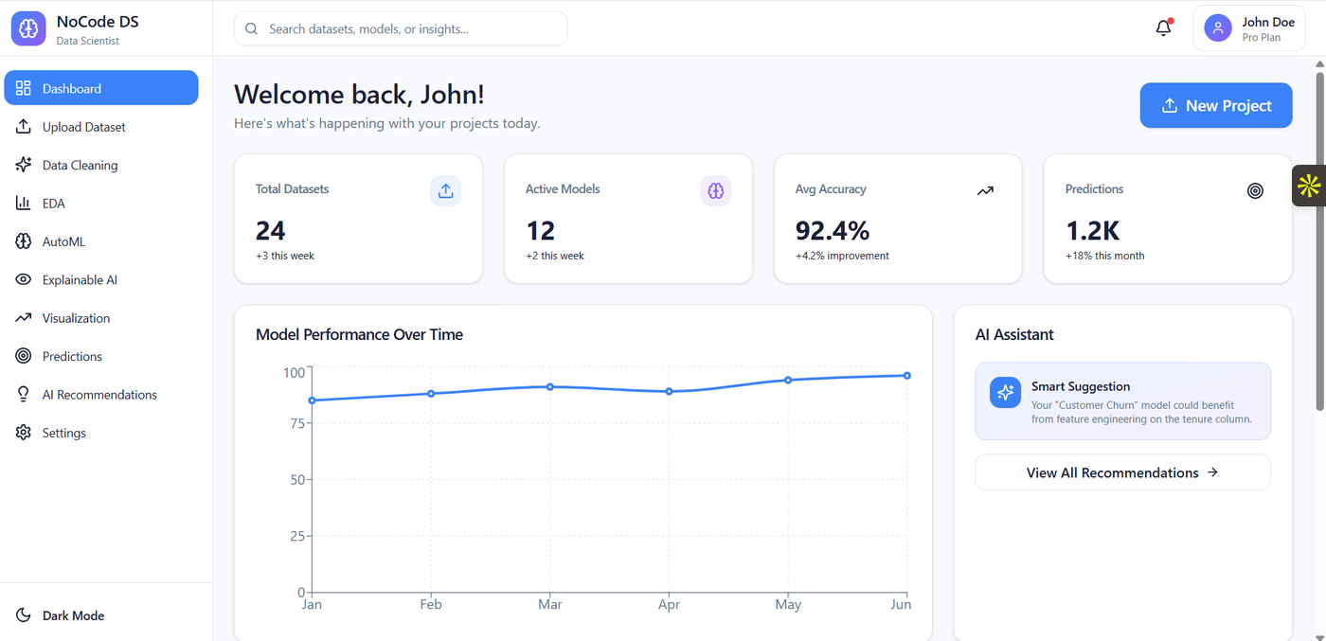
Figure 1: Prototype dashboard overview of the proposed no-code platform
Source: Author's own prototype, designed in Figma (2026).
Figure 1 shows the landing dashboard, surfacing workflow indicators alongside an assistant panel that proactively suggests the next best action, driven by the recommendation engine described in Section 3.3.
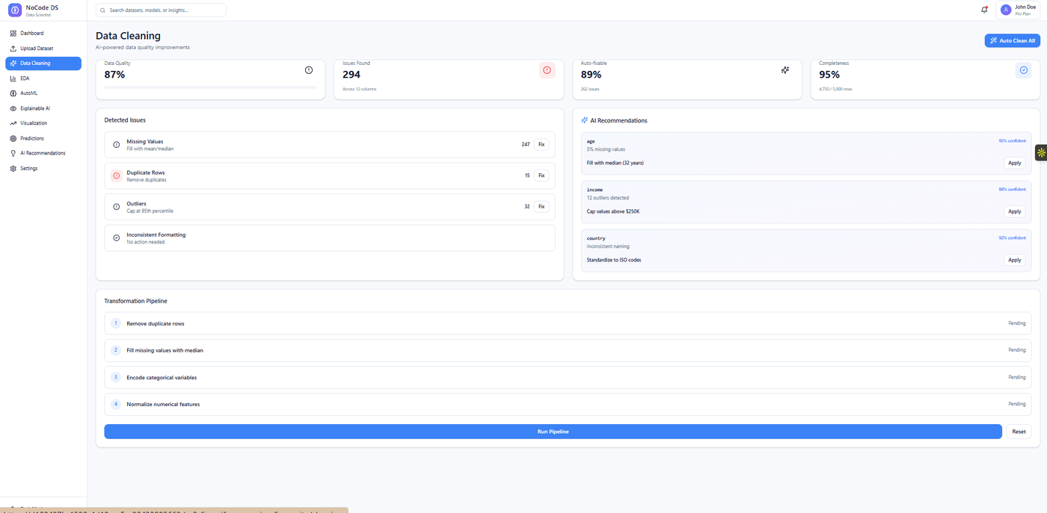
Figure 2: AI-assisted automated data-cleaning module
Source: Author's own prototype, designed in Figma (2026).
Figure 2 shows automated cleaning: detected issues are listed with a plain-language recommendation and confidence score, added to a visible, user-approved pipeline — responding directly to Pletzl et al.'s [2] transparency concerns.
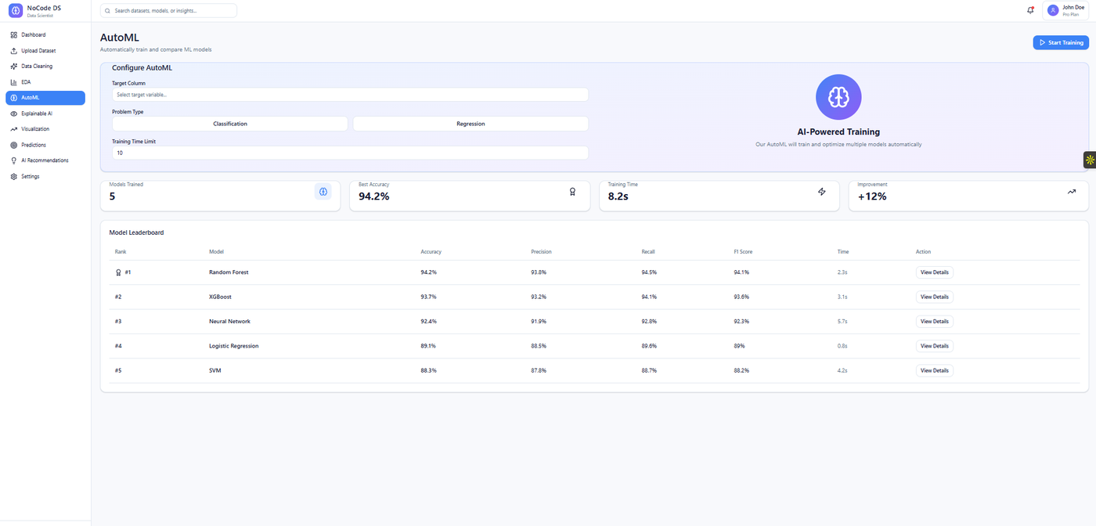
Figure 3: AutoML model-training and leaderboard interface
Source: Author's own prototype, designed in Figma (2026).
Figure 3 shows AutoML configuration and the leaderboard: the user selects only a target column, problem type and time budget, and the platform trains and ranks candidate algorithms automatically, consistent with the auto-sklearn approach of Feurer et al. [8].
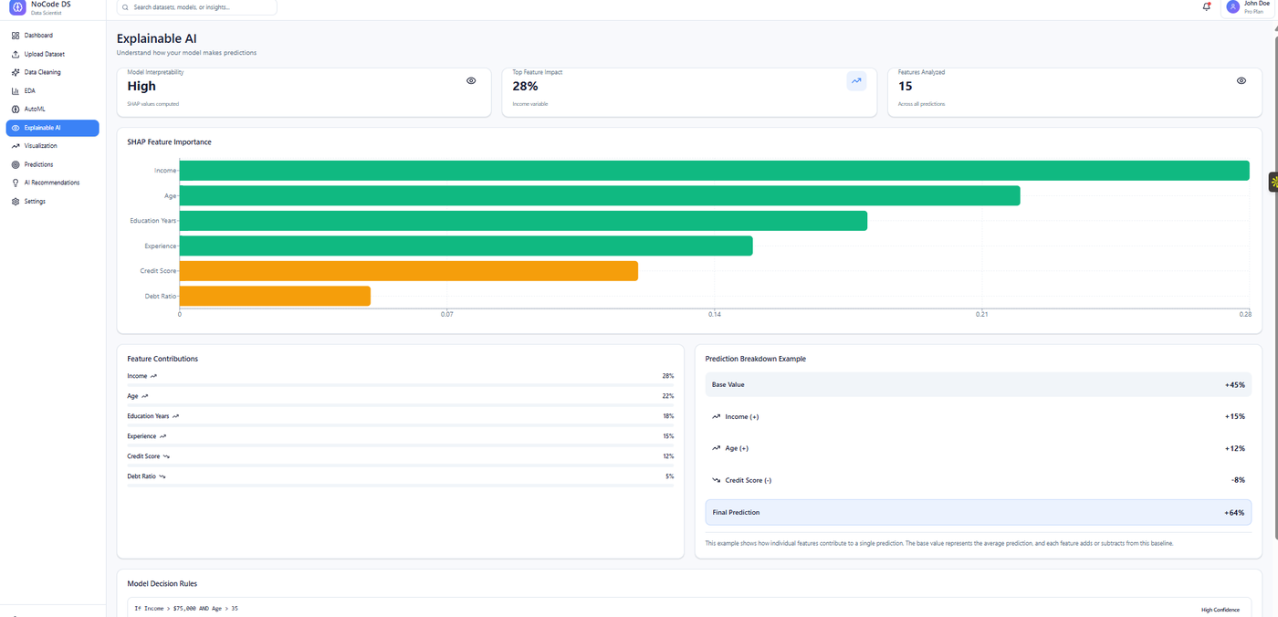
Figure 4: Explainable AI (SHAP-based) feature-importance interface
Source: Author's own prototype, designed in Figma (2026).
Figure 4 shows the Explainable AI module, reporting SHAP-based feature importance [10] with a plain-language default view and an optional detail view, in response to the audience-calibration finding of Abarca et al. [20].
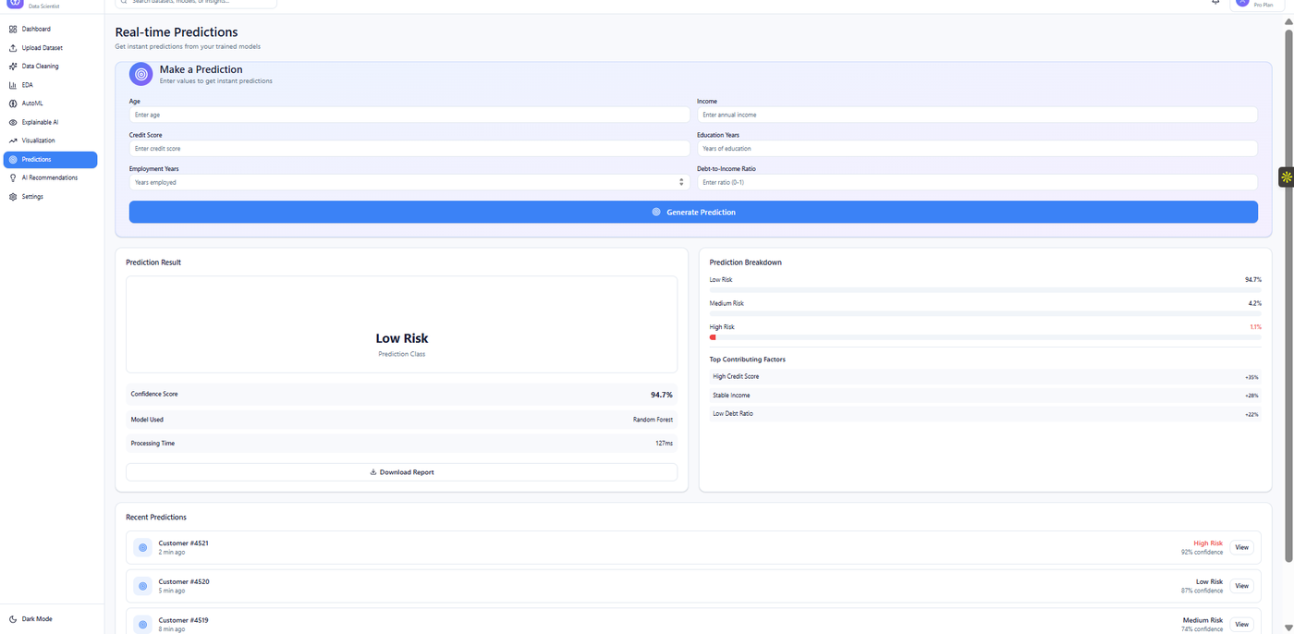
Figure 5: Real-time prediction interface
Source: Author's own prototype, designed in Figma (2026).
Figure 5 shows real-time prediction: a user supplies input values and receives a classification with a confidence score and top contributing factors, surfacing explanation alongside the prediction.

Figure 6: High-level system architecture of the proposed platform
Layer | Responsibility | Illustrated in
Frontend & App (Streamlit) | Upload, dashboards, navigation, prediction UI | Figs. 1, 3, 5
ML Processing (in-process) | Pre-processing, model orchestration | Underlies all modules
AutoML Engine (Scikit-learn) | Automated pre-processing, training, leaderboard | Fig. 3
Explainability Engine (SHAP) | Feature-importance and prediction breakdowns | Fig. 4
Recommendation Engine | Rule-based, confidence-scored suggestions (3.3) | Figs. 1, 2
Database (PostgreSQL) | Persisting datasets, models, workflow state | Underlies all modules
Cloud Layer (AWS/Docker) | Storage, compute-on-demand, deployment, backup | Underlies all modules
Source: Author's own synthesis of the architecture described in Section 3.4, informed by [7], [9].

3.5 Research Strategy
Implementation follows iterative Agile sprints covering requirement refinement, development, testing, feedback and release. The modular platform allows components to be tested independently before integration, aligning with the DSR design-demonstrate-evaluate cycle [13], and each sprint is reviewed against the relevant objective in Table 2.

3.6 Research Materials
Data Sources and Collection. The research uses named public benchmark datasets, selected for reproducibility and to focus evaluation on platform automation and explainability rather than proprietary data access.
Table 4: Candidate public datasets for experimentation
Dataset | Problem Type | Size (approx.) | Purpose
Telco Customer Churn (Kaggle, IBM sample data) | Binary classification | 7,043 rows / 21 cols | Pre-processing + AutoML benchmarking
Walmart Store Sales Forecasting (Kaggle) | Regression | 6,435 rows / 8 cols | Regression metrics (MAE, RMSE, R²)
Statlog (German Credit Data), UCI | Binary/multi-class classification | 1,000 rows / 20 attributes | Explainability (SHAP) evaluation
Source: Kaggle and the UCI Machine Learning Repository; exact dataset versions to be confirmed at implementation, following benchmarking practice in [7], [8].
Justification. These datasets reflect realistic problems for non-technical users and are widely used in comparable AutoML literature [7], [8], supporting controlled comparison against manually configured baselines rather than uncontrolled comparison against unrelated published figures.
Ethical Considerations. Model development uses public, de-identified datasets licensed for academic use; no primary personal data will be collected for training. Human usability testing requires informed consent, withdrawal rights, anonymisation and University-approved storage. The institutional ethics self-assessment (Appendix A) will be submitted via the required Moodle link before recruitment begins; per the assessment brief, the proposal is deemed a failure without it.
Software and Hardware. Table 3 (Appendix C) summarises the proposed stack, centred on Python, Streamlit, Scikit-learn, SHAP, PostgreSQL, Docker and AWS/Streamlit Community Cloud. Development uses a standard workstation, with AWS compute provisioned only if local resources are insufficient.

3.7 Evaluation Metrics
Table 5: Evaluation metrics
Category | Metric | Purpose
Classification | Accuracy, Precision, Recall, F1-score | Correctness and balance
Regression | MAE, RMSE, R² | Error magnitude
System | Training time, latency, concurrent-user response | Efficiency; scalability evidence
Usability | Task completion, validated SUS, thematic analysis | Accessibility (RO6)
Explainability | Comprehension rating, novice/expert comparison | Calibration need [20]
Source: Standard classification/regression metrics as applied in AutoML benchmarking [7], [8], supplemented with usability instruments validated in [19], [20].
Automated pipeline results will be compared against manually configured baselines under identical train-test splits and preprocessing, rather than against uncontrolled published figures, since dataset and split differences would otherwise invalidate the comparison.

Chapter 4 — Expected Outcomes

4.1 Anticipated Results
The expected outcome is a functional prototype integrating ingestion, automated cleaning, EDA, AutoML, XAI, visualisation and real-time prediction in one non-technical interface. Under the controlled comparison in Section 3.7, performance is expected to be broadly comparable with manually configured baselines, since the platform integrates established algorithm families rather than a new modelling method. Usability testing will empirically assess whether audience-calibrated explainability narrows the novice-expert comprehension gap reported in [19] and [20], rather than assuming it will.

4.2 Implications
If achieved, the results would indicate that tiered, built-in explanation can coexist with automation and simplicity, and that a rule-based recommendation engine can be trustworthy without an unspecified "AI" claim. Academically, the study extends the human-centred AutoML paradigm from position statement [18] to an evaluated artefact, testing the design principles of Thys et al. [19] in an explainability-by-default context. Practically, the platform may support students, educators and small organisations lacking specialist data-science staff.

4.3 Limitations
Limitations include reliance on benchmark rather than live organisational data; a purposive sample of 12-15 participants, restricting statistical generalisability though supporting the thematic analysis planned; cloud-cost constraints on dataset scale; automation bias, whereby users may over-trust recommendations regardless of explanation quality; the risk that SHAP outputs are misread as causal rather than associative; and preprocessing-induced data leakage if transformations are not fitted exclusively within training folds. These are mitigated through fold-isolated preprocessing and interface language distinguishing association from causation.

Chapter 5 — Timeline
The project is organised into eight phases aligned with the DSR activities in Section 3.1 [13].
Table 6: Project timeline, milestones and resource allocation
Phase | Milestone / Deliverable | Duration | Period | Primary Resource
1. Problem definition & lit. review | Literature review finalised; objectives confirmed | 2 Week | Week 1-2 | Researcher; supervisor
2. Ethics approval & architecture | Ethics form approved; architecture finalised | 1 Week | Week 2 | Researcher; supervisor sign-off
3. Core module dev. (Sprints 1-3) | Upload, cleaning, EDA modules functional | 2 Week | Week 3-4 | Researcher; workstation
4. AutoML & XAI (Sprints 4-5) | Leaderboard and SHAP module functional | 2 Week | Week 5-6 | Researcher; conditional AWS
5. Visualisation, UI & integration | End-to-end workflow demonstrable (Figs. 1-5) | 1 Week | Week 7 | Researcher
6. Quantitative benchmarking | Model performance results (Table 5) collected | 1 Week | Week 8 | Researcher; datasets
7. Qualitative usability study | User-study data collected and analysed | 1 Week | Week 9 | Researcher; 12-15 participants; 2nd coder
8. Analysis, write-up & submission | Final dissertation drafted and submitted | 2 Week | Week 9-10 | Researcher; supervisor
Source: Author's own project plan, structured using the six-activity DSR process model of Peffers et al. [13].
Milestone reviews follow Phases 2, 4 and 6, allowing supervisor feedback before subsequent work. Quantitative evaluation precedes usability testing so technical results can inform user-study tasks [12], [13].

Chapter 6 — Conclusion
This proposal defines a DSR study to develop and evaluate an AI-assisted no-code data-science platform for non-technical users. The literature review shows that even recent, well-evaluated no-code and AutoML systems leave a measurable trust and comprehension gap between novice and expert users [19], [20], and that explainability must be calibrated to audience rather than applied uniformly [1], [20] — a more current and specific gap than affordability or configuration complexity alone.
The proposed response combines a modular Streamlit-based architecture, a rule-based recommendation engine with logged, user-approved transformations, SHAP explanations with tiered depth, and real-time prediction. The mixed-methods evaluation — a validated SUS instrument, reflexive thematic analysis of a 12-15 participant study, and controlled benchmarking against matched baselines — is designed to test whether this calibration narrows the gap identified in Section 2.10, rather than to demonstrate task completion alone. A working low-fidelity prototype (Figures 1-6, Appendix B) demonstrates the intended workflow ahead of full implementation [12], [13], providing a sound, evidence-grounded foundation for a full MSc project within a realistic ten-week, DSR-aligned timeline.

References
[1] C. Tantithamthavorn, J. Cito, H. Hemmati and S. Chandra, "Explainable AI for SE: Challenges and Future Directions," IEEE Software, vol. 40, no. 3, pp. 29-33, May 2023.
[2] S. Pletzl, A. Haberl, T. Ross-Hellauer and S. Thalmann, "Reproducible AutoML: An Assessment of Research Reproducibility of No-Code AutoML Tools," in Proc. Wirtschaftsinformatik, 2024.
[3] M. Truss and M. Schmitt, "Human-Centered AI Product Prototyping with No-Code AutoML: Conceptual Framework, Potentials and Limitations," arXiv preprint arXiv:2402.07933, 2024.
[4] D. Rall, B. Bauer and T. Fraunholz, "Towards Democratizing AI: A Comparative Analysis of AI as a Service Platforms and the Open Space for Machine Learning Approach," arXiv preprint arXiv:2311.04518, 2023.
[5] T. A. Han, M. Pandit, S. Joneidy et al., "An Explainable AI Tool for Operational Risks Evaluation of AI Systems for SMEs," in Proc. Int. Conf. Software, Knowledge, Information Management and Applications (SKIMA), IEEE, 2024, pp. 1-6.
[6] R. Wirth and J. Hipp, "CRISP-DM: Towards a Standard Process Model for Data Mining," in Proc. 4th Int. Conf. Practical Applications of Knowledge Discovery and Data Mining, 2000, pp. 29-39.
[7] F. Hutter, L. Kotthoff and J. Vanschoren, Eds., Automated Machine Learning: Methods, Systems, Challenges. Cham, Switzerland: Springer, 2019.
[8] M. Feurer, A. Klein, K. Eggensperger, J. Springenberg, M. Blum and F. Hutter, "Efficient and Robust Automated Machine Learning," in Advances in Neural Information Processing Systems (NeurIPS), 2015, pp. 2962-2970.
[9] X. He, K. Zhao and X. Chu, "AutoML: A Survey of the State-of-the-Art," Knowledge-Based Systems, vol. 212, art. 106622, 2021.
[10] S. M. Lundberg and S. I. Lee, "A Unified Approach to Interpreting Model Predictions," in Advances in Neural Information Processing Systems (NeurIPS), 2017, pp. 4765-4774.
[11] M. T. Ribeiro, S. Singh and C. Guestrin, "'Why Should I Trust You?': Explaining the Predictions of Any Classifier," in Proc. 22nd ACM SIGKDD Int. Conf. Knowledge Discovery and Data Mining, 2016, pp. 1135-1144.
[12] A. R. Hevner, S. T. March, J. Park and S. Ram, "Design Science in Information Systems Research," MIS Quarterly, vol. 28, no. 1, pp. 75-105, 2004.
[13] K. Peffers, T. Tuunanen, M. A. Rothenberger and S. Chatterjee, "A Design Science Research Methodology for Information Systems Research," Journal of Management Information Systems, vol. 24, no. 3, pp. 45-77, 2007.
[14] P. Mell and T. Grance, "The NIST Definition of Cloud Computing," National Institute of Standards and Technology, Gaithersburg, MD, USA, Special Publication 800-145, 2011.
[15] M. A. Waller and S. E. Fawcett, "Data Science, Predictive Analytics, and Big Data: A Revolution That Will Transform Supply Chain Design and Management," Journal of Business Logistics, vol. 34, no. 2, pp. 77-84, 2013.
[16] D. Sculley et al., "Hidden Technical Debt in Machine Learning Systems," in Advances in Neural Information Processing Systems (NeurIPS), 2015, pp. 2503-2511.
[17] J. W. Creswell and J. D. Creswell, Research Design: Qualitative, Quantitative, and Mixed Methods Approaches, 5th ed. Thousand Oaks, CA, USA: SAGE Publications, 2018.
[18] M. Lindauer et al., "Position: A Call to Action for a Human-Centered AutoML Paradigm," in Proc. 41st Int. Conf. Machine Learning (ICML), vol. 235, pp. 30566-30584, Jul. 2024.
[19] J. Thys, D. Vanacken and G. Rovelo Ruiz, "Engineering Trustworthy Automation: Design Principles and Evaluation for AutoML Tools for Novices," arXiv preprint arXiv:2511.22352, 2025.
[20] N. Abarca, A. Carvallo, C. López Moncada and F. Bravo-Marquez, "Explaining AI Without Code: A User Study on Explainable AI," arXiv preprint arXiv:2602.11159, 2026.

