Thomas Evans p145653
Thomas Evans
145653
Responsive Web Development
UWTSD

Table of contents
-Introduction
-Implementation
-Responsiveness
-Evaluation

Introduction
For this assignment, the author of this report was tasked to create a website. The brief states that the website must work with all major browsers. The brief also states that the website must work responsively on any screen stating that the website must be mobile compatible to some degree. W3 school states that a responsive website is created by using HTML and CSS to make a website look correct on a variety of devices by automatically changing and resizing a page depending on the device it is being displayed on [2]. The author of this report must use the techniques taught in this module amongst techniques learned from independent study to create a website that is responsive whilst still containing all the content that is needed for the website to bring in the target audience. Firstly, in this report the author of this report will discuss the purpose of the website and its subject matter. Secondly, the report will discuss how the author of this report achieved the level of responsibility when creating the website stating the learning sources used to create it. Finally, in the evaluation section the report will consist of the problems that were crossed when developing the website and the ways in which they were solved. Also, there will be a section discussing the improvements that could be made if the project was revisited later.

Implementation
For the purpose of this task the author of this report decided to create a website for a small business in which he holds a part time job. The business doesn’t currently have a website and believes that it could increase the business’s exposure. The business the website is being created for is a bar in Swansea called ‘La Cantina’.
When designing the website, it will be important to design the website for mobile first. This is important as it will ensure that the website will run smoothly when used on mobile. This is important as mobile web use is incredibly large market with 1.2 billion [3] mobile web users. Also, a survey in the U.S. stated that 25% of mobile web users were mobile only. Therefore by not catering firstly to mobile the website may not be accessible to a large part of the target audience.
The purpose of the website will be to promote the bar as well as provide a platform for the user to make bookings for the available function room inside of the venue. The website will also provide a platform outside of social media to display the venues drinks offers and hold a gallery of images taken inside of the venue. The opening hours will also be displayed on the website.
The website’s target audience is anyone who might attend the venue and will be used to draw in more customers going forward. The main target audience the bar wishes to appeal to is to students as the venue wishes to gain more popularity on student nights and believes it will greatly improve the amount of money the venue is able to take.
The webpage will be made using 6 pages: a home page, menu, bookings, gallery, contact us and opening hours. The home page will be a simple welcoming page with a slogan or perhaps a link to social media with some images of the drinks available. The menu page will have a summary of the offers available on each day. The bookings page will provide details on the function room and show the prices and facilities available to any possible customers. The gallery will contain a plethora of images from the venue of both the venue itself and some of the extravagant drinks available on at the venue. The contact us page will provide contact details for the venues management for arranging future bookings and inquires. The opening hours will contain the websites opening hours.
To ensure the website is responsive it will be vital that the inclusion of media queries is done in a positive and responsive manner. Media queries will be used to validate the images sizes on all pages to ensure that they do not become too large or too small when viewed on different devices with different sized displays.
The website will conform the colour scheme of the venue and all resources used inside of the venue and the staff uniform. Using mainly burgundy yellow and white.

Responsiveness
For the creation of this website the author of this report and the developer of the website used a series of the resources used from the Moodle page for this module and used w3 schools the assist in learning how to create a responsive website.
The author of this website created a simple responsive website by using the line of code.
<meta name="viewport" content="width=device-width, initial-scale=1.0" shrink-to-fit = no>

This code allows the website to change the size of the webpage to scale to the size of the devices screen. This is the main thing used to make the website responsive as well as using responsive images which fit can fit nicely to the scale of any device.
Home page
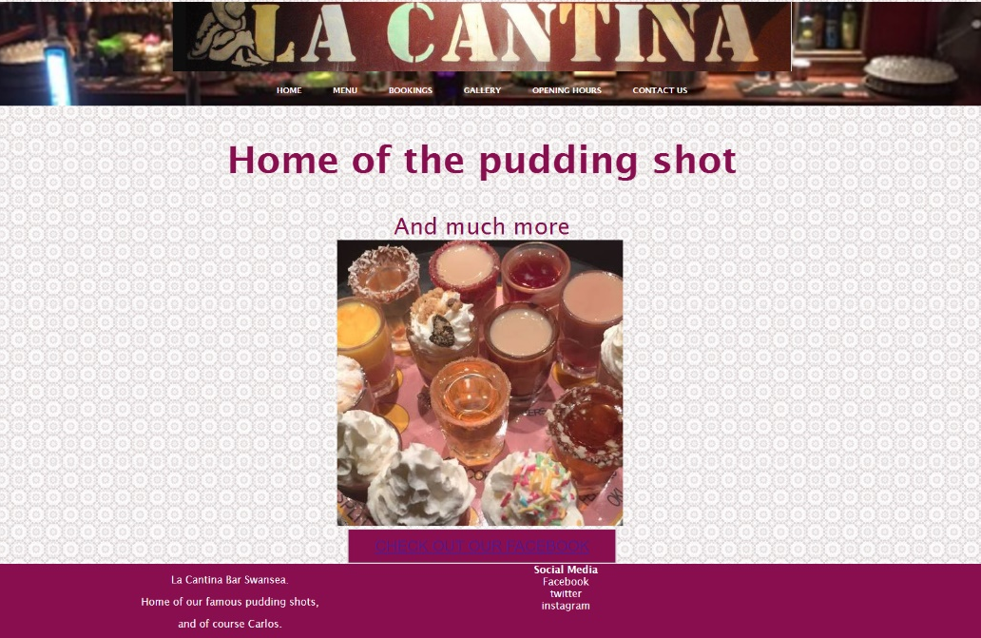
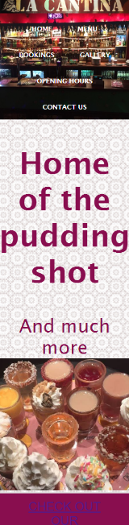

Above are screenshots of the website both displayed in a large window and a small one similar to a mobile. These screenshots show that the home page is clearly responsive as everything on the page reshapes nicely and everything on the page has rendered correctly. As discussed earlier in the report the home page is a simple welcome to webpage with a slogan, image and button to lead top social media page.

Menu
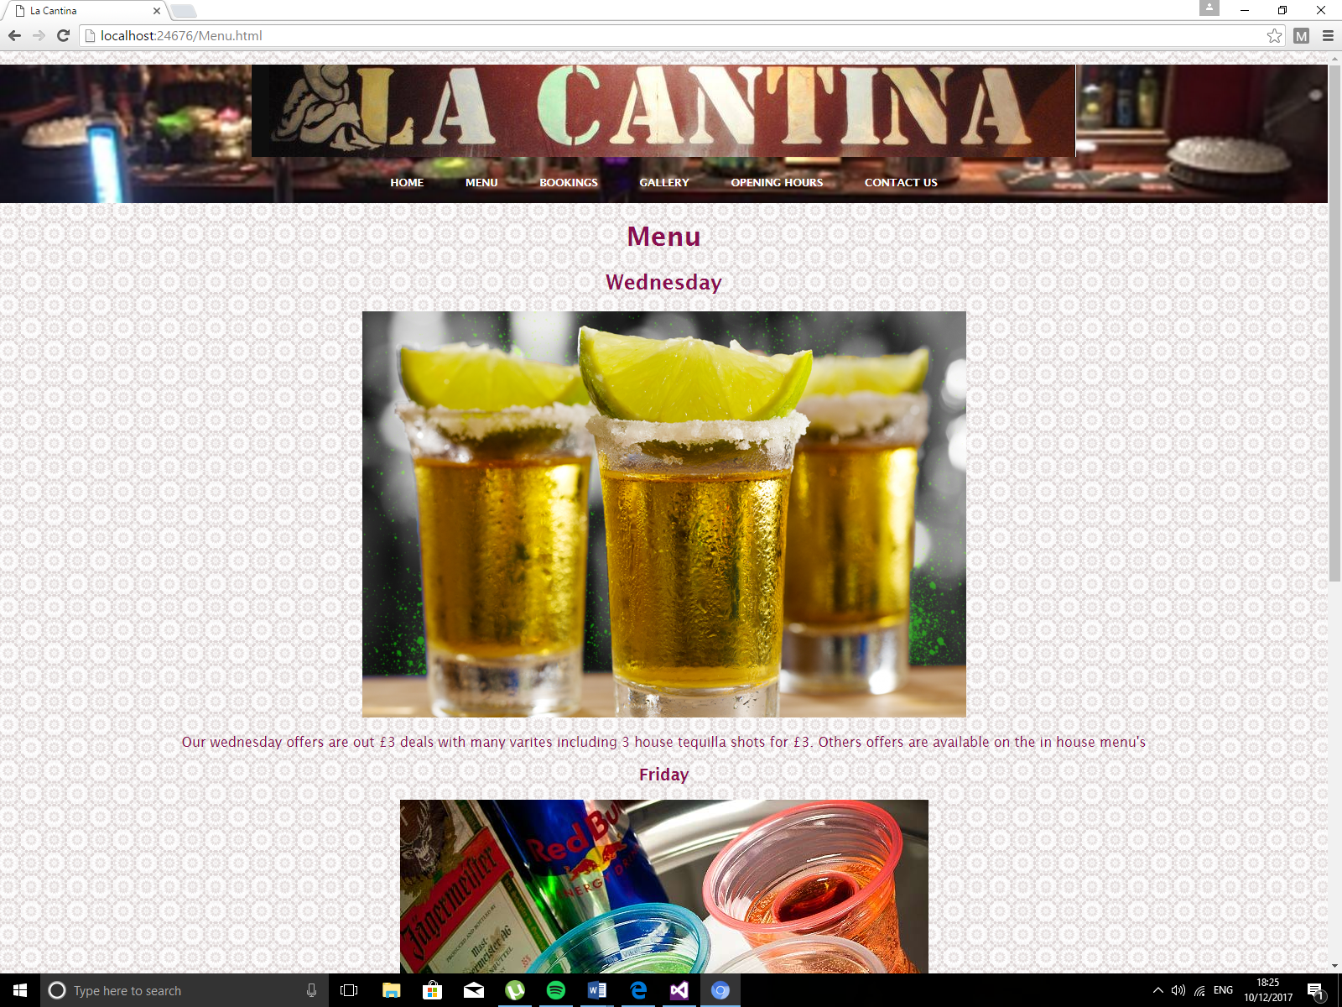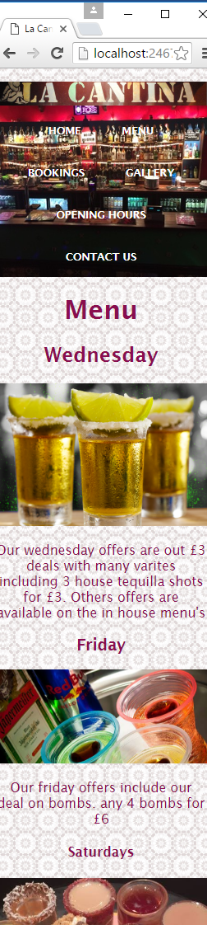
Above are screenshots of the menu page both in a large and small window as can be seen the page effectively displays the offers for each day the venue is open and does it in a responsive manner with all images and text reshaping appropriately. The page shows the 3 nights a week that the bar is open and then displays the main offers for that night along with a description the offer. The page also states that more offers are available inside the venue. Media queries are used here to validate the size of images to ensure they still look good.
Bookings

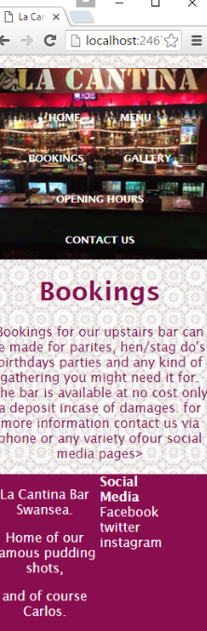
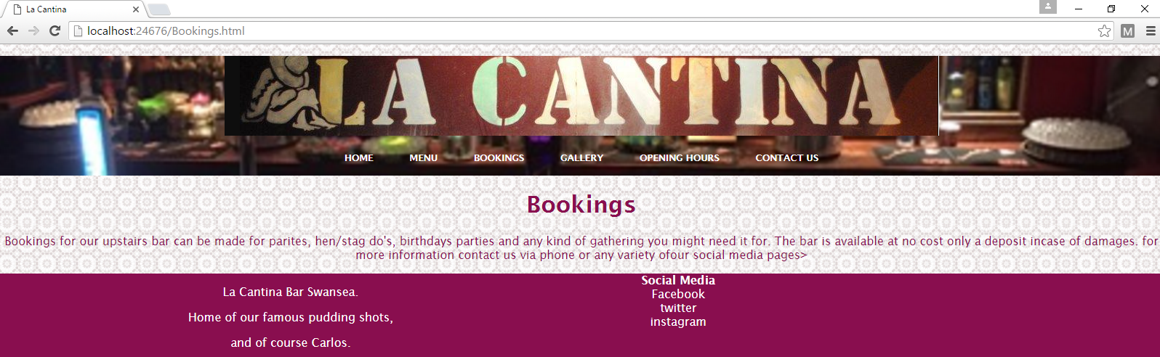
The third page of the website bookings is simply a paragraph with information concerning bookings. As can be seen the page does this effectively and responsively with the text the changing and reshaping effectively so that the page can be used in both large and small windows. Therefore, the page is responsive and fit for mobile.

Gallery
As can be seen by viewing the screenshots below the gallery page displays a selection of advertising images used by the venue on the Facebook page. Similarly, to the other pages included on the website the page includes the header images logo and navigation menu. Below in can be seen the effectiveness of using media queries. Inside the stylesheet for the website there some media queries that change the image sizes depending on the size of the device. Below is a good example of the website altering the image sizes.
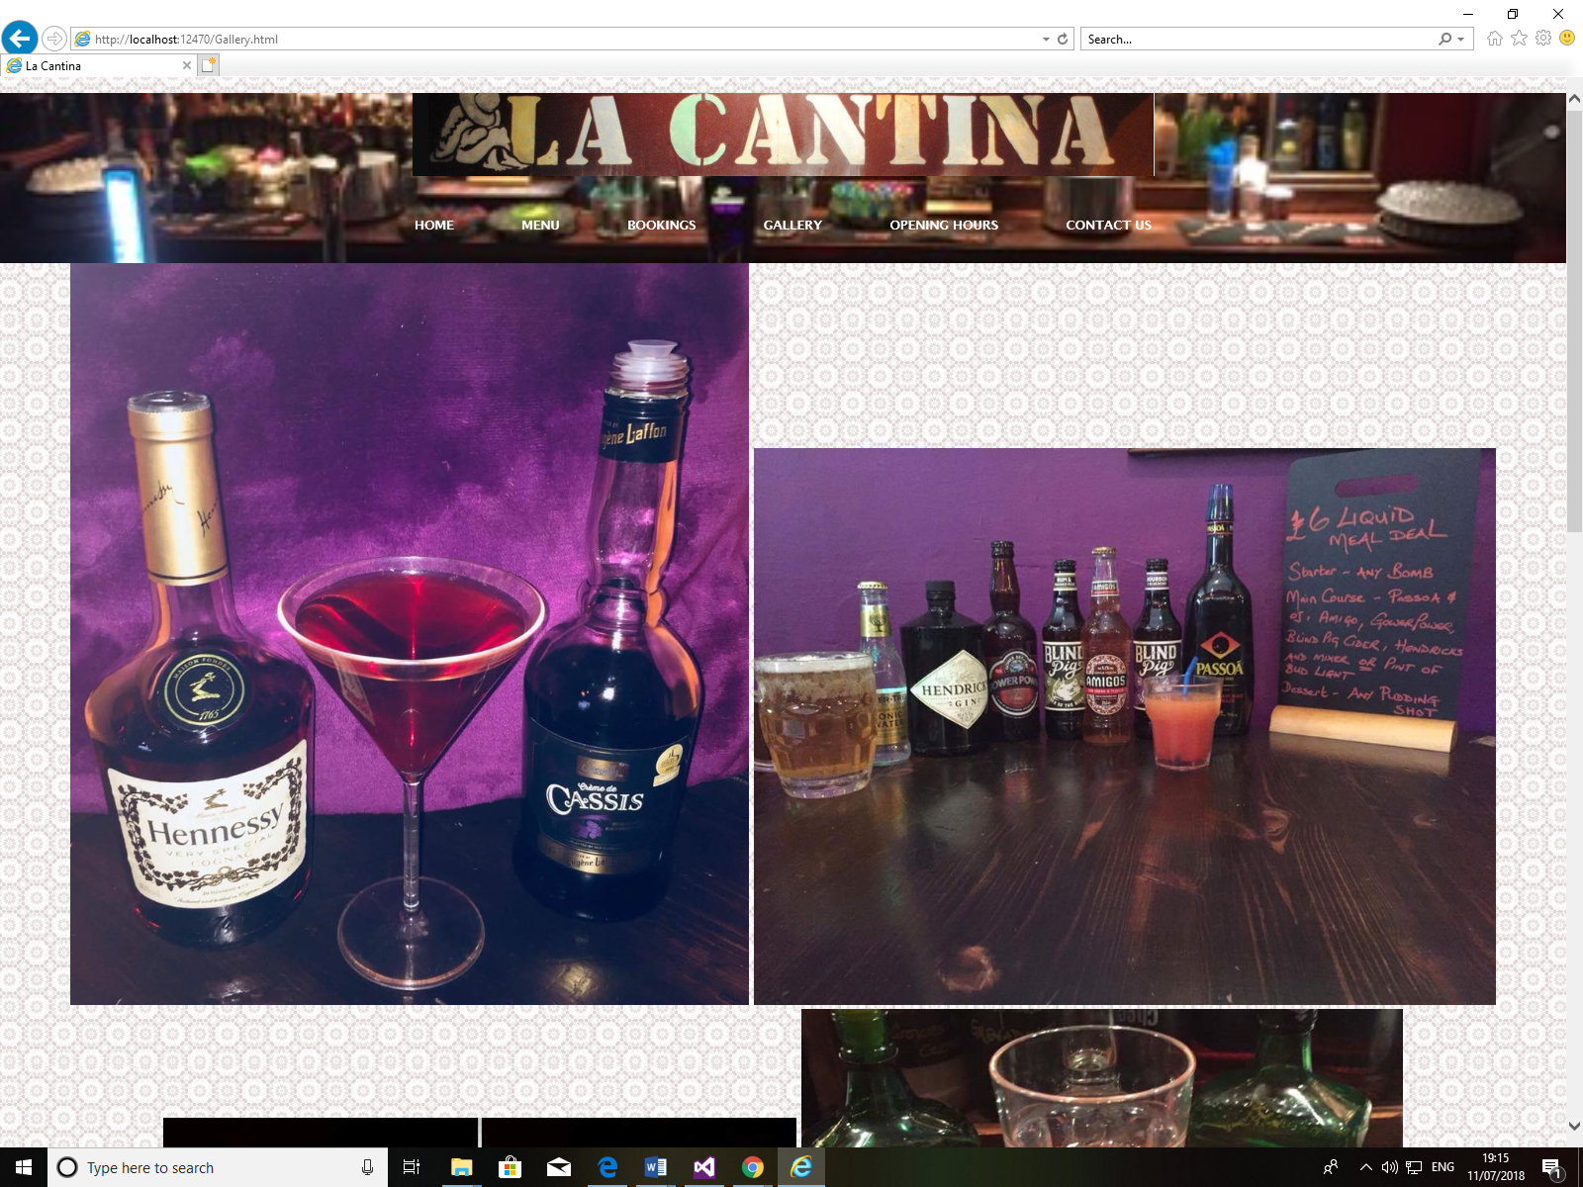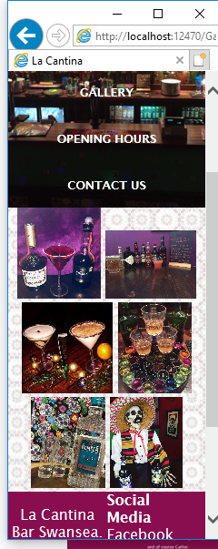
Opening times and contact us
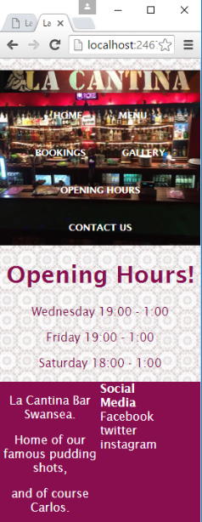
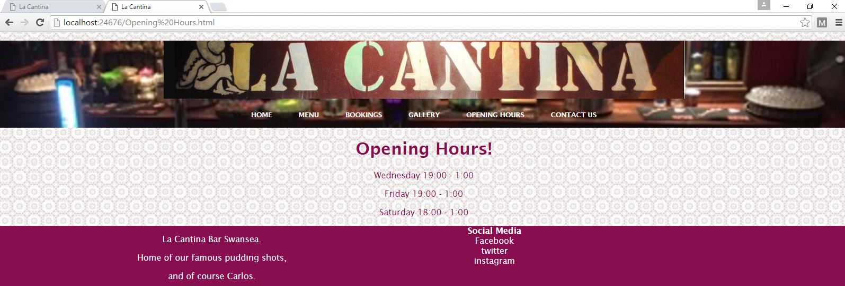
As can be seen by the screenshots above the website works effectively and responsively. The website effectively displays the days and times the venue is open. The contact us page is similar as the page only contains text and a button there fore it is also responsive and effectively does its purpose. It can be seen below.
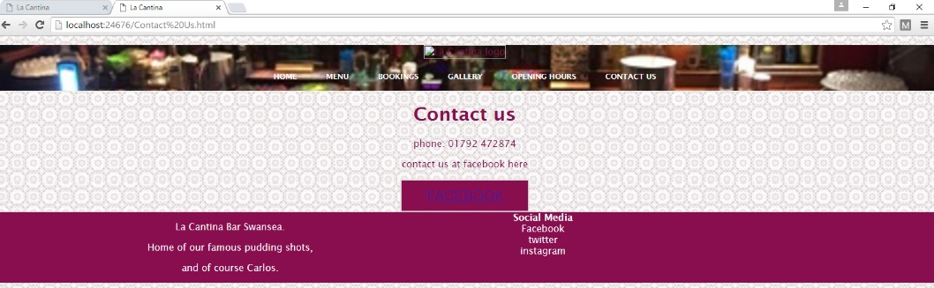
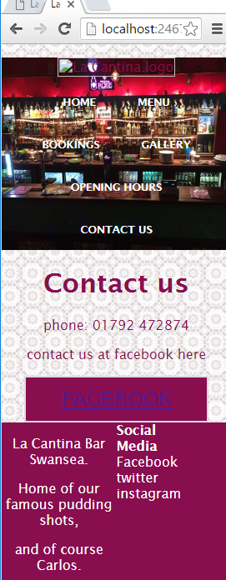

The images used throughout this website were taken from the venues Facebook page [1].

Evaluation
When developing this website, the author of this report came across a few errors when it came to ensure that website was responsive. Most of which came to finding images that were responsive and that were suitable for the website. Most of the images used are images taken inside the venue.
When adding media queries to the website it was essential to ensure that the correct image sizes were appointed for every device size. To overcome this the style sheet includes a series of media queries for each of the possible device
Looking back on task 1 the developer of the website and author of this report believes that the task can be considered a success despite the errors that have found during this report. As the website (despite the gallery page) is completely responsive and works effectively. All the working pages do what they were intended to do and as such are a success. The brief tasked the author of this report to create a responsive website and the website creating for this report is exactly that a completely responsive website.
The responsiveness of the website could be improved by consulting more of the responsive web design principles. For example, using breakpoints would enable the website to me more fluid. Would allow the layout to change more drastically when the device changes size.
Despite this it is obvious that much could be improved with the website. The bookings page could be greatly improved by providing a platform for users to be able to make booking through the website by using a php booking system to connect the website to a server-side database. This would allow the website to store any enquires and contact details in table that could be accessed by the website admin or business owner to view. This could not only improve the website’s effectiveness but also increase revenue by allowing the user to enquire about room bookings much easier. PHP could also be used to increment a booking system for the extra bar for those who wish to do so. The gallery page could be greatly improved by ensuring that the page functions correctly. The contact us page could be improved by the system allowing the user to leave a message for the venue staff via the website. In future add more images to the website and use higher quality images and improve the overall design of the website to make it more drawing to users. Improve the websites footer to ensure that the links to the venues social media accounts work. Finally, the author of the report feels that the website could be greatly improved both functionally and design wise by adding JavaScript to the website to add more features or design quirks.

References
[1] Facebook.com. (2018). Log in or sign up to view. [online] Available at: https://www.facebook.com/LaCantinaSwansea/ [Accessed 11 Jul. 2018].
[2] W3schools.com. (2018). HTML Responsive Web Design. [online] Available at: https://www.w3schools.com/html/html_responsive.asp [Accessed 11 Jul. 2018].
[3] Mayven | Software Design & Development | San Francisco & Austin. (2018). Mobile First Design: Why It's Great and Why It Sucks - Top Digital Agency | San Francisco & Austin. [online] Available at: https://mayvendev.com/blog/mobilefirst [Accessed 11 Jul. 2018].

Bibliography
W3schools.com. (2018). W3Schools Online Web Tutorials. [online] Available at: https://www.w3schools.com/ [Accessed 11 Jul. 2018].
Studio by UXPin. (2018). How to Use Media Queries in Responsive Web Design. [online] Available at: https://www.uxpin.com/studio/blog/media-queries-responsive-web-design/ [Accessed 11 Jul. 2018].
Ruluks, S. (2018). 9 basic principles of responsive web design. [online] Design the open web. Available at: http://blog.froont.com/9-basic-principles-of-responsive-web-design/ [Accessed 11 Jul. 2018].
Moodle.uwtsd.ac.uk. (2018). UWTSD Moodle 17/18: Log in to the site. [online] Available at: https://moodle.uwtsd.ac.uk/course/view.php?id=2285 [Accessed 11 Jul. 2018].

marking criteria and Student FEEDBACK

This section details the assessment criteria. The extent to which these are demonstrated by you determines your mark. The marks available for each criterion are shown. Lecturers will use the space provided to comment on the achievement of the task(s), including those areas in which you have performed well and areas that would benefit from development/improvement.

Common Assessment Criteria Applied (Assignment 1) | Marks available | Marks  awarded
1. Research-informed Literature
Extent of research and/or own reading, selection of credible sources, application of appropriate referencing conventions.
References are satisfactory, but there is room for improvement in the range of references consulted. Expanding the scope will also help you to further enhance your overall implementation and understanding of concepts. (Grade mark: 40.00%) | 5 | 2
2. Knowledge and Understanding of Subject
Extent of knowledge and understanding of concepts and underlying principles associated with the discipline.
Demonstrates a fairly good understanding of responsive web design (RWD), but there is also room for improvement. There is some use of media queries in this submission, but note that you should aim for a mobile first strategy. This means that your default CSS styles are for smaller screens and you use media queries to adjust for larger screens and/or any other special cases. (Grade mark: 46.67%) | 15 | 7
3. Analysis
Analysis, evaluation and synthesis; logic, argument and judgement; analytical reflection; organisation of ideas and evidence
A good discussion of some of the challenges faced and the provided evaluation is reasonable. (Grade mark: 60.00%) | 15 | 9
4. Practical Application and Deployment
Deployment of methods, materials, tools and techniques; application of concepts; formulation of innovative and creative solutions to solve problems.
A good attempt featuring a simple website with some well-thought-out content. Consider opening links to external websites in a new tab/window. Also, be careful with text on patterned background and ensure that there is enough contrast between the text and background. (Grade mark: 41.67%) | 60 | 25
5. Skills for Professional Practice
Attributes in professional practice: individual and collaborative working; deployment of appropriate media; presentation and organisation.
The report is of a good standard. (Grade mark: 60.00%) | 5 | 3

Assignment Mark (Assessment marks are subject to ratification at the Exam Board. These comments and marks are to give feedback on module work and are for guidance only until they are confirmed. ) | Late Submission Penalties (tick if appropriate) |  | 46%
 | Up to one week late |  | 46%
 | 1st/2nd/3rd attempt? |  | 46%

Note that as this is a RESIT attempt, the mark is capped at 40%.

