Name: Ema-Roxana Matei
Student number: 1816275
Module Title: M4X01915 – Hospitality & Guest services
Lecturer: Dr. Olu Adegbite

In this report I will be discussing the service provided by a five-star hotel chosen by myself, quality management, how the hotel adapts to customer preferences and reviews and how these changes impact guest service management. Guest service, also known as Customer service, is the interaction between the hotel and the consumer and is critical for the businesses’ success. In a hotel, guest services provide the visitors with help, facilities and support, for example guest services may include providing free drinks in the morning, afternoon or evening to the customers and room service or laundry. Within the hotel, quality management takes an important role as it oversees all activities and duties to conserve a wished level of eminence. Quality the board is an order for guaranteeing that yields, benefits, and the procedures by which they are conveyed, meet partner necessities and are fit for reason. This relates to the hotel that I have chosen which is The Milestone Hotel based in London because as a five-star hotel they provide an excellent experience with their helpful guest service and facilities.

The Milestone Hotel service provision is one of the best in London as it is number one on the charts for best hotels on TripAdvisor. Customers have the best experience in the hotel since the arrival to the departure because the staff is welcoming and very helpful. Guest service has an important role in this hotel as it provides an excellent encounter for the visitors and makes them feel as they are home, for example, if it is mentioned that consumers want to maintain special occasion, the housekeeping department will help with the décor and arrangements within the room they have booked in. Quality management is critical in this hotel because it aids the staff to manage the activities and facilities around the hotel, for example making sure that the front office has everything on point.
The central theme, hotel adaptation to changing consumer preferences, is analysed within the following evaluation. In a hotel, new faces come in every time of the day or night and have different selections and choices from what they eat to what they drink. Understanding your client's purchasing conduct is additionally significant. As an entrepreneur, you have to grasp what kind of individual is well on the way to need or need the item or administration you give. Clients need to feel that you esteem them and their patronage. You show this by selling them what they need and not simply the items you need to move, by approaching them with deference and kindness and by taking care of objections, issues and questions so clients finish up their business feeling fulfilled. Some people that book in rooms might have divergent requirements from others and wish for the food or drinks to be in a certain way, for example one person could be vegetarian and would only like to eat vegetable-based dishes or someone might be allergic to nuts and wants to make sure that what they order food nut-free. The hotel adapts to these changes that the customers make because the business must be to its best ability and assure that the visitors have the finest experience in the hotel. As the hotel has a wide data base, clients remain in the system with their personal preferences which means that is a person comes back to the hotel in the future, the staff would exactly know what they are most likely to prefer, e.g. if one’s allergic to the hotel’s shampoo, they can ask for an organic shampoo that does not cause an allergic reaction and the next time that person goes to the hotel would get the same treatment as last time because it would be written on the system about it. Changes to a hotel happen because of the different reviews they get from their customers, if multiple visitor complain about something then the manager takes that in consideration and makes sure that the problem is fixed in order to keep the hotel at its greatest. One advantage of the adaptation is that the hotel that takes in consideration the consumer’s preferences and ensures that the staff is well prepared for future visitors and their demands. If the hotel is to its best ability, then more people would be attracted to it and would most likely book in rooms. The staff is the most important in a hotel because they assure that everything is in place and supply aid to costumers, they are the ones who need to have the best knowledge of the hotel. It’s absolutely impossible your advertising systems can be fruitful on the off chance that you don't know whom you are showcasing to. Thusly understanding client inclinations gives your advertising efforts a superior possibility of yielding outcomes. Outfitted with the information on who your clients are, and their places of get in touch with you can successfully choose a reasonable media. The selection of media in advertising matters a ton since it decides if your clients get the message or not. Focusing on clients is vital to understanding their preferences. It might appear to be a tough assignment to take part in all the previously mentioned exercises just to get customers. Anyway, the prizes are incredible. Right off the bat you will significantly improve the picture of your association. Besides, you get various recurrent deals and even referrals. Note that the assessment of clients matter a great deal. This is on the grounds that a great many people will depend on their companions, family members and partners to disclose to them the best items and specialist co-ops. Thusly the negative understanding of a solitary customer can send away huge amounts of potential customers. It is in this way significant that an association puts however much as could be expected in understanding client inclinations.
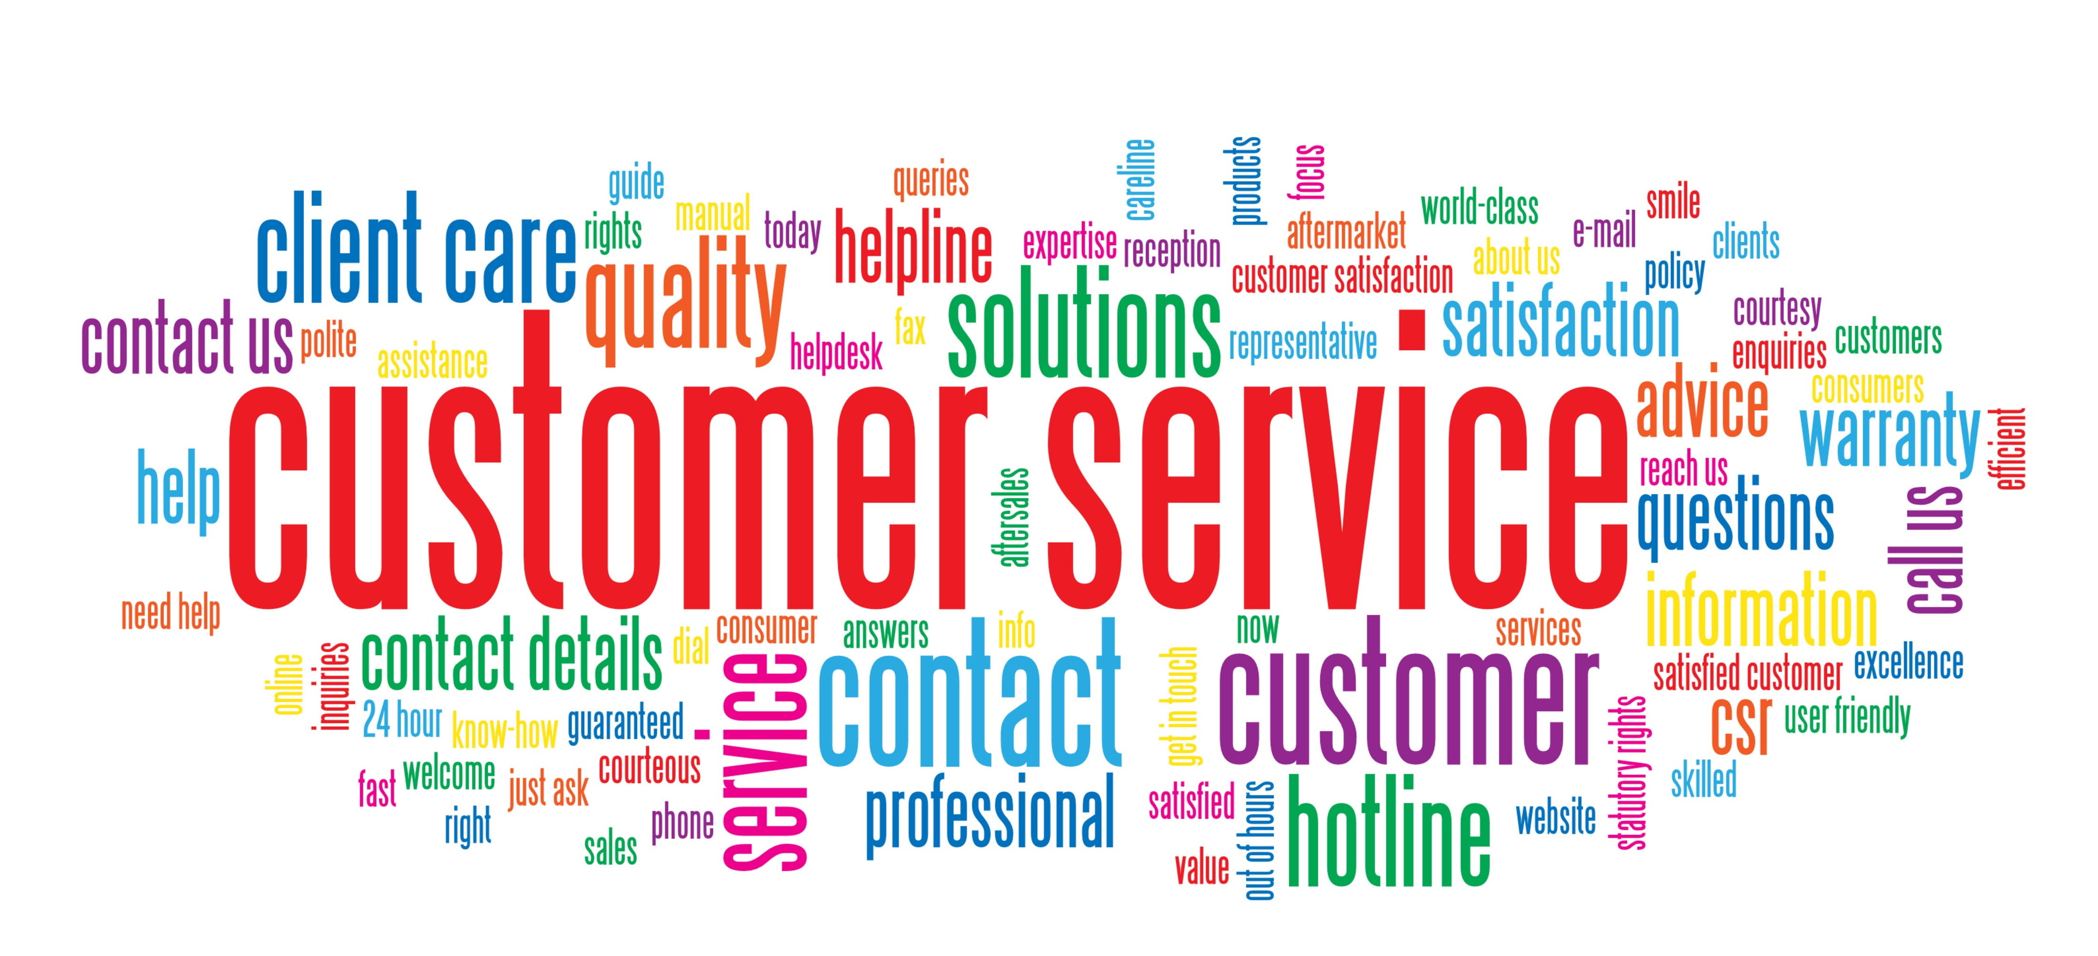
The significance of client support is that clients care about whether your business treats them well. You may have awesome items at incredible costs, yet on the off chance that your cutting-edge representatives are impolite or unhelpful, 68% of clients state that is a major issue. On the off chance that your client support and quality are first rate, you're substantially more liable to win their arrival business. Changing consumer preferences impacts guest service management can have advantages and disadvantages. One advantage of this is that the staff will know how to prepare themselves and how act with future customers and their requirements. They would have to pay more attention to what clients prefer and also will have to make sure they are on point with the client’s choices. Another advantage of this is that the business would increase economically as the hotel will improve and more visitors would come with pleasure to the hotel as the past clients gave good reviews. Also, guest service quality it increases sales and satisfied consumers are more likely to buy again from the hotel. It improves the manner in which individuals see your organization, which supports your notoriety and your image. As I was saying earlier, changing consumer preferences can have disadvantages and one of them would be that staff could make mistakes about the client’s requirements and forget about any personal demands. This is because five-star hotels have high demand of requirements which means that a lot of people book in rooms and have different problems, e.g. allergies. Another disadvantage is that, sometimes, the client’s complaint is not taken into consideration and a problem within the hotel might continue without anyone from the staff actually knowing about it, this could affect the business as people would avoid to go to the hotel because of this one certain thing or the person complaining might give a bad review of the hotel to other people and they would likely not visit and book in a room when needed. Bad reviews of a hotel can also have an impact on it as people would circumvent making their way to the hotel when they are supposed to. This affects the hotel financially because less clients would make reservations and less money would go in the business. Good reviews of the hotel have a good impact on the hotel as more people would hear nice things about it and would like to go and visit and maybe book a room when in a holiday or needed. This would have a good financial effect on the hotel because more people will like to join the hotel as past clients were happy with their accommodation and services. Staff should always understand the costumers’ wants and needs or if they are not sure what they desire the guest service should help them figure out. Within a hotel, the staff from guest service should at all times be honest with their customers and tell them when they don’t know the answer to a question, but in many hotels this is not the case as the employees know their services really well because they are well prepared for their job. The significance of administration quality is never more noteworthy than when clients are disappointed. In the event that they remain disappointed, it can cost you a client. They may likewise be feeling awful when they report their objections, so representatives need to keep their cool while managing a client who is losing hers. In this case, staff should be respectful and listen to the persons’ disappointments and maybe try to apologize for their bad service. Given the significance of administration quality, keeping the quality high ought to be a constant procedure. Have standard instructional meetings. Tune in to client input about their experience. Disappointed clients frequently simply quit coming, so don't utilize client grievances to your organization as the main metric. Potentially, your staff preparing is off, or organization arrangement doesn't address the clients' issues. It might Search on the web and see what clients state when they're conversing with other individuals. It might be difficult to keep each client upbeat, however in the event that you see a steady example to the surveys or remarks, that may show an issue that requirements fixing. be that the main problem is some kind of problem with your items that your assistance work area can't resolve.

Lastly, clients ought to be viewed as a benefit for any business or relationship, for without the client your affiliation would not exist. While client support strategies for the phone are gigantic, you ought to comparatively recognise how to reasonably interface with your clients extremely close. On the off chance that you get the telephone association right and the nearby help wrong, it can leave a horrible tendency for the client's mouth concerning your business, understanding the loss of offers.
At the point when you offer an incredible client care understanding, your clients are undeniably bound to stay and utilize your business any possibility the minute emerges. In any event, with regards to subordinate administrations, shoppers additionally ready to work with a business that they've had an incredible involvement in before than to discover another person. Dealing with your clients passes on a solid arrangement of virtues and convictions in the organization's crucial. It implies that it's rising above the need for benefits by concentrating on building its clan. It additionally implies that there are more noteworthy powers at work here than minor benefits. It's demonstrative of a more profound want to fabricate something of significant worth, to help other people, and to by one way or another, here and there or another, change the world a piece thusly.
In conclusion, guest service management and quality management have a significant role in a hotel because they control and make sure that the business is working well as it should be, also because clients rely the most on these two as they assure that they will have the best experience in the hotel. With these two, consumers make up their own opinion on the hotel and make sure they come back if they felt like the service given was excellent.
- Bizfluent.com. (2019). [online] Available at: https://bizfluent.com/way-5391180-face-face-customer-service-procedures.html [Accessed 20 Nov. 2019].
- Barone, A. (2019). Quality Management: An Inside Look. [online] Investopedia. Available at: https://www.investopedia.com/terms/q/quality-management.asp [Accessed 20 Nov. 2019].
- Collinsdictionary.com. (2019). Guest services definition and meaning | Collins English Dictionary. [online] Available at: https://www.collinsdictionary.com/dictionary/english/guest-services [Accessed 20 Nov. 2019].
- Our Insight. (2019). 5 reasons good customer service is important | Ameritas Insight. [online] Available at: https://www.ameritasinsight.com/wellness/health-and-wellness/good-customer-service [Accessed 20 Nov. 2019].
- Adams, R. (2019). 10 Reasons Why Good Customer Service Is Your Most Important Metric. [online] Entrepreneur. Available at: https://www.entrepreneur.com/article/284799 [Accessed 20 Nov. 2019].
- Clark, A. and Clark, A. (2019). Understanding Your Customer Preferences - I Want it NOW. [online] I Want it NOW. Available at: https://iwantitnow.walkme.com/understanding-your-customer-preferences/ [Accessed 20 Nov. 2019].
- DMNews.com. (2019). The Importance of Customer Preference. [online] Available at: https://www.dmnews.com/data/article/13036702/the-importance-of-customer-preference [Accessed 20 Nov. 2019].
- Survicate. (2019). 5 Reasons Why Customer Satisfaction Is Important - Survicate. [online] Available at: https://survicate.com/customer-satisfaction/importance-customer-satisfaction/ [Accessed 20 Nov. 2019].

