
SOFTWARE SOLUTIONS FOR BUSINESS
Component 1 Coursework Portfolio

Student Name | Nazmean Akhtar
Student ID | 2543383
Programme | CertHE Computing Skills for Workplace
Module | Software Solutions for Business
Module Code | ACCA4026
Lecturer(s) | Osman Elgawi; Mohd Syafiq Bin Zolkeply
University | University of Wales Trinity Saint David
Submission Date | 27th November 2026

Table of Contents
Table of Contents ii
List of Figures iii
List of Tables iii
Task 1 e-Commerce Website Builders 1
1.1 Context and Selection Criteria 1
1.2 Shopify 1
1.3 WooCommerce 1
1.4 Comparative Evaluation and Recommendation 2
Task 2 Mind Mapping for Business Operations 3
2.1 Concept and Business Benefits 3
2.2 Critical Limitations and Good Practice 3
2.3 Mind Map of Contemporary Applications 4
Task 3 Office Applications for Business Information 5
3.1 Four Office Applications: Evaluation 5
3.1.1 Microsoft Word 5
3.1.2 Microsoft PowerPoint 5
3.1.3 Microsoft Excel 6
3.1.4 Microsoft Access 6
3.1.5 Comparative and Information-Lifecycle Evaluation 7
3.2 Practical Test 1: VLOOKUP 9
3.3 Practical Test 2: IF Function 11
Task 4 Communication and Collaboration Applications 13
4.1 Application Analysis and Comparative Evaluation 13
4.1.1 Slack as a Communication Application 13
4.1.2 Trello as an Online Collaboration Application 13
4.1.3 Comparative Judgement and Governance 14
4.2 Practical Tests: Communication and Collaboration Features 15
4.2.1 Slack Thread 15
4.2.2 Trello Card Movement 17
References 19

ii

List of Figures
Figure 3. 1 Product_Catalog worksheet used as the VLOOKUP master-data source... 10
Figure 3. 2 Orders worksheet populated through exact-match VLOOKUP formulas..... 10 Figure 3. 3 Show Formulas audit view confirming the fixed lookup range and FALSE exact-match argument ...................................................................................................... 11 Figure 3. 4 IF function comparing current stock with the retrieved reorder level ............. 12
Figure 3. 5 Filtered exception view showing the six records flagged for purchasing review
.......................................................................................................................................... 12
Figure 4. 1 Simulated #website-launch channel retaining routine updates in the main
conversation ..................................................................................................................... 16
Figure 4. 2 Threaded diagnosis, test evidence and final decision for the mobile-checkout
issue .................................................................................................................................. 16
Figure 4. 3 Simulated board with the mobile-checkout card in progress and three of five
checks complete ............................................................................................................... 17
Figure 4. 4 Simulated board after the retested card reaches Done with five of five checks
complete ........................................................................................................................... 18

List of Tables
Table 1. 1 Decision-oriented comparison of Shopify and WooCommerce ....................... 2
Table 3. 1 Comparative suitability of Microsoft Office applications .................................. 8
Table 4. 1 Comparative role of Slack and Trello in a modern business workflow .......... 15

iii

Task 1 e-Commerce Website Builders

1.1 Context and Selection Criteria
An e-commerce platform is not just a website editor, but a virtual store with catalogue control, payment, order processing and management information for a small or medium-sized enterprise. However, research relating to small business digitalisation links e-commerce with reach and resilience, while also revealing that the lack of resources, skills and trust are barriers to ecommerce adoption [1]. The best option, therefore, is dependent upon operational ability, risk, and not length of feature list. Shopify and WooCommerce are two very different modern models: a Software as a Service (SaaS) hosted software and an open source WordPress plugin.

1.2 Shopify
Shopify offers hosting, store administration and commerce capabilities in a single integrated solution. It currently features unlimited products and bandwidth, fraud analysis, manual orders, discounts, market-specific pricing, abandoned-checkout recovery, analytics, finance reports, and online sales channels and point-of-sale support [1]. The setup can cut down the implementation time and lower the burden of server upkeep, security patching and platform upgrading for a growing retailer like the fictional Northstar Office Supplies. A uniform administration system also facilitates the coordination of products, customers and orders from non-specialist staff. The drawback is Shopify's dependence on its subscription, transaction and application ecosystem. Expenses may increase with specialist extensions, and there is a reduced level of server-based control or flexibility over the redesign of processes. Shopify is better suited for situations where the need for quick, consistent deployment and management is more of a priority than the depth of technical independence.

1.3 WooCommerce
WooCommerce is an open-source commerce extension of WordPress. Product features include presentation, measurements, review, inventory, notification, and notify to downloadable products [3], and order management includes statuses, filtering, manual orders, payment flows, privacy actions, testing, and abandoned cart recovery [4]. The integration of content and commerce is tightly coupled, the business selects the host it wants to use and can customise the store with themes, extensions or custom-built code. By appearing free, it passes on operational responsibility to the organisation or their supplier. The hosting environment, backups, updates, plugin compatibility, cyber-security and troubleshooting should all be managed on purpose, so that having a zero-cost core doesn't mean a low total cost of ownership. WooCommerce best fits when a WordPress feature already is present, and there's a legitimate and understandable maintenance strategy available.
Table 1. 1 Decision-oriented comparison of Shopify and WooCommerce
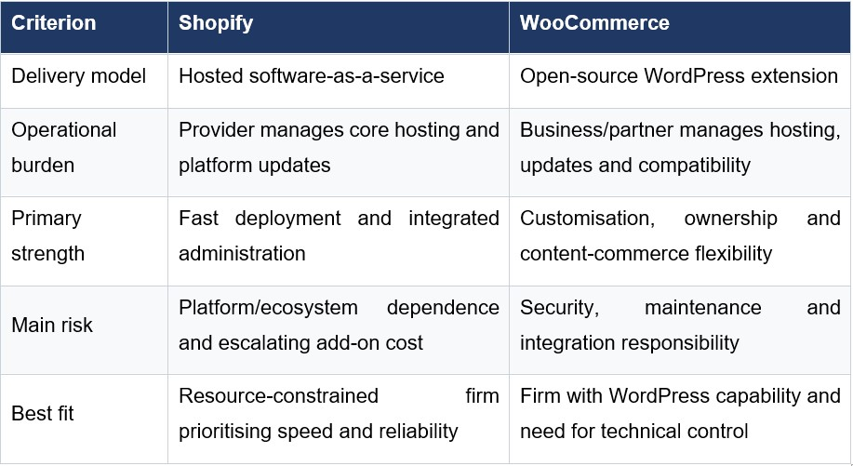

1.4 Comparative Evaluation and Recommendation
The central issue is a governance trade-off. Shopify embeds more of the tech details within itself and will probably work best for a retailer whose resources are limited and who is looking for speed, uniformity and measurable assistance. While WooCommerce can offer more visibility into areas of technology use, with a more customizable opportunity, it does that when businesses are willing to navigate change and integration risk. Shopify would be the initial best option for Northstar if the point was to roll out an omnichannel strategy rapidly with minimal technical force, while a bold strategy of differentiated content, data control and constant customisation may be more appealing in WooCommerce. The main priorities to consider before committing are the headline monthly cost, migration options, integrations, security responsibilities and capability of staff, rather than three-year total cost. This is a context-dependent point of view, far more useful than pretending you know that either platform is a superior platform. This is recognised as an opportunity for AIassisted planning and language refinement in [1].

Task 2 Mind Mapping for Business Operations

2.1 Concept and Business Benefits
Mind mapping is a visual approach that shows the application of connecting objects or ideas from a central theme or problem on branches, keywords, and sub-branches. Unlike linear notes, it shows the association and hierarchy in a single view without losing the global pattern, enabling a user to navigate from a high-level problem to the parts. Mind mapping is defined as the process of creating ideas, making notes, organising thoughts and building concepts in mind maps using a meta-analysis, and it was found that the overall effect was positive in the studies that were analysed [5]. This evidence primarily comes in the form of education but also applies to business activities where employees are required to externalise and cluster complex knowledge and discuss it.
The first advantage in business activities is structured exploration. A team can discuss the proposed service instead of introducing it into a paragraph discussion, and requirements gaps and duplicated assumptions become apparent early on in the requirements discovery. Secondly, it is advantageous for alignment that they share the map. Concept maps proved useful in exploring shared understanding in a multi-disciplinary context in a recent project case [6]. Third, Maps can help to improve meeting preparation, onboarding, and knowledge transfer by allowing a new employee to identify how the functions relate, rather than just being handed a list of functions. They also facilitate decision preparation. Alternatives, evaluation criteria and consequences can be organised around an 'alternative software' decision question before a formal decision is written. Rather than being decorative, the benefit is that the reduced fragmentation of the brain and the shared reference point for discussion.

2.2 Critical Limitations and Good Practice
Mind maps nevertheless have boundaries. Concept maps can be constructed in a diverse manner, with open-ended research reports, while emphasising that the application and analysis should be coherent with the purpose of the map [7]. In practice, map complexity or clutter can obscure priorities, vague connections can have the effect of suggesting connections that have never been validated, and an appealing appearance can lead to inaccuracies. The mind map cannot be substituted by a process model where sequence and control are important, a timeline where dates and dependency are important, or a database where records need to be validated. Good practice involves keeping the question/s in focus, keeping branch length manageable, applying consistent labels, and reviewing the map with stakeholders to convert agreed branches into actions or requirements [20].

2.3 Mind Map of Contemporary Applications
In the case of the simulated software for Northstar's application, these concepts are illustrated in Figure 2.1. The first-level branches are divided into eight different aspects such as office productivity, communication, collaboration, cloud storage, customer relationship management, finance, e-commerce, and business intelligence. Under each branch, application examples are provided which relate applications to actual outcomes, not just brand names. Complementarity is also represented on the map, as data about transactions in e-commerce can be recorded in cloud services and then analysed in Excel or Power BI, shared in Slack and turned into tasks in Trello. A systems view can help avoid the standard procurement trap of choosing individual tools without keeping an eye on information flow, ownership and integration. The planning and refinement of language is supported by AI in this task, as noted in [1].
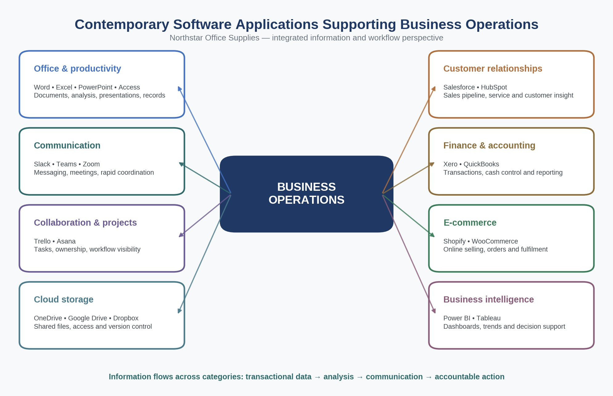
Figure 2. 1 Mind map of contemporary software applications supporting business operations
Source: Author

Task 3 Office Applications for Business Information

3.1 Four Office Applications: Evaluation
Office applications transform business information into useful documents, presentations, calculations and records. Their value is greatest if they support the structure of information desired in the document: Information that conveys a story should be in a document system, an audiencefacing argument in a presentation application, quantitative models in a spreadsheet, and repeatable relational records in a database. The following evaluation is thus a comprehensive assessment of features, control, business fit and limitations.

3.1.1 Microsoft Word
Word is used for text-based communication that has a logical flow, like policies, proposals, reports, contracts, procedures and customer correspondence. Repeatable production is possible by using styles, headings, templates, tables and captions, references and mail merge, and decision-making is made easier through comments and Track Changes. OneDrive allows Word to be shared and co-edited, showing participants where they are working, and providing options for accepting or rejecting edits [8]. A controlled template might standardize how suppliers try to handle records for Northstar, which helps ensure consistency in the brand and ease the process of easing the need for reformatting. Also, when Word is governed by Version control and Ownership, there is an auditable history from Draft to Approval. It falls short if consumers adopt it as a "one size fits all" information system. Finally, large numbers of data entries can be hard to validate, two or more people can edit them at once, and roles can be ambiguous. As Word is the approved presentation layer for approved narrative information, it should not be the master source for stock, sales or customer records.

3.1.2 Microsoft PowerPoint
Microsoft PowerPoint. PowerPoint is based on a visual sequence and is appropriate for management briefings, training, sales proposals and project updates. Templates, layouts, charts, diagrams, images, media, and speaker notes guide an author in communicating detailed evidence into a story told for an audience. Presenter View is useful for presenters because it shows them the current slide, the next slide, and Private Notes with timing, annotation and navigation controls [9]. Designers can suggest professionally formatted layouts for pictures, charts or tables, with certain capabilities requiring Microsoft 365 and connecting services [10]. From a business perspective, PowerPoint is useful when making decisions that need explaining and emphasis, not just raw facts and statistics. An Excel-based sales analysis can be summarised into a “regional performance briefing” by a Northstar manager, and the detailed workbook may be held as a challenge document. The greatest danger here is rhetorical oversimplification: there's a big danger of having glossy visuals that are not backed up by great uncertainty, likewise, a lack of methodological aspects, or even too heavy a decorative overlayer on your viewers. Requires a clear message, contrast that is readable, meaningfully presented charts, easy-to-understand alternative text for images, and an evident trail of connections between conclusions and source data.

3.1.3 Microsoft Excel
Microsoft Excel. The spreadsheet in Excel is a flexible, versatile grid that can be used to gather, compute, filter, summarise and display numeric or categorical data. It's ideal for budgets, pricing, sales analysis, stock monitoring and operational models, and can include tables, formulas, conditional formatting, charts and what-if tools. IF performs one operation on true and another on false; VLOOKUP looks up a value in a particular column and returns it after searching the far left column of a table, with FALSE if the value is found exactly [11] [12]. The functions can interact with each other and load standard master data into the function and parameters and exception contracts as rules that flag for action. Another weakness of the spreadsheet program Excel is flexibility. Formulas can be rewritten, assumptions can be unknown, and a workbook may be an informal critical system with no documentation, assurance or review. Spreadsheet-risk awareness was associated with recognised organisational standards, based on survey findings, and identified little uptake of the use of the features for mitigating risk [13]. Northstar should thus implement data validation, protected formula cells, named tables, version control, and peer review and reconciliation totals. Of course, Excel can do the job nicely in the small-scale domain for transparent analysis, but this is not a replacement for a controlled transactional database.

3.1.4 Microsoft Access
Microsoft Access. Access is a relational database software application for storing multiple related subjects in multiple tables and associating them by establishing keys and relationships. A key characteristic of the central objects of this approach, namely tables, queries, forms and reports, is that they allow for the separation of the way data is stored from how it is retrieved, presented and used [14]. As a result, for instance, Northstar might have supplier stored only once and product only once, and purchase order only once, rather than having to re-enter the supplier information again and again in flat spreadsheet files. Validation rules and controlled forms answer operational questions with queries, and provide consistent output with reports. Thus, Access is better suited if the many records have repeatable relationalities and the users need control over input while not needing to perform any calculation ad hoc. But it's still a departmental solution and not an open enterprise platform. According to the Microsoft specification, the database size is capped at 2Gb (excluding system space), and the number of users is 255 [15]. From a practical standpoint, there's a Windows dependency, database-design knowledge and less suitability to high-volume Web transactions, among others. They require some normalisation, primary keys, permissions, a planned path for migration and maintenance if they are required to scale or in the event of an increased availability requirement.

3.1.5 Comparative and Information-Lifecycle Evaluation
Comparative judgement: Table 3.1 shows that the four applications are complementary. Word's strength is in the long-form narrative, PowerPoint is about focused attention and oral presentation, Excel is about quantitative reasoning while working transparently, and Access provides the relational integrity. Transferring information between them should be meaningful: Controlled records are stored in Access or another business system, an approved extract of the system is analysed in Excel, the conclusions are put together in a PowerPoint, and the final decisions or procedure are recorded in Word. When presentation files become data stores, spreadsheets are uncontrolled multi-user databases, or database outputs communicated without interpretation, problems must occur. The proper business question is what business information structure, what level of the business information decision and control does this task require?

Table 3. 1 Comparative suitability of Microsoft Office applications
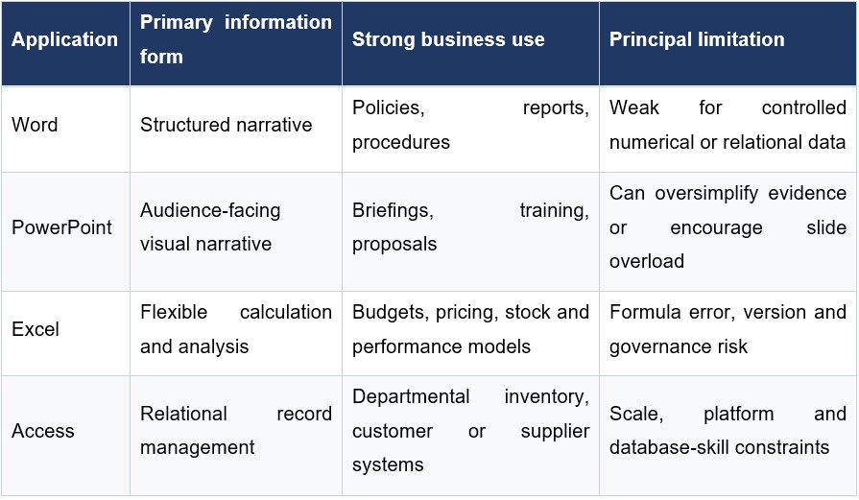
Information Life Cycle and control: An implementation at the distinction level should also include the study of information flow between applications. Distribution data and product data could be stored in Northstar, exported as a read-only dataset to Excel with a stamp and date, analysed to calculate performance metrics, reported in PowerPoint and approved as a corrective procedure in Word. Any transfer must have a named owner, purpose, triggering/reconciliation date and a point where checking occurs to tell a user which data to trust. Otherwise, handy copies turn into ghost versions, and decisions can be made with rough or varied numbers. Access to people should match job roles. Excel input and formulas should be distinguished visually and secured, whereas Word documents should be defined by version, own and approved status of a document, and PowerPoint claims should link back to the analytical input. Operational accessibility features meaningful headings, alternative text, readable contrast, descriptive links, and sensible structures to make information accessible to a broader workforce. Training should emphasise judgement along with buttons – when using a spreadsheet is more appropriate than a database, how checking an extract is appropriate, when a slide needs supporting detail. Business value in the suite is thus not just about having a licence; it is the result of an information lifecycle managed and governed their way.
Selection and cost: Selection also needs to be put in context along with cost. Microsoft 365 can minimise installation and version conflicts on the local platform, but at the same time, you will face subscription fees, storage costs, support, training fees, etc. The availability of access depends on the device and licence deployments, and Collaboration via the cloud relies on connectivity requirements and identity management. A sound business case should be made against comparison with licence costs, reduced error, improved reporting, reduced duplication, etc., versus time saved. Also, it should consider adoption risk: technically capable software is worth little if one forgets to adopt it, definitions are not uniform, or staff keep their own personal files. Therefore, the benefits of deployment are less legitimate than those of work-based training, agreed data definitions, named application owners and the notion of short, task-based training. Design and validation of tests for practical: The two Excel tests to follow are based on this same fictional scenario, rather than on separate functions, to produce a coherent process. Product master data and twelve order records were created specifically for assessment; no live customer, employee or employer data were included. Tested inputs, expected output, and extremes were verified prior to taking screenshots. The absolute references are hard-coded to the rows and columns the formula references, while a relative reference adjusts down a rule. This testing strategy is repeatable, and shows evidence of operation and verification. There was a separate verification sheet which recorded outcomes in the catalogue and stock decisions, thus allowing the errors that occurred in formula/reference to be determined prior to documenting evidence.

3.2 Practical Test 1: VLOOKUP
Synthetic, non-sensitive data was used to design a controlled workbook for the fictional Northstar
Office Supplies. There are eight product codes named on the Product_Catalog worksheet (Figure
3.1), which are provided with standard names and categories, unit prices, and reorder levels. There is an Orders worksheet, which includes an Order number, Product Code, Quantity, and
Current Stock amount. The controlled master data is then retrieved by VLOOKUP. The formula =VLOOKUP($B2, Product_Catalog!$A$2:$E$9,2, FALSE) in cell C2, for example, will return the name of the product when the return-column index is changed; in turn, category, price or reorder level will be returned. FALSE was chosen due to the risk that an approximate match would present: One product code always needs to match one catalogue record. The populated results are shown in Figure 3.1, and the Formula view confirms the fixed lookup range and copied formulas in Figure 3.2. The test provides a tangible advantage for the process of the model. Staff can enter a short code only once, and standard description and price are used repeatedly, which will reduce the keys to be rekeyed and will help orders to be taken faster. The findings were double-checked independently with the Catalogue, and 12 records were found with a result as expected. However, even though governance can be enforced, it will be necessary that an invalid code returns #N/A, the keyword must always be in the leftmost column in the lookup table, and hard-coded column numbers will be prone to error of change when the table structure changes. Therefore, data validation, error handling, protected catalogue cells and periodic reconciliation are necessary prior to operational use.
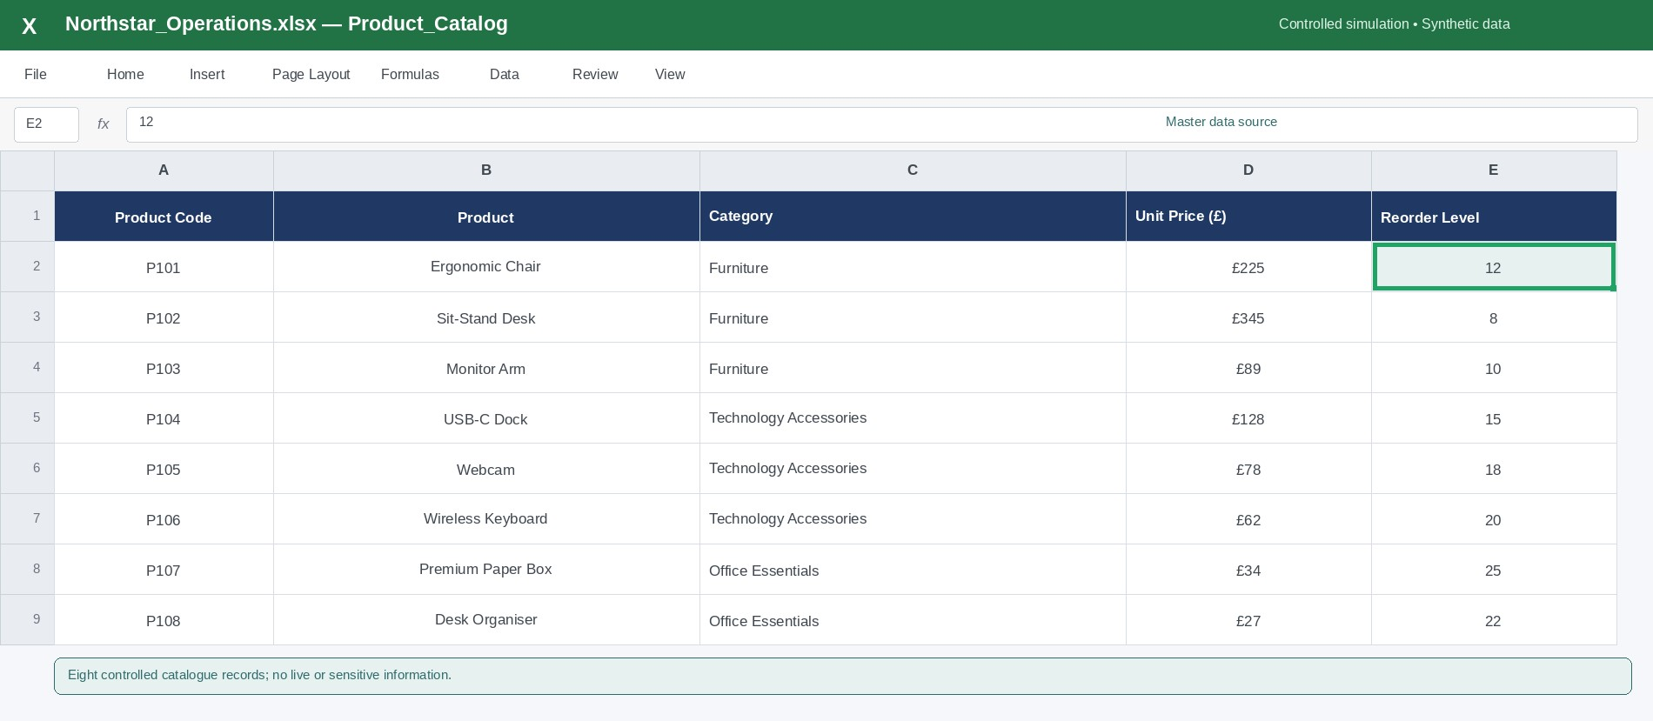
Figure 3. 1 Product_Catalog worksheet used as the VLOOKUP master-data source
Source: author’s controlled Excel simulation; synthetic data
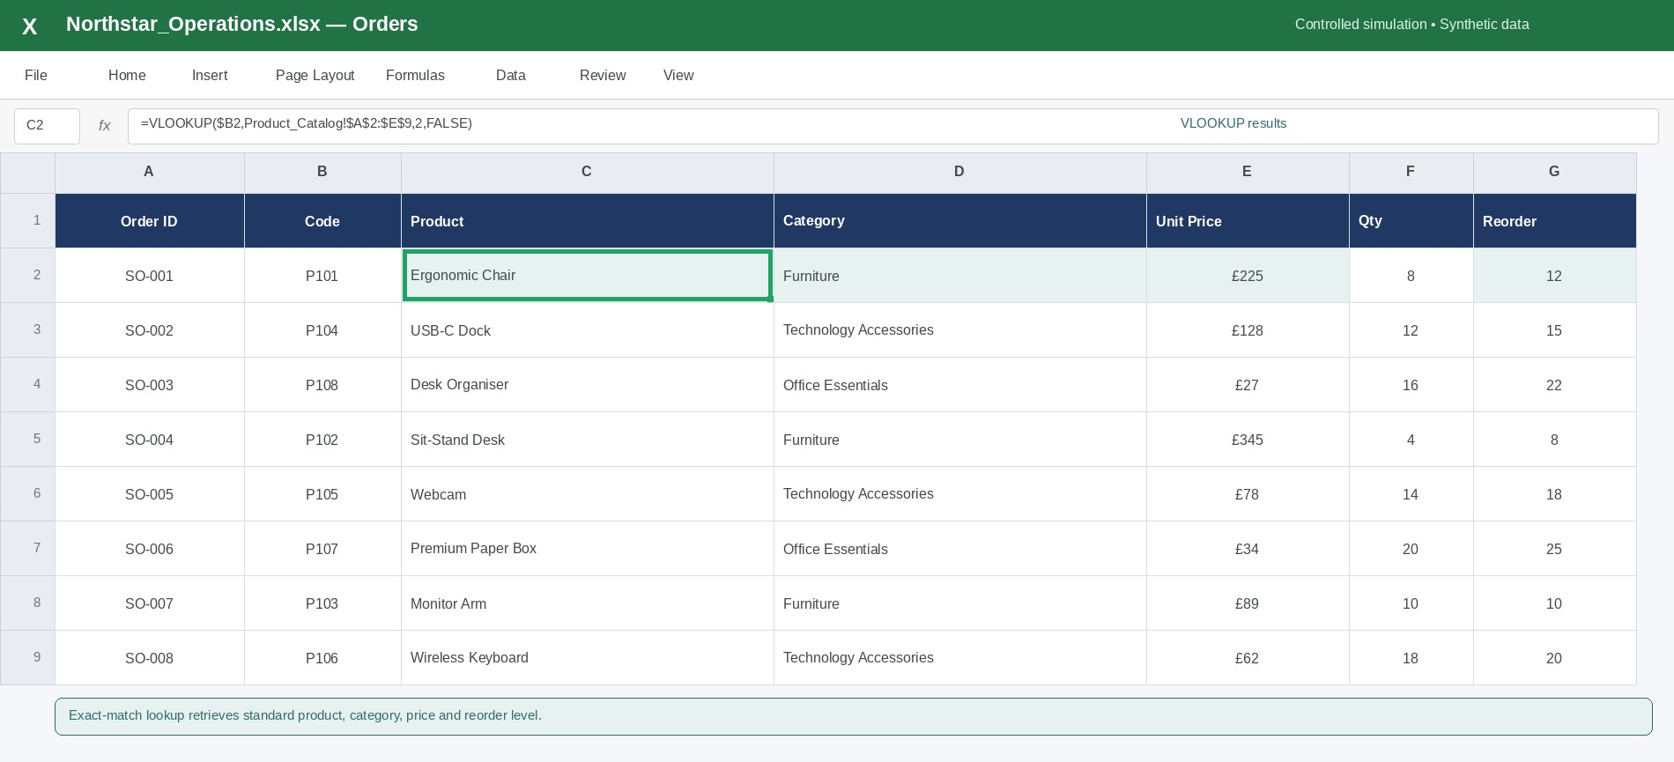
Figure 3. 2 Orders worksheet populated through exact-match VLOOKUP formulas
Source: Author
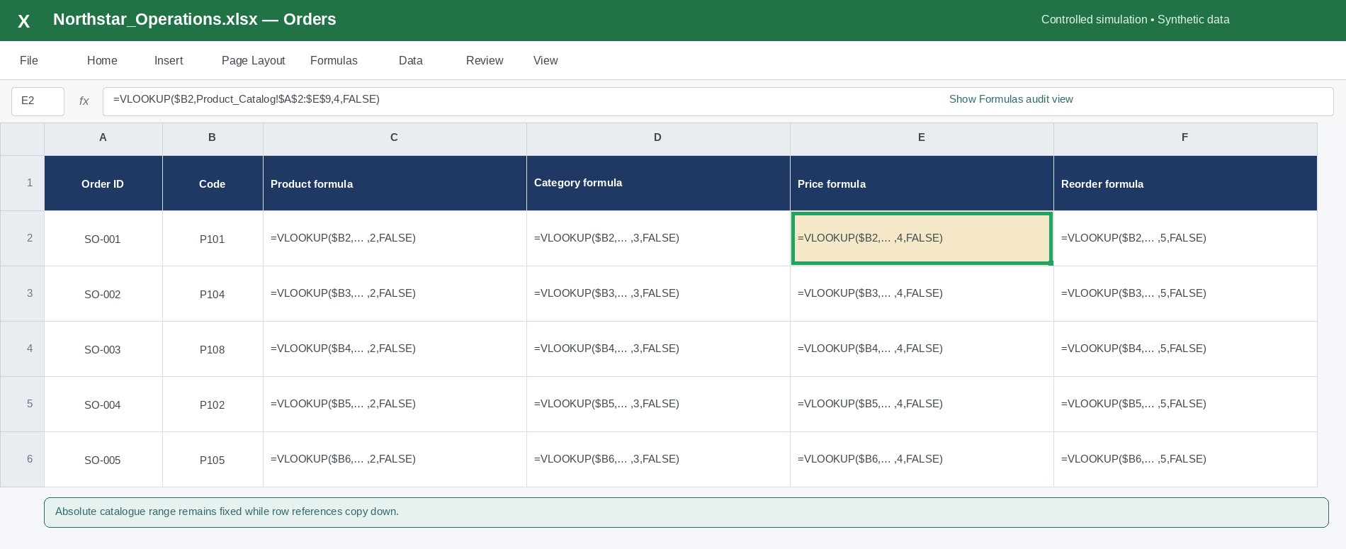
Figure 3. 3 Show Formulas audit view confirming the fixed lookup range and FALSE exactmatch argument
Source: Author
The sample also allows you to interpret it quantitatively: the unit prices retrieved can be multiplied by the quantities and should produce a uniform order-value field that can be used by a purchasing manager to rank the commitments without having to search through a price list. The catalogue is the only reference as the authorised price change can be cascaded through to subsequent calculations. Historical orders should always record the actual applicable selling price of the transaction, and not indefinitely recalculate from the transactions catalog. This provides the difference between current master data and the history of the transactions; this will be key to the auditability.

3.3 Practical Test 2: IF Function
The IF function is used in the same workbook to convert stock data into an exception driven purchasing signal. Current stock (H2) is being compared with the standard reorder level (G2), because of the =IF function. It customer accounts when stock level is at or under the threshold or otherwise it returns SUFFICIENT. The formula and results are displayed across the order sample in Figure 3.4 and the six flagged products are further filtered down to an action view in Figure 3.5. It's helpful for the operational aspects as a buyer can focus on the exception instead of reading through each quantity, and it indicates a rule that's easy to take a quick look at. Results involved numbers less than, equal to and greater than the threshold; all showed equality as an alert, supporting the <= operator. The result, however, is a decision prompt and not an independent purchasing directive. This ignores supplier lead times, open purchase orders, seasonal demand and minimum order volumes or cash constraints. If it is a stronger system, then the flag would be used in conjunction with forecast demand and approved supplier data. Thus the test proves useful in two ways: It shows true skill and appropriate scepticism, Excel can run orderly and fast, but management needs to determine if the rule is actually the case or not. AI-supported planning, synthetic-data design and language refinement for this task are acknowledged in [1].
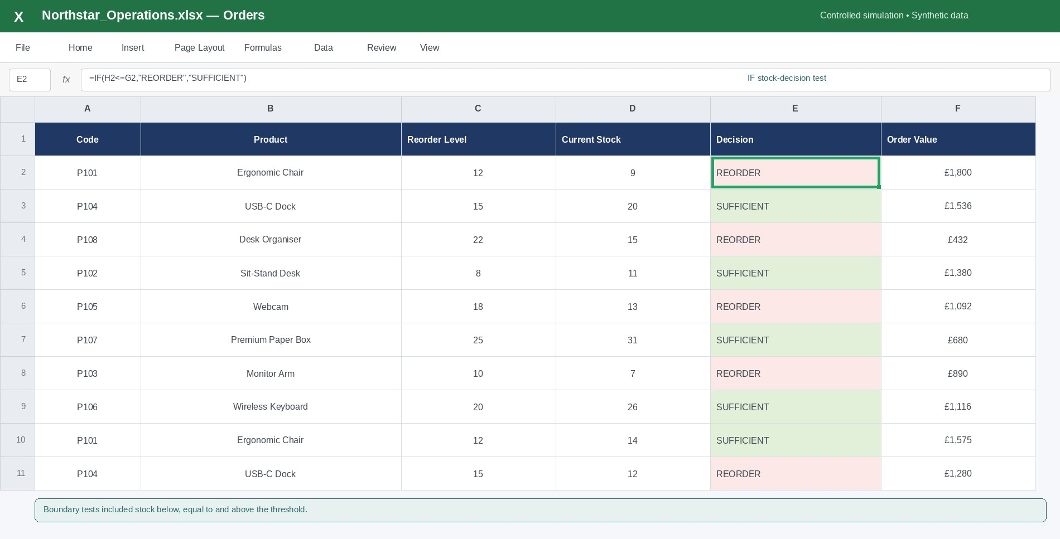
Figure 3. 4 IF function comparing current stock with the retrieved reorder level Source: Author
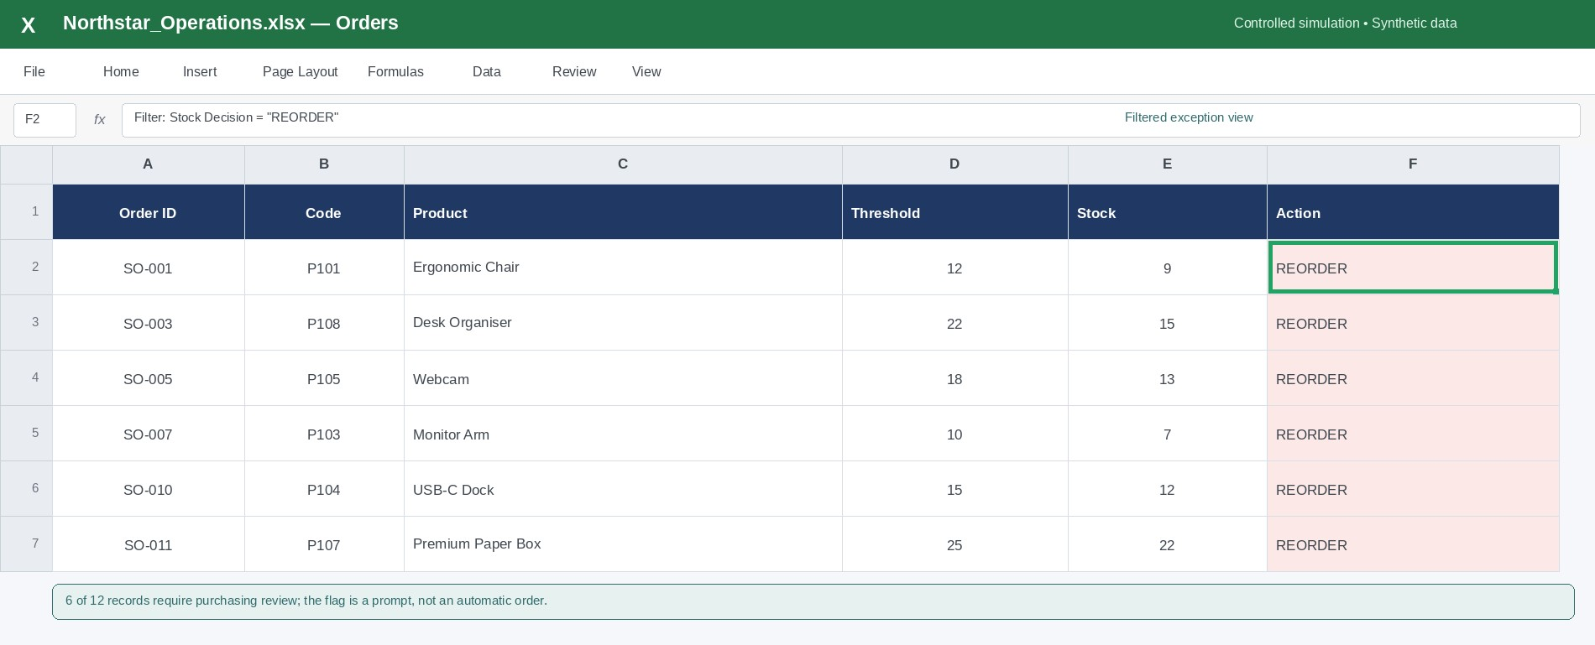
Figure 3. 5 Filtered exception view showing the six records flagged for purchasing review
Source: Author

Task 4 Communication and Collaboration Applications

4.1 Application Analysis and Comparative Evaluation
Communication is necessary as well as collaboration in a modern organisation. Communication tools facilitate the transmission of information and shared knowledge as well as collaboration tools organise collaboration, collaboration tasks, and collaboration progress. The core information model of Slack is a conversation and Trello's is a work-item-centred model, although they share remark features via integration and comments. It is important to treat them individually, because increasing the number of messages does not necessarily lead to greater coordination.

4.1.1 Slack as a Communication Application
Slack. Slack keeps communication between colleagues in the workplace with channels, direct messages, searchable past, files, calls, notifications and application integrations. The threads are particularly significant since they hold detailed answers to a message rather than cluttering the main thread [16]. A channel might host a single place to see the launches but a thread might hold the discussion of a checkout problem from the technical perspective. The greater part of this investigation on naturally occurring communication in a journalistic team's Slack environment revealed that working together and interacting was possible in the same communicative space [17]. This is useful because there are two aspects of cooperation in a team, task cooperation and social connection. Slack can help to minimize disjointed email conversations, speed up inquiries, and increase access to cross-functional information. But speed can turn into noise: Information can get scattered across the many channels of communication and missed notifications can distract users, or the back-and-forth of informal decisions can minimize important commitments. Therefore the use of strong use should be accompanied with the following: Naming of channels, norms of notifications, summary of decisions, retention rules, access control and clear guidelines on what to make part of a formal record.

4.1.2 Trello as an Online Collaboration Application
Trello. Trello is a board filled with lists and cards representing work. Cards may contain descriptions, due dates, labels, checklist, attachments, assigned individuals, moved to/from lists to suggest status [18]. This will make it easy to see what is happening without any special projectmanagement training. Lists like To Do, In Progress, Review and Done make Northstar's website launch easy to see at a glance if bottlenecks, who owns each list item or if it's completed. Studies for collaborative board-based tools focus on the flexibility but also show that users need an appropriate board structure to use the tool, and according to an analysis of 91 Trello designs, there are reusable patterns for common work arrangements [19]. In fact, findings from a projectlearning case study that used Trello do indicate that social influence and motivation have the potential to increase the level of collaboration and satisfaction, while the educational environment prevents the direct transfer to all businesses. Trello's downside is that it is visually easy might obscure dependencies, capacity conflicts and risk at the portfolio level. Teams should then have clear cards definitions, a strict schedule for when cards are due, caps on the number of cards in progress, and a process to escalate problems that they cannot model well on a board.

4.1.3 Comparative Judgement and Governance
Table 4.1 indicates that Slack answers 'What are people discussing and deciding?' whereas Trello answers 'What work exists, who owns it and what state is it in?' Slack is better suited for quick clarity, community and context drive conversation; Trello is better suited for task visibility and workflow control over the long haul. Relying solely on Slack invites loose change in messages, and Trello mostly eliminates the dialog required to flush out meaning of ideas. A material discussion generates a named Trello card and the card or channel includes a short decision history. IT needs to not cause any duplicate notifications or source of truth. One system should be responsible for tasks status, and communication for exceptions and decisions.
Pilot implementation, not full scale implementation, should start with a small, controlled pilot. Success will be measured by response time to blocked work, overdue-card rate, fewer duplicate status meetings or clarity as described by the users. Administrators should also establish guest access, retention, data classification, offboarding and acceptable integrations prior to the introduction of any sensitive information. Mobile accessibility and notification options should be trialed with various roles, as an accessibility feature is helpful to a project manager but not to a specialist contributor. These controls transform usability into a sustainable professional practice.

Table 4. 1 Comparative role of Slack and Trello in a modern business workflow
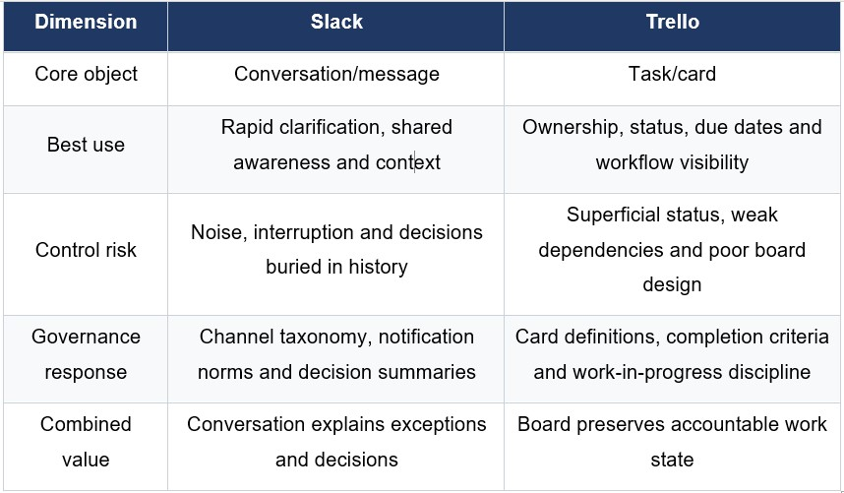

4.2 Practical Tests: Communication and Collaboration Features

4.2.1 Slack Thread
A controlled interface simulation was created with synthetic project information. The project manager posts an issue related to mobile-checkout and attributes it to channel #website-launch, as you can see in figure 4.1, while adding critical information whether it is related to the issue or just a plain update. Technical information, testing evidence, and a final decision are provided in a figure 4.2. The test reveals that threading maintains the main channel's signal and maintains context. It also tells the service operator that there was a control need: the closing response records the owner, action and retest time, as a discussion without a clear action would be operationally weak, but can still be discovered.
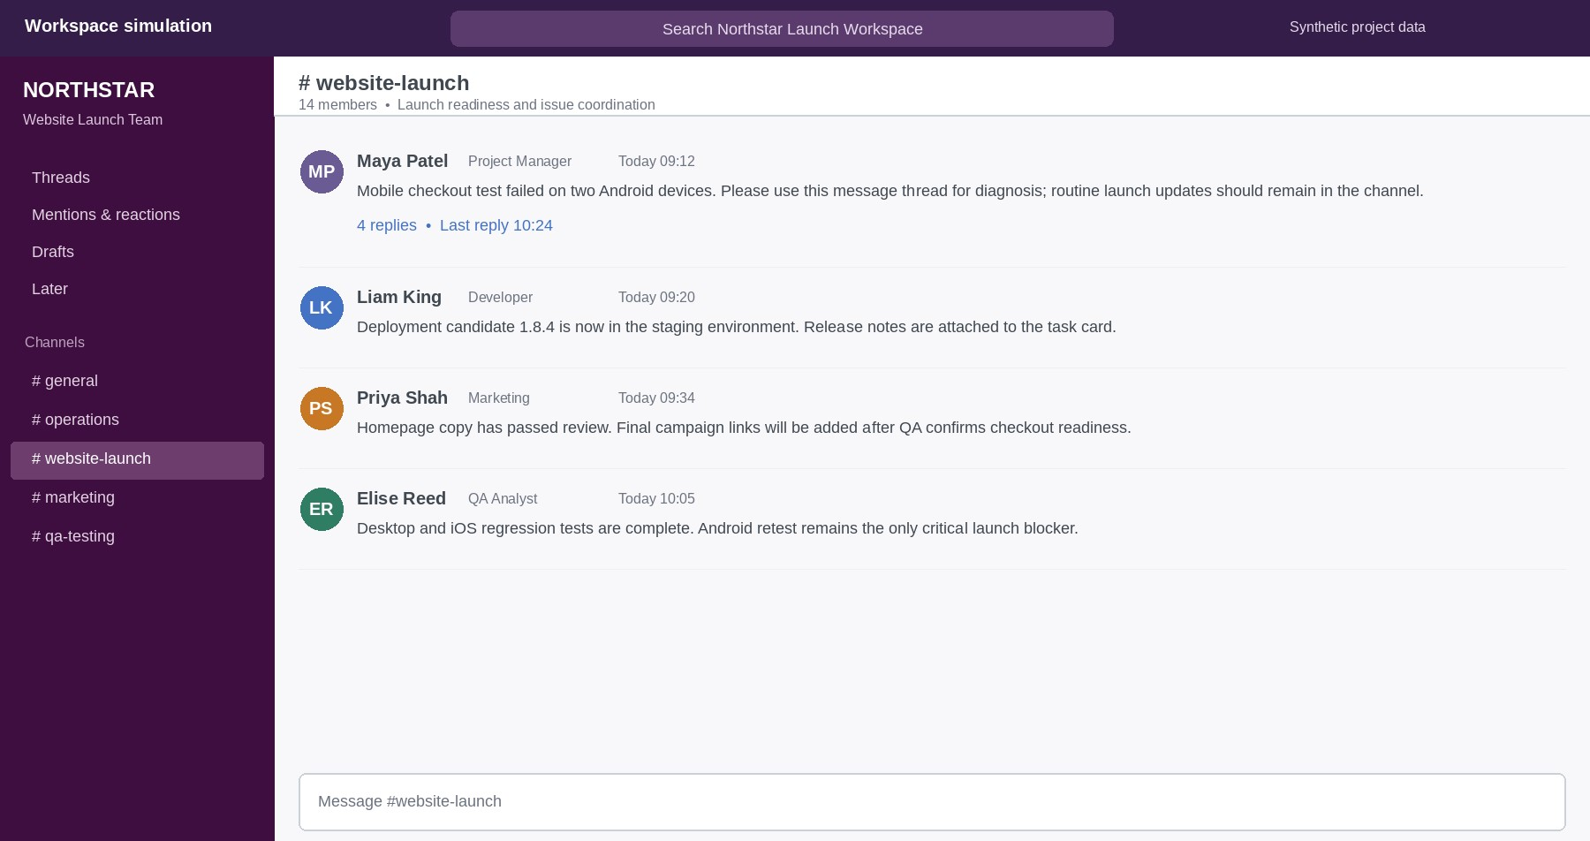
Figure 4. 1 Simulated #website-launch channel retaining routine updates in the main conversation
Source: author

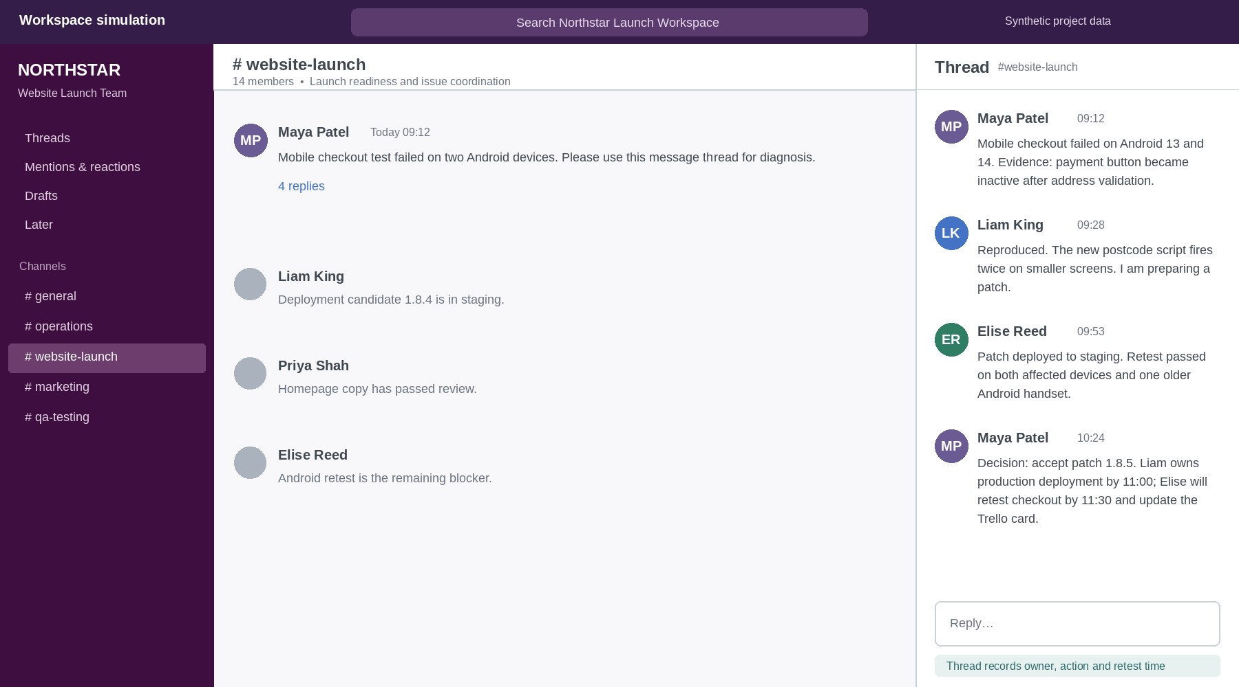
Figure 4. 2 Threaded diagnosis, test evidence and final decision for the mobile-checkout issue
Source: Author

4.2.2 Trello Card Movement
A simulated website-launch board was developed using To Do, In Progress, Review lists and Done lists. The 'Mobile checkout test' card is in use, with a due date, assignee, risk indicator, and partial check list as can be seen in Figure 4.3. The completed checklist and move to Done after retesting been recorded in figure 4.4. The feature allows for immediate sharing, vistas, and an easy audit trail. However, this is not a quality of moving, because the criteria for completion and actual evidence must be established beforehand to fit a card into Done. If it is a live pilot, cards would be reviewed weekly and work would be reopened and it would become apparent if the board accelerates the flow of work or not. This review should differentiate between unavoidable waiting time and poor ownership, and the solution may be capacity, more precise meaning of the acceptance criteria, escalation or the redesign of the process itself. In general terms, Slack and Trello are most useful when governance turns conversation into accountable action.
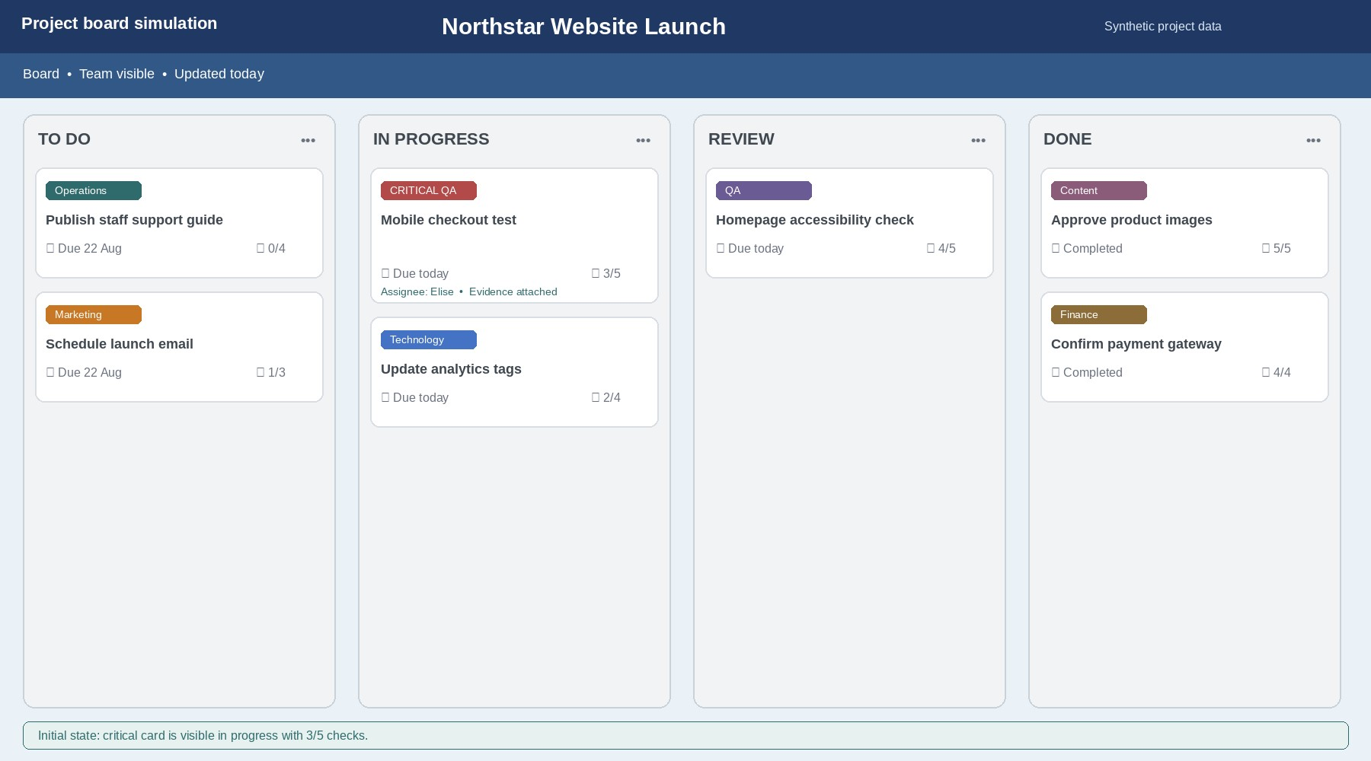
Figure 4. 3 Simulated board with the mobile-checkout card in progress and three of five checks complete
Source: author’s controlled interface simulation; synthetic project data
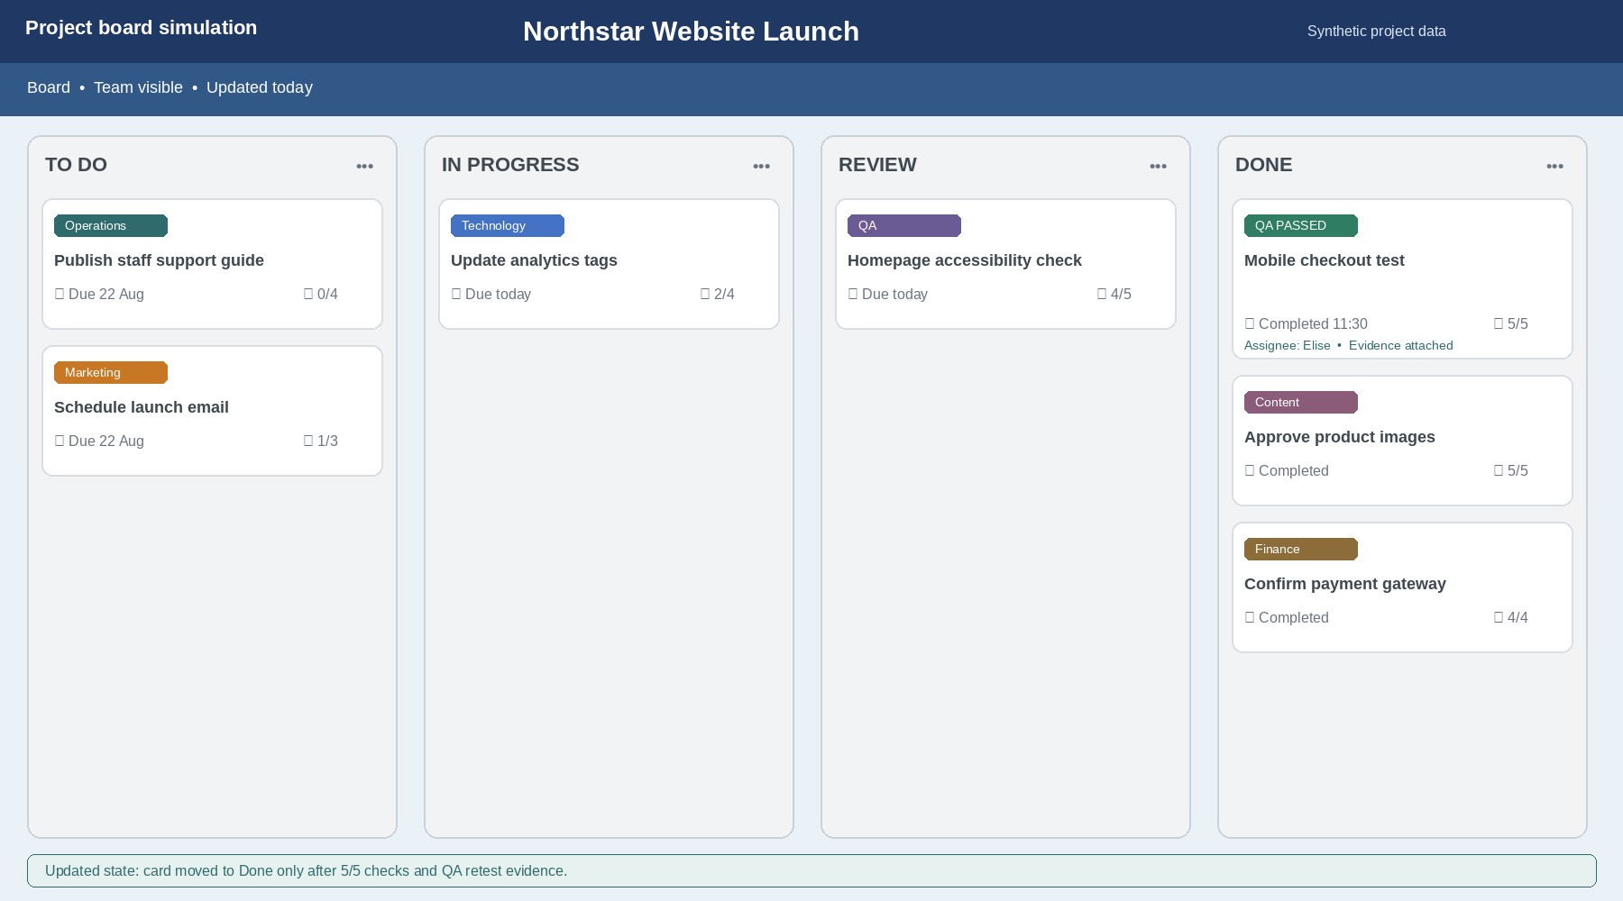
Figure 4. 4 Simulated board after the retested card reaches Done with five of five checks complete
Source: Author

References
- J. Costa and R. Castro, “SMEs Must Go Online—E-Commerce as an Escape Hatch for Resilience and Survivability,” Journal of Theoretical and Applied Electronic Commerce Research, vol. 16, no. 7, pp. 3043–3062, 2021, doi: 10.3390/jtaer16070166.
- Shopify Help Center, “Features on all plans.” [Online]. Available: https://help.shopify.com/en/manual/intro-to-shopify/pricing-plans/plans-features/features-onall-plans . Accessed: Aug. 21, 2026.
- WooCommerce, “Products Settings Documentation.” [Online]. Available: https://woocommerce.com/document/configuring-woocommerce-settings/products/.
Accessed: Aug. 21, 2026.
- WooCommerce, “Managing orders Documentation.” [Online]. Available: https://woocommerce.com/document/managing-orders/ . Accessed: Aug. 21, 2026.
- Y. Shi, H. Yang, Y. Dou, and Y. Zeng, “Effects of mind mapping-based instruction on student cognitive learning outcomes: a meta-analysis,” Asia Pacific Education Review, vol. 24, pp. 303–317, 2023, doi: 10.1007/s12564-022-09746-9.
- P. Kumar, A. Gowda, H. R. Cooley, and J. Summers, “Mapping project alignment: a case study of using concept maps to analyse shared understanding in a multi-disciplinary long-term creative practice project,” Proceedings of the Design Society, vol. 5, pp. 2351–2361, 2025, doi: 10.1017/pds.2025.10249.
- K. E. de Ries, H. Schaap, A.-M. M. J. A. P. van Loon, M. M. H. Kral, and P. C. Meijer, “A literature review of open-ended concept maps as a research instrument to study knowledge and learning,” Quality & Quantity, vol. 56, pp. 73–107, 2022, doi: 10.1007/s11135-021-01113x.
- Microsoft Support, “Collaborate in Word.” [Online]. Available: https://support.microsoft.com/enus/word/training/collaborate-in-word. Accessed: Aug. 21, 2026.
- Microsoft Support, “Use Presenter View in PowerPoint.” [Online]. Available: https://support.microsoft.com/en-US/PowerPoint/training/use-presenter-view-in-powerpoint.
Accessed: Aug. 21, 2026.
- Microsoft Support, “Create professional slide layouts with Designer.” [Online]. Available:
https://support.microsoft.com/en-us/powerpoint/create-professional-slide-layouts-withdesigner. Accessed: Aug. 21, 2026.
- Microsoft Support, “IF function.” [Online]. Available: https://support.microsoft.com/enus/office/if-function-69aed7c9-4e8a-4755-a9bc-aa8bbff73be2. Accessed: Aug. 21, 2026.
- Microsoft Support, “VLOOKUP function.” [Online]. Available: https://support.microsoft.com/en-us/office/vlookup-function-0bbc8083-26fe-4963-8ab893a18ad188a1. Accessed: Aug. 21, 2026.
- L. Raković, M. Sakal, P. Matković, and V. Pavlićević, “A survey of factors influencing spreadsheet risk awareness,” Environmental Engineering and Management Journal, vol. 19, no. 5, pp. 761–772, 2020, doi: 10.30638/EEMJ.2020.072.
- Microsoft Support, “Learn the structure of an Access database.” [Online]. Available:
https://support.microsoft.com/en-us/access/learn-the-structure-of-an-access-database.
Accessed: Aug. 21, 2026.
- Microsoft Support, “Access specifications.” [Online]. Available: https://support.microsoft.com/en-us/access/access-specifications. Accessed: Aug. 21, 2026.
- Slack, “Use threads to organize discussions.” [Online]. Available: https://slack.com/help/articles/115000769927-Use-threads-to-organize-discussions-in-Slack. Accessed: Aug. 21, 2026.
- K. Laitinen, S.-M. Laaksonen, and M. Koivula, “Slacking with the Bot: Programmable Social Bot in Virtual Team Interaction,” Journal of Computer-Mediated Communication, vol. 26, no.
6, pp. 343–361, 2021, doi: 10.1093/jcmc/zmab012.
- Atlassian Support, “Add and customize cards and lists.” [Online]. Available:
https://support.atlassian.com/trello/docs/add-and-customize-cards-and-lists/. Accessed: Aug. 21, 2026.
- J. Peña, A. Bravo, A. del-Río-Ortega, M. Resinas, and A. Ruiz-Cortés, “Design Patterns for Board-Based Collaborative Work Management Tools,” in Advanced Information Systems Engineering, Lecture Notes in Computer Science, vol. 12751. Cham, Switzerland: Springer, 2021, pp. 177–192, doi: 10.1007/978-3-030-79382-1_11.
- D. Oluwajana, I. Adeshola, and S. Clement, “Does the use of a web-based collaborative platform reduce cognitive load and influence project-based student engagement?” Current Psychology, vol. 42, pp. 8265–8278, 2023, doi: 10.1007/s12144-021-02145-0.

