Module Title: Developing Relationships and Workplace Achievements
Module Code: BMSW 5102
Assessment 1
Student Name: Didina-Maria Stratulat
Student ID: 1909067
Lecturer's name: Nandish Patel

Table of Contents
1. Introduction 3
2. Company Context 3
3. Personal role description 5
4. Current knowledge, skills, and competencies of HR officer 6
5. HR Officer’s Career Plan & Training Needs 7
6. Scheduled Review and Performance Assessment Plan 11
7. Conclusion 12
Reference List 14

Introduction
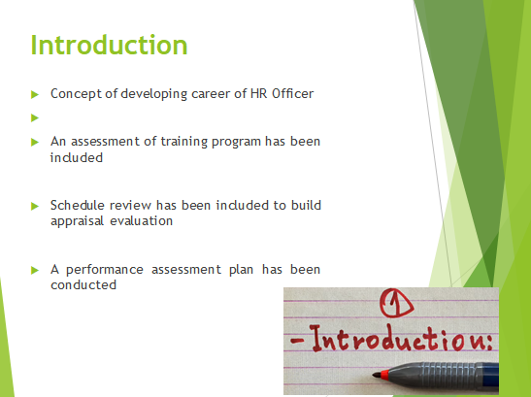
This presentation has consisted of the concept of developing the career of an HR officer. In order to construct the presentation, a training program has been assessed, which has helped review the schedule and conduct a performance assessment plan.

Company Context
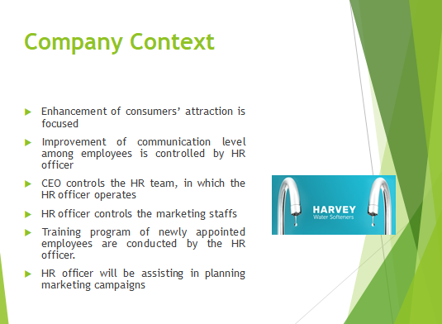
It has been evident that Harvey Water Softeners has been concerned regarding the enhancement of consumers’ attraction in the UK market. In order to do that, they are required to improve the communication level of the employees, which can be operated by the HR Officer. Under the CEO, Harvey Bowden, the HR team operates (Harveywatersofteners, 2021). The HR officer is responsible for controlling the marketing staff of the company, who are directly interacting with the customers. Therefore, the HR officer is capable to improve the standard of employees regarding their communication and skills in marketing campaigning It is because; with the help of an HR officer, the adequate training program of the company is held, which can be helpful. Additionally, the HR officer is responsible for controlling the employment process, orienting new staff, and managing payroll (OKOLIE and UDOM, 2019). Guiding the planning of marketing campaign is also the responsibility of the HR officer.

Personal role description
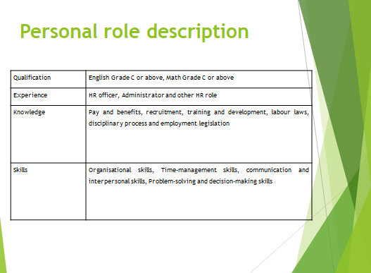
The candidates of HR officer are required to qualify as English and Maths Grade C. Besides, they should be having experience of working in the same role or any other administrative or HR role (OKOLIE and UDOM, 2019). They should be knowing pay and benefits, recruitment along with training and development and some others as regulations. The skills required are organisational skills, time management skills, communication, and interpersonal skills, which are necessary to be present .

Current knowledge, skills, and competencies of HR officer
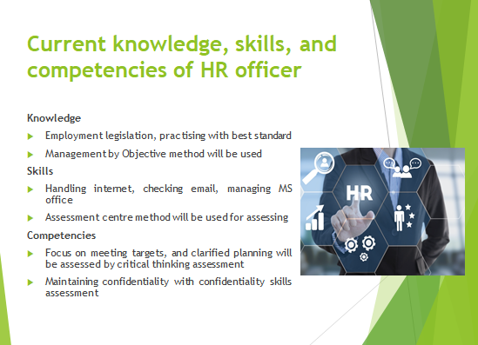
The current knowledge in HR officer is required about employment legislation, and developments. Knowledge about best practice standards is also required (Rodríguez-Sánchez, Mora-Valentín and Ortiz-de-Urbina-Criado, 2018). This knowledge will be assessed by Management by Objective method.
Skills
The current skills of HR officers needed are using the internet, using email, Microsoft Office products (Mauro, 2017). These skills will be assessed by the Assessment centre method.
Competencies
The competencies of a focused approach for meeting targets, clear planning assessed by critical thinking assessment, maintaining confidentiality are required, which will be assessed by confidentiality skills assessment (Kustiany, 2019).

HR Officer’s Career Plan & Training Needs
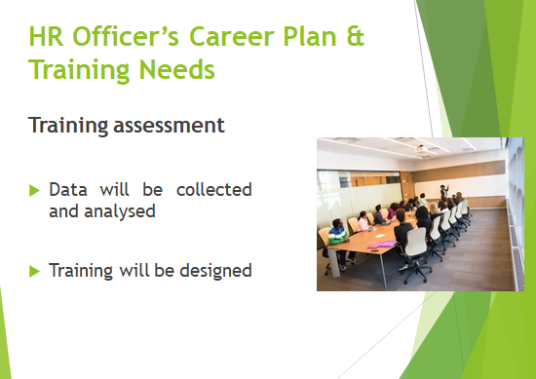
Training assessment
The steps of assessment will be collecting and analysing data, in which the needs of training will be assessed (Hecksteden et al., 2018). The next step is designing training based on providing the knowledge of employment legislation and business objectives accordingly.
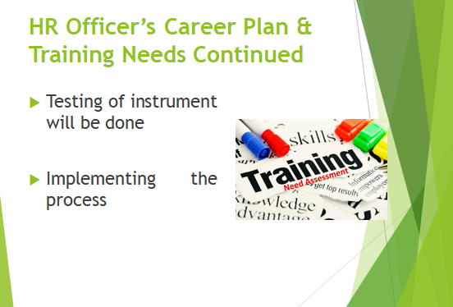
Testing will be the next step, in which the information through the projector and other instruments will be checked (Hecksteden et al., 2018). In order to implement, an update of the progress is required. The last step is to collect data regarding the review and analysis.
Training program
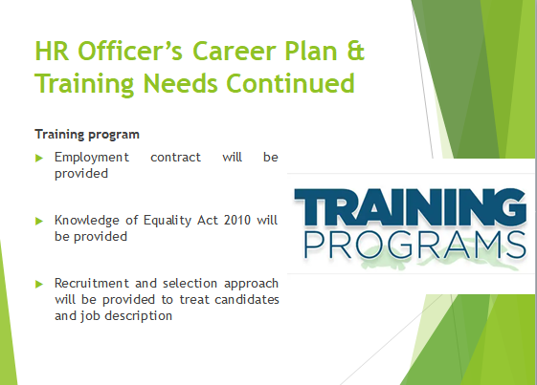
In the training program, the contract of employment will be provided based on the Employment Rights Act, 1996 (Legislation.gov.uk, 2021). Apart from that, the knowledge about Equality Act 2010 will be provided to prevent discrimination (Legislation.gov.uk, 2021).
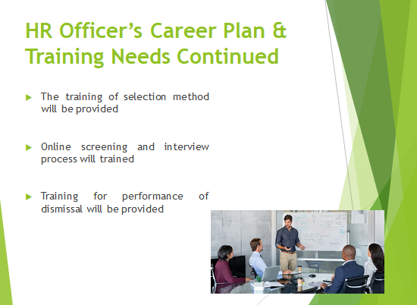
In order to provide recruitment and selection knowledge, the approach will be treating candidates like customers and creating a compelling job description The selection method of online screening and shortlisting along with interviews will be provided as training. They will be trained regarding the judgment of performance to dismissal, which is measuring the performance with business objectives and dismiss employees.
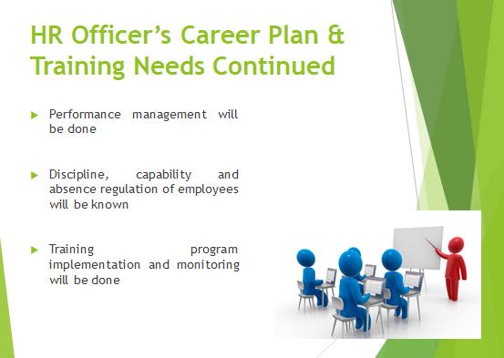
Besides, the performance will be managed by this and employees will be receiving appraisal based on their good performance (Massenberg, Schulte and Kauffeld, 2017). In the case of underperformance, the knowledge of discipline will be provided, along with controlling the capability and informing employees about the absence of regulations. The process of the training program will be monitored as well.
.

Scheduled Review and Performance Assessment Plan
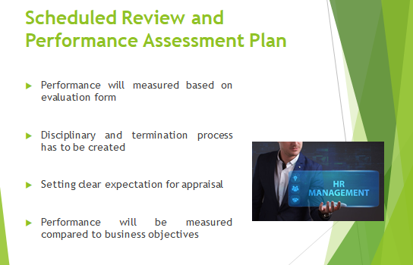
The performance will be measured along with generating disciplinary and termination procedures. A clear expectation is needed to provided appraisal. Against the business objectives, the individual performance will be compared.

Conclusion
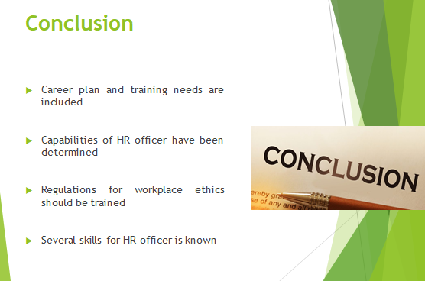
This presentation has consisted of the career plan and training need for HR officers within Harvey Water Softeners. The knowledge, skills, and competencies have helped to determine the capability of an HR officer. However, The Workplace Regulations, 1992 should be included to maintain ethics in the workplace. Certain skills for HR officers, such as organisational skills, time-management skills, communication, and others are known from this assessment.

Reference List



