

An evaluation of fixed betting odds terminals
Are they the most harmful form of gambling?
May 1, 2018
James Steward
UWTSD

Declaration 1

This work has not previously been accepted in any form or substance for work that is not concurrently submitted for this degree.

Signed........................................

Date...........................................

Declaration 2

The researcher is currently employed within the industry and as such additional effort will be made to keep this dissertation free from subjective validation and bias.

Signed........................................

Date...........................................

Statement 1
This dissertation is being submitted in partial fulfilments of the requirements for completion of this degree program.

Signed........................................

Date...........................................

Statement 2
This dissertation is the result of independent investigation except where otherwise started. All sources have been referenced to avoid plagiarism and give credit to the original author.

Signed........................................

Date...........................................

Statement 3
The researcher provides full consent for this piece of work to be obtainable for photocopied reproduction and to be available both online through the UWTSD internal library and a physical copy to be stored in the university archive.

Signed........................................

Date...........................................

Acknowledgements

I did not think over a decade ago when my friends were leaving to go to university that I would ever get to write an acknowledgement to a dissertation. I did not think I had neither the capability nor the academic acumen to succeed. .As a mature student it was a difficult decision to go back to education, to give up paid positions in order to follow a dream seemed antiquated but it was something I could never have achieved without the resounding support from UWTSD.
From my initial interview with Beth Cummings, always inspiring conversation with Gareth Hughes and my long discussions with my tutor Caroline Jawad I have been instilled a confidence and appreciation for the hard work that goes into being a university student and the support that goes with it. I am truly grateful.

Abstract
The following dissertation will seek to evaluate fixed odds betting terminals and whether they are in their current form, the most harmful form of gambling.
The aim of this study was to critically analyse the social and economic impacts of FOBTs. The objectives were first to critically review existing literature on gambling, fixed odds betting terminals and impact in the community. Secondly, to critically evaluate if reducing the FOBT maximum stake threshold would be beneficial to both the consumer and the betting industry. The final objective is to critically evaluate the external influences that affect the decision making process of a gambler. Both quantitative and qualitative research methods were undertaken in order to gain a greater understanding of the sensitive subject matter and the subsequent data will be analysed using a variety of statistical and descriptive methods. Both positive and negative responses have been analysed and attention drawn to the relevant resulting statistics. The main findings reflect a growth in FOBT use predominantly for younger men with this demographic spending more online in addition to in store machine usage. Responsible gambling in addition to social responsibility is recognised and undertaken by UK bookmakers and it is the extent of the responsibility that will be critically evaluated fully in this dissertation.

Table of Contents

Chapter 1 - Introduction 1
1.1 Objectives 1
1.2 Rationale 2
1.3 Conclusion 3
Chapter 2 - Literature Review 4
2.1 Introduction to Literature Review 4
2.2 Gambling Definitions 4
2.3 Unstimulated demand 4
2.4 Gambling Industry Business Model – BCG Matrix 5
2.5 BCG Matrix within a bookmaker 7
2.6 Is Gambling Harmful? 8
2.7 The Association of British Bookmakers 9
2.7.1 GamCare 10
2.8 Profit or Purpose 10
2.9 Stockholder Theory 10
2.10 Stakeholder Theory 11
2.11 Corporate Social Responsibility 11
2.11.1 Corporate Social Responsibility within any business. 11
2.12 The Senet Group 13
2.12.1 Corporate Social Responsibility in the Betting Industry 14
2.13 Conclusion 15
Chapter 3 – Research Methodology 17
3.1 Research Paradigm 17
3.1.1 Research Strategy 17
3.1.2 Research Philosophy 18
3.2 Survey 18
3.2.1 Deductive 18
3.2.2 Cross sectional 19
3.2.3 Multi method 19
3.2.4 Positivism 19
3.2.5 Survey Question Matrix 19
3.3 Interview 21
3.3.1 Interviews 21
3.3.2 Interpretive 21
3.3.3 Secondary Research 22
3.3.4 Interview Design 22
3.4 Ethical / Moral considerations 22
3.5 Questioning 22
3.6 Conclusion 23
Chapter 4 - Data analysis and findings 24
4.1 Sample characteristics 24
4.2 Data Analysis - Survey 25
4.2.1 Age / Frequency of playing 25
4.2.2 Session spend / voluntary limit exceeded 25
4.2.3 Harmful Effects – strongly agree and agree 26
4.2.4 Harmful effects – Strongly disagree and disagree 27
4.2.5 Specific appeal triggers 28
4.2.6 Online / In-store frequency 28
4.3 Statistical Analysis – Survey 29
4.3.1 The Average Customer 29
4.3.2 Chi Square Statistical Testing 29
4.3.3 Chi Square 2 30
4.4 Data analysis - Interview 31
4.4.1 Debit card transactions 31
4.4.2 Free credit / tournaments 31
4.4.3 Slowing down game play 32
4.4.4 Reducing the maximum allowed stake 33
4.5 Limitations of the study 33
4.6 Conclusion 34
Chapter 5 – Conclusion 35
5.1 Areas of further research 37
5.2 Recommendations 38
5.3 Final Comments 39
References 40
Appendices 46

Chapter 1 - Introduction
At the turn of the millennium, Labour politicians in the UK offered a solution to the economic and social problems that existed within struggling local communities (John, et al., 2017). That resolution was gambling. Initially classified by the department of culture, media and sport as a safe bet for economic and job creation within communities, this cultural shift was viewed as a way for gambling to contribute to society (Banks, 2017). The 2005 Gambling Act further added to the liberalisation of gambling and as such a primary argument from Labour politicians was that, much like any other industry, there should be fundamental opportunities for growth.
Within betting shops across the UK exists fixed odds betting terminals, commonly known as FOBT’s (Woodhouse, 2017). FOBT’s are classified by the government as a category B2, meaning they can only exist in betting shops and casinos (Gambling Commission, 2018) and are random. These FOBT machines have a maximum pay out of £500 per turn and allow for stakes ranging from 5p to £100 with a maximum of 4 FOBT’s allowed within a betting shop (B2 gaming machines, 2018). As of 2016, the city of Swansea has 19 betting shops and a total of 68 FOBT’s (Stop The Fobt's, 2016).
FOBT’s were introduced into betting shops in 2001 and allowed customers to play a ‘small number of high margin games’ (Woodhouse, 2017, p. 4) .Bookmakers have lobbied the decision and retort that ‘£2 would cost 20,000 jobs and £1.1bn in tax revenue by 2020’ (Drewett, 2017, p. 2).FOBT’s have been described as ‘sucking money out of the pockets of families’ (Harris, 2017, p. 1) and as a product that ‘can cause real harm to individuals... and communities’ (Watson, 2017, p. 6). Snowdon notes that in recent years there has been a notable increase in fixed odds betting terminals (Fixed-odds betting terminals, 2016) available in bookmakers and as such more customers playing them.

Objectives
To review existing literature on gambling, FOBT’s and their impact in the community.
This will be done to gain an up to date knowledge on a topic that is prominent in society at present. It will look at the theories behind gambling motivation and triggers in order to see what has been done in this field.
To critically evaluate whether reducing the FOBT maximum stake threshold would be beneficial to both consumer and the betting industry.
This will be achieved by researching and analysing the available data the 12 week consultation period and by interviewing both gamblers and staff within the betting industry to gauge a variety of responses to the chosen topic.
To investigate any external influences that affect the decision making process of a gambler
This will critically evaluate any cultural or societal impact that can affect the decision making process of a gambler. The information will be gathered through qualitative interviews and quantitative surveys and will be backed up secondary observations.

1.2 Rationale
On the 31st October 2017, the UK Government announced that the Department for Culture, Media and Sport (DCMS) was to undergo a 12 week consultation where it will evaluate whether to reduce the maximum allowed stake on Fixed Odds Betting Terminals (FOBT’s) from its current threshold of £100 to between £2 and £50 (Woodhouse, 2017). The four proposals differ in maximum stake from £50, £30, £20 and £2 (Harris, 2017). Within the UK there is currently 34,388 B2 (Gambling Commission, Industry statistics, 2017) which resulted in customers spending £1.8B (Drewett, 2017). This dissertation is timely due to it being undertaken at a time of reviewing the FOBT regulations within the UK and looks to evaluate and rationalise the perceptions held by both bookmaker and customer to see if the proposed changes would reduce the described harmful nature of FOBT’s (Woodhouse, 2017).
In 1980 pathological gambling was recognised as a classified psychological disorder by the American Psychological Association (BBC, 2001). This allowed problem gamblers to get assistance from the state for their problems, however, Gainsbury notes that due to its highly stigmatised nature of problem gambling (The Public Stigma of Problem Gambling, 2016), and many who suffer find it difficult to acknowledge their potential addiction. Reith infers that the gambling act of 2005 has failed since it was created to “satisfy, but not stimulate existing demand’ (Reith, 2006, p. 75)
Through looking at the definitions of gambling it becomes clear that the original ethos behind gambling has changed over time. Gambling has evolved into its current state of accessibility for all and access or ease for the user (Reith, 2006). Due to the technological advancement, gamblers are able to use their phones or tablets (Thorley, Stirling, & Huynh, 2016) in order to continue betting once an in shop experience is over and extend their game play. Customers are able to transfer winnings in store to their account and subsequently play online.
Some European countries have already taken steps to minimise the societal impact of FOBT’s. In 2008, a government review in Ireland found that B2 FOBT machines would be detrimental to the Irish betting industry and were subsequently only allowed in Casino’s (Cullen, 2008). FOBT’s, also known as video lottery terminals (VLT’s) or electronic gaming machines (EGM’s) within North America and have been a hot topic of debate since their initial introduction in the mid-1980s (Rose & Loeb, 1998). They are seen by many as detrimental to low income communities however are kept due to the massive government revenue earned from them (Uttley, 2018). Within the US, casino corporation MGM engages heavily in CSR with enterprises such as ‘inspiring our world’ (Donnalyn, 2017) and by giving their employees more fiscal benefits in order for their staff to mitigate any negative publicity. However, the question can be asked, is enough CSR being done by UK bookmakers with regards to FOBT’s and a moral obligation to negate the ‘growing gambling stigma’ (Strauss, 2015).

1.3 Conclusion
In an industry under current media scrutiny, it will be relevant to the researcher to remain bias free when conducting research. As the UK government stalls its decision on whether to reduce the maximum allowed stake on fixed odds betting terminals a question is proposed what could and what should be done to help with problem gambling (Uttley, 2018). As a secondary aim this dissertation will look at bookmakers as an industry and whether it will be impacted by the proposed £100 FOBT maximum stake reductions in addition to the harm caused by FOBT machines.
The following chapter will provide an insight and as such, evaluating chosen key literature will allow this dissertation to be free from prejudice and will incorporate a wide range of opinions views.

Chapter 2 - Literature Review

2.1 Introduction to Literature Review
The purpose of this chapter is to conduct a review of available literature with reference to the potential harmful effects of fixed odds betting terminals to provide a knowledge base for the research. Consideration of previous literature will assist the researcher in Chapter 3. Secondary data will be gathered from a wide range of sources identified by the literature review to include internet search engines, the UWTSD Library catalogue, electronic journals and sector specific data. In particular this chapter will analyse Archie Carroll’s pyramid of CSR and its modern adoption to FOBT’s within bookmakers.

2.2 Gambling Definitions
“Wagering of money on an uncertain outcome” | (Rose & Loeb, 1998, p. 109)
“Gambling is defined as betting, gaming or participating in a lottery” | (Gambling Commission, 2018, p. 1)
“The essence of gambling is economics – gambling involves money” | (Thompson, 2001, p. 105)
“Gambling is a peculiarly difficult to define; it is tempting to include almost any area of risk” | (Munting, 1996, p. 1)
FOBTs are widely regarded as the most high risk form of gambling (Cullen, 2008). A Welsh gambling behaviour study in 2016 indicated that ‘61.3% of adults have gambled on at least one occasion (John, et al., p. 4)’. This dissertation seeks to understand how safer gambling environments can be developed and how much harm is caused by fixed odds betting terminals through the perceptions of customers and betting shop managers.

2.3 Unstimulated demand
Unstimulated demand is a concept whereby a product or service can be offered but not advertised (Volberg, 2000). Volberg states that “British gambling policy was shaped by unstimulated demand” (p. 1556). Banks noted in 2017 that once the demand conditions were removed, establishments such as casinos, the national lottery, bingos and bookmakers were now “unconstrained” (Banks, 2017). The industry supplied opportunities for bookmakers to advertise directly to customers thus becoming more accessible to the mainstream public that ever before. This concept enabled fast economic growth in otherwise stagnant areas of the industry (Shaw, 2016). The business model of a bookmaker was changing as a direct result of the industry changes and the removal of barrier that were in place from decades before.

Liberalisation within the UK shows of a gradual acceptance of gambling within UK culture. This has directly led to what Donoughue calls the ‘normalisation of gambling’ (2011, p. 1). Due to this liberalisation of gambling (The History of Betting, 2018), it is only in recent years that bookmakers were able to show advertisements (2015) for their products and have such since expanded to be encompassing a global gambling industry. Many gambling companies sponsor sports teams in order to promote awareness of their products (Lamont, Hing, & Gainsbury, 2011). Through the mainstream acceptance of sport, gambling companies can be viewed positively by youths and at risk gamblers to whom enjoy sport. Lamont et al note that gambling companies are “increasingly promoting hard types of gambling (p. 248)”, specifically FOBT’s. A champion of CSR, Archie Carroll, raised the issue of whether the perspective of the business should incorporate a wider range of affected people (The pyramid of corporate social responsibility: Toward the moral management of organizational stakeholders, 1991) in order to better the industry.

2.4 Gambling Industry Business Model – BCG Matrix
The Boston matrix is a consultancy tool created by the Boston Consultancy Group to a clear “positioning of an organisation’s products” (Torkildsen, 2010). This growth share matrix is designed to function as an analytical tool for business to use to analyse their specific products and their life cycles by looking at both the relative market share within an industry and the market growth rate (Shaw, 2016). It is broken down into four distinct sections:

Cash Cow | High market share in a slow growing industry. Most profitable
Dogs | Low market share in a slow growing industry. Least profitable
Stars | High market share in a high growth market. High competition
Question Marks | Low market share in a high growth market. Uncertainty of future

The Boston Matrix can be used to highlight the individual aspects within a market that are more or less profitable than others and their relative share.
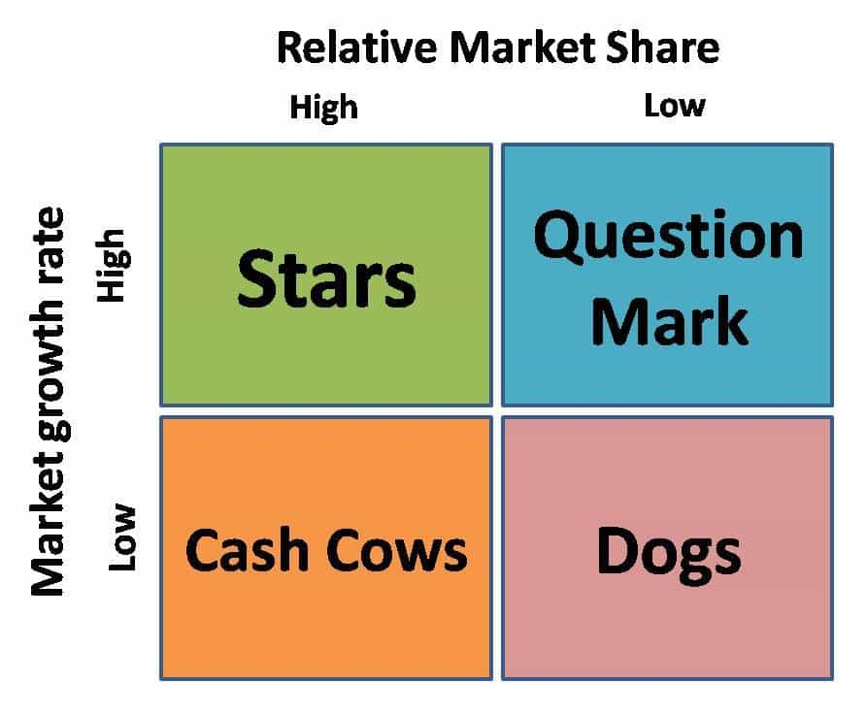
Figure 1 sourced from: https://www.marketing91.com/bcg-matrix/. [Accessed 09-05-18]
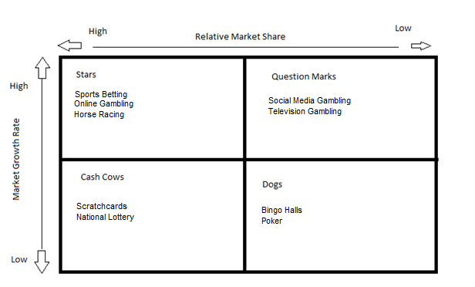
Figure 2: Adapted BCG Matrix from Shaw (2016)
The placement of each market within an industry will highlight that products growth rate in relation to the overall market share.
Stars: Sports betting is viewed as the primary form of gambling (in addition to horse racing and in recent years online gambling) and accounts for the majority of bookmaker revenue. UK Bookmakers took almost £14bn in 2017 (Uttley, 2018). Whilst offering no new unique products the market failed to grown however still attain record profits ever year.
Question marks: Whilst initially prominent in the late 2000’s, television gambling has had a major decline since the introduction of online betting. Social media gambling is also a volatile market that predominantly reflects the micro transaction and gaming side of the industry over traditional betting.
Cash Cows: The primary cash cows of the industry are the national lottery, established in 1994, scratch cards in 1995 and bookmakers since the ban on advertising was lifted in 2005 primarily due to their accessibility stemming from lowered age restrictions.
Dogs: Whilst it has been established that the gambling industry is ‘very profitable’ (Shaw, 2016, p. 31) markets such as poker (online and table), bingo halls and UK greyhound based betting have suffered in recent years. Six of the largest greyhound tracks within the UK are owned by bookmakers thus expanding its monopoly. It is noted that £2.5b is staked annually on UK greyhounds (Anon, 2018) however, the average race winnings for the greyhound trainer is £100 (Banks, 2017).

2.5 BCG Matrix within a bookmaker
This can be explored further in a supplementary Boston Matrix with reference to the available products that exist within a bookmaking establishment with specific attention to the placement of FOBT’s.
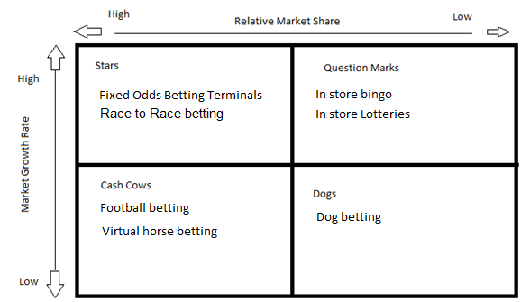
Figure 3: BCG Matrix within a bookmaker. Created by Steward. Adopted from Shaw (2016)
The “profit powerhouse” that is fixed odds betting terminals (Davies, 2017) introduce new FOBT games each week (Coral, 2018) that other companies don’t have in order to attract new players. There are also promotions only available to machine customers in order to seem more initially attractive and attract new business.
Dubbed the ‘crack cocaine of gambling’ by various sources (Snowdon, 2016), FOBT’s take on average 3p for every £1 spent on games. In comparison, Snowden notes that the national lottery takes 50p for every £1 (Fixed-odds betting terminals, 2016, p. 4). FOBT’s are the most profitable aspect of the industry (Davies, 2017).

2.6 Is Gambling Harmful?

“FOBT machines and internet sports event gambling are clearly identified as major factors in harmful gambling behaviour”
John et al (2017 p.46)
In 1980 pathological gambling was recognised as a classified psychological disorder by the American Psychological Association (BBC, 2001). This was the first step to allow problem gamblers to get assistance from the state for their problems. The primary drawback attached to this has been noted by Gainsbury (The Public Stigma of Problem Gambling, 2016, p. 76) whom explores the societal reasoning as to why ‘problem gambling is highly stigmatised’ and as a result deters gamblers from acknowledging their difficulties. The 2005 Gambling Act was initially implemented to ‘satisfy, but not stimulate existing demand’ (Reith, 2006).
Mark Griffiths is a professor and psychologist who specialises on behavioural addiction and it if his belief that FOBT’s should not be reduced as they simple allow people access to what they can already do online (2018). Dr Griffiths infers similar to Gainsbury in that if problem gambling is a psychological disorder that some people have a predisposition to. Griffiths highlights that the UK population gambling is on the decline (2015) and that the UK figures for problem gambling are considerably lower than other similarly developed nations.
A study by Professor Bev John et al (2017) on the societal impact of problem gambling in Wales concluded that ‘FOBT machines and internet sports’ event gambling are clearly identified as major factors in harmful gambling behaviour’ (An Investigation of the Social Impact of Problem Gambling in Wales, p. 6). John et al inform that FOBT machines should be more heavily regulated and as a direct result there would be less problem gamblers in society.
It has been established that certain types of games that have greater associated with problem gambling than others (Gainsbury, 2016). Specifically, the characteristics within a game that is more appealing such as quick wins and bonus features (Fabricatore, 2014). This idea has been explored further with Dr Mark Griffiths indicating there are three types of problem gamblers all of whom experience the same common factors such availability and access as the driving factors being problem gambling (2015). Specifically, Fabricatore looks at the important of game play and interaction as the key fundamentals to an appealing FOBT game. It can be assumed therefore, that in order to facilitate the ever changing wants and needs of a modern gambler; bookmakers have needed to extend their products to cater to a wider range of player (Snowdon, 2016).
Uttley (2018) states in a Marketline report that social issues concerning gambling debt costs the UK economy £8.3bn a year. She draws reference to a study undertaken by Howard Reed who found that £1bn lost on FOBT machines to the UK, could support 20,000 jobs (p. 5).

2.7 The Association of British Bookmakers
The ABB state that with the reduction of the maximum allowed stake currently allowed on FOBT’s, from its current threshold of £100 to a lower value, would directly result in 4500 shop closures by 2020 (Gerrard, 2018) and that the 21000 job losses this would cause would have a negative correlation towards unemployment figures (Streeter, 2018). The ABB also affirm that the UK government itself would miss out on £1.1bn in tax revenue if the reduction in stake is to go ahead (ABB, 2017). The UK government currently spends up to £1.2bn a year in problem gambling costs (NHS, 2016) and fixed odds betting terminals have been directly implicated in encouraging irresponsible gambling (Thorley, Stirling, & Huynh, 2016). Uttley believes the cost of problem gambling is considerably higher at over £8bn (2018, p. 5). It is interesting to note that in the last four years, as the government tax revenue from FOBT’s has sharply increased (Davies, 2017), so has the money spent on helping problem gamblers (Gerrard, 2017). By reducing the maximum allowed stake and subsequently minimising the fiscal loss for those deemed at risk gamblers, this would ultimately give them more protection. The ABB support GamCare (2018), an organisation set up to assist problem gamblers in the UK who have the backing of many of the large UK bookmakers.

2.7.1 GamCare
GamCare assist with both problem gamblers (Working with Problem Gamblers, 2018) and with the industry in order to reduce the harm in caused problem gambling (GamCare). Through their initiatives, GamCare have introduced interaction based computer training programmes for industry employees to use in addition to producing posters and leaflets available in stores to highlight the dangers of problem gambling [See Appendix F and G]. GamCare believe that problem gambling is caused by underlying psychological symptoms (Why Do People Gamble, 2018) and that the action of winning is more often more important the fiscal reward.

2.8 Profit or Purpose
Businesses exist to make profit or serve a purpose (Friedman, 1970). Friedman believed the primary responsibility of business is to increase profit. This can be broken down to incorporate a company’s desired profit levels, and as a natural result, everything else will naturally fit into place (Mitroff, 1983). Strauss (2015) claims that this theory can no longer be applied to the modern business era. Profit is no longer the mitigating factor and as a result, it is the purpose of the business that should be explored (Palazzo & Richter, 2005).
CSR is not a mandated law but an ethos that if as a company something can be done, then there is a responsibility to do it (Carroll, 1991). As modern society becomes more ecologically and sustainability minded, it is a fundamental aspect of business that can no longer be overlooked for the traditional mindset of profit over purpose (Crane, Matten, & Spence, 2008).

2.9 Stockholder Theory
There are two main normative ethical theories – Friedman and Freeman. The former, the only responsibility of business is a fiduciary one, to make money for the owners and or stockholders as the solo priority of the business (The Social Responsibility of Business is to Increase its Profits, 1970). Friedman’s theory was that the solo function of a business is to make profit. If that business turns a profit then as a natural result the other areas of the business will fall into place. Whilst there is no law indicating a commitment to CSR, there is an ever increasing public stigma to do more if in a position to do more. Most businesses will adopt try to adopt stakeholder theory (Mitroff, 1983) whereby they balance these shareholder interests and the interests of stakeholders such as customers or suppliers.

2.10 Stakeholder Theory
Freeman’s stakeholder theory is a bridge between Friedman and Carroll. Freeman believed that in order to make a profit for stockholder - “The basic idea is that businesses, and the executives who manage them, actually do and should create value for customers, suppliers, employees, communities, and financiers (or shareholders) (Strategic Management: A Stakeholder Approach, 1984, pp. 63-64) ”Whilst both the stock holder and the stakeholder recognise the economic vitality of business, Freeman and to a large extent Mitroff infer that in order to maximise the economic interests of the company, the interest of all stakeholders must be considered (Mitroff, 1983). This draws a parallel to Carroll’s theory of corporate social responsibility (Carroll, 1991) and the balance between stakeholders. The theory explores the moral and values behind management decisions within an organisation (Freeman E. , 1984). This changed the landscape that was solely focuses on the profit of stockholders as established by Friedman and gave way to a stakeholder centric approach whereby the needs of others were considers over fiscal profit. (Crane, Matten, & Spence, 2008) Profit is no longer the encompassing crucial variable and as such it is the purpose of the business that should be explored (Mitroff, 1983). By creating a sustainable, socially responsible business the prospective profit should also be subsequently achieved (Carroll, 1991).

2.11 Corporate Social Responsibility
The idea of corporate social responsibility (CSR) has been floated around since the 1950s; Archie Carroll proposed the question of where a firm’s responsibility should lie within its society (1991). Milton Friedman established the grounded ethos that the primary function of a business is to deliver profits to its stockholders (1970) and Carroll proposed a shift in the culture paradigm of industry. Carroll questioned that the ultimate goal would be to have a company profit through an ethically sound business practise through three ethical approaches; immoral, amoral and moral. Carroll idealised that, “the entire range of the business responsibilities are embraced” (p. 40) through the decision making of a moral management.

2.11.1 Corporate Social Responsibility within any business.
Companies often identify their corporate social responsibility as a method to garner better exposure or simply improve the overall image of a company (Astara, Mitoula, & Eleni, 2017). In recent years the corporate social responsibility issue has become a key issue within a business (Strauss, 2015) as industries adapt to technology and social media. There are many ethical variables to ascertain where responsibility should lie and where the boundary of corporate social responsibility ends (Crane, Matten, & Spence, 2008) and individual decision making and responsibility begins and this can be directly applied to FOBT’s. John Campbell offers a differing opinion in that he suggests that as the primary function, as established by Friedman, is to maximise profit, there is no underlying benefit for a company take part in CSR (Why Would Corporations Behave in Socially Responsible Ways?, 2013). Campbell advocates the assumption “that maximising profits will prevent a company from acting socially responsibly (p. 953)” however, concludes that in an industry where the profit margin is easily attainable, the company would then have a secondary duty to be socially responsibly to their shareholders and stakeholders. Carroll created a framework (1991) in order to classify his four areas of corporate social responsibility that a business should assume in order to fully recognise all stakeholder interest that exists within a business (Strauss, 2015). These areas are broken down into the following individual principles relating to the business practise. Philanthropic; Ethical; Legal; and Economic factors (Carroll, 1991).

Carroll’s Pyramid Of Corporate Social Responsibility
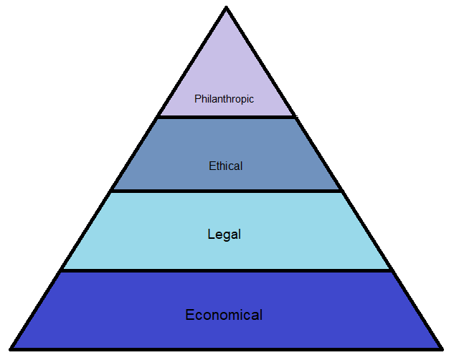
Figure 4 created by Steward: Adapted from Carroll (The pyramid of corporate social responsibility: Toward the moral management of organizational stakeholders, 1991).
The Philanthropic responsibility of a business is to reinvest profits within the local community such as investing in scholarships or developing local areas. Ladbrokes, one of the leading bookmakers in the UK donated £245,000 to charitable causes in 2015 (Ladbrokes, 2015). Other than similar sized charitable donations there are limited philanthropic activities that are undertaken by UK bookmakers.
The Ethical responsibility of a business is to conduct business in a fair and open manner. A key proponent in recent years that can be highlighted as a business’s ethical responsibility is to minimise its carbon footprint, waste and harm to the local environment (Coral, 2018). Bookmakers achieve this through appropriate in store signage with information for problem gambling available and my recycling all its waste paper (Ladbrokes, 2015). William Hill are committed to the same waste processes in addition to reducing their carbon dioxide emissions (Environment, 2018).
The Legal responsibility of a business is to make sure they exist within the set rules governed by law (Carroll, 1991). This can be viewed in many organisations as healthy and safety regulations. With regards to FOBT’s the current legislature only permits a maximum of 4 machines in a shop (Watson, 2017). Through GamCare (2018), literature is available in bookmakers to problem gamblers and regular adverts are promoted to raise awareness to GamCare and responsible gambling.
The Economic responsibility of a business is to achieve overall profit (Friedman, 1970). This can be providing consistent dividend returns to the shareholders or achieving economies of scale by being more efficient in their due processes. Due to inter-company mergers, Ladbrokes Coral Group achieved an operating profit of £1.2b in 2017 (Ahmed, 2017). It is imperative to retain a strong competitive position within a competitive marketplace and as such many bookmakers and online betting exchanges merge to create monopolies.
It is vitally important for a business in the modern world to be ethical and as a result ‘many issues in the relationship between business and society have been studied initially from the ethical perspective’ (Crane, Matten, & Spence, 2008, p. 57). The question can be raised how a bookmaking organisation can continue to show stable long term fiscal growth in a business environment utilising FOBT’s that have been deemed both unethical (Gaming-Business, 2013) and creating a “social injustice” (Walker, 2018).

2.12 The Senet Group

“They are being asked to help the bookmakers convey the impression that they are in favour of individuals ‘gambling responsibly’”
Anti FOBT pressure group Stop the FOBT’s on the social responsibility of bookmakers (2018)

In 2014, many of the large UK bookmakers created the Senet Group (Promoting responsible gambling standards, 2018) which is an independent body set up to promote responsible gambling. The Senet Group was created after negative publicity on gambling had started to affect the industry. There are several criticisms to the Senet Group such as lobbying the EU in order to not identify customers who spend more than £1500 a day (Is The Senet Group Responsible?, 2018). The Senet Group website states that funding is solely provided by bookmakers which questions whether they are truly promoting responsible gambling. With regards to FOBT’s, the Senet Group is one of the largest organisations to promote responsible gambling standards (responsible-gambling-standards, 2018) though commitments such as customers being given the option to set limits and by stores having no FOBT advertising in shop windows. It is therefore questionable to an industry to which the largest support group is funded, operated and controlled by the industry itself (Cassidy, 2014). It can therefore be surmised that this is a direct conflict of interest.

2.12.1 Corporate Social Responsibility in the Betting Industry

‘There is no evidence that any particular product is more harmful that the other’
William Hill PLC on encouraging responsible gambling. (2018)
William Hill produced its first CSR report in 2013 and subsequently undertakes this annually. In their 2017 CSR report (William Hill, 2017) and using statistics provided from the English Health Survey, William Hill have ascertained that the percentage of adults with a propensity to have a problem gambling is 0.5%. This raises the initial question should something be changed to benefit the small minority of FOBT uses who experience a problem in gambling. In February of 2018, the ABB highlighted a research paper undertaken by the gambling commission that showed that customers risk losing more money in arcades than on FOBT terminals (ABB, 2017). It has been publically noted that customers playing FOBT’s within bookmakers lost a combined total of £1.8b in 2017 (Pratley, 2018). As Friedman affirmed the purpose of a business is to make money. William Hill state that ‘there is no evidence that any particular product is more harmful that the other’. However, various pressure groups have stated that not enough is being done by bookmakers to be responsible towards FOBT’s (Watson, 2017) (Harris, 2017). As with any product being reduced, the initial short term loss on the product would be offset by an increase in similarly available products such as horse racing and other sporting bets. This would provide a much needed boost to a stagnated industry. UK bookmakers Ladbrokes, in addition to William Hill have stated that many local charity and community projects around the UK that a reliant on direct bookmaker funding would cease to exist with the loss in revenue from B2 FOBT machines (William Hill, 2017).
With current regulatory scrutiny around problem gambling in recent years it has encouraged the once ‘shady industry’ (The History of Betting, 2018) to be more transparent in their operations and corporate social responsibilities. The key idea of sustainability is the uncertainty of greater regulation from government and William Hill found that the environmental impact was their primary factor for long term sustainability (2018).

“FOBT stakes will be cut to ensure we have a safe and sustainable industry where vulnerable people and children are protected”
Department for Culture, Media and Sport 22/1/18

As a member of the Senet Group, Coral (running from a division of the Gala Coral group), as part of their responsible gambling initiative (Coral, 2018) introduced several measures in order to promote safer gambling such as a budget calculator available from their website, the ability to set deposit limits and a monetary diary to keep track of winnings and losses (Shaw, 2016). However, whilst these options are available online, there is little available to protect problem gamblers within a bookmakers other than the commitments agreed to by the Senet Group (Cassidy, 2014). In contrast, within a typical book maker store there will be signage showing the licensing agreement to accept bets and various posters highlighting CSR initiatives such as helping to reduce problem gambling leaflets (Coral, 2018). It has been noted by Peter J Adams that ’gambling corporate social responsibility efforts have not yet embraced the potential of redesigning the product’ (Moral Jeopardy: Risks of Accepting Money from the Alcohol, Tobacco and Gambling, 2016, p. 97). It needs to be reiterated that as CSR itself is not law, it is not imposable on any organisation and again raises the question
A £6.2m fine imposed on William Hill by the gambling commission for ‘abusing the system through exploitation’ (Monaghan, 2018, p. 1) by being overtly trusting to where problem gamblers get their money from. This is shortly after online casino giant 888 was fined £7.8m for the same reason, failure to protect its vulnerable customers (Davies, 2017). Labour MP Tom Watson proclaimed that ‘this is an industry that talks about “responsible gambling, they are turning a blind eye to dirty money (2017, p. 1)’.

2.13 Conclusion
As Friedman’s views were replaced with Carroll’s in the eyes of many with regards to how a business should operate, there exist no laws to force any company or organisation to undertake any element of CSR. CSR remains an idea that has not been fully integrated into every business because it has no need to be. However, in such industries where there morally should be a level of responsibility, it remains to be seen what is done on a grass roots level to prevent problem gambling and to reduce perceived harm that exists within fixed odds betting terminals. Donoughue affirms that that UK Government “lives or dies by its regulation and that it’s better to be ahead of the game than playing catch-up” (2014, p. 1). The UK Government, since the introduction of the 2005 Gambling Act, has recently introduced GamCare as a support network for problem gamblers who choose to contact them.
The following section will provide details of and the subsequent justification of the methods used whilst conducting research. This chapter will surmise the necessary techniques needed to fulfil the objective criteria.

Chapter 3 – Research Methodology

Saunders et al describe research as “something that people undertake in order to find out things in a systematic way, thereby increasing their knowledge” (2009, p. 5) and Kothari (2012) has expanded this definition to incorporate a primary objective as the sole function; “the systematic search for pertinent information on a specific topic” (Research Methodology; methods and techniques, p. 21)
The primary focus of this research is on fixed odds betting machines and whether they are the most harmful form of gambling. This dissertation look to understand what attracts customers to FOBT’s and if enough is being done by third parties to prevent harmful gambling.
Objective 1 – To critically evaluate what attracts customers to using FOBT machines
Objective 2 – To analyse the opinions or FOBT customers with regards to FOBT’s in relation to harmful gambling

3.1 Research Paradigm
In the book Research Methods for Business Students, Saunders et al introduce the concept of the research onion (2009) . This concept looks at the varied layers of research techniques that can be peeled away to reveal more encompassing data and understanding the philosophical rationale behind each level (Cameron & Price, 2009). This research will use both quantitative and qualitative methods of research in order to identify any patterns or correlations with the rich data (Shaw, 2016). As a subsequence of this, the researcher will be able to examine the individual responses to ultimately understand what actions can be done to reduce the perceived harm in problem gambling, specifically caused by fixed odds betting terminals.

3.1.1 Research Strategy
The research strategy is the methodology that will be followed through the investigatory process (Cameron & Price, 2009). This study will conduct qualitative interviews with customers and bookmakers to gauge their opinion of whether the proposed reduction in FOBT maximum stakes would result in a reduction of FOBT players. The questions posed will be non-obtrusive and can be anonymous in response. There will also be secondary data collected in the form of a Survey regarding the frequency of play of FOBT’s. These questions will be aiming to better understand what makes customers play FOBT machines. The questions pose a direct link to ethnography (Babbie, 2007) and the underpinning emotional response generated from gambling from a customer perspective (Saunders, Lewis, & Thornhill, 2009).
In order to promote both arguments of the proposed thesis, an interview will be conducted with an area manager from within the betting industry in order to gain more information with regards to machine profits and the volume of customers using FOBT’s. The advantage of an interview technique is that with a conversational method (Cameron & Price, 2009), the interviewee responses would be natural and without the interviewer leading the discussion. Sapsford and Jupp describe the interview segment of data collection as ‘the most naturalistic form’ and promotes a degree of structure (Data Collection and Analysis, 2006, p. 114) and subsequently should have the most focus due to its in-depth nature.

3.1.2 Research Philosophy
Saunders et al, write that the outer most layer of the research onion is the philosophy and is followed by the research approach. The philosophical aspect looks at the development of the initial knowledge into a more tangible theory. These initial assumptions will ‘underpin any subsequent research’ (Research methods for business students, p. 108), investigatory responses and the interpretation of data.

3.2 Survey
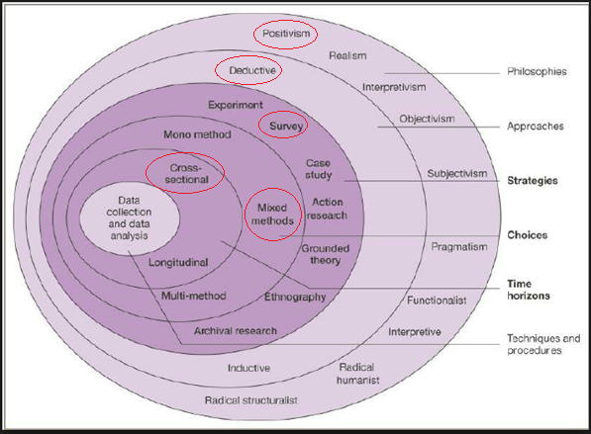
Figure 5 - The Research Onion (Saunders, Lewis, & Thornhill, Research methods for business students, 2009). Adopted for specific methodology pathways – Survey

3.2.1 Deductive
Saunders et al state that a deductive approach shapes the qualitative research process and builds on a grounded established theory (Research Methods for Business Students, 2009). Using Carroll’s corporate social responsibility pyramid it provides the initial analytical framework and structure (1991).

3.2.2 Cross sectional
The data gathered by the researcher will be collated during a short period of time and as a result, a cross sectional method is appropriate (Shaw, 2016). As such, “time is not considered one of the study variables” (Lavrakas, 2008, p. 170). The data gathered allows for opinions to be characterised as a summary of the immediate population (Saunders, Lewis, & Thornhill, Research Methods for Business Students, 2009).

3.2.3 Multi method
As a mono-method would provide limited scope for this type of analysis, a multi method has been chosen. The multi method involves the qualitative and quantitative research methodologies in order to sufficiently answer the research questions (Lavrakas, 2008) and as a result uses both inductive inquiries and in greater detail deductive reasoning. Lavrakas highlights that the primary advantage of a multi method design is that it “provides a more comprehensive and enhances image of the research problem” (p. 750). Due to limitations in time, a third method was not incorporated and as a result, triangulation was not considered.

3.2.4 Positivism
The fundamental aspect of positivism is that it remains objective and free from bias (David, 2004). By utilising quantitative data a variety of statistics and analyse can be produced by the researcher. Houghton argues that a single paradigm will subliminally encourage the researcher to interpret the results in a way that fits the overall narrative (2011).

3.2.5 Survey Question Matrix

Question | Reasoning | Source
What is your gender? | To better understand the difference in betting patterns between genders | (Jawad, 2010)
What is your age grouping? | To gauge if age is a mitigating variable in responsible gambling | (Jawad, 2010)
Frequency of FOBT usage | To understand how often FOBT customers use the machines | (Jawad, 2010)
Frequency of gambling online | To analyse similarities between FOBT usage and online gambling | (Griffiths, 2015)
Other product usage | See what other products FOBT customers use | (Griffiths, 2015)
Appealing aspects of FOBT | Critically evaluate what are the primary driving forces behind playing these machines. | (Jawad, 2010)
What is your overall planned session spending? | Understand how much initially a customer is prepared to stake before the game begins. | (Monaghan, 2018) (bookmakers-cannot-prevent-problem-gambling, 2015)
Do you ever go over your own predetermined limit? | Following on from the previous question, this will be asked after a brief pause in each survey to allow the customer to experience the FOBT without fear of being monitored or watched. | (Shaw, 2016)
Government proposal awareness | To explore if machine users are aware of the current government proposal to reduce the maximum allowed stake | (ABB, 2017)
Is the proposal a good idea? | Gauge customer opinions on the matter | (ABB, 2017) (Watson, 2017)
Are FOBT’s harmful? | A dichotomous question to ascertain the opinion of the FOBT user. | (Davies, 2017)
What can reduce this harm? | A likert question to critically evaluate set responses that have been grounded in existing literature. | (ABB, 2017) (Is The Senet Group Responsible?, 2018) (Jawad, 2010) (Shaw, 2016)

3.3 Interview
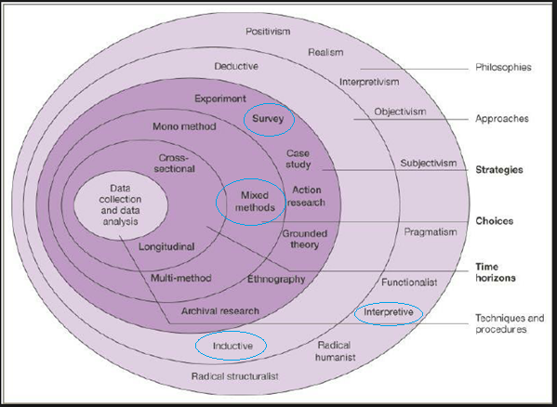
Figure 6 - The Research Onion (Saunders, Lewis, & Thornhill, Research methods for business students, 2009). Adopted for specific methodology pathways – Interview
An inductive method is done after the deductive quantitative stage in order to provide the researcher with greater insight into the research parameters (Saunders, Lewis, & Thornhill, 2009). This allows any themes or patterns discovered in the customer surveys to be explored further in other interviews.

3.3.1 Interviews
Two interviews will be conducted after the data from the survey has been gathered. This approach of quantitative data before qualitative data allows the researcher to see the numerical statistics and facts before undertaking any interpretive research. A semi structured interview allows for the researcher to have specific questions relating to the primary research in addition to unstructured questions that arise as part of the conversation (Saunders, Lewis, & Thornhill, 2009). The interview mixed method of research uses inductive reasoning in order to better interpret any available data sourced (Cameron & Price, 2009).

3.3.2 Interpretive
Unlike quantitative data in which the credible factual statistics represent the gathered data to set questions, with interpretive questioning the responses given by the respondent can be explored further for elaboration or clarification (Shaw, 2016). By following the established semi structured interview pattern, the interpretive response should be value free from bias and avoid generalisations.

3.3.3 Secondary Research
In order for the researcher to gain greater understanding within the chosen topic, a wide variety of literature was reviewed prior to the primary research stage. This is imperative to provide a clear framework for the future research methods in addition to the reasoning behind each decision (Babbie, 2007). An extensive literature review was conducted in Chapter 2.

3.3.4 Interview Design
The two interviews carried out in the primary data collecting stage will be semi structured and as a result, allows for greater flow and less bias than a full structured interview (Shaw, 2016). Saunders et al infer that the initial preparation of the questions is the most important aspect of the interview (2009). The semi structured format allows for personal interpretation and follow up questions to explore the personal experiences for the respondent. Galletta states that the semi structured interview incorporates the research goals through “theoretically driven questions (Mastering the Semi-Structured Interview and Beyond, 2013, p. 45)” and encourages the interpretation of a respondents personal experiences. A formal approach will be considered over informal due to the over flexibility of an informal discussion and maximise “generating meaningful responses” (p. 46).

3.4 Ethical / Moral considerations
As highlighted in the extensive literature review, FOBT’s are still viewed as a stigma within society and as such careful consideration will be taken by the researcher when conducting both surveys and interviews. Shaw suggests that gamblers may find it uncomfortable or difficult to discuss openly regarding their betting patterns (2016) in a public setting. As such, of the 100 planned surveys, none will be undertaken if the betting shop is considered busy due to the public awareness of the situation and the sensitive subject matter. Due to this high level of sensitivity, anonymity will be guaranteed for all participants. An anonymised ethics form has been attached [See Appendix h] and all steps have been validated by a supervisor.

3.5 Questioning
The survey questions will use a variety of questioning techniques (Cameron & Price, 2009) such as dichotomous, likert type scale questions and multiple choice questions with the primary view of gaining a better understanding from the customer perspective of their habitual betting requirements. A likert scale has been used to register the attitudes towards specific aspects of fixed odds betting terminals as a way to perceive any suggested harm. This scaling method (Kothari, 2012) allows the researcher to better understand particular viewpoints to many aspects of the FOBT’s. This type of question also removes any underlying central tendency bias and includes neither as a formatted response available.

3.6 Conclusion
Using both quantitative and qualitative research methods this will allow the research to gain additional access to information than if a singular method of research was undertaken (Saunders, Lewis, & Thornhill, Research methods for business students, 2009). By utilising both a large survey and experience driven personal interviews this will allow for a broader understanding of the subject matter in addition to generating a greater field of responses.
The following chapter surmises the data analysis of both quantitative and qualitative research methods in addition to statistical testing. The aim of Chapter 4 is to align the key theory as outlined in Chapter 2 to the primary research results.

Chapter 4 - Data analysis and findings

The following chapter contains data collected from customers within betting shops by the researcher. 100 participants were surveyed over a four day period [Wednesday to Saturday] in order to provide the researcher with different types of customer. Three betting shops and as such three different companies were explored over the four day period with a variety of customers within the Swansea area. The data collected has been analysed in Microsoft Excel using a variety of data analytical tools with primary conclusions stemming from the underlying thesis as outlined in Chapter 2. Typed transcripts of both interviews can be located in the appendix to this dissertation in addition to the hard data survey results [See Appendix b and d].

4.1 Sample characteristics
Babbie (2007) writes that in order to fundamentally understand research, a fair cross sectional gender selection should always be present if applicable. The sample was initially projected to be a 75 / 25 split with regards to gender however, across the four days where primary data was gathered, only three females were sampled. This can be attributed to the predominantly male dominated gambling industry (Gambling Commission, Industry statistics, 2017) and as such Babbie’s gender representation is not applicable to this form of research. The minimum age for the survey due to legal requirements is 18 years old with no maximum allowed age permitted. All 100 participants had gambled on the fixed odds betting terminals before being approached by the researcher.

4.2 Data Analysis - Survey

4.2.1 Age / Frequency of playing
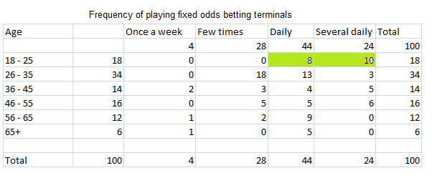
Figure 7 – Data sourced and analysed by Steward (2018)
This cross sectional analysis looks at age in relation to the overall frequency of FOBT usage during a typical week. The analysed data has been highlighted to show that all 18 respondents between age bracket 18 – 25 gamble every day and 56% have more than one FOBT session daily. It has been grounded in chapter 2 by Gerda Reith that the gambling act of 2005 has failed since it was created to “satisfy, but not stimulate existing demand’ (Research on the Social Impact of Gambling, 2006, p. 75). The data collected shows that FOBT’s are stimulating a new generation of gamblers which it directly opposing what it was created to do. It was designed to give existing gamblers the option, not prospective gamblers the means.

4.2.2 Session spend / voluntary limit exceeded
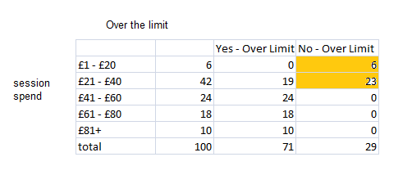
Figure 8 – Data sourced and analysed by Steward (2018)
This cross section looks at the relationship between going over a predetermined set fiscal limit and the average sessions spend per customer. The data collated highlights that the customers that spend the least amount on FOBT games do not go over the pre-determined limit. All 52 surveyed customers who spend more than £41 per session substantiate that they frequently spend more than they are initially wanting to. This indicates to the researcher a lack of internal controls in place to minimise customer excessive spending on FOBT’s and as a direct result the research indicates that loss on control is an issue. Uttley (2018) claims that higher stakes reduce the individual decision making power that a player has and believes this to a non-sustainable long term plan by bookmakers.

4.2.3 Harmful Effects – strongly agree and agree

Figure 9 – Data sourced and analysed by Steward (2018)

The above bar graph shows the collected responses regarding question 12 filtered for strongly agree and agree with the aforementioned statements. The participant responses show that 88% believe that removing debit card transactions from fixed odds betting terminal sessions would reduce assist in reducing the perceived harm in FOBT’s. The results also indicate that over 90% of respondents feel the removed of bonus features would also reduce the harm of FOBT’s. This draws a comparison to the conclusion drawn by Lindberg et al suggesting that by removing the bonus features from within games would reduce the overall appeal to at risk customers (Impulsivity and Cognitive Distortions in Problem Gambling: Theory and Application, 2014). It is also affirmed by Fabricatore (Gameplay and game mechanics design, 2014) that bonuses allow the customer to feel they have won even if the returns are lower than they have put in, this only encourages them to play more. As discussed in Chapter 2, a key proponent on business in recent is years is the term corporate social responsibility (Carroll, 1991). 86% of questioned customers believe that the bookmaker should do more to identify problem gamblers. This mirrors the ethical paradox of profit over responsibility (Friedman, 1970). However, Mark Griffiths infers that the identification of problem gamblers by bookmakers would not prevail due to the accessibility of online gambling (Should virtual roulette machines be banned from high street bookmakers?, 2018) and would only minimise a shop’s profit in the short term.

4.2.4 Harmful effects – Strongly disagree and disagree

Figure 10 – Data sourced and analysed by Steward (2018)
The above bar graph shows the collected responses regarding question 12 [What else can be done (other than reducing the maximum allowed stake) in order to reduce the harmfulness of fixed odds betting terminals] filtered for strongly disagree and disagree with the aforementioned statements. With B2 category games, a customer is able to get up to £100 every 20 seconds. 72% of respondents believe that decreasing game variety would not reduce the harm in fixed odds betting terminals. The data collected affirms this as 98 / 100 respondents chose their FOBT game because they have played it before. Highlighting the time and day on the screen retained almost 30%, mirroring the established theme in casinos of not showing the time or day (Streeter, 2018).

4.2.5 Specific appeal triggers
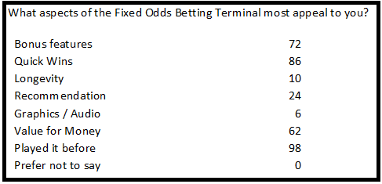
Figure 11 – Data sourced and analysed by Steward (2018)
Question 6 of the survey looks at the individual aspects that appeal to an FOBT user as to what draws them to play it. 98% of respondents said they chose their game because they have played it before. Betting shops add new games each week to their machines (Bookmakers, 2017) however, the vast majority of those responded said this does not impact their decision making process as they will choose to play the same game each time. Fabricatore suggests that graphics and audio are key indicators (2014) when deciding whether to play a machine however, the primary data suggests that this is not applicable to a betting shop customer over a standard casino customer. 72% of customers replied that the specific bonus features are the underlying reason for playing a certain game which mirrors the 92% that believe that bonus features ultimately provide harm to players.

4.2.6 Online / In-store frequency
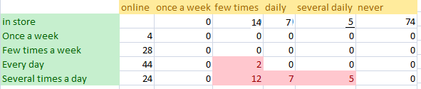
Figure 12 – Data sourced and analysed by Steward (2018)
The above table shows the frequency of gambling in store on the vertical axis, and the frequency of online gambling on the horizontal axis with specific data highlighted. The data gathered shows that of the 26 people that have gambled online, 92% gamble in store more than once a week in addition to multiple times a week online. This further highlights the access available for people to gamble as inferred by Griffiths (2015).

4.3 Statistical Analysis – Survey

4.3.1 The Average Customer
As specific customer ages were not specified but characterised within age group brackets, an average age can be estimated out using the mean age groups (18+25/2 = 20.5) resulting in 21.5; 30.5; 40.5; 50.5; 60.5 and 70.5. The average customer age can therefore be extrapolated from the 100 surveys to produce an average customer age of 39.4 and through the 97/3 male to female respondent ratio it can be assumed that the gender of the average customer would be male. Using the mathematical statistical assumption discipline whereby using real statistics to conclude an assumption based on similar outcomes it can be presented with a high probability that the average customer would have played his chosen FOBT game previously and to a lesser but still likely probability would choose this FOBT game for its quick wins (98% and 86% respectively [Section 4.2.5]) over any other specific appeal trigger. In addition, it can be assumed with 93% probability that since the average customer is aged between 36 and 45 and the quantitative survey highlighted 1 in 14 customers within that age grouping have never gambled online, it can be thought that the average customer does not gamble online. It can also be supposed based off the primary research data that the average FOBT customer believes removing debit card transactions from FOBT’s would reduce the harm (88% Section 4.2.3).

4.3.2 Chi Square Statistical Testing
A chi square test for independence can be used in order to view any correlation between two inconsequential variables (Greenwood & Nikulin, 1996). The tests can be used to analyse any numerical value stemming from primary research and look at these variables between two data figures. Using a 2 x 2 squared method, the research is able to analyse the following tables to indicate any significance.

4.3.2.1 Chi Square 1
The following chi square test highlights the ratios of age to gamble online frequency.
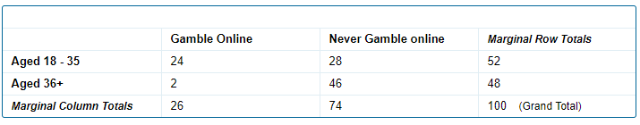
Figure 13 – Data sourced and analysed by Steward (2018)
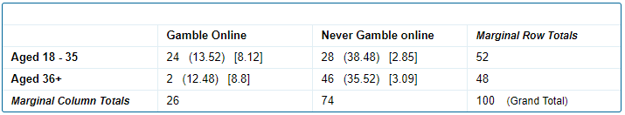
Figure 14 – Data sourced and analysed by Steward (2018)
The chi-square statistic is 22.8704. The p-value is .000002. This result is significant at p < .05.

4.3.2.2 Summary of test results
The given significant p value indicates a strong correlation in ages 18-35 with reference to frequent gambling online in retrospect to the large proportion of customer over 36+ to whom have never gambled online. This significant result indicated a correlation to the researcher and as such may be indicative of a trend that younger people who gamble in store, also gamble frequently online.

4.3.3 Chi Square 2
The following chi square test highlights the ratios of age to gamble in store daily frequency.

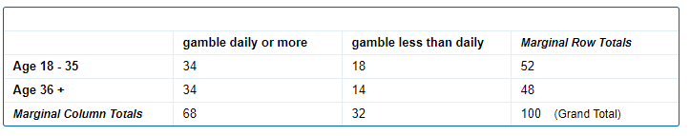
Figure 15 – Data sourced and analysed by Steward (2018)

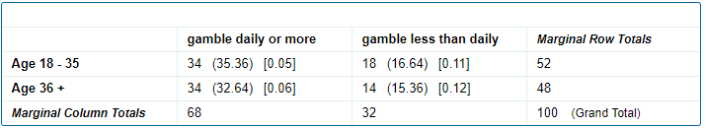.
Figure 16 – Data sourced and analysed by Steward (2018)
The chi-square statistic is 0.3405. The p-value is .559515. This result is not significant at p < .05.

4.3.3.1 Summary of test results
The value of P representing age to in store gambling is inconsequential and as such does not pose any significance to the findings.
Due to the multiple 0 data figures within the numerical findings, a typical 5x5 calculate chi square test cannot be performed without manipulating the hard data.

4.4 Data analysis - Interview
The following analysis is of two interview transcripts [See Appendix E and F] regarding a semi structured interview format as outlines in Appendix D.
Both respondents interviewed said that they would like that more could be done to prevent those deemed at risk gamblers and agreed with the question that enough is not being done by bookmakers to assist in this (See Appendix G – Employee pamphlet).

4.4.1 Debit card transactions
The issue of using a debit card was raised by respondent Manager 1 as the primary shop they work in is affected by a high amount of money laundering due to its central location. They believe more should be done to prevent it. Through the quantitative survey data gained, it is evident that customers would prefer the option of using debit cards to be removed from the fixed odds betting terminals (88% see section 4.2.3).

4.4.2 Free credit / tournaments
The secondary literature research looked at what companies do to attract customers. It was noted that companies such as Coral introduce new games ever week and offer free credit and tournaments to appeal to a wider audience. This was exemplified in interview question 7.
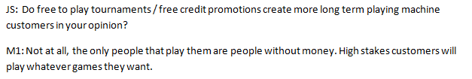
Figure 18 – Data sourced and analysed by Steward (2018)
Manager1’s responses show that the tournaments in fact do not offer long term sustainable machine usage from customers and instead create short term players.
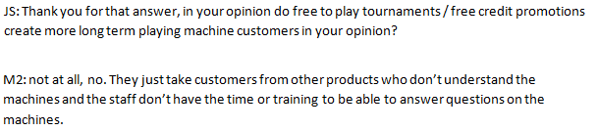
Figure 19 – Data sourced and analysed by Steward (2018)
In agreement with Manager1, Manager2 also conferred that free to play tournaments and free credit promotions do not create more machine customers and could be argued to be detrimental to other aspects of gambling. This mirrors the quantitative survey data question (98/100 Section 4.2.5) where the vast majority of FOBT customers stated that they choose their game based on the fact that they have played it previously.

4.4.3 Slowing down game play
The quantitative data collection analysis (Section 4.2.3) infers that 67% of FOBT users surveyed responded that slowing down game play on the terminals would reduce the harm in them. Manager2 brought up a similar proposal during the second qualitative interview.
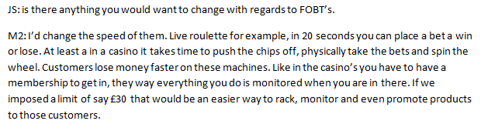
Figure 20 – Data sourced and analysed by Steward (2018)
Both the survey and interview indicate that slowing down gameplay would be a factor in reducing he harm stemming from FOBT’s however, in a segmented industry that is regulated less than casino’s, younger players are actively playing the machines more.
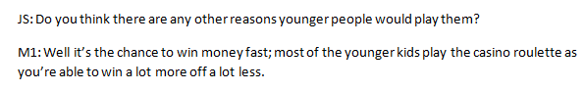
Figure 21 – Data sourced and analysed by Steward (2018)

4.4.4 Reducing the maximum allowed stake
With the UK government’s decision on whether to reduce the maximum allowed FOBT stake due imminently, a question was asked to both interviewees whether the reduction of the stake should be done. Manager1 responded:
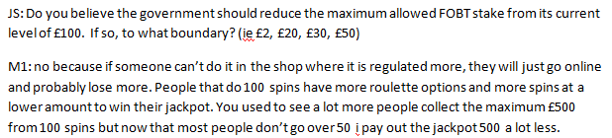
Figure 22 – Data sourced and analysed by Steward (2018)
Manager2 responded:
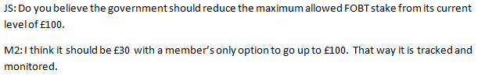
Figure 23 – Data sourced and analysed by Steward (2018)
Manager1 surmises that no, reducing the stake would not as it simply eliminates one option of betting. The quantitative survey data showed only 26% of FOBT customers have gambled online and it could therefore be argued that reducing the stake would reduce the harm in FOBT’s Griffiths (2018) infers that everyone if not able to bet in store will bet online however, the interview analysis indicates that is not accurate summary. Manager2 offers a solution of greater monitoring capabilities on FOBT transactions over £30. Such policies exist within casinos whereby a players spending is constantly tracked and assessed as explored in chapter 2 however, it could be argued this would infringe on the freedoms that people associate with gambling. As discussed previously, in a casino where there is a lot more monitoring, many customers would not want their data stored for machine usage. The question regarding the current in store procedure of asking a customer if they want to play stakes over £50, both interviewees responded that it is not beneficial in reducing problem gambling due to the minority of players that play them.

4.5 Limitations of the study
Due to the cross sectional data research method, time was a mitigating factor through the dissertation process and as such, it can be argued that a fair representation of society was not reflected in the main findings. This reaffirms the Gambling Commission’s view of a male dominated industry.
With respect to the sensitive subject matter, with greater experience to the researcher, more challenging open ended survey questions could be asked with regards to the customer feelings and emotions that would include secondary observations for non-auditory cues such as body language.
The sample data was also disproportionate to the gender divide in society and as such, a much large sample survey should incorporate more female opinions (Babbie, 2007).
The study was conducted within a localised area and further studies would be necessary to gauge the opinions on a wider national level to avoid data analysis bias through cultural differences. For example, if the age frequencies of daily FOBT users in other areas of the UK are similar to the customer base of FOBT’s within Swansea.

4.6 Conclusion
It is evident from the primary research that younger players are more frequently playing FOBT’s and as a result are causing an increase in FOBT usage than in previous years. Discussed in Chapter 2, the gambling act was established to allow the industry the same opportunity as others but it has become a gateway for young people to start gambling with higher stakes (Reith, 2006). 99% responded in the quantitative survey that reducing the maximum allowed FOBT stake is a good idea and all 100 surveyed customers agreed with the statement that fixed odds betting terminals are harmful. There is a noted strong correlation between younger gamblers and the propensity to gamble online in addition to in store and as such could be viewed as potential problem gamblers. A fundamental objective of the Gambling Act is to ensure young people are not harmed by gambling (bookmakers-cannot-prevent-problem-gambling, 2015). Younger gamblers, based off the primary research, are more likely to spend over their pre-determined limit each session and are the largest age group (18 – 25) to gamble online. This indicates a potential trend that younger gamblers are more prone to have less internal controls to limit their game play. This could be attributed to the social acceptance of gambling through sporting sponsorships.
The final chapter will conclude the dissertation and as such seek to surmise the analysed primary research with the grounded secondary research with specific reference to the initial objectives as outlined in Chapter 1.

Chapter 5 – Conclusion

The following chapter will surmise the dissertation and seek to answer whether the primary objectives of the dissertation have been fulfilled.
The stigma of problem gambling still exists and it seems that until the proposed government regulation, the industry was working in the shadow and recouping huge profits off FOBT’s without any recourse. Gambling has always been a way for customers to escape from reality and its premise is rooted in the culture of society.
Objective 1 - To review existing literature on gambling, FOBT’s and any impact in the community.
Archie Carroll believed that a business have an ethical and moral responsibility to its customers and as a result, the community (1991). One of the primary objectives in this dissertation is to ascertain what the local bookmaker does for the local community. In Chapter 2 it was noted that several UK bookmakers claim to actively engage in corporate social responsibility (William Hill, 2017) (Coral, 2018) (Ladbrokes, 2015). Both interview respondents affirmed that other than a charity box that goes to a central unit, nothing is done for the surrounding environment or community. However, with only 2 stores geographically surveyed it does not provide a sound representation of the UK industry as a whole. The research does over a view into a segment into society and as such a society with a propensity to gamble and a lack of awareness from the industry to the perceived dangers it can cause. With the National Health Service spending £1.2B a year on problem gambling (NHS, 2016), it can be concluded that enough is not being done by the industry to prevent this (2016). It can also be affirmed based off the primary quantitative data capturing and qualitative interviews that FOBT’s are a harmful product, however, are a consistently profitable product in the eyes on the government and the industry. The main findings insinuate that there is currently a large correlation between FOBT customers under 35 who are not in control of their gambling. This is evident through the data analysis and as such, further questions the responsibility of business (Carroll, 1991). Due to the exponential growth of the industry in recent years there does not exist the required tools to assist in the reduction of problem gambling. It was established in Chapter 2 that more young people are gambling more than ever before (backed up by the quantitative data sample) raising the question of awareness. For many stigmatic areas of society there does not exist a spokesperson or a voice for that isolated community. That voice does not exist in the gambling industry and as such there is a large vulnerable section of society with a predisposition to problem gambling that receives no help and limited support. The public spending on problem gambling from the NHS is not an accurate portrayal of the overall health of the gambling nation and as such more studies should be undertaken looking into the physiological and psychological triggers underlying the causality of problem gambling. As a result of the industries practises, limited unbiased literature is available highlighting the wider implications on society of problem gambling (William HIll, 2018).

Objective 2 - To critically evaluate whether reducing the FOBT maximum stake threshold would be beneficial to both consumer and the betting industry.

By reducing the maximum allowed stake on FOBT’s the government would be losing millions of pounds in tax levies and as such several charities and organisations that principally rely on those funds in order to operate would cease to exist. The surveyed consumers indicate reducing the threshold from £100 would be beneficial [99%] and a question to fixed odds betting terminal users of whether such machines are harmful resulted in a 100% affirmation. The quantitative data analysis highlighted that a majority of FOBT users go over their pre-determined stake on a regular basis but few customer spend amounts that the government would consider harmful. Through the qualitative interviews it was affirmed that very few customers stake between £50 and £100 per turn. From an industry perspective, through the research process, it seems reducing the stake would not be beneficial to the industry. This has been established in Chapter 2 that the industry as a result of the proposed government changes would lose millions in revenue and thousands of job losses (Gerrard, 2017).. From a consumer perspective, with in store bookmakers there exists greater regulation and a supervisory monitoring policy in place. If the maximum stake of £100 was removed, those customers would either go to a casino or most likely bet online where statistically, those lost customers would be able to lose more money faster. The statistical results also indicate that over 90% of respondents feel the removed of bonus features would reduce the harm of FOBT’s and it can be assumed removing those features would result in less usage. However, it can naturally be applied that customer who play for those features what play different games such as roulette or card games. FOBT users are allowed the right to gamble between 5p and £100 and it is their choice to what stakes they play at. Reducing the overall stake allowed on the machines would reduce the short term harm, but there are other areas to explore such as greater regulation in the overall industry and more support groups being created to assist on the grass roots level of problem gambling. Reducing the maximum allowed stake would only impact a minority of customers however, research indicates customers than spend more are at a higher risk of developing issues regarding problem gambling.

Objective 3 - To investigate any external influences that affect the decision making process of a gambler

Fabricatore stated that the graphical and auditory responses from a game creates long term appeal (2014) however, the quantitative data findings show that only 6% of customers choose their game based on those highly sensory triggers and as such the majority of those surveyed choose their game on having played it previously, quick wins and specific bonus features [98%, 86% and 72% respectively affirmed this statement]. The main findings indicate that a large percentage of players play FOBT machines primarily due to these reasons. The primary research showed that more young players between 18 and 25 have a higher propensity to chase their loses and a as a result lose more money to the fixed odds betting terminals. With no public marketing available for these machines due to existing government laws, the only three viable scenarios for young customers initially playing FOBT’s are:

- Playing FOBT’s as a secondary option after placing initial sporting bets.
- Playing similar games online through online casino’s
- Word of mouth

Whilst option 1 remains the viewpoint of the Government and option 2 seems unlikely given the higher risk, higher reward with online services, option 3 was affirmed in the research interview by one respondent who believes that young people are hearing about the machines either from the media or from their friends who have played them. With the decline of the traditional penny slot arcades, FOBT’s are in danger of becoming a gateway into high risk and reward gambling.
It is only the small minority of those FOBT uses that stake between £50 and £100 and reducing the overall limit could result in those customers taking their businesses to less reputable places. The larger issue stemming from the primary research is the amount spent by younger machine players and their propensity to gamble online in addition to in store on a regular basis, negating the original objectives of the UK Gambling Act.
The long term implications are a millennial generation gambling far and above their means and those levels being accepted into the culture of society. More empirical studies need to be done in order to highlight the underlying true dangers of problem gambling which FOBT’s do not appear to be. FOBT’s are simply a means to an end, if they were not available in store, customers would go online where it has been established there exists less regulation and as a consequence greater risk for the user.

5.1 Areas of further research
As the cross sectional method of data gathering was used due to time limitations there would be several key proponents that require further critical analysis through greater quantitative and qualitative research.
Areas of further research needed | Reasoning for the decision
Conduct a larger quantitative survey over a wider geographical area. | This would produce more primary data in order to draw greater conclusions (Buchanan & Bryman, 2009). The subsequent data gathered may also provide an insight into cultural trends and habits.
Ask survey participants a wealth grouping question in order to evaluate FOBT usage in correlation to weekly spending. | This question would allow comparisons to be draw between terminal usage and overall product spending.
Conduct more qualitative interviews. | Provide more sound data backed up by personal experiences.
Utilise a greater variety of research methods such as focus groups, observations and online questionnaires. | Provide more data sources for a wider opinion of both quantitative and qualitative data.
Ask survey participants whether they stake over £50 spins / play the hi-roller spins (stakes between £10 and £50 for a higher percentage payout). | More qualitative data that be applied to the data findings. This question would allow the researcher to gain more numerical data regarding customer that spend higher amounts.

5.2 Recommendations

More empirical studies are needed to understand the motivation behind young people and FOBT gambling and the direct causality it has on problem gambling. Further research is recommended to encompass a larger geographical area of study which would generate not only more subject responses for analysis but would allow potential exploration into the cultural trends of gambling
Greater monitoring by bookmakers of those deemed at risk gamblers. This would include more communication between organisations and the sharing of resources. This has recently been deployed in the form of GamCare; an extension of the existing NHS gambling helpline, however there is nothing giving problem gamblers the immediate assistance they require.
Mandatory in store membership for customers whom wish to bet more than the final proposed government maximum stake (as identified in a respondent interview, membership only for higher stakes on FOBT’s would mean greater customer protection). Stemming from the interviews, the research shows that it would be in the FOBT player’s best interest to gamble in store where there is some form of regulation.

5.3 Final Comments

In its current format it is one of the most expensive forms of escapism and one that will only be more costly to the state in years to come once the true costs of problem gambling have been accounted for. Whilst reducing the maximum allowed stake is viable one option to reduce the harm caused by larger losses on the terminals, there exists the underlying harm in the amount of young people playing these machines, who predominately don’t gamble high stakes every spin (over £50) but do represent a worrying trend in problem gambling. Ethically and morally, more should be done by bookmakers to assist in this issue other than recording record profits through the FOBT machines. Bookmakers are not fully utilising corporate social responsibility towards all levels of stakeholders (although claiming to undertake high amounts of CSR), including their clientele and as a result the industry will continue to have a stigma attached. The Senet Group’s conflict of interest questions the reality of their responsible gambling policies and as such there exists few other semi regulatory bodies with any power to wield changes to the industry. However, with very little public spending with regards to research into problem gambling and as subsequence limited information exists on the matter that is free from bias. As a consequence the question of social responsibility toward problem gamblers should explored further in greater research.

References
ABB. (2017, 02 09). new-evidence-from-the-gambling-commission-reveals-that-gamblers-risk-losing-more-money-and-are-playing-for-longer-on-gaming-machines-in-arcades-than-on-fobts. Retrieved 03 03, 2017, from abb: https://www.abb.uk.com/new-evidence-from-the-gambling-commission-reveals-that-gamblers-risk-losing-more-money-and-are-playing-for-longer-on-gaming-machines-in-arcades-than-on-fobts/
Adams, P. (2016). Moral Jeopardy: Risks of Accepting Money from the Alcohol, Tobacco and Gambling. Cambridge: Cambridge University Press.
Ahmed, M. (2017). Ladbrokes: ‘encouraging’ 2017 start as online gambling offsets high street declines. London: FT.
Anon. (2018, 01 14). the-structure-of-the-greyhound-racing-industry/the-money-makers. Retrieved 03 01, 18, from greytexploitations: http://greytexploitations.com/the-structure-of-the-greyhound-racing-industry/the-money-makers/
Astara, O. H., Mitoula, R., & Eleni, T. (2017). Corporate Social Responsibility: A marketing tool and/or a factor for the promotion of sustainable development for companies? International Journal for Strategic Management, 17.
Babbie, E. (2007). The Basics of Social Research. London: Ceneage Learning.
Banks, J. (2017). Gambling, Crime and Society. Berlin: Springer.
BBC. (2001). High Stakes: Problem gambling. Retrieved 11 15, 2017, from http://news.bbc.co.uk/1/hi/audiovideo/programmes/high_stakes/1138226.stm
Bookmakers, A. o. (2017). The Truth about Betting Shops and Gaming Machines. London: ABB.
bookmakers-cannot-prevent-problem-gambling. (2015, 02 03). Retrieved 05 12, 2018, from politicshome: https://www.politicshome.com/news/uk/culture/opinion/campaign-fairer-gambling/64322/bookmakers-cannot-prevent-problem-gambling
Buchanan, D., & Bryman, A. (2009). The SAGE Handbook of Organizational Research Methods (1st ed.). London: Sage.
Cameron, S., & Price, D. (2009). Business Research methods (1st ed.). London: Chartered Institute of Personnel Development.
Campbell, J. (2013). Why Would Corporations Behave in Socially Responsible Ways? The Academy of Management Review, 32(3), 946-967.
Carroll, A. (1991). The pyramid of corporate social responsibility: Toward the moral management of organizational stakeholders. Business horizons, 39-48.
Cassidy, R. (2014, 09 24). Window dressing the senet group and self regulation. Retrieved 05 11, 2018, from WordPress: https://gamblingacrossborders.wordpress.com/2014/09/24/window-dressing-the-senet-group-and-self-regulation/
Coral, G. (2018, 01 01). corporate-social-responsibility. Retrieved 02 06, 2018, from galacoralinteractive: http://www.galacoralinteractive.com/corporate-social-responsibility/
Crane, A., Matten, D., & Spence, L. J. (2008). Corporate Social Responsibility. New York: Routledge.
Cullen, P. (2008). Gambling committee chief opposes betting machines. Retrieved November 03, 2017, from https://www.irishtimes.com/news/gambling-committee-chief-opposes-betting-machines-1.898604
David, M. (2004). Research Methods for Political Science. Charleston: Sharpe.
Davies, R. (2017, 08 31). gambling-firm-888-fined-online-bookmaker-problem-gamblers. Retrieved from The Guardian: https://www.theguardian.com/society/2017/aug/31/gambling-firm-888-fined-online-bookmaker-problem-gamblers
Davies, R. (2017, 05 25). uk-gamblers-fobt-dcms-losses. Retrieved 02 27, 18, from theguardian: https://www.theguardian.com/society/2017/may/25/uk-gamblers-fobt-dcms-losses
Donnalyn, P. (2017). Corporate Social Responsibility, Sustainability, and Ethical Public Relations. New York: Emerald Group Publishing.
Donoughue, S. (2011, 05 06). the-normalisation-of-gambling-in-the-uk. Retrieved 02 14, 2018, from thersa: https://www.thersa.org/discover/publications-and-articles/rsa-comment/2011/05/the-normalisation-of-gambling-in-the-uk
Donoughue, S. (2014, 09 16). Not a game of passing the buck... Retrieved 05 02, 2018, from sbcnews: https://www.sbcnews.co.uk/sportsbook/2014/09/16/not-a-game-of-passing-the-buck-but-definitely-more-to-play-for-the-senet-group/
Drewett, Z. (2017, October 31). maximum-stake-on-crack-cocaine-fixed-odds-betting-machines-slashed-704081. Retrieved November 2017, 10, from metro: http://metro.co.uk/2017/10/31/maximum-stake-on-crack-cocaine-fixed-odds-betting-machines-slashed-7040815/
Environment. (2018, 03 01). Retrieved 05 09, 18, from William Hill PLC: https://www.williamhillplc.com/responsibility/environment/
Environment. (2018, 05 03). Retrieved 05 06, 2018, from William Hill PLC: https://www.williamhillplc.com/responsibility/environment/
Fabricatore, C. (2014). Gameplay and game mechanics design. London: OECD.
Freeman, E. (1984). Stakeholder Theory. Academy of Management, 366-368.
Freeman, R. E. (1984). Strategic Management: A Stakeholder Approach. London: Harlow.
Friedman, M. (1970). The Social Responsibility of Business is to Increase its Profits. The New York Times Magazine, 57.
Gainsbury, S. (2016). The Public Stigma of Problem Gambling. Journal of Gambling Studies, 2(32), 847-864.
Galletta, A. (2013). Mastering the Semi-Structured Interview and Beyond. New York: NYU Press.
Gambling Commission. (2017). Industry statistics. London: Uk Gambling Commission.
Gambling Commission. (2018, 01 01). B2 gaming machines. Retrieved 04 11, 18, from Gambling Commission: http://www.gamblingcommission.gov.uk/for-gambling-businesses/Compliance/Sector-specific-compliance/Arcades-and-machines/Gaming-machine-categories/B2-gaming-machines
GamCare. (2018, 02 01). Why Do People Gamble. Retrieved 05 06, 2018, from GamCare: http://www.gamcare.org.uk/get-advice/why-do-people-gamble
GamCare. (2018, 02 01). Working with Problem Gamblers. Retrieved 05 06, 2018, from GamCare: http://www.gamcare.org.uk/about-us/working-problem-gamblers
GamCare. (2018, 02 01). Working within the Industry. Retrieved 05 06, 2108, from GamCare: http://www.gamcare.org.uk/about-us/working-gambling-industry
Gaming-Business. (2013, 11 12). ladbrokes-refutes-fobts-and-unethical-business-claims. Retrieved from igamingbusiness: http://www.igamingbusiness.com/news/ladbrokes-refutes-fobts-and-unethical-business-claims
Gerrard, B. (2017, 11 05). High stakes as Government targets problem gambling. The Telegraph, p. 46.
Gerrard, B. (2018, 03 09). gvc-warns-ladbrokes-closures-betting-machine-stakes-slashed. Retrieved from telegraph: https://www.telegraph.co.uk/business/2018/03/09/gvc-warns-ladbrokes-closures-betting-machine-stakes-slashed/
Greenwood, P., & Nikulin, M. (1996). A guide to chi square testing. New York: John Wiley and Sons.
Griffiths, M. (2015). Has problem gambling in Great Britain decreased? Nottingham: Word Press.
Griffiths, M. (2018). Should virtual roulette machines be banned from high street bookmakers? Nottingham: Word Press.
Hannes, K., & Lockwood, C. (2011). Synthesizing Qualitative Research: Choosing the Right Approach (1st ed.). Chichester: John Wiley and Sons.
Harris, C. (2017). MPs Launch Report into Fixed Odds Betting Terminals. Swansea: Labour Party.
Houghton, T. (2011). Does positivism really ‘work’ in the social sciences? London: University College London.
Is The Senet Group Responsible? (2018, 01 01). Retrieved 05 12, 2018, from stopthefobts: http://www.stopthefobts.org/is-the-senet-group-socially-responsible/
Jawad, D. (2010). Taming of the casino dragon. Swansea: UWTSD.
John, B., Holloway, K., Davies, N., May, T., Buhociu, M., & Roderique-Davies, G. (2017). An Investigation of the Social Impact of Problem Gambling in Wales. Cardiff: University of South Wales.
Kothari, C. R. (2012). Research Methodology; methods and techniques. London: New Age International Pvt Ltd Publishers.
Ladbrokes. (2015). Corporate Responsibility Report. London: Ladbrokes PLC.
Lamont, M., Hing, N., & Gainsbury, S. (2011). Gambling on sport sponsorship: A conceptual framework for research and regulatory review. Sport Management Review, 14(3), 246-257.
Lavrakas, P. (2008). Encyclopedia of Survey Research Methods. London: Sage.
Lindberg, A., Clark, L., & Bowden-Jones, H. (2014). Impulsivity and Cognitive Distortions in Problem Gambling: Theory and Application (1st ed.). London: Palgrave Macmillan.
Mitroff, I. (1983). Stakeholders of the organisational mind. San Francisco: Jossey-bass.
Monaghan, A. (2018, 02 20). the-guardian-view-on-gambling-a-system-ripe-for-exploitatio. Retrieved from The Guardian: https://www.theguardian.com/commentisfree/2018/feb/20/the-guardian-view-on-gambling-a-system-ripe-for-exploitation
Munting, R. (1996). An Economic and Social History of Gambling in Britain and the USA. Manchester: Manchester University Press.
NHS. (2016, 12 12). problem-gamblers-cost-uk-government-1-2-billion-per-year. Retrieved 03 07, 2018, from cnwl: https://www.cnwl.nhs.uk/news/problem-gamblers-cost-uk-government-1-2-billion-per-year/
Oxford Dictionary (127th ed.). (2017). London: Oxford University Press.
Palazzo, G., & Richter, U. (2005). CSR business as usual. The case of the tobacco industry. Journal of Business Ethics, 387 - 400.
Pratley, N. (2018, 01 22). fobts-bookmakers-pay-price-failing-clean-up-their-act. Retrieved 02 04, 2018, from theguardian: https://www.theguardian.com/uk-news/nils-pratley-on-finance/2018/jan/22/fobts-bookmakers-pay-price-failing-clean-up-their-act
Preston, L., & Donaldson, T. (1995). Stakeholder Theory Of Corporation. Academy Of Management, 20(1), 67.
Promoting responsible gambling standards. (2018, 01 01). Retrieved 04 16, 2018, from Senet Group: https://senetgroup.org.uk/
Reith, D. G. (2006). Research on the Social Impact of Gambling. Glasgow: Scottish Executive Social Research .
responsible-gambling-standards. (2018, 01 01). Retrieved 05 12, 2018, from senetgroup: https://senetgroup.org.uk/responsible-gambling-standards/
Riege, A. (1998). Qualitative Market Research: An International Journ. Marketing - An International Journ, 6(2), 75 - 86.
Rose, N., & Loeb, R. (1998). Blackjack and the Law (1st ed.). Oakland: RGE Publishers.
Sapsford, R., & Jupp, V. (2006). Data Collection and Analysis (2nd ed.). London: Sage Publications.
Saunders, M., Lewis, P., & Thornhill, A. (2009). Research methods for business students (5th ed.). Edinburgh: Pearson.
Saunders, M., Lewis, P., & Thornhill, A. (2009). Research Methods for Business Students. London: Pearson Educational.
Shaw, R. J. (2016). Critical Analysis of Corporate Social Responsibility within the UK Gambling Industry. Swansea: UWTSD.
Snowdon, C. (2016). Fixed-odds betting terminals. London: International Energy Agency.
Stop The Fobt's. (2016, 12 31). Retrieved 05 12, 2018, from stopthefobts: http://www.stopthefobts.org/
Strauss, J. R. (2015). Challenging Corporate Responsiblity . In J. R. Strauss, Challenging Corporate Responsiblity (pp. 164-173). New York: Routledge.
Streeter, J. (2018, 01 12). abb-dismisses-latest-fobt-report-flawed. Retrieved 02 26, 18, from sbcnews.co.uk: https://www.sbcnews.co.uk/retail/2018/01/12/abb-dismisses-latest-fobt-report-flawed/
The History of Betting. (2018, 01 01). Retrieved 02 11, 2018, from ukbookmakers: https://www.ukbookmakers.info/history-of-betting
Thompson, W. N. (2001). Gambling in America: An Encyclopedia of History, Issues, and Society. Las Vegas: ABC- CLIO.
Thorley, C., Stirling, A., & Huynh, E. (2016). The cost to government associated with problem gambling. London: Public Policy Research.
Torkildsen, G. (2010). Torkildsen's Sport and Leisure Management. Taylor & Francis: Sheffield.
Turner, N. (2004). How Do Slot Machines And Other Electronic Gambling Machines Work? Centre for Addiction and Mental Health, 75(5), 72.
Uttley, E. (2018). Three reasons why regulations is a step in the right direction. London: MarketLine.
Volberg, R. (2000). The future of gambling in the United Kingdom. British Medical Journal, 320(7249), 1556.
Walker, P. (2018, 1 21). gambling-ministers-urged-to-be-bold-with-curbs-on-fobts. Retrieved from The Guardian: https://www.theguardian.com/uk-news/2018/jan/21/gambling-ministers-urged-to-be-bold-with-curbs-on-fobts
Watson, T. (2017, October 31). Government Proposal. FOBT Crackdown. (G. Wood, Interviewer)
Who are we. (2018, 02 01). Retrieved 05 06, 2018, from GamCare: http://www.gamcare.org.uk/about-us/who-we-are
William Hill. (2017). Responsible in everything we do. London: William Hill PLC.
William HIll. (2018, 03 12). /encouraging-responsible-gambling. Retrieved from williamhillplc: http://www.williamhillplc.com/responsibility/responsible-gambling/encouraging-responsible-gambling/
Woodhouse, J. (2017). Fixed odds betting terminals. London: House Of Commons Briefer.

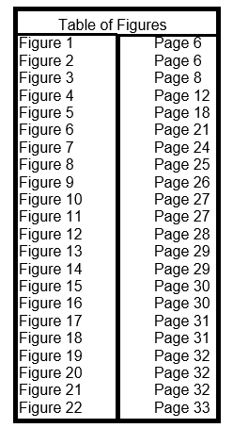

Appendices

Appendix a - Questionnaire – Betting Shop customers
- What is your gender?

Male
Female
Prefer Not To Say

- What is your age?


18 to 25
26 to 35
36 to 45
46 to 55
56 to 65
Older than 65
Prefer Not To Say

- How many times a week do you play fixed odds betting terminals?

Once a week
Few times a week
Every day
Several times a day

- How frequently do you gamble online?
Once a week
Few times a week
Every day
Several times a day
Never

- What product has attracted you to the betting shop today?
Sports betting
Fixed odds terminals
Racing Betting
Other

- What aspects of the FOBT most appeal to you?
Bonus Features Graphics / Audio
Quick Wins Value for money
Longevity of a game Played it before
Recommendation Prefer Not To Say

- How much do you intend to spend in a single session on the FOBT?

£1 - £20 £21 - £40 £41 - £61 £61 - £80 £81+

- Do you ever go over this limit?
Yes No

- Are you aware of the UK Government’s proposed plans to reduce the maximum allowed stake on fixed odds betting terminals?
Yes No

- Do you think this is a good idea?
Yes No

- Do you agree with the Government in their assessment that in their current state fixed odds betting terminals are harmful?
Yes No

- In your opinion, what else can be done (other than reducing the maximum allowed stake) in order to reduce the harmfulness of fixed odds betting terminals?

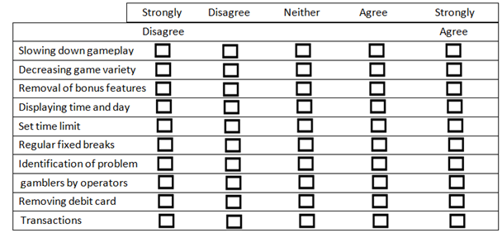

Appendix b - Betting shop data results - totals

Gender
Male | 97
Female | 3
Prefer not to say | 0
total | 100
Age
18 - 25 | 18
26 - 35 | 34
36 - 45 | 14
46 - 55 | 16
56 - 65 | 12
65+ | 6
Prefer not to say | 0
total | 100
Frequent of playing
Once a week | 4
Few times a week | 28
Every day | 44
Several times a day | 24
total | 100
Gamble online frequency
Once a week | 0
Few times a week | 14
Every day | 7
Several times a day | 5
Never | 74
Total | 100
Products today
Sports | 26
FOBT | 100
Racing | 31
Other | 5
What aspects of FOBT's appeal
Bonus features | 72
Quick Wins | 86
Longevity | 10
Recommendation | 24
Graphics / Audio | 6
Value for Money | 62
Played it before | 98
Prefer not to say | 0
How much session spend
£1 - £20 | 6
£21 - £40 | 42
£41 - £60 | 24
£61 - £80 | 18
£81+ | 10
Total | 100
Over limit
Yes | 71
No | 29
Proposal Awareness
Yes | 95
No | 5
Good idea
Yes | 99
No | 1
Are they harmful
Yes | 100
No | 0
Likert scale question
 | Strongly disagree | Disagree | Neither | Agree | Strongly Agree
Slowing down game play | 2 | 22 | 8 | 30 | 38
Decreasing game variety | 10 | 62 | 0 | 16 | 12
Removal of bonus features | 0 | 8 | 0 | 46 | 46
Displaying time and day | 0 | 28 | 70 | 2 | 0
Set time limit | 10 | 42 | 6 | 28 | 14
Regular fixed breaks | 26 | 66 | 0 | 8 | 0
Identify problem gamblers | 6 | 8 | 0 | 38 | 48
Remove d/c transactions | 2 | 8 | 2 | 22 | 66

Appendix c - Semi structured interview questions – betting shop managers

1. Would you please tell me what the betting shop was like you when first started work? Atmosphere, customer base etc
2. What were your initial thoughts when FOBT’s were introduced?
3. In your opinion, has the customer base of FOBT’s changed since their introduction?
4. What do you believe are the factors that draw customers to use FOBT’s
5. Is there anything you would change with regards to FOBT’s?
6. Do you believe that having customers verbally agree to stake of £50 (current rules) is beneficial and worthwhile? Why?
7. Do you think enough is being done by bookmakers to encourage responsible gambling? Why?
8. Do free to play tournaments / free credit promotions create more long term playing machine customers in your opinion?
9. What, if any, has your store done for its immediate local community?
10. Do you believe the government should reduce the maximum allowed FOBT stake from its current level of £100. If so, to what boundary? (ie £2, £20, £30, £50)
11. Have you has any different experiences whilst working within a different store with regards to FOBT customers?
12. Is there a level of responsibility that a business should have towards its customers with regards to protection that the industry cannot cope with.
13. How reliant is the industry’s overall profit on FOBT’s

Appendix d - Interview 1 – Transcript
JS – interviewer
M1 (manager1) –respondent
02/03/18 12.30pm
JS: Hello, my name is James Steward and I am an Accounting student at UWTSD Business School. I will be interviewing you today regarding yours view on fixed odds betting terminals and perceived harm they may cause. Fixed odds betting terminals will be referred to as FOBT’s for the purpose of this interview. Your responses will be documented in written format and later a copy of this interview will be stored in the university archives. Do you consent to take part in an interview today?
M1: Yes I do
JS: Excellent, may I begin by asking how long you have worked in the bookmaking industry?
M1: I’ve worked for my current company for almost 4 years and another company before that for 5 years.
JS: So almost 10 years of service?
M1: Yes, I’ve seen the job go from maths based to sales based and it isn’t the same that it once was.
JS: Going back to when you began, what was the the betting shop was like you when first started work?
M1: Well back then the computers were in so it was easier than what my dad had to deal with when he was working. It was mainly older customers betting on the horses. We had early FOBT’s but nobody really played them, it was just a way to gamble a pound or two to put back into more horses more the normal crowd.
JS: And you said that your customer base was mainly older customers back then?
M1: Yeah it isn’t what it’s like now with kids coming in as soon as they turn 18 because their older mates are playing the machines and winning occasionally.
JS: Interesting point thank you, what were your initial thoughts with the fobt’s?
M1: They were similar to fruit machines in clubs but they weren’t really marketed so nobody played them unless they saw them there and had a pound spare.
JS: You’ve said that you find a lot of younger customers come in to play the machines?
M1: Yeah, people that don’t bet on anything else just come in, load up a few notes and try and win a couple of hundred to cover their night out. See it all the time these days and as a result having to ID a lot more people that what I used to do.
JS: Why do you think they are playing them? Just to double up?
M1: Yeah they see it or heard about it as a quick way of making money. They hear about them from their friends or from all the stuff about it in the news and they come in try it because of the appeal of winning money quickly.
JS: Do you think there are any other reasons younger people would play them?
M1: Well it’s the chance to win money fast, most of the younger kids play the casino roulette games as your able to win alot more off a lot less. Its these kids that wouldn’t go into a casino so for them its their version.
JS: Ok
M1: its low stake, high reward and if they see one of their mates doing it, they’ll all want a go of it andit goes from there
JS: do you find that the younger customers bet higher amounts?
M1: a small amount do, as i say the majority of them just put 20 or 40 quid in and do a few spins and are gone in 5 minutes. Rarely do the younger customers go over £50 a spin or even spend that much in their session unless their chasing
JS: Chasing? Would you elaborate the term please?
M1: chasing their losses, trying to get their first £20 back by putting more in and betting more riskier.
JS: I see, thank you. Based on what you have told me so far, there anything you think you’d change with regards to fobts
M1: Where my shop is located we have a problem with money laundering. For example, if police stop someone in town and they have a large amount of cash, they can just say they won it in a bookie and be gone. I think it supports a lot of crime and my idea is that any payouts over a certain amount have to go to a debit card. That way, large amounts of money can be traced better if needed.
JS: do you get a lot of people who use a debit card on the machines
M1: only people that are losing and its such a bad idea. At least with cash, know it sounds dumb, but you can hold it and physically see it before you hand it over or put it in a machine. With the debit card it can load hundreds in seconds and be gone in a few minutes and they come back wanting more, and we cant stop them. We can say no we cant take it, we got to take it and let them gamble.
JS: Do you believe that having customers verbally agree to stake of £50 (current rules) is beneficial and worthwhile?
M1: it makes no difference, the transaction isn’t being monitored and the only people that want to do it ask for it.
JS: am i right in surmising then, that you feel that has no impact on responsible gambling
M1: yeah
JS: Do you think enough is being done by bookmakers to encourage responsible gambling?
M1: there’s only so much a business can do responsibly. Anyone over the age of 18 is able to come in and bet. Its their personal decision to do so. I mean you can get wasted in a pub and they will cut you off. We cant do that. Theres less regulation on the internet so people can just go elsewhere to do it.
JS: Do free to play tournaments / free credit promotions create more long term playing machine customers in your opinion?
M1: Not at all, the only people that play them are people without money. High stakes customers will play whatever games they want.
JS: What, if any, has your store done for its immediate local community?
M1: we give free coffee’s and teas (laughs). Nothing really, i know coral used to do scratchcards where like a percentage goes to charity but we don’t.
JS: Do you believe the government should reduce the maximum allowed FOBT stake from its current level of £100. If so, to what boundary? (ie £2, £20, £30, £50)
M1: no because if someone cant do it in the shop where it is regulated more, they will just go online and probably lose more. People that do 100 spins have more roulette options and more spins at a lower amount to win their jackpot. You used to see a lot more people collect the maximum £500 from 100 spins but now that most people don’t go over 50 i pay out the jackpot 500 a lot less.
JS: why do you think that is
M1: well its because they don’t really spend over 50 so they cant cover as much roulette numbers as a large stake would.
JS: thank you, just going back to an earlier question, you said the machines customers theres days are young..?
M1: mainly young but at some times during the day you get a lot of Chinese customers doing high bets but in shops ive worked in outside of the city you just get elderly horse betters and no machine customers.
JS: so it varies by location would you say?
M1: i know this sounds bad but the more poor the area is the more machine customers you get.
JS: studies have shown that bookmakers to tend to operate in areas that have lower than average wealth.
M1: you do see that, people off the street, like homeless, putting in all their 5p and 10ps in the machine to make it up to a pound spin then leaving.
JS: that sounds depressing
M1: it is, and when they win say like a fiver, they don’t take it, they keep going and always end up losing it.
JS: Almost there, Is there a level of responsibility that a business should have towards its customers with regards to protection that the industry cannot cope with.
M1: i think it would only work if it was members only to play the machines and to force daily / weekly limits on everyone. We could monitor it also.
JS: do you not think that will take the freedom aspect out of gambling?
M1: yeah i suppose but something needs to be done
JS: Thank you, my final question is one you prepared for me, may i ask for your shop what your overall profit was from fobt’s last year?
M1: Yes, in my shop 78% of our profit came from FOBT’s.
JS: thank you very much for your time today and once again assisting me in my dissertation research.

Appendix E - Interview 2 – Transcript
JS – interviewer
M2 (manager2) –respondent
11/04/18 18.06pm
JS: Hello, my name is James Steward and I am an Accounting student at UWTSD Business School. I will be interviewing you today regarding yours view on fixed odds betting terminals and perceived harm they may cause. Fixed odds betting terminals will be referred to as FOBT’s for the purpose of this interview. Your responses will be documented in written format and later a copy of this interview will be stored in the university archives. Do you consent to take part in an interview today?
M2: Sure
JS: excellent, how long have you worked in the bookmaking industry?
M2: I have worked here for 7 years
JS: thank you, what was your customer base like when you first began.
M2: in the shop I began in it was predominantly working class and repeat customers. Rarely did we see anyone new of under 21 unless it was a customers son or daughter.
JS: What were your initial thoughts about fobts
M2: I initially thought they were good in moderation. A cheaper alternative to your traditional casinos and has less of a stigma attached to casinos.
JS: Has the customer base changed in recent years on fobt’s
M2: a lot more youngsters playing these days, more unemployed people and people on benefits using the machines trying to double their money. Its only really the youngsters that play high stakes
JS: why do you think they play them?
M2: they are everywhere. There’s a range of games and they are lot closer to people that would never go to casino. Lots of our customers play for the quick wins on roulette or bonus features on games.
JS: is there anything you would want to change with regards to fobt’s.
M2: I’d change the speed of them. Live roulette, in 20 seconds you can place a bet a win / lose. At least a in a casino it takes time to push the chips off, physically take the bets and spin the wheel. Customers lose money faster on these machines. Like in the casino’s you have to have a membership to get in, they way everything you do is monitored when you are in there. If we imposed a limit of say £30 that would be an easier way to rack, monitor and even promote products to those customers.
JS: that’s a very interesting concept
M2; ive thought about it before (laughs)
JS: Do you believe that having customers verbally agree to stake of £50 (current rules) is beneficial and worthwhile?
M2: no, few people understand ‘do you wish to play stakes of more than 50 pound or more’ and just say yes for the sake of it. I’d say 1/10 would ever ask for it and they are the repeat customers.
JS: Do you think enough is being done by bookmakers to encourage responsible gambling?
M2:No because going back to casinos and their login requirements and spending tracked. About 30% of all machine customers are monitored for their high spending. I actually got a call from player protection about a particular known customer
JS: What about?
M2: they want to know about him, his job, his estimated income who he gambles with so they can build a profile as he spend and subsequently loses a lot. They wanted me to ask him whether he was ok to lose the amount he loses. That’s a good thing but that’s the first time I’ve ever had that phone call and there are plenty more worse customers. There should be more monitoring but customers feel there is a stigma about monitoring loses and some refuse to use their membership card on the machine so it doesn’t get tracked.
JS: Thank you for that answer, in your opinion do free to play tournaments / free credit promotions create more long term playing machine customers in your opinion?
M2: not at all, no. They just take customers from other products who don’t understand the machines and the staff don’t have the time or training to be able to answer questions on the machines.
JS: What, if any, has your store done for its immediate local community?
M2: Nothing, only the charity bucket that goes to a centralised donation. A colleague i know is running the marathon for charity, his own company won’t sponsor him or advertise internally.
JS: Do you believe the government should reduce the maximum allowed FOBT stake from its current level of £100.
M2: i think it should be £30 with a member’s only option to go up to £100. That way it is tracked and monitored.
JS: Have you has any different experiences whilst working within a different store with regards to FOBT customers?
M2: Each shop is different;I’ve been in ones with proper upper class betting greyhounds and nobody touching the machines and then other shops full of the unemployed pumping the machines. You tend to get that in poorer areas though, rich people know not to play them for just £500 jackpot.
JS: Is there a level of responsibility that a business should have towards its customers with regards to protection that the industry cannot cope with.
M2: there should be but there isn’t. Customers are able to spend thousands on their debit cards and all staff are able to say is are you sure. We aren’t allowed to stop anyone from gambling unless banned or being violet or aggressive.
JS: Thank you, my final question is one you prepared for me; may i ask for your shop what your overall profit was from fobt’s last year?
M2: i got you two shops. One in the city and one outside the city (the specific shops were given to the researcher but these were removed due to anonymity). City shop was 82%, outside city was 57%.
JS: that is fantastic, thank you for your time today and for assisting me in my dissertation research.

Appendix f - Ladbrokes employee pamphlet
Employee’s guide to responsible gambling
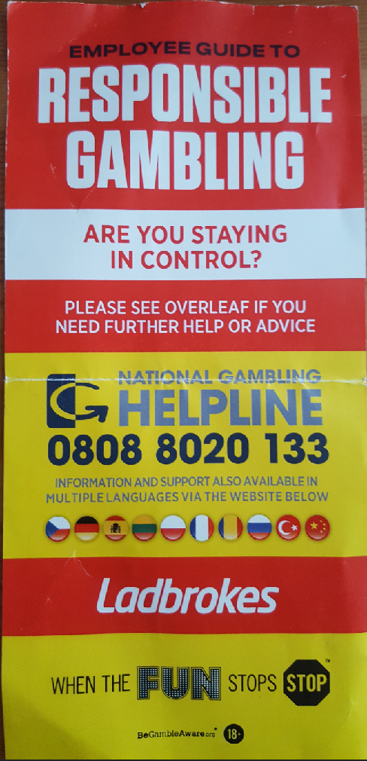

Appendix g - Ladbrokes employee pamphlet
Employee’s guide to responsibly gambling – reverse.
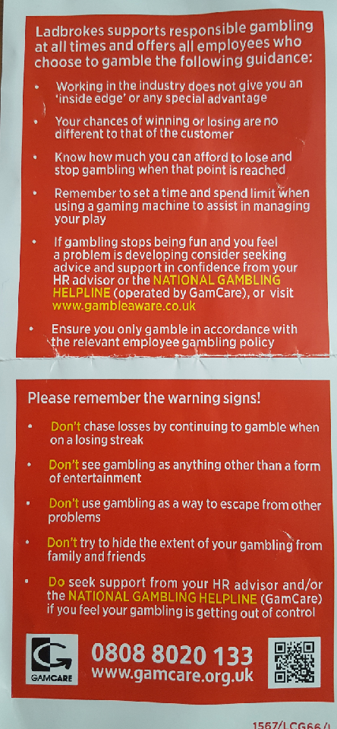

Appendix h – Ethics form
SECTION A:
Full Name: |  |  | James Steward
Member of staff: | ☐ | Student: |  | ☒ | Honorary research fellow: |  | ☐
Faculty/School/Centre: |  |  | UWTSD
Campus: |  |  | Swansea Business School
E-mail address: |  |  | Jsteward.148073@student.uwtsd.ac.uk
Contact Telephone Number: |  |  | 07531461134
For students:
Student Number: |  |  | P148073 |  |  | Undergraduate |  | ☒
Programme of Study: |  |  | BA Accountancy |  |  | Taught Postgraduate |  | ☐
Director of Studies/Supervisor: |  |  | Caroline Jawad |  |  | Research |  | ☐

SECTION B: Approval for Research Activity
Has the research activity received approval in principle?  (please check the Guidance Notes as to the appropriate approval process for different levels of research by different categories of individual) |  | YES | ☒ | NO | ☐
 |  |  |  | Date
If Yes, please indicate source of approval (and date where known): | Research Degrees Committee |  | ☐
 | Faculty Research Committee |  | ☐
 | Other (write in) |  | ☒ | supervisor
Approval in principle must be obtained from the relevant source prior to seeking ethical approval.
SECTION C: External Ethical Guidance Materials
Please list the core ethical guidance documents that have been referred to during the completion of this form (including any discipline-specific codes of research ethics, and also any specific ethical guidance relating to the proposed methodology). Please tick to confirm that your research proposal adheres to these codes and guidelines.
Dissertation handbook | ☒
Advise from supervisor | ☒
 | ☐

SECTION E: Details of Research Activity
Indicative title: | An evaluation of fixed odds betting terminals: are they the most harmful form of gambling
Proposed start date: | 30/09/2017 | Proposed end date: | 04/05/2018
Purpose of research activity (including aims and objectives)
Outline the purpose, aims and objectives of the research activity, including key research questions. Show briefly how existing research has informed the proposed activity and explain what the research activity will add and how it addresses an area of importance. (Maximum 300 words)
The aims and objectives of the research will be explored using both quantitative and qualitative methods of data collection and said data will be investigated using analytical tools.
To accomplish the aim of this study, the primary objectives are:
To review existing literature on gambling, FOBT’s and their impact in the community.
This will be done to gain an up to date knowledge on a topic that is prominent in society at present. It will look at the theories behind gambling motivation and triggers in order to see what has been done in this field.
To access the levels of support given to problem gamblers within the betting industry.
This will be achieved through the analysis of problem gambler data. It is an important aspect to see if sufficient levels of support are being offered to help with problem gamblers.
To explore whether reducing the FOBT maximum stake threshold would be beneficial to both consumer and the betting industry.
This will be achieved by researching and analysing the available data the 12 week consultation period and by interviewing both gamblers and staff within the betting industry to gauge a variety of responses to the chosen topic.
To investigate any external influences that affect the decision making process of a gambler
This will explore any cultural or societal impact that can affect the decision making process of a gambler. The information will be gathered through qualitative interviews and quantitative surveys and will be backed up secondary observations.
Proposed methods
This study will conduct qualitative interviews with customers and bookmakers to gauge their opinion of whether the proposed reduction in FOBT maximum stakes would result in a reduction of FOBT players. The questions posed will be non-obtrusive and can be anonymous in response. There will also be secondary data collected in the form of a Survey regarding the frequency of play of FOBT’s. These questions will be aiming to better understand what makes customers play FOBT machines. The questions pose a direct link to ethnography and the underpinning emotional response generated from gambling from a customer perspective
There will be 3 methods uses for research analysis. Survey and interviews.
The presented survey will attempt to access a fair cross section of society using deductive reasoning and use positivism to verify only sound data.
The interview mixed method of research uses inductive reasoning in order to better interpret any available data sourced.
Location of research activity
Identify all locations where research activity will take place.
Betting shops within the Swansea Area.

SECTION F: Scope of Research Activity
Will the research activity include: | YES | NO
Use of a questionnaire or similar research instrument? | ☒ | ☐
Use of interviews? | ☒ | ☐
Use of diaries? | ☒ | ☐
Participant observation with their knowledge? | ☒ | ☐

SECTION G: Intended Participants

Who are the intended participants: | YES | NO
Students or staff at the University? | ☒ | ☐
Adults (over the age of 18 and competent to give consent)? | ☒ | ☐
Vulnerable adults? | ☐ | ☒
Children under 18? | ☐ | ☒
Prisoners? | ☐ | ☒
Young offenders? | ☐ | ☒
Those who could be considered to have a particularly dependent relationship with the investigator or a gatekeeper? | ☐ | ☒
People engaged in illegal activities? | ☐ | ☒
Others (please identify): | ☐ | ☐

Participant numbers and source
Provide an estimate of the expected number of participants. How will you identify participants and how will they be recruited?
Survey – 100 customers of betting shops
Interview – 2 betting shop managers

Information for participants: | YES | NO | N/A
Will you describe the main research procedures to participants in advance, so that they are informed about what to expect? | ☒ | ☐ | ☐
Will you tell participants that their participation is voluntary? | ☒ | ☐ | ☐
Will you obtain written consent for participation? | ☒ | ☐ | ☐
Will you explain to participants that refusal to participate in the research will not affect their treatment or education (if relevant)? | ☒ | ☐ | ☐
If the research is observational, will you ask participants for their consent to being observed? | ☒ | ☐ | ☐
Will you tell participants that they may withdraw from the research at any time and for any reason? | ☒ | ☐ | ☐
With questionnaires, will you give participants the option of omitting questions they do not want to answer? | ☒ | ☐ | ☐
Will you tell participants that their data will be treated with full confidentiality and that, if published, it will not be identifiable as theirs? | ☒ | ☐ | ☐
Will you debrief participants at the end of their participation, in a way appropriate to the type of research undertaken? | ☒ | ☐ | ☐

Information for participants: | YES | NO | N/A
Will participants be paid? | ☐ | ☒ | ☐
Is specialist electrical or other equipment to be used with participants? | ☐ | ☒ | ☐
Are there any financial or other interests to the investigator or University arising from this study? | ☐ | ☒ | ☐
Will the research activity involve deliberately misleading participants in any way, or the partial or full concealment of the specific study aims? | ☐ | ☒ | ☐
SECTION J: Data Protection and Storage
Will the research activity involve storing personal data on one of the following: | YES | NO
Manual files (i.e. in paper form)? | ☐ | ☒
University computers? | ☒ | ☐
Private company computers? | ☐ | ☐
Home or other personal computers? | ☒ | ☐
Laptop computers/ CDs/ Portable disk-drives/ memory sticks? | ☒ | ☐
“Cloud” storage or websites? | ☐ | ☒
Other – specify: | ☐ | ☐
Password Protected files and full anonymisation for participants

List all who will have access to the data generated by the research activity:
James Steward
Caroline Jawad

SECTION K: Declaration
The information which I have provided is correct and complete to the best of my knowledge. I have attempted to identify any risks and issues related to the research activity and acknowledge my obligations and the rights of the participants.

In submitting this application I hereby confirm that I undertake to ensure that the above named research activity will meet the University’s Research Ethics and Integrity Code of Practice
Signature of applicant: | James Steward | Date: | 20/11/2017
For students:
Director of Studies/Supervisor: | Caroline Jawad
Signature: | 
Date: | 20/11/17

