6/22/2026
University of Wales Trinity Saint David
London campus
E-Portfolio Link:
Module Name: Learning In the Digital Era
Module Code: ACCA 4025

Student Name: Lorraine Kazondovi
Student ID: 2531577
Group: 1

Lecturer’s Name: Koushik Modak

LDE Assignment 1
E-Portfolio
Table of Contents
Introduction 2
Main Body 2
Task 1: Essential Academic and Employment Skills for the future career Path 2
Task 1 (a): Report on Essential Academic and Employment Skills 2
Task 1 (b): Evaluation of Task 1 (a) based on Similarity report 3
Task 2: Collaborative Mind Map and Individual Poster 3
Mind Map (Collaborative) 3
Poster (Individual) 3
Task 3: Virtual Collaboration and RefWorks 3
Report on Virtual Collaboration 3
Step-by-step process of using RefWorks with visuals 3
Task 4: E-Portfolio Creation and Evaluation 3
Task 4 (a): E-Portfolio Creation 3
Task 4 (b): Illustrative Review of E-Portfolio tool Selection 3
Conclusion 5
References 6
Task 1 References: 6
Task 3 References: 6

Introduction

Main Body

Task 1: Essential Academic and Employment Skills for the future career Path

Task 1 (a): Report on Essential Academic and Employment Skills
Essential Academic and Employment Skills
Three different skills have been identified as essential for cybersecurity professionals. Namely soft skills, hard skills, and professional certifications. This is according to data collected from Stack Overflow and various job advertisements. [1]
Stack Overflow ‘platform is widely used by developers and security professionals as a means of learning and understanding complex expertise’. [1]
Communication skills and project management are the skills that are most sought after in terms of soft skills. Information security, information technology and security clearance are in high demand in terms of hard/technical skills. CISSP and CISM are among the highly recommended for certifications of professionals. [1]
CISSP is an acronym for Certified Information Systems Security Professional. It covers the following domains: Security and Risk Management; Asset Security; Security Architecture and Engineering; Communication and Network Security; Identity and Access Management (IAM); Security Assessment and Testing; Security Operations; Software Development Security. [2]
CISM is an acronym for Certified Information Security Manager. CISM provides foundational knowledge needed for efficient security management and consulting. ‘It is oriented toward information risk management and addresses management, design, and technical security issues at a conceptual level.’ [2]
Cybersecurity is synonymous with information security, which is the practice of safeguarding information and the electronic systems that process it from unauthorized access. ‘Cybersecurity is the domain of research, technologies and practices aimed at protecting connected technology systems, data and people from attack, unauthorized use and damage’. [3]
The development of the following essential skills will support a career in cybersecurity: Setting up configured firewalls; Storing or transferring personal data; Detecting and removing malware; Penetration testing; Forensic analysis and security architecture; Incident response; Threat assessment or information risk management; Assurance, audits, compliance or testing; Cyber security research; Implementing secure systems; Governance; Leadership and management skills. [4]
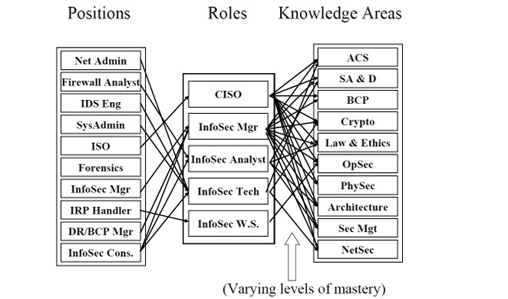
Mapping Positions and Roles to Knowledge Areas [2]

Academic skills are the core competencies, strategies, and habits required to efficiently research, develop, and communicate ideas

Task 1 (b): Evaluation of Task 1 (a) based on Similarity report

Task 2: Collaborative Mind Map and Individual Poster

Mind Map (Collaborative)

Poster (Individual)

Task 3: Virtual Collaboration and RefWorks

Report on Virtual Collaboration
Put your Chosen topic here

Step-by-step process of using RefWorks with visuals

Task 4: E-Portfolio Creation and Evaluation

Task 4 (a): E-Portfolio Creation

Task 4 (b): Illustrative Review of E-Portfolio tool Selection

Conclusion

References

Task 1 References:

References

[1] | Ullah, Faheem Xiaohan Ye Uswa Fatima Zahid Akhtar Yuxi Wu Hussain Ahmad, “Emerald Insight,” 17 February 2026. [Online]. Available: https://www.emerald.com/ics/article-abstract/doi/10.1108/ICS-01-2025-0027/1341543/What-skills-do-cybersecurity-professionals-need.
[2] | Michael E. Whitman, Ph.D Herbert J. Mattord, Ph.D, “Kennesaw State University,” March 2021. [Online]. Available: https://campus.kennesaw.edu/colleges-departments/coles/centers/cyber-center/resources/docs/model-curriculum-2021.pdf.
[3] | A. Miller, Cybersecurity Career Guide, New York: Manning Publications Co., 2022.
[4] | Daniel Pedley Tania Borges Alex Bollen Jayesh Navin Shah Sam Donaldson Professor Steven Furnell David Crozier, “Cyber security skills in the UK labour market 2020,” Department for Digital, Culture, Media & Sport, London, 2020.

Task 3 References:

