Student Name: Daniel Jenkins
P Number: 150627
Module: (M4X01559) Ways of Perceiving

noun: loss; plural noun: losses
- The fact or process of losing something or someone.
The phenomenon of loss is one of the few unescapable truths within our existence, to live is to lose. Nothing in life is permanent therefore everything and everyone is in the process of being lost, so why do we struggle with something that is so inevitable. Scholars and artists have pondered over the subject of loss and life’s impermanence throughout the ages but I feel that in an age like today where people are far too unrealistic with their ideas regarding ownership and control, that it is important to revaluate how helpless we as beings, truly are to the cycle of nature. Loss can be used to describe the passing of a life, the misplacement of an object, the failure at a competitive event and so on but it seems that loss has a common theme within our society and that is the sobering reminder that despite our vast array of accomplishments as a species, we are not infallible and we are not immune to the trials of existence.
Loss is felt by all, no one can live a life unscathed by it, whether it be great or small, it is a fact of life and unescapable, because of this there are countless records within artistic and creative culture that tackle the subject of loss. Many hold the belief that through loss we are able to grow and find ourselves, this school of thought is evident in recent pop culture for instance Chuck palahnuik’s Fight Club (1996) “It's only after we've lost everything that we're free to do anything.” This nihilistic approach to life and to suffering itself is actually empowering to a certain degree due to the idea that through pain and loss we are forced to adapt and evolve into a higher version of ourselves, therefore loss inspires growth. However there are individuals returning from places (physical and or metaphorical) of such severe loss that it has had a detrimental effect to their being as a whole, for instance a soldier suffering from PTSD or depression after active service. Another school of thought is that the suffering bought on by loss is a self-inflicted and is buried deep in human culture brought on by our fascination with consumerism we start to view people and our relationship like we view our possessions, resulting in a feeling of theft and injustice when we lose these people or relationships, and that is where most of our sadness stems from. When in reality we are not to expect anything from anything, therefore there we should just be gratefulness for what time we’ve had with that person or relationship. Paulo Coelho phrased it elegantly “No one loses anyone, because no one owns anyone. That is the true experience of freedom: having the most important thing in the world without owning it”
Within my exhibition I aim to convey how grief and loss are often connected with the arts, for instance when observing how we deal with death. The funeral service itself is often a place of artistic expression. The arts such as poetry, music and art can provide great comfort and an avenue of expression for many individuals. The works I have chosen for the exhibition are meant to show the vast array of grief humans can feel. Stephanie L Brooke explained it precisely “When people hear the word grief, they usually associate it with death. However, grief is a universal and multidimensional experience” I wanted my exhibition to punctuate this point and change the way we view loss and grief.
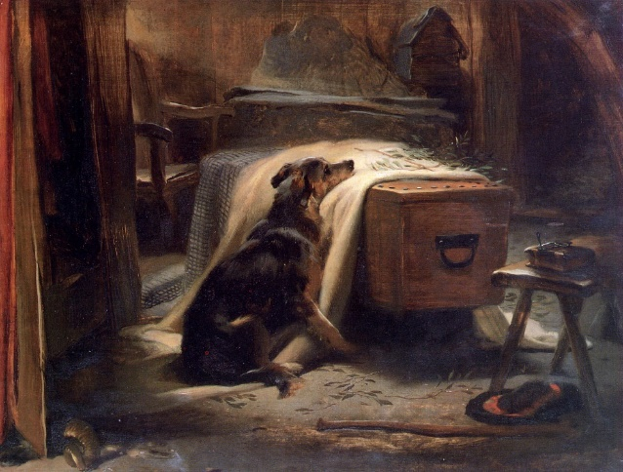
The first piece that sprung to mind when I was accumulating the works I’d like to include is Landseer Edwin’s Old Shepherds Chief Mourner (1837). To me this piece encapsulates arguably the most overpowering sense of loss and that is the loss felt after the death of a loved one, the rendition of the mourning dog is not only a reminder of the helplessness one can feel after the passing of a loved one but also that loss is not exclusively human in its nature, and some feel that sometimes the loneliness felt within grief is a large contributor to the sadness felt.
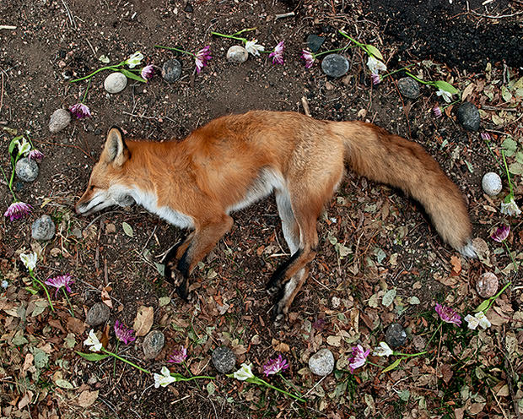
I felt one piece in the exhibition should tackle the loss of connectivity that many seem to feel in this day and age not only to each other but to nature. I then discovered the work of Emma Kisiel. Her collection of works titles “At rest” aims to tackle the problem with humanities tendency to alienate themselves from nature, more so in more economically developed countries such as America and Britain. The artist claims that we have distanced ourselves from nature to the point where we barely acknowledge the death of animals. These sombre yet effective works show that by creating these memorials for road kill that we should not disregard the lives of animals and we must confront the loss of connection we have ultimately brought upon ourselves.
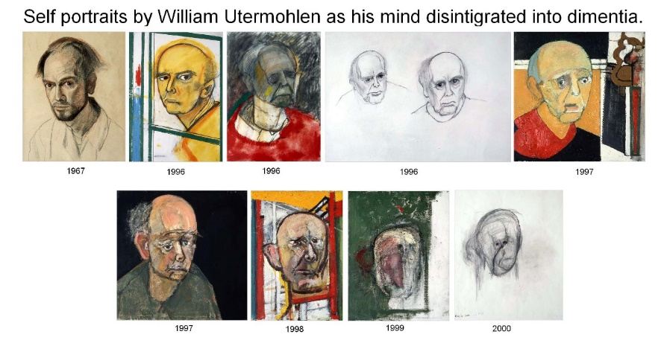
I felt that my exhibition had to feature the distressing collection of self-portraits by William Utermohlen’s. This collection marks the heart wrenching decline of an artist’s knowledge of himself and his craft. This deterioration is caused due to the progression of Utermohlens Alzheimer’s. I thought this to be a necessary addition to the exhibition because it is a rare example of someone processing the loss of themselves.

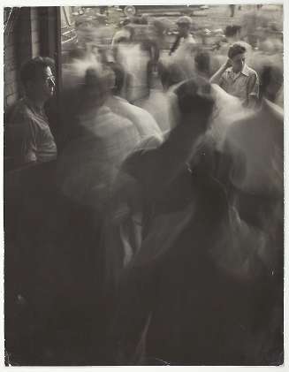
I thought an interesting piece to include was Art Shay’s photograph of famous devoted fan Nelson Algren experiencing another white sox loss. I felt this piece would bring variety to the concept of the exhibition, showing that loss does not always revolve around death and or health but our everyday lives are filled with forms of loss but of varying severity.
In conclusion I feel a good exhibition should take the viewer on a journey stimulating both visual appreciation and introspective thought. Therefor I have thought about the placement of the pieces and positioned them according to the belief that it is important not to be too guided with the natural path of the exhibition, allowing all pieces to be in no apparent order yet each piece is placed adjacent to their connected piece for instance I have placed Landseer Edwin’s Old Shepherds Chief Mourner across the space from Emma kisiels At rest due to the fact they both stress our connectivity to nature and hopefully that will trigger a serious of thoughts in the viewer regarding how loss is not just a human phenomenon but it is a natural fact of existence, or perhaps about our relationships with nature itself and whether or not they felt grief when animals or pets have passed. I feel it is important not to dictate the path of thought but to supply a start point for the trail of thought, that way the viewer’s intelligence is not insulted or “spoon fed” so to speak. Regarding the last two pieces I feel they obvious contrast in subject matter may encourage thought into how loss is not always connected to death and can be felt when our favourite baseball team loses, I also think there is a point to be made about how sometimes we as humans can craft our own feelings of loss, we choose to participate in competitive activities, therefore risking loss, do we do this because the risk excites us or is this a distraction from more dire instances of loss that we feel in life, for instance Utermohlens loss of identity.

Bibliography
Palahniuk,Chuck (1996) Fight Club. Vintage Books London.
Coelho, Paulo (2003) Eleven Minutes. HarperCollins UK.
Brooke. Stephanie L. Miraglia. Dorothy A. (2015) Using the Creative Therapies to Cope With Grief and Loss Charles C Thomas. Publisher. LTD

