Louise Rimmer - Student No. 2306111
Programme: Contextual practices
Module: Ways of Thinking
Module code: ADDA4022
Assignment title: Portfolio of writing

Manifesto statements practice:
- Art can be weaponized and used for the better or worse
- There should not be a singular correct way of creative processes due to individual interpretations
- Art and creativity is limitless
- Has art become too political in postmodern society?
- Art is about experimentation and the process of creativity
- Sometimes art needs no meaning/ purpose– can be about just aesthetics
- Glass work is the most rewarding due to its fragility and the feeling of being able to manipulate something so weak into something creative
- We all experience/ perceive things differently, therefore no person will ever interpret a piece of art the same way

- Art can be weaponized and used for the better or worse
The use of art throughout history in order to push across propaganda or become physical is due to the fact that art strikes people in a more profound way rather than to just be told or read about something. This is due to art, under normal circumstances, being considered as recreational viewing, solely for the pleasure of the viewer and the artist. However, once art begins to be used in a more cynical, aggressive sense, the world takes notice due to the irregularity of methods used. Examples of this come from the horrors of the Israeli -Palestinian conflict, as since 2015 the Israeli military has been using tactics called ‘cement sealing’, in which concrete is poured into Palestinian houses to destroy domestic lives, that have gained profound recognition due to the use of urbanism and architecture to create fear and punishment.

“intended goal is not only to punish one household, but to colonize the urban environment with permanent nightmares of the everyday, transforming domesticity into an aesthetic artefact that uses time as its most powerful weapon to create death-worlds.” -
Delso. (2018). Concrete punishment: Time, architecture and art as weapons in the Israeli-Palestinian conflict. Political Geography, 66, 57–66. https://doi.org/10.1016/j.polgeo.2018.08.012
6. Sometimes art needs no meaning/ purpose– can be about just aesthetics
Art in postmodern society can easily become centered around the social and political influences and implications, which is not at all a bad thing because art is an excellent way of expressing a person’s beliefs and raising awareness to certain situations and topics. However, sometimes the beauty of a piece of art can get lost behind the depth and weight of meaning, and the public loses the enjoyment of simple viewing and aesthetics. “L’art pour l’art” (art for art’s sake) is just as important to culture as political and social art, as beauty and aesthetics cannot be overlooked in the importance of creativity.
Britannica, The Editors of Encyclopaedia. "art for art’s sake". Encyclopedia Britannica, 23 Jan. 2015, https://www.britannica.com/topic/art-for-arts-sake . (Accessed 31st October 2023.)

- We all experience/ perceive things differently, therefore no person will ever interpret a piece of art the same way
Every person’s brain works in different ways and we all have different trains of thoughts, therefore meaning that when it comes to creating and also consuming artwork, no person will ever have the same experience, interaction or interpretation. This is how art becomes so unique as some artist will use this to their advantage and create pieces that may not be seen exactly the same from certain angles, or nobody ever really knows the true intentions behind a piece of work. This is in order to create speculation, enhance a person’s experience and build momentum behind their work.
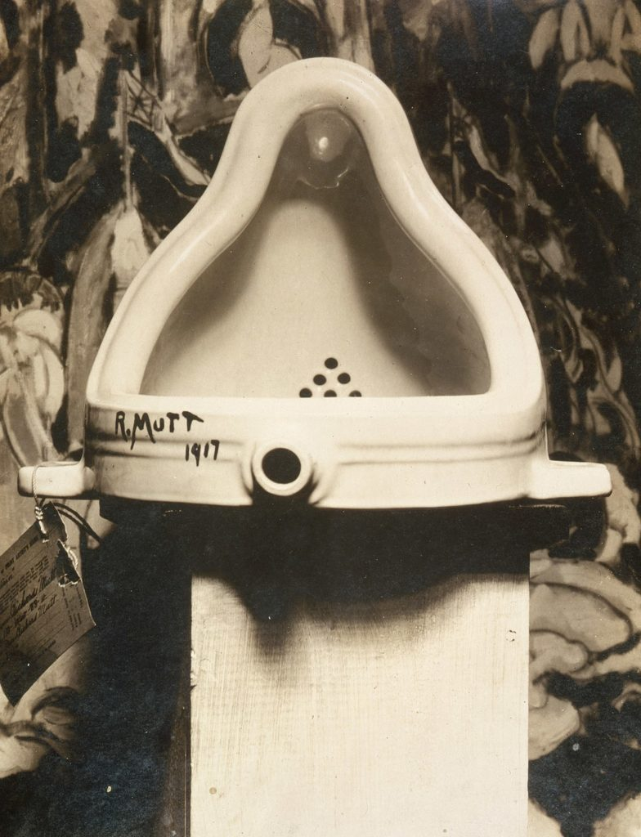
A prime example of conceptual art is ‘The Fountain’ by Marcel Duchamp in 1917, which has been argued to have been a revolutionary piece of art, because “its artistic quality and value came largely from its capacity to make viewers think, have open conversations, and disagree about what it meant. It caused a huge uproar at the time, with its fair share of critics.”
Therieau L. (2021) 8 Pieces of art That Literally Changed The World 8 Pieces of Art That Literally Changed The World (To Share With Your Students) - (ipaintmymind.org) (accessed 31st October 2023)

Observational writing practice
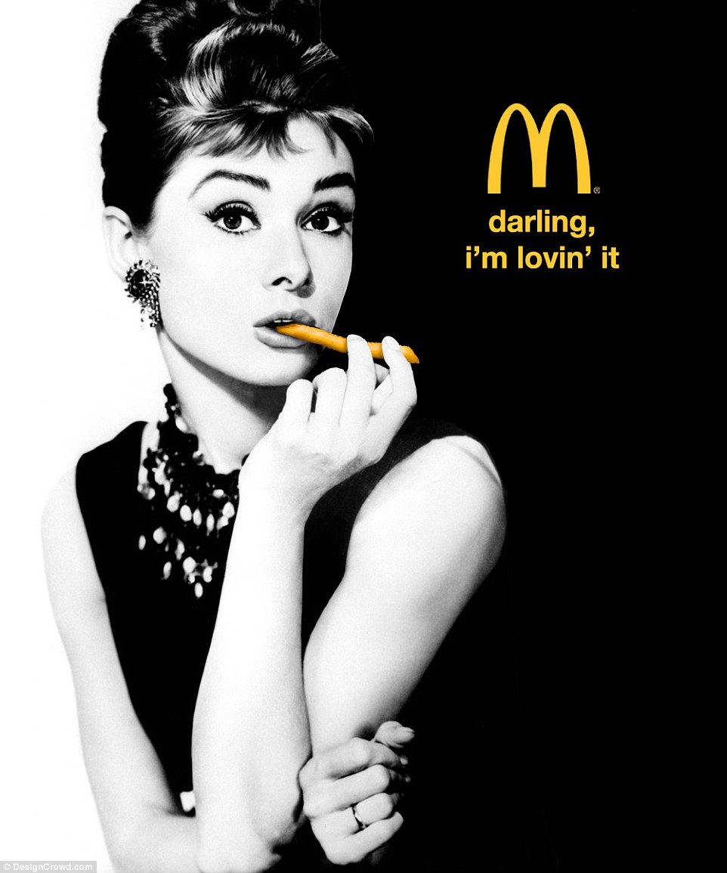

This advert is for McDonalds fast food chain and depicts Aubrey Hepburn with a French fry in her mouth replicating a cigarette, the McDonald’s signature ‘M’ logo, and the short text “darling, I’m lovin’ it”. The lack of text except from the “darling, I’m lovin’ it” aids in the simplicity in understanding this advert and communicating its purpose, which is to promote McDonalds food brand. The language used in this sentence can be separated clearly into the two sections of this advert; ‘Darling’ which was a frequently used phrase by Audrey Hepburn, indicating a softspoken and eloquent manner about her, and then ‘I’m lovin’ it’ which is the iconic catchphrase of McDonalds, which is also well known worldwide. The careful choice of anchorage text means that the meaning behind this advert can be simply decoded by a worldwide audience, with little regard for language barriers due to famous signifiers withing the poster, such as the imagery and the simple catchphrase usage. The main person within this advert is Aubrey Hepburn, considered to be one of the most famous people of all time, and a definite iconic sign within the advert, as she looks and embodies the concept of class, elegance and beauty, which then uplifts the brand she’s paired with, bringing a new level of class to even a fast food chain. The polysemic colouring in this advert has been carefully chosen in order to make the intention of the brand stand out the most. The whole image, including Audrey, is in black and white, yet the McDonalds logo and the text is in the iconic yellow colour associated with the brand. The denotations of these colour choices are to ensure that despite the eye-catching face of Audrey Hepburn being used to grab the audience’s attention, their main takeaway should be that its an advert for McDonalds, and that bright yellow lettering should come to mind thereafter. Additionally, though, the connotations of Audrey Hepburn being in black and white are a sign of respect and mourning to the fact that she is no longer alive, and the bright colouring of the McDonalds logo connotes that this is not a vintage poster, they are the modern brand being advertised. Within the advert, the iconic sign of Hepburn holding a French fry which is actually replacing a cigarette is used as strategic promotion for one of their most famous products while still maintaining the classy image of Hepburn.

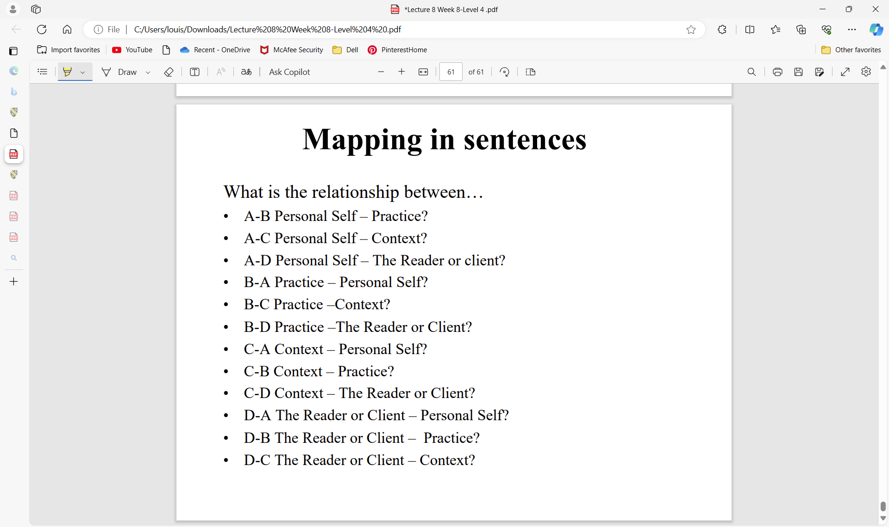
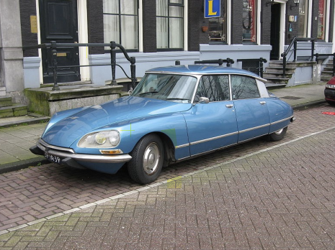

The car
Personal self opinion
context
Reader/client opinion

