INTRODUCTION TO PUBLIC HEALTH
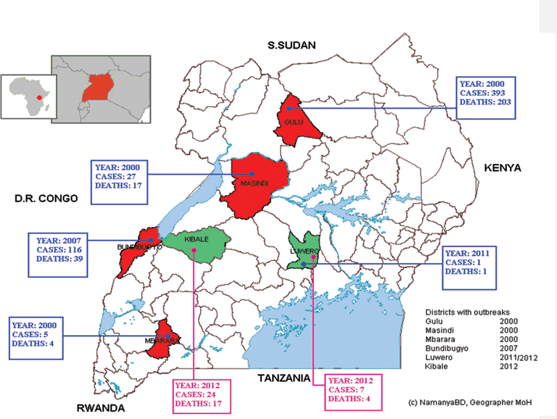
EBOLA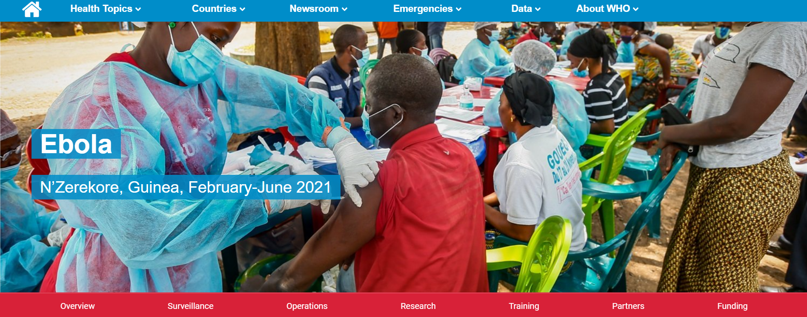

Student Name: Sharon Barnett
Student Number: 2217515
Tutor: Bianca Sanfilippo

TABLE OF CONTENTS

Table of Contents PAGE 2

Introduction PAGE 3

Public Health Measures Available PAGE 3

Key Determinants/Risk Factors of The Disease PAGE 5

Short-Term Public Health Consequences
of The Disease In Health And Social Care PAGE 6

Short-Term Public Health Consequences
of The Disease In Health And Social Care PAGE 6

Conclusion PAGE 7

Reference PAGE 9

EBOLA

INTRODUCTION

Over the years various diseases and viruses have emerged, and when this happens little is usually known about them initially. This was so when the Ebola virus plagued West Africa. An article written by the UK Health Security Agency (2014), stated that the Ebola virus was first identified in 1976 with few isolated cases, however, it was not until 2014 that there was an outbreak in the Democratic Republic of Congo (DRC) and it quickly spread to other West African countries causing an epidemic. The World Health Organization (WHO) explains that the Ebola virus is a severe and sometimes fatal disease in humans, this is transferred through contact with blood, secretions, organs and any other body fluids of infected primates in the Rain Forrest. An article written by Jonathan et al stated that between 2014-2016 over 28,000 people across Western Africa were infected with this disease of which up to 11,000 were fatal (40%). The WHO announced that there was one confirmed case in the UK and this was a healthcare worker who returned from working in an Ebola treatment center in Sierra Leone, the patient was however placed in Isolation swiftly and no further cases were published. It is important to note that early detection of the virus is critical to survival but sadly, there were cases in which palliative treatment became necessary and so instead of focusing on curing the disease itself, the focus became; helping or supporting someone to have the best possible life, living with the disease (Samuel, O. et al. 2016)
PUBLIC HEALTH MEASURES AVAILABLE
The Ebola virus has proven to be deadly and so any public health measures of that are considered will require the involvement of everyone who will possibly come into contact with the virus. The diagram below is an organizational model that was used in Africa to combat the Ebola Virus.
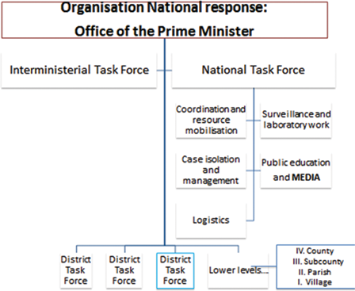
The threat began as a young boy contracted the virus and quickly passed it on to relatives and then to nearby communities. (Wilson, R. 2018) . This is very Interesting as in this case the virus was quite new to this region and this was also a region with very limited resources (Okware 2016) From the model studied, the following measures arose:
Coordination and Resource Mobilisation
Surveillance and Laboratory work
Case Isolation and Management
Public Education and Media (Okware, S. 2016)

Coordination and Resource mobilization had the media playing a vital role in passing information to everyone both locally and internationally. Community leaders from all sectors were called upon, additional healthcare workers were recruited and paid to undertake the risk. Isolation and triage units were set up in hospitals and there were daily updates and press briefings that were made available to everyone. This was also a way of identifying new cases as well as informing of progress with existing cases.

Surveillance and laboratory work are crucial in controlling the spread of the disease. In this sense, it is important to identify possible cases and to quickly get samples to the lab for testing. The lab also has to be fully equipped with the necessary equipment and staff to ensure that measures are effective. In the model presented by Okware 2016, a task force was set up at the community level and their responsibility was to identify new cases of Ebola, and for this effort, they were paid an incentive for each Ebola case reported and confirmed. All the teams were trained and retrained in their areas of operation as this was a matter of life and death. Through close and constant coordination, patients who died from the disease were handled by specialist burial teams to ensure the disease was not passed on. Clubs were also setup to monitor the health and social integration of those who survived the disease and were discharged for the hospital. The severe consequences of this disease moved the communities to impose quarantine on anyone who was suspected of contracting the disease.

Case Isolation and Management

In managing the risks posed by Ebola, early detection is critical survival of the community. Having a lab with the capabilities of effective testing also plays an important role in case isolation and management. The quicker a case is confirmed, the earlier the individual can be moved into isolation and a course of treatment starts. This is also a practice that set the community at ease and therefore improve the social order. Contact Tracing is also a vital tool in this effort as it identifies people who have possibly come into contact with an infected person. Contact Tracing also monitors the well-being of all who were involved in the person-to-person contact which is an important part of the epidemiological investigation. The recommendation is that persons identified by contact tracing must be observed in isolation for 21 days. This period is known as the maximum incubation period for the Ebola virus. (WHO 2014
All these efforts now come together to help with the management of the virus.

Public Education and Media

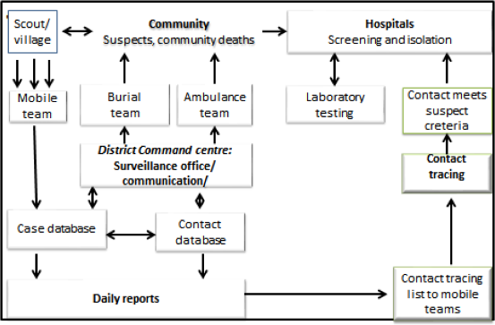
Keeping the general local community as well as the international community well informed about the Ebola Virus Disease is critical to the rate of success. The flowchart below shows how communities worked with all the other teams in the fight against the virus. Daily reports were key aspects of this effort as the communities with the help of the media educating the public on matters relating to the safety of everyone. The public education effort involved church leaders, school principals and politicians at the local level. (Okware, S. 2016)

In addition to the model studied, the below are guidelines provided by the World Health Organisation (WHO) and the Centre for Disease Control (CDC), for the control and prevention of the transmission of Ebola. Included in these guidelines are:

- Early identification and isolation of suspected or confirmed Ebola cases.

- Contact tracing of individuals who may have been in contact with Ebola-infected people.

- Safe and dignified handling of human remains to prevent transmission of Ebola virus.

- Infection prevention and control practices, including the use of personal protective equipment (PPE) by healthcare workers.

- Implementation of quarantine and isolation measures.

- Health promotion and education, including community engagement and the promotion of safe hygiene practices.

Additionally, the Centers for Disease Control and Prevention (CDC) emphasizes the importance of vaccination in controlling Ebola virus disease, as well as the need for strong surveillance systems to monitor outbreaks and identify new cases. (Centers for Disease Control and Prevention 2023).

THE KEY DETERMINANTS/RISKS FACTORS OF THE DISEASE

The key determinants of the Ebola virus are:

- Contact with infected animals, such as bats or non-human primates, through bushmeat consumption or handling.

- Direct contact with bodily fluids of infected individuals, such as blood, vomit, or feces.

- Contact with objects contaminated with bodily fluids of infected individuals.

- Close contact with infected individuals, such as caring for or living with someone who has Ebola

- Poor infection prevention and control practices in healthcare settings

- Poor public health infrastructure, including limited access to healthcare and inadequate outbreak response capabilities. (Nadezhda, D. et al. 2015)

SHORT-TERM PUBLIC HEALTH CONSEQUENCES OF THE DISEASE IN A HEALTH AND SOCIAL CARE SECTOR

Incredibly communicable and capable of causing severe haemorrhagic fever, the Ebola virus disease (EVD) has the potential to spread in epidemics with high mortality rates. The following are only a few examples of the potentially serious short-term effects of Ebola on public health in the health and social care sector:

Enhanced risk of infection for healthcare workers: Due to their intimate contact with Ebola patients, healthcare personnel are more vulnerable to infection. Previous Ebola outbreaks have resulted in the infection and death of numerous healthcare personnel.

Overburdened health care system: The health care system can become overburdened in regions where Ebola epidemics take place. It may be difficult for healthcare professionals to provide care to every patient due to the huge volume of cases and little resources.

Community dread and panic: Ebola epidemics can engender community fear and panic, which can result in social stigma and discrimination against persons who have contracted the disease or are suspected of having it. (WHO 2021)

LONG-TERM PUBLIC HEALTH CONSEQUENCES OF THE DISEASE IN A HEALTH AND SOCIAL CARE SECTOR

The long-term public health consequences of Ebola in the health and social care setting are significant. In addition to the immediate impact of the disease on individuals and communities, there are several long-term consequences to consider. One of the most significant consequences is the impact on mental health. Survivors of Ebola often experience psychological trauma, such as depression, anxiety, and post-traumatic stress disorder (PTSD) due to the fear and isolation they experienced during their illness.

Another long-term consequence of EVD is the impact on healthcare systems. During the West Africa outbreak, healthcare resources were diverted from other health issues to respond to the Ebola crisis. This left other health problems unaddressed and created a backlog of patients seeking care, leading to a weakened healthcare system.

Furthermore, the trust in healthcare systems and healthcare workers was diminished due to mistrust and fear of contracting the disease. This has significantly impacted the delivery of healthcare services in affected areas and poses a challenge for future outbreaks.

In addition to the long-term consequences for individuals and healthcare systems, there are also social and economic consequences to consider. The Ebola outbreak had a significant impact on the economies of the affected countries, with decreased economic growth, trade, and tourism due to fear and travel restrictions.

Overall, the long-term consequences of EVD in the health and social care setting are significant and require continued attention and support. Effective treatment and prevention measures, as well as ongoing support for survivors and healthcare systems, are needed to mitigate these consequences in the future. (Centre for Disease Control and Prevention. 2020) World Health Organization. (2018)

CONCLUSION

Global health is being endangered by the deadly Ebola virus illness (EVD). The World Health Organization (WHO) claims that the Ebola outbreak that began in Guinea in March 2014 was the biggest and most complicated since the virus was first identified in 1976. From Guinea, Liberia, and Sierra Leone, a total of 28,646 cases and 11,323 fatalities were documented. (ECDC no date)) It is important to note that to date the data indicates that the UK has only seen two cases of the virus since its discovery in 1976. The first case was that of a laboratory worker who accidentally infected himself and the second case was a 29-year-old care worker who worked at an Ebola Specialist Centre in Sierra Leone. (bbc.co.uk 2014)

To stop the spread of EVD in healthcare and social care settings, it's crucial to implement effective infection prevention and control strategies. This involves using the appropriate personal protective equipment, washing your hands, following safe burial procedures, and isolating suspected or confirmed cases.
The management and control of EVD has been the subject of numerous studies and reports. It was discovered in a study by Saqib et al in Sierra Leone that applying infection prevention and control procedures in healthcare facilities was successful in decreasing the spread of Ebola. The most successful interventions were found to be proper usage of personal protective equipment and hand cleanliness.
Ansumana et al discovered in a different study conducted in Sierra Leone that community involvement and awareness-raising initiatives were crucial in preventing the spread of EVD. It was discovered that educating the local population on appropriate burial procedures and avoiding contact with diseased people were efficient countermeasures.
Finally, it should be noted that effective infection prevention and control procedures as well as community involvement are needed for the treatment and control of Ebola in health and social care settings. Implementing these strategies can effectively stop the spread of EVD, according to studies.

REFERENCES

World Health Organization. (2023). Ebola virus disease – fact sheet.
https://www.who.int/health-topics/ebola/#tab=tab_1.
Accessed 11 April 2023

CDC. (2016). Ebola Virus Disease
https://www.cdc.gov/vhf/ebola/index.html
Accessed 11 April 2023

Samuel O et al (2016)T1 - Managing Ebola in Low-resource Settings: Experiences from Uganda, BT - Ebola
https://doi.org/10.5772/63056
Accessed 04 April 2023

Okware S (2016) Managing Ebola in Low-resource Settings: Experiences from Uganda. Ebola. InTech. DOI: 10.5772/63056.

https://www.intechopen.com/chapters/50511
Accessed 11 April 2023

WHO 2014
https://www.who.int/publications/i/item/9789290232575
Accessed 11 April 2023

Okware S (2016) Managing Ebola in Low-resource Settings: Experiences from Uganda. Ebola. InTech. DOI: 10.5772/63056)
https://www.intechopen.com/chapters/50511
Accessed 11 April 2023

Wilson, R. (2018) Epidemic Ebola and the Global Scramble to Prevent the Next Killer Outbreak. Washington, D.C: Brookings Institution Press.
https://librarysearch.uwtsd.ac.uk/discovery/fulldisplay?docid=alma99100463079102421&context=L&vid=44WHELF_UWTSD:44WHELF_UWTSD_VU1&lang=en&search_scope=Search_ELEC&adaptor=Local%20Search%20Engine&tab=Everything&query=any,contains,ebola,AND&sortby=rank&mode=advanced&pfilter=rtype,exact,books,AND
Accessed 10 April 2023

World Health Organization. (2021) Ebola virus disease: Key facts. Retrieved from https://www.who.int/news-room/fact-sheets/detail/ebola-virus-disease
Accessed 10 April 2023

Centers for Disease Control and Prevention (2023) Ebola (Ebola virus disease). Retrieved from https://www.cdc.gov/vhf/ebola/index.html
Accessed 10 April 2023

Centers for Disease Control and Prevention (2023). Ebola virus disease prevention: What the CDC is doing. Retrieved from
https://www.cdc.gov/vhf/ebola/prevention/index.html

Accessed 10 April 2023

(Nadezhda, D. et al. 2022) Risk factors for Ebola virus disease among household care providers, Sierra Leone, 2015, International Journal of Epidemiology, Volume 51, Issue 5, October 2022, Pages 1457–1468,

https://doi.org/10.1093/ije/dyac081

Accessed 11April 2023

World Health Organization. (2018). Ebola virus disease: Key facts. Retrieved from
https://www.who.int/news-room/fact-sheets/detail/ebola-virus-disease

Accesses 11 April 2023

Centers for Disease Control and Prevention. (2020). Ebola (Ebola Virus Disease). Retrieved from https://www.cdc.gov/vhf/ebola/index.html
Accessed 9 April 2023

World Health Organization. (2018). Ebola virus disease. Retrieved from
https://www.who.int/health-topics/ebola/#tab=tab_1
Accessed 9 April 2023

(bbc.co.uk 2014)
https://www.bbc.co.uk/news/blogs-the-papers-28923201
Accessed 11 April 2023

ECDCEuropean Centre for Disease Prevention and Control no date
https://www.ecdc.europa.eu/en/infectious-disease-topics/z-disease-list/ebola-virus-disease/facts/factsheet-about-ebola-disease

Okware S (2016) Managing Ebola in Low-resource Settings: Experiences from Uganda. Ebola. InTech. DOI: 10.5772/63056.
https://www.intechopen.com/chapters/50511

