

BA Business Management
Module name: Entrepreneurship

Module code: LCBB5001
Module leader: Vasilio Tavlaridis

Assignment title: Assessment Component 1
(Written Report/ Business Plan)

Student name: Gurduz Ana
Student ID:2029605

Table of Contents
Introduction 3
Overview of the business idea and its product/service. 4
Ownership and Legal format of the startup. 4
Management of the company 5
Evaluation of the business idea by using the SWOT analysis model. 5
Assessment of the current external environment by using the PESTEL analysis model. 7
Identification of the key marketing factors by using the 4Ps of the marketing mix model. 8
Explanation of the target market and the marketing strategies 9
Cash flow forecast for the first 12 months 11
Conclusion 13
References 14

Introduction
This report aims to design a business plan for the company named ‘‘HomeClean’’ which is based in the Oakham, UK for offering the domestic cleaning services to the customers of the UK for a competitive rate. Cleaning services can be defined as commercial services including the removal of the dust, dirty substances, and agents of the infectious objects from the reporting areas (Tripathi & Oivo, 2020). In this report, the discussion would be followed up by the rationale of selecting the cleaning services as the business idea with the core services that would be offered to the customers. The discussion will emphasise the management and legal structure while the evaluative models such as SWOT and PESTLE analysis would be conducted to report the marketing strategy using the 4Ps of the marketing mix (Secundo & Capaldo, 2020). A 12-month start-up cash flow statement would be indicated in the later discussion.
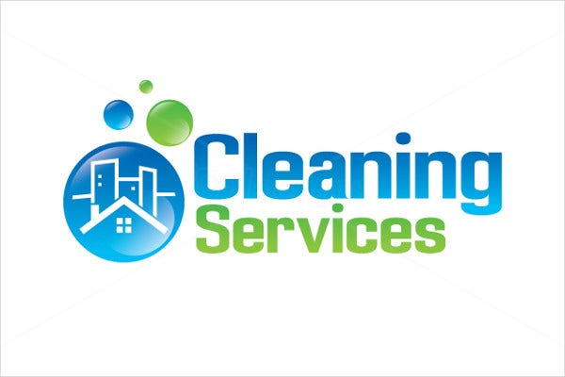

Overview of the business idea and its product/service.
According to Srhoj et al. (2021), 1/10 of UK domestic families appoint a commercial cleaner in their home for regular domestic cleaning services while about 34% growth in the recent 2021 has indicated that the demand for professional domestic cleaning services has been increased in the recent period. This business idea has been selected as The British Institute of Cleaning Science has reported that in the recent case of Covid-19, the rate of appointments of the professional cleaners have been substantially increased in the UK while the Hygiene and Home environment cleaning with the help of the professional cleaners have been increased due to the objective of securing the family members for infectious substance (Mason et al., 2020). Besides, the high demand the core services such as Regular domestic, Carpet, Oven, Hard floor, Window, cleaning by the current cleaning services have been working as a good reason while most the companies are targeting the Premium and Luxury customers where the scopes of targeting Price Sensitive customers as well can increase the return in the future.

Ownership and Legal format of the start-up.
Following the Partnership GOV.UK the current business idea of cleaning services would be formed as a Partnership business in the UK which is based in Oakham. Interested capitalists would be offered and communicated with the agreement of business formation with the legal structure of selling the equal share among the members of the Partnership business (Sekliuckiene et al., 2018). Here, the main advantage of forming the Partnership business is the distribution of the higher costs and investment burdens in the initial pace while the management and customer services would require more than one head for overall operation. Besides, the distribution of equal ownership among the members would generate fruitful output by specifying the individual roles and responsibilities for the core services. If there are not external investors engaged, the partnership will be created from two person. It will be me (Ana) and my partner (Andrei).

Management of the company
(Slavik, 2019) has indicated in his research this common agreement with win the cleaning company. In the case of Management of the Company, the initial number of employees would be 30 who would be recruited based on a project-based compensation agreement where the 70% of the charged prices would be offered to the cleaners while the rest of the charges would be counted as the revenue for the start-up. Thus, initially, the business would be handled by the formation of 3 agent/branch locations in the Oakham including the main City, Langham and Cottesmore where each branch would be equipped with the 10 employees or the cleaners who would be connected using the Mobile Application regarding their availability status in the case of client orders. Each branch would be managed by 2 directors who would perform their roles as the Administrative Executives along with the dedicated 2 cleaning experts certified by The British Institute of Cleaning Science.
Evaluation of the business idea by using the SWOT analysis model.
According to Brun (2019), the SWOT analysis model includes the Company's internal Strengths, Weaknesses and External Opportunities and Threats which can be applied in the current case.

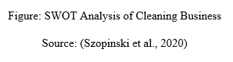
Strengths: The major strong points of this business can include the local experts, certified cleaners with competitive rates, experienced administrative bodies, successive financial backup and periodical training and coaching on the development of the cleaning services (Elkomy et al., 2019). Here, the placement of 6 local experts in the 3 branches has worked with the periodical training to the certified cleaners sourced from the Oakham for competitive rates. Besides, the locational advantage of having 3 branches is another strength of this venture.
Weaknesses: The major Weaknesses of the venture can include the lack of market research, lack of employees in each branch, inadequate experts for training, limited services, and lack of employee satisfaction (Grimshaw et al., 2019). Here, the lower rate of wages for project-based compensation worked as a potential weakness while the lack of market data regarding the middle-income family clients in the London city is another weakness. The inadequate ratio of experts and cleaners can increase the delay in the services which would increase the customer's dissatisfaction.
Opportunities: The contemporary opportunities in the current business idea can include the expansion of the branch office, increasing the number of services, recruiting more cleaners, and providing free internships for future leaders etc. Here, the future opportunities of expanding the offices and areas of the services such as Langham and Cotessmore could be executed with the 20% higher cleaners with regular recruitment who will serve not only the domestic customers but also the corporate bodies with professional and commercial cleaning services (British Institute of Cleaning Science, 2022). Moreover, the free internship opportunities in this venture would work as a good scope of train the graduates and future leaders in business management.
Threats: There are some influential threats commonly seen in the market including the number of established companies, higher rate of compensation packages, new entry threats and fear of customer complaints in the market. In this regard, current, more than 60000 companies are operating their business in the UK and are offering higher compensation packages to their experienced cleaners which may motivate the in-house cleaners to switch to this start-up (Elkomy et al., 2019). Besides, the free entry to the cleaning industry and fear of customers' complaints about their Word-of-Mouth marketing are some potential threats to the venture which may lower the revenue and create a barrier to future growth.
Assessment of the current external environment by using the PESTEL analysis model.
According to Szopinski et al. (2020), the PESTLE model indicates the analysis of the effects of the Political, Economic, Social, Technological, Legal and Environmental factors which would affect the business of the current start-up.
Political: The effects of positive and incentivised assurance of trade-friendly government supports from the UK, lower tax rates, interim credit facilities and stable political affiliations have indicated the positive political environment for the cleaning services business in Oakham (Tohanean & Weiss, 2019). Thus, the corruption in some of the tax and revenue offices by the political parties may create a barrier for the business.
Economic: The increment of the GDP growth rate by the 0.8% in the first half of the 2022 and increased pattern of the GDP per capita in the UK with £40,216 have indicated that the clients are demanding the services with the motivation of increased purchasing in this sector (Tykkyläinen & Ritala, 2021). Besides, the 67% increased demand for the price-sensitive packages for the recent hygiene-based cleaning services has indicated the favourable market for the current business idea.
Social: The society and beliefs towards the cleaning and domestic cleaning packages have been positively shaped in the UK culture where the domestic substances, gardens and surroundings are generally cleaned and cared for by the professional carers for the effective hygiene care and environment for the next generation (Breier et al., 2021). Besides, a sustainable living environment with a suitable budget for a safe environment and dust-free services are demanded by the clients of the UK.
Technological: The availability of the Mobile Apps and the real server system in the UK business has been practised for a long time which enabled this market to be trade friendly (Osterwalder et al., 2020). Thus, the higher costs of technological advancement and lower incentive for the external technical collaboration with computer-aided cleaning services for the start-ups have indicated a negative concern for the current cleaning services development.
Legal: The UK government has enacted several regulations and acts in this market to protect the interests of the environment and customers while dealing with the activities of the cleaning service providers. Here, the Cleaning Chemical Safety regulation and Environment Protection Act 1997 have been aligned recently to authorise the services and equipment which are directly procured and used in the cleaning services in the UK. In this regard, the precautions regarding the use of additives and chemicals in the domestic cleaning services would be affected by the Consumer Rights Act 2015 with significant legal intervention (Wicki & Hansen, 2019).
Environmental: While the cleaning services in the UK have been praised and motivated by society the prime benefit of such services is the reduction of dust and polluted substances from the environment. As a result, the local environmental protection campaigns such as Environment Go, Clean UK and Fast clean would be supportive of the promotion of the low-cost cleaning services.
Identification of the key marketing factors by using the 4Ps of the marketing mix model.
Product: The core services of the cleaning services would include Regular domestic, Carpet, Oven, Hard floor, Window cleaning which would be fulfilled by the professional and certified cleaners and customers would be responded with the quality services following the choices regarding the cleaning and decoration (Ghezzi & Cavallo, 2020). The potential services would include the scopes of rating the services and having the special gifts from this start-up.
Price: The price range of the cleaning services would be determined by following the Price Penetration policy where the lower range of the prices would be charged for the price-sensitive customers. Besides, the Premium customers' segments would be targeted who would be charged higher quotes for VIP services (Utomo & Kurniasari, 2021). Thus, the average price range would be £8 to £15 per hour.
Place: The customers would have the option of ordering the services from the online counter and online order links where the online websites and their addresses would be promoted on social media and TVCs (Planing, 2018). In the online platform, the payment channels and options of mobile payments would enable the clients to quick order and placement services for the physical visit by the cleaners’ team.
Promotion: The cost-effective sources and modes of the promotions for this business would include Facebook micro-blogs, posting the daily updates on the customers' reviews and price discounts for the cleaning services (Di Guardo et al., 2022). Besides, the local commercial TV channels would be targeted using the TVCs in the local channels where the physical mass cleaning programs would be sponsored by the startup for effective public relations.

Explanation of the target market and the marketing strategies
The target market of the cleaning business is mostly adult customers in the age range of 20 years old and the higher who will know about online cleaning service ordering systems. Besides, the demographic segmentation has included the Oakham where the three branches would facilitate male and female clients (O’Reilly & Binns, 2019). Here, the psychological segmentation has included the customers who think about the dust-free and virus-free living areas for secure health and a sustainable environment. The recommended marketing strategy can include the introduction of the contract-based services where the temporary cleaners would be recruited in the business which would increase the number of employees in the business to fulfil the higher demand of the clients in the London city. Besides, it is also recommended to promote the services and feedback of the clients on social media where the video clips and customer ratings would be presented among the customers (Ghazinoory et al., 2021). Here, the customers would be effectively reached and communicated as their stories and feedback regarding the satisfaction of the services would work positive. Another marketing strategy would be the use of local cleaning week sponsorship and safety campaign which would work as CSR activities to inform the new customers about the available services.
Socio-demographic: Carefully curate your campaign to segment customers based on several factors, such as age, gender, income, education, and family status. This ensures every segment receives communications relevant to their grouping. . APTECO INSIGHT INTO ACTION
Available at: http://www apteco.com/solution/use-case/customer-segmentation (Accessed: 29 June 2022)



Psychographic: The type of lifestyle a person leads can be a huge influence in ensuring your audience has relevant marketing communications. Analysis of their leisure activities and social or personal characteristics can help you maximise the performance of your campaigns.


Behaviour-based: A common source for customer segmentation data is data derived from buying behaviour. Especially around the recency, frequency, and monetary value (RFM) of purchases. This allows you to tailor content accordingly and increase loyalty or the likelihood of a transaction. APTECO INSIGHT INTO ACTION
Available at: http://www apteco.com/solution/use-case/customer-segmentation (Accessed: 29 June 2022)



Cash flow forecast for the first 12 months
The detailed cash flow has been indicated below-

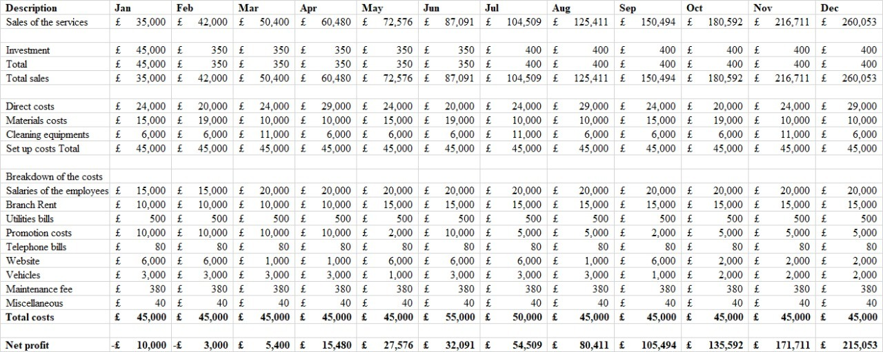

Conclusion
The report has indicated the designed and equipped business idea on starting a cleaning service business in the London city. The discussion has successively reported the analysis on the SWOT and PESTLE model where the trained personnel equipped with the experts in the three branches and future motives of the expansion into three more locations have been indicated. The report has found that the favourable and trade-friendly government of the UK with the support of price-sensitive and environment concern customers have indicated a potential market for domestic cleaning services. The discussion of the marketing mix has indicated the usage of online ordering systems and social media marketing recommendations for the target market. The later demonstration of the detailed 12 monthly cash flow indicated the forecasted sales and expenses for the business.


References
Breier, M., Kallmuenzer, A., Clauss, T., Gast, J., Kraus, S. and Tiberius, V., (2021). The role of business model innovation in the hospitality industry during the COVID-19 crisis. International Journal of Hospitality Management, 92, p.102723.
British Institute of Cleaning Science, (2022). What We Do - BICSc. [online] BICSc. Available at: <https://www.bics.org.uk/what-we-do/> [Accessed 18 June 2022].
Brun, E.C., (2019). Understanding a business incubator as a start-up factory: A value chain model perspective. International Journal of Innovation and Technology Management, 16(03), p.1950025.
Di Guardo, M.C., Marku, E., Bonivento, W.M., Castriotta, M., Ferroni, F., Galbiati, C., Gorini, G. and Loi, M., (2022). When nothing is certain, anything is possible: open innovation and lean approach at MVM. R&D Management, 52(2), pp.165-177.
Elkomy, S., Cookson, G. and Jones, S., (2019). Cheap and dirty: the effect of contracting out cleaning on efficiency and effectiveness. Public Administration Review, 79(2), pp.193-202.
Ghazinoory, S., Phillips, F., Afshari-Mofrad, M. and Bigdelou, N., (2021). Innovation lives in ecotones, not ecosystems. Journal of Business Research, 135, pp.572-580.
Ghezzi, A. and Cavallo, A., (2020). Agile business model innovation in digital entrepreneurship: Lean startup approaches. Journal of business research, 110, pp.519-537.
Ghezzi, A. and Cavallo, A., (2020). Agile business model innovation in digital entrepreneurship: Lean startup approaches. Journal of business research, 110, pp.519-537.
Grimshaw, D., Cartwright, J., Keizer, A. and Rubery, J., (2019). Market exposure and the labour process: The contradictory dynamics in managing subcontracted services work. Work, Employment and Society, 33(1), pp.76-95.
Mason, C., Anderson, M., Kessl, T. and Hruskova, M., (2020). Promoting student enterprise: Reflections on a university start-up programme. Local Economy, 35(1), pp.68-79.
O’Reilly, C. and Binns, A.J., (2019). The three stages of disruptive innovation: Idea generation, incubation, and scaling. California Management Review, 61(3), pp.49-71.
Osterwalder, A., Pigneur, Y., Smith, A. and Etiemble, F., (2020). The invincible company: how to constantly reinvent your organization with inspiration from the world's best business models (Vol. 4). John Wiley & Sons.
Planing, P., (2018). Towards a circular economy-how business model innovation will help to make the shift. International Journal of Business and Globalisation, 20(1), pp.71-83.
Secundo, G. and Capaldo, G., (2020). Facilitating business startup launch: an interpretative framework based on project management. In Innovative entrepreneurship in action (pp. 55-69). Springer, Cham.
Sekliuckiene, J., Vaitkiene, R. and Vainauskiene, V., (2018). Organisational learning in startup development and international growth. Entrepreneurial Business and Economics Review, 6(4), p.125.
Slávik, Š., (2019). The Business model of start-up—Structure and consequences. Administrative Sciences, 9(3), p.69.
Srhoj, S., Lapinski, M. and Walde, J., (2021). Impact evaluation of business development grants on SME performance. Small Business Economics, 57(3), pp.1285-1301.
Szopinski, D., Schoormann, T., John, T., Knackstedt, R. and Kundisch, D., (2020). Software tools for business model innovation: current state and future challenges. Electronic Markets, 30(3), pp.469-494.
Tohanean, D. and Weiss, P., (2019). Digital entrepreneurship and green business model innovation: Lean startup approaches. Quality-Access to Success, 20(S2), pp.630-634.
Tripathi, N. and Oivo, M., (2020). The roles of incubators, accelerators, co-working spaces, mentors, and events in the startup development process. In Fundamentals of Software Startups (pp. 147-159). Springer, Cham.
Tykkyläinen, S. and Ritala, P., (2021). Business model innovation in social enterprises: An activity system perspective. Journal of Business Research, 125, pp.684-697.
Utomo, P. and Kurniasari, F., (2020). Investigating factors impelling the innovation performance: A perspective from internal corporate new business venturing on manufacturing industry. In Conference Series (Vol. 3, No. 1, pp. 695-705).
Wicki, S. and Hansen, E.G., (2019). Green technology innovation: Anatomy of exploration processes from a learning perspective. Business Strategy and the Environment, 28(6), pp.970-

