我的学校
fy ysgol
my school

Vocabulary

中文 | Pinyin | Cymraeg | English
英语 | yīnɡyǔ | Saesneg | English
威尔士语 | Wēiěrshìyǔ | Cymraeg | Welsh
中文 | zhōngwén | Tsieineeg | Chinese
数学 | shùxué | Mathemateg | Mathematics
科学 | kēxué | Gwyddoniaeth | Science
地理 | dìlǐ | Daeryddiaeth | Geography
历史 | lìshǐ | Hanes | History
音乐 | yīnyuè | Cerddoriaeth | Music
美术 | měishù | Celf | Art
体育 | tǐyù | Addysg Gorfforol | P.E.
老师 | lǎoshī | athro  athrawes | teacher

* colour code for tones: first tone (blue), second tone (yellow), third tone (green), fourth tone (red), neutral tone (grey）

sentence builder 1
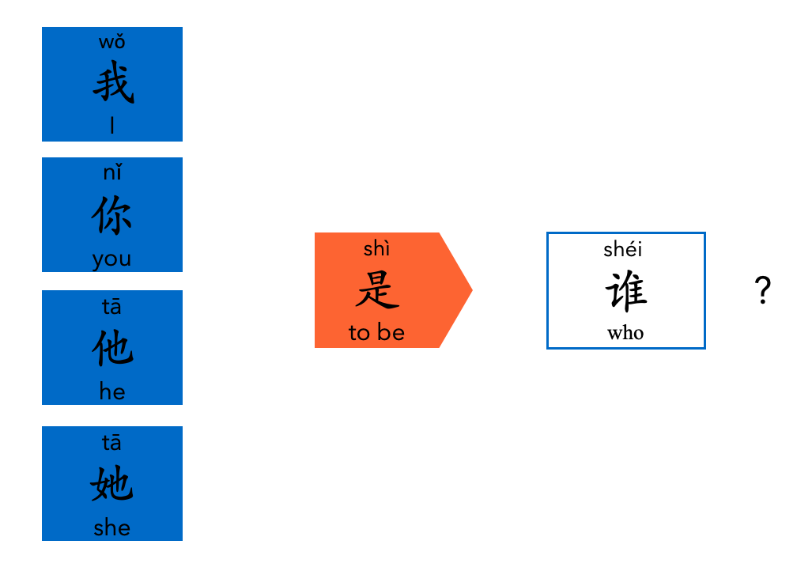

sentence builder 2
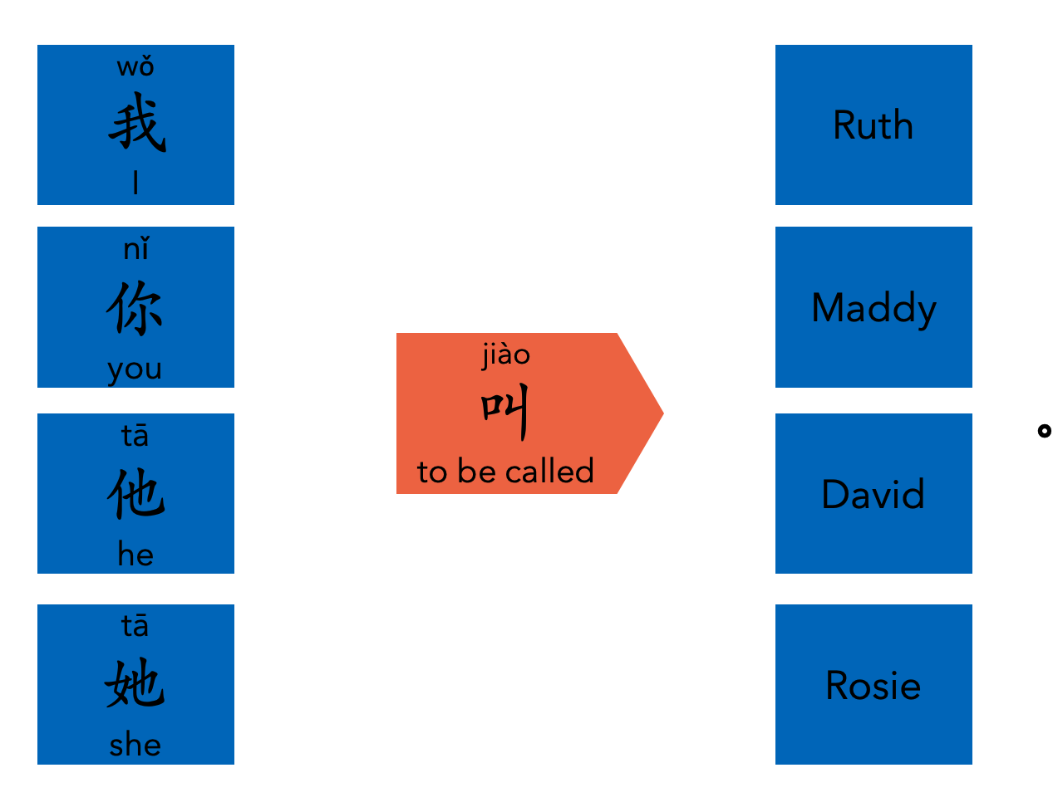

sentence builder 3


