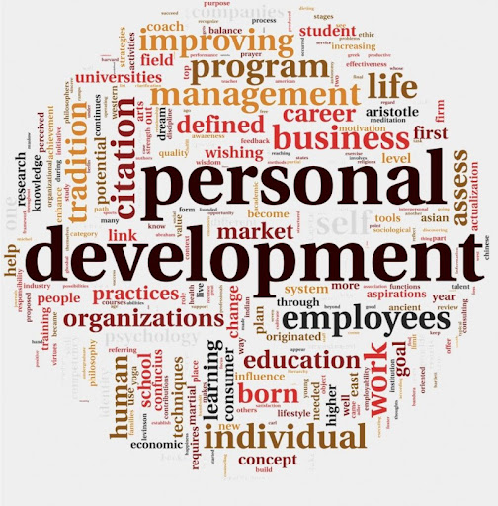

Professional Career Development
Student name: Ioana Stefania Ursu
Student id: (2013620)
Course code: BMSW4005
Lecturer: Sylvia Hoffmann

Table of Contents
Task 2: 3
1.0 Introduction 3
2.0 Reflection 3
3.0 Career Planning 5
4.0 What employers want 5
5.0 Self-Motivation 6
6.0 Learning styles (VAK theory) 6
7.0 Personal Development plan 7
8.0 Employability Goals 8
9.0 Conclusion 9
Reference 10
Appendix: Task 1 11
Job description 11
Person Specific: 11
Role play 13
Conversation 1 (As an interviewer) 13
Conversation 2 (As an interviewee) 14

Task 2:

1.0 Introduction
Self-reflection is the practice that will help in making the candidate understand the existing skills and the gaps lying in a person. The actions or the activities that the person has been performing could also be measured with the help of this reflective practice. The Task will be covering the reflection aligning with reflective theory. Further, a career plan is being discussed over here keeping in mind the matter of the future. Some learning styles are being discussed. A discussion on self-motivation is also done in this essay. With the learning style, VAK theory is being aligned to support the segment more. Further, PDP is developed to successfully understand the self-awareness part. Lastly, a discussion will be done based on the employment goals.

2.0 Reflection
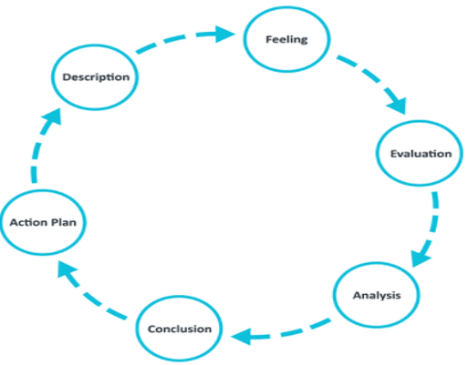

Figure 1: Gibb’s Reflective Cycle
(Source: The University of Edinburgh, 2021)

The reflective style of Gibbs helps encouraging people to systematically reflect on various experiences faced by them during a particular scenario or context. It helped me to a great extent for understanding my skill gaps related to recruitment and selection.
Description of my experience: I have played the roles of both interviewee and interviewee in the role-playing activity with my partner. We have asked each other about the necessary qualifications of a manager, the strengths and the weaknesses of a marketing manager. As the main role of the marketing manager is to develop significant strategies for attracting consumers, he needs to possess great communication skill and organisational skills. However, my approach has been more theoretical and I could not organise the questions methodically and express my perspectives properly.
Feelings: When the task was assigned to us, I was excited regarding the dynamics of the role-playing session and its positive outcome. However, at the end of the session, I felt that the outcome would have been more fruitful had I properly planned the session or express myself in a better manner. Hence, I was initially not happy regarding the outcome of the session and realised that I needed to work harder on those skills. However, I felt satisfied afterward as it helped to bring out my elementary weaknesses of mine which I could transform into my strength later.
Evaluation: The positive part of the interview was the revelation of my understanding of the roles and responsibilities of a marketing manager, the dream which I have always cherished. At the same time, it revealed that I have creativity and adaptability that are essential for the adaptation of a competitive position in export marketing strategy (Ali et al, 2020). My partner has helped me to assess my skills in this regard. On the other hand, I have also helped my partner formulate a proper idea regarding his skills in this field. However, the lack of communication and planning skills acted as barriers to the full potential outcome of the session.
Analysis: The team roles of Belbin suggest that every individual is equipped with a few strengths, as well as weaknesses which he brings in the group (Lynch et al, 2018). The positive outcome of this session has been possible for our teamwork. On the other hand, we could not achieve the full potentiality of the process owing to the weakness. The outcome of the result helped me to conceptualise the fundamental problems that could hinder my progress as a future marketing manager and rectify the same.
Development of my Action plan: I have now decided to formulate a proper action plan for the improvement of my skills. While I would try to enhance my strengths revealed from the session and work on my weaknesses. I need to enhance my communication skill, numerical skill, as well as organisational and planning skills through proper resources and by adopting a proper timeframe which would be discussed below.

3.0 Career Planning
I have learned that career planning is the most vital activity to be performed. Proper planning can help in establishing a strong point and that helps in gaining the confidence level, along with choosing the right way to move forward. I personally feel that I need to improve my presentation skill to develop my managerial quality. For being a manager I need to be very vocal and there should be proper body language with control over the vocal. Career planning has to be very relevant to the dream job. According to Chetana and Mohapatra (2017), a target should be there and with a time frame. A career plan is something that helps a person to focus on the set goal.
The other career planning I have is to learn various languages which will be beneficial to become a good interpreter. Whenever I will be in some other countries for job purposes I can avoid the issue of the language barrier. This will certainly help me to solve the cultural difference problem much.
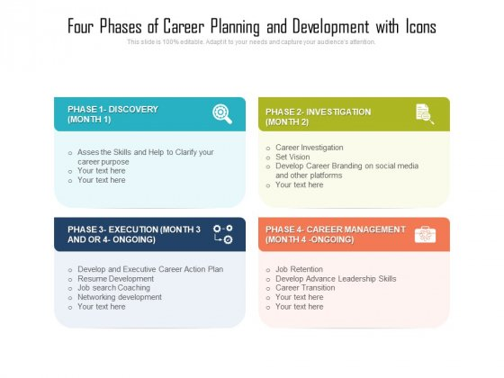
Figure 2: Phases of career planning
(Source: Chetana and Mohapatra, 2017)

4.0 What employers want
For recruiting a marketing manager, the employers try to find out some relevant qualities like managing time efficiently, the candidate needs to have some effective strategy building power. Further, it has been understood that employers seek innovative minds in their organisation especially in the marketing department. This has been always said that proper marketing can only make the company prominent in the market. In the recent time of COVID 19 pandemic situation most of the companies have turned out to be digital which means the offline storage facility is almost gone it services are provided online the clients are attracted towards the business through efficient online marketing strategies (deloitte, 2021). Thus, it has become mandatory part to hire a marketing person with high technical skills. I feel that I need to improve myself in this part. I am stable with other relevant skills like innovation, managing time, and others but the technical segment is a bit weak than those skills.

5.0 Self-Motivation
Self-motivation is a self-driven activity to carry on with actions to pursue goals and complete the allotted tasks. This is about staying motivated throughout and without depending on others. It is the internal force that helps us reach the goal seamlessly. According to Odanga (2018), when everything tries to pull you down the only thing that stands by our side is self-motivation, as we all are aware of the fact that self-help is the best help. According to me, I get motivated by the activity that helps in identifying the negative aspect present within the task and by identifying it and rectify the same with self-effort. My practicing level gets enhanced when the focusing level is high. The best part of self-motivation is it does not allow a person to give yup up easily.
I have identified that I can work for a longer time compared to others when I am self-motivated. There remains less existence of negativity in this part. Self-motivation can help in gaining a leadership attitude and thus, the candidate can become a future leader. I even noticed that the person who is self-motivated try to set goals on their own and give themselves deadlines so that they could complete their works on time or much before the actual deadline given for the work.

6.0 Learning styles (VAK theory)
Individuals differ from each other and their learning styles as well. There are several kinds of styles present in learning and if the VAK theory is aligned to this part then we will get to see that specifically there are three main types of learning present visual, auditory and kinaesthetic (Bakri et al., 2019). The learners could enhance their learning ability by visualising. Here, the parts could be made strong by highlighting those. The visual recordings can be made for future use. In the auditory part, the voice recording is beneficial in learning. The more the content will be repeatedly heard this can make the learning process more sweet and efficient. The last one is the kinaesthetic learning theory which is the combination of both visual and auditory learning styles. Here, learning could be possible by touching the object.
We use all the types of learning but specifically, one form of learning is mostly preferred among the others. I personally prefer the visual learning style. In this form of learning the understanding is deeper and the performance could be enhanced much efficiently. When something is presented visually it lasts for a long. The learning could be utilised utmost and even in future. Once I was facing a problem with a chapter in the class, later on, I was forwarded visual content and I understood the chapter so easily. Even I remember some of the important parts today as well.
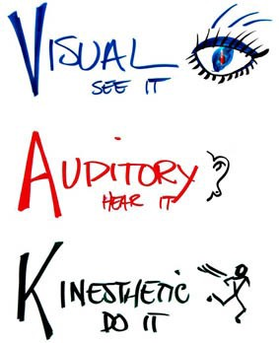

Figure 3: VAK learning style
(Source: Bakri et al., 2019)

7.0 Personal Development plan
Objective | Activities | Resources needed | Success measurement | Time frame
To improve my communication skills | I need to access videos of experts. Interacting with different people from different backgrounds and so on. | I will require internet, books on communication | Trying to present some relevant content as per the situation. | 3 months will be enough for it.
Planning and organising skill needs to be enhanced | Attending seminars, webinars | Strong internet connectivity | It will be better to conduct some projects | 5 months
Enhancing Numerical skills | Practicing mathematics | Some exercise books | Solving some tough numerical problems related to accountancy and marketing | Nearly 8 months

8.0 Employability Goals
Everyone has certain employability goals. According to Rehman and Mehmood (2014), they work really hard to achieve the set goal. The employability goals are based on the targeted job role. For the job role of manager, the employees will require team managing ability on the other hand, if the job role is handling finances of the company the employee needs to have high numerical skills and so on. The employability goal helps in setting a path for the employees to reach the targeted job interview. I want to reach the post of marketing manager and thus, my employability goals are:
- To increase professional experiences through practical projects
- To gain situational leadership style
- To enhance innovative skills
- To improve the team managing skill

9.0 Conclusion
Through this, the reflection on recruitment and selection has been stated moreover, the career plan I have is also identified here. Moreover, the skills that the employers require for the marketing manager in their business are also identified along with the skills that I need to improve in this part have been also measured. Some lacking or weaknesses have been identified previously and the need for its improvement has been understood and the required actions are measured through a personal development plan. Further, how self-motivation help in enhancing my skills has been identified as well. Here the learning style I prefer has been identified and with the help of VAK theory, it became quite prominent. Some of the employability skills have also been identified.

Reference
Ali, S., Li, G. and Latif, Y., 2020. Unleashing the importance of creativity, experience and intellectual capital in the adaptation of export marketing strategy and competitive position. Plos one, 15(11), p.e0241670.
Bakri, R.A., Rahman, M.A. and Jabu, B., 2019. Exploring the Impact of VAK Learning Style on Teenager Level Language Learners in Indonesia. Journal of Language Teaching and Research, 10(4), pp.807-814.
Chetana, N. and Mohapatra, A.K., 2017. Career planning and career management as antecedents of career development: A study. Asian Journal of Management, 8(3), pp.614-618.
deloitte.com., 2021. Shaping the business through digital marketing. [Online] Available at: <https://www2.deloitte.com/content/dam/Deloitte/global/Documents/About-Deloitte/COVID-19/gx-technology-digital-COVID-19-recovery-shaping-future-digital-business.pdf> [Accessed 9 August 2021].
Lynch, D.S., Lynch, M.J. and Clemens, C.M., 2018. Belbin Team Roles. The Handbook of Communication Training: A Best Practices Framework for Assessing and Developing Competence.
Odanga, S.J., 2018. Strategies for increasing students’ self-motivation. Asian Research Journal of Arts & Social Sciences, pp.1-16.
Rehman, S. and Mehmood, A., 2014. Employability skills, The need of the graduates and the employer. VSRD International Journal of Business and Management Research. Retrieved from www. researchgate. net.
The University of Edinburgh. 2021. Gibbs' Reflective Cycle. [online] Available at: <https://www.ed.ac.uk/reflection/reflectors-toolkit/reflecting-on-experience/gibbs-reflective-cycle> [Accessed 9 August 2021].

Appendix: Task 1

Job description
Job Title: Marketing Manager
Terms: 5 working days with, Saturday and Sunday off
Salary: 50000 per annum.
Requirement: The marketing manager needs to have relevant degrees like Bachelor of Business Management (BBA), and equivalents. The most vital requirement is to have the practical knowledge of marketing as only having a relevant degree will not be enough. Moreover, having stable communication skills is another important requirement. Effective communication is required as the marketing manager needs to connect different departments to carry out responsibilities.
Responsibilities: The marketing managers are responsible for working with top management officials and further, they supervise the other entire marketer in his team and also provide training and education as per their requirement. They try to find out the skills gaps within them and make them understand them. The marketing manager is also responsible for launching new products and services and also identifies the appropriate channels used for distributing the products and services. The marketing strategies are also selected by them. They generate marketing plans and try to make the subordinates follow them accordingly and achieve the set goal. The managers should be recognised as good motivators and should keep others morally up throughout. The manager needs to handle all the situations both positive and negative efficiently.

Person Specific:
 | Essential Required skills | Desirable skills
Skills | For marketing, it is essential to have depth knowledge regarding public communication. The relevant degrees are required for that. The degree of mass communication can be very relevant for this field and along with that, some managerial skills are also required to be present within the candidate. | The expectation of showing some practical knowledge in the part of marketing and recruitment is often high on the company's part. Further, prior experience of working in different companies as a team member of the marketing department is also quite beneficial.
Experience | Working in marketing in the marketing team for a minimum of 2 years is essential. The experience of working as a team is also essential. The more the employee will be habituated with the teamwork they will understand the benefits and limitations of the team working and will be able to manage a team as a manager well out of their experience. | This is an added benefit if the candidate has worked head to some companies previously then the matter of managing team in the workplace could be done in a most effective manner.
Knowledge | The marketing manager should be having in-depth knowledge of different leadership techniques. They should have the idea of applying the appropriate style of leadership as per the situation. They should know having rigidity in managing style can often result negatively. | Along with the marketing knowledge if the person is also having some added knowledge of managing products then there will be a high chance for that person to get selected for the job.
Attitude | The right attitude for the right situation is quite an essential thing. To be an efficient leader it is important to have positivity attitude in every situation even if the situation is negative. This is because to resist other team members from getting panicked. The more they will start panicking it will take a lot of time to work and most importantly the quality of the work will get negatively affected. The manager needs to have the personality of being an idol to other members from whom they can adopt such qualities and enhance the chance of becoming a future leader. | Within the managers, if there is a presence of a curious nature or attitude then they can definitely reach the targeted goal efficiently.

Role play

Conversation 1 (As an interviewer)
Interviewer: What are the qualifications required for a marketing manager? | Interviewee: One of the basic qualifications in this part is to have a bachelor's degree in management. Moreover, patience is required at every single stage. Further, having knowledge of all the associated departments with whom they work.
Interviewer: In what ways would you enhance your skills and try implementing those in your tasks? | Interviewee: The best way to enhance skills is to get engaged with every department. The most important part is to keep the other members engaged in the business operation greatly. The more there will be engagement the more knowledge and skills will automatically enhance. Practical work is always the best way to improve one's skills. Moreover, when there will be a practical gain of knowledge the innovative thinking ability will enhance. Those innovative ideas and thoughts could be incorporated into the business in the future.
Interviewer: What is the most essential thing for the marketing manager to keep in mind? | Interviewee: The marketing manager needs to keep the company's well-being part over anything. Accordingly, they need to develop strategies to maintain the other members of the company. The members are recruited after conducting several tests to pass through. Moreover, the trending distribution channels need to be kept in mind so that the clients could access them efficiently. For maintaining the updated technologies, it is required to strong technical base employees.
Interviews: In what ways you will handle product failure if any? | Interviewee: Here, I will start evaluating the members of the teams in some different ways. The efficient ones will be asked to stay for the tasks to re-build the structure of the operation and bring innovation to the product that failed to grab the market share efficiently. The marketing strategies would also be changed so that the re-created products do not fail to capture the market once again.
Interviewer: What are your strengths and the weaknesses as a marketing manager you have identified? | Interviewee: I have a quality of understanding the requirement of the co-workers and bring out a possible solution to their problems and requirements. This quality is beneficial for avoiding the issues that might be faced in long run. Efficient employees can be identified by this quality and they could be placed to the business operations as per their skills and potential.

Conversation 2 (As an interviewee)
Interviewer: What are the responsibilities of the marketing manager and the limitations that are being to fulfil those? | Interviewee: The marketing manager has the role to play. The product that is being manufactured in the company needs certain ways of distribution to reach the targeted audience otherwise it will be no use to produce so many products. The marketing manager with the help of some effective marketing strategies can reach the products to the clients and in an effective manner so that the clients can get attracted to the business operations. Moreover, managing the marketing team is another important responsibility of the manager.  There are certain personal limitations that resist me from fulfilling my responsibilities/. My communication part is a bit low than other skills, whereas on the other side my organising ability is also quite less. The numerical part is also less.
Interviewer: With which departments the marketing managers are directly associated? | Interviewee: The marketing managers are directly involved with the teams other than marketing teams are Human Resource Management department, finance and accounts department, production department, and many more. These departments are the core of the business. Above all these accounts and the HR departments are the most important departments to be connected by the marketing manager. Firstly, the accounts department helps in getting the status of the company's finance. Here, the adoption of new marketing strategies could be done based on the budget. On the other, the HR department helps in getting the information of the employees to the manager. The manager collects the background history of the clients from the application forms and can start managing things based on the information present in the application form.
Interviewer: In what ways you would prefer to choose your team members? | Interviewee: I would prefer to have a conversation with the applicants in a quite friendly manner. The more the members will be getting a comfort zone they will gain the confidence to exchange thoughts and ideas genuinely. From there, I will gain knowledge about them and understand their existing skills. I will make do some practical tasks on the spot and will measure their potential as well to work in a team and achieve the set goal efficiently. In these ways, I will try to find out efficient workers for my team out of the lot.
Interviewer: How far do you agree that the management and the leadership can affect decisions and success? | Interviewee: I strongly agree with the statement. The managers or the leaders are the backbones of any department and thus, their effective leadership or managing style can inspire the team members greatly and they enhance morality and try to contribute to the business operation by putting their best efforts into it. The more there will be efficiency in the workers it is no doubt that the company will gain success in the industry On the other hand, effective management and leadership also help in decision making well.
Interviewer: Would you suggest that before creating any plan the finance and strategy makers should consult the marketing manager? | Interviewee: I genuinely feel that all the departments are related to each other as their target is to achieve the same goal at the end of the day. Though the functionalities of the departments are different from each other their targets are the same. Thus, from this point of view I suggest that strategy makers and marketing, finance team need to consult the marketing manager. The new plans before implementation should be discussed with the marketing manager and the finance as well so that by staying within the financial boundaries only some great effective marketing strategies could be implemented within the business operation.

