Joshua Garcia-Gray

Advanced Web Design
BSc Applied Computing

Table of Contents
Task1 3
Intro 3
Design Patters 3
The range and capability of server-side Frameworks 3
Data Access Concepts 4
Data transport technologies 4
Database technologies 5
Task2 6
Design web application 6
User Personas 6
User scenarios 7
Task analysis 7
Mood Board 8
Sitemap 9
Content Plan 9
ERD 10
DFD 10
Wireframes 11
Mock ups 12
Task 1
Intro
The following report will endeavour to explain the benefits, drawbacks, features and constraints regarding design patters, server side frameworks, data access concepts, data transport technologies, database technologies and machine learning services in the context of developing data driven web applications.
Design Patterns
Enterprise design patters are tried and tested solutions to problems and are used in industry. They are general solutions which can be adapted to specialised problems, (1) making them indispensable tools for faster development of problem solving methods. Enterprise designs patters often divide applications into tiers, such as client tier, web tier, or business tier.
Model, View, Controller(MVC) is an architectural pattern who's defining feature is that it splits an application into three different components; the model, the view, and the controller. The user uses the controller to manipulate the model, the model then in turn updates the view, the view is then seen by the user and thus influences their interaction with the controller(2). The benefits of this are that by clearly separating each section, the application is modularised and thus development can be split into teams which enables parallel development. The separation of the layers also provides the benefit of each layer not being able to see beyond itself, which provides a level of increased security by making it so that one compromised layer wouldn’t be able to access the others. Another benefit of this architecture is that it allows the efficient reuse of code.

The range and capability of server-side frameworks
CakePHP is an open source rapid development framework for PHP, meaning that it provides groundwork for the creation of web applications. Cake provides a number of tools for web application development, such as access to a flexible database access layer. CakePHP uses the MVC as mentioned earlier, as well as providing components, behaviours and plugs ins to extend projects with generalised libraries which can be shared between models, controllers or views.(3) CakePHP also provides features which provide convenience to the developer such as making the user only have to manage database connections, so the user needn’t make any other configuration for setting specific locations of the library. Cake offers a means of converting data between incompatible type systems in databases and object orientated programming languages. CakePHP has built in create, read, update, and delete functions for database interaction as these are some of the most basic and common database functions.
Node.js is the product of an attempt by a man called Ryan Dahl to create real time websites with push capability. What this means is that instead of being based on a request/response paradigm between the server and the client, instead Node.js establishes a communication which is two way, with either being capable of initiating. Node uses Googles V8 JavaScript engine, the libuv platform abstraction layer and a core library mostly in JavaScript. Node.js programming is asynchronous, meaning that parts of the processing can continue before the transmissions is finished. Node.js uses something called an event loop for scheduling asynchronous operations, it does this by checking the task queue and taking processes from the top of that queue whenever the event stack was clear and moving the process to that event stack. This allows the processor to compute processes while waiting for a reply on other processes that might take longer due to external factors such as making network requests. The limitation of Node.js is that it works best on applications with large amounts of users, but which require relatively small amounts of processing power.(4)
ASP.NET has three frameworks for web applications; Web Forms, ASP.NET MVC and ASP.NET Web Pages. ASP.NET Web Forms is for building dynamic websites using drag and drop controls and an event driven model, it has a large number of controls and components for advanced UI design. ASP.NET MVC provides pattern based tools for dynamic website creation with a separation between the model, view and controller. ASP.NET Web Pages is a more minimalist tools in comparison to the previous two, and provides a means of combining server code and HTML to create dynamic websites.(5) The three frameworks are based on the .NET framework and share the core functionality, because of this the use of one of the frameworks doesn’t exclude the others, thus it is possible to build components of an application using different frameworks.
Data access concepts
Representational State Transfer(REST) is an architectural style that imposes a constraint upon the architecture into a client/server architecture that utilises a stateless communication protocol. RESTful applications use four standardised operations; PUT, GET, POST and DELETE. Put for creating a new resource, GET retrieves a representation of the state of a specified resource, POST changes the state of a resource and DELETE removes a resource. Resources are identifies using Uniform Resource Identifiers(URIs) which work as global addressing for resources. Every interaction with a resource is stateless which means that requests from clients contain all the information required to service the request and the state of the sessions is stored by the client.(6) Any programming language that can make web-based requests using HTTP can be used to invoke a RESTful API, thus making it a very versatile resource.
Microservice architecture is an architectural style which uses multiple small services running different processes and communicating between them using APIs as a means of building a single application. This offers scalability in that each update is modular instead of where an entire application might need to be updates to accommodate changes. Microservice architecture uses some libraries but it tends to use services more, services are out of process components which communicate with a mechanism, whereas libraries are components that are linked to the program and are called upon.(7) Services are each independently deployable, thus when updated, only that services requires updating, not the whole application. The modular nature of the microservices architecture allows for easier division of work and fault isolation. This allows microservice architecture built applications to evolve very quickly.
Data transport technologies
Extensible Markup Language (XML) is a language used to describe data, providing a flexible way to create information formats through using the Document Type Definition DTD.(8) The browser then uses the DTD to interpret the commends it’s given. XML works similarly to a stylesheet in that it dictates how to interpret other data, therefore each document would be required to start by specifying which DTD is to be used. Lack of uniformity across different types of computer using the internet could cause a range of compatibility issues, XML is as attempt to remedy this by providing a standardised method of describing data.
Ajax(Asynchronous JavaScript and XML) offers a means of updating web pages without having to reload their content without reloading the whole page. This is done using something called a XMLHttpRequest object which is a part of Ajax, XMLHttpRequest allows browsers to communicate with the server without requiring the reload of the page. Ajax requests are asynchronous meaning that a callback function is used to handle the response and the code continues to execute while waiting for the request to be answered, which will go onto the task queue until the event stack is clear before being processed.(9) This decoupling of the data interchange layer and the presentation layer is what allows Ajax to request and retrieve data from a server without reloading the already displayed page, this is referred to as asynchronous processing.
JavaScript Object Notation(JSON) is a data interchange format. When exchanging data between browsers and servers, the data can only be in text format. JSON provides a means of converting any JavaScript into plain JSON text and back. The benefit of using JSON is that it can be used with basically any programming language because it stores everything as text which can then be translated appropriately into whatever might be needed, thus making it extremely versatile.(10) JSON provides a means of formatting data which consists of creating objects, and inside each object is any number of name and value pairs. It is also possible to store more objects inside one variable, creating an array. Ajax cannot call resources from different domains than the one hosting it, but JSON provides a means of overcoming this limitation.
Database technologies
Mysql is a relational database management system that uses Structured Query Language(SQL) ideal for serving relatively small websites that runs on virtually all platforms. It’s an open source technology which is owned by Oracle so it has a range of support, but Oracle also offers other Database management services at a cost which are more scalable and have more resources. MySQL allows data to be stored or accessed on multiple different storage engines.(11) MySQL provides a level of transaction integrity by making it that should a transaction fail at any stage, the entire transaction fails. One of the things which makes MYSQL a cut above SQL is that SQL could only be used on Windows, whereas MySQL can be used on a range of platforms including Windows. Another important feature of MySQL is that it doesn’t differentiate between a database and a schema, and SQL Server treats them differently. Due to being a free service offered by a company who sells better services has led to the development of MySQL slowing down due to no longer being community driven and a relatively low priority for Oracle as it doesn’t generate the revenue of their other products.
Mongo is a non relational NoSQL database that stores data in a format called Binary JSON(BSON) . Documents in Mongo are self describing, so they needn’t be declared to the system. Mongo is open sourced, meaning it is free and developed by its community. Using Mongo instead of MySQL removes the complicated object relational mapping(ORM) which translates objects in code to relational tables.(12) Mongo provides scalability within and across multiple distributed data centres, making it more scalable than MySQL. Mongo uses JSON documents to store data, rather than in columns like in a relational database. Mongo is designed to work best with real time analytics, social networking sites and loosely coupled systems which may evolve over time, with this is mind it’s not suited to transaction intensive systems, or systems with tightly coupled systems.
Neo4j is a graph database. Graph databases are simpler databases which prioritises relationships, unlike other databases. Graph databases are primarily designed with transactional systems in mind. Graph databases update the node and related relationships of a search instead of the whole graph when responding to inquiries. Relational databases suffer performance issues when the data queries increase, but graph databases don’t have this issue. Of the graph databases technologies available, Neo4j is the most popular, with the largest amount of community support. Node represents data elements as nodes, relationships are the connection between nodes, properties are attributes of a node or a relationship, and labels are used to group nodes, but a node may have multiple labels. Neo4j uses a declarative query language that allows users to state what they want, without explicitly describing it.(13)
Cassandra is a NoSQL database management system designed for large amounts of data across multiple servers written in Java. It was initially developed for Facebook but was later released as open source. Cassandra is a decentralised system designed to create no single point of failure in order to protect data, and failed nodes can be replaced without downtime. Cassandra provides high performance even with larger systems and is best suited to large databases. However Cassandra does a large quantity of tasks asynchronously meaning that performance can vary(14).
Additional functionality through the application of machine learning provides web applications with the ability to process large quantities of data in order to identify trends that can be used in order to influence decision making. This type of data harvesting provides a means of improving a web service such as an ecommerce website with improved advertisement tailoring, or improve stock efficiency. Trend identification is not always useful in website development and might a waste of resources such as when a website doesn’t generate enough quality data for processing or where resources are limited.
Task 2
Design web application
Core functionality required by the web application is to host reviews similar to TripAdvisor, but for the review and discussion of members of Parliament using text and a score system. It requires a means of creating new user accounts which can be used to review as well as comment on each other's reviews. Administrator accounts will exist and have permission to add new items as well as moderate the content.
The framework selected to build this web application is CakePHP, the reasons for this are that it uses the MVC design pattern which will be useful for developing different views for different account types, providing more visible options for administrator accounts. CakePHP also has many of the tools required for web databases built in as well as a breadth of libraries to extend projects. Had the web application been required to update very often, using Node.js would have also been a good option thanks to it’s asynchronous process which would allow the reviews themselves to refresh without reloading the entire webpage, but this is not imperative for the web application.
MySQL is a suitable relational database for the web application. It’s open sourced, so it’s free to download, being owned by Oracle means that it will have suitable levels of support for the development of the web application. MySQL supports XML as a markup language to describe the data contained, providing a level of consistency for the web application on different platforms.
User Personas
Persona 1
Name: James Harris
Sex: Male
Age: 28
Occupation: Sales manager
Education: Marketing degree
Location: Swansea
Income: £26000 per year
Environment: Working in administration in a large company.
Family status: Married with 1 child
Persona 2
Name: Aaron Davis
Sex: Male
Age: 24
Occupation: Unemployed
Education: Mechanical engineering degree
Location: Cardiff
Income: N/A
Environment: Recently left education and looking for work
Family status: Single

Persona 3
Name: Jill Turner
Sex: Female
Age: 21
Occupation: Student
Education: A levels
Location: Cardiff
Income: £7000
Environment: Studying and working part time
Family status: Single
User scenarios
James is an active member of the conservative political party. James has become disillusioned with Brexit as the situation develops and wants to vent his frustrations and discuss how he feels about his party’s current leader.
Aaron is an unemployed student, looking for work in a post recession Britain. Unemployment has left Aaron apathetic towards politics. Aaron researches other people opinions towards the current political hierarchy in an attempt to understand the state of the nations politics through it’s electorate in order to better understand the countries position.
Jill is working part time as an administrator of the web application. A recent political scandal has caused allegations toward a member of parliament to come to light. The conversation in the comments concerning this political figure has become unfriendly and generates a negative image, so Jill wants to remove the conversation.
Task analysis
James seeking to complain about a political leader in particular, would find the website and when he attempted to make a post, if he lacked an account, he would be prompted to then make one. Once the account registration is done, James would be able to go onto the page with reviews about Theresa May, see the reviews about her and add his own.
Aaron upon finding the website would be able to search for the members of parliament who interest him, there he will see the reviews left by users with accounts. Clicking one of those reviews will allow Aaron to view the comments by other users about that review. Should Aaron be inclined to join the discussion, he would be required to create an account, once he has he can join he conversation happening in the comments.
Jill as an administrator will have access to administrator credentials which will provide her to a different view of the page than normal users. Jill will have the permission to either delete individual comments from each review, delete the review with those comments, or remove user access to comment on that particular member of parliament until whoever is in charge of the website decides to reimplement reviews of that person.
Moodboard

The political basis of the web application has inspired a politics theme background. Historically the main political divides have been represented as right vs left and red vs blue. Both of these themes have been influential in the design, splitting the pages vertically and using those colours creates a reflection of the right and left mentality on the page itself. For contextualisation into British politics, the members of the Conservative party could have blue review boxes and Labour party members could have red review boxes.

Sitemap
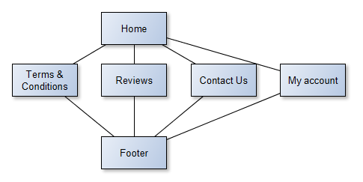
Content plan
Page | Content
Homepage | Navigation/Selected reviews for promotional purposes
Reviews | Navigation/Application with search feature, reviews and comments
Contact us | Navigation/Company contact information
My account | Navigation/Modify account details

ERD
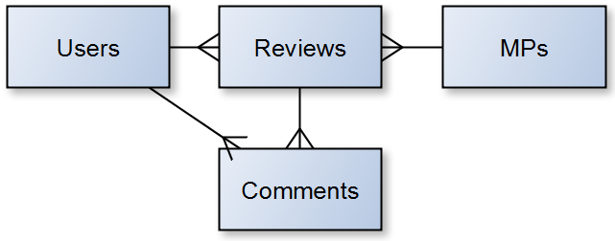
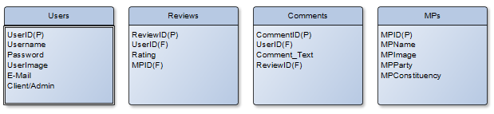
Data Flow Diagram
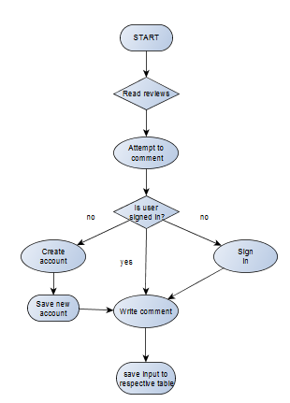

Wireframes
Homepage
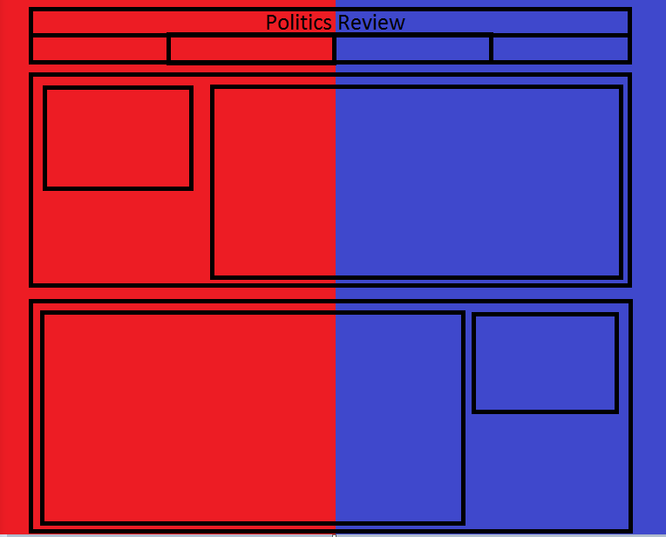
The top bar holds the title and logo, the second is a navigation tool. Below that on the homepage will be some of the more popular or interesting MPs posted with reviews and comments in order interest potential clients.
Review page
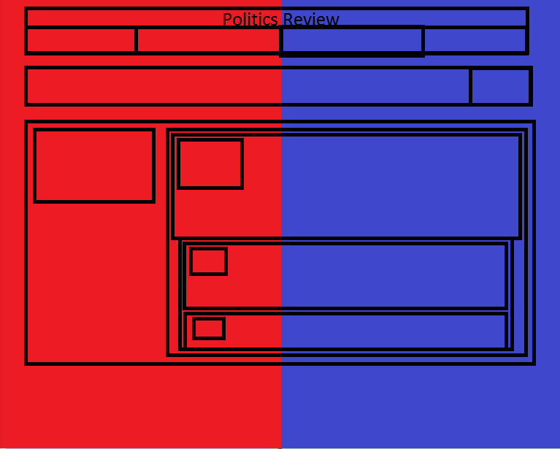
The review page will contain all MPs in order with more detailed views of the reviews as well as the comments on those reviews. Users will be able to search in the top bar either by name, party or constituency in order to browse the selection of MPs using a search bar at the top of this page.
Mock ups
Homepage
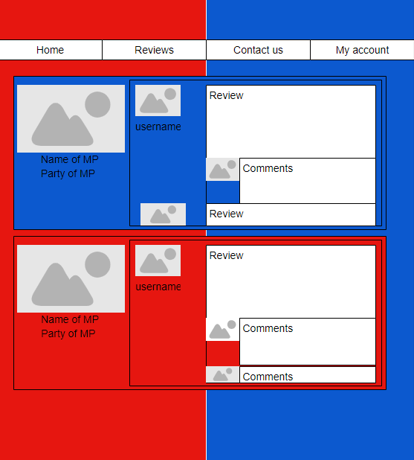
Review Page
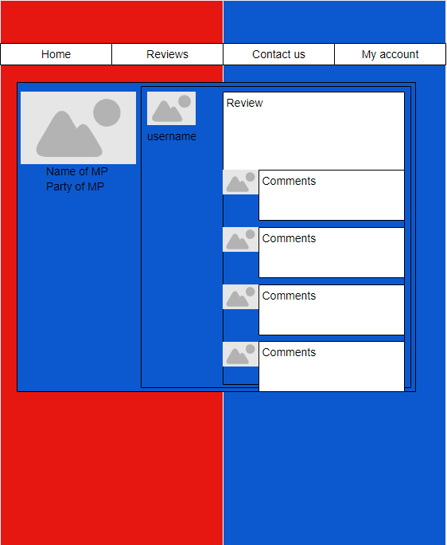
Bibliography
(1)Martin Fowler Patterns
Available from: https://www.martinfowler.com/ieeeSoftware/patterns.pdf
[Accessed: 17/12/2018]
(2) Code Academy MVC: Model, View, Controller
Available from: https://www.codecademy.com/articles/mvc
[Accessed: 17/12/2018]
(3)CakePHP What is CakePHP? Why use it?
Available from: https://book.cakephp.org/1.2/en/The-Manual/Beginning-With-CakePHP/What-is-CakePHP-Why-Use-it.html
[Accessed: 17/12/2018]
(4) Dan McGhan Asynchronous Processing in Node.js
Available from: https://blogs.oracle.com/oraclemagazine/asynchronous-processing-in-nodejs
[Accessed: 17/12/2018]
(5) Microsoft ASP.NET Overview
Available from: https://docs.microsoft.com/en-gb/aspnet/overview
[Accessed: 17/12/2018]
(6) Oracle What Are RESTful Web Services?
Available from: https://docs.oracle.com/javaee/6/tutorial/doc/gijqy.html
[Accessed: 17/12/2018]
(7) Martin Fowler Microservices
Available from: https://martinfowler.com/articles/microservices.html
[Accessed: 17/12/2018]
(8) Silmaril Consultants The XML FAQ: Why should I use XML?
Available from: http://xml.silmaril.ie/whyxml.html
[Accessed: 17/12/2018]
(9) jQuery Ajax jQuery Learning Centre
Available from: https://learn.jquery.com/ajax/
[Accessed: 17/12/2018]
(10) JSON Introducing JSON
Available from: https://www.json.org/
[Accessed: 17/12/2018]
(11) MySQLTutorial What is MySQL and Why It Is the World’s Most Popular Open Source Database
Available from: http://www.mysqltutorial.org/what-is-mysql/
[Accessed: 17/12/2018]
(12) MongoDB MongoDB and MySQL Compared
Available from: https://www.mongodb.com/compare/mongodb-mysql
[Accessed: 17/12/2018]
(13)The Neo4j Graph Platform
Available from: https://neo4j.com/product/
[Accessed: 17/12/2018]

