Investigating Data and Development of EUC within an MIS

Paige Harris

P145700

Contents
Introduction 3
Data 3
Excel Document 4
Home Page 4
Hospital Admissions due to Alcohol-specific and Attributable Conditions 5
Deprivation Decline and Quintile 6
Deprivation Decline and Quintile (2) Averages 7
Maps for Hospital Admissions 9
Maps for Deprivation 10
Maps 11
Bing Maps 11
Hospital admissions related to alcohol for Financial Years 13/14 and 14/15 11
Average Deprivation for each area Within Neath Port-Talbot for 2014 12
Power Maps 13
Hospital admissions related to alcohol for Financial Years 13/14 and 14/15 13
Average Deprivation for each area Within Neath Port-Talbot for 2014 14
Charts 15
Problems 16
Data Problems 16
Bing Map Problems 17
Power Map Problems 18
Bibliography 19

Introduction
The main focus of this assignment will be to show critical understanding of the end-user computing environment and where and when it is appropriate. It will discuss and demonstrate how Microsoft Excel can be used to analysis data from the UK Data Service and Health Maps Wales.

Data
The data that has been used which was taken from the UK Data Service and Health Maps Wales. The first data set retrieved was Deprivation data on the Neath Port Talbot area. “The Welsh Index of Multiple Deprivation (WIMD) is designed to identify the small areas of Wales that are the most deprived. The most recent WIMD was published in 2014. However a selection of indicators used within WIMD are updated annually.” [1]. The second data set used was from Health Maps Wales and was titled “Hospital Admissions due to Alcohol-specific and Attributable Conditions” the number of admissions from alcohol related

Excel Document

Home Page
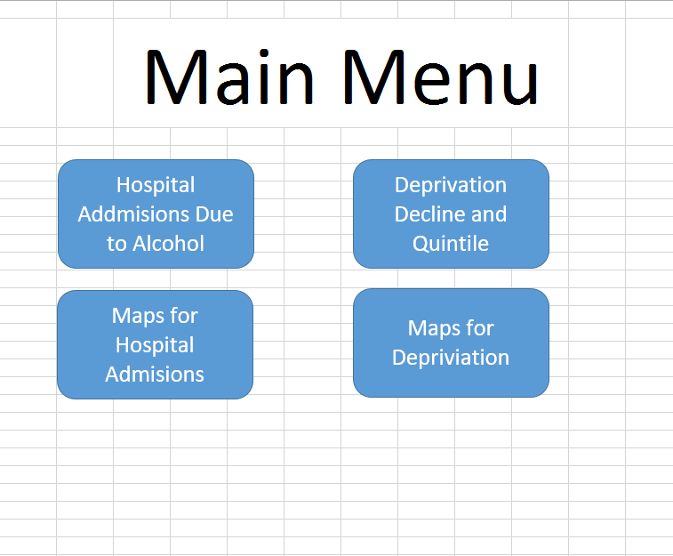
The main menu is the first page the user will see when the open the spreadsheet. It has buttons that allow the user to navigate through the system at ease. These macros are located throughout the system as will be shown in the screenshots below.

Hospital Admissions due to Alcohol-specific and Attributable Conditions
This is a screenshot of the Hospital Admissions due to alcohol related conditions. There is data for Admissions per 100k population on a 3 year average, person based admissions per 100k population on a 2 year average and person based admissions per 100k population on a 3 year average. To quickly identify which section is which, a light background colour has been used and averages have been calculated along the bottom of each numeric column. The Macros are available to take the user to the Maps information on Hospital Admissions due to alcohol related conditions and to return to the home page. Two Graphs have been created to visualise the data within the table, the data in them will be described in Charts.
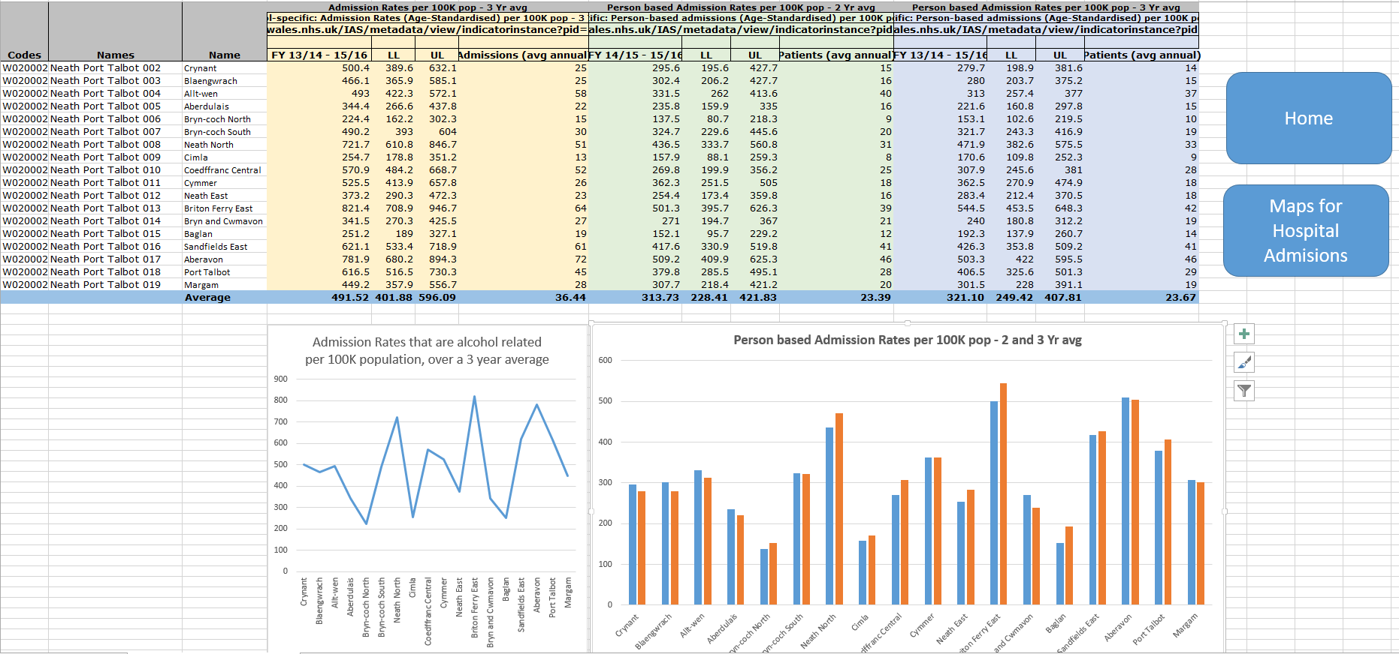

Deprivation Decline and Quintile
This is the Deprivation Decline and Quintile page, where we able to see the most and least deprived areas within Neath Port-Talbot. As can be seen from the table, there is a lot of data related to the same area, however these areas have been broken down to up to 4 areas. As Aberavon is a large area, there is data for Aberavon 1, 2, 3 and 4, using data like this made it harder for the maps to work, therefore I averaged them out as can be seen on the next page. There are macros on this page that allow the user to return home and navigate to the Maps for Deprivation screen.
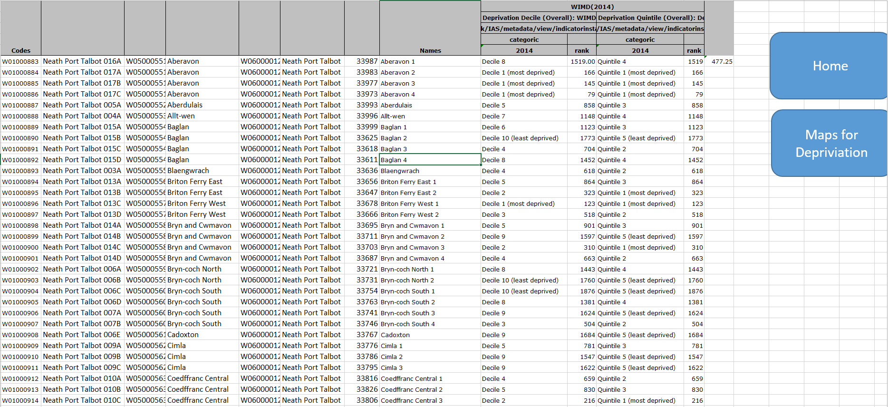

Deprivation Decline and Quintile (2) Averages
This is another copy of the information above, but it has been edited to make working with easier. The Category 2014 has been separated to 3 different columns using the ‘Text to Columns’ tool in the Data tab. This allowed the numeric data within that category to be split from the text to be used within a calculation.
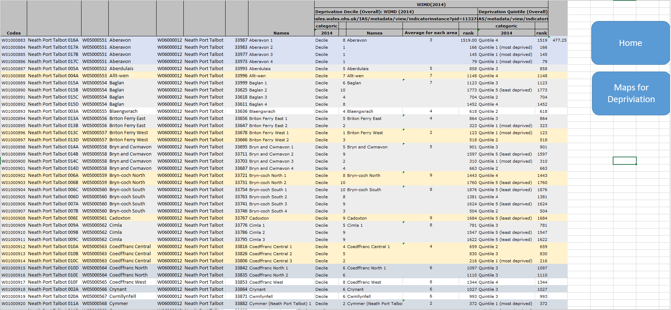

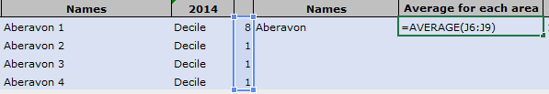
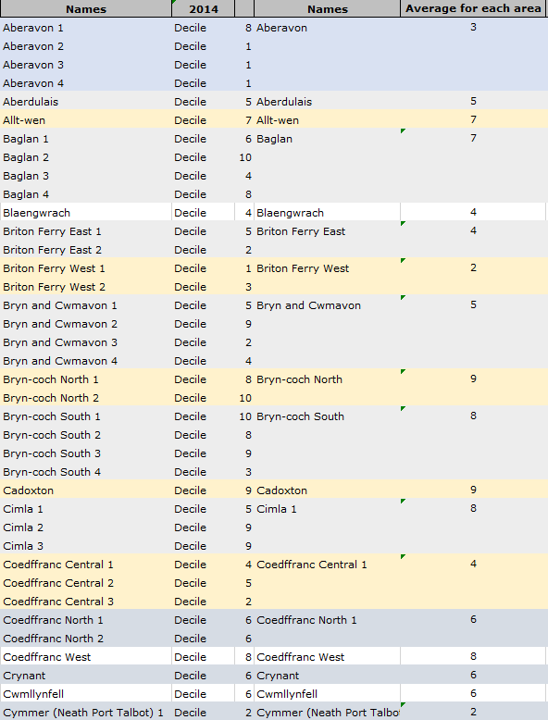
Calculating the average for Aberavon was done by using the formular shown below and using the four values for Aberavon. The formular automatical will calculate the average for this group. An average was generated for every area with more than one name to it. The single areas such as aberdulais and alltwen were transferred over to the same colunm.

Maps for Hospital Admissions
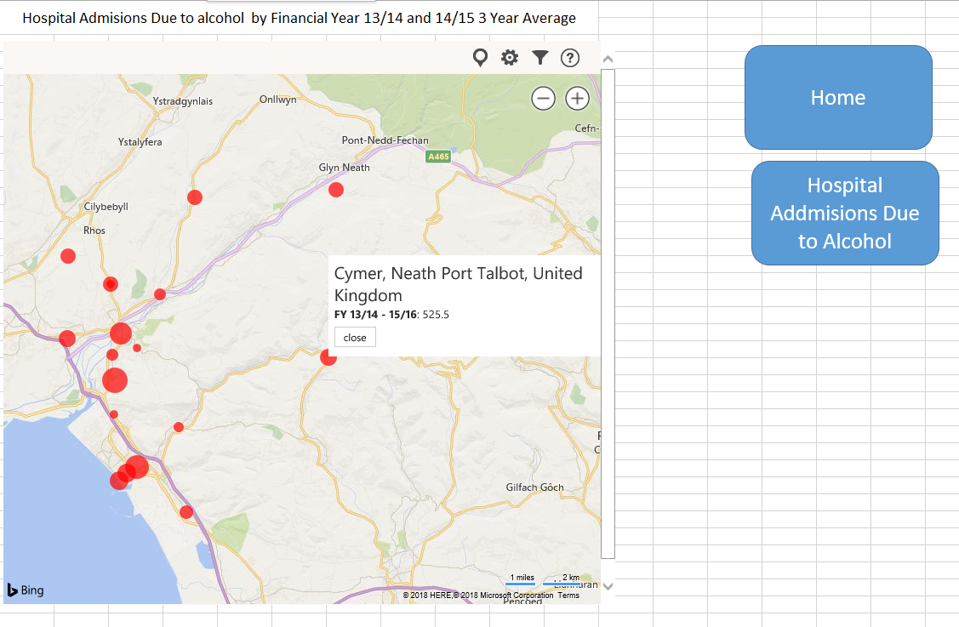
This screen shot shows the Hospital Admissions Due to Alcohol by Financial Year 13/14 and 14/15 3 Year Average Map that has been generated using Bing maps. It has Macros that enable to user to navigate to the home page and to the Hospital Admissions due to Alcohol page where they can find the data that links to the map.

Maps for Deprivation
This screen shot shows the Deprivation average per area within Neath Port-Talbot for 2014 Map that has been generated using Bing maps. It has Macros that enable to user to navigate to the home page and to the Hospital Admissions due to Alcohol page where they can find the data that links to the map.
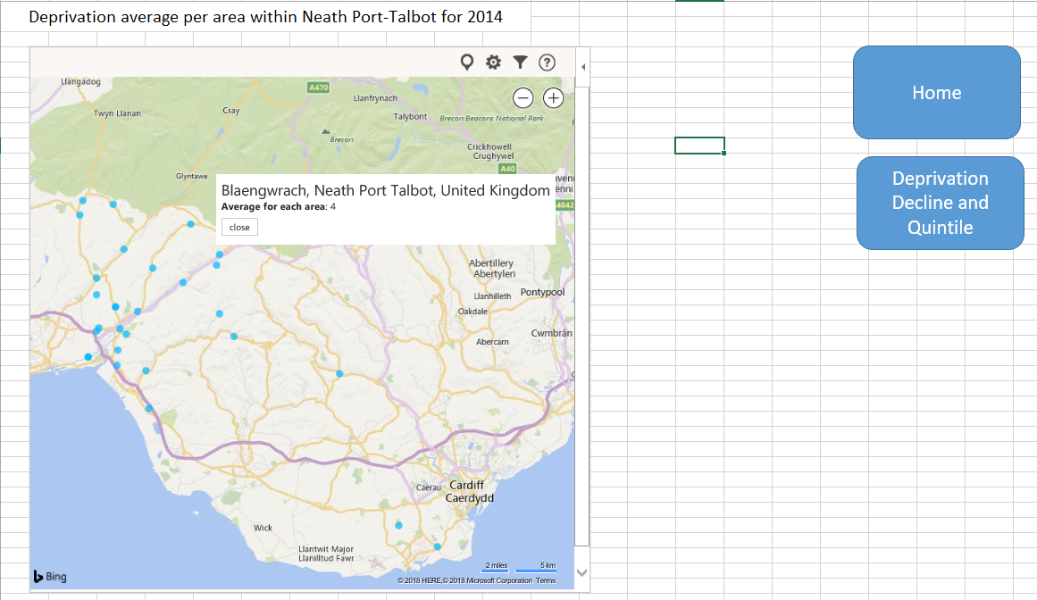

Maps
Using Bing maps and Power Map allows the user to quickly identify areas which suffer with more Deprivation and also the number of Admissions over a two and three year period.

Bing Maps

Hospital admissions related to alcohol for Financial Years 13/14 and 14/15
This map has been created using Bing Maps and is a visual representation of the Hospital admissions related to alcohol for Financial Years 13/14 and 14/15. This map allows the user to quickly visualise the areas which have a higher admissions rates. When using the map, the user is able to click on the red dot to view the actual information behind it, as shown below with Cymer.
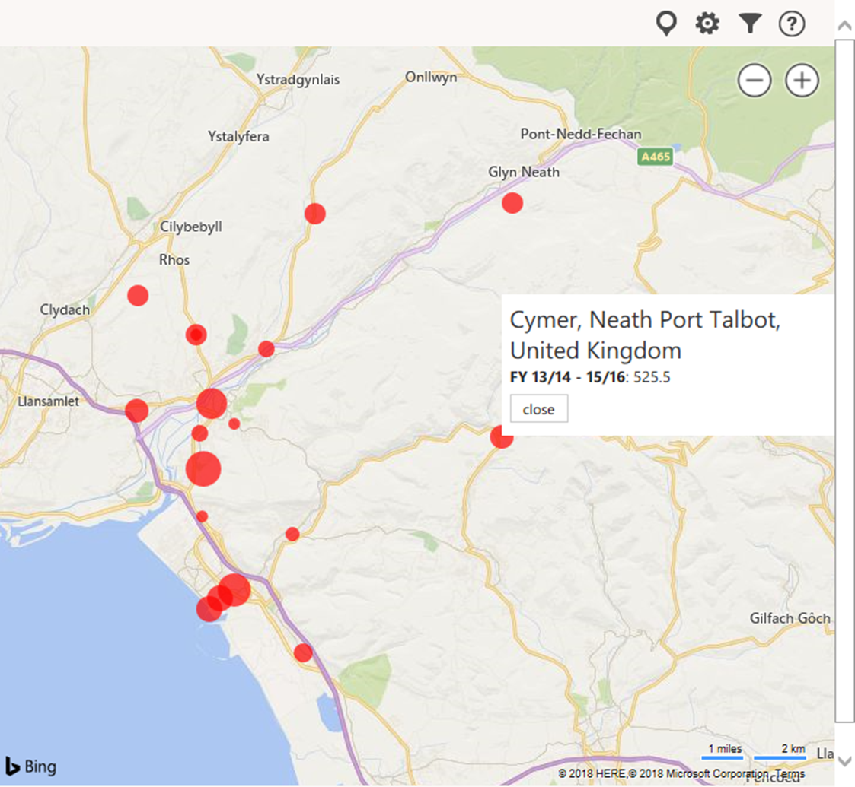

Average Deprivation for each area Within Neath Port-Talbot for 2014
The map below shows the average deprivation for each area within Neath Port-Talbot for the year 2014. This map does not show any of the area labels or have a key to making it difficult for the viewer to determine the location of the information.
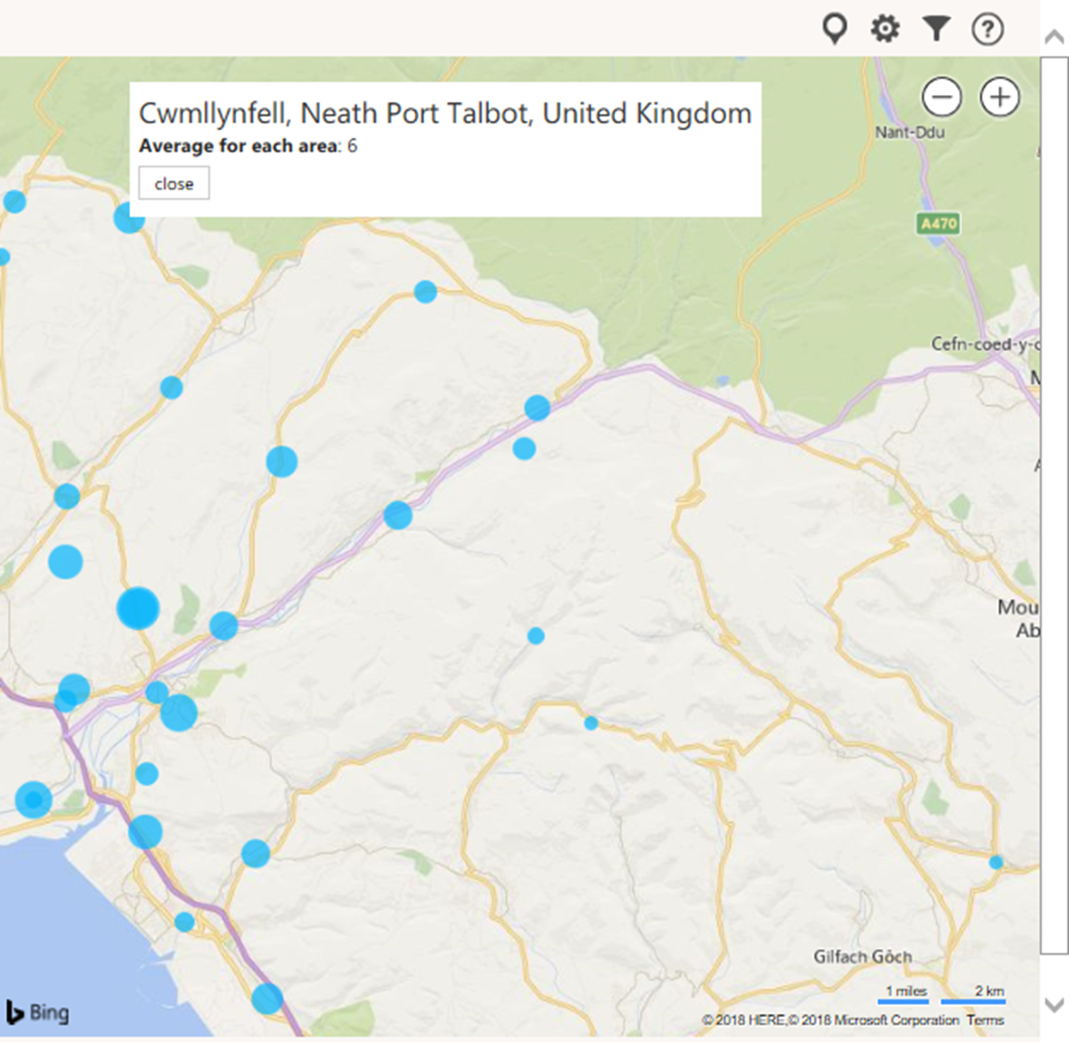

Power Maps

Hospital admissions related to alcohol for Financial Years 13/14 and 14/15
This map has been created using Power Maps and is a visual representation of the Hospital admissions related to alcohol for Financial Years 13/14 and 14/15. This map allows the user to quickly visualise the areas which have a higher admissions rates. To help visualise the data on this map, a heat map has been used and a key is shown so the user can see the redder the dot, the higher the hospital admissions in that area are. Just looking at this map, we are able to see that Aberdulais has a low rate and Briton Ferry has a high rate of admissions.

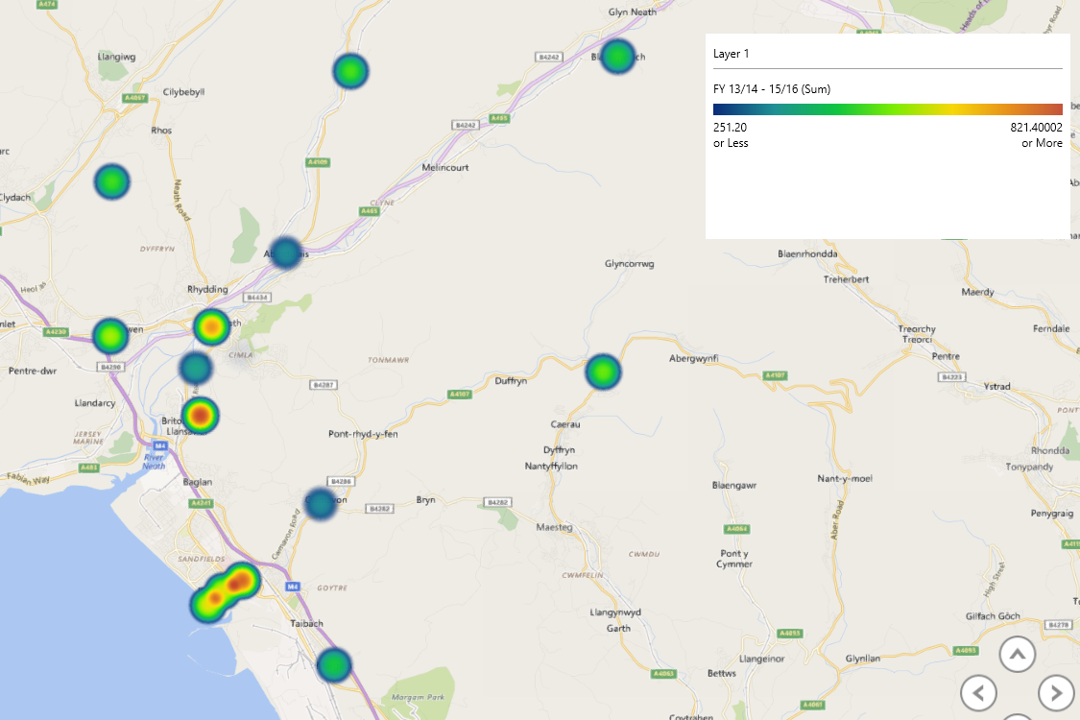

Average Deprivation for each area Within Neath Port-Talbot for 2014
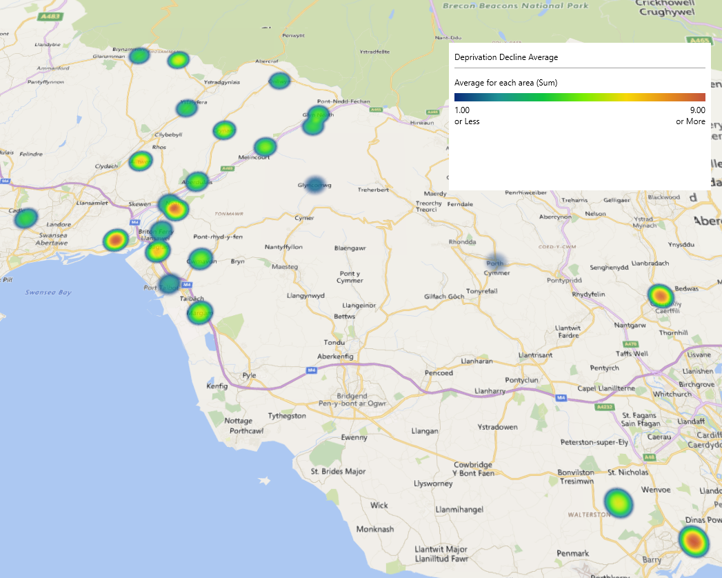
This power map shows the average deprivation for each area within Neath Port-Talbot for the year 2014. It is showing the average from 1 or less being the most deprived and 9 or more being the least deprived. It uses the heat scale from blue to red, blue being the most deprived and red being the least deprived. For an example like this, it would be ideal if the colours could be changed to red to green, as red is a colour perceived to be bad and blue is a neutral colour.

Charts
Charts have been used to analyse the data within excel. There are a good way to quickly visualise data. By using bar charts and line graphs, the viewer is able to instantly identify the highest and lowest fact.
The chart below shows the Admission Rates that are alcohol related per 100K population, over a 3 year average for each area within Neath Port-Talbot. It is clear from the chart that Bryn-Coch north has a lower admission rate compared to Bryn-Coch South. There could be many reasons for this, one being the population might be higher in south. It can be seen from the chart that Briton ferry East has the highest Admission rate overall within the Neath Port-Talbot area.

The bar graph below shows the person based admission rates per 100k of the population for a 2 and 3 year average. The 2 year average consists of data from the financial yeas 14/15 and 15/16 and the 3 year data consists of the years 13/15 through to 15/16.

Problems

Data Problems
When adding the data and wanting to create an average, the formula used would not be accepted as the data was set to text. The data then had to be changed from text to number in order for the formula to work, also the columns labelled LL and UL could not be understood, after looking into the meta data to try and identify what the data in the columns represented, there was no information to explain them.
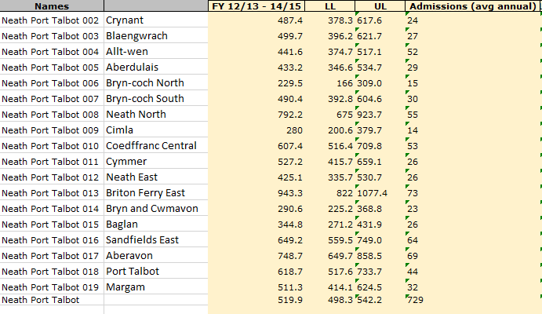

Bing Map Problems
When using Bing map, some of the location data would not recognise the location being in Neath Port-Talbot. For example, Sandfields is an area of Port-Talbot, however, the map believes that it is a location within Warrington. They has happened for many pieces of data, including an area in London. It is also not clear when you zoom in on the map the exact area for the data unless the dot is clicked on. Although when using the app, you can view the numeric values by clicking on the dot, it has no option to add labels to the data to view it as a picture or a print out which would make the map useless if there is no specific data.
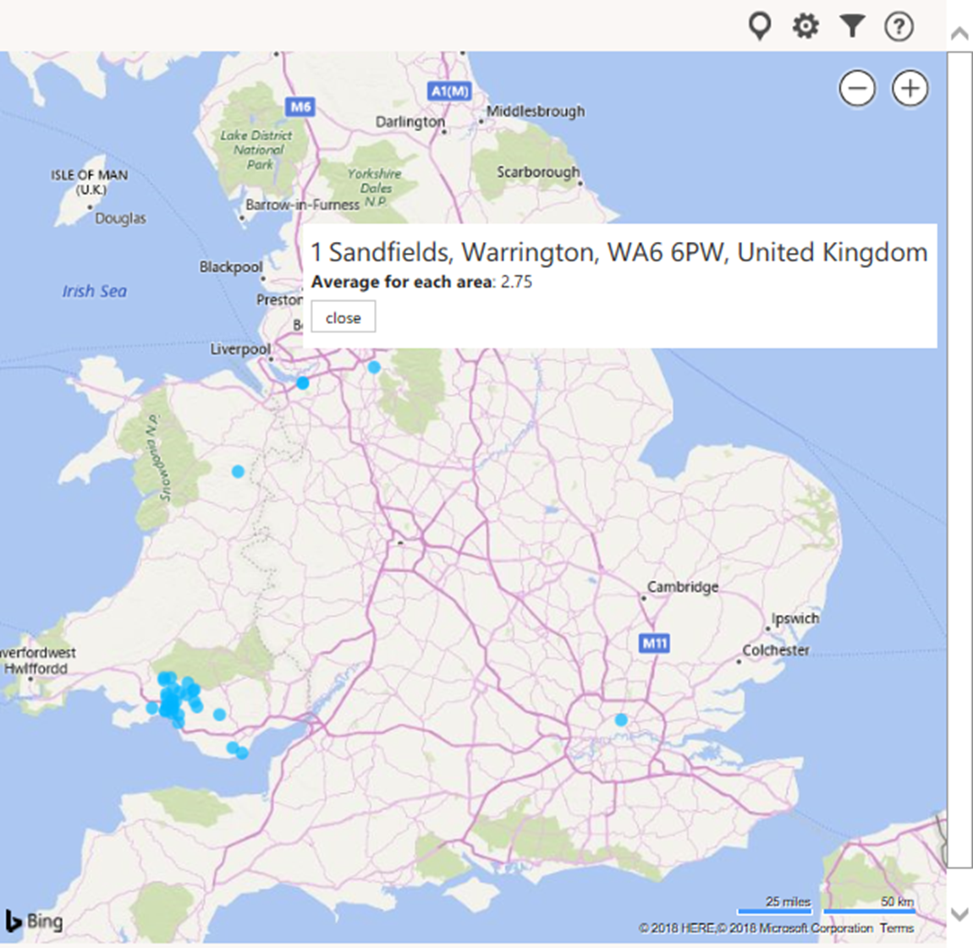

Power Map Problems
When using the power map, it is clear that some of the places are not being shown within the Neath Port-Talbot and are being shown elsewhere in the country. This could be because there is a place with the same name in a different area, this is not good when analysing Neath Port-Talbot as not all of the relevant data will be shown in that area.

Bibliography

[1] | “welsh-index-multiple-deprivation,” [Online]. Available: http://gov.wales/statistics-and-research/welsh-index-multiple-deprivation/?lang=en. [Accessed 01 02 2018].

