Student Name: Shazia Begum
Student Number:2117727
Module: Changemakers: Creativity and Value Creation
Module Code: BMHP5014_BIRM
Assignment Title: E-Portfolio
Lecturer: Robert Nartowski

Contents Page

Artefact Task 3
Word Pitch..........................................................................Page 3
Selling My Pitch..................................................................Page 4

Artefact Task 4
Poster..................................................................................Page 6
Poster Explanation..............................................................Page 7
Reference Page..................................................................Page 9

Artefact Task 3
My Pitch
My name is Shazia and I work alongside my colleagues at the hyperlipidemia and translation service. Our responsibility is to bring the Mirpuri community's attention to the problem of hyperlipidemia and to offer a translation service for those who suffer from the condition. A biological illness called hyperlipidemia, which is common in today's culture together with a poor diet and insufficient exercise, has been identified as the main risk factor for cardiovascular disease as stated by Nie, (2021). We offer a service that is available to everyone and is dependent on the NHS. Since my husband has hyperlipidemia, the topic is one that I care deeply about. When my husband was born, his mother and father, both of whom speak Mirpuri, were unable to understand the English language, making it difficult for them to learn about the condition. As a result, my husband was diagnosed too late, requiring multiple hospital visits before he was finally diagnosed, which led him to spend the rest of his life taking medication. If early intervention or an interpreter service had been available this might have not been the case today. According to Avgil, et al (2017), due to its connection to cardiovascular disease, hyperlipidemia is a significant global cause of disease risk. We propose to offer a service which will be available online and in person with translation available so that suffers can get help and prevent them from needing medication. A specially tailored diet plan will also be available for individuals who suffer from the condition. Over the previous ten years, public health has placed a lot of emphasis on the primary prevention and treatment of hyperlipidemia as stated by Avgil, et al (2017). Furthermore, we aim to educate expectant parents who have the condition about the route they can take once their child is born. Expectant parents can get their new-borns tested at one of our centres which again will take the burden of the mainstream hospitals. When I had my child, this service was not available, and I had to wait 6 months before my child could be tested which led my child to suffer the same fate as his father. This is why we believe that these external services that we provide will make a difference within the community. Workshops will be held in schools for parents and children so they can understand the condition better. Furthermore, specially developed diet plans will be provided as well as blood testing for individuals. We believe early intervention can help the burden on the NHS as hyperlipidemia can lead to many health complications. Early intervention can aid in easing pressure on the NHS. Early intervention of the condition can also help individuals lead a healthier life. We will be working alongside dieticians which will also ease pressure of the NHS. Early intervention of the condition can also help the individuals lead a healthier life we will be working alongside translators who can provide Mirpuri written diet plans for service users.
Selling My Pitch
It is proposed to obtain additional funding for all our centres and workshops from The NHS directly as according to Iacobucci (2018), the budget for NHS England would be affected by a 3.4% rise in the next 10 years this indicates that extra funding is available. This funding will enable the organisation to offer a service that will relieve pressure on the NHS, reducing hospital waiting lists and ensuring that patients with the condition are seen more effectively. With the aid of this financing, specially trained dieticians will also be able to create diet plans that are translated into Mirpuri for service users. Chambers (2020), states in the early 1960s, migrants and their families left Mirpur in Pakistan's underdeveloped Azad Kashmir region for England. This programme would be ideal for this group of Mirpuri speaking individuals. Tailoring the programme to make it suitable for this group is the purpose of the services provided. This funding will also allow the organisation to hire more nurses who are trained in taking blood samples, making testing Lipid levels easier for patients. According to Kao, et al (2020) lipids are essential for maintaining good health because they are the fundamental part of cell structures. Additionally Grants for Schools will also be providing funding as it is something that they are interested in highlighting within their schools. By closely monitoring patient health conditions and educating them about the service we will be able to help those who are suffering from the illness manage it and gain a better understanding of it. Shanker (2020), states the key to preventing serious health issues that can cause mortality is early detection and action. Healthy meal ideas will also be taught in the proposed workshops according to Wood, et al (2021), workshops are made to assist parents and boost parental effectiveness by giving parents engaging, hands-on learning opportunities and useful take-away activities that they can use at home. The proposed workshops will also give the child and parent an opportunity to learn how to cook healthy meals together. Children and parents who both have the condition can then help each other by putting the skills they have learnt into practice. Online information will be translated into Mirpuri. Additionally, there will be online sessions this will enable patients to stay in touch with their dieticians even if they are unable to visit the centres due to their busy schedules. Volunteers who speak Mirpuri and have the condition will also be recruited this will in turn help keep costs down which will enable the organisation to put funding towards the running costs of the service. According to Gray (2020), volunteering frequently involves a group effort. Volunteering can be done on an individual basis, but most volunteers work with organisations and groups that coordinate activities for a shared cause. The individuals with the ailment may be able to live a life without medicine which would result in less money being spent by the NHS on medication. Early detection and treatment of hyperlipidemia is always preferred since it can reduce the strain on the NHS and the individual who has the condition will be learning how to manage their lifestyle with hyperlipidemia more effectively.

My Poster

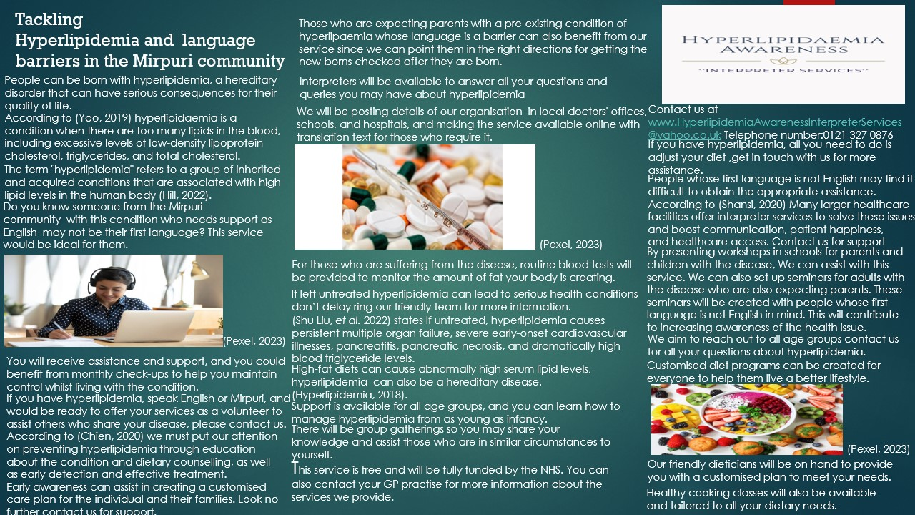

Al Shansi H, et al. (2020) Implications of language barriers for healthcare: a systematic review. Oman medical journal, 35(2), p.e122.
Chien, I.C. and Lin, C.H. (2020) Increased risk of hyperlipidemia in patients with anxiety disorders: A population-based study.
Hill, M.F. and Bordoni, B. (2022). Hyperlipidemia. In StatPearls [Internet]. StatPearls Publishing.
Hyperlipidemia. (2018) A Dictionary of Public Health. 2nd edn. Oxford University Press.
Pexel, (2023) Available at: https://www.pexels.com/search/healthy%20food/ . (Accessed: 7 February 2023).
Yao Q, et al. (2019). Moxibustion for treating patients with hyperlipidemia: a systematic review and meta-analysis protocol. Medicine, 98(48).

Artefact Task 4
Poster
The proposed topic is a single-sided A3 poster which will raise awareness of hyperlipaemia in the Mirpuri community and how language barriers can prevent people from receiving the adequate support services for themselves or their families. According to Lai, M et al (2022), It has been established that hyperlipidemia is linked to several health issues, including diabetes, obesity, and hypertension. The proposed topic was picked since the South Asian community has a history of not asking for help even when it is available as they are not sure which route to take due to language barriers. As multicultural education has grown, so have patient outcomes, as stated by Narayanasamy, (2021). The proposed poster will help break the language barrier and will help Mirpuri speaking patients receive the help they require. Mirpur is in Pakistan's undeveloped Azad Kashmir area. According to Chambers (2020), in the early 1960s, immigrants and later their families relocated to England because of the push of being displaced at home and the draw of Britain's demand for factory employees. The posters aim is to increase awareness of hyperlipidemia in the Mirpuri community and to help people realise that language barriers should just not prevent them from receiving support and assistance. The poster is also aimed at expectant parents who have a history of hyperlipidemia and want to get their child checked for the condition. The poster will display the contact number and website these expectant parents can contact. Furthermore, the website will have translation available, and a phone number will be printed on the poster so that people may call it with any queries they may have in the Mirpuri language. The most significant and effective means of audience engagement is advertising as stated by Ghassan, (2021). Furthermore, local authorities like GP clinics will display the poster and individuals can receive more information from their GP surgeries about the services provided. Hospitals, schools, maternity wards, gymnasiums, and grocery stores will also be asked to advertise the poster this way a wide range of people will be able to see it and can then contact the service for further assistance. People can be born with hyperlipidemia, a hereditary disorder that can have profound consequences for their quality of life. Workshops would be conducted at schools for parents and children to assist them to understand help and support is available. According to Narayanasamy (2021), the delivery of healthcare is improved by meetings, conferences, workshops, training programmes, education sessions, and interpreters. Additionally, workshops can be offered to inform expectant parents who have the condition about the resources available to them once their child is born as early awareness can aid in early prevention. Individuals will not have to worry about being unable to understand how to access the information they need because an interpreter service will be provided over the phone and online. The primary dietary risk factors for obesity and cardiovascular risks are potentially modifiable as stated by Abdurahman, et al (2020). People will be able to control their nutrition, ensuring a higher quality of life, by having access to personal diet programmes and blood testing which will help individuals in controlling hyperlipidemia. Children and parents will have an activity they can undertake together such as cooking classes. This will then ensure they can put their learning into effect together whilst they prepare low fat food which will help them maintain a healthy lifestyle.

2020 Many larger healthcare facilities offer interpreter services to solve these issues and boost communication, patient happiness, and healthcare access. Contact us for support.

Reference Page

Abdurahman, A.A. et al. (2020) ‘The association between diet quality and obesity-related metabolic risks’, Human antibodies, 28(1), pp. 1–9.

Al Shansi H, et al. (2020) Implications of language barriers for healthcare: a systematic review. Oman medical journal, 35(2), p.e122.

Avgil T, M. et al. (2017) ‘Primary Prevention of Hyperlipidemia: Treatment and Compliance in Real World Practice’, Value in health, 20(9), p. A625.

Chambers, C. (2020) ‘Burminggaon? Nottinggaon? Biradforrd?”: British Asian Noir Depictions of Bradford, Forum for modern language studies, 56(3), pp. 259–279.

Chien, I.C. and Lin, C.H. (2020) Increased risk of hyperlipidemia in patients with anxiety disorders: A population-based study.

Ghassan F. J, (2021) ‘Methods to stimulate consumer desire included in the production of communicative formats for contemporary commercial advertisements.

Gray, D. and Stevenson, C., (2020) ‘How can we help’? Exploring the role of shared social identity in the experiences and benefits of volunteering. Journal of Community & Applied Social Psychology, 30(4), pp.341-353.

Hill, M.F. and Bordoni, B. (2022). Hyperlipidemia. In StatPearls [Internet]. StatPearls Publishing.

Hyperlipidemia. (2018) A Dictionary of Public Health. 2nd edn. Oxford University Press.

Kao, Y.-C. et al. (2020) ‘Lipids and Alzheimer’s Disease’, International journal of molecular sciences, 21(4), p. 1505.

Lacobucci, G. (2018) ‘NHS to get funding boost of 3.4% a year over next five years’, BMJ, 361, pp. k2682–k2682.

Lai, M. et al. (2022) ‘IL-38 in modulating hyperlipidemia and its related cardiovascular diseases’, International immunopharmacology, 108, pp. 108876–108876.

Narayanasamy, S.N. and Thomas, P. (2021) ‘EP.TU.292Role of varying cultural backgrounds on patient safety in modern health care (NHS)’, British journal of surgery, 108(Supplement_7).

Nie Y, and Luo, F. (2021) ‘Dietary Fiber: An Opportunity for a Global Control of Hyperlipidemia’, Oxidative medicine and cellular longevity, 2021, pp. 5542342–20.

Pexel, (2023) Available at: https://www.pexels.com/search/healthy%20food/ . (Accessed: 7 February 2023).

Shankar M, et al. (2020) ‘Subjective Global Assessment and Quality of Life in Hemodialysis Patients- A Clinical Observational Study’, Journal of clinical and diagnostic research, 14(6), pp. OC13–OC17.

Shu Liu, et al. (2022) ‘Case Report: Successful Management of a 29-Day-Old Infant with Severe Hyperlipidemia from a Novel Homozygous Variant of GPIHBP1 Gene’, Frontiers in paediatrics, 10.

Wood, K.R. et al. (2021) ‘Workshop Training to Facilitate Parent-Child Instructional Opportunities for Reading and Social Development with Kindergarten Students’, Journal of research in childhood education, 35(3), pp. 438–457.

Yao Q, et al. (2019). Moxibustion for treating patients with hyperlipidemia: a systematic review and meta-analysis protocol. Medicine, 98(48).

